**TEAM AGREEMENT TEMPLATE & GUIDELINES**

**For**

**<Data Scientist>**

**Prepared by:**

***Team Member:***

***Minwoo kang n9913351***

***Mary Rose n10086820***

***LunLu n0000000***

***Project Due Date***

***<07/04/2019>***

# Sign-off and Approvals

|  |  |  |
| --- | --- | --- |
| **Team Agreement Sign-Off:** | | |
| The undersigned members of this team agree to abide by this team agreement to ensure the successful completion of the ***<insert project name>*** project to meet the client’s requirements and timeframes. | | |
| Student number & name | Signature | Date |
| 1. ***Minwoo kang / n9913351*** | *Minwoo kang* | *8/03/2019* |
| 1. ***Mary Rose / n10086820*** |  |  |
| 1. ***LunLu / n0000000*** |  |  |

# Document Change History

| Revision Number | Date of Issue | Author(s) | Brief Description of Change |
| --- | --- | --- | --- |
| 1 | 8-Apr-2019 | SK | Initial working draft, based upon semester 2 template |
| 2 | 8-Apr-2019 | SK | Incorp. RN feedback – Communications and Code of Conduct moved to sep doc. |
| 3 | 8-Apr-2019 | RN | Align project details with project overview and background briefing notes. |
| 4 | 8-Apr-2019 | RN | Updated to incorporate revised project requirements |
| 5 | 8-Apr-2019 | RN | Separate Team Agreement developed. |
| 0.6 | 8-Apr-2019 | SK | Team Agreement updated. |
| 0.7 | 8-Apr-2019 | RN | Agreement & Guidelines Merged |
|  |  |  | ***Add intermediate versions as required*** |
| *1.0* | ***dd-mm-yyyy*** | ***Initials*** | ***Version to be submitted*** |
|  |  |  | ***Add subsequent versions if required*** |

***Instructions: You should use this template to plan and discuss your team agreement by substituting and adding your own ideas and text wherever there are italics throughout the document.***

Table of Contents

Sign-off and Approvals 2

Document Change History 2

1 Task 1. Data Selection and Distribution. 4

2 Task 2. Predictive Modelling Using Decision Trees 4

3 Task 3. Predictive Modelling Using Regression 5

4 Task 4. Predictive Modelling Using Neural Networks 5

5 Task 5. Generating an Ensemble Model and Comparing Models 6

6 Task 6. Final Remarks: Decision Making 7

# Task 1. Data Selection and Distribution.

**1. What is the proportion of cars who can be classified as a “kick”?**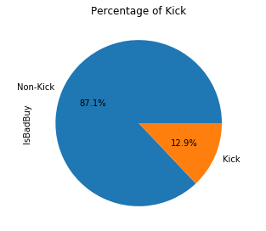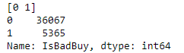

Figure 1

12.9% (5365) is categorised into a “kick” while 87.1% (36067) is categorised into a “non-kick”

**2. Did you have to fix any data quality problems? Detail them.**

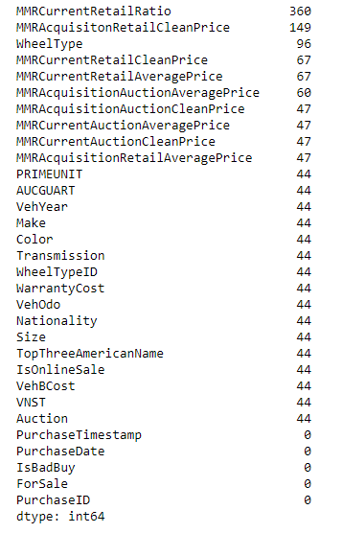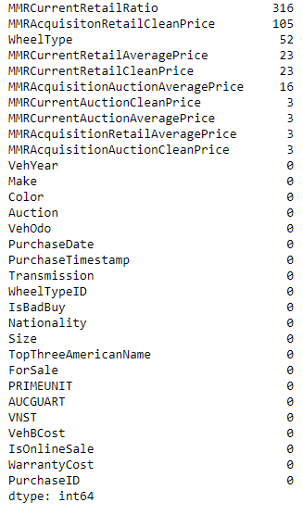

Figure 2 Figure 3

1. By using“MissingData = df1.isnull().sum()” codes, we identified there are some missing values in various columns depicted in figure 2. At first, we explored dataset where 44 null values appeared and decided to remove entire rows depicted in figure 3.
2. In Colour column, “?” and “NOT AVAIL” are replaced to OTHER
3. In Transmission column, “?” is replaced into “AUTO” as “AUTO” is representing majority in a Transmission column. “Manual” is replaced into “MANUAL” for consistency
4. “?” is replaced into 1 as “1” is representing majority in a “WheelTypeID” column. “WheelTypeID” column is transformed into a categorical type.
5. “nan value” and “?” are replaced into “Alloy” as it is representing majority in “WheelType” column.
6. “?”, “USA”, and “OTHER” are replaced into AMERICA as it is representing majority in a NATIONALITY column.
7. “?” is replaced into “MEDIUM” as it is representing majority in a SIZE column.
8. “?” is replaced into “GM” as it is representing majority in a TOPAMERICANNAME column
9. MMRAcquisitionAuctionAveragePrice: “?” is replaced placed and then it is filled with mean values calculated in the column.
10. MMRAcquisitionAuctionCleanPrice: “?” is replaced placed and then it is filled with mean values calculated in the column.
11. MMRAcquisitionRetailAveragePrice: “?” is replaced placed and then it is filled with mean values calculated in the column.
12. MMRAcquisitonRetailCleanPrice: “?” is replaced placed and then it is filled with mean values calculated in the column.
13. MMRCurrentAuctionAveragePrice: “?” is replaced placed and then it is filled with mean values calculated in the column.
14. MMRCurrentAuctionCleanPrice: “?” is replaced placed and then it is filled with mean values calculated in the column.
15. MMRCurrentRetailAveragePrice: “?” is replaced placed and then it is filled with mean values calculated in the column.
16. MMRCurrentRetailCleanPrice: “?” is replaced placed and then it is filled with mean values calculated in the column.
17. MMRCurrentRetailRatio: “?” is replaced placed and then it is filled with mean values calculated in the column.
18. “?” is replaced into 0 in VehBCost column
19. IsOnlineSale: ‘?’,’2’,’4,’ are replaced into ‘0’ as it is representing majority and ‘-1.0’,’0.0’ are replaced into ‘1’ and ‘0’ for consistency. Afterwards, the type of the column is changed into categorical type
20. ForSale: ‘yes’,’YES’ are replaced into ‘Yes’ for consistency. ‘?’ is replaced into “Yes” representing majority values. ‘0’ is replaced into ‘No” as it can be understood as no in binary.

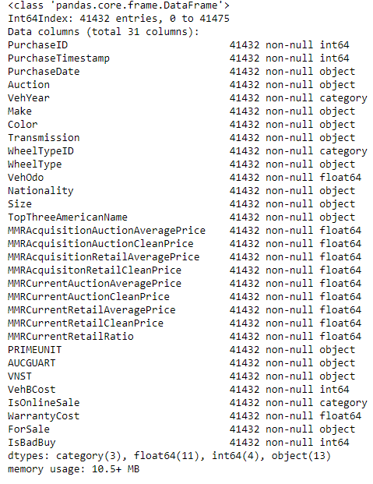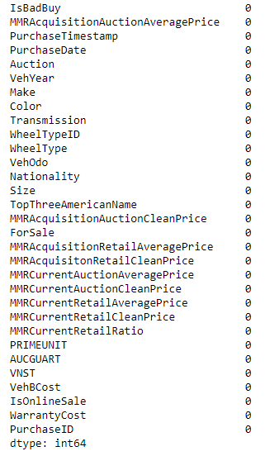

Figure 4 Figure 5

**3. Can you identify any clear patterns by initial exploration of the data using histogram or box plot?**

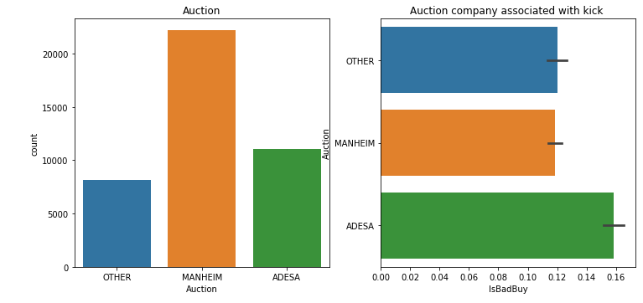

Figure 6

In figure 6, ADESA shows higher probability to be categorised as a kick in consideration to number of cars.

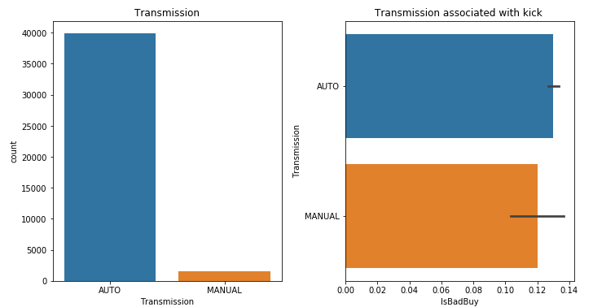

Figure 7

In figure 7, Auto has higher probability to be categorised as a kick in consideration to number of cars.

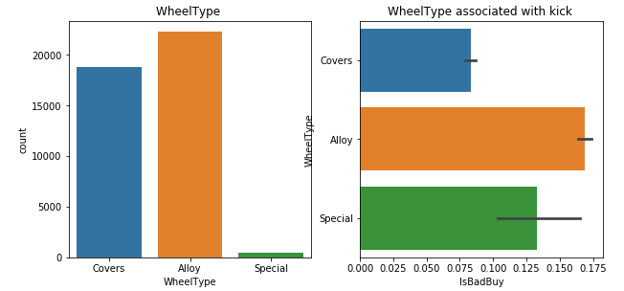

Figure 8

In figure 8, Alloy wheel has higher probability to be categorised as a kick in consideration to number of cars.

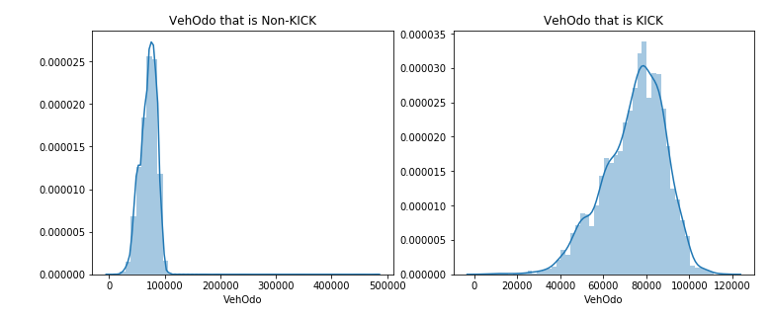

Figure 9

In figure 9, cars drive between 70000 and 90000 has higher probability to be categorised as a kick.

**4. What variables did you include in the analysis and what were their roles and measurement level**

**set? Justify your choice.**

We include all except for ’PurchaseID', 'PurchaseTimestamp', 'PurchaseDate' , 'WheelTypeID', 'PRIMEUNIT', 'AUCGUART', 'IsOnlineSale', 'ForSale'

* ’PurchaseID', 'PurchaseTimestamp', 'PurchaseDate' are excluded as it is not necessary information for training model
* 'WheelTypeID' is excluded as ‘WheelType’ exist
* 'PRIMEUNIT', 'AUCGUART' are excluded as majority data are missing
* 'IsOnlineSale', 'ForSale' are excluded as one values in two are extremely surpassing.

**5. What distribution scheme did you use? What data partitioning allocation did you set? Explain your selection.**

# Task 2. Predictive Modelling Using Decision Trees

**1. Python: Build a decision tree using the default setting.**

a. What is the classification accuracy on training and test datasets?

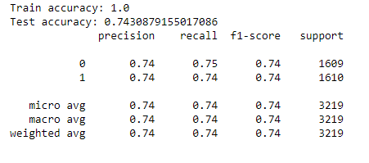

Figure 10

b. What is the size of tree (i.e. number of nodes)?

The depth of a decision tree is the length of the longest path from a root to a leaf.

The size of a decision tree is the number of nodes in the tree.

c. How many leaves are in the tree that is selected based on the validation data set?

d. Which variable is used for the first split? What are the competing splits for this first split?

e. What are the 5 important variables in building the tree?

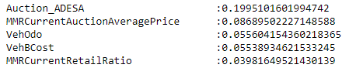

Figure 11

f. Report if you see any evidence of model overfitting.



Figure 12

g. Did change the default setting (i.e., only focus on changing the setting of the number of splits to create a node) help improving the model? Answer the above questions on the best performing tree.

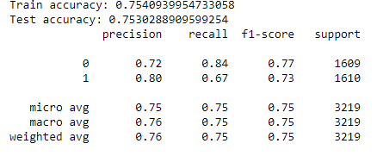

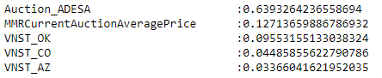

2. Python: Build another decision tree tuned with GridSearchCV

a. What is the classification accuracy on training and test datasets?

b. What is the size of tree (i.e. number of nodes)? Is the size different from the maximal tree or the tree in the previous step? Why?

c. How many leaves are in the tree that is selected based on the validation data set?

d. Which variable is used for the first split? What are the competing splits for this first split?

e. What are the 5 important variables in building the tree?

f. Report if you see any evidence of model overfitting.

g. What are the parameters used? Explain your choices.

3. What is the significant difference do you see between these two decision tree models (steps 2.1 & 2.2)? How do they compare performance-wise? Explain why those changes may have happened.

4. From the better model, can you identify which cars could potential be “kicks”? Can you provide some descriptive summary of those cars?

# Task 3. Predictive Modelling Using Regression

1. In preparation for regression, is any imputation of missing values needed for this data set? List the variables that needed this.

2. Apply transformation method(s) to the variable(s) that need it. List the variables that needed it

3. Build a regression model using the default regression method with all inputs. Once you done it, build another one and tune it using GridSearchCV. Answer the followings:

h. Name the regression function used.

i. How much was the difference in performance of two models build, default and optimal?

j. Show the set parameters for the best model. What are the parameters used? Explain your decision. What are the optimal parameters?

k. Report which variables are included in the regression model.

l. Report the top-5 important variables (in the order) in the model.

m. What is classification accuracy on training and test datasets?

n. Report any sign of overfitting.

3. See whether you can further improve the performance by applying transformation to regularize input distributions. Report the variables that required transformation. What transformation function did you use and why?

4. Choose the best model in previous step (step 3.2: SAS) to apply transformation of variables. Does it improve the performance?

5. Using the best regression model, which cars could potential be “kicks”? Can you provide some descriptive summary of those cars?

# Task 4. Predictive Modelling Using Neural Networks

1. Build a Neural Network model using the default setting. Answer the following:

a. What is the network architecture?

b. How many iterations are needed to train this network?

c. Do you see any sign of over-fitting?

d. Did the training process converge and resulted in the best model?

e. What is classification accuracy on training and test datasets?

2. Python: Refine this network by tuning it with GridSearchCV.

a. What is the network architecture?

b. How many iterations are needed to train this network?

c. Sign of overfitting?

d. Did the training process converge and resulted in the best model?

e. What is classification accuracy on training and test datasets? Is there any improvement in the outcome?

3. Would feature selection help here?

Build another Neural Network model with inputs selected from RFE with regression (use the best model generated in Task 3) and selection with decision tree (use the best model from Task 2).

a. Did feature selection help here? Any change in the network architecture? What inputs are being used as the network input?

b. What is classification accuracy on training and test datasets? Is there any improvement in the outcome?

c. How many iterations are now needed to train this network?

d. Do you see any sign of over-fitting? e. Did the training process converge and resulted in the best model?

4. Using the comparison methods, which of the models (i.e one with selected variables and another with all variables) appears to be better?

From the better model, can you identify cars those could potential be “kicks”?

Can you provide some descriptive summary of those cars? Is it easy to comprehend the performance of the best neural network model for decision making?

# Task 5. Generating an Ensemble Model and Comparing Models

1. Generate an ensemble model to include the best regression model, best decision tree model, and best neural network model.

a. Does the Ensemble model outperform the underlying models? Resonate your answer.

2. Use the comparison methods (or the comparison node) to compare the best decision tree model, the best regression model, the best neural network model and the ensemble model.

a. Discuss the findings led by (a) ROC Chart (and Index); (b) Score Ranking (or Accuracy Score); (c) Fit Statistics; (or Classification report) and (4) Output.

b. Do all the models agree on the cars characteristics? How do they vary?

# Task 6. Final Remarks: Decision Making

1. Finally, based on all models and analysis, is there a particular model you will use in decision making? Justify your choice.

2. Can you summarise positives and negatives of each predictive modelling method based on this analysis?

3. How the outcome of this study can be used by decision makers?

Can you identify any clear patterns by initial exploration of the data using histogram or box plot?

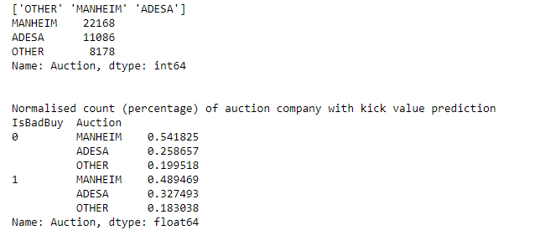

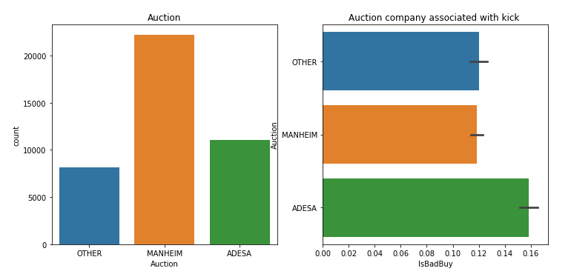

ADESA and Other shows higher probability of a kick while it occupied less volume of cars

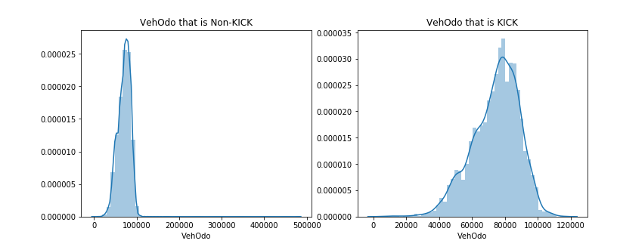

More drive, more kick