UNIT-1

Basic Concepts of C++ ,Structure of a C++ program, Data types, Declaration of variables, Expressions, Operators, Operator Precedence, Evaluation of expressions, Type conversions. Flow control statement- if, switch, while, for, do, break, continue, goto statements. Functions, scope of variables, Parameter passing, Default arguments. Templates-types of templates, Class - definition, structure, objects, access modifiers, scope, this pointer, Constructors and Destructors, inheritance, virtual functions.

C++ OOPs Concepts
The major purpose of C++ programming is to introduce the concept of object orientation to the C programming language.
Object Oriented Programming is a paradigm that provides many concepts such as inheritance, data binding, polymorphism etc.
The programming paradigm where everything is represented as an object is known as truly object-oriented programming language. Smalltalk is considered as the first truly object-oriented programming language.

OOPs (Object Oriented Programming System)
Object means a real word entity such as pen, chair, table etc. Object-Oriented Programming is a methodology or paradigm to design a program using classes and objects. It simplifies the software development and maintenance by providing some concepts:

- Object
- Class
- Inheritance
- Polymorphism
- Abstraction
- Encapsulation

Object
Any entity that has state and behavior is known as an object. For example: chair, pen, table, keyboard, bike etc. It can be physical and logical.
Class
Collection of objects is called class. It is a logical entity.

Inheritance
When one object acquires all the properties and behaviours of parent object i.e. known as inheritance. It provides code reusability. It is used to achieve runtime polymorphism.
Polymorphism
When one task is performed by different ways i.e. known as polymorphism. For example: to convince the customer differently, to draw something e.g. shape or rectangle etc.

In C++, we use Function overloading and Function overriding to achieve polymorphism.

Abstraction

Hiding internal details and showing functionality is known as abstraction. For example: phone call, we don't know the internal processing.

In C++, we use abstract class and interface to achieve abstraction.

Encapsulation
Binding (or wrapping) code and data together into a single unit is known as encapsulation. For example: capsule, it is wrapped with different medicines.

Advantage of OOPs over Procedure-oriented programming language
- OOPs makes development and maintenance easier where as in Procedure-oriented programming language it is not easy to manage if code grows as project size grows.
- OOPs provide data hiding whereas in Procedure-oriented programming language a global data can be accessed from anywhere.
- OOPs provide ability to simulate real-world event much more effectively. We can provide the solution of real word problem if we are using the Object-Oriented Programming language.
- Both Procedural Oriented Programming (POP) and Object Oriented Programming (OOP) are the high level languages in programming world and are widely used in development of applications. On the basis of nature of developing the code both languages have different approaches on basis of which both are differentiate from each other.
- Following are the important differences between Procedural Oriented Programming (POP) and Object Oriented Programming (OOP)

Sr.  No. | Key | Object Oriented Programming (OOP) | Procedural Oriented Programming (POP)
1 | Definition | Object-oriented Programming is a programming language that uses classes and objects to create models based on the real world environment. In OOPs it makes it easy to maintain and modify existing code as new objects are created inheriting characteristics from existing ones. | On other hand Procedural Oriented Programming is a programming language that follows a step-by-step approach to break down a task into a collection of variables and routines (or subroutines) through a sequence of instructions. Each step is carried out in order in a systematic manner so that a computer can understand what to do.
2 | Approach | In OOPs concept of objects and classes is introduced and hence the program is divided into small chunks called objects which are instances of classes. | On other hand in case of POP the main program is divided into small parts based on the functions and is treated as separate program for individual smaller program.
3 | Access | In OOPs access modifiers are introduced namely as Private, | On other hand no such modifiers are

Sr.  No. | Key | Object Oriented Programming (OOP) | Procedural Oriented Programming (POP)
 | modifiers | public, and Protected. | introduced in POP.
4 | Security | Due to abstraction in OOPs data hiding is possible and hence it is more secure than POP. | On other hand POP is less secure as compare to OOPs.
5 | Complexity | OOPs due to modularity in its programs is less complex and hence new data objects can be created easily from existing objects making object-oriented programs easy to modify | On other hand there is no simple process to add data in POP at least not without revising the whole program.

C++ history
History of C++ language is interesting to know. Here we are going to discuss brief history of C++ language.

C++ programming language was developed in 1980 by Bjarne Stroustrup at bell laboratories of AT&T (American Telephone & Telegraph), located in U.S.A.

Bjarne Stroustrup is known as the founder of C++ language.

It was develop for adding a feature of OOP (Object Oriented Programming) in C without significantly changing the C component.

C++ programming is "relative" (called a superset) of C, it means any valid C program is also a valid C++ program.

Structure of C++ program:
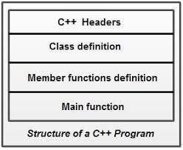

C++ Features
C++ is object oriented programming language. It provides a lot of features that are given below.

- Simple
- Machine Independent or Portable
- Mid-level programming language
- Structured programming language
- Rich Library
- Memory Management
- Fast Speed
- Pointers
- Recursion
- Extensible
- Object Oriented
- Compiler based

Simple
C++ is a simple language in the sense that it provides structured approach (to break the problem into parts), rich set of library functions, data types etc.

Machine Independent or Portable
Unlike assembly language, c programs can be executed in many machines with little bit or no change. But it is not platform-independent.

Mid-level programming language
C++ is also used to do low level programming. It is used to develop system applications such as kernel, driver etc. It also supports the feature of high level language. That is why it is known as mid-level language.

Structured programming language
C++ is a structured programming language in the sense that we can break the program into parts using functions. So, it is easy to understand and modify.

Rich Library
C++ provides a lot of inbuilt functions that makes the development fast.

Memory Management
It supports the feature of dynamic memory allocation. In C++ language, we can free the allocated memory at any time by calling the free() function.

Speed
The compilation and execution time of C++ language is fast.

Pointer
C++ provides the feature of pointers. We can directly interact with the memory by using the pointers. We can use pointers for memory, structures, functions, array etc.

Recursion
In C++, we can call the function within the function. It provides code reusability for every function.

Extensible
C++ language is extensible because it can easily adopt new features.

C++ Basic Input/Output
C++ I/O operation is using the stream concept. Stream is the sequence of bytes or flow of data. It makes the performance fast.

If bytes flow from main memory to device like printer, display screen, or a network connection, etc, this is called as output operation.

If bytes flow from device like printer, display screen, or a network connection, etc to main memory, this is called as input operation.

I/O Library Header Files
Let us see the common header files used in C++ programming are:

Header File | Function and Description
<iostream.h> | It is used to define the cout, cin and cerr objects, which correspond to standard output stream, standard input stream and standard error stream, respectively.
<iomanip> | It is used to declare services useful for performing formatted I/O, such as setprecision and setw.
<fstream> | It is used to declare services for user-controlled file processing.

Standard output stream (cout)

The cout is a predefined object of ostream class. It is connected with the standard output device, which is usually a display screen. The cout is used in conjunction with stream insertion operator (<<) to display the output on a console

Standard input stream (cin)
The cin is a predefined object of istream class. It is connected with the standard input device, which is usually a keyboard. The cin is used in conjunction with stream extraction operator (>>) to read the input from a console.

Let's see the simple example of standard input stream (cin):

Standard end line (endl)
The endl is a predefined object of ostream class. It is used to insert a new line characters and flushes the stream.

Let's see the simple example of standard end line (endl): #include <iostream.h.h>
int main( ) {
cout << "C++";
cout << " KMIT"<<endl;
cout << "End of line"<<endl;
}

C++ Data Types
A data type specifies the type of data that a variable can store such as integer, floating, character etc. There are 4 types of data types in C++ language.
Types | Data Types
Basic Data Type | int, char, float, double, etc
Derived Data Type | array, pointer, etc
Enumeration Data Type | enum
User Defined Data Type | structure

Basic Data Types
The basic data types are integer-based and floating-point based. C++ language supports both signed and unsigned literals.

The memory size of basic data types may change according to 32 or 64 bit operating system. Let's see the basic data types. It size is given according to 32 bit OS.
Data Types | Memory Size | Range
char | 1 byte | -128 to 127
signed char | 1 byte | -128 to 127
unsigned char | 1 byte | 0 to 127
short | 2 byte | -32,768 to 32,767
signed short | 2 byte | -32,768 to 32,767
unsigned short | 2 byte | 0 to 32,767
int | 2 byte | -32,768 to 32,767
signed int | 2 byte | -32,768 to 32,767
unsigned int | 2 byte | 0 to 32,767
short int | 2 byte | -32,768 to 32,767
signed short int | 2 byte | -32,768 to 32,767
unsigned short int | 2 byte | 0 to 32,767
long int | 4 byte | -2,147,483,648 to 2,147,483,647
signed long int | 4 byte | -2,147,483,648 to 2,147,483,647
unsigned long int | 4 byte | 0 to 18,446,744,073,709,551,615
float | 4 byte
double | 8 byte
long double | 10 byte

Variable
A variable is a name of memory location. It is used to store data. Its value can be changed and it can be reused many times.

It is a way to represent memory location through symbol so that it can be easily identified. Let's see the syntax to declare a variable:
type variable_list;

The example of declaring variable is given below:

int x; float y; char z;
Here, x, y, z are variables and int, float, char are data types.

We can also provide values while declaring the variables as given below:

int x=5,b=10; //declaring 2 variable of integer type
float f=30.8;
char c='A';

Rules for defining variables
A variable can have alphabets, digits and underscore.

A variable name can start with alphabet and underscore only. It can't start with digit. No white space is allowed within variable name.
A variable name must not be any reserved word or keyword e.g. char, float etc. Valid variable names:
int a; int _ab; int a30;
Invalid variable names:

int 4;
int x y;
Int double;

Expressions
An expression is a combination of operators, constants and variables. An expression may consist of one or more operands, and zero or more operators to produce a value. 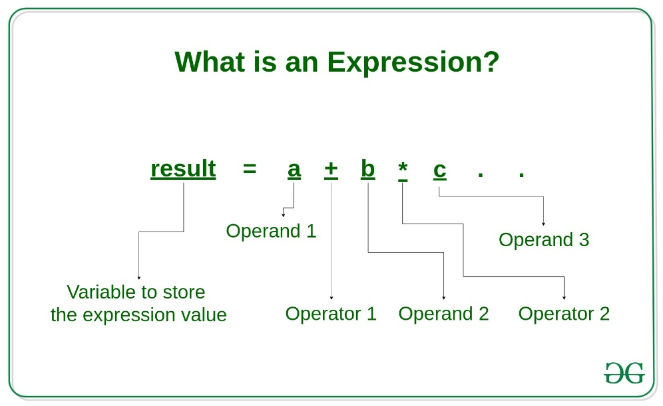
Types of Expressions: Expressions may be of the following types: 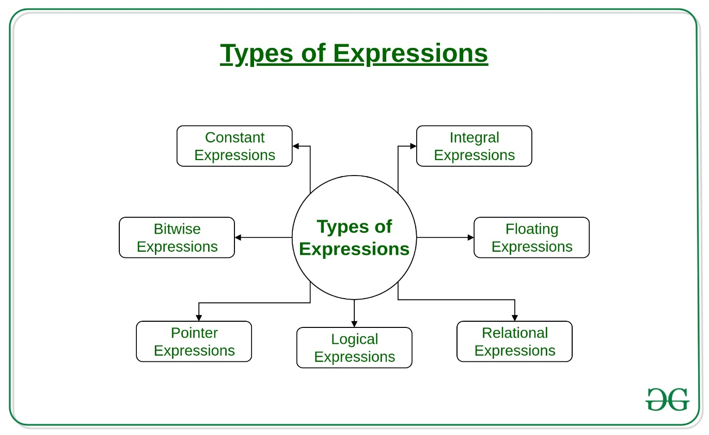
- Constant expressions: Constant Expressions consists of only constant values. A constant value is one that doesn't change. Examples:
5, 10 + 5 / 6.0, 'x’
- Integral expressions: Integral Expressions are those which produce integer results after implementing all the automatic and explicit type conversions. Examples:
x, x * y, x + int( 5.0)
where x and y are integer variables.
- Floating expressions: Float Expressions are which produce floating point results after implementing all the automatic and explicit type conversions. Examples:
x + y, 10.75
where x and y are floating point variables.
- Relational expressions: Relational Expressions yield results of type bool which takes a value true or false. When arithmetic expressions are used on either side of a relational operator, they will be evaluated first and then the results compared. Relational expressions are also known as Boolean expressions. Examples:
x <= y, x + y > 2
- Logical expressions: Logical Expressions combine two or more relational expressions and produces bool type results. Examples:
x > y && x == 10, x == 10 || y == 5
- Pointer expressions: Pointer Expressions produce address values. Examples:
&x, ptr, ptr++
where x is a variable and ptr is a pointer.
- Bitwise expressions: Bitwise Expressions are used to manipulate data at bit level. They are basically used for testing or shifting bits. Examples:
x << 3
shifts three bit position to left
y >> 1
shifts one bit position to right. Shift operators are often used for multiplication and division by powers of two.

Operators
An operator is simply a symbol that is used to perform operations. There can be many types of operations like arithmetic, logical, bitwise etc.

There are following types of operators to perform different types of operations in C language.

- Arithmetic Operators
- Relational Operators
- Logical Operators
- Bitwise Operators
- Assignment Operator
- Unary operator
- Ternary or Conditional Operator
- Misc Operator
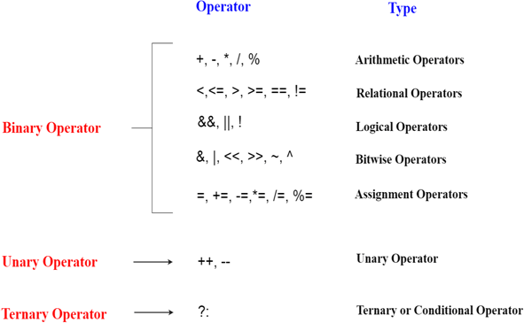

Precedence of Operators in C++
The precedence of operator species that which operator will be evaluated first and next. The associativity specifies the operators direction to be evaluated, it may be left to right or right to left.

Let's understand the precedence by the example given below:

- int data=5+10*10;

The "data" variable will contain 105 because * (multiplicative operator) is evaluated before + (additive operator).

The precedence and associativity of C++ operators is given below:

Category | Operator | Associativity
Postfix | () [] -> . ++ - - | Left to right
Unary | + - ! ~ ++ - - (type)* & sizeof | Right to left
Multiplicative | * / % | Left to right
Additive | + - | Right to left
Shift | << >> | Left to right
Relational | < <= > >= | Left to right
Equality | == !=/td> | Right to left
Bitwise AND | & | Left to right
Bitwise XOR | ^ | Left to right
Bitwise OR | | | Right to left
Logical AND | && | Left to right
Logical OR | || | Left to right
Conditional | ?: | Right to left
Assignment | = += -= *= /= %=>>= <<= &= ^= |= | Right to left
Comma | , | Left to right

Identifiers
C++ identifiers in a program are used to refer to the name of the variables, functions, arrays, or other user-defined data types created by the programmer. They are the basic requirement of any language. Every language has its own rules for naming the identifiers.

In short, we can say that the C++ identifiers represent the essential elements in a program which are given below:

  - Constants
  - Variables
  - Functions
  - Labels
  - Defined data types

Expression Evaluation
1. Introduction to Expressions
An expression in C++ is a combination of variables, constants, operators, and function calls that produces a value.
Example:
int result = 5 + 3 * 2;
2. Operator Precedence
Operator precedence determines which operator is evaluated first in an expression.
Example:
5 + 3 * 2 -> 5 + (3 * 2) = 11
Common Operator Precedence (High to Low):
Operators | Description
() | Parentheses
++ -- | Increment / Decrement
* / % | Multiplication / Division / Modulus
+ - | Addition / Subtraction
< <= > >= | Relational Operators
== != | Equality Operators
&& | Logical AND
|| | Logical OR
= | Assignment
3. Associativity
Associativity determines the direction of evaluation when operators have the same precedence.
Left to Right Example:
10 - 5 - 2 -> (10 - 5) - 2 = 3
Right to Left Example (Assignment):
a = b = c = 10;
4. Order of Evaluation and Undefined Behavior
C++ does not always evaluate expressions left to right. Modifying a variable more than once in a single expression leads to undefined behavior.
Example (Avoid):
int i = 5;
int result = i++ + ++i;
5. Short-Circuit Evaluation
Logical AND (&&): If the first condition is false, the second is not evaluated.
Logical OR (||): If the first condition is true, the second is not evaluated.
6. Increment and Decrement Operators
Prefix: ++i (Increment first, then use value)
Postfix: i++ (Use value first, then increment)

Type Conversions in C++
1. Implicit Type Conversion (Type Promotion)
Implicit conversion is automatically performed by the compiler when different data types are used in an expression.
Example:
int a = 5;
double b = 2.0;
double result = a + b;
Promotion Order: char -> int -> float -> double -> long double
2. Integer Division
If both operands are integers, integer division is performed and fractional parts are discarded.
Example:
int a = 5;
int b = 2;
double result = a / b; // Result = 2
Correct Method:
double result = static_cast<double>(a) / b;
3. Explicit Type Conversion (Casting)
C-Style Cast: (double)a
C++ Style Cast (Recommended): static_cast<double>(a)
4. Narrowing Conversion
When a larger data type is converted into a smaller type, data loss may occur.
Example:
double x = 3.7;
int y = x; // y = 3
5. Boolean Conversion
0 is treated as false. Any non-zero value is treated as true.

Flow Control Statement
In C++ programming, if statement is used to test the condition. There are various types of if statements in C++.

  - if statement
  - if-else statement
  - nested if statement
  - if-else-if ladder

IF Statement
The C++ if statement tests the condition. It is executed if condition is true.

if(condition){
//code to be executed
}
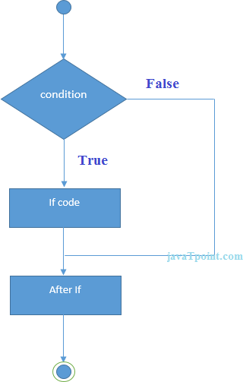

If Example
#include <iostream.h>
void main () {
int num = 10;
if (num % 2 == 0)
{
cout<<"It is even number";
}
return 0;
}

Output:
It is even number

IF-else Statement
The C++ if-else statement also tests the condition. It executes if block if condition is true otherwise else block is executed.

if(condition){
//code if condition is true
}else{
//code if condition is false
}
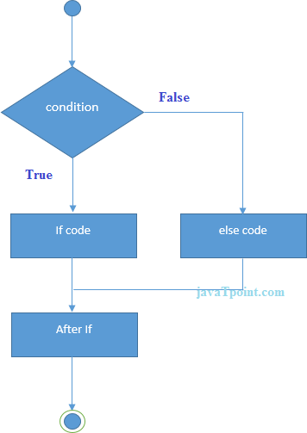

If-else Example
#include <iostream.h> void main () {
int num = 11;
if (num % 2 == 0)
{
cout<<"It is even number";
}

else
{
cout<<"It is odd number";
}
return 0;
}
Output:

It is odd number

If-else Example: with input from user
#include <iostream.h>
void main () {
int num;
cout<<"Enter a Number: "; cin>>num;
if (num % 2 == 0)
{
cout<<"It is even number"<<endl;
}

else
{
cout<<"It is odd number"<<endl;
}
return 0;
}
Output:
Enter a number:11 It is odd number
Output:
Enter a number:12 It is even number

IF-else-if ladder Statement
The C++ if-else-if ladder statement executes one condition from multiple statements.

if(condition1){
//code to be executed if condition1 is true
}else if(condition2){
//code to be executed if condition2 is true
}
else if(condition3){
//code to be executed if condition3 is true
}
...

else{
//code to be executed if all the conditions are false
}

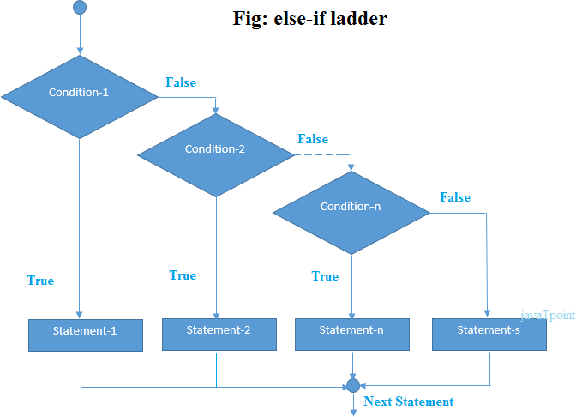

If else-if Example
#include <iostream.h>
void main () {
int num;
cout<<"Enter a number to check grade:"; cin>>num;
if (num <0 || num >100)
{
cout<<"wrong number";
}
else if(num >= 0 && num < 50){ cout<<"Fail";
}
else if (num >= 50 && num < 60)
{
cout<<"D Grade";
}
else if (num >= 60 && num < 70)
{
cout<<"C Grade";
}
else if (num >= 70 && num < 80)
{
cout<<"B Grade";

}
else if (num >= 80 && num < 90)
{
cout<<"A Grade";
}
else if (num >= 90 && num <= 100)
{
cout<<"A+ Grade";
}
}
Output:
Enter a number to check grade:66 C Grade
Output:
Enter a number to check grade:-2 wrong number

switch
The C++ switch statement executes one statement from multiple conditions. It is like if-else-if ladder statement in C++.

switch(expression){ case value1:
//code to be executed;
break; case value2:
//code to be executed;

break;
......

default:
//code to be executed if all cases are not matched;

break;
}

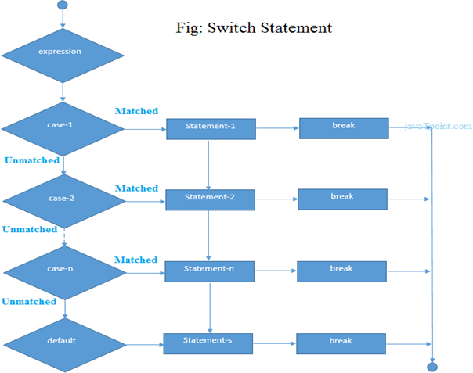

Switch Example
#include <iostream.h>
void main () {
int num;
cout<<"Enter a number to check grade:"; cin>>num;
switch (num)
{
case 10: cout<<"It is 10"; break;
case 20: cout<<"It is 20"; break;
case 30: cout<<"It is 30"; break;
default: cout<<"Not 10, 20 or 30"; break;
}
}

Output:
Enter a number:
10
It is 10

Output:
Enter a number:
55
Not 10, 20 or 30

For Loop
The C++ for loop is used to iterate a part of the program several times. If the number of iteration is fixed, it is recommended to use for loop than while or do-while loops.

The C++ for loop is same as C/C#. We can initialize variable, check condition and increment/decrement value.

for(initialization; condition; incr/decr){
//code to be executed
}
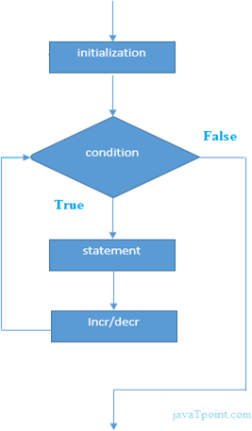

#include <iostream.h>
void main() {
for(int i=1;i<=10;i++){ cout<<i <<"\n";
}
}

Output:
1
2
3
4
5
6
7
8
9
10

Nested For Loop Example
Let's see a simple example of nested for loop in C++. #include <iostream.h>
void main () {
for(int i=1;i<=3;i++){
for(int i=1;j<=3;j++){ cout<<i<<" "<<j<<"\n";
}
}
}

Output:
1 1
1 2
1 3
2 1
2 2
2 3
3 1
3 2
3 3

While loop
In C++, while loop is used to iterate a part of the program several times. If the number of iteration is not fixed, it is recommended to use while loop than for loop.

while(condition){
//code to be executed
}
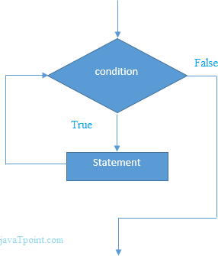

While Loop Example
Let's see a simple example of while loop to print table of 1. #include <iostream.h>
void main() {
int i=1;
while(i<=10)
{
cout<<i <<"\n"; i++;
}
}

Output:
1
2
3
4
5
6
7
8
9
10

Do-While Loop
The C++ do-while loop is used to iterate a part of the program several times. If the number of iteration is not fixed and you must have to execute the loop at least once, it is recommended to use do-while loop.

The C++ do-while loop is executed at least once because condition is checked after loop body.

do{
//code to be executed
}while(condition);



do-while Loop Example
Let's see a simple example of C++ do-while loop to print the table of 1. #include <iostream.h>
void main() {
int i = 1;
do{
cout<<i<<"\n"; i++;
} while (i <= 10) ;
}

Output:
1
2
3
4
5
6
7
8
9
10

Break Statement
The C++ break is used to break loop or switch statement. It breaks the current flow of the program at the given condition. In case of inner loop, it breaks only inner loop.

jump-statement;

break;
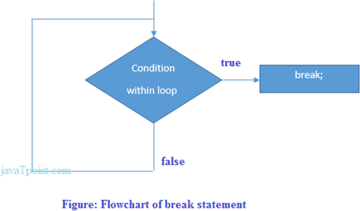

Break Statement Example
Let's see a simple example of C++ break statement which is used inside the loop. #include <iostream.h>
void main() {
for (int i = 1; i <= 10; i++)
{
if (i == 5)
{

break;
}
cout<<i<<"\n";
}
}

Output:

1
2
3
4

Continue Statement
The C++ continue statement is used to continue loop. It continues the current flow of the program and skips the remaining code at specified condition. In case of inner loop, it continues only inner loop.

jump-statement;
continue;

Continue Statement Example

#include <iostream.h> void main()
{
for(int i=1;i<=10;i++){
if(i==5){ continue;
}
cout<<i<<"\n";
}
}

Output:
1
2
3
4
6
7
8
9
10

Goto Statement
The C++ goto statement is also known as jump statement. It is used to transfer control to the other part of the program. It unconditionally jumps to the specified label.

It can be used to transfer control from deeply nested loop or switch case label.

Goto Statement Example
Let's see the simple example of goto statement in C++. #include <iostream.h>
void main()
{
ineligible:
cout<<"You are not eligible to vote!\n"; cout<<"Enter your age:\n";
int age; cin>>age;
if (age < 18){
goto ineligible;

}

else
{

}

cout<<"You are eligible to vote!";

}

Output:
You are not eligible to vote! Enter your age:
16
You are not eligible to vote! Enter your age:
7
You are not eligible to vote! Enter your age:
22
You are eligible to vote!

Functions
The function in C++ language is also known as procedure or subroutine in other programming languages.

To perform any task, we can create function. A function can be called many times. It provides modularity and code reusability.

Advantage of functions
There are many advantages of functions.

Code Reusability

By creating functions in C++, you can call it many times. So we don't need to write the same code again and again.

Code optimization

It makes the code optimized, we don't need to write much code.

Suppose, you have to check 3 numbers (531, 883 and 781) whether it is prime number or not. Without using function, you need to write the prime number logic 3 times. So, there is repetition of code.

But if you use functions, you need to write the logic only once and you can reuse it several times.

Types of Functions
There are two types of functions in C programming:

- Library Functions: are the functions which are declared in the C++ header files such as ceil(x), cos(x), exp(x), etc.

- User-defined functions: are the functions which are created by the C++ programmer, so that he/she can use it many times. It reduces complexity of a big program and optimizes the code.
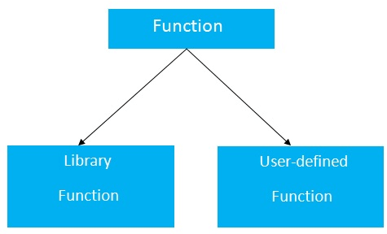

Declaration of a function
The syntax of creating function in C++ language is given below: return_type function_name(data_type parameter...)
{
//code to be executed
}

Function Example
Let's see the simple example of C++ function.

#include <iostream.h>
void func() {
static int i=0; //static variable
int j=0; //local variable i++;
j++;
cout<<"i=" << i<<" and j=" <<j<<endl;
}
void main()
{
func();
func();

func();
}

Output:
i= 1 and j= 1
i= 2 and j= 1
i= 3 and j= 1

Scope of Variables

1. Introduction
Scope refers to the region of a program where a variable is accessible. In C++, the scope of a variable determines where it can be used and accessed. Understanding variable scope is essential for writing efficient and error-free C++ programs. Proper management of scope improves readability, maintainability, and prevents unintended side effects.

2. Types of Scope in C++
C++ supports the following types of variable scope:
• Local Scope
• Global Scope
• Function Parameter Scope
• Block Scope
• Static Local Scope

3. Local Scope
A variable declared inside a function is called a local variable. It can only be accessed within that function.
Example:
void display() {
int x = 10; // Local variable
}
// x cannot be accessed outside the function
Local variables are created when the function is called and destroyed when the function ends.

4. Global Scope
A variable declared outside all functions is called a global variable. It can be accessed by all functions in the program.
Example:
int g = 100; // Global variable
void show() {
cout << g;
}
Global variables exist throughout the entire execution of the program.

5. Function Parameter Scope
Function parameters are treated as local variables within the function.
Example:
void add(int a, int b) {
int sum = a + b;
}
Parameters are accessible only inside the function body.

6. Block Scope
Variables declared inside a block (within { }) are accessible only within that block.
Example:
void test() {
int x = 5;
if (x > 0) {
int y = 10; // Block scope
}
// y cannot be accessed here
}

7. Static Local Variables
A static local variable retains its value between function calls.
Example:
void counter() {
static int count = 0;
count++;
cout << count;
}
Static variables are initialized only once and preserve their value during program execution.

8. Scope Resolution Operator (::)
The scope resolution operator (::) is used to access global variables when a local variable has the same name.
Example:
int x = 50; // Global
void show() {
int x = 10; // Local
cout << ::x; // Refers to global x
}

9. Scope vs Lifetime
Scope refers to where a variable can be accessed. Lifetime refers to how long the variable exists in memory.
• Local variables: Lifetime is during function execution.
• Global variables: Lifetime is entire program execution.
• Static variables: Lifetime is entire program execution, but scope is limited.

10. Best Practices
• Prefer local variables over global variables.
• Minimize use of global variables.
• Use meaningful variable names.
• Avoid variable shadowing when possible.
• Use static variables only when necessary.

Parameter passing

There are different ways in which parameter data can be passed into and out of methods and
functions.
Let us assume that a function B() is called from another function A(). In this case A is
called the “caller function” and B is called the “called function or callee function”. Also, the
arguments which A sends to B are called actual arguments and the parameters of B are called
formal arguments.

Important methods of Parameter Passing

Call By Value:

Changes made to formal parameter do not get transmitted back to the caller. Any modifications
to the formal parameter variable inside the called function or method affect only the separate
storage location and will not be reflected in the actual parameter in the calling environment. This
method is also called as pass by value.

Call by pointer

The call by pointer method of passing arguments to a function copies the address of an argument
into the formal parameter. Inside the function, the address is used to access the actual argument
used in the call. This means that changes made to the parameter affect the passed argument.

Call by value and call by reference in C++
There are two ways to pass value or data to function in C language: call by value and call by reference. Original value is not modified in call by value but it is modified in call by reference.

Let's understand call by value and call by reference in C++ language one by one.

Call by value in C++
In call by value, original value is not modified.

In call by value, value being passed to the function is locally stored by the function parameter in stack memory location. If you change the value of function parameter, it is changed for the current function only. It will not change the value of variable inside the caller method such as main().
Let's try to understand the concept of call by value in C++ language by the example given below: #include <iostream.h>
void change(int data);
int main()
{
int data = 3; change(data);
cout << "Value of the data is: " << data<< endl;
return 0;
}

void change(int data)
{
data = 5;
}

Output:

Value of the data is: 3

Call by reference in C++
In call by reference, original value is modified because we pass reference (address).

Here, address of the value is passed in the function, so actual and formal arguments share the same address space. Hence, value changed inside the function, is reflected inside as well as outside the function.

Note: To understand the call by reference, you must have the basic knowledge of pointers.
Let's try to understand the concept of call by reference in C++ language by the example given below: #include<iostream.h>
void swap(int *x, int *y)
{
int swap; swap=*x;
*x=*y;
*y=swap;
}
int main()
{
int x=500, y=100;
swap(&x, &y); // passing value to function cout<<"Value of x is: "<<x<<endl; cout<<"Value of y is: "<<y<<endl; return 0;
}

Output:
Value of x is: 100 Value of y is: 500
Difference between call by value and call by reference in C++

No. | Call by value | Call by reference

1 | A copy of value is passed to the function | An address of value is passed to the function
2 | Changes made inside the function is not reflected on other functions | Changes made inside the function is reflected outside the function also
3 | Actual and formal arguments will be created in different memory location | Actual and formal arguments will be created in same memory location

Default arguments in C++

In a function, arguments are defined as the values passed when a function is called. Values passed are the source, and the receiving function is the destination.
Definition

A default argument is a value in the function declaration automatically assigned by the compiler if the calling function does not pass any value to that argument.

Characteristics for defining the default arguments

Following are the rules of declaring default arguments -
- The values passed in the default arguments are not constant. These values can be overwritten if the value is passed to the function. If not, the previously declared value retains.
- During the calling of function, the values are copied from left to right.
- All the values that will be given default value will be on the right.

Example

void function(int x, int y, int z = 0)
Explanation - The above function is valid.
Here z is the value that is predefined as a part of the default argument.

Void function(int x, int z = 0, int y)
Explanation - The above function is invalid.
Here z is the value defined in between, and it is not accepted.

#include<iostream>
using namespace std;
int sum(int x, int y, int z=0, int w=0) // Here there are two values in the default arguments
{ // Both z and w are initialised to zero
return (x + y + z + w); // return sum of all parameter values
}
int main()
{
cout << sum(10, 15) << endl; // x = 10, y = 15, z = 0, w = 0
cout << sum(10, 15, 25) << endl; // x = 10, y = 15, z = 25, w = 0
cout << sum(10, 15, 25, 30) << endl; // x = 10, y = 15, z = 25, w = 30
return 0;
}

Templates in C++

1. Introduction to Templates
Templates in C++ support Generic Programming. They allow writing functions and classes that work with any data type without rewriting code for each type.

2. Need for Templates
Without templates, separate functions/classes must be written for each data type. Templates reduce code duplication and improve maintainability.
int add(int a, int b) { return a + b; }
double add(double a, double b) { return a + b; }
Using templates avoids duplication.

3. Types of Templates in C++
C++ supports the following types of templates:
• Function Templates
• Class Templates
• Template Specialization (Full & Partial)
• Non-Type Template Parameters
• Default Template Arguments
• Member Function Templates
• Variadic Templates

4. Function Templates
template <typename T>
T add(T a, T b) {
return a + b;
}
Usage:
int x = add(5, 10);
double y = add(2.5, 3.5);

5. Class Templates
template <typename T>
class Box {
T value;
public:
Box(T v) : value(v) {}
T getValue() { return value; }
};
Box<int> obj1(10);
Box<double> obj2(3.14);

6. Template Specialization
A specialized implementation for a specific data type.
Full Specialization Example:
template <>
class Box<char> {
char value;
public:
Box(char v) : value(v) {}
};
Partial Specialization Example:
template <typename T>
class Box<T*> {
T* value;
};

7. Non-Type Template Parameters
template <typename T, int size>
class Array {
T arr[size];
};

8. Default Template Arguments
template <typename T = int>
class Sample {
T data;
};

9. Member Function Templates
class MyClass {
public:
template <typename T>
void display(T value) {
cout << value;
}
};

10. Variadic Templates (Advanced)
template<typename... Args>
void print(Args... args) {
// handle multiple arguments
}

11. Advantages of Templates
• Code Reusability
• Type Safety
• Compile-time Polymorphism
• Better Maintainability

12. Templates vs Macros
Templates are type-safe and checked by the compiler. Macros are preprocessor directives and are not type-safe.

Templates enable generic programming in C++. They allow writing reusable and flexible code that works with multiple data types efficiently.

Classes

Classes are created using the keyword class. A class declaration defines a new type that links code and
data. This new type is then used to declare objects of that class. Thus, a class is a logical abstraction, but an
object has physical existence. In other words, an object is an instance of a class.
A class declaration is similar syntactically to a structure. Here is the entire general form of a
class declaration that does not inherit any other class.
class class-name {
private data and functions
access-specifier:
data and functions
access-specifier:
data and functions
// ...
access-specifier:
data and functions
} object-list;
The object-list is optional.
If present, it declares objects of the class. Here, access-specifier is one of these
three C++ keywords:
public
private
protected

By default, functions and data declared within a class are private to that class and may be accessed only by
other members of the class. The public access specifier allows functions or data to be accessible to other
parts of your program. The protected access specifier is needed only when inheritance is involved. Once
an access specifier has been used, it remains in effect until either another access specifier is encountered or
the end of the class declaration is reached.
You may change access specifications as often as you like within a class declaration. For example, you
may switch to public for some declarations and then switch back to private again. The class declaration in
the following example illustrates this feature:
C++ Class
In C++, object is a group of similar objects. It is a template from which objects are created. It can
have fields, methods, constructors etc.
Let's see an example of C++ class that has three fields only.
class Student
{
public:
int id; //field or data member
float salary; //field or data member
String name;//field or data member
}
C++ Object

In C++, Object is a real world entity, for example, chair, car, pen, mobile, laptop etc.
In other words, object is an entity that has state and behavior. Here, state means data and behavior
means functionality.
Object is a runtime entity, it is created at runtime.
Object is an instance of a class. All the members of the class can be accessed through object.
Let's see an example to create object of student class using s1 as the reference variable.
Student s1; //creating an object of Student
In this example, Student is the type and s1 is the reference variable that refers to the instance of
Student class.
C++ Object and Class Example
Let's see an example of class that has two fields: id and name. It creates instance of the class,
initializes the object and prints the object value.
#include <iostream>
using namespace std;
class Student {
public:
int id;//data member (also instance variable)
string name;//data member(also instance variable)
};
int main() {
Student s1; //creating an object of Student
s1.id = 201;
s1.name = "Sonoo Jaiswal";
cout<<s1.id<<endl;
cout<<s1.name<<endl;
return 0;
}
Output:
201
Sonoo Jaiswal

C++ Class Example: Initialize and Display data through method
Let's see another example of C++ class where we are initializing and displaying object through
method.

#include <iostream>
using namespace std;
class Student {
public:
int id;//data member (also instance variable)
string name;//data member(also instance variable)
void insert(int i, string n)
{
id = i;
name = n;
}
void display()
{
cout<<id<<" "<<name<<endl;
}
};
int main(void) {
Student s1; //creating an object of Student
Student s2; //creating an object of Student
s1.insert(201, "Sonoo");
s2.insert(202, "Nakul");
s1.display();
s2.display();
return 0;
}
Output:
201 Sonoo
202 Nakul

C++ Class Example: Store and Display Employee Information

Let's see another example of C++ class where we are storing and displaying employee information
using method.
#include <iostream>
using namespace std;
class Employee {
public:
int id;//data member (also instance variable)
string name;//data member(also instance variable)
float salary;
void insert(int i, string n, float s)
{
id = i;
name = n;
salary = s;
}
void display()
{
cout<<id<<" "<<name<<" "<<salary<<endl;
}
};
int main(void) {
Employee e1; //creating an object of Employee
Employee e2; //creating an object of Employee
e1.insert(201, "Sonoo",990000);
e2.insert(202, "Nakul", 29000);
e1.display();
e2.display();
return 0;
}
Output:
201 Sonoo 990000
202 Nakul 29000

Access Specifiers

Access modifiers are used to implement an important aspect of Object-Oriented Programming known as Data Hiding.

Access Modifiers or Access Specifiers in a class are used to assign the accessibility to the class members, i.e., they set some restrictions on the class members so that they can’t be directly accessed by the outside functions.

There are 3 types of access modifiers available in C++:

Public

Private

Protected

Note: If we do not specify any access modifiers for the members inside the class, then by default the access modifier for the members will be Private. Understanding how to use public, private, and protected access modifiers is essential.

Public: All the class members declared under the public specifier will be available to everyone. The data members and member functions declared as public can be accessed by other classes and functions too. The public members of a class can be accessed from anywhere in the program using the direct member access operator (.) with the object of that class.

#include<iostream>

using namespace std;

// class definition

class Circle

{

public:

double radius;

double compute_area()

{

return 3.14*radius*radius;

}

};

// main function

int main()

{

Circle obj;

// accessing public datamember outside class

obj.radius = 5.5;

cout << "Radius is: " << obj.radius << "\n";

cout << "Area is: " << obj.compute_area();

return 0;

}

Private: The class members declared as private can be accessed only by the member functions inside the class. They are not allowed to be accessed directly by any object or function outside the class. Only the member functions or the friend functions/ friend class are allowed to access the private data members of the class.

Example:

// C++ program to demonstrate private

2// access modifier

​#include<iostream>

using namespace std;

class Circle

{

// private data member

private:

double radius

// public member function

public:

double compute_area()

{ // member function can access private

// data member radius

return 3.14*radius*radius;

}

};

​

// main function

int main()

{

// creating object of the class

Circle obj;

// trying to access private data member

// directly outside the class

obj.radius = 1.5;

cout << "Area is:" << obj.compute_area();

return 0;

}

3. Protected: The protected access modifier is similar to the private access modifier in the sense that it can’t be accessed outside of its class unless with the help of a friend class. The difference is that the class members declared as Protected can be accessed by any subclass (derived class) of that class as well.

#include <bits/stdc++.h>

using namespace std;

// base class

class Parent

{

// protected data members

protected:

int id_protected;

};

// sub class or derived class from public base class

class Child : public Parent

{

public:

void setId(int id)

{

// Child class is able to access the inherited

// protected data members of base class

id_protected = id;

}

void displayId()

{

cout << "id_protected is: " << id_protected << endl;

}

};

// main function

int main() {

Child obj1;

// member function of the derived class can

// access the protected data members of the base class

obj1.setId(81);

obj1.displayId();

return 0;

}
Scope in Classes in C++
Prepared for Undergraduate Students

1.Scope in Classes
In C++, scope in classes refers to the visibility and accessibility of data members and member functions declared inside a class. The scope determines where these members can be accessed in a program.
2. Class Scope
Variables and functions declared inside a class belong to the class scope. Their accessibility depends on access specifiers such as public, private, and protected.
class Student {
private:
int marks;
public:
void setMarks(int m) {
marks = m;
}
};
3. Access Specifiers and Their Effect on Scope
C++ provides three access specifiers:
• Private – Accessible only within the class.
• Public – Accessible from outside the class using objects.
• Protected – Accessible within the class and derived classes.
4. Scope Resolution Operator (::)
The scope resolution operator is used to define member functions outside the class.
class Sample {
public:
void display();
};
void Sample::display() {
cout << "Hello";
}
5. Objects and Class Scope
Class members are accessed using objects of the class. Each object has its own copy of non-static data members.
Student s1;
s1.setMarks(90);
6. Static Members in Class Scope
Static data members belong to the class rather than individual objects and are shared among all objects.
class Counter {
public:
static int count;
};
int Counter::count = 0;
7. Nested Class Scope
A class defined inside another class is called a nested class. The nested class has its own scope.
class Outer {
public:
class Inner {
public:
void show();
};
};
8. Scope vs Lifetime in Classes
Scope determines where class members can be accessed. Lifetime depends on how long the object exists.
• Non-static members exist as long as the object exists.
• Static members exist for the entire program execution.
9. Best Practices
• Keep data members private (Data Hiding).
• Use public functions to access private data.
• Use protected members carefully in inheritance.
• Avoid unnecessary public data members.
Summary
Scope in classes defines how class members are accessed and controlled using access specifiers, objects, and static members. Proper understanding of class scope is essential for object-oriented programming in C++.

C++ this Pointer

In C++ programming, this is a keyword that refers to the current instance of the class. There can be
3 main usage of this keyword in C++.
o It can be used to pass current object as a parameter to another method.
o It can be used to refer current class instance variable.
o It can be used to declare indexers.

C++ this Pointer Example

Let's see the example of this keyword in C++ that refers to the fields of current class.
#include <iostream>
using namespace std;
class Employee {
public:
int id; //data member (also instance variable)
string name; //data member(also instance variable)
float salary;
Employee(int id, string name, float salary)
{
this->id = id;
this->name = name;
this->salary = salary;
}
void display()
{
cout<<id<<" "<<name<<" "<<salary<<endl;
}
};
int main(void) {
Employee e1 =Employee(101, "Sonoo", 890000); //creating an object of Employee
Employee e2=Employee(102, "Nakul", 59000); //creating an object of Employee
e1.display();
e2.display();
return 0;
}
Output:
101 Sonoo 890000
102 Nakul 59000

Constructors

In C++, constructor is a special method which is invoked automatically at the time of object creation. It is used to initialize the data members of new object generally. The constructor in C++ has the same name as class.
There can be three types of constructors in C++.
Default constructor
Parameterized constructor
Copy constructor
C++ Default Constructor
A constructor which has no argument is known as default constructor. It is invoked at the time of creating object.
#include <iostream>
using namespace std;
class Employee
{
public:
Employee()
{
cout<<"Default Constructor"<<endl;
}
};
int main()
{
Employee e1; //creating an object of Employee
Employee e2;
return 0;
}
C++ Parameterized Constructor

A constructor which has parameters is called parameterized constructor. It is used to provide different values to distinct objects.
#include <iostream>
using namespace std;
class A {
private:
int num1, num2 ;
public:
A(int n1, int n2) {
num1 = n1;
num2 = n2;
}
void display() {
cout<<"num1 = "<< num1 <<endl;
cout<<"num2 = "<< num2 <<endl;
}
};
int main() {
A obj(3,8);
obj.display();
return 0;
}

Copy Constructor

In the C++ programming language, a copy constructor is a special constructor for creating a new object
as a copy of an existing object. Copy constructors are the standard way of copying objects in C++,
Syntax of Copy Constructor
Classname (classname & objectname)
{
. . . .
}
#include<iostream>
using namespace std;
class Samplecopyconstructor
{
private:
int x, y; //data members
public:
Samplecopyconstructor(int x1, int y1)
{
x = x1;
y = y1;
}
/* Copy constructor */
Samplecopyconstructor (Samplecopyconstructor &sam)
{
x = sam.x;
y = sam.y;
}
void display()
{
cout<<x<<" "<<y<<endl;
}
};
/* main function */
int main()
{
Samplecopyconstructor obj1(10, 15); // Normal constructor
Samplecopyconstructor obj2 = obj1; // Copy constructor
cout<<"Normal constructor : ";
obj1.display();
cout<<"Copy constructor : ";
obj2.display();
return 0;
}
Special characteristics of Constructors:
- They should be declared in the public section
- They do not have any return type, not even void
- They get automatically invoked when the objects are created
- They cannot be inherited through derived class can call the base class constructor
- Like other functions, they can have default arguments
- You cannot refer to their address
- Constructors cannot be virtual

Constructor Overloading

Just like other member functions, constructors can also be overloaded. Infact when you have both default and parameterized constructors defined in your class you are having Overloaded Constructors, one with no parameter and other with parameter.
You can have any number of Constructors in a class that differ in parameter list.
classStudent
{
introllno;
stringname;
public:
Student(intx)
{
rollno=x;
name="None";
}
Student(intx,stringstr)
{
rollno=x;
name=str;
}
};
intmain()
{
StudentA(10);
StudentB(11,"Ram");
}

In above case we have defined two constructors with different parameters, hence overloading the constructors.
One more important thing, if you define any constructor explicitly, then the compiler will not provide default constructor and you will have to define it yourself.
In the above case if we write Student S; in main(), it will lead to a compile time error, because we haven't defined default constructor, and compiler will not provide its default constructor because we have defined other parameterized constructors.

Destructors
Destructor is a special class function which destroys the object as soon as the scope of object ends. The destructor is called automatically by the compiler when the object goes out of scope.
The syntax for destructor is same as that for the constructor, the class name is used for the name of destructor, with a tilde ~ sign as prefix to it.
class A
{
public:
~A();
};
Destructors will never have any arguments.

Example to see how Constructor and Destructor is called
class A
{
A()
{
cout << "Constructor called";
}
~A()
{
cout << "Destructor called";
}
};
int main()
{
A obj1; // Constructor Called
int x=1
if(x)
{
A obj2; // Constructor Called
} // Destructor Called for obj2
} // Destructor called for obj1

Single Definition for both Default and Parameterized Constructor
In this example we will use default argument to have a single definition for both defualt and parameterized constructor.
class Dual
{
int a;
public:
Dual(int x=0)
{
a=x;
}
};
int main()
{
Dual obj1;
Dual obj2(10);
}
C++ virtual function

o A C++ virtual function is a member function in the base class that you redefine in a derived
class. It is declared using the virtual keyword.
o It is used to tell the compiler to perform dynamic linkage or late binding on the function.
o There is a necessity to use the single pointer to refer to all the objects of the different classes.
So, we create the pointer to the base class that refers to all the derived objects. But, when
base class pointer contains the address of the derived class object, always executes the base
class function. This issue can only be resolved by using the 'virtual' function.
o A 'virtual' is a keyword preceding the normal declaration of a function.
o When the function is made virtual, C++ determines which function is to be invoked at the
runtime based on the type of the object pointed by the base class pointer.
Late binding or Dynamic linkage
In late binding function call is resolved during runtime. Therefore compiler determines the type of
object at runtime, and then binds the function call.

Rules of Virtual Function
o Virtual functions must be members of some class.
o Virtual functions cannot be static members.
o They are accessed through object pointers.
o They can be a friend of another class.
o A virtual function must be defined in the base class, even though it is not used.
o The prototypes of a virtual function of the base class and all the derived classes must be
identical. If the two functions with the same name but different prototypes, C++ will consider
them as the overloaded functions.
o We cannot have a virtual constructor, but we can have a virtual destructor
o Consider the situation when we don't use the virtual keyword.

#include <iostream>
using namespace std;
class A
{
int x=5;
public:
void display()
{
std::cout << "Value of x is : " << x<<std::endl;
}
};
class B: public A
{
int y = 10;
public:
void display()
{
std::cout << "Value of y is : " <<y<< std::endl;
}
};
int main()
{
A *a;
B b;
a = &b;
a->display();
return 0;
}
Output:
Value of x is : 5

C++ virtual function Example

Let's see the simple example of C++ virtual function used to invoked the derived class in a program.
#include <iostream>
{
public:
virtual void display()
{
cout << "Base class is invoked"<<endl;
}
};
class B:public A
{
public:
void display()
{
cout << "Derived Class is invoked"<<endl;
}
};
int main()
{
A* a; //pointer of base class
B b; //object of derived class
a = &b;
a->display(); //Late Binding occurs
}
Output:
Derived Class is invoked

Pure Virtual Function

o A virtual function is not used for performing any task. It only serves as a placeholder.
o When the function has no definition, such function is known as "do-nothing" function.
o The "do-nothing" function is known as a pure virtual function. A pure virtual function is a
function declared in the base class that has no definition relative to the base class.
o A class containing the pure virtual function cannot be used to declare the objects of its own,
such classes are known as abstract base classes.
o The main objective of the base class is to provide the traits to the derived classes and to create
the base pointer used for achieving the runtime polymorphism.

Pure virtual function can be defined as:
virtual void display() = 0;

Let's see a simple example:

#include <iostream>
using namespace std;
class Base
{
public:
virtual void show() = 0;
};
class Derived : public Base
{
public:
void show()
{
std::cout << "Derived class is derived from the base class." << std::end
l;
}
};
int main()
{
Base *bptr;
//Base b;
Derived d;
bptr = &d;
bptr->show();
return 0;
}
Output:
Derived class is derived from the base class

C++ Inheritance

In C++, inheritance is a process in which one object acquires all the properties and behaviors of its parent object automatically. In such way, you can reuse, extend or modify the attributes and behaviors which are defined in other class.

In C++, the class which inherits the members of another class is called derived class and the class whose members are inherited is called base class. The derived class is the specialized class for the base class.

Advantage of C++ Inheritance
Code reusability: Now you can reuse the members of your parent class. So, there is no need to define the member again. So less code is required in the class.

Types Of Inheritance
C++ supports five types of inheritance:

Single inheritance
Multiple inheritance
Hierarchical inheritance
Multilevel inheritance
Hybrid inheritance
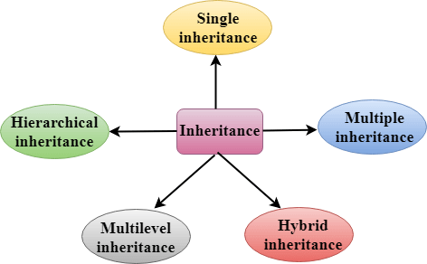

Derived Classes
A Derived class is defined as the class derived from the base class. The Syntax of Derived class:
class derived_class_name : visibility-mode base_class_name
{
// body of the derived class.
}

Where,

derived_class_name: It is the name of the derived class.

visibility mode: The visibility mode specifies whether the features of the base class are publicly inherited or privately inherited. It can be public or private.

base_class_name: It is the name of the base class.

When the base class is privately inherited by the derived class, public members of the base class becomes the private members of the derived class. Therefore, the public members of the base class are not accessible by the objects of the derived class only by the member functions of the derived class.
When the base class is publicly inherited by the derived class, public members of the base class also become the public members of the derived class. Therefore, the public members of the base class are accessible by the objects of the derived class as well as by the member functions of the base class.
In C++, the default mode of visibility is private.
The private members of the base class are never inherited.

C++ Single Inheritance
Single inheritance is defined as the inheritance in which a derived class is inherited from the only one base class.

Where 'A' is the base class, and 'B' is the derived class.

C++ Single Level Inheritance Example: Inheriting Fields
When one class inherits another class, it is known as single level inheritance. Let's see the example of single level inheritance which inherits the fields only.
#include <iostream> using namespace std; class Account {
public:
float salary = 60000;
};
class Programmer: public Account {
public:
float bonus = 5000;
};
int main(void) { Programmer p1;
cout<<"Salary: "<<p1.salary<<endl;
cout<<"Bonus: "<<p1.bonus<<endl;
return 0;
}

Output:

In the above example, Employee is the base class and Programmer is the derived class.

C++ Single Level Inheritance Example: Inheriting Methods

Let's see another example of inheritance in C++ which inherits methods only.
#include <iostream>
using namespace std;
class Animal {
public:
void eat() { cout<<"Eating..."<<endl;
}
};
class Dog: public Animal
{
public:
void bark(){ cout<<"Barking...";
}
};
int main(void) { Dog d1; d1.eat();
d1.bark();
return 0;
}

Output:

Let's see a simple example.

#include <iostream> using namespace std; class A
{
int a = 4; int b = 5; public: int mul()
{
int c = a*b;
return c;
}
};

class B : private A
{
public:
void display()
{
int result = mul();
std::cout <<"Multiplication of a and b is : "<<result<< std::endl;
}
};
int main()
{
B b; b.display();

return 0;
}

Output:

Multiplication of a and b is : 20

In the above example, class A is privately inherited. Therefore, the mul() function of class 'A' cannot be accessed by the object of class B. It can only be accessed by the member function of class B.

How to make a Private Member Inheritable
The private member is not inheritable. If we modify the visibility mode by making it public, but this takes away the advantage of data hiding.

C++ introduces a third visibility modifier, i.e., protected. The member which is declared as protected will be accessible to all the member functions within the class as well as the class immediately derived from it.

Visibility modes can be classified into three categories:
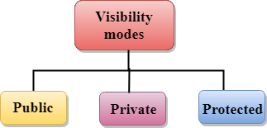

Public: When the member is declared as public, it is accessible to all the functions of the program.
Private: When the member is declared as private, it is accessible within the class only.
Protected: When the member is declared as protected, it is accessible within its own class as well as the class immediately derived from it.
Access Control and Inheritance
A derived class can access all the non-private members of its base class. Thus base-class members that should not be accessible to the member functions of derived classes should be declared private in the base class.
We can summarize the different access types according to - who can access them in the following way −

Access | public | protected | private
Same class | yes | yes | yes
Derived classes | yes | yes | no
Outside classes | yes | no | no

C++ Multilevel Inheritance
Multilevel inheritance is a process of deriving a class from another derived class.


C++ Multi Level Inheritance Example
When one class inherits another class which is further inherited by another class, it is known as multi level inheritance in C++. Inheritance is transitive so the last derived class acquires all the members of all its base classes.
Let's see the example of multi level inheritance in C++. #include <iostream>
using namespace std;
class Animal {
public:
void eat() { cout<<"Eating..."<<endl;
}
};
class Dog: public Animal
{
public:
void bark(){ cout<<"Barking..."<<endl;
}
};
class BabyDog: public Dog
{
public: void weep() {
cout<<"Weeping...";
}
};
int main(void) { BabyDog d1; d1.eat();
d1.bark();
d1.weep();
return 0;
}

Output:

C++ Multiple Inheritance
Multiple inheritance is the process of deriving a new class that inherits the attributes from two or more classes.
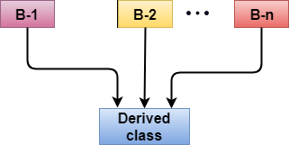
Syntax of the Derived class:

class D : visibility B-1, visibility B-2, ?
{
// Body of the class;
}
Let's see a simple example of multiple inheritance. #include <iostream>
using namespace std;
class A
{
protected:
int a;
public:
void get_a(int n)
{
a = n;
}
};

class B
{
protected:
int b;
public:
void get_b(int n)
{
b = n;
}
};
class C : public A,public B
{
public:
void display()
{
std::cout << "The value of a is : " <<a<< std::endl; std::cout << "The value of b is : " <<b<< std::endl; cout<<"Addition of a and b is : "<<a+b;
}
};
int main()
{
C c; c.get_a(10);
c.get_b(20);
c.display();

return 0;
}

Output:

In the above example, class 'C' inherits two base classes 'A' and 'B' in a public mode.

Ambiquity Resolution in Inheritance
Ambiguity can be occurred in using the multiple inheritance when a function with the same name occurs in more than one base class.
Let's understand this through an example:

#include <iostream> using namespace std; class A
{
public:
void display()
{
std::cout << "Class A" << std::endl;
}
};
class B
{
public:
void display()
{
std::cout << "Class B" << std::endl;
}
};
class C : public A, public B
{
void view()
{
display();
}
};
int main()
{
C c; c.display(); return 0;
}

Output:

The above issue can be resolved by using the class resolution operator with the function. In the above example, the derived class code can be rewritten as:

class C : public A, public B
{
void view()
{
A :: display(); // Calling the display() function of class A.
B :: display(); // Calling the display() function of class B.

}
};

An ambiguity can also occur in single inheritance. Consider the following situation:
class A
{
public: void display()
{
cout<<?Class A?;
}
} ;
class B
{
public:
void display()
{
cout<<?Class B?;
}
} ;

In the above case, the function of the derived class overrides the method of the base class. Therefore, call to the display() function will simply call the function defined in the derived class. If we want to invoke the base class function, we can use the class resolution operator.

int main()
{
B b;
b.display(); // Calling the display() function of B class.
b.B :: display(); // Calling the display() function defined in B class.
}

C++ Hybrid Inheritance
Hybrid inheritance is a combination of more than one type of inheritance.

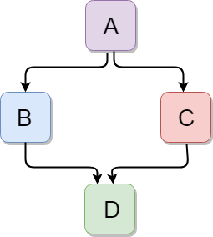

Let's see a simple example:

#include <iostream> using namespace std; class A
{
protected: int a; public: void get_a()
{
std::cout << "Enter the value of 'a' : " << std::endl; cin>>a;
}
};

class B : public A
{
protected: int b; public: void get_b()
{
std::cout << "Enter the value of 'b' : " << std::endl; cin>>b;
}
};
class C
{
protected: int c; public: void get_c()
{
std::cout << "Enter the value of c is : " << std::endl; cin>>c;
}
};

class D : public B, public C
{
protected: int d; public: void mul()
{
get_a();
get_b();
get_c();
std::cout << "Multiplication of a,b,c is : " <<a*b*c<< std::endl;
}
};
int main()
{
D d; d.mul(); return 0;
}

Output:

C++ Hierarchical Inheritance
Hierarchical inheritance is defined as the process of deriving more than one class from a base class.
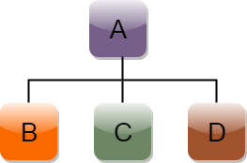
Syntax of Hierarchical inheritance:

class A
{
// body of the class A.
}
class B : public A
{
// body of class B.
}
class C : public A
{
// body of class C.
}
class D : public A
{
// body of class D.
}
Let's see a simple example: #include <iostream>
using namespace std;
class Shape // Declaration of base class.
{
public:
int a;
int b;
void get_data(int n,int m)
{
a= n; b = m;
}
};
class Rectangle : public Shape // inheriting Shape class
{
public:
int rect_area()
{
int result = a*b;
return result;
}
};
class Triangle : public Shape // inheriting Shape class
{
public:
int triangle_area()
{
float result = 0.5*a*b;
return result;
}
};
int main()
{
Rectangl r;
Triangle t;
int length,breadth,base,height;
std::cout << "Enter the length and breadth of a rectangle: " << std::endl;
cin>>length>>breadth;
r.get_data(length,breadth);
int m = r.rect_area();
std::cout << "Area of the rectangle is : " <<m<< std::endl;
std::cout << "Enter the base and height of the triangle: " << std::endl;
cin>>base>>height;
t.get_data(base,height);
float n = t.triangle_area();
std::cout <<"Area of the triangle is : " << n<<std::endl;
return 0;
}

