Difference between Tree and Graph:
Tree is a restricted type of Graph Data Structure, just with some more rules. Every tree will always be a graph but not all graphs will be trees. Linked List, Trees, and Heaps all are special cases of graphs.
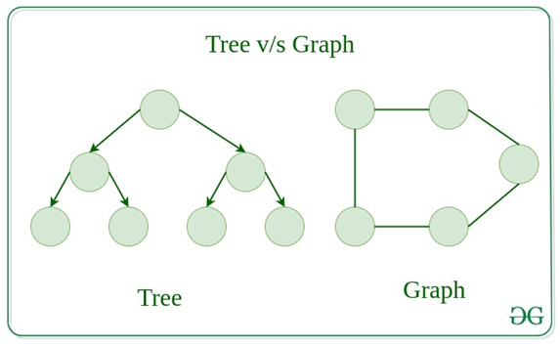
1. Weighted Graphs
A weighted graph is a graph where each edge has a number (weight) that represents distance, cost, or time.
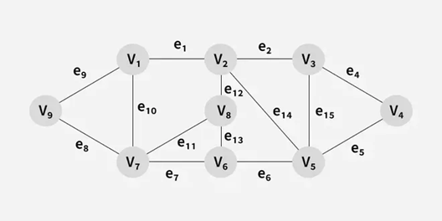
2. Unweighted Graphs
An unweighted graph is a graph where all edges are treated equally, with no extra values like distance or cost
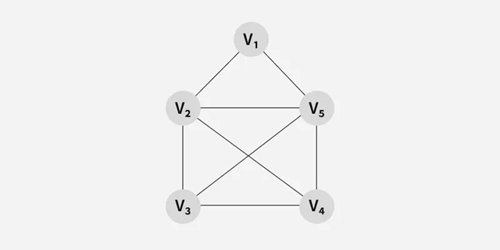
Undirected Graph
A graph in which edges do not have any direction. That is the nodes are unordered pairs in the definition of every edge.
4. Directed Graph
A graph in which edge has direction. That is the nodes are ordered pairs in the definition of every edge.
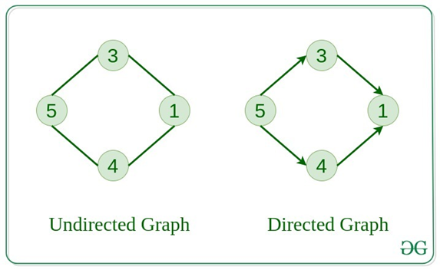

Representation of Graph Data Structure:
There are multiple ways to store a graph: The following are the most common representations.
- Adjacency Matrix
- Adjacency List
Adjacency Matrix Representation of Graph Data Structure:
In this method, the graph is stored in the form of the 2D matrix where rows and columns denote vertices. Each entry in the matrix represents the weight of the edge between those vertices.
matrix[i][j] = 1 if there is an edge between vertex i and vertex j.
matrix[i][j] = 0 if there is no edge.
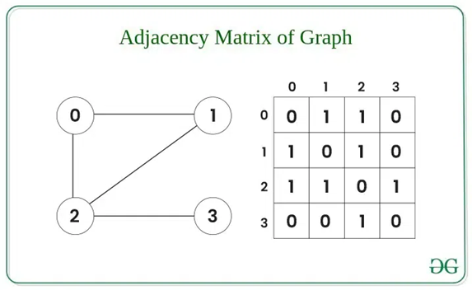
Adjacency List Representation of Graph:
This graph is represented as a collection of array lists. There is an array of pointer which points to the edges connected to that vertex.
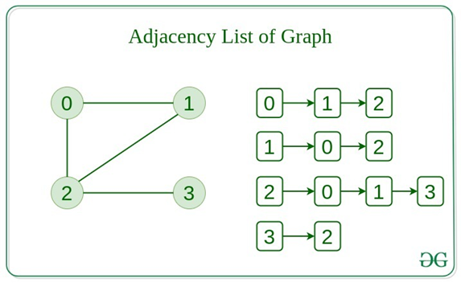
Traversal Technique of Graph:
Traversal techniques are used to visit all the vertices of a graph systematically. These methods help to explore the graph completely and are useful for solving many graph-related problems.
Depth First Search (DFS):
- Explores as far as possible along each branch before backtracking.
- Uses a stack (or recursion).
Breadth First Search (BFS)
- Explores all neighbors of a vertex before moving to the next level.
- Uses a queue.
Breadth First Search (BFS)
Breadth First Search (BFS) is a graph traversal algorithm that starts from a source node and explores the graph level by level. First, it visits all nodes directly adjacent to the source. Then, it moves on to visit the adjacent nodes of those nodes, and this process continues until all reachable nodes are visited.
- BFS is different from DFS in a way that closest vertices are visited before others. We mainly traverse vertices level by level.
- Popular graph algorithms like Dijkstra's shortest path, Kahn's Algorithm, and Prim's algorithm are based on BFS.
- BFS itself can be used to detect cycle in a directed and undirected graph, find shortest path in an unweighted graph and many more problems.
nput: adj[][] = [[1, 2], [0, 2], [0, 1, 3, 4], [2], [2]]
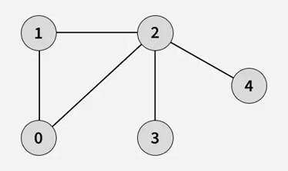
Output: [0, 1, 2, 3, 4]
Explanation: Starting from 0, the BFS traversal proceeds as follows:
Visit 0 - Print: 0
Visit 1 (neighbor of 0) - Print: 1
Visit 2 (next neighbor of 0) - Print: 2
Visit 3 (first neighbor of 2 that hasn't been visited yet) - Print: 3
Visit 4 (next neighbor of 2) - Print: 4

Input: adj[][] = [[2, 3], [2], [0, 1], [0], [5], [4]]
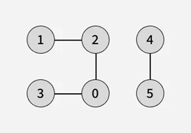
Output: [0, 2, 3, 1, 4, 5]
Explanation: Starting from 0, the BFS traversal proceeds as follows:
Visit 0 - Print: 0
Visit 2 (first neighbor of 0) - Print: 2
Visit 3 (next neighbor of 0) - Print: 3
Visit 1 (neighbor of 2 that hasn't been visited yet) - Print: 1
