Karen Mitchell
February 18, 2026
CS320 Project 2

Summary and Reflections Report
Summary
For each of the three features I utilized a structured unit testing approach, focusing on functional requirements and constraints. For each feature I tested object creation with valid and invalid inputs, constraint validation, service functionality, duplicate and non-existent IDs, and utilized getters to verify stored values, all of which helped directly satisfy the requirements given.
For example, for the Contact feature, I tested valid object creation using valid inputs. I tested enforcement of constraints so that length limits met the requirements, and null input would not be accepted. Service operations were also tested such as adding, deleting, and updating data while handling errors for invalid input, duplicates, and non-existent IDs. For example, in testContactCreatesSuccessfully() in my ContactTest.java, I validated that all getters returned the correct stored values using assertEquals().
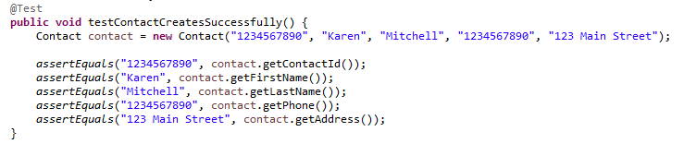
This confirmed that valid inputs were properly accepted and stored. In addition, another example from my code that throws an error for a null ID validates that error handling correctly throws an exception for invalid input.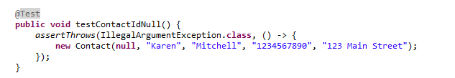
My testing approach was closely aligned with the documented software requirements because each test case directly corresponded to a specific functional rule. By testing both valid and invalid inputs for every constraint, I ensured full traceability between requirements and test cases, and the overall quality of my JUnit tests is supported by my code coverage across all three service classes.
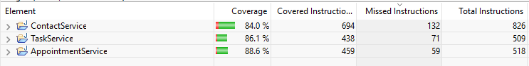
These coverage percentages show that the majority of instructions and logical branches were covered, and because the tests validated both expected behavior as well as invalid input scenarios, the final result demonstrates strong reliability.
Writing the JUnit tests strengthened my understanding of how software requirements translate into enforceable validation logic. Initially interpreting each constraint and translating that into a test which was also correctly implemented required a lot of attention to detail. However, after writing my initial tests for ContactService I was able to essentially reuse code and establish a pattern of testing, making the process more systematic and efficient. While using online resources to support my development process, I developed a stronger ability to think defensively by testing not just valid inputs but also invalid data and boundary conditions, reinforcing how critical it is to anticipate how users might misuse the system, whether maliciously or unintentionally.
I ensured technical soundness by verifying expected outputs and enforcing constraint validation using targeted assertions. For example,
The assertion using assertEquals() verified that valid inputs were stored correctly, while the use of assertThrows(IllegalArgumentException.class,..) ensured that setter methods consistently enforced length and format requirements.
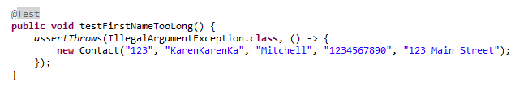
Both snippets of code confirm that the implementations adhered to the requirements. To ensure efficiency, I kept each test case isolated to focus on single behaviors. For example, the test to add a contact in my ContactServiceTest.java, which validated adding and retrieving a contact by ID without relying on shared state between tests.
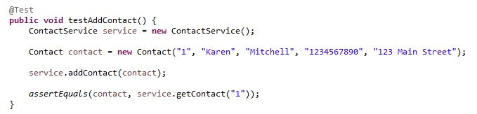
This code structure validates one requirement at a time, making the code more readable and improving execution speed. There were no unnecessary steps or redundant validation, making my code efficient and reliable.

Reflection
Unit tests were the main type of tests I used throughout the three features. Unit testing validates individual classes and methods in isolation (García, 2017). I also utilized boundary tests to test edge cases such as maximum and minimum field lengths. Additionally, I used negative / exception testing by intentionally using invalid data and input to make sure exceptions were thrown.
I did not use integration testing, system testing, or performance testing because this application was limited to isolated service-layer logic without external dependencies. Integration testing would have been of use in a larger system where the different components had to be tested working as a whole, which in this case wasn’t necessary. System testing would evaluate the entire application, and performance testing would assess scalability and response time under load. All of these testing methods have their place, but with these three features they were not needed nor were they applicable.
Unit testing is especially important in larger software systems because it allows defects to be detected early before components are integrated. Boundary testing is critical in applications that enforce strict data constraints, such as financial or healthcare systems, where small input errors can cause serious issues. Negative and exception testing are particularly important in security-sensitive systems to ensure that invalid or malicious inputs do not compromise stability. In contrast, integration, system, and performance testing become essential in enterprise environments where multiple services interact and scalability is a concern.

Mindset
Acting as a software tester, it is important to have a cautious and analytical mindset because in a real-world project the consequences of complacency could be critical and expensive. In this project, the validation logic directly affected service layer behavior, so a failure to test both valid and invalid inputs could prevent the service from working as intended. For example, if ID validation failed at object creation it would prevent proper addition into the service. Therefore, understanding these interrelationships ensured that tests covered direct functionality and the broader impact of validation rules across the system.
To limit bias, I intentionally wrote tests designed to break the system rather than confirm it worked. This included testing null values, duplicate IDs, boundary violations, and invalid updates. When developers test their own code, confirmation bias can lead to overlooking edge cases. By focusing on failure scenarios, I tried to reduce the likelihood of assuming correctness without verification.
Maintaining discipline is important for long term software quality (García, 2017). As stated above, complacency can cause critical and expensive issues. Security is of the utmost importance and taking shortcuts creates fragile code. Creating technical debt slows the team down, creates issues when new developers are brought on, bug frequency increases, and most importantly to real-life companies/customers is damage to their reputation and financial risk.
References
García, B. (2017). Mastering software testing with JUnit 5. Packt Publishing.

