Koneru Lakshmaiah Education Foundation (KL University Hyderabad)
Department of Computer Science and Engineering
Hyderabad, Telangana, India

CLOUDNOTE AI: CLOUD-BASED INTELLIGENT
VIDEO NOTE EXTRACTION AND
SEMANTIC SEARCH PLATFORM
CloudNote AI
PROJECT ANALYSIS REPORT
Engineering Capstone Project - 1 (23IE4053R/23IE4053A)
Submitted by
K. Mithilesh Reddy | 2320030330
Nitin Tulugu | 2320030186
Sargu Sai Chetan | 2320030348
Under the guidance of
Dr. G. Neelima
Department of Computer Science and Engineering
Academic Year 2026-27
TABLE OF CONTENTS
1. Executive Summary 1
2. Objectives versus Outcomes 1
3. Requirements Coverage Analysis 2
3.1 Functional requirements by module 2
3.2 Non-functional requirements 2
4. Architecture and Design Decision Analysis 3
5. Performance Analysis 4
5.1 End-to-end API latency 4
5.2 Cold versus warm Lambda execution 4
5.3 Pipeline timing 4
5.4 Front-end payload 5
5.5 Language-model behaviour 5
6. Security Analysis 5
6.1 STRIDE threat model 5
6.2 OWASP Top 10 (2021) mapping 5
6.3 Security test results 6
6.4 Compliance considerations 6
6.5 Identified security gaps 6
7. Data Analysis 7
7.1 Data model composition 7
7.2 Observations from the sample library 8
8. Cost Analysis 8
8.1 Serverless versus an always-on server 8
8.2 Cost optimisation options 8
9. Code Quality and Maintainability 9
9.1 Maintainability strengths 9
9.2 Technical debt 9
10. Risk Analysis 9
11. Limitations and Future Work 10
11.1 Limitations 10
11.2 Future work 10
12. Conclusion 10

1. Executive Summary
This report analyses CloudNote AI, a cloud-based platform that turns recorded lectures into timestamped notes, answers questions from a learner's own recordings with citations, and recovers the context that individual recordings leave out by linking references between them. It complements the Final Project Report, which describes what was built; this document evaluates how well it was built, what it costs, how secure it is and what should change next.
The key findings are:
- All objectives were met and every functional requirement is implemented and exercised on the live deployment; 59 automated tests and 43 live checks passed with no failures.
- The application is fast; the network is not. The API function's median server-side time was 14.9 ms over 626 invocations, while end-to-end medians seen from India were about 0.5 to 1.6 s because the stack runs in us-east-1 and the client network was unstable.
- Security controls held under deliberate misuse: unauthenticated, forged-token, cross-user, unsigned-storage and injection attempts were all refused.
- Cost so far is zero: Cost Explorer reported 0.00 USD for October 2026. Transcription is the only significant cost driver at scale.
- Main risks: reliance on free-tier language models while the Bedrock quota is zero, open sign-up, and accuracy of reference recovery not yet measured on real lecture series.

2. Objectives versus Outcomes
Table 2.1: Objectives and outcomes
Objective | Outcome | Status
Timestamped transcription | Amazon Transcribe with EventBridge completion; SRT, WebVTT, Transcribe JSON and text import; real clip transcribed in 16.4 s on 31 Oct | Achieved
Verifiable notes | Model notes tied to chunk numbers, invalid items dropped; extractive fallback; source label on every recording | Achieved
Grounded question answering | Ask tab answers from transcript moments and ask-your-notes answer with enforced citations; off-topic questions declined | Achieved
Cross-video context recovery | 6 backward and 7 forward patterns, candidate scoring, remembered references, single notifications, library map | Achieved; accuracy on real series not yet measured
Secure serverless deployment | Cognito, JWT authorizer, per-user partitions, private S3, CSP/HSTS, one SAM stack | Achieved
Honest evaluation | Live tests, CloudWatch timing, cost data, limitations documented | Achieved

3. Requirements Coverage Analysis

3.1 Functional requirements by module
Table 3.1: Functional requirement coverage
Module | FRs | Covered | Evidence
Common and authentication | 5 | 5 | AUTH-01 to AUTH-13, ISOL-14 to ISOL-17; domain restriction implemented but disabled by choice
Library and ingestion | 6 | 6 | STOR-26 to STOR-33, TRAN-31; API tests for import, limits, deletion
Notes and questions | 6 | 6 | FEAT-34, FEAT-35, FEAT-38; core notes and ask tests
Context recovery | 6 | 6 | Engine and API reference tests; FEAT-36, FEAT-37

3.2 Non-functional requirements
Table 3.2: Non-functional requirement assessment
Requirement | Assessment | Status
Authentication and isolation | JWT checked at the gateway; partition key from verified claims; cross-user access returned 404 | Met
Storage and transport security | Private buckets, presigned and signed URLs, HTTPS only, HSTS, CSP | Met
Honest AI output | Citations enforced; provenance labels on notes, answers and explanations | Met
Performance | Server median 14.9 ms; end-to-end from India 0.5 to 1.6 s median | Met server-side; network-bound for India
Reliability | Fallback chain worked when Bedrock and Gemini failed | Met
Recovery | DynamoDB PITR; data retained on stack deletion | Met
Usability | Responsive layout and command bar; no formal study | Partly met

4. Architecture and Design Decision Analysis
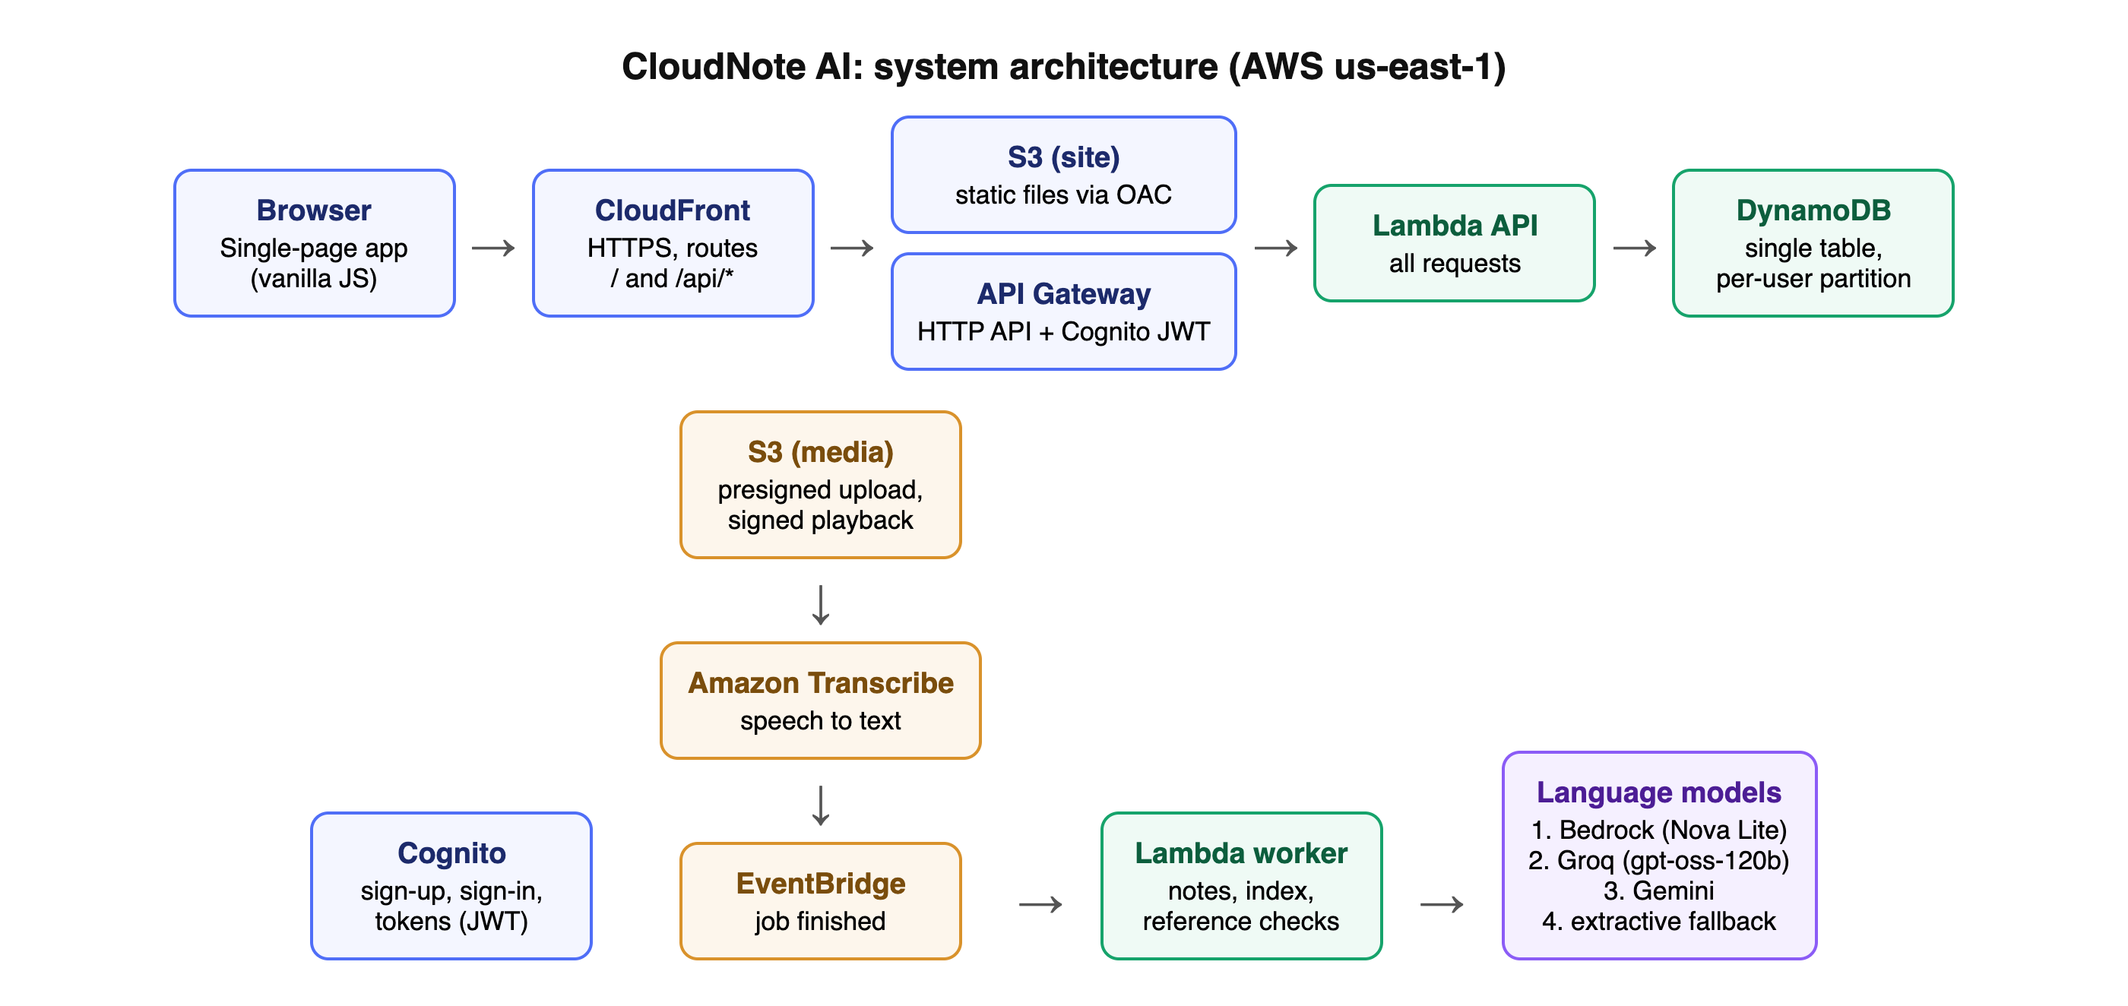
Figure 4.1: Deployed architecture
Table 4.1: Key design decisions
Decision | Chosen | Alternative | Rationale and trade-off
Compute | Lambda (serverless) | EC2 or containers | No idle cost and no patching; accepts cold starts (median init 361 ms) and time limits
Database | DynamoDB single table | Relational database | Per-user partitions give isolation by design and near-zero idle cost; cross-user analytics are harder
Authorisation | API Gateway JWT authorizer | Checks in application code | Rejects requests before code runs; one place to configure
Media path | Presigned S3 upload | Upload through Lambda | Avoids payload limits and Lambda time; requires CORS on the bucket
Speech | Amazon Transcribe | Self-hosted Whisper | Managed, event-driven, no GPU hosting; billed per audio second
Language model | Chain: Bedrock, Groq, Gemini | Single provider | Survived a zero Bedrock quota; free tiers rate-limit bursts and send text outside AWS
Search | TF-IDF, Titan when available | Vector database | No extra service for small libraries; misses paraphrases until embeddings are enabled
Reference detection | Hand-written patterns | Trained classifier | Explainable, no training data; recall on unscripted speech unknown
Linking | User confirmation | Automatic linking | Prevents silent mistakes at the cost of one click
Region | us-east-1 | ap-south-1 (Mumbai) | Broadest model availability; adds about 0.3 s round trip for users in India

5. Performance Analysis

5.1 End-to-end API latency
Measured on 31 October 2026 from a client in India over one reused HTTPS connection; the network was unstable during the run.
Table 5.1: End-to-end latency from India (ms)
Endpoint | n | Min | Median | p95 | Max
GET /api/me | 40 | 433 | 744.6 | 3,448.6 | 4,076.6
GET /api/videos | 40 | 477.8 | 755 | 2,106.3 | 3,745.4
GET /api/videos/:id | 40 | 355.9 | 800.6 | 4,413.8 | 7,393.1
GET /api/notes | 40 | 445.7 | 1,591.1 | 5,916.7 | 6,116.6
GET /api/search?q= | 40 | 338 | 541.4 | 1,915.1 | 8,970.4
GET /api/map | 40 | 370.5 | 553.5 | 813.8 | 839.3
GET /api/notifications | 40 | 374.7 | 570.5 | 1,377.6 | 1,606.6
POST /api/notes/ask (AI) | 10 | 1,329.6 | 1,945.8 | 10,333.4 | 10,333.4

5.2 Cold versus warm Lambda execution
Table 5.2: Server-side Lambda duration from CloudWatch
Function | n | Median | p95 | Cold starts | Init median | Max memory
API | 626 | 14.9 ms | 232.5 ms | 2 | 361 ms | 135 MB
Worker | 6 | 3,283.3 ms | 4,781.1 ms | 2 | 451.6 ms | 136 MB

The gap between the 14.9 ms server median and the end-to-end medians shows that the network, not the application, dominates. The minimum end-to-end time of about 340 ms matches the round trip from India to North Virginia. Memory use (at most 135 MB) is far below the 1024 MB configured, so memory could be lowered, although Lambda CPU scales with memory.

5.3 Pipeline timing
Table 5.3: Pipeline timing on the live deployment
Operation | Runs | Median | Range
Transcript import to AI notes (29 Oct) | 3 | 4.6 s | 4.4 to 4.9 s
Upload, Transcribe, AI notes, 11-s clip (29 Oct) | 3 | 17.3 s | 8.4 to 21.2 s
Upload, Transcribe, AI notes, 11-s clip (31 Oct) | 1 | 16.4 s | -
Ask your notes (29 Oct) | 10 | 2.5 s | 2.0 to 21.9 s
Know more (29 Oct) | 5 | 4.1 s | 2.3 to 15.0 s

5.4 Front-end payload
The application bundle is 139.7 KB of JavaScript (47.4 KB gzip-compressed) and 35.3 KB of CSS (8.1 KB compressed), with no framework. CloudFront serves it from the edge; fonts are cached for a year.

5.5 Language-model behaviour
Bedrock failed every call (quota zero), so Groq answered most requests in about 2 to 3 s. When Groq returned HTTP 429 under bursts, the chain moved to Gemini, which was often overloaded; the slowest observed answer took 21.9 s before falling back to keyword results. A paid or quota-raised Bedrock model would remove this variance.

6. Security Analysis

6.1 STRIDE threat model
Table 6.1: STRIDE threat model
Threat | Example | Mitigation
Spoofing | Calling the API as another user | Cognito-signed JWT validated by API Gateway; user id taken from verified claims
Tampering | Editing another user's references or notes | Partition per user; conditional writes; no user id accepted from the request
Repudiation | Denying an action | CloudWatch logs per request; no user-visible audit trail (gap)
Information disclosure | Reading media or another library | Private encrypted S3, signed expiring URLs, 404 for foreign ids
Denial of service | Flooding uploads or AI calls | API throttling (about 25 requests/s), 30-video and 500 MB limits; no WAF (gap)
Elevation of privilege | Lambda reaching other resources | Per-function least-privilege IAM policies

6.2 OWASP Top 10 (2021) mapping
Table 6.2: OWASP Top 10 mapping
Category | CloudNote AI control
A01 Broken Access Control | Gateway authorizer; per-user partitions; cross-user tests ISOL-14 to ISOL-17 passed
A02 Cryptographic Failures | TLS everywhere, HSTS; S3 server-side encryption; DynamoDB encryption at rest (AWS default)
A03 Injection | No string-built queries; prompt-injection test produced no answer; model output never executed
A04 Insecure Design | User confirmation before linking; citations enforced
A05 Security Misconfiguration | Public access blocked on buckets; CSP and frame denial; one template reviewed with cfn-lint
A06 Vulnerable Components | No frontend framework; AWS SDK from the Lambda runtime; dependency scanning not automated (gap)
A07 Identification and Authentication Failures | Cognito password policy; same error for unknown user and wrong password; no MFA (gap)
A08 Software and Data Integrity Failures | Infrastructure as code; deployment from a reviewed repository
A09 Logging and Monitoring Failures | CloudWatch logs for all functions; no alarms yet (gap)
A10 Server-Side Request Forgery | Backend calls only fixed AWS, Groq and Gemini endpoints

6.3 Security test results
Table 6.3: Live security test results
Category | Checks | Passed
Authentication | 13 | 13
Isolation | 4 | 4
Input validation | 6 | 6
Injection | 2 | 2
Storage | 6 | 6
Headers and transport | 5 | 5

6.4 Compliance considerations
Recordings can contain personal data of lecturers and students. Under India's Digital Personal Data Protection Act, 2023, a production service would need a clear purpose statement, consent, the ability to delete data (already supported per recording), and disclosure of processors. While Groq or Gemini is used, transcript text is processed outside AWS by those providers; this must be disclosed, or the service should run only on Bedrock.

6.5 Identified security gaps
- Open sign-up without e-mail verification; anyone with the link can use transcription credits.
- No multi-factor authentication or password reset.
- No AWS WAF or per-user rate limits beyond API Gateway throttling.
- Model API keys live in Lambda environment variables rather than Secrets Manager.
- Media bucket CORS allows any origin (uploads still need presigned URLs).
- No user-visible audit log and no CloudWatch alarms or budget alarm configured in the stack.
- The deployment IAM user has AdministratorAccess and should be removed after deployment.

7. Data Analysis

7.1 Data model composition
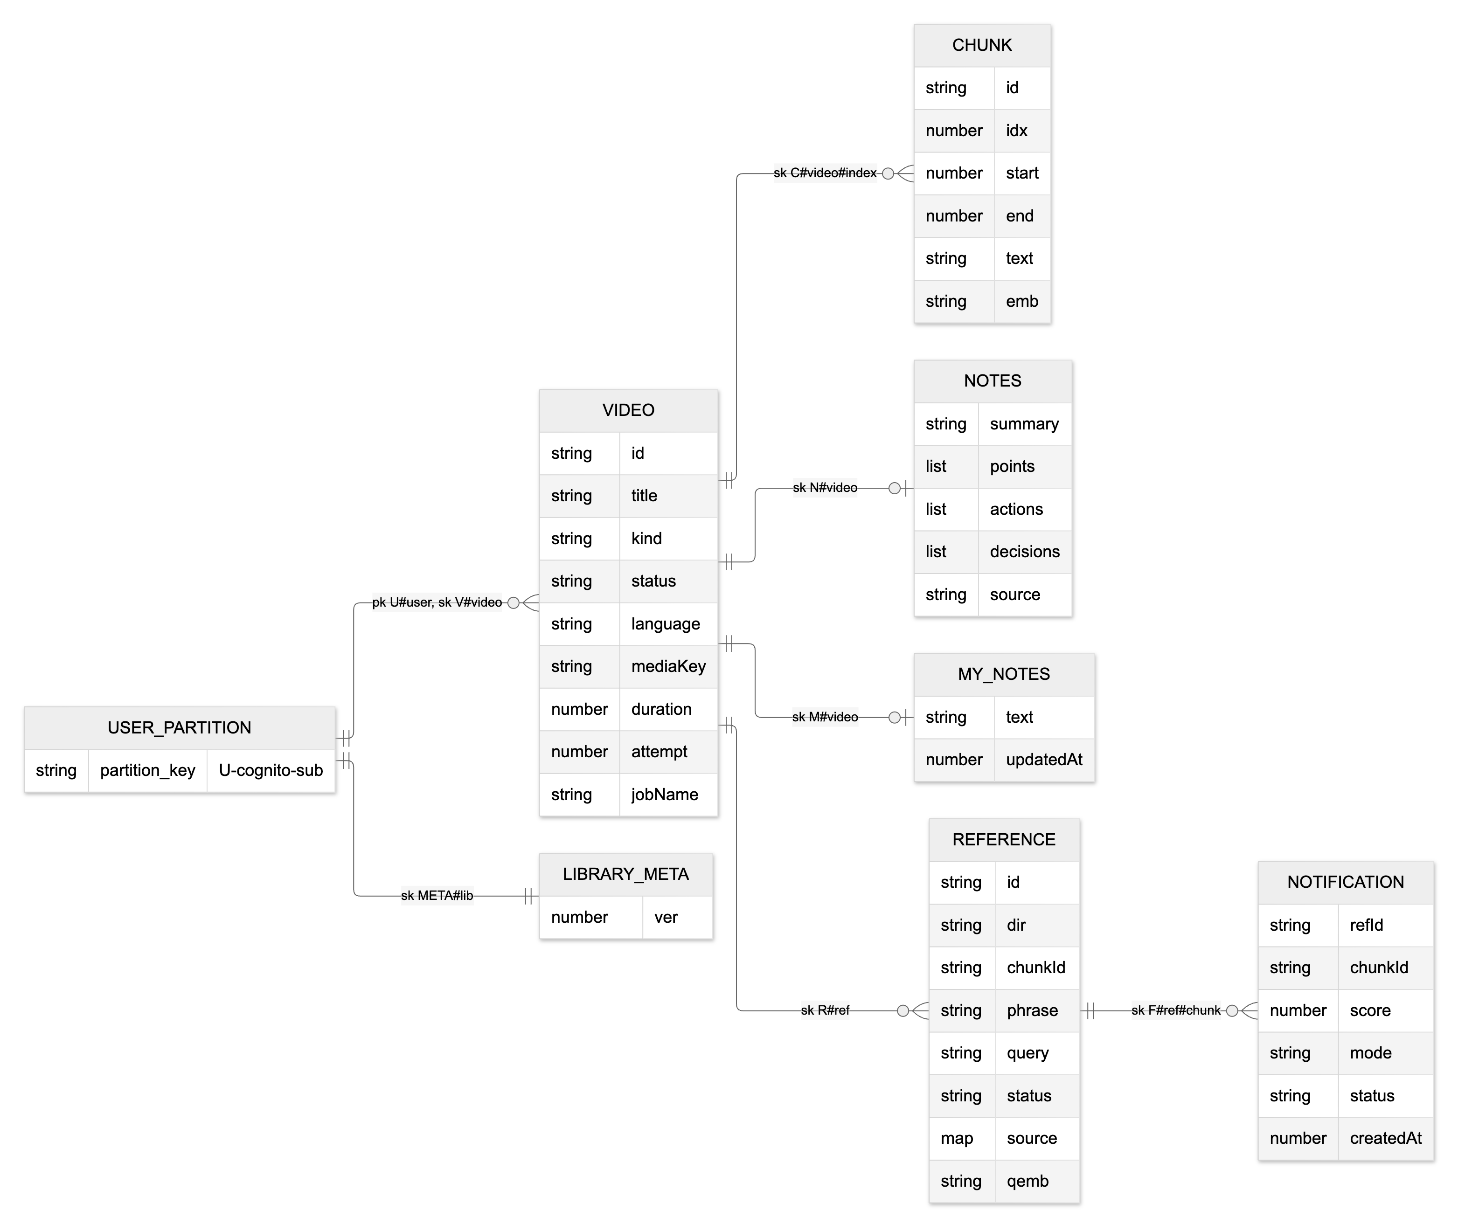
Figure 7.1: Single-table data model
Each user's partition contains video items, transcript chunks (about 60 words each), notes, own notes, references, notifications and one library version item. A one-hour lecture produces roughly 100 to 150 chunks, so a library of 30 recordings stays in the low thousands of items, well within DynamoDB's single-partition throughput for one learner. Media files dominate storage and live in S3, not in the table.

7.2 Observations from the sample library
The four illustrative sample recordings contain backward references, a follow-up kept by a later recording and a follow-up kept by none, so the library map shows linked edges, open gaps and follow-ups. A real 18-minute graph-traversal lecture uploaded by the team produced 131 moments with AI notes, and on a graph-traversal transcript the Ask tab answered "what is DFS" with an explanation citing the moments at 9:30, 12:10 and 15:36. These are demonstrations, not measured accuracy.

8. Cost Analysis
AWS Cost Explorer reported 0.00 USD for October 2026. Table 8.1 estimates transcription, the dominant cost, at about 0.024 USD per audio minute (us-east-1 standard batch price at the time of writing).
Table 8.1: Estimated transcription cost
Scenario | Audio minutes | Approx. USD
Capstone demo: 4 recordings of 5 minutes | 20 | 0.48
One student, one course: 30 lectures of 50 minutes | 1,500 | 36
60 students uploading the same 30 lectures each | 90,000 | 2,160
Same class, lectures shared once | 1,500 | 36

8.1 Serverless versus an always-on server
An always-on virtual machine large enough to run the API would cost a fixed monthly amount even with no users, plus patching and monitoring effort. The serverless design costs nothing when idle and scales automatically; its costs grow with use, so it suits a course project and small classes well. At sustained high load a container or instance could become cheaper, but transcription would still dominate.

8.2 Cost optimisation options
- Import existing captions as transcripts instead of transcribing.
- Share course libraries so each lecture is transcribed once.
- Restrict sign-up and add an AWS Budgets alarm.
- Lower Lambda memory for the API after measuring CPU-bound paths.
- Use Bedrock (paid per token, small) instead of rate-limited free tiers for reliability.

9. Code Quality and Maintainability
Table 9.1: Code size (non-blank lines)
Part | Files | Lines
Web application (JavaScript, CSS, HTML) | 21 | 1,667
Backend | 15 | 1,276
Shared engine | 2 | 350
Infrastructure | 3 | 354
Tests | 16 | 981

9.1 Maintainability strengths
- One language across browser, backend and shared engine.
- Provider interfaces let the same code run locally (memory and disk) and on AWS.
- All infrastructure in one template; deploy and destroy are single commands.
- 59 automated tests cover parsing, notes, references, API behaviour, isolation and failure paths.

9.2 Technical debt
- The AWS and Cognito test suites need a local AWS mock (moto) and are not run routinely.
- No continuous integration pipeline or dependency scanning.
- Some UI modules are long single files without component tests.
- The per-container in-memory search index will not scale beyond a few hundred recordings per user.
- Configuration such as thresholds is in environment variables without a settings screen.

10. Risk Analysis
Table 10.1: Risk register
Risk | Likelihood | Impact | Mitigation
Free-tier model provider rate-limits or changes terms | High | Medium | Fallback chain; request Bedrock quota
Bedrock quota stays at zero | Medium | Medium | Groq fallback; AWS Support case
Open sign-up leads to transcription spend | Medium | High | Domain restriction, budget alarm, per-user limits
Transcript text sent to third-party providers | High while used | Medium | Disclosure; move to Bedrock
Reference recovery mislinks on real speech | Medium | Medium | User confirmation; labelled evaluation planned
Deployment key misuse | Low | High | Delete IAM key; never commit keys
Region latency for Indian users | High | Low | Deploy in ap-south-1 when models are available

11. Limitations and Future Work

11.1 Limitations
- Reference recovery exercised on illustrative samples, not scored on real lecture series.
- English-only reference patterns.
- Semantic search disabled while Bedrock is unavailable.
- Small performance samples from one client location; no usability or learning study.

11.2 Future work
- Labelled dataset of real lecture series and measured recall and precision.
- Bedrock and Titan embeddings with tuned thresholds.
- Hindi and Telugu reference patterns.
- Shared course libraries and instructor gaps reports.
- Production safeguards: verification, MFA, WAF, alarms, Secrets Manager.
- Deployment in ap-south-1 and a user study with students.

12. Conclusion
CloudNote AI meets its objectives as a working, deployed and tested system. Its application logic is fast, its security controls held under deliberate misuse, and it has cost nothing to run so far. The analysis identifies three priorities before wider use: restrict and harden sign-up, move language-model work to a dependable provider within AWS, and measure reference recovery on real lecture series.

