**Excel Assignment - 6**

**1. What are the various elements of the Excel interface? Describe how they're used?**

The Excel interface consists of various elements that allow you to interact with and manipulate your data effectively. They are as follows:

* Title Bar: The title bar is at the top of the Excel window and displays the name of the current workbook.
* Ribbon: The ribbon is a horizontal toolbar that runs along the top of the Excel window. It is divided into multiple tabs, each containing groups of related commands.
* Tabs: The tabs on the ribbon correspond to different categories of functionality, such as formatting, data manipulation, formulas, and more.
* Groups: Within each tab, you'll find groups of related commands.
* Formula Bar: The formula bar, located above the worksheet grid, displays the content of the currently selected cell.
* Cell Grid: The main area of the Excel interface is the cell grid, where you input and manipulate your data.
* Column and Row Headers: The column headers and row headers allow you to identify and navigate to specific columns and rows in the cell grid.
* Worksheet Tabs: If your workbook contains multiple worksheets, you'll see worksheet tabs at the bottom of the Excel window.

**2. Write down the various applications of Excel in the industry.**

Excel is a versatile software application widely used across various industries for a multitude of tasks. Its spreadsheet capabilities make it a valuable tool for data management, analysis, visualization, and decision-making.

Here are some applications of excel in the industry:

* Finance and Accounting
* Business and Management
* Human Resources
* Education
* Healthcare

**3. On the ribbon, make a new tab. Add some different groups, insert commands in the groups and name them according to their commands added. Copy and paste the screenshot of the steps you followed.**

Here are the steps:

* Go to File - Options - Customize Ribbon.
* Right-click on the ribbon and select Customize the Ribbon from the context menu

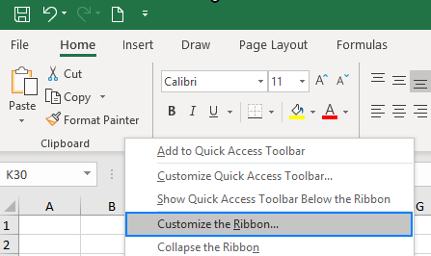

* In the Customize the Ribbon window, under the list of tabs, click the New Tab button.

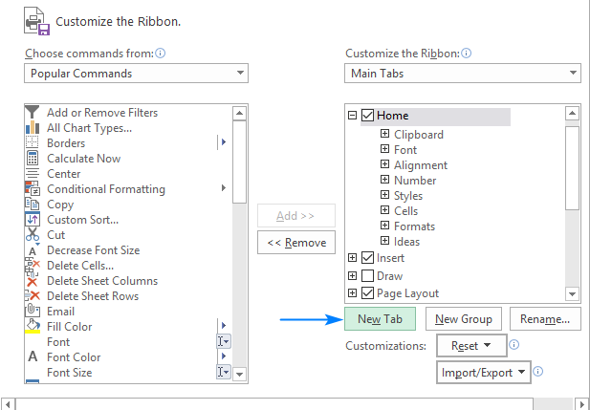

* Select the newly created tab, named New Tab, and click the Rename button to give your tab an appropriate name.
* When done, click OK to save the changes

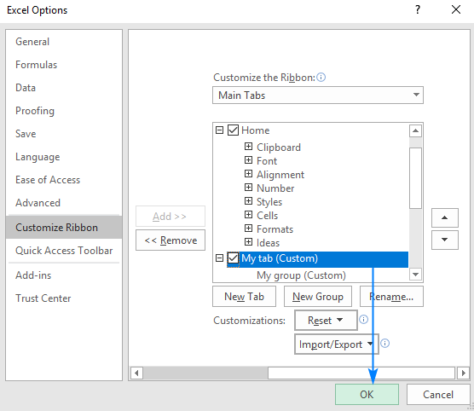

* In the right part of the Customize the Ribbon window, select the tab to which you'd like to add a new group.
* Click the New Group button. To create a new group in a specific location, select the group after which the new group is to appear.

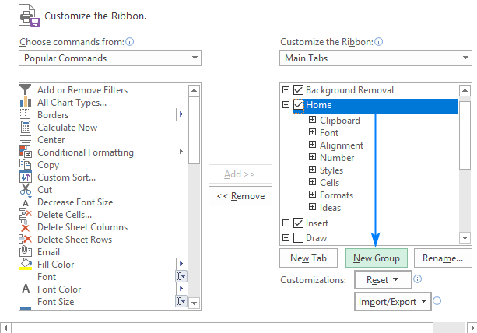

* To rename your custom group, select it, click the Rename button, type the desired name, and click OK.
* In the list under Customize the Ribbon, select the target custom group.
* In the Choose commands from drop-down list on the left, select the list from which you want to add commands, for example, Popular Commands or Commands Not in the Ribbon.
* In the list of commands on the left, click the command you want to add.
* Click the Add button.
* Click OK to save the changes.

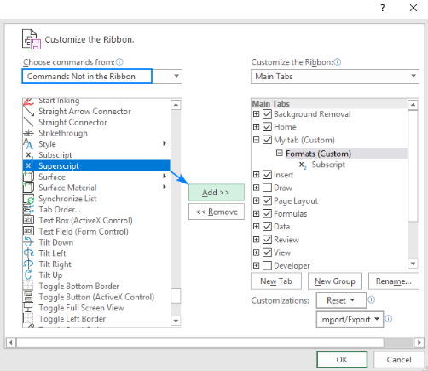

**4. Make a list of different shortcut keys that are only connected to formatting with their functions.**

Here are the list of shortcut keys regularly used in excel:

* Ctrl + B: Bold
* Ctrl + I: Italicize
* Ctrl + U: Underline
* Ctrl + 1: Format Cells Dialog Box
* Ctrl + Shift + 7: Apply Border Format
* Ctrl + Shift + 9: Hide Rows
* Ctrl + Shift + 0: Hide Columns
* Ctrl + Shift + F: Font Dialog Box
* Ctrl + Shift + P: Format Painter

**5. What distinguishes Excel from other analytical tools?**

Microsoft Excel is a widely used spreadsheet software that offers a range of features for data analysis, manipulation, and visualization. Here are some distinguishes excel from other tools:

User-Friendly Interface, Versatility, Ease of Use, Customizable, Data Visualization, Integration, Widespread Adoption, Scalability, Limited Statistical Analysis, Version Control, Data Cleaning, Complex Analyses, Data Source Connectivity.

**6. Create a table and add a custom header and footer to your table.**

Here are the steps to create a table and add a custom header and footer to your table:

Creating a Table in Microsoft Excel:

* Open Microsoft Excel.
* Click on a cell where you want to start your table.
* Go to the Insert tab in the top menu.
* Click on the Table button. A dialog box will appear.

Adding Custom Header and Footer:

* Select a cell just above the table for the header or just below the table for the footer.
* Type in your custom header or footer text.
* Format the custom header and footer cells as needed by adjusting font styles, sizes, colors, and alignment.