**Excel Assignment - 8**

**1. What do you mean by AutoComplete feature in Excel and what are the benefits of using this feature?**

The AutoComplete feature in Excel is a functionality that predicts and suggests values based on patterns it identifies in a column of data.

Benefits of using the AutoComplete feature in Excel are as follows:

Efficiency, Accuracy, Consistency, Time Saving, Reduced Repetition, Less Typing, Data Validation, Error Prevention.

**2. Explain working with workbooks and working with cells.**

In Excel, a workbook is a file that contains one or more worksheets (also known as spreadsheets). Each worksheet is made up of cells organized in rows and columns. Cells are the fundamental units of data storage in Excel and are where you enter, manipulate, and display data.

While working with workbooks we can do the following:

* We can create a new workbook.
* We can saving a workbook.
* We can opening an Existing workbook.
* We can manage worksheets.

While working with cells we can do the following:

* We can enter data.
* We can use cell references.
* We can format cells.
* We can use formulas and functions.
* We can copy and paste the content in the cells.
* We can use data validation.
* We can sort and filter.
* We can merge cells.

**3. What is fill handle in Excel and why do we use it?**

The fill handle in Excel is a small square or dot located at the bottom-right corner of a selected cell. It's a versatile tool that allows you to quickly and easily fill adjacent cells with data, patterns, or formulas based on the content of the selected cell. The fill handle can be used for various purposes, including:

* AutoFill Series
* Copying Formulas
* Copying Values
* Custom Series
* Incremental Values
* Dates and Times.

We will use fill handle because, the fill handle is a time-saving feature that helps you quickly populate cells with consistent data, and it's particularly useful when dealing with large datasets.

**4. Give some examples of using the fill handle.**

Here are some examples of using the fill handle in Excel:

* Creating a Number Sequence:

Enter the first number in a cell.

Click and drag the fill handle down to create a series of ascending numbers.

* Creating a Date Series:

Enter a date in a cell.

Click and drag the fill handle down to generate a series of consecutive dates.

* Copying Formulas with Relative References:

Enter a formula in a cell.

Click and drag the fill handle down or to the right to apply the formula to adjacent cells while adjusting references automatically.

**5. Describe flash fill and what the different ways to access the flash fill are.**

Flash Fill is a powerful feature in Excel that allows you to quickly extract, split, combine, or transform data based on patterns that Excel detects.

Here are the different ways to access Flash Fill are as follows:

* Automatic Flash Fill
* Using the Flash Fill Button
* Accepting Suggested Flash Fill.

**6. Extract first name and last name from the mail id and then from the address column, extract the city, state, and pin code using the flash fill. Given below is an example of the columns you have to create. Paste the screenshot of what you have created using the flash fill command. Example: Mail Id, Address, First name, Last name, State, City, Pincode.**

Here the screenshots of what I have created using flash fill:

The screenshot without using flash fill command:

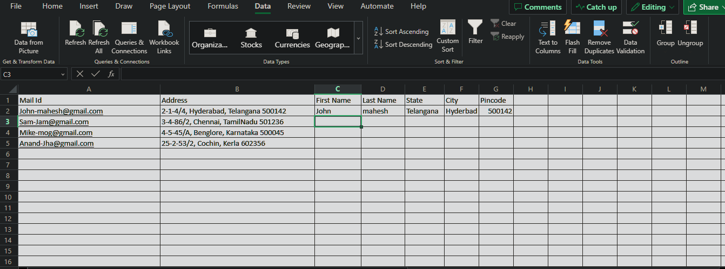

Screenshot with using Flashfill command:

