**Coventry University**

**BScBIT-Year 2**

**2018-19**

**ALL Project Two**

**Group 5**

**Group Members:**

|  |  |  |
| --- | --- | --- |
| Name | Student ID | Role |
| Kwan Lap Wei | 5520 1488 | part of the python , SQL programing and design the diagrams of 104&118 |
| Yip Kai Chung | 5520 2356 | part of the python , SQL programing and design the diagrams of 104&118 |
| Ng Kiu Fung | 5520 2320 | part of the python , SQL programing and design the diagrams of 104&118 |
| Mui Yen Ching | 5520 2184 | part of the python , SQL programing and design the diagrams of 104&118 |

**Content**

Introduction ………………………………………………………………...….3

Details of GUI interactions ……………………………………………….4 - 8

Descriptions on GUI commands ……………………………………….9 - 10

GUI Test Report ………………………………………………………..…....11

GUI Limitation ……………………………………………………………….12

ER Diagram ………………………………………………………………….13

Database Design ……………………………………………………….......14

Use Case …………………………………………………………………….15

Activity Diagram (Login System) …………………………………………..16

Activity Diagram (Selling Sysyem) ……………………………………….. 17

Sequence Diagram ………………………………………………………….18

Company Overview ………………………………………………………....19

Service Blueprint …………………………………………………………….20

AS-IS vs TO-BE ……………………………………………………………..21

Process Analysis Diagram ………………………………………………....22

Process Analysis ……………………………………………………....23 - 24

Cost Benefit Analysis ………………………………………………….25 - 29

Service Catalog ……………………………………………………………..30

Service Level Agreement ……………………………………………..31 - 34

SWOT ……………………………………………………………………….. 35

**Introduction**

Meat Meat Frozen Meat Company was a traditional company, it is without an appropriate and automatic system to operate their company in order to compete with the nowadays companies. Due to the fact that, they hired Ez programming company to produce a selling system for them which is like Point Of Sales.

Meat Meat put it next to the door of their shop

customers will see it once they come in.

The whole consuming procedures of buying meat is replaced by a automatic way:

Firstly, customers choose their products from the system.

And then, the staff of Meat Meat will follow the order generated by the selling system to take the meats from the freezer.

Consequently, it can ensure that the products will be handed in to the customers at the first time in order to ensure the freshness and the cleaness, the meat will only be transferred by the staff of Meat Meat before sent to the customers.

Finally, the meat is taken out from the freezer and packaged by the staff, It will be ready for the customers to do the payment.

**Details of GUI interactions**

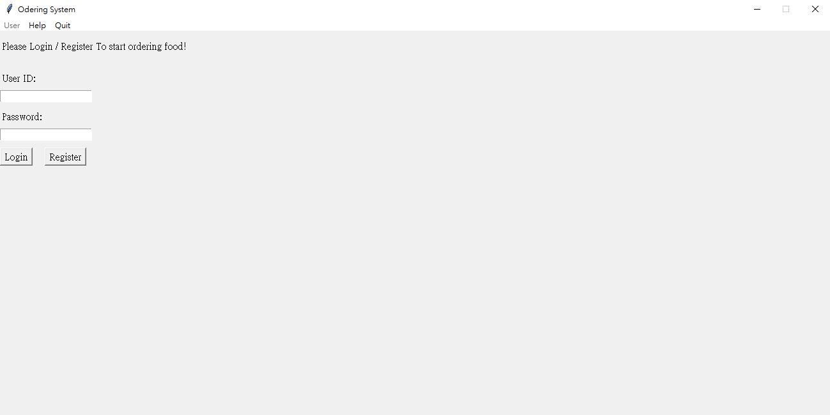

Screenshot of first stage of the program (Login and Register page).

**First**, users has to enter their id and password to **login** to this ordering system.

A pop up window will alert if they logged in the system successfully.

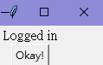

**Besides**, users can **register** a new account by entering their information and click “register”. If there is no repeated usersID that has been registered ,the registration will be successful and show a pop up window alert that the users already created their account.

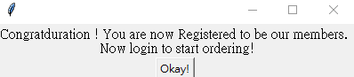

On the other hand, menu bar on the top also provided some functions such as **help and quit**. To be mentioned, “Help” tap is a drop-down menu that contain three more functions.

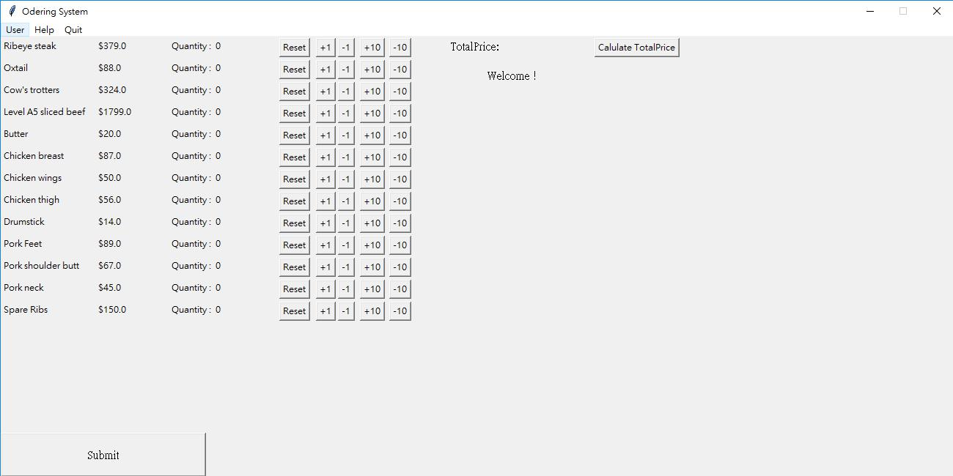

Screenshot after logged in.

Second, users can start choosing product they want by pressing **+1, -1, +10, -10 button** to change the **quantity** of correspond product. Also, if users need to clear the number of a product, they can simply press “**Reset**” button and return to zero.

 -> 

Demonstration of “**Reset**” button effect.

The “**Calculate TotalPrice**” is for users to calculate the total price they have to pay. By this formula :

self.entries[0-12].cget(“text”) is the label in gui, means quantity of products no. 1 -13

results[0-12][3] means prices of products no. 1-13, Since it is imported from **phpmyadmin SQL database** and stored into a list call “results”, an example of item 1 in “results” : (1, 'Cow', 'Ribeye steak', 379.0)

Screenshot in FinalGUI.py .

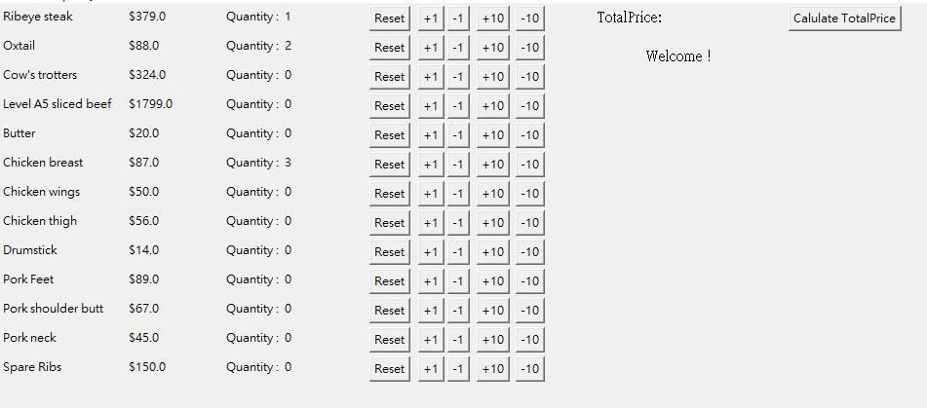

Screenshot of before calculating.

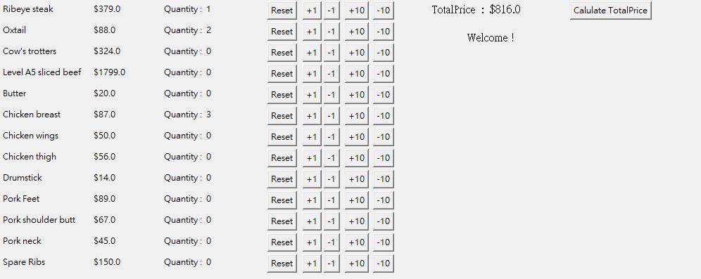

Screenshot of after calculating.

Third, when users is ready for order and pressed the “Submit” button, it will show a **confirm windows** to confirm the users have double check their orders before **submission** to prevent mistaken order.

Pressing “No!” button will destroy this windows and return to order menu.

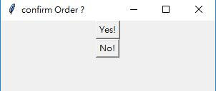

Screenshot of confirm windows.

Fourth, after pressing “Yes!”, the content inside will change to show a ‘**Thanks message**’, order has been **confirmed notice** and show the **order ID**.

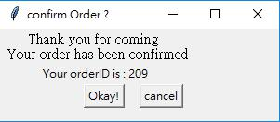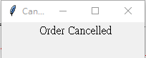

By pressing cancel, users can **cancel** the order they have just submitted, if they ordered it mistakenly or really do not want to order it.

**Menubar content** :

 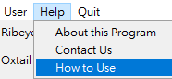

Screenshot of menubar.

When user press any menubar function, there is a event or popup window return :

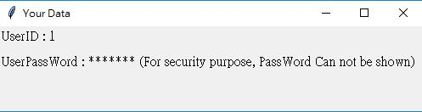Under “User” menu, “Your Data” Provided information of users logged in.

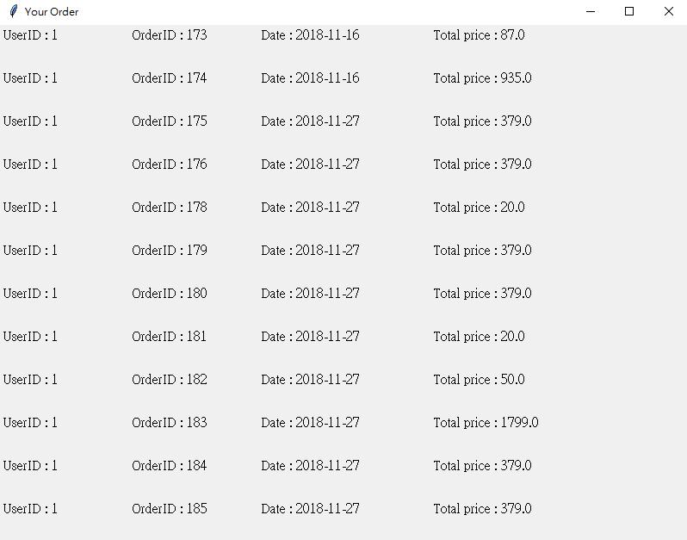

Under “User” menu, “Your Order” provide information of user’s order history.

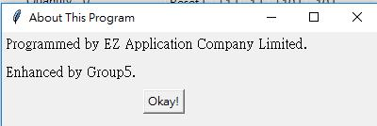

Under “Help” menu, “About This Program” provide information of developer of this program.

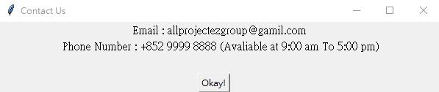

Under “Help” menu, “Contact Us” provide ways to contact program developer for debugging or asking.

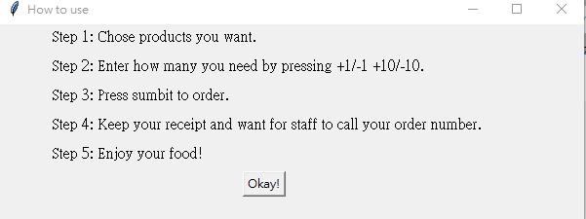

Under “Help” menu, “How to use” provided steps by steps tutorial of the program.



“Quit” is for user to turn off this program if needed.

**Database Design**

`user table:

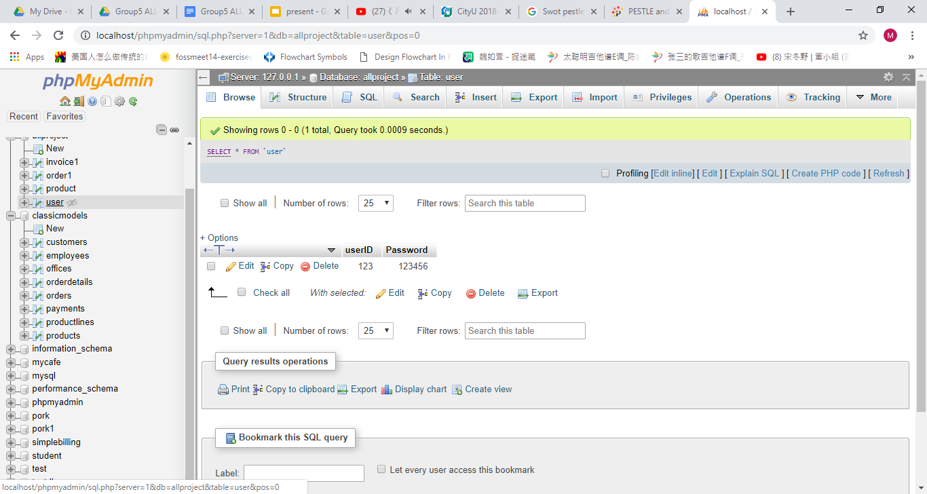

`product` table:

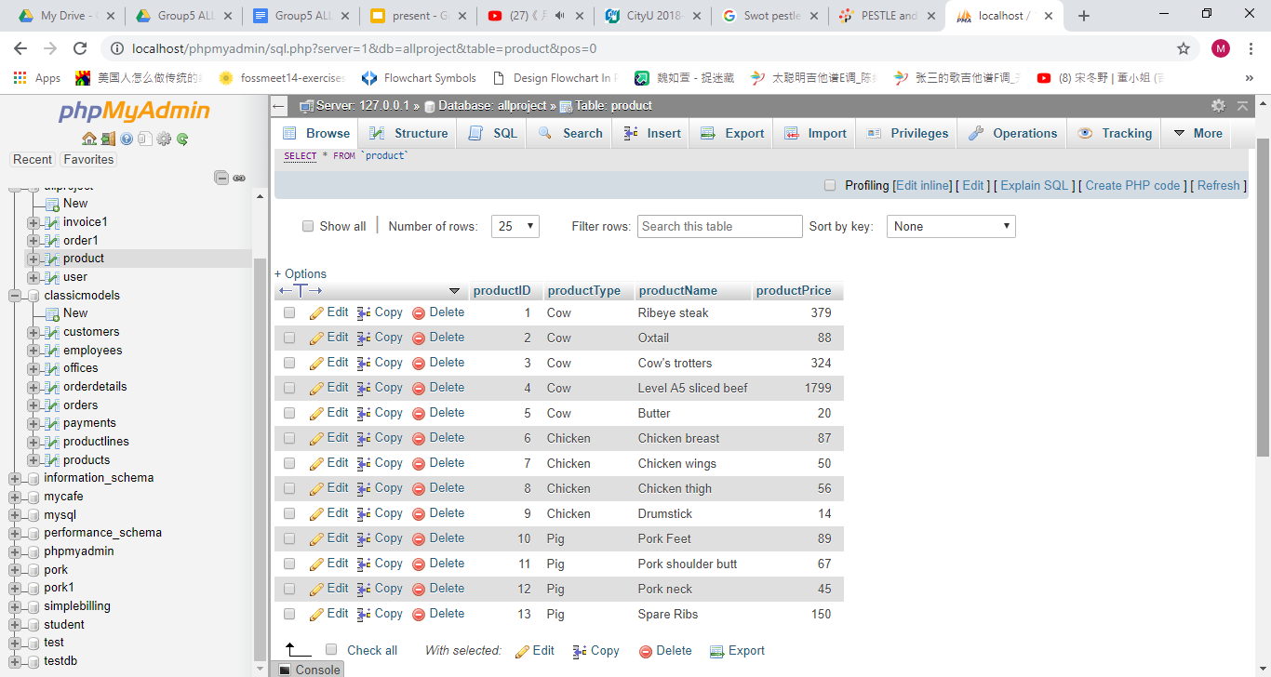

`invoice` table: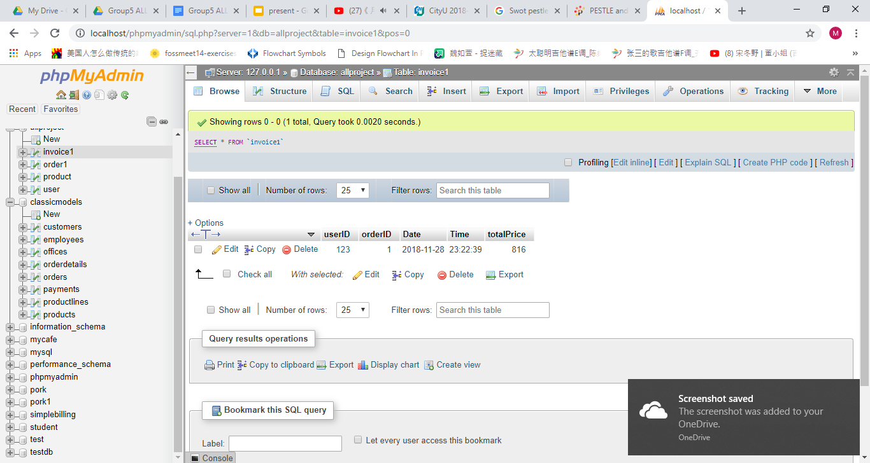

`order` table:

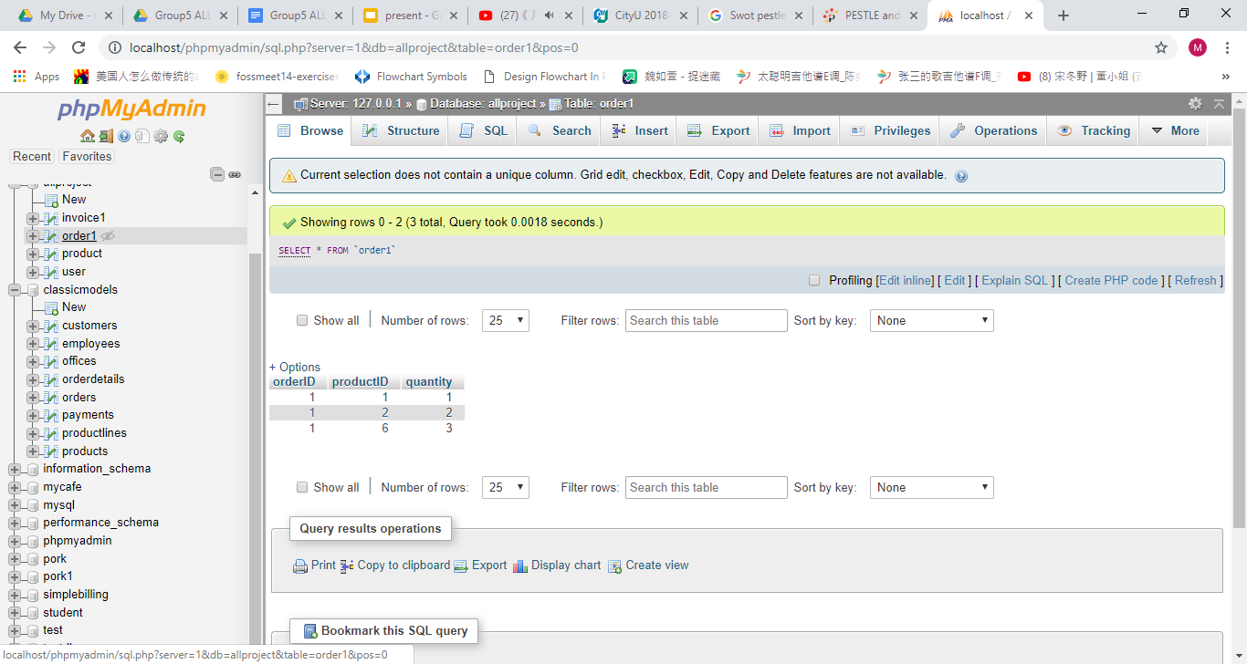

**Descriptions on GUI commands**

**Class Diagram** :

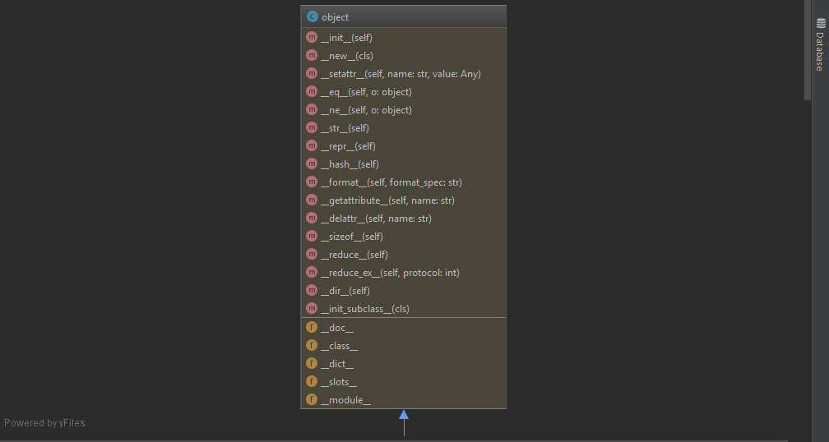

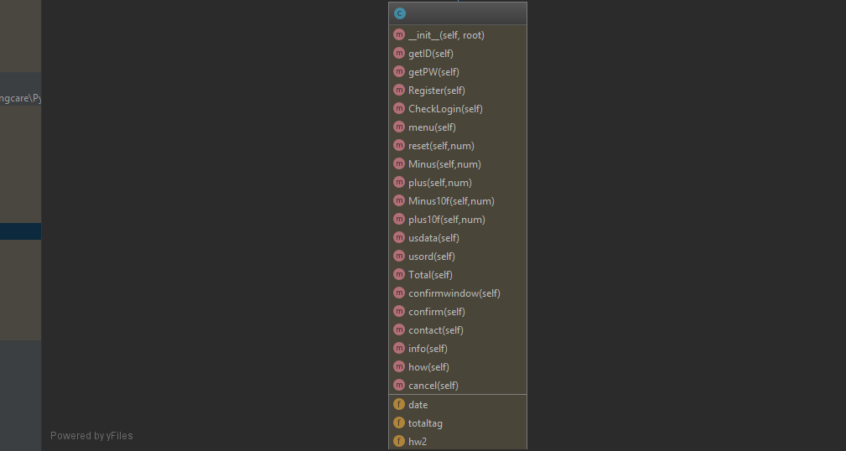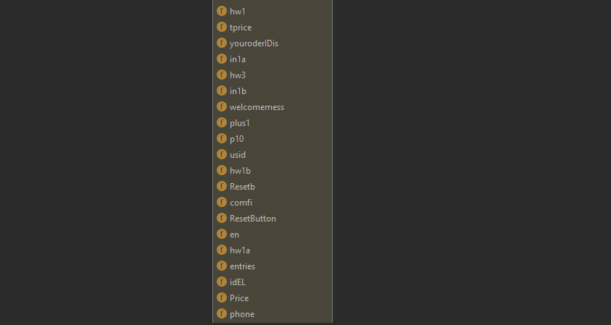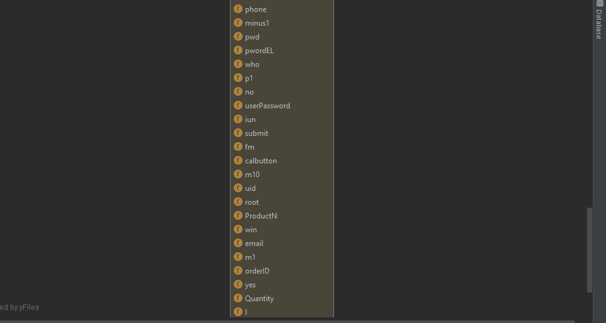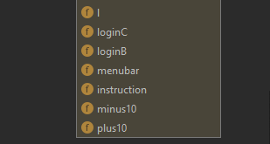

There is only 1 class -**GUI**. Containing 21 functions. Which can be separated into four parts.

**Login and Register** :

* _init_ ( constructor method, define the first look of the program, size of gui, which contain 2 entry box for ID and password, two labels to tag which entry box is for (id and password), two buttons “Login” and “Register” and a text label to guide users what to do.)
* getID (method to get usersID in the idEL entry box.)
* getPW (method to get usersPassword in the pwordEL entry box.)
* Register (method for new users registration, also checking whether the id is repeated or ID and password is missing.)
* CheckLogin (method to check the ID and password inputted is matching in database or not. If yes, call menu() otherwise popup windows the userID is created and show a error message.)

**Main Body** :

* menu (Create a different widget for a ordering system, 2 for loop is used for generating product related content and buttons based on the database, a welcoming message label, submit order button and a button for calculating total price.)
* reset (command for button”Resetbutton” to set the quantity of a product to 0)
* Minus (command for button”minus1” to set the quantity of a product to -= 1 if it is greater than 0.)
* plus (command for button”plus1” to set the quantity of a product to += 1)
* Minus10f (command for button”minus10” to set the quantity of a product to -=1 if it is greater than 9.)
* plus10f (command for button”plus10” to set the quantity of a product to += 10)
* Total (command for button”calbutton” to calculate total price of all product.)

**Submition** :

* confirmwindow (Command of “submit” button in Main Body , creating a popup window for authorizing if the users want to order. Two buttons “Yes” and “No” in this popup window. Pressing “Yes” will destroy the Mainbody and “No" will destroy confirmwindow itself.)
* confirm (Command for Pressing “Yes” in confirmwindow(), Change the content of confirmwindow to a Thanks message plus displaying the orderID. Two buttons “Okay!” and “Cancel” in this screen.)
* cancel (Command for button “Cancel”, delete the latest order record in database plus a message to notice the users that order is canceled.)

**Menubar windows** :

* usdata (create a windows to display users data of logged in users.)
* usord (create a windows to display users’s order of logged in users.)
* contact (create a window to display contact information of ours company.)
* info (create a windows to display developer of this program.)
* how (create a windows to display step by step of explanation of using this program.)

**GUI Test Report**

|  |  |  |  |
| --- | --- | --- | --- |
| ID | Test Data | Expected Output | Pass |
| 1 | Registered with  userID : 1  Password : 123456  Login with  userID : 1  Password : 123456 |  | Yes |
| 2 | Login with  userID : 1  Password : 9999 |  | Yes |
| 3 | Login with  userID: aaaaa  Password : 123456 |  | Yes |
| 4 | Register with  userID : apple1  Password: banana1 |  | Yes |
| 5 | Register with  userID :  Password : 2345 |  | Yes |
| 6 | Register with  userID : orange1  Password : |  | Yes |
| 7 | Register with existed ID  userID : 1  Password : Tree |  | Yes |

**GUI Limitation**

1. **Scrolled bar didn’t included. Since reading the tkinter documentation in python.org, it is only with a Listbox, Canvas, or Text widget. But our gui is implemented on a frame. So the official way doesn’t work. While searching on the internet, there are some other python module for it. But we are afraid that is too complex and might messed up the plan for our project, so we didn’t solve it.**
2. **In the program code it is without filtering since the data is from phpmyadmin SQL database and inside the fields and records we already sorted it in other way : sorted by the orders such as the product name**

**it will demonstrate in a suitable way.**

**104KM  
Enterprise Information system**

**ER Diagram:**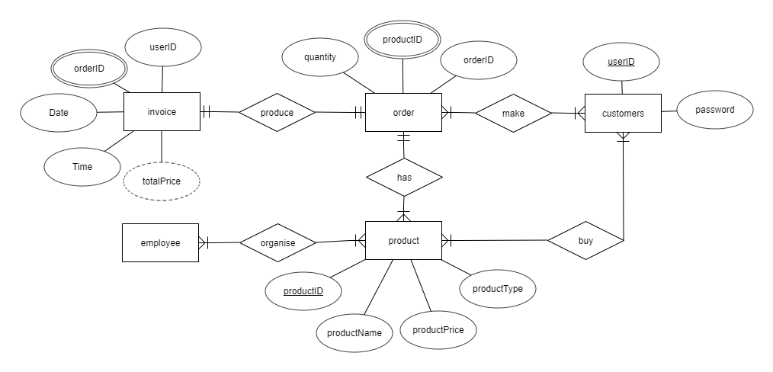

First, customers buy products they want from our Meat Selling System.   
Then, a order is made, with the ID of the order, ID of the products bought as well as the quantity of item.   
 After receiving the order, workers(employee) collect the products that customers required to have from the refrigerator.   
 Finally, a invoice is produced with the detail information of the order, including customers’ user ID, the specific ID of the order, the generated date and time of the order, and the total price of the order.

**Database Design:**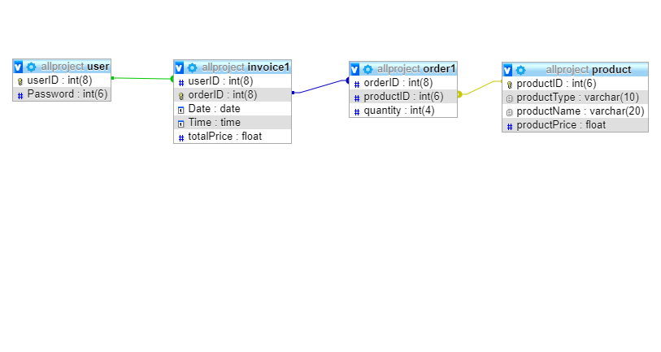  
 There are four table, `user`, invoice1`, `order1`, `product`.  
`user`: for login system, including fields userID (primary key), Password.  
  
`invoice1`: for Meat Meat Frozen Meat Company’s record saving, including fields orderID (primary key), userID (foreign key reference userID from `user`), Date, Time, totalPrice.  
  
`product`: table of information of all products, including productID (primary key), productType, productName, productPrice.  
  
`order1`: for a foreign table of `invoice1`, including orderID (foreign key reference orderID from `invoice1`), productID (foreign key reference productID from `product`), quantity.

**Use Case:**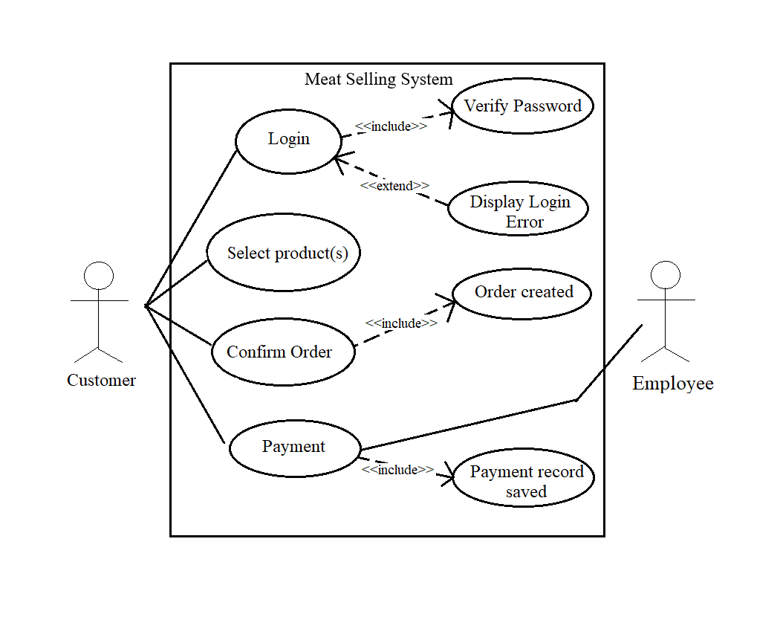  
   
 In normal situation, customers get into the store, login the Meat Selling System with verifiable password.

Then, customers select the product(s) they want and the amount. After finishing the pick, customers can confirm the order they made,or cancel it.

After confirming the order, customers can go to the cashier to do the payment.

**Activity Diagram (Login System):** 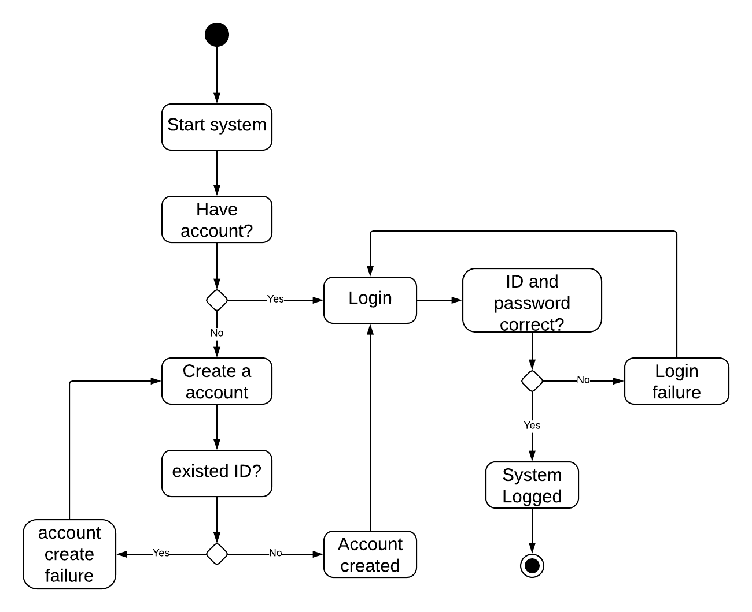  
 Within the whole system, there are two main GUI.   
 At the start of the system, user first creates an account if he or she is the first time using the system. After enter the ID and password, the account will be created if the ID number is the user’s specific ID and not the existed ID. Afterwards, user can log into the system and start the selling GUI.   
 If user has already created an account, he or she will skip the registration and straight log into the selling GUI.

**Activity Diagram (Selling System):**   
  
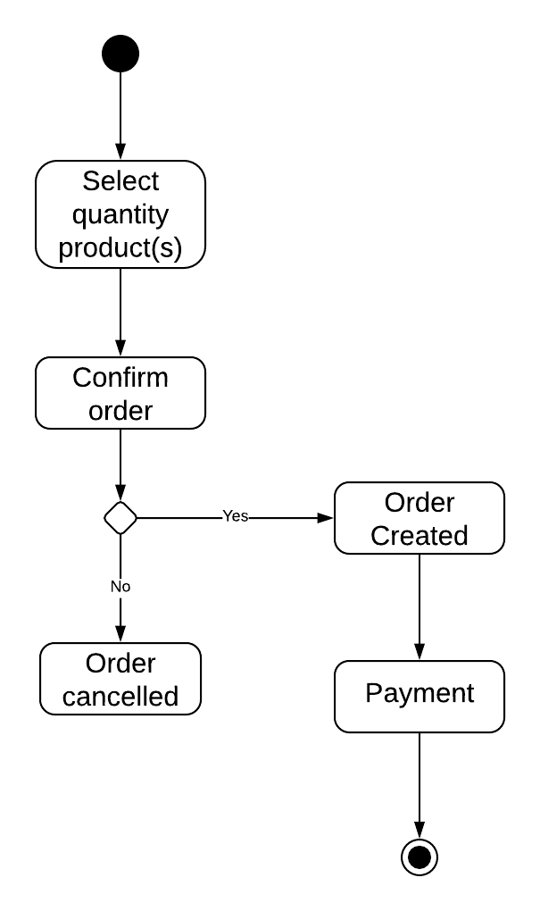

After logged into the selling system, user may begin select the quantity of product(s). Then, user can decide to confirm the order, or cancel the order he or she made. Finally, user leaves the system and go for the payment.

**Sequence Diagram:**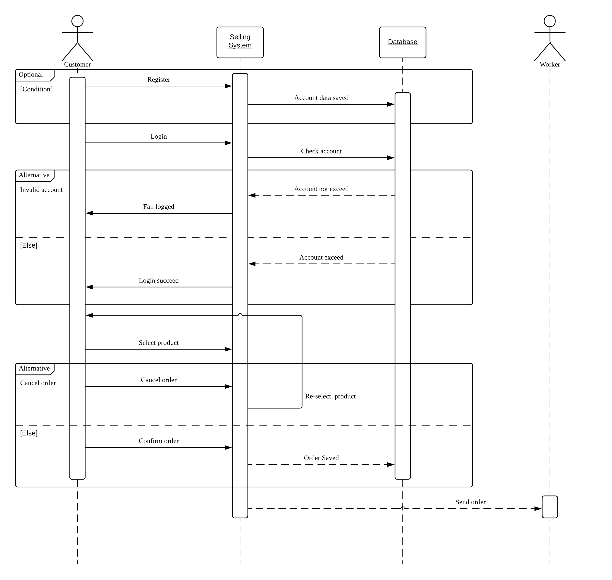  
   
 In the whole workflow, there are four actors, including the customer, the Meat Selling System, the database and the worker.   
 At the beginning of the system, new customers have to register first (optional), and the account data will be saved in database.   
Next, customers need to login the system, and the system will check if the ID and password exist. In case, the ID and password are correct, and the user will log. Otherwise, the Login system will reject the login.   
 After logged in, customer may select the quantity of product(s). Then, user may choose to cancel the order or confirm the order. The former will lead user to the selling GUI and re-select the product(s), and the latter will save the order to the database.   
At the end, order will be sent to worker.

**118COM**

**IT Infrastructure and Service Management**

**Company Overview:**

**Company: Meat Meat Frozen Meat Company Limited**

Company overview (or company summary): Meat Meat Frozen Meat Company Limited is a limited company that sells frozen meats, such as, chicken, cow and pig products.

Company history: Founded in 1960s, Meat Meat Frozen Meat Company Limited is on old company that has sell frozen meat for many years.

Management team: Chan Tai Man runs the company.

Legal structure and ownership: Mr Chan’s family own the company.

Locations and facilities: Meat Meat Frozen Meat Company Limited has many factories in Hong Kong.

Mission statement: Meat Meat Frozen Meat Company Limited aims to provide the best frozen meat and service for customers.

**Company: Ez Application Company Limited**

Company overview (or company summary): Ez Application Company Limited is a limited company that provide IT service for other company. For example, making ordering system, IT support.

Company history: Founded in 2000s, Ez Application Company Limited is on old company that has sell product of pigs for many years.

Management team: Cheung Siu Ming runs the company.

Legal structure and ownership: Cheung’s family own the company.

Locations and facilities: Ez Application Company Limited has many factories in Hong Kong.

Mission statement: Ez Application Company Limited aims to provide the best application for company.

**Service Blueprint:**

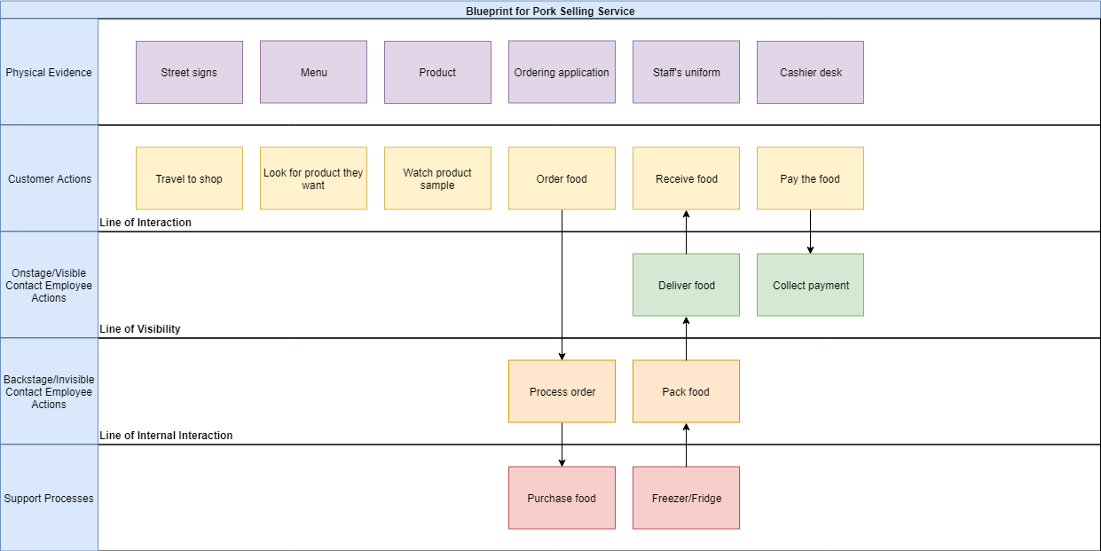

The ordering system is for the customers of Meat Meat Frozen Meat Company Limited. Above is the service blueprint of the ordering system.

First, the physical evidence, customer will first see the shop’s street sign, inside the shop, there are menu, products, ordering application, staff and cashier desk.

Second customer actions, after the customer travel to the shop, they will see a ordering machine running the ordering application, they can choose the food they want and the quantity of the food, they can also have a look of the product sample. After they press the confirm button, An order is created and received, backstage staff will check the stock level of the food. If there are no sufficient stock, the shop will suggest the customer to change the order. If there are sufficient stock, staff will take out the food from the freezer, prepare the food and pack the food, onstage staff will deliver the food to the customer. Customer will then pay the food, on stage staff will collect the payment, an invoice will be printed and give to the customer, the whole ordering process is completed.

**AS-IS vs TO-BE:**

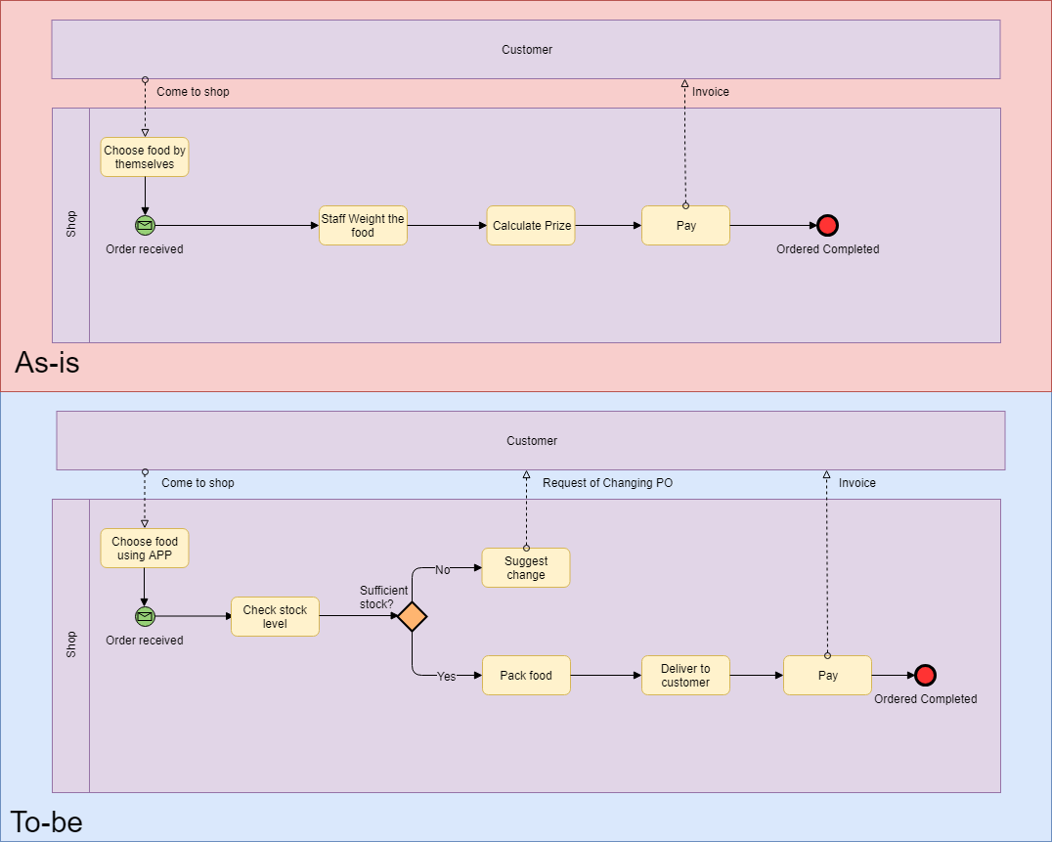

Before using the ordering system(AS-IS)

A customer come to the shop, they choose the food they want by themselves, they bring the food to the cashier desk, the staff will weight the food and calculate the prize. After that, the customer pay and the staff collect the payment, an invoice will be printed and give to the customer, the whole ordering process is completed.

After using the ordering system(TO-BE)

A customer come to the shop, they will see a ordering machine running the ordering application, they can choose the food they want and the quantity of the food, they can also have a look of the product sample. After they press the confirm button, An order is created and received, backstage staff will check the stock level of the food. If there are no sufficient stock, the shop will suggest the customer to change the order. If there are sufficient stock, staff will take out the food from the freezer, prepare the food and pack the food, onstage staff will deliver the food to the customer. Customer will then pay the food, on stage staff will collect the payment, an invoice will be printed and give to the customer, the whole ordering process is completed.

**Process Analysis Diagram:**

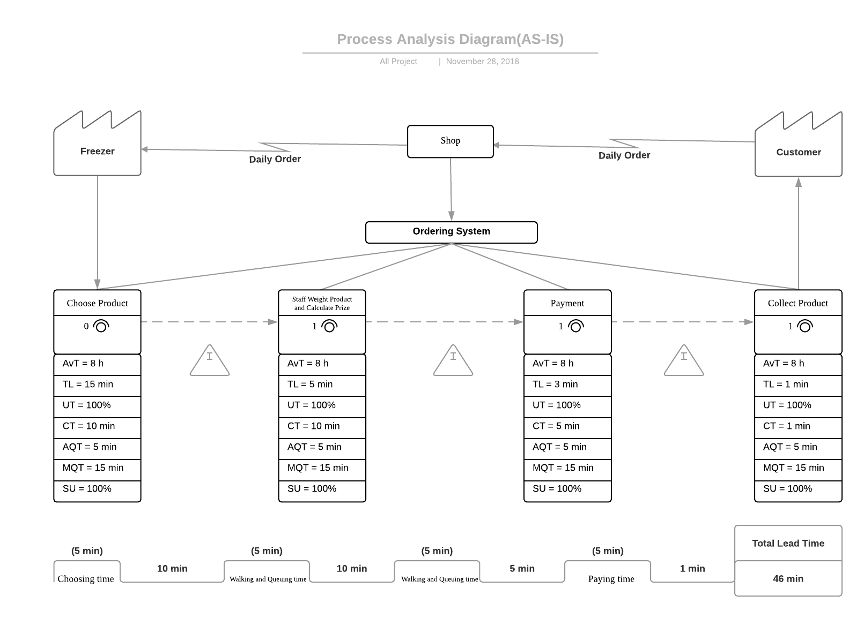

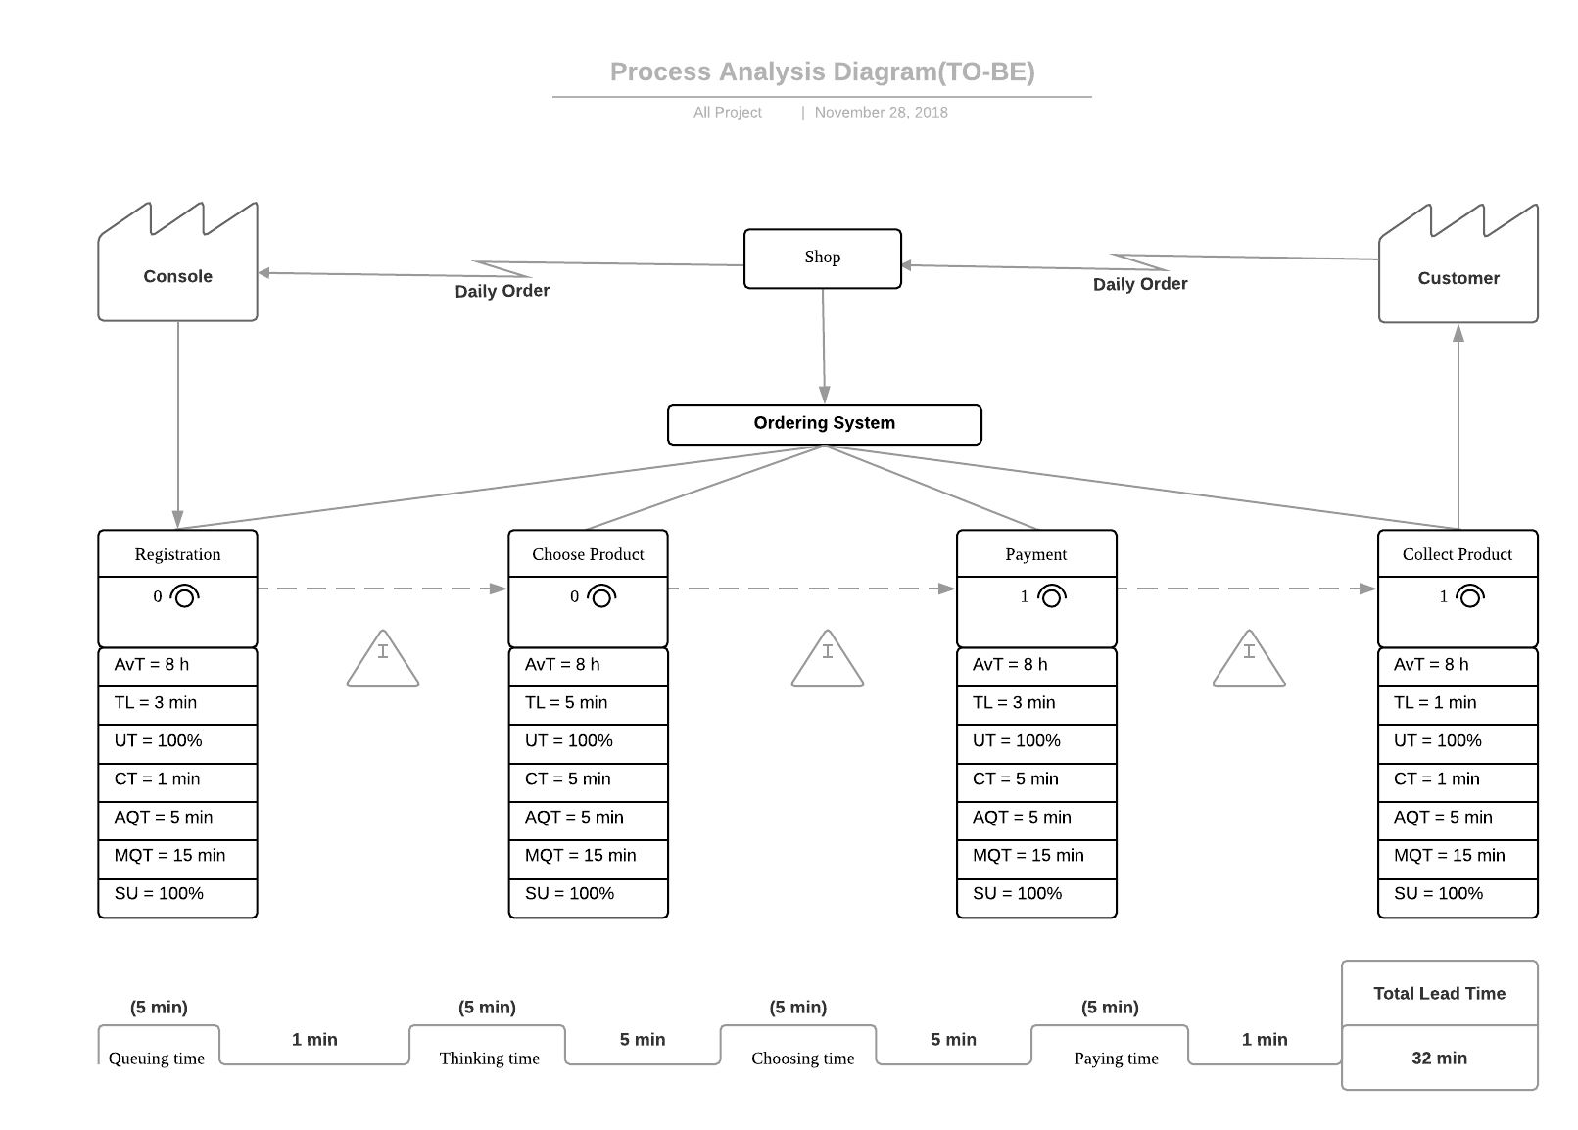

**Process Analysis:**

Before using the ordering system(AS-IS)

|  |  |  |  |  |
| --- | --- | --- | --- | --- |
| Step | Step Name | Processing time | Wait time | Remarks |
| A | Customer come to the shop. |  |  |  |
| B | Customer choose the food they want by themselves. | 10 minutes | 5 minutes |  |
| C | Customer bring the food to the cashier desk. | 5 minutes |  |  |
| D | Staff weight the food and calculate the prize | 10 minutes | 5 minutes |  |
| E | Customer pay the product | 5 minutes | 5 minutes |  |
| F | Customer collect the product | 1 minute | 5 minutes |  |

After using the ordering system(TO-BE)

|  |  |  |  |  |
| --- | --- | --- | --- | --- |
| Step | Step Name | Processing time | Wait time | Remarks |
| A | Customer come to the shop. |  |  |  |
| B | Customer register account for buying product. | 1 minute | 5 minutes |  |
| C | Customer choose product and quantity of product. | 5 minutes | 5 minutes |  |
| D | Customer pay the product. | 5 minutes | 5 minutes |  |
| E | Customer collect the product. | 1 minute | 5 minutes |  |

**Cost Benefit Analysis:**

**Benefits**

* Cost Reduction:

Cost reduction because of saving manpower. Before using the application from Ez Application Company Limited, Meat Meat Frozen Meat Company Limited need a staff to record the order from customer. After using the application, they do not need a staff to record the order since the customer can make order themselves with the application.

* Revenue Increase:

From the process analysis diagram, we can see that before using the application, the total lead time is 46 minutes, after using the application, the total lead time is 32 minutes. The process of buying food become faster and more convenient. There can be more transaction process per one day. Moreover new high-tech system may attract more customer, there will be increase in revenue.

* Quantitative Estimation for the benefits:

1. Labour cost saving due to use of software:

After using the application, they can hire two less cashier clerk, each month: $12,406 x 2 = $24,812

1. Revenue increase due to engagement of more customers and faster transaction process:

After using the application, they attract more customers and more transaction can be done each month: $30,000(estimate)

**Cost**

* The estimated cost for development:

Programming days: 22 days per month

Salary payment: $25,160 per month

Programmers: 5

Total: $25,160 x 5 = $125,800

* The initial cost:

Staff x 120 x $14,560 = $1,747,200 per month

Rent x 20 x $30,000 = $60,000 per month

Utility bills = $200,000 per month

Total: $1,747,200 + $60,000 + $200,000 = $2,007,200

* The running cost:

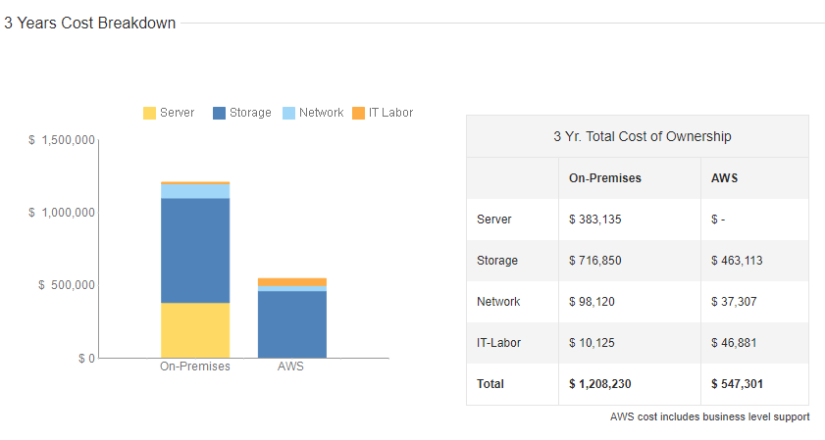

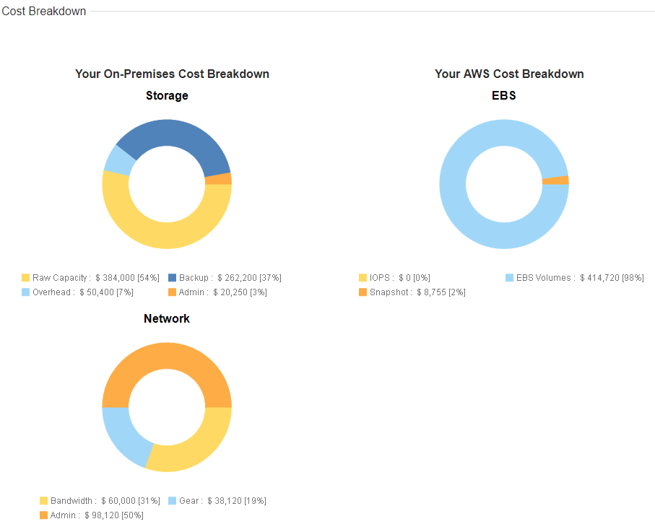

Hardware housed internally vs cloud services:

USD 3 year cost: $1,208,230 vs $547,301

USD 1 year cost: $402,743 vs $182,434

HKD 1 year cost: $3,221,944 vs 1,459,472

HKD 1 month cost: $268,495 vs 121,623

Details of server specifications:

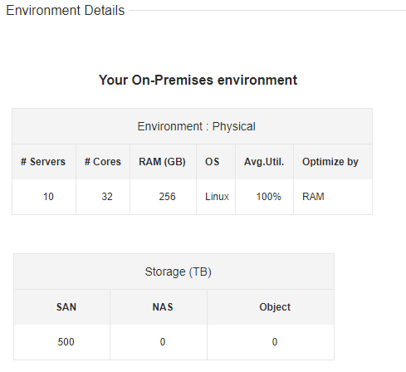

**Payback Period**

* How many years will be take for the benefits matching the cost(Hardware housed internally):

Original benefits per month:

$2,300,000

Additional benefits per month after using application:

$24,812 + $30,000 = $54,812

Total benefits:

$2,300,000 + $54,812 = $2,354,812

Cost per month:

$125,800 + $2,007,200 + $268,495 = $2,401,495

Benefits per year:

$2,354,812 x 12 = $28,257,744

Cost per year:

$2,401,495 x 12 = $28,817,940

Payback period:

$28,817,940/$28,257,744 = 1.0198

1 year for the benefits matching the cost.

* How many years will be take for the benefits matching the cost(Cloud services):

Original benefits per month:

$2,300,000

Additional benefits per month after using application:

$24,812 + $30,000 = $54,812

Total benefits:

$2,300,000 + $54,812 = $2,354,812

Cost per month:

$125,800 + $2,007,200 + $121,623 = $2,254,623

Benefits per year:

$2,354,812 x 12 = $28,257,744

Cost per year:

$2,254,623 x 12 = $27,055,476

Benefits already match the cost.

**Service Catalog:**

|  |  |
| --- | --- |
| Element | Description |
| Service | Meat Selling System |
| Status | PROPOSED |
| Description | Selection of products for customers, order transmission for workers and storage of customers’ consumption record, |
| Standard Service Features | Customers can purchase products with the semi-automate order system.  The order system reduce the process of carrying goods, which produce convenience and hand-free environment for customers.  Because of the system, customers will not have contact with products. Without contact, the quality of goods will not be affected by other external factors – inoperative refrigerator led to not well-closed door, Bacteria thrived as meat thaw accidentally. |
| Optional Service Features | Request a screen for displaying the system  Request a receiver for workers to take order |
| Delivery Scope | Each branch of Meat Meat Frozen Meat Company Limited |
| Delivery Channels | Intranet of Meat Meat Frozen Meat Company Limited |
| Service Hours | Same as the opening hour of stores of Meat Meat Frozen Meat Company Limited |
| User Requirement | A membership (ID and password) |
| Service Initiation | Every branch of Meat Meat Frozen Meat Company Limited |
| Service Support | Every store of Meat Meat Frozen Meat Company Limited  Or the number of Ez Application Company Limited 00000000 |
| Standard Costs | None |
| Service Targets | The time when customers want to consume products  Metrics for successful delivery:   1. Downtime 2. Error reported 3. Time to add new product(s) |

**Service Level Agreement (SLA)**

**for** Meat Meat Frozen Meat Company Limited

**by**

Ez Application Company Limited

**Effective Date: 10-08-2010**

|  |  |
| --- | --- |
| **Document Owner:** | Ez Application Company Limited |

**Version**

|  |  |  |  |
| --- | --- | --- | --- |
| **Version** | **Date** | **Description** | **Author** |
| 1.0 | 08-11-2018 | Service Level Agreement | Jimmy Yip |
| 1.1 | 9-11-2018 | Service Level Agreement Revised | Ryan Mui |
|  |  |  |  |

**Approval**

*(By signing below, all Approvers agree to all terms and conditions outlined in this Agreement.)*

|  |  |  |  |
| --- | --- | --- | --- |
| **Approvers** | **Role** | **Signed** | **Approval Date** |
| Ez application Company Limited | Service Provider |  | 08-11-2018 |
| Meat Meat Frozen Meat Company Limited | Customer |  | 08-11-2018 |

**Table of Contents**

1. Agreement Overview 3

2. Goals & Objectives 3

3. Stakeholders 3

4. Periodic Review 4

5. Service Agreement 4

5.1. Service Scope 4

5.2. Customer Requirements 5

5.3. Service Provider Requirements 5

5.4. Service Assumptions 5

6. Service Management 6

6.1. Service Availability 6

6.2. Service Requests 6

1. **Agreement Overview**

This Agreement represents a Service Level Agreement (“SLA” or “Agreement”) between Ez Application Company Limited. and Meat Meat Frozen Meat Company Limited for the provisioning of IT services required to support and sustain the application

This Agreement remains valid until superseded by a revised agreement mutually endorsed by the stakeholders.

This Agreement outlines the parameters of all IT services covered as they are mutually understood by the primary stakeholders. This Agreement does not supersede current processes and procedures unless explicitly stated herein.

1. **Goals & Objectives**

The **purpose** of this Agreement is to ensure that the proper elements and commitments are in place to provide consistent IT service support and delivery to the Meat Meat Frozen Meat Company Limited by Ez Application Company Limited.

The **goal** of this Agreement is to obtain mutual agreement for IT service provision between the Ez Application Company Limited and Meat Meat Frozen Meat Company Limited.

The **objectives** of this Agreement are to:

* + Provide clear reference to service ownership, accountability, roles and/or responsibilities.
  + Present a clear, concise and measurable description of service provision to the customer.
  + Match perceptions of expected service provision with actual service support & delivery.

1. **Stakeholders**

The following Service Provider(s) and Customer(s) will be used as the basis of the Agreement and represent the **primary** **stakeholders** associated with this SLA:

**IT Service Provider(s):** Ez Application Company Limited (“Provider”)

**IT Customer(s):** Meat Meat Frozen Meat Company Limited (“Customer”)

1. **Periodic Review**

This Agreement is valid from the **Effective Date** outlined herein and is valid until further notice. This Agreement should be reviewed at a minimum once per fiscal year; however, in lieu of a review during any period specified, the current Agreement will remain in effect.

The **Business Relationship Manager** (“Document Owner”) is responsible for facilitating regular reviews of this document. Contents of this document may be amended as required, provided mutual agreement is obtained from the primary stakeholders and communicated to all affected parties. The Document Owner will incorporate all subsequent revisions and obtain mutual agreements / approvals as required.

**Business Relationship Manager:** Ez Application Company Limited

**Review Period:** Bi-Yearly (6 months)

**Previous Review Date:** 01-08-2018

**Next Review Date:** 01-12-2019

1. **Service Agreement**

The following detailed service parameters are the responsibility of Ez Application Company Limited in the ongoing support of this Agreement.

* 1. Service Scope

The following Services are covered by this Agreement;

* + Manned application support
  + Monitored database of ordered products support
  + Further upgrade of the application
  + Planned or Emergency Onsite assistance (extra costs apply)
  + Monthly system health check

* 1. Customer Requirements

Meat Meat Frozen Meat Company Limited responsibilities and/or requirements in support of this Agreement include:

* Payment for all support costs at the agreed interval.
* Reasonable availability of customer representative(s) when resolving a service related incident or request.
  1. Service Provider Requirements

Ez Application Company Limited responsibilities and/or requirements in support of this Agreement include:

* Meeting response times associated with service related incidents.
* Appropriate notification to Customer for all scheduled maintenance.

* 1. Service Assumptions

Assumptions related to in-scope services and/or components include:

* Changes to services will be communicated and documented to all stakeholders.

1. **Service Management**

Effective support of in-scope services is a result of maintaining consistent service levels. The following sections provide relevant details on service availability, monitoring of in-scope services and related components.

* 1. Service Availability

Coverage parameters specific to the service(s) covered in this Agreement are as follows:

* Telephone support : 9:00 A.M. to 5:00 P.M. Monday – Friday
  + Calls received out of office hours will be forwarded to a mobile phone and best efforts will be made to answer / action the call, however there will be a backup answer phone service
* Email support: Monitored 9:00 A.M. to 5:00 P.M. Monday – Friday
  + Emails received outside of office hours will be collected, however no action can be guaranteed until the next working day
* Onsite assistance guaranteed within 72 hours during the business week

* 1. Service Requests

In support of services outlined in this Agreement, the Service Provider will respond to service related incidents and/or requests submitted by the Customer within the following time frames:

* 0-8 hours (during business hours) for issues classified as **High** priority.
* Within 48 hours for issues classified as **Medium** priority.
* Within 5 working days for issues classified as **Low** priority.

Remote assistance will be provided in-line with the above timescales dependent on the priority of the support request.

**SWOT**

|  |  |
| --- | --- |
| **Strength** | **Weaknesses** |
| **The selling system works automatically.**  **Hire less staff to record orders.** | **Regular maintenance is needed**  **Program has to update if new products came out** |
| **Opportunities** | **Threats** |
| **More customers will be attracted since the transaction process is much faster and convenient** | **Company may seen this api as a gimmick, and not use it in long term.**  **Competition this type of api is huge, since many restaurant have there ordering api (Mcdonalds, Kfc or MX)** |