UNIVERSITY OF SAN CARLOS SCHOOL OF ARTS AND SCIENCES

DEPARTMENT OF COMPUTER AND INFORMATION SCIENCES

[Pizza Central Hub]

A CENTRALIZED HUB FOR ORDERING LOCAL PIZZAS ONLINE

FINAL PROJECT OUTPUT

IT 2103

WEB APPLICATIONS DEVELOPMENT & EMERGING TECHNOLOGIES

By:

Burce, Kyle Matthew Laurence C.

Yu, Ridenzel T.

Interview Letters

1. Introduction

**Company Name**: Pizzeria Michelangelo

**Established**:

**Owner**:

**Branches & Locations**

* One Paseo, Paseo Saturnino, Cebu City, 6000 Cebu
* Mantawi Avenue, Tipolo, Mandaue City, 6014 Cebu
* General Maxilom Ave, Cebu City, Cebu

**Industry**: Food Industry **Employees**:

**Company History**

Established in 2012, it was formerly called “Hola Español” until Michel Lhullier bought the company and renamed it to Pizzeria Michelangelo or ‘Michelangelo’s Pizzeria’. It is currently managed by her son, Michael Lhullier and stands on One Paseo, Paseo Saturino Banilad in Cebu City directly beside Henry’s hotel.

**Existing Online Presence**

* [**https://web.facebook.com/PizzeriaMichelangeloPhilippines/?_rdc=1&_rdr**](https://web.facebook.com/PizzeriaMichelangeloPhilippines/?_rdc=1&_rdr)

1. Use Case Diagram

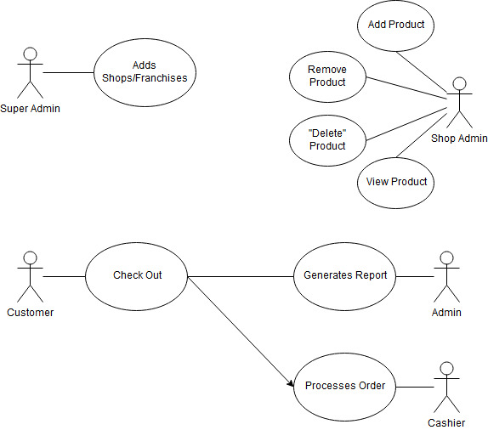

1. Business Process Flow

%3CmxGraphModel%3E%3Croot%3E%3CmxCell%20id%3D%220%22%2F%3E%3CmxCell%20id%3D%221%22%20parent%3D%220%22%2F%3E%3CmxCell%20id%3D%222%22%20value%3D%22%22%20style%3D%22rounded%3D0%3BwhiteSpace%3Dwrap%3Bhtml%3D1%3B%22%20vertex%3D%221%22%20parent%3D%221%22%3E%3CmxGeometry%20x%3D%2220%22%20y%3D%22-80%22%20width%3D%22970%22%20height%3D%22720%22%20as%3D%22geometry%22%2F%3E%3C%2FmxCell%3E%3CmxCell%20id%3D%223%22%20style%3D%22edgeStyle%3DorthogonalEdgeStyle%3Brounded%3D0%3Bhtml%3D1%3BexitX%3D1%3BexitY%3D0.5%3BentryX%3D0%3BentryY%3D0.5%3BjettySize%3Dauto%3BorthogonalLoop%3D1%3B%22%20edge%3D%221%22%20source%3D%224%22%20target%3D%226%22%20parent%3D%221%22%3E%3CmxGeometry%20relative%3D%221%22%20as%3D%22geometry%22%2F%3E%3C%2FmxCell%3E%3CmxCell%20id%3D%224%22%20value%3D%22%22%20style%3D%22ellipse%3BwhiteSpace%3Dwrap%3Bhtml%3D1%3B%22%20vertex%3D%221%22%20parent%3D%221%22%3E%3CmxGeometry%20x%3D%2265%22%20y%3D%22-15%22%20width%3D%2230%22%20height%3D%2230%22%20as%3D%22geometry%22%2F%3E%3C%2FmxCell%3E%3CmxCell%20id%3D%225%22%20style%3D%22edgeStyle%3DorthogonalEdgeStyle%3Brounded%3D0%3Bhtml%3D1%3BexitX%3D1%3BexitY%3D0.5%3BentryX%3D0%3BentryY%3D0.5%3BjettySize%3Dauto%3BorthogonalLoop%3D1%3B%22%20edge%3D%221%22%20source%3D%226%22%20target%3D%228%22%20parent%3D%221%22%3E%3CmxGeometry%20relative%3D%221%22%20as%3D%22geometry%22%2F%3E%3C%2FmxCell%3E%3CmxCell%20id%3D%226%22%20value%3D%22Select%20Brand%22%20style%3D%22shape%3Dprocess%3BwhiteSpace%3Dwrap%3Bhtml%3D1%3BbackgroundOutline%3D1%3B%22%20vertex%3D%221%22%20parent%3D%221%22%3E%3CmxGeometry%20x%3D%22140%22%20y%3D%22-30%22%20width%3D%22120%22%20height%3D%2260%22%20as%3D%22geometry%22%2F%3E%3C%2FmxCell%3E%3CmxCell%20id%3D%227%22%20style%3D%22edgeStyle%3DorthogonalEdgeStyle%3Brounded%3D0%3Bhtml%3D1%3BexitX%3D1%3BexitY%3D0.5%3BentryX%3D0%3BentryY%3D0.5%3BjettySize%3Dauto%3BorthogonalLoop%3D1%3B%22%20edge%3D%221%22%20source%3D%228%22%20target%3D%2210%22%20parent%3D%221%22%3E%3CmxGeometry%20relative%3D%221%22%20as%3D%22geometry%22%2F%3E%3C%2FmxCell%3E%3CmxCell%20id%3D%228%22%20value%3D%22Place%20order%22%20style%3D%22shape%3Dprocess%3BwhiteSpace%3Dwrap%3Bhtml%3D1%3BbackgroundOutline%3D1%3B%22%20vertex%3D%221%22%20parent%3D%221%22%3E%3CmxGeometry%20x%3D%22300%22%20y%3D%22-30%22%20width%3D%22120%22%20height%3D%2260%22%20as%3D%22geometry%22%2F%3E%3C%2FmxCell%3E%3CmxCell%20id%3D%229%22%20style%3D%22edgeStyle%3DorthogonalEdgeStyle%3Brounded%3D0%3Bhtml%3D1%3BexitX%3D1%3BexitY%3D0.5%3BentryX%3D0%3BentryY%3D0.5%3BjettySize%3Dauto%3BorthogonalLoop%3D1%3B%22%20edge%3D%221%22%20source%3D%2210%22%20target%3D%2212%22%20parent%3D%221%22%3E%3CmxGeometry%20relative%3D%221%22%20as%3D%22geometry%22%2F%3E%3C%2FmxCell%3E%3CmxCell%20id%3D%2210%22%20value%3D%22Check%20out%22%20style%3D%22shape%3Dprocess%3BwhiteSpace%3Dwrap%3Bhtml%3D1%3BbackgroundOutline%3D1%3B%22%20vertex%3D%221%22%20parent%3D%221%22%3E%3CmxGeometry%20x%3D%22460%22%20y%3D%22-30%22%20width%3D%22120%22%20height%3D%2260%22%20as%3D%22geometry%22%2F%3E%3C%2FmxCell%3E%3CmxCell%20id%3D%2211%22%20style%3D%22edgeStyle%3DorthogonalEdgeStyle%3Brounded%3D0%3Bhtml%3D1%3BexitX%3D1%3BexitY%3D0.5%3BentryX%3D0.5%3BentryY%3D0%3BjettySize%3Dauto%3BorthogonalLoop%3D1%3B%22%20edge%3D%221%22%20source%3D%2212%22%20target%3D%2216%22%20parent%3D%221%22%3E%3CmxGeometry%20relative%3D%221%22%20as%3D%22geometry%22%2F%3E%3C%2FmxCell%3E%3CmxCell%20id%3D%2212%22%20value%3D%22Order%20Again%3F%22%20style%3D%22rhombus%3BwhiteSpace%3Dwrap%3Bhtml%3D1%3B%22%20vertex%3D%221%22%20parent%3D%221%22%3E%3CmxGeometry%20x%3D%22640%22%20y%3D%22-40%22%20width%3D%2280%22%20height%3D%2280%22%20as%3D%22geometry%22%2F%3E%3C%2FmxCell%3E%3CmxCell%20id%3D%2213%22%20value%3D%22%22%20style%3D%22endArrow%3Dclassic%3Bhtml%3D1%3BentryX%3D0.5%3BentryY%3D1%3BexitX%3D0.5%3BexitY%3D1%3B%22%20edge%3D%221%22%20source%3D%2212%22%20target%3D%226%22%20parent%3D%221%22%3E%3CmxGeometry%20width%3D%2250%22%20height%3D%2250%22%20relative%3D%221%22%20as%3D%22geometry%22%3E%3CmxPoint%20x%3D%22330%22%20y%3D%22220%22%20as%3D%22sourcePoint%22%2F%3E%3CmxPoint%20x%3D%22380%22%20y%3D%22170%22%20as%3D%22targetPoint%22%2F%3E%3CArray%20as%3D%22points%22%3E%3CmxPoint%20x%3D%22680%22%20y%3D%2270%22%2F%3E%3CmxPoint%20x%3D%22440%22%20y%3D%2270%22%2F%3E%3CmxPoint%20x%3D%22200%22%20y%3D%2270%22%2F%3E%3C%2FArray%3E%3C%2FmxGeometry%3E%3C%2FmxCell%3E%3CmxCell%20id%3D%2214%22%20style%3D%22edgeStyle%3DorthogonalEdgeStyle%3Brounded%3D0%3Bhtml%3D1%3BexitX%3D0%3BexitY%3D0.5%3BentryX%3D1%3BentryY%3D0.5%3BjettySize%3Dauto%3BorthogonalLoop%3D1%3B%22%20edge%3D%221%22%20source%3D%2216%22%20target%3D%2217%22%20parent%3D%221%22%3E%3CmxGeometry%20relative%3D%221%22%20as%3D%22geometry%22%2F%3E%3C%2FmxCell%3E%3CmxCell%20id%3D%2215%22%20style%3D%22edgeStyle%3DorthogonalEdgeStyle%3Brounded%3D0%3Bhtml%3D1%3BexitX%3D0.5%3BexitY%3D1%3BjettySize%3Dauto%3BorthogonalLoop%3D1%3B%22%20edge%3D%221%22%20source%3D%2216%22%20target%3D%2223%22%20parent%3D%221%22%3E%3CmxGeometry%20relative%3D%221%22%20as%3D%22geometry%22%2F%3E%3C%2FmxCell%3E%3CmxCell%20id%3D%2216%22%20value%3D%22Collect%20Data%22%20style%3D%22shape%3Dprocess%3BwhiteSpace%3Dwrap%3Bhtml%3D1%3BbackgroundOutline%3D1%3B%22%20vertex%3D%221%22%20parent%3D%221%22%3E%3CmxGeometry%20x%3D%22720%22%20y%3D%22190%22%20width%3D%22120%22%20height%3D%2260%22%20as%3D%22geometry%22%2F%3E%3C%2FmxCell%3E%3CmxCell%20id%3D%2217%22%20value%3D%22Stores%20Data%22%20style%3D%22shape%3Dprocess%3BwhiteSpace%3Dwrap%3Bhtml%3D1%3BbackgroundOutline%3D1%3B%22%20vertex%3D%221%22%20parent%3D%221%22%3E%3CmxGeometry%20x%3D%22540%22%20y%3D%22190%22%20width%3D%22120%22%20height%3D%2260%22%20as%3D%22geometry%22%2F%3E%3C%2FmxCell%3E%3CmxCell%20id%3D%2218%22%20value%3D%22Customer%22%20style%3D%22text%3Bhtml%3D1%3BstrokeColor%3Dnone%3BfillColor%3Dnone%3Balign%3Dcenter%3BverticalAlign%3Dmiddle%3BwhiteSpace%3Dwrap%3Brounded%3D0%3B%22%20vertex%3D%221%22%20parent%3D%221%22%3E%3CmxGeometry%20x%3D%2220%22%20y%3D%22-80%22%20width%3D%2260%22%20height%3D%2220%22%20as%3D%22geometry%22%2F%3E%3C%2FmxCell%3E%3CmxCell%20id%3D%2219%22%20value%3D%22System%20Admins%22%20style%3D%22text%3Bhtml%3D1%3BstrokeColor%3Dnone%3BfillColor%3Dnone%3Balign%3Dcenter%3BverticalAlign%3Dmiddle%3BwhiteSpace%3Dwrap%3Brounded%3D0%3B%22%20vertex%3D%221%22%20parent%3D%221%22%3E%3CmxGeometry%20x%3D%2225%22%20y%3D%22160%22%20width%3D%2240%22%20height%3D%2220%22%20as%3D%22geometry%22%2F%3E%3C%2FmxCell%3E%3CmxCell%20id%3D%2220%22%20value%3D%22%22%20style%3D%22endArrow%3Dnone%3Bhtml%3D1%3B%22%20edge%3D%221%22%20source%3D%222%22%20parent%3D%221%22%3E%3CmxGeometry%20width%3D%2250%22%20height%3D%2250%22%20relative%3D%221%22%20as%3D%22geometry%22%3E%3CmxPoint%20x%3D%22160%22%20y%3D%22330%22%20as%3D%22sourcePoint%22%2F%3E%3CmxPoint%20x%3D%2220%22%20y%3D%22280%22%20as%3D%22targetPoint%22%2F%3E%3C%2FmxGeometry%3E%3C%2FmxCell%3E%3CmxCell%20id%3D%2221%22%20value%3D%22Cashier%22%20style%3D%22text%3Bhtml%3D1%3BstrokeColor%3Dnone%3BfillColor%3Dnone%3Balign%3Dcenter%3BverticalAlign%3Dmiddle%3BwhiteSpace%3Dwrap%3Brounded%3D0%3B%22%20vertex%3D%221%22%20parent%3D%221%22%3E%3CmxGeometry%20x%3D%2225%22%20y%3D%22280%22%20width%3D%2240%22%20height%3D%2220%22%20as%3D%22geometry%22%2F%3E%3C%2FmxCell%3E%3CmxCell%20id%3D%2222%22%20style%3D%22edgeStyle%3DorthogonalEdgeStyle%3Brounded%3D0%3Bhtml%3D1%3BexitX%3D0.5%3BexitY%3D1%3BentryX%3D0.5%3BentryY%3D0%3BjettySize%3Dauto%3BorthogonalLoop%3D1%3B%22%20edge%3D%221%22%20source%3D%2223%22%20target%3D%2229%22%20parent%3D%221%22%3E%3CmxGeometry%20relative%3D%221%22%20as%3D%22geometry%22%2F%3E%3C%2FmxCell%3E%3CmxCell%20id%3D%2223%22%20value%3D%22Process%20Order%22%20style%3D%22shape%3Dprocess%3BwhiteSpace%3Dwrap%3Bhtml%3D1%3BbackgroundOutline%3D1%3B%22%20vertex%3D%221%22%20parent%3D%221%22%3E%3CmxGeometry%20x%3D%22720%22%20y%3D%22300%22%20width%3D%22120%22%20height%3D%2260%22%20as%3D%22geometry%22%2F%3E%3C%2FmxCell%3E%3CmxCell%20id%3D%2224%22%20value%3D%22%22%20style%3D%22endArrow%3Dnone%3Bhtml%3D1%3BexitX%3D0%3BexitY%3D0.25%3BentryX%3D1%3BentryY%3D0.25%3B%22%20edge%3D%221%22%20source%3D%222%22%20target%3D%222%22%20parent%3D%221%22%3E%3CmxGeometry%20width%3D%2250%22%20height%3D%2250%22%20relative%3D%221%22%20as%3D%22geometry%22%3E%3CmxPoint%20x%3D%22430%22%20y%3D%22330%22%20as%3D%22sourcePoint%22%2F%3E%3CmxPoint%20x%3D%22993%22%20y%3D%22271%22%20as%3D%22targetPoint%22%2F%3E%3C%2FmxGeometry%3E%3C%2FmxCell%3E%3CmxCell%20id%3D%2225%22%20value%3D%22%22%20style%3D%22endArrow%3Dnone%3Bhtml%3D1%3BentryX%3D1%3BentryY%3D0.5%3BexitX%3D0%3BexitY%3D0.5%3B%22%20edge%3D%221%22%20source%3D%222%22%20target%3D%222%22%20parent%3D%221%22%3E%3CmxGeometry%20width%3D%2250%22%20height%3D%2250%22%20relative%3D%221%22%20as%3D%22geometry%22%3E%3CmxPoint%20x%3D%2220%22%20y%3D%22380%22%20as%3D%22sourcePoint%22%2F%3E%3CmxPoint%20x%3D%22200%22%20y%3D%22430%22%20as%3D%22targetPoint%22%2F%3E%3C%2FmxGeometry%3E%3C%2FmxCell%3E%3CmxCell%20id%3D%2226%22%20value%3D%22Kitchen%22%20style%3D%22text%3Bhtml%3D1%3BstrokeColor%3Dnone%3BfillColor%3Dnone%3Balign%3Dcenter%3BverticalAlign%3Dmiddle%3BwhiteSpace%3Dwrap%3Brounded%3D0%3B%22%20vertex%3D%221%22%20parent%3D%221%22%3E%3CmxGeometry%20x%3D%2230%22%20y%3D%22390%22%20width%3D%2240%22%20height%3D%2220%22%20as%3D%22geometry%22%2F%3E%3C%2FmxCell%3E%3CmxCell%20id%3D%2227%22%20value%3D%22%22%20style%3D%22endArrow%3Dnone%3Bhtml%3D1%3BexitX%3D0%3BexitY%3D0.647%3BexitPerimeter%3D0%3BentryX%3D1.004%3BentryY%3D0.649%3BentryPerimeter%3D0%3B%22%20edge%3D%221%22%20source%3D%222%22%20target%3D%222%22%20parent%3D%221%22%3E%3CmxGeometry%20width%3D%2250%22%20height%3D%2250%22%20relative%3D%221%22%20as%3D%22geometry%22%3E%3CmxPoint%20x%3D%22120%22%20y%3D%22560%22%20as%3D%22sourcePoint%22%2F%3E%3CmxPoint%20x%3D%22170%22%20y%3D%22510%22%20as%3D%22targetPoint%22%2F%3E%3C%2FmxGeometry%3E%3C%2FmxCell%3E%3CmxCell%20id%3D%2228%22%20style%3D%22edgeStyle%3DorthogonalEdgeStyle%3Brounded%3D0%3Bhtml%3D1%3BexitX%3D0.5%3BexitY%3D1%3BentryX%3D0.5%3BentryY%3D0%3BjettySize%3Dauto%3BorthogonalLoop%3D1%3B%22%20edge%3D%221%22%20source%3D%2229%22%20target%3D%2232%22%20parent%3D%221%22%3E%3CmxGeometry%20relative%3D%221%22%20as%3D%22geometry%22%2F%3E%3C%2FmxCell%3E%3CmxCell%20id%3D%2229%22%20value%3D%22Cooks%20Order%22%20style%3D%22shape%3Dprocess%3BwhiteSpace%3Dwrap%3Bhtml%3D1%3BbackgroundOutline%3D1%3B%22%20vertex%3D%221%22%20parent%3D%221%22%3E%3CmxGeometry%20x%3D%22720%22%20y%3D%22410%22%20width%3D%22120%22%20height%3D%2260%22%20as%3D%22geometry%22%2F%3E%3C%2FmxCell%3E%3CmxCell%20id%3D%2230%22%20value%3D%22Delivery%22%20style%3D%22text%3Bhtml%3D1%3BstrokeColor%3Dnone%3BfillColor%3Dnone%3Balign%3Dcenter%3BverticalAlign%3Dmiddle%3BwhiteSpace%3Dwrap%3Brounded%3D0%3B%22%20vertex%3D%221%22%20parent%3D%221%22%3E%3CmxGeometry%20x%3D%2225%22%20y%3D%22510%22%20width%3D%2240%22%20height%3D%2220%22%20as%3D%22geometry%22%2F%3E%3C%2FmxCell%3E%3CmxCell%20id%3D%2231%22%20style%3D%22edgeStyle%3DorthogonalEdgeStyle%3Brounded%3D0%3Bhtml%3D1%3BexitX%3D0%3BexitY%3D0.5%3BentryX%3D1%3BentryY%3D0.5%3BjettySize%3Dauto%3BorthogonalLoop%3D1%3B%22%20edge%3D%221%22%20source%3D%2232%22%20target%3D%2234%22%20parent%3D%221%22%3E%3CmxGeometry%20relative%3D%221%22%20as%3D%22geometry%22%2F%3E%3C%2FmxCell%3E%3CmxCell%20id%3D%2232%22%20value%3D%22Delivers%20Product%22%20style%3D%22shape%3Dprocess%3BwhiteSpace%3Dwrap%3Bhtml%3D1%3BbackgroundOutline%3D1%3B%22%20vertex%3D%221%22%20parent%3D%221%22%3E%3CmxGeometry%20x%3D%22720%22%20y%3D%22540%22%20width%3D%22120%22%20height%3D%2260%22%20as%3D%22geometry%22%2F%3E%3C%2FmxCell%3E%3CmxCell%20id%3D%2233%22%20style%3D%22edgeStyle%3DorthogonalEdgeStyle%3Brounded%3D0%3Bhtml%3D1%3BexitX%3D0%3BexitY%3D0.5%3BentryX%3D1%3BentryY%3D0.5%3BjettySize%3Dauto%3BorthogonalLoop%3D1%3B%22%20edge%3D%221%22%20source%3D%2234%22%20target%3D%2235%22%20parent%3D%221%22%3E%3CmxGeometry%20relative%3D%221%22%20as%3D%22geometry%22%2F%3E%3C%2FmxCell%3E%3CmxCell%20id%3D%2234%22%20value%3D%22Gets%20Payment%22%20style%3D%22shape%3Dprocess%3BwhiteSpace%3Dwrap%3Bhtml%3D1%3BbackgroundOutline%3D1%3B%22%20vertex%3D%221%22%20parent%3D%221%22%3E%3CmxGeometry%20x%3D%22520%22%20y%3D%22540%22%20width%3D%22120%22%20height%3D%2260%22%20as%3D%22geometry%22%2F%3E%3C%2FmxCell%3E%3CmxCell%20id%3D%2235%22%20value%3D%22%22%20style%3D%22ellipse%3BwhiteSpace%3Dwrap%3Bhtml%3D1%3B%22%20vertex%3D%221%22%20parent%3D%221%22%3E%3CmxGeometry%20x%3D%22410%22%20y%3D%22555%22%20width%3D%2230%22%20height%3D%2230%22%20as%3D%22geometry%22%2F%3E%3C%2FmxCell%3E%3CmxCell%20id%3D%2236%22%20value%3D%22%22%20style%3D%22endArrow%3Dnone%3Bhtml%3D1%3BexitX%3D0.002%3BexitY%3D0.803%3BentryX%3D1.003%3BentryY%3D0.797%3BentryPerimeter%3D0%3BexitPerimeter%3D0%3B%22%20edge%3D%221%22%20source%3D%222%22%20target%3D%222%22%20parent%3D%221%22%3E%3CmxGeometry%20width%3D%2250%22%20height%3D%2250%22%20relative%3D%221%22%20as%3D%22geometry%22%3E%3CmxPoint%20x%3D%22300%22%20y%3D%22500%22%20as%3D%22sourcePoint%22%2F%3E%3CmxPoint%20x%3D%22350%22%20y%3D%22450%22%20as%3D%22targetPoint%22%2F%3E%3C%2FmxGeometry%3E%3C%2FmxCell%3E%3C%2Froot%3E%3C%2FmxGraphModel%3E

%3CmxGraphModel%3E%3Croot%3E%3CmxCell%20id%3D%220%22%2F%3E%3CmxCell%20id%3D%221%22%20parent%3D%220%22%2F%3E%3CmxCell%20id%3D%222%22%20value%3D%22%22%20style%3D%22rounded%3D0%3BwhiteSpace%3Dwrap%3Bhtml%3D1%3B%22%20vertex%3D%221%22%20parent%3D%221%22%3E%3CmxGeometry%20x%3D%2220%22%20y%3D%22-80%22%20width%3D%22970%22%20height%3D%22720%22%20as%3D%22geometry%22%2F%3E%3C%2FmxCell%3E%3CmxCell%20id%3D%223%22%20style%3D%22edgeStyle%3DorthogonalEdgeStyle%3Brounded%3D0%3Bhtml%3D1%3BexitX%3D1%3BexitY%3D0.5%3BentryX%3D0%3BentryY%3D0.5%3BjettySize%3Dauto%3BorthogonalLoop%3D1%3B%22%20edge%3D%221%22%20source%3D%224%22%20target%3D%226%22%20parent%3D%221%22%3E%3CmxGeometry%20relative%3D%221%22%20as%3D%22geometry%22%2F%3E%3C%2FmxCell%3E%3CmxCell%20id%3D%224%22%20value%3D%22%22%20style%3D%22ellipse%3BwhiteSpace%3Dwrap%3Bhtml%3D1%3B%22%20vertex%3D%221%22%20parent%3D%221%22%3E%3CmxGeometry%20x%3D%2265%22%20y%3D%22-15%22%20width%3D%2230%22%20height%3D%2230%22%20as%3D%22geometry%22%2F%3E%3C%2FmxCell%3E%3CmxCell%20id%3D%225%22%20style%3D%22edgeStyle%3DorthogonalEdgeStyle%3Brounded%3D0%3Bhtml%3D1%3BexitX%3D1%3BexitY%3D0.5%3BentryX%3D0%3BentryY%3D0.5%3BjettySize%3Dauto%3BorthogonalLoop%3D1%3B%22%20edge%3D%221%22%20source%3D%226%22%20target%3D%228%22%20parent%3D%221%22%3E%3CmxGeometry%20relative%3D%221%22%20as%3D%22geometry%22%2F%3E%3C%2FmxCell%3E%3CmxCell%20id%3D%226%22%20value%3D%22Select%20Brand%22%20style%3D%22shape%3Dprocess%3BwhiteSpace%3Dwrap%3Bhtml%3D1%3BbackgroundOutline%3D1%3B%22%20vertex%3D%221%22%20parent%3D%221%22%3E%3CmxGeometry%20x%3D%22140%22%20y%3D%22-30%22%20width%3D%22120%22%20height%3D%2260%22%20as%3D%22geometry%22%2F%3E%3C%2FmxCell%3E%3CmxCell%20id%3D%227%22%20style%3D%22edgeStyle%3DorthogonalEdgeStyle%3Brounded%3D0%3Bhtml%3D1%3BexitX%3D1%3BexitY%3D0.5%3BentryX%3D0%3BentryY%3D0.5%3BjettySize%3Dauto%3BorthogonalLoop%3D1%3B%22%20edge%3D%221%22%20source%3D%228%22%20target%3D%2210%22%20parent%3D%221%22%3E%3CmxGeometry%20relative%3D%221%22%20as%3D%22geometry%22%2F%3E%3C%2FmxCell%3E%3CmxCell%20id%3D%228%22%20value%3D%22Place%20order%22%20style%3D%22shape%3Dprocess%3BwhiteSpace%3Dwrap%3Bhtml%3D1%3BbackgroundOutline%3D1%3B%22%20vertex%3D%221%22%20parent%3D%221%22%3E%3CmxGeometry%20x%3D%22300%22%20y%3D%22-30%22%20width%3D%22120%22%20height%3D%2260%22%20as%3D%22geometry%22%2F%3E%3C%2FmxCell%3E%3CmxCell%20id%3D%229%22%20style%3D%22edgeStyle%3DorthogonalEdgeStyle%3Brounded%3D0%3Bhtml%3D1%3BexitX%3D1%3BexitY%3D0.5%3BentryX%3D0%3BentryY%3D0.5%3BjettySize%3Dauto%3BorthogonalLoop%3D1%3B%22%20edge%3D%221%22%20source%3D%2210%22%20target%3D%2212%22%20parent%3D%221%22%3E%3CmxGeometry%20relative%3D%221%22%20as%3D%22geometry%22%2F%3E%3C%2FmxCell%3E%3CmxCell%20id%3D%2210%22%20value%3D%22Check%20out%22%20style%3D%22shape%3Dprocess%3BwhiteSpace%3Dwrap%3Bhtml%3D1%3BbackgroundOutline%3D1%3B%22%20vertex%3D%221%22%20parent%3D%221%22%3E%3CmxGeometry%20x%3D%22460%22%20y%3D%22-30%22%20width%3D%22120%22%20height%3D%2260%22%20as%3D%22geometry%22%2F%3E%3C%2FmxCell%3E%3CmxCell%20id%3D%2211%22%20style%3D%22edgeStyle%3DorthogonalEdgeStyle%3Brounded%3D0%3Bhtml%3D1%3BexitX%3D1%3BexitY%3D0.5%3BentryX%3D0.5%3BentryY%3D0%3BjettySize%3Dauto%3BorthogonalLoop%3D1%3B%22%20edge%3D%221%22%20source%3D%2212%22%20target%3D%2216%22%20parent%3D%221%22%3E%3CmxGeometry%20relative%3D%221%22%20as%3D%22geometry%22%2F%3E%3C%2FmxCell%3E%3CmxCell%20id%3D%2212%22%20value%3D%22Order%20Again%3F%22%20style%3D%22rhombus%3BwhiteSpace%3Dwrap%3Bhtml%3D1%3B%22%20vertex%3D%221%22%20parent%3D%221%22%3E%3CmxGeometry%20x%3D%22640%22%20y%3D%22-40%22%20width%3D%2280%22%20height%3D%2280%22%20as%3D%22geometry%22%2F%3E%3C%2FmxCell%3E%3CmxCell%20id%3D%2213%22%20value%3D%22%22%20style%3D%22endArrow%3Dclassic%3Bhtml%3D1%3BentryX%3D0.5%3BentryY%3D1%3BexitX%3D0.5%3BexitY%3D1%3B%22%20edge%3D%221%22%20source%3D%2212%22%20target%3D%226%22%20parent%3D%221%22%3E%3CmxGeometry%20width%3D%2250%22%20height%3D%2250%22%20relative%3D%221%22%20as%3D%22geometry%22%3E%3CmxPoint%20x%3D%22330%22%20y%3D%22220%22%20as%3D%22sourcePoint%22%2F%3E%3CmxPoint%20x%3D%22380%22%20y%3D%22170%22%20as%3D%22targetPoint%22%2F%3E%3CArray%20as%3D%22points%22%3E%3CmxPoint%20x%3D%22680%22%20y%3D%2270%22%2F%3E%3CmxPoint%20x%3D%22440%22%20y%3D%2270%22%2F%3E%3CmxPoint%20x%3D%22200%22%20y%3D%2270%22%2F%3E%3C%2FArray%3E%3C%2FmxGeometry%3E%3C%2FmxCell%3E%3CmxCell%20id%3D%2214%22%20style%3D%22edgeStyle%3DorthogonalEdgeStyle%3Brounded%3D0%3Bhtml%3D1%3BexitX%3D0%3BexitY%3D0.5%3BentryX%3D1%3BentryY%3D0.5%3BjettySize%3Dauto%3BorthogonalLoop%3D1%3B%22%20edge%3D%221%22%20source%3D%2216%22%20target%3D%2217%22%20parent%3D%221%22%3E%3CmxGeometry%20relative%3D%221%22%20as%3D%22geometry%22%2F%3E%3C%2FmxCell%3E%3CmxCell%20id%3D%2215%22%20style%3D%22edgeStyle%3DorthogonalEdgeStyle%3Brounded%3D0%3Bhtml%3D1%3BexitX%3D0.5%3BexitY%3D1%3BjettySize%3Dauto%3BorthogonalLoop%3D1%3B%22%20edge%3D%221%22%20source%3D%2216%22%20target%3D%2223%22%20parent%3D%221%22%3E%3CmxGeometry%20relative%3D%221%22%20as%3D%22geometry%22%2F%3E%3C%2FmxCell%3E%3CmxCell%20id%3D%2216%22%20value%3D%22Collect%20Data%22%20style%3D%22shape%3Dprocess%3BwhiteSpace%3Dwrap%3Bhtml%3D1%3BbackgroundOutline%3D1%3B%22%20vertex%3D%221%22%20parent%3D%221%22%3E%3CmxGeometry%20x%3D%22720%22%20y%3D%22190%22%20width%3D%22120%22%20height%3D%2260%22%20as%3D%22geometry%22%2F%3E%3C%2FmxCell%3E%3CmxCell%20id%3D%2217%22%20value%3D%22Stores%20Data%22%20style%3D%22shape%3Dprocess%3BwhiteSpace%3Dwrap%3Bhtml%3D1%3BbackgroundOutline%3D1%3B%22%20vertex%3D%221%22%20parent%3D%221%22%3E%3CmxGeometry%20x%3D%22540%22%20y%3D%22190%22%20width%3D%22120%22%20height%3D%2260%22%20as%3D%22geometry%22%2F%3E%3C%2FmxCell%3E%3CmxCell%20id%3D%2218%22%20value%3D%22Customer%22%20style%3D%22text%3Bhtml%3D1%3BstrokeColor%3Dnone%3BfillColor%3Dnone%3Balign%3Dcenter%3BverticalAlign%3Dmiddle%3BwhiteSpace%3Dwrap%3Brounded%3D0%3B%22%20vertex%3D%221%22%20parent%3D%221%22%3E%3CmxGeometry%20x%3D%2220%22%20y%3D%22-80%22%20width%3D%2260%22%20height%3D%2220%22%20as%3D%22geometry%22%2F%3E%3C%2FmxCell%3E%3CmxCell%20id%3D%2219%22%20value%3D%22System%20Admins%22%20style%3D%22text%3Bhtml%3D1%3BstrokeColor%3Dnone%3BfillColor%3Dnone%3Balign%3Dcenter%3BverticalAlign%3Dmiddle%3BwhiteSpace%3Dwrap%3Brounded%3D0%3B%22%20vertex%3D%221%22%20parent%3D%221%22%3E%3CmxGeometry%20x%3D%2225%22%20y%3D%22160%22%20width%3D%2240%22%20height%3D%2220%22%20as%3D%22geometry%22%2F%3E%3C%2FmxCell%3E%3CmxCell%20id%3D%2220%22%20value%3D%22%22%20style%3D%22endArrow%3Dnone%3Bhtml%3D1%3B%22%20edge%3D%221%22%20source%3D%222%22%20parent%3D%221%22%3E%3CmxGeometry%20width%3D%2250%22%20height%3D%2250%22%20relative%3D%221%22%20as%3D%22geometry%22%3E%3CmxPoint%20x%3D%22160%22%20y%3D%22330%22%20as%3D%22sourcePoint%22%2F%3E%3CmxPoint%20x%3D%2220%22%20y%3D%22280%22%20as%3D%22targetPoint%22%2F%3E%3C%2FmxGeometry%3E%3C%2FmxCell%3E%3CmxCell%20id%3D%2221%22%20value%3D%22Cashier%22%20style%3D%22text%3Bhtml%3D1%3BstrokeColor%3Dnone%3BfillColor%3Dnone%3Balign%3Dcenter%3BverticalAlign%3Dmiddle%3BwhiteSpace%3Dwrap%3Brounded%3D0%3B%22%20vertex%3D%221%22%20parent%3D%221%22%3E%3CmxGeometry%20x%3D%2225%22%20y%3D%22280%22%20width%3D%2240%22%20height%3D%2220%22%20as%3D%22geometry%22%2F%3E%3C%2FmxCell%3E%3CmxCell%20id%3D%2222%22%20style%3D%22edgeStyle%3DorthogonalEdgeStyle%3Brounded%3D0%3Bhtml%3D1%3BexitX%3D0.5%3BexitY%3D1%3BentryX%3D0.5%3BentryY%3D0%3BjettySize%3Dauto%3BorthogonalLoop%3D1%3B%22%20edge%3D%221%22%20source%3D%2223%22%20target%3D%2229%22%20parent%3D%221%22%3E%3CmxGeometry%20relative%3D%221%22%20as%3D%22geometry%22%2F%3E%3C%2FmxCell%3E%3CmxCell%20id%3D%2223%22%20value%3D%22Process%20Order%22%20style%3D%22shape%3Dprocess%3BwhiteSpace%3Dwrap%3Bhtml%3D1%3BbackgroundOutline%3D1%3B%22%20vertex%3D%221%22%20parent%3D%221%22%3E%3CmxGeometry%20x%3D%22720%22%20y%3D%22300%22%20width%3D%22120%22%20height%3D%2260%22%20as%3D%22geometry%22%2F%3E%3C%2FmxCell%3E%3CmxCell%20id%3D%2224%22%20value%3D%22%22%20style%3D%22endArrow%3Dnone%3Bhtml%3D1%3BexitX%3D0%3BexitY%3D0.25%3BentryX%3D1%3BentryY%3D0.25%3B%22%20edge%3D%221%22%20source%3D%222%22%20target%3D%222%22%20parent%3D%221%22%3E%3CmxGeometry%20width%3D%2250%22%20height%3D%2250%22%20relative%3D%221%22%20as%3D%22geometry%22%3E%3CmxPoint%20x%3D%22430%22%20y%3D%22330%22%20as%3D%22sourcePoint%22%2F%3E%3CmxPoint%20x%3D%22993%22%20y%3D%22271%22%20as%3D%22targetPoint%22%2F%3E%3C%2FmxGeometry%3E%3C%2FmxCell%3E%3CmxCell%20id%3D%2225%22%20value%3D%22%22%20style%3D%22endArrow%3Dnone%3Bhtml%3D1%3BentryX%3D1%3BentryY%3D0.5%3BexitX%3D0%3BexitY%3D0.5%3B%22%20edge%3D%221%22%20source%3D%222%22%20target%3D%222%22%20parent%3D%221%22%3E%3CmxGeometry%20width%3D%2250%22%20height%3D%2250%22%20relative%3D%221%22%20as%3D%22geometry%22%3E%3CmxPoint%20x%3D%2220%22%20y%3D%22380%22%20as%3D%22sourcePoint%22%2F%3E%3CmxPoint%20x%3D%22200%22%20y%3D%22430%22%20as%3D%22targetPoint%22%2F%3E%3C%2FmxGeometry%3E%3C%2FmxCell%3E%3CmxCell%20id%3D%2226%22%20value%3D%22Kitchen%22%20style%3D%22text%3Bhtml%3D1%3BstrokeColor%3Dnone%3BfillColor%3Dnone%3Balign%3Dcenter%3BverticalAlign%3Dmiddle%3BwhiteSpace%3Dwrap%3Brounded%3D0%3B%22%20vertex%3D%221%22%20parent%3D%221%22%3E%3CmxGeometry%20x%3D%2230%22%20y%3D%22390%22%20width%3D%2240%22%20height%3D%2220%22%20as%3D%22geometry%22%2F%3E%3C%2FmxCell%3E%3CmxCell%20id%3D%2227%22%20value%3D%22%22%20style%3D%22endArrow%3Dnone%3Bhtml%3D1%3BexitX%3D0%3BexitY%3D0.647%3BexitPerimeter%3D0%3BentryX%3D1.004%3BentryY%3D0.649%3BentryPerimeter%3D0%3B%22%20edge%3D%221%22%20source%3D%222%22%20target%3D%222%22%20parent%3D%221%22%3E%3CmxGeometry%20width%3D%2250%22%20height%3D%2250%22%20relative%3D%221%22%20as%3D%22geometry%22%3E%3CmxPoint%20x%3D%22120%22%20y%3D%22560%22%20as%3D%22sourcePoint%22%2F%3E%3CmxPoint%20x%3D%22170%22%20y%3D%22510%22%20as%3D%22targetPoint%22%2F%3E%3C%2FmxGeometry%3E%3C%2FmxCell%3E%3CmxCell%20id%3D%2228%22%20style%3D%22edgeStyle%3DorthogonalEdgeStyle%3Brounded%3D0%3Bhtml%3D1%3BexitX%3D0.5%3BexitY%3D1%3BentryX%3D0.5%3BentryY%3D0%3BjettySize%3Dauto%3BorthogonalLoop%3D1%3B%22%20edge%3D%221%22%20source%3D%2229%22%20target%3D%2232%22%20parent%3D%221%22%3E%3CmxGeometry%20relative%3D%221%22%20as%3D%22geometry%22%2F%3E%3C%2FmxCell%3E%3CmxCell%20id%3D%2229%22%20value%3D%22Cooks%20Order%22%20style%3D%22shape%3Dprocess%3BwhiteSpace%3Dwrap%3Bhtml%3D1%3BbackgroundOutline%3D1%3B%22%20vertex%3D%221%22%20parent%3D%221%22%3E%3CmxGeometry%20x%3D%22720%22%20y%3D%22410%22%20width%3D%22120%22%20height%3D%2260%22%20as%3D%22geometry%22%2F%3E%3C%2FmxCell%3E%3CmxCell%20id%3D%2230%22%20value%3D%22Delivery%22%20style%3D%22text%3Bhtml%3D1%3BstrokeColor%3Dnone%3BfillColor%3Dnone%3Balign%3Dcenter%3BverticalAlign%3Dmiddle%3BwhiteSpace%3Dwrap%3Brounded%3D0%3B%22%20vertex%3D%221%22%20parent%3D%221%22%3E%3CmxGeometry%20x%3D%2225%22%20y%3D%22510%22%20width%3D%2240%22%20height%3D%2220%22%20as%3D%22geometry%22%2F%3E%3C%2FmxCell%3E%3CmxCell%20id%3D%2231%22%20style%3D%22edgeStyle%3DorthogonalEdgeStyle%3Brounded%3D0%3Bhtml%3D1%3BexitX%3D0%3BexitY%3D0.5%3BentryX%3D1%3BentryY%3D0.5%3BjettySize%3Dauto%3BorthogonalLoop%3D1%3B%22%20edge%3D%221%22%20source%3D%2232%22%20target%3D%2234%22%20parent%3D%221%22%3E%3CmxGeometry%20relative%3D%221%22%20as%3D%22geometry%22%2F%3E%3C%2FmxCell%3E%3CmxCell%20id%3D%2232%22%20value%3D%22Delivers%20Product%22%20style%3D%22shape%3Dprocess%3BwhiteSpace%3Dwrap%3Bhtml%3D1%3BbackgroundOutline%3D1%3B%22%20vertex%3D%221%22%20parent%3D%221%22%3E%3CmxGeometry%20x%3D%22720%22%20y%3D%22540%22%20width%3D%22120%22%20height%3D%2260%22%20as%3D%22geometry%22%2F%3E%3C%2FmxCell%3E%3CmxCell%20id%3D%2233%22%20style%3D%22edgeStyle%3DorthogonalEdgeStyle%3Brounded%3D0%3Bhtml%3D1%3BexitX%3D0%3BexitY%3D0.5%3BentryX%3D1%3BentryY%3D0.5%3BjettySize%3Dauto%3BorthogonalLoop%3D1%3B%22%20edge%3D%221%22%20source%3D%2234%22%20target%3D%2235%22%20parent%3D%221%22%3E%3CmxGeometry%20relative%3D%221%22%20as%3D%22geometry%22%2F%3E%3C%2FmxCell%3E%3CmxCell%20id%3D%2234%22%20value%3D%22Gets%20Payment%22%20style%3D%22shape%3Dprocess%3BwhiteSpace%3Dwrap%3Bhtml%3D1%3BbackgroundOutline%3D1%3B%22%20vertex%3D%221%22%20parent%3D%221%22%3E%3CmxGeometry%20x%3D%22520%22%20y%3D%22540%22%20width%3D%22120%22%20height%3D%2260%22%20as%3D%22geometry%22%2F%3E%3C%2FmxCell%3E%3CmxCell%20id%3D%2235%22%20value%3D%22%22%20style%3D%22ellipse%3BwhiteSpace%3Dwrap%3Bhtml%3D1%3B%22%20vertex%3D%221%22%20parent%3D%221%22%3E%3CmxGeometry%20x%3D%22410%22%20y%3D%22555%22%20width%3D%2230%22%20height%3D%2230%22%20as%3D%22geometry%22%2F%3E%3C%2FmxCell%3E%3CmxCell%20id%3D%2236%22%20value%3D%22%22%20style%3D%22endArrow%3Dnone%3Bhtml%3D1%3BexitX%3D0.002%3BexitY%3D0.803%3BentryX%3D1.003%3BentryY%3D0.797%3BentryPerimeter%3D0%3BexitPerimeter%3D0%3B%22%20edge%3D%221%22%20source%3D%222%22%20target%3D%222%22%20parent%3D%221%22%3E%3CmxGeometry%20width%3D%2250%22%20height%3D%2250%22%20relative%3D%221%22%20as%3D%22geometry%22%3E%3CmxPoint%20x%3D%22300%22%20y%3D%22500%22%20as%3D%22sourcePoint%22%2F%3E%3CmxPoint%20x%3D%22350%22%20y%3D%22450%22%20as%3D%22targetPoint%22%2F%3E%3C%2FmxGeometry%3E%3C%2FmxCell%3E%3C%2Froot%3E%3C%2FmxGraphModel%3E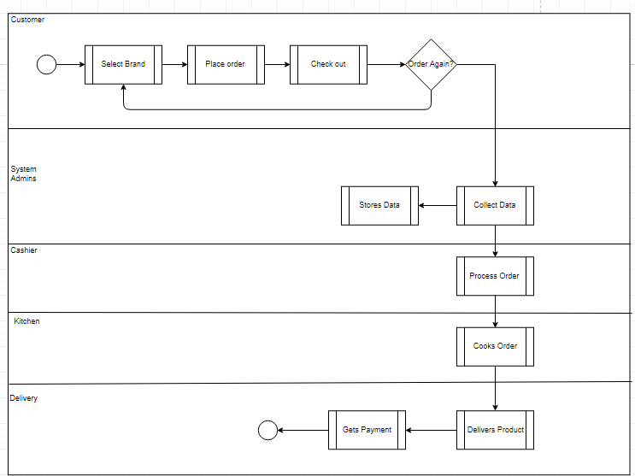

1. Enterprise Data Model
2. Entity Relationship Diagram

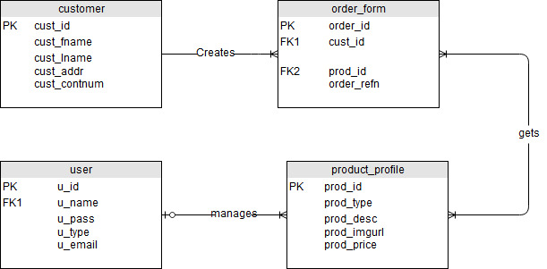

1. Relationship Table

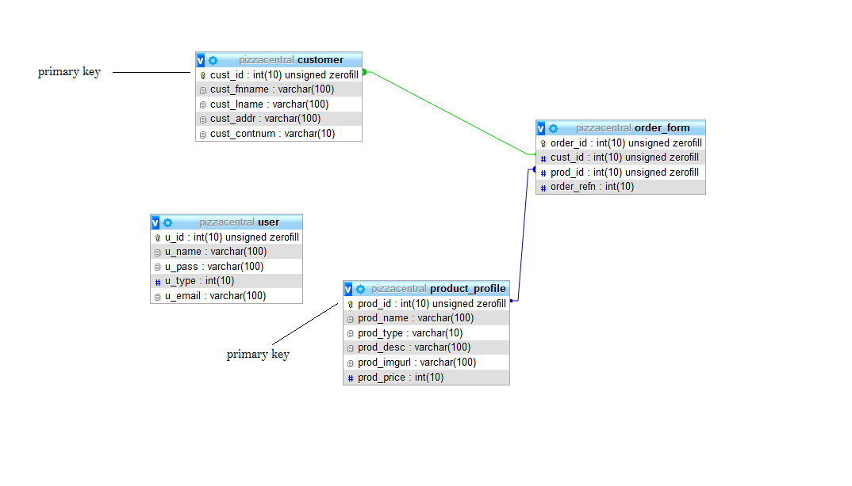

1. Meta Data

|  |  |  |  |  |
| --- | --- | --- | --- | --- |
| Column | Data type | Ref | Required | Description |
| cust_id | int |  | # | # |
| cust_fname | varchar |  | Yes | First Name |
| cust_lname | varchar |  | Yes | Last Name |
| cust_addr | varchar |  | Yes | Address |
| cust_contnum | int |  | Yes | Contact Number |
| u_id | int |  | # | # |
| u_name | vachar |  | Yes | Username |
| u_pass | vachar |  | Yes | User password |
| u_type | int |  | No | Access level |
| u_email | varchar |  | Yes | User Email |
| order_id | int |  | # | # |
| cust_id | int | Customer Table | # | # |
| prod_id | int | Product Profile Table | # | # |
| order_refn | int |  | # | # |
| prod_id | int |  | # | # |
| prod_type | varchar |  | Yes | Product type |
| prod_desc | varchar |  | Yes | Product Description |
| prod_imgurl | varchar |  | Yes | Product img URL |
| prod_price | int |  | Yes | Product Price |

1. Mock-ups

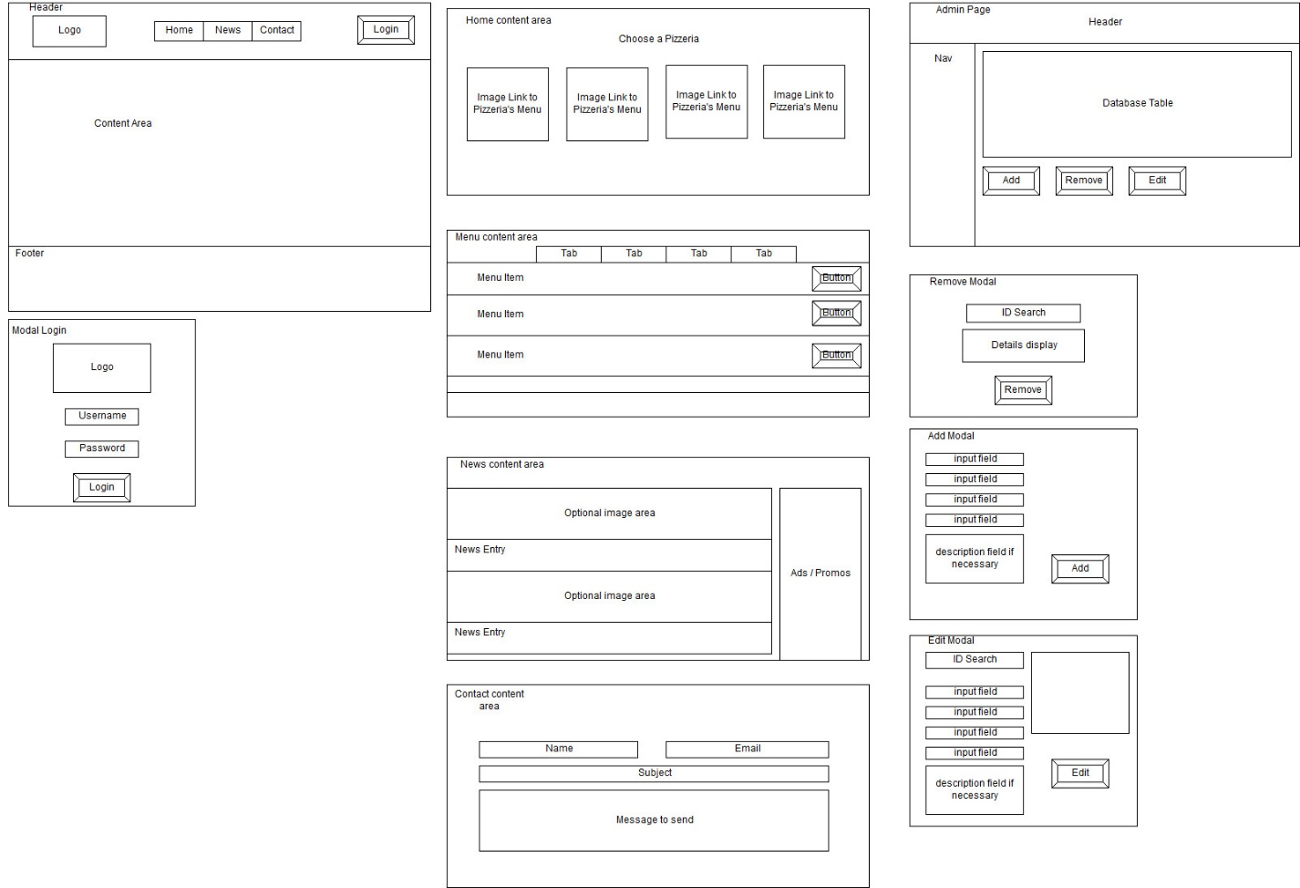

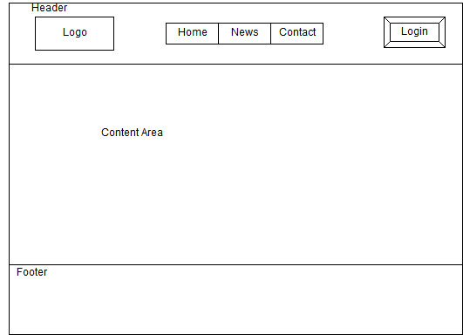

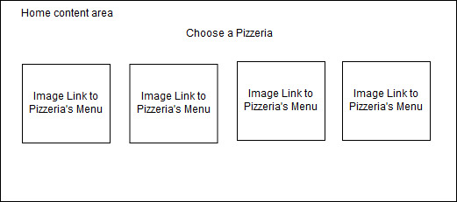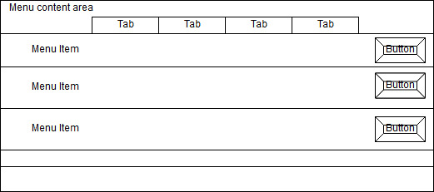

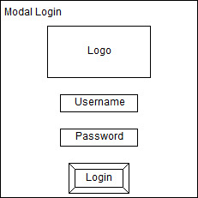

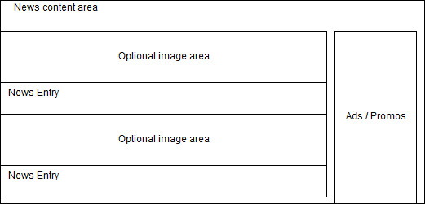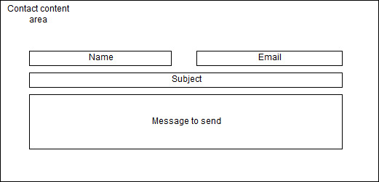

**APPENDICES**

**Existing Web Presence**



**Figure 1. Facebook page commonly used to view the location and review the restaurant**

**TRANSCRIPT OF INTERVIEW**

**Venue: Michelangelo’s Pizza Banilad Branch Date of Interview:** September 22 2018

**Interviewer Name:** Kyle Matthew Laurence Burce [KB] **Time of Interview:** 10:30 AM

**Interviewee Name:** Rolland Bajan [RB]

[KB]: Good Morning sir, first off, what is the name of this restaurant?

[RB]: It is now called Michelangelo’s Pizzeria, but before, it was called Hola España up until late 2017.

[RB] By the way, My name is Rolland Bajan supervisor of this restaurant.

[KB] Were you always the supervisor of this restaurant Sir?

[RB] No, before then, I was the head waiter of this branch for 4 years and only got promoted to supervisor 2 years ago.

[KB] You mentioned that this restaurant was established in quite a while ago, who was the manager then?

[RB] The manager then was the Italian National called ‘Maximo de la Maña’. He was given freedom to travel around with a budget and frequently bought wine from international sources.

[KB]: I see. May we ask who the current owner of the restaurant is?

[RB]: The current owner is Ma’am Michelle Lhullier, but it is her son, Michael that oversees the restaurant.

[KB]: When is it usually open? Do you have days where the restaurant is completely closed?

[RB]: No, but we are usually open on weekdays and weekends.

[KB]: Which day can you say that the restaurant is usually busy?

[RB]: It is usually during Fridays to Sundays.

[KB]: Can we talk about the business so far? Do you think the current location of the restaurant is advantageous to you?

[RB]: I think so. We are currently benefitting from Henry’s Hotel next door, and customers from the village up ahead. We have a spacious parking lot to accommodate our customers, all the while Henry’s bring in some customers that are staying at their hotel.

[KB]: I see. Can we get on the topic of customers? Which ‘nationality’ do usually dine here? Can you say that most of them are foreign tourists?

[RB]: I cannot say so. We have foreign tourist coming in to dine, but for most part it is local customers that come in.

[KB]: On the topic of price, I can see that it is a fancy restaurant, but have you received any complaints on your prices?

[RB]: None that I have heard off. I think I can say that most of our customers are satisfied with what we serve them. Most of our local customers come from the village that is located further down the road here.

(Side Note: The said village is for “rich” individuals)

[KB]: I see. We can clearly see that there is a lot of quality involved in your dishes.

[RB]: Yes, We pride ourselves in the foreign ingredients we use in making our pizza. All of our wine comes from international brands

[RB]: Although, with the TRAIN law in effect, we had to raise our prices a little bit. If I remember right the lowest price pizza before was only 260 pesos. Now it is 350 pesos.

[KB]: I see. Then my next question is: Do you deliver?

[RB]: We can deliver, but we only take delivery orders when it is within the area. Our area of coverage is limited, so we try to limit the deliveries we do.

[KB]: So have you ever received a delivery order from within the city?

[RB]: We have at times, but we decline them unless they are willing to pay additional fees.

[RB]: It is also noteworthy that we were partnered to FoodPanda before, but we discontinued it because of business reasons.

[KB]: Would you care to explain?

[RB]: Yes, their method of payment was by monthly to our account. As a small business, it is not very good in terms of profit. There were also times when then money transfer was delayed so we had accounting issues.

[KB]: I see. Thank you. What about advertisements sir? As far as we have researched, we only have seen your Facebook page. Do you have any other forms of advertisement?

[RB]: We had, at one point. We were distributing leaflets and hanging up banners, but that was already a long time ago.

[KB]: Are you open to having advertisements online?

[RB]: Yes, It would be good for business especially since most of our customers are using their phones.

[KB]: I think we are nearing the end Sir… Last but not the least, can you give us your recommendations on the menu?

[RB]: Certainly. Our specialty is the Robertino pizza. It is commonly ordered by Caucasian tourists, while the Margharita and Hawaiian pizza is ordered by Korean tourists as well as local customers.

[KB]: I think that’s about it. Thank you again sir for your time.

* **End –**

**Interview End:** 11:23 AM