# Running Xerces2 J 2.11 xsd1.1 (beta) in Oxygen (tested with v14)

1. Set the Windows PATH variable
   1. Advanced system settings -> Environment Variables -> User variables -> New (if absent)
   2. Set variable name to PATH and add the file path to the lib directory to the variable value as shown in the screenshot, e.g. C:\SVN\validationSuite\XercesJ211xsd11beta\lib

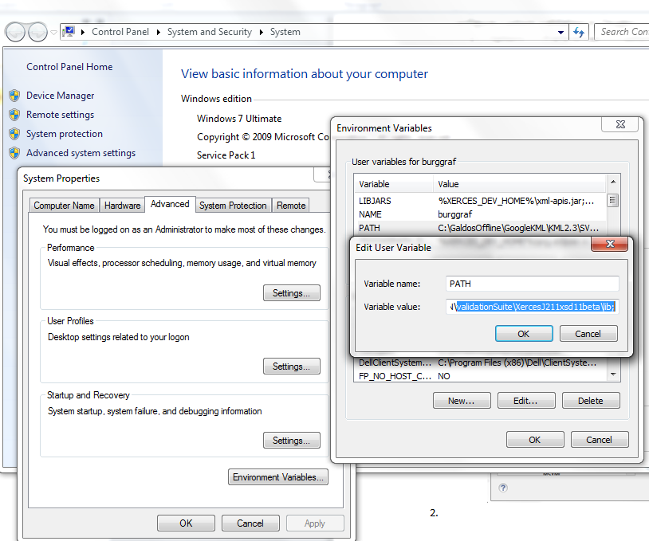

1. Configure Custom Validation in Oxygen
   1. Options -> Preferences –> Custom Validation Engines -> New
   2. Fill in options as shown in the following screenshot, then click OK

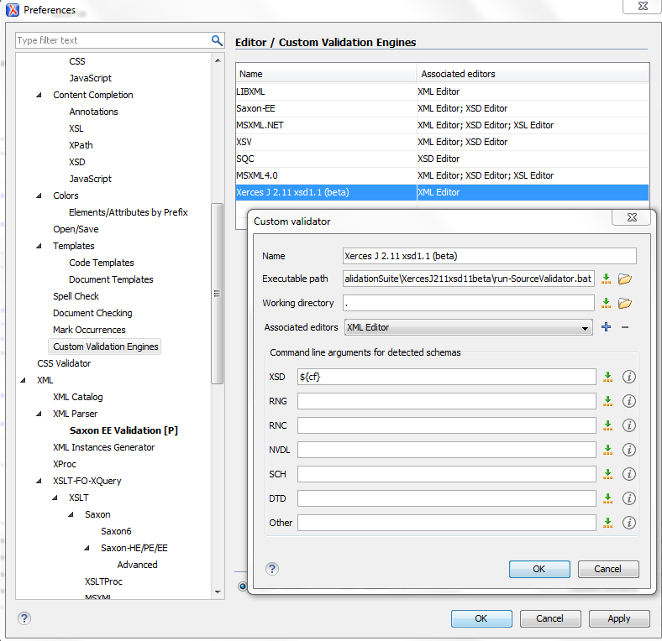

1. Configure and run a new validation scenario to use custom validation
   1. Open the desired XML Instance to be validated (keep in focus for during step 2)
   2. Click Configure Validation Scenario(s) -> New
   3. Enter options as shown in the following screenshot
   4. Click `apply associated` to run the validator

