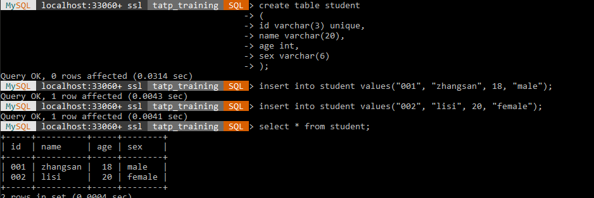

Create student table with command create table. ID is unique in this table. Can insert record using insert into command. Finally display the table with select command.

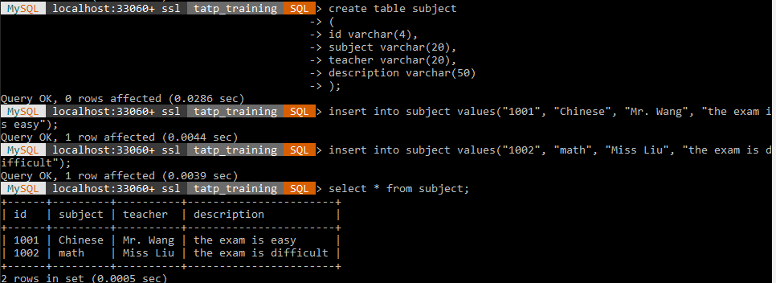

Create subject table with create command. All column is in char string data type.

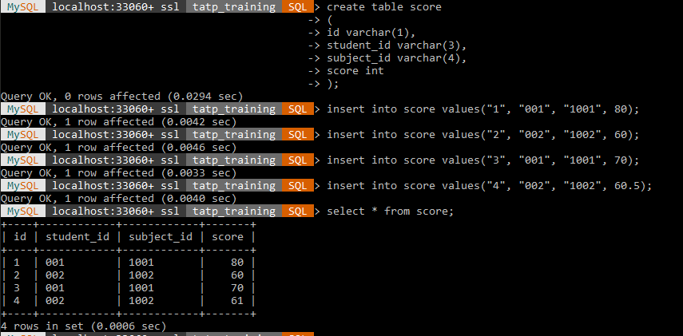

Create score table with create command. Id are in char string data type, while score are int.