# **Software Requirements Specification**

# **for**

# **Railway Reservation**

**Prepared by Shubham Raj [15114069]**

**OOAD Tutorial**

**November 5, 2016**

**CONTENTS**

1. OBJECTIVE
2. INTRODUCTION ABOUT THE SOFTWARE
3. TECHNOLOGY(TOOLS AND TECHNIQUES)
4. SOFTWARE REQUIREMENT SPECIFICATION
   1. CLASS DIAGRAM
   2. USE CASE DIAGRRAM
   3. SEQUENCE DIAGRAMS
   4. ACTIVITY DIAGRAMS
   5. OBJECT DIAGRAM
5. SOURCE CODE
6. LIMITATIONS
7. FUTURE SCOPE
8. BIBLIOGRAPHY / REFERENCES

# OBJECTIVE

To develop software for railway reservation system with various functional and non-functional part of design namely,

* PROBLEM ANALYSIS AND REQUIREMENT ANALYSIS.
* TRAIN ENQUIRY
* TICKET GENERATION
* TICKET CANCELLATION

The ultimate goal of this project is to develop a database that integrates the process of the Reservation of railway.

INTRODUCTION

The purpose of this source is to describe the railway reservation system which provides the train timing details, reservation, billing and cancellation on various types of reservation namely,

* Confirm Reservation for confirm Seat.
* Reservation against Cancellation.
* Online Reservation.
* PNR Generation

TECHNOLOGY USED

USER INTERFACE:

* Keyboard and Mouse

HARDWARE REQUIREMENT:

* Printer
* Normal PC
* CPU – Intel Core 2 Duo E7300
* RAM – 512MB (MIN)
* Hard Disk – 80GB
* Operating System – Windows XP (MIN)

SOFTWARE REQUIREMENT:

* Turbo C++, C

OPERATING ENVIRONMENT:

The OS used are

* Windows XP

**SOFTWARE REQUIREMENT SPECIFICATIONS**

**FOR**

**RAILWAY RESERVATION SYSTEM**

The initial specifications of user requirements may be based on interviews with the database users and on the designers own analysis of the enterprise. The basic issues that the SRS writer(s) shall address are the following:

*a***) Functionality***.* What is the software supposed to do?

**b) External interfaces***.* How does the software interact with people, the system’s hardware, other hardware, and other software?

**c) Performance**. What is the speed, availability, response time, recovery time of various software functions, etc.?

**d) Attributes***.* What are the portability, correctness, maintainability, security, etc. considerations?

An SRS should be  
a) Correct   
b) Unambiguous   
c) Complete   
d) Consistent   
e) Ranked for importance and/or stability   
f) Verifiable   
g) Modifiable   
h) Traceable

**4.1 INTRODUCTION**

4.1.1 PURPOSE

The purpose of this source is to describe the railway reservation system which provides the train timing details, reservation, billing and cancellation on various types of reservations namely,

* Confirm Reservation for confirm Seat.
* Reservation against Cancellation.
* Online Reservation
* PNR Generation.

4.1.2 INTENDED AUDIENCE AND READING SUGGESTIONS

The different types of readers are

* Developers
* Customers

Management people specifically,

* Passengers
* Clerk

4.1.3 DEFINITIONS, ACRONYMS AND ABBREVIATIONS

* PRS – passenger reservation system

It consists of

* Train details
* Reservation form
* Billing
* Cancellation.

**4.2GENERAL DESCRIPTION**

4.2.1 .PRODUCT PERSPECTIVE

It enables us to maintain the railway train details like their timings, number of seat available and reservation billing and cancelling the tickets.

OPERATIONS

* Any Reservation counter from 8 am to 8 pm.
* Prior to 90 days of Journey.
* One form for 6 persons only.
* To save time & queues Agent is others guides.

4.2.2 PRODUCT FUNCTION

It tells the short note about the product.

4.2.2.1 TRAIN DETAILS

Customers may view the train timing at a date their name and number of tickets.

4.2.2.2 RESERVATION

After checking the number of seats available the customers reserve the tickets.

4.2.2.3 BILLING

After reserving the required amount of tickets, the customer paid the amount.

4.2.2.4 CANCELLATION

If the customers want to cancel the ticket.

4.2.2.4. USER CHARACTERISTICS

* Knowledgeable user
* No voice user
* Expert user

4.2.4 CONSTRAINTS

* There is no maintainability of back up so availability will get affected.
* Real-life credit card validation and Banking system is not implemented.
* No multilingual support.

# Administrator

**Database Management:** Control the database and keep track of all records of customers.

**View all details:** View the details of all orders and control the whole application.

# Customers

**Login:** Customers must have a valid login id(PNR number) to enter into the site.

**Registration:** New users can sign up by creating new ID.

**View and edit Own Details:** Can view/edit his preservation details, payment details, anddetails about services provided.

**Choosing and comparing products:** Can view all reservation products.

**Order:** Can order any service through valid credit card.

**Logout:** Customer must logoutof the site after purchasing products.

**4.3 SPECIFIC REQUIREMENTS**

## *4.3.1 Functional requirements definitions*

Functional Requirements are those that refer to the functionality of the system, i.e., what services it will provide to the user. Nonfunctional (supplementary) requirements pertain to other information needed to produce the correct system and are detailed separately.

**4.3.2 EXTERNAL INTERFACES**

* Train Delay Alert Service.
* Booking Terminals.
* Interactive voice Response System.
* Touch Screen.
* Passengers operated Enquiry Terminals.

**4.4 PERFORMANCE REQUIREMENTS**

It is available during all 24 hours.

About N Trains runs daily.

*Variety of compartments based on comfort:*

* AC first class.
* AC sleeper.
* First class.
* AC three tier.
* AC chair car.
* Sleeper class
* Ordinary chair car.

**4.5 SOFTWARE SYSTEM ATTRIBUTES**:

* Reliable
* Available
* Secure

# 

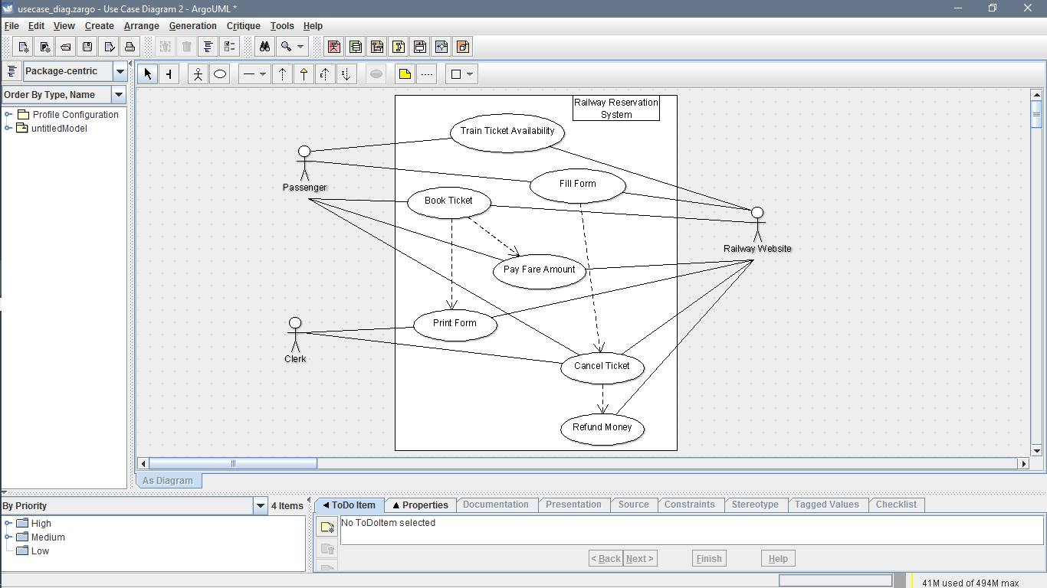

# 

# 

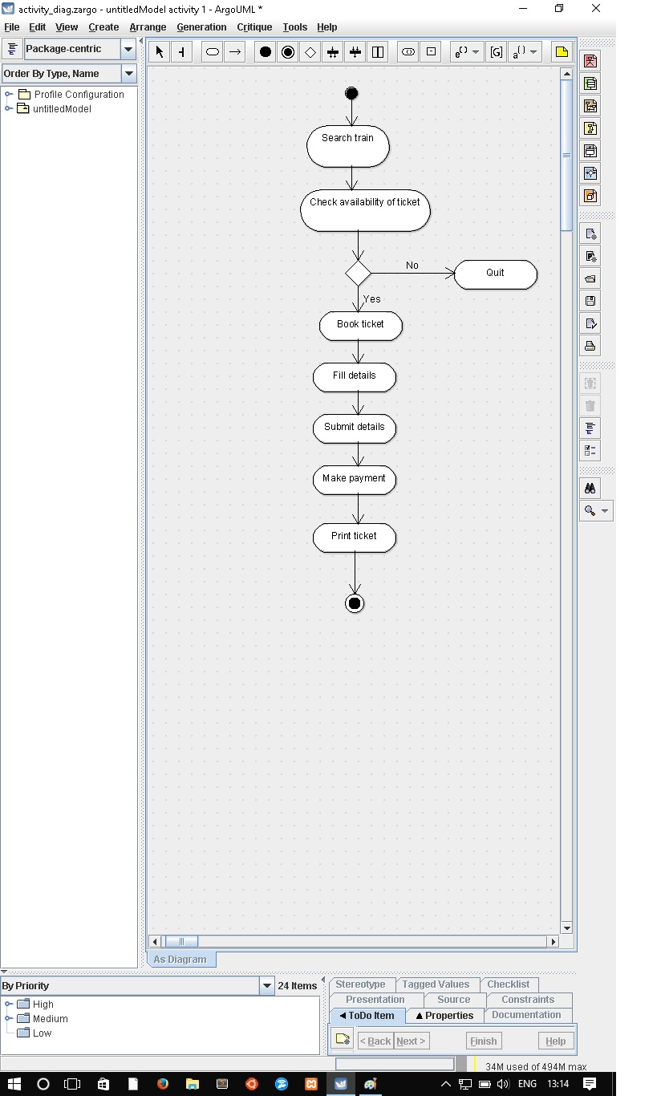

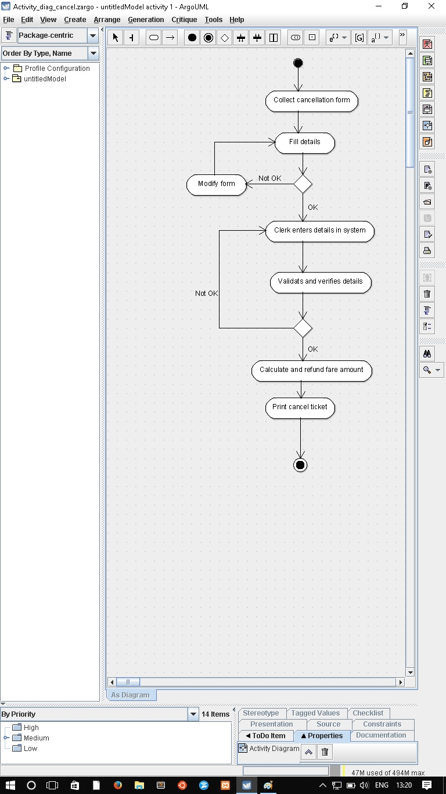

# **LIMITATIONS**

* It does not work in Linux OS.
* Not supports web based operations
* Multiprocessing not allowed.
* Extensive help is not provided.
* Not support in the OS lower than windows

# **FUTURE SCOPE**

* Freight Revenue enhancement.
* Passenger Revenue enhancement.
* Improved & optimized service.

# BIBLOGRAPHY/ REFERENCES

We have taken these websites as a reference for our project:

* [www.scribd.com](http://www.scribd.com/)
* [www.google.com](http://www.google.com/)