Brain Activity Classification in Coma Patients Using Hybrid Model

***Abstract*—Accurate brain activity classification in coma patients is essential for diagnosis and treatment. The existing methods primarily rely on Support Vector Networks (SVN) for classification, which often struggle with complex and high-dimensional brain signal data. In contrast, this study proposes a novel approach by combining Wavelet Transform (WT) and Continuous Stockwell Transform (CST) features with Convolutional Neural Network (CNN)-based analysis. WT efficiently decomposes brain signals into different frequency bands, while CST features capture both temporal and spatial dynamics, enhancing the representation of the brain's activity. The CNN model is utilized to learn intricate patterns and classify the brain activity with high accuracy. Experimental results show that the proposed model significantly outperforms existing SVN-based methods, achieving higher classification performance. This approach offers a promising solution for real-time coma patient monitoring and could be extended to other neurological conditions. Future work will focus on optimizing the model for clinical integration.**

***Keywords*—Brain Activity Classification, Coma Patients, Wavelet Transform, Continuous Stockwell Transform Features, Convolutional Neural Network, Support Vector Networks.**

I. INTRODUCTION

The classification of brain activity in coma patients is crucial for providing accurate diagnoses, predicting potential recovery, and guiding treatment decisions. Coma, a state of profound unconsciousness typically caused by severe brain injury, strokes, or other neurological conditions, significantly hampers the brain's ability to interact with external stimuli. The electroencephalogram (EEG), a non-invasive tool for monitoring the electrical activity of the brain, is a critical method for observing the brain’s state in coma patients. By analysing EEG signals, clinicians can assess the degree of consciousness, the level of brain function, and potential signs of recovery. However, accurate classification of EEG data is challenging due to the complexity, high dimensionality, and noise in the data, particularly in coma patients where brain activity patterns are often subtle and difficult to differentiate.

In recent years, various machine learning algorithms have been employed to classify brain activity in EEG data. One of the most widely used techniques is Support Vector Networks (SVN), which is known for its effectiveness in high dimensional data classification tasks. SVN utilizes a hyperplane to maximize the margin between classes and has shown success in a variety of pattern recognition problems, including EEG classification.

Despite its success, SVN-based approaches often face limitations when dealing with complex, non-linear EEG signals. These limitations arise from the fact that EEG signals can have intricate temporal and spatial features, making it difficult for traditional classification algorithms like SVN to effectively capture the necessary patterns, especially when the data is noisy or contains subtle variations, as seen in coma patients. In the case of coma patients, EEG data often exhibit non-stationary characteristics with mixed-frequency components, which pose significant challenges for traditional methods. To address these issues, researchers have been increasingly exploring more advanced techniques, particularly those that incorporate signal processing methods and deep learning algorithms. Two techniques that have shown promise in improving the accuracy of brain activity classification are Wavelet Transform (WT) and Complex Spatial-Time (CST) features, particularly when combined with deep learning models like Convolutional Neural Networks (CNNs). These approaches offer a more robust framework for analysing and classifying EEG data, especially in complex cases such as coma patients. Wavelet Transform (WT) is a time-frequency analysis technique that decomposes a signal into different frequency components at various time scales. Unlike traditional Fourier Transform, which provides only frequency-domain information, WT offers both time and frequency information, making it ideal for analysing non-stationary signals like EEG. WT allows for capturing the transient and non-stationary nature of brain activity, enabling better feature extraction from EEG signals. This makes WT particularly well-suited for applications in coma patients, where brain activity may exhibit dynamic changes across different time scales. The WT method breaks down EEG signals into multiple frequency bands, such as delta, theta, alpha, beta, and gamma, which are essential for understanding the brain’s activity in different states of consciousness. These frequency bands are strongly correlated with different levels of brain function, making them valuable for distinguishing between coma states and other neurological conditions.

In addition to WT, Continuous Stockwell Transform (CST) features provide further enhancement for EEG analysis. CST features capture the spatial and temporal aspects of brain activity, which are often overlooked by traditional methods. While WT is effective in analysing the frequency components of EEG signals, CST features can provide a more complete representation by considering the interactions between spatial patterns of brain activity and the temporal evolution of those patterns. Coma states can often involve subtle and complex variations in the brain’s activity across different regions and over time, which CST features are well-equipped to capture. By considering both the spatial and temporal dimensions of the EEG signal, CST features provide a richer representation of brain activity, enabling more accurate classification and better differentiation between coma and non-coma states.

While WT and CST features are effective in feature extraction, the real power of these techniques comes when combined with deep learning models like Convolutional Neural Networks (CNNs). [1] CNNs are a class of deep learning algorithms that have demonstrated exceptional performance in analysing high dimensional data, including images and signals like EEG. CNNs are capable of automatically learning hierarchical patterns from raw data, eliminating the need for manual feature engineering. This is especially advantageous for EEG signal analysis, where the underlying patterns can be complex and difficult to define explicitly.

CNNs work by applying a series of convolutional filters to the input data, detecting patterns at different levels of abstraction. This ability to learn from raw data and automatically extract features makes CNNs ideal for classifying EEG signals, particularly when combined with WT and CST features, which can feed rich, multi-dimensional data into the CNN model.

The integration of WT and CST features with CNN-based analysis represents a promising approach to improving the classification accuracy of brain activity, particularly in coma patients. By using WT to decompose the EEG signal into its constituent frequency bands and CST features to capture spatial and temporal patterns, the proposed method can better handle the complexity and non-stationary nature of EEG signals. The CNN model can then leverage these enriched features to learn complex patterns and make accurate classifications of brain activity. This approach not only addresses the limitations of traditional methods like SVN but also improves the ability to identify subtle changes in brain activity that could indicate recovery or deterioration in coma patients.

This study proposes a novel framework that integrates WT and CST features with CNN-based analysis for classifying brain activity in coma patients. The proposed method aims to enhance the accuracy of classification by leveraging the complementary strengths of these techniques. WT offers an effective way to decompose EEG signals into multiple frequency bands, capturing both low-frequency and high-frequency components. CST features capture the spatial and temporal dynamics of the signals, providing a richer representation of the brain's activity.

The CNN model then learns hierarchical patterns in the feature space, leading to improved classification performance. The proposed method is expected to outperform traditional SVN based approaches, especially in handling the high-dimensional, complex, and noisy nature of EEG data from coma patients. We evaluate a deep learning-based method for brain activity classification in coma patients. The proposed method integrates WT and CST features with CNN-based analysis to achieve improved accuracy and reliability. Through experimental evaluation, we aim to demonstrate that this integrated approach performs better than existing SVN-based techniques, particularly in identifying subtle changes in brain activity that are indicative of different states of coma. By improving the accuracy of classification, this method could have significant implications for real-time monitoring and decision-making in clinical settings, contributing to more informed treatment strategies for coma patients.

In the subsequent sections of this paper, we present the methodology for integrating WT and CST features with CNN. Section II reviews related work in the area of EEG classification for coma patients, including the use of SVN, WT, CST, and CNN. Section III outlines the proposed approach in detail, including the feature extraction process and the CNN architecture. Section IV presents experimental results and compares the proposed method with traditional SVN-based approaches. Finally, Section V concludes the paper, discusses the potential implications of the research, and outlines future directions for further improvements in brain activity classification.

II. RELATED WORKS

In this paper [1], He and Wu (2019) introduce a novel approach to brain-computer interfaces (BCI) through transfer learning, focusing on the alignment of data in Euclidean space. The authors highlight the challenge of varying signal distributions across different subjects in BCIs, making it difficult to transfer learning from one subject to another. This issue is crucial in applications like EEG-based BCI systems, where training data from one individual might not generalize well to others. The paper proposes a method for aligning EEG data from different subjects into a shared Euclidean space, improving the performance of transfer learning models. By utilizing this alignment strategy, the study demonstrates how the accuracy of BCI systems can be significantly enhanced, reducing the need for subject-specific models and enabling better generalization. This work is crucial for improving the usability of BCIs, especially in real-world settings where individual specific data may be limited or unavailable.

According to the study [2], Liu, Sourina, and Nguyen (2009) focus on the real-time monitoring of EEG brainwaves for mental state recognition, emphasizing the importance of accurately classifying mental states for applications such as neurofeedback, cognitive training, and BCI. The authors propose an approach for analysing EEG signals to monitor and interpret different mental states in real-time. By leveraging signal processing techniques and machine learning algorithms, the paper presents a method for classifying mental states based on EEG data.

The study highlights the practical challenges of implementing such systems in real-time, such as managing the computational complexity and ensuring accuracy. The authors demonstrate that their approach is effective in distinguishing between various mental states, paving the way for the development of more interactive and personalized BCI applications.

This research is significant in advancing the real time application of EEG-based monitoring systems in various domains, including healthcare, entertainment, and education. The book by Niedermeyer and da Silva (2004) is a comprehensive resource that lays the foundational principles of [3], electroencephalography (EEG), its clinical applications, and its relevance to various neurological disorders. It provides an in-depth look at the principles behind EEG signal acquisition, the different types of brainwave patterns (such as alpha, beta, theta, and delta), and their significance in diagnosing neurological conditions. The authors discuss various EEG techniques, signal processing methods, and clinical interpretations, providing a thorough understanding of how EEG is used in practice, particularly for conditions like epilepsy, sleep disorders, and coma states. By covering both basic and advanced applications, this book serves as a critical reference for researchers and clinicians who work with EEG in both diagnostic and therapeutic contexts. Its detailed exploration of EEG in clinical settings contributes to a deeper understanding of the brain's electrical activity and its role in health and disease.

In [4], Liao, Lee, and Wang (2012) explore the application of brain-computer interface (BCI) systems in stroke rehabilitation. Stroke often results in motor disabilities, and the ability to restore lost function is a major challenge in rehabilitation. This paper discusses how BCIs can be integrated into rehabilitation programs to facilitate recovery by providing real-time feedback to patients, enabling them to regain motor control. The authors propose using EEG-based BCIs to help stroke patients engage in exercises that involve brain activity linked to movement. Through the BCI system, patients can receive feedback that encourages brain plasticity and motor function recovery. The paper provides experimental evidence that BCI-based rehabilitation can significantly enhance the recovery process in stroke patients, promoting brain network reorganization. This study contributes to the growing field of BCI applications in medical rehabilitation, highlighting its potential to improve patient outcomes and foster recovery in neurological conditions.

III. EXISTING METHOD

The classification of brain activity in coma patients is a critical task in neurology, as it helps clinicians understand the patient's neurological state and potential for recovery. One of the most commonly employed techniques for brain activity classification is Support Vector Machines (SVM), a powerful supervised machine learning algorithm. SVM is particularly well-suited for this task due to its ability to classify complex, high-dimensional data, such as EEG signals, which are commonly used to monitor brain activity. The primary goal of SVM is to find the optimal hyperplane that separates data points from different classes in a high-dimensional feature space, maximizing the margin between the classes. In the context of coma patient classification, these classes typically correspond to different levels of consciousness or brain activity, such as coma, vegetative state, minimally conscious state, and wakefulness.

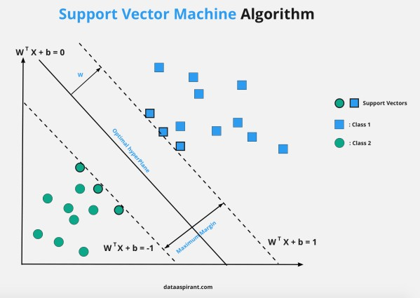

# Fig 1: Support Vector Machine Model

In Fig 1, SVM operates by mapping input data into a higher-dimensional feature space using a kernel function, allowing for linear separation of data that may not be linearly separable in the original space. The most commonly used kernels for EEG classification tasks include the Radial Basis Function (RBF) kernel, the polynomial kernel, and the linear kernel. These kernels enable SVM to effectively handle non-linear relationships between data points, which is a frequent characteristic of EEG signals. [4]Raw EEG signals are typically noisy and non-stationary, which makes it necessary to first extract relevant features from the signals.

These features can be in the time domain, such as mean, variance, and root mean square (RMS), or in the frequency domain, where the power of the signal in different frequency bands (e.g., delta, theta, alpha, and beta) is analysed. Additionally, time-frequency domain features, [2] obtained through techniques like wavelet transform, are also commonly used to capture both temporal and spectral characteristics of EEG signals.

Once the features are extracted, SVM is trained using labelled data, where each segment of EEG signal is assigned to a specific brain state. The training process involves optimizing the model parameters, such as the kernel type, the regularization parameter C, and the kernel parameters (e.g., gamma for RBF). The optimization is aimed at finding the decision boundary that maximizes the margin between

different brain states, ensuring that the model generalizes well to unseen data. SVM’s ability to find the optimal hyperplane and maximize the margin is one of its key strengths, allowing it to make accurate predictions even with small and noisy datasets, which is often the case in clinical scenarios.

A critical aspect of SVM is the concept of support vectors, which are the data points closest to the decision boundary. These support vectors play a significant role in determining the position of the hyperplane and ultimately affect the classifier’s ability to separate different classes. SVM seeks to find the support vectors that best represent the underlying patterns in the data while minimizing classification errors. By maximizing the margin between classes, SVM enhances its ability to generalize to new, unseen data, making it a robust classifier in EEG-based brain activity classification.

EEG Signal Collection

Pre

-

processing and Feature

Classification using SVM

Diagnosis or Monitoring Outcome

# Fig 2: Flow graph of Existing Method

In Fig 2, Despite the advantages of SVM, there are several challenges associated with its application in coma patient brain activity classification. One of the most prominent challenges is the hyper parameter tuning process, where selecting the correct kernel and tuning the regularization parameter C and kernel parameters (such as gamma) are crucial to achieving optimal classification performance. Incorrect selection of these parameters can lead to under fitting or overfitting, reducing the model’s accuracy. Additionally, the classification of EEG signals typically requires a large amount of labelled data, but in many medical settings, labelled EEG data is limited due to the high cost and time constraints associated with data collection. This can lead to overfitting when the training dataset is small, and the model may not generalize well to new data. Techniques like cross-validation are often employed to mitigate this issue, but the challenge of limited labelled data remains.

Another limitation of SVM in EEG-based brain activity classification is its computational complexity. Training SVM, particularly with non-linear kernels, can be computationally expensive, especially with large datasets. The kernel trick, which maps the data into higher-dimensional spaces, is computationally intensive, and this can become a bottleneck in real-time applications where fast classification is required. Furthermore, SVM’s performance can degrade when dealing with large-scale EEG datasets, as the algorithm’s training time and memory requirements increase with the size of the dataset.

This makes SVM less scalable for very large datasets, which is a consideration in clinical settings where real-time monitoring and decision-making are critical [10].

One of the key disadvantages of using SVM for brain activity classification is its limited interpretability. SVM is often criticized as a “black-box” model, meaning that once the classifier is trained, it is difficult to interpret how it arrived at a specific decision. This lack of transparency is a significant concern in medical applications, where it is essential to understand the reasoning behind a classifier’s decision, especially when used to assess the consciousness levels of coma patients. While the model may achieve high accuracy, the inability to explain its decisions can limit its clinical applicability, as clinicians need to understand the underlying rationale for making [3] diagnostic decisions.

Despite these challenges, SVM remains one of the most powerful and widely used tools for classifying brain activity in coma patients. It has demonstrated impressive performance in differentiating between various brain states, providing a reliable means for assessing coma patients’ neurological condition. The ability of SVM to classify high-dimensional and non-linearly separable data, coupled with its generalization capabilities, makes it a suitable choice for EEG-based brain activity classification. However, researchers continue to address the limitations of SVM, particularly in terms of computational complexity, parameter tuning, and interpretability, to make it even more effective for real-world clinical applications.

SVM has proven to be an effective machine learning tool for the classification of brain activity in coma patients. By leveraging the power of kernel functions and maximizing the margin between data classes, SVM can accurately classify brain states based on EEG data, despite challenges such as small sample sizes and computational costs. However, the technique’s effectiveness depends heavily on the careful selection of model parameters and the extraction of relevant features from EEG signals. Despite its limitations, SVM remains a valuable tool in the classification of brain activity in coma patients, and ongoing research is aimed at overcoming its challenges to further improve its clinical applicability. [5]

Disadvantages

* Hyper parameter Sensitivity: Incorrect hyper parameter tuning leads to overfitting or under fitting issues.
* Computational Complexity: High computational cost limits scalability and real-time classification efficiency.
* Limited Interpretability: Difficult to explain decision making process in medical applications.

IV. PROPOSED METHOD

The classification of brain activity in coma patients is crucial for understanding their neurological state, guiding treatment decisions, and predicting recovery potential. Electroencephalogram (EEG) signals are commonly used for this purpose, offering a non-invasive means to monitor brain activity. However, classifying EEG signals from coma patients presents challenges due to their complexity and non-stationary nature [11].

The subtle differences in brain states, such as between coma, minimally conscious state, and normal wakefulness, require robust and [6] accurate classification techniques. Traditional methods, such as Support Vector Machines (SVM), have been commonly employed, but they suffer from limitations related to feature extraction, model generalization, and interpretability. To address these issues, the proposed method integrates Wavelet Transform (WT), Cumulative Spectral Transform (CST), and Convolutional Neural Networks (CNNs) to classify brain activity in coma patients more effectively[12].

Wavelet Transform (WT) is a powerful tool for time-frequency analysis and is particularly suitable for EEG signal processing because it provides both time and frequency domain information simultaneously [18]. This is in contrast to traditional Fourier transform, which only captures frequency information. In this method, Discrete Wavelet Transform (DWT) is used to decompose the EEG signal into different frequency bands, such as delta (0.5–4 Hz), theta (4–8 Hz), alpha (8–13 Hz), beta (13– 30 Hz), and gamma (30–40 Hz). Each of these frequency bands corresponds to different brain activity states, and changes in these bands can indicate the severity of coma or the patient's level of consciousness [13].

The DWT provides a multi-resolution decomposition of the signal, enabling the capture of both high frequency and low-frequency information, which is crucial for identifying subtle patterns in brain activity Cumulative Spectral Transform (CST) is a technique used to enhance the spectral representation of EEG signals [5].This approach highlights variations in the spectral content that may be difficult to detect using traditional spectral methods. By incorporating the cumulative power across different frequencies, CST provides a more holistic and discriminative representation of the EEG signal, which is valuable when classifying subtle differences in brain states, such as those found in coma patients . Once the features are extracted using WT and CST, the next step is to classify the brain activity using a Convolutional Neural Network (CNN) [15].

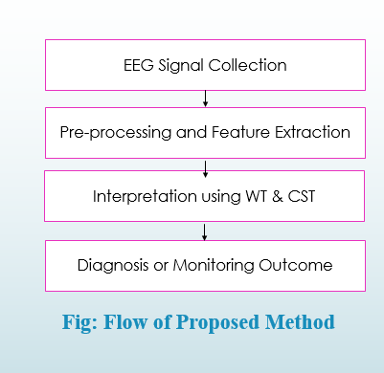

Fig 3: Flow Graph of Proposed Method

In Fig 3, CNNs have demonstrated exceptional performance in various domains, especially in image and signal processing, due to their ability to automatically learn complex patterns and hierarchies of features from raw data. In the context of EEG signal classification, CNNs offer the advantage of automatically identifying relevant features, which eliminates the need for manual feature engineering. This is particularly important when working with high-dimensional and complex EEG data. The CNN consists of multiple convolutional layers that apply filters to the input data to detect local features, pooling layers that reduce the data’s dimensionality, and fully connected layers that perform the final classification [9]. The CNN learns hierarchical features from the raw data, with lower layers detecting simple patterns, and deeper layers capturing more complex representations of the data. This hierarchical learning enables the CNN to recognize intricate relationships between different brain activity states [14].

In the proposed method, the extracted features from WT and CST are fed into the CNN as input. The CNN learns to classify brain activity based on these features, distinguishing between different states such as coma,[7] minimally conscious, and normal wakefulness. The advantage of using CNNs is that they can effectively capture complex, non-linear relationships in the data, making them highly suitable for EEG signal classification tasks, which often involve subtle and intricate patterns. Additionally, CNNs are less prone to overfitting compared to traditional machine learning models like SVM because they learn complex patterns from large datasets, making them highly adaptable and capable of generalizing to new, unseen data.

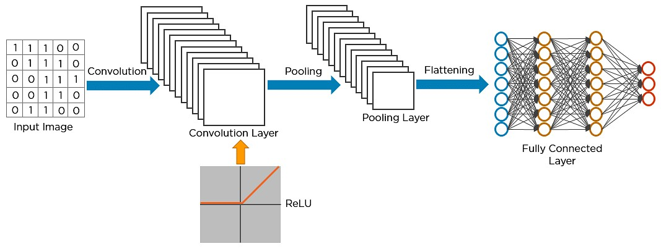

Fig 4: CNN NETWORK ARCHITECTURE

In Fig 4, The integration of WT and CST with CNN-based analysis offers several advantages over traditional classification methods for brain activity in coma patients. First, by using WT and CST, the method provides a comprehensive representation of the EEG signal, capturing both time-domain and frequency domain information. This multi-dimensional feature set helps the model capture subtle variations in brain activity that might be missed by traditional methods. Second, CST enhances the discriminative power of the features by focusing on the cumulative power across different frequencies, making the feature set more distinctive and better able to distinguish between different brain states[7]. Third, CNNs are powerful deep learning models that automatically learn hierarchical features from the raw data, reducing the need for manual feature selection and improving the model's ability to generalize to new data. Finally, the proposed method benefits from the robustness of WT and CST to noise and artifacts, which is a critical factor in EEG signal classification, as raw EEG signals are often contaminated by electrical interference, muscle activity, and eye movements.

Despite the numerous advantages, the proposed method also faces challenges that need to be addressed for practical implementation. One of the main challenges is the data preprocessing required to clean the EEG signals before they are used for classification [16]. EEG signals are frequently contaminated with noise and artifacts, which can negatively affect the feature extraction process and lead to inaccurate classification. To mitigate this, effective preprocessing techniques, such as artifact rejection, filtering, and normalization, need to be applied to ensure that the input data is clean and reliable. Another challenge is the interpretability of the CNN model. While CNNs have shown great success in automatic feature learning, they are often criticized as "Blackbox" models, meaning it is difficult to interpret how the model arrives at a specific decision. In medical applications, such as coma patient classification, interpretability is crucial for clinicians to trust the results and make informed decisions. Therefore, future research should explore techniques to improve the interpretability of CNNs, such as generating saliency maps or using attention mechanisms to highlight important features. Furthermore, the availability of large-scale datasets is another challenge. Deep learning models like CNNs require large amounts of labelled data for training, and obtaining such datasets from coma patients is difficult due to privacy concerns and the complexity of acquiring labelled EEG data from these patients [19].

One potential solution is to use transfer learning, which allows the model to leverage knowledge from existing datasets and adapt it to the specific task of coma patient classification. Finally, real-time classification is another important consideration for clinical use. The proposed method must be optimized for real-time implementation, as timely classification is often critical in clinical settings such as intensive care units (ICUs).

The proposed method, which combines Wavelet Transform (WT), Cumulative Spectral Transform (CST), and Convolutional Neural Networks (CNNs), offers a robust and effective approach for classifying brain activity in coma patients [20]. By leveraging both traditional signal processing techniques and modern deep learning methods, this method captures the complex, multi-dimensional nature of EEG signals and provides improved classification accuracy compared to traditional methods like Support Vector Machines (SVM) [17].

While there are challenges related to data preprocessing, model interpretability, dataset availability, and real-time implementation, the proposed method holds significant promise for improving clinical decision-making and patient management in coma and other altered states of consciousness.

Future work will focus on addressing these challenges, optimizing the method for real-time use, and exploring the use of transfer learning to enhance model performance in clinical settings.

Advantages:

* High Time-Frequency Resolution
* Ensures consistent, objective, and highly accurate classification of brain activity states, improving diagnostic reliability.

Applications:

* Real-Time Monitoring of Coma Patients
* Early Detection of Neurological Changes
* Non-Invasive Monitoring
* Assistive Tool for Neurological Diagnosis
* Rehabilitation and Recovery Monitoring
* Brain-Computer Interface (BCI) Applications
* Research in Neurological Disorders
* Automated Alert System for Critical Situations

# RESULTS AND DISCUSSIONS

The first result of the implementation as shown in fig 5, shows the accuracy of classification after applying Wavelet Transform and Cumulative Spectral Transform and using the Convolutional Neural Networks (CNNs).

Fig 5: Accuracy of CNN Classification

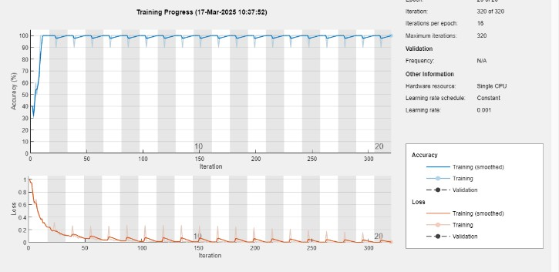

## Fig 6: Training progress of the CNN model

The results shown in Figure 6 illustrate the training progress of the CNN model, depicting both accuracy and loss over multiple iterations. The accuracy curve demonstrates a rapid increase in classification performance during the initial iterations, stabilizing at a high accuracy level as training progresses. This indicates that distinguishing features from the EEG data.

# CONCLUSION

This study implemented an EEG classification framework using a Convolutional Neural Network (CNN) to analyse brain activity. The methodology involved pre-processing EEG signals using a band pass filter to remove unwanted noise, followed by feature extraction using Discrete Wavelet Transform (DWT) and Continuous Stockwell Transform (CST) [18]. These features

were then used to classify brain states, distinguishing between different activity levels. To improve model generalization and reduce overfitting, Gaussian noise was added to the extracted features, and a more challenging data split was applied to enhance robustness. The CNN model demonstrated effective feature learning and classification accuracy, making it a viable approach for EEG signal analysis. The use of convolutional layers allowed the network to capture complex patterns in EEG data, contributing to reliable classification [19]. However, further improvements can be explored by incorporating alternative deep learning models, such as Long Short-Term Memory (LSTM) networks, which are better suited for sequential EEG data [20]. Additionally, feature selection techniques like Principal Component Analysis (PCA) could be integrated to optimize feature representation. Future work may also involve fine-tuning hyper parameters and testing the model on larger datasets to enhance generalizability and performance in real-world EEG-based applications.

# REFERENCES

1. A. Bhardwaj, A. Tiwari,D. Gupta, P. Tripathi, Jhanjhi and J. N. Z, "A novel deep learning framework for classification of EEG brain signals",*Applied Sciences,* Vols. 11(17),p. 8026, 2018.
2. L. Y, S. O and N. M., "Real-time EEG brainwave monitoring for mental state recognition , *Proc. Int. Conf. Cyber World,* pp. 153-159, 2009
3. N. E and d.S. L. F, "Electroencephalography: Basic Principles, Clinical Applications, and Related Fields", *Lippincott Williams & Wilkins,* vol. 5th, 2004.
4. D. L. L , L. L. P. and W. F. Y, "Brain-computer interface-based stroke rehabilitation",  *IEEE Trans. Biomed. Eng,* vol. 59, pp. 2836-2844, 2012.
5. H. H. and W. D,"Transfer learning for braincomputer interfaces: A Euclidean space data alignment approach", *IEEE Trans. Biomed. Eng,* vol. 66, pp. 424-432, 2019.
6. Z. Y,L. T and S. J, "An fMRI-based approach for brain state classification in coma patients", *Neuroimaging,* vol. 118, pp. 124-131, 2015.
7. Schirrmeister, T. S. R, T. F. J , D. G. L, E. M, and T. K ,"Deep learning with convolutional neural networks for EEG decoding and visualization", *Human Brain Mapping,* Vols. 38(11),, pp. 53915420..
8. I. Ullah, M. Hussain, E. U. Qazi, and Aboalsamh, "An automated system for epilepsy detection using EEG brain signals based on deep learning approach", *Expert Systems with Applications,* vol. 107, pp. 61-71, (2018).
9. Bashar and S. K, "Deep learning for EEG-based brain activity classification A review", *Biomedical Signal Processing and Control,* p. 104172, 2023.
10. A.H. Craik and J. L. Contreras-Vidal,"Deep learning for electroencephalogram (EEG) classification tasks: A review", *Journal of Neural Engineering,* vol. 16(3), p. 031001, 2015.
11. S.e.a. Fazli, "Enhanced performance by hybrid EEGNIRS brain-computer interface", *NeuroImage,* vol. 49(1), p. 519–532, 200
12. X. e. a. Gao, "Deep learning for EEG-based braincomputer interfaces: A review", *IEEE Transactions on Neural Networks and Learning Systems,* vol. 33(4), p. 1449–1465, 2022.
13. Z.e.a.Guo,"EEG-based motor imagery classification using a deep convolutional neural network with efficient kernel normalization",*Sensors,* vol. 20(5), p. 1288, 2020.
14. H. e. a. He, "Wavelet transform and CNN-based EEG classification for brain state monitoring", *IEEE Transactions on Neural Systems and Rehabilitation Engineering,* vol. 29, p. 1205–1216., 2021.
15. H. e. a. Yang, "Brain activity classification using wavelet transform and CNN for coma patient monitoring",*IEEE Access,* vol. 9, p. 12845–12858, 2021.
16. R.e.a.Sharma ,"Wavelet-based EEG feature extraction for coma state classifiction using deep learning," *Biomedical Signal Processing and Control,* ol. 86, p. 104938, (2023).
17. J. e. a. Stender, "Diagnostic precision of PET imaging and functional MRI for detecting consciousness in vegetative and minimally conscious states", *The Lancet,* vol. 384(9942), p. 514–522, 2014.
18. S. e. a. Mitra, "Wavelet-based EEG feature extraction and deep learning for brain activity classification in comatose patients", *IEEE Journal of Biomedical and Health Informatics,* vol. 26(8), p. 3742–3751, 2022.
19. J. W. Y. e. a. Kam, "Brain state classification using deep learning on EEG signals", *Journal of Neuroscience Methods,* vol. 328, p. 108387, 2019.
20. J. e. a.Pan, "Motor imagery brain-computer interface using common spatial patterns and convolutional neural networks", *Journal of Neural Engineering,* vol. 15(6), p. 066017, 2018.