Question 2a)

There are three different copies of x

|  |  |  |  |
| --- | --- | --- | --- |
| Parent | Child 1 | Child 2 | Code line number |
| x = 100 | x = 100 |  | Line 9 |
|  | x = 90 |  | Line 12 |
|  |  | x = 100 | Line 15 |
| x = 80 |  | x = 80 | Line 16 |
| x = 70 |  |  | Line 18 |

So, the final answers are x = 70, x = 90 and x = 80.

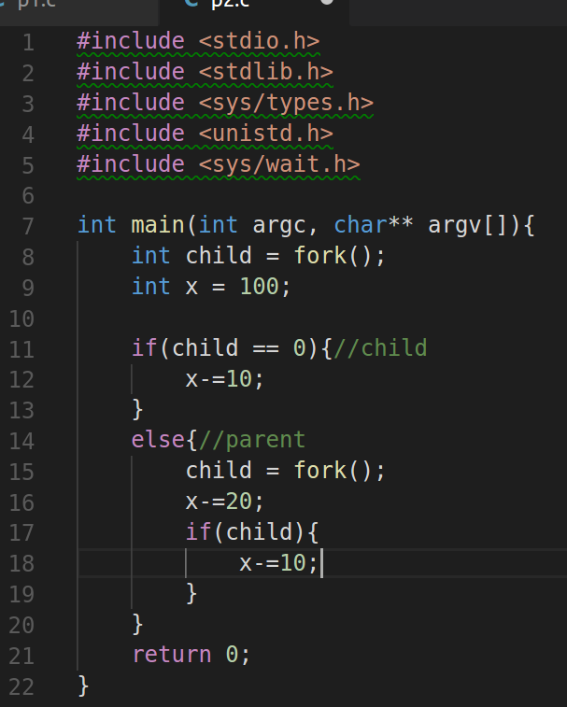

2b)

For this we would look at an example where we have two processes with several threads, in the case of user-level threads a thread would be picked and run until it is finished or becomes blocked, it then looks for another thread in the same process and continues. After the process is finished it moves onto the next process and repeats the process of running the threads as detailed before. The advantage of this is that this can be implemented in an operating system that does not support threads.

Now in the case of kernel-level threads, the first thread is picked and run until it is blocked or complete. The kernel-level thread however has the option to either run a ready thread in the same process or if none are available it goes to the next process and runs a thread that is ready there. This repeats until both processes are finished. The advantage here is that if there is a page fault in a process the kernel can still move to another thread that is ready while the page is brought in from the disk.