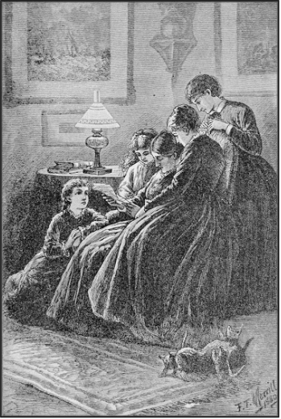
"They
all drew to the fire, mother in the big chair; with Beth at her feet"
(See page 9) FRONTISPIECE
LITTLE WOMEN
OR
Meg, Jo, Beth, and Amy
LOUISA M. ALCOTT

