1. Write a “C” program, which finds only a path (not all the paths) between two given cities according to the directed graph below. This program also calculates the distance between given these two cities.

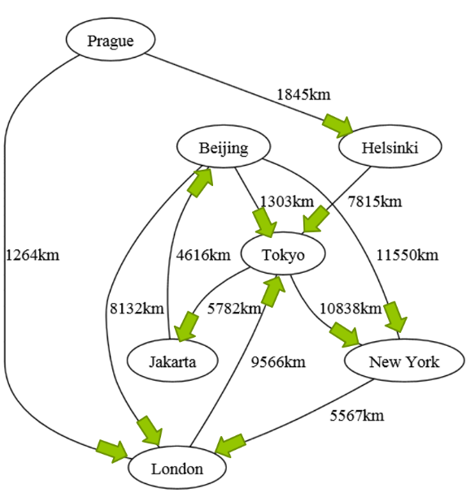

**Note:** You may need to research for this project from internet or course resources. You can also find helpful codes related with data structures in the course resources section of this course in Ninova (under Tutorial folder).

Sample screeen output of the question

