# Trilogy 1

## Episode 1

The Phantom Menace

Figure 1: Bspec

## Episode 2

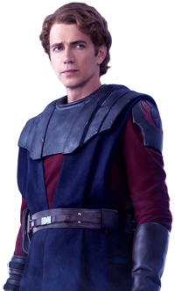

Figure 2: Anakin Skywalker

See Figure 2 for a depiction of young Anakin

## Episode 3

Revenge of the Sith

# Trilogy 2

## Episode 4

A New Hope

## Episode 5

The Empire Strikes Back

## Episode 6

Return of the Jedi