* NILAKANTHA SINGH DEO

*nilakantha.deo@capgemini.com*

SUPPLY CHAIN FINANCE ON

BLOCKCHAIN

Contents

Fundamentals of supply chain finance 2

Supply chain finance (SCF) eco system 2

SCF transactions and traditional supply chain 2

Work flow of SFC 2

The cloud based traditional SFC and Blockchain SFC 3

What can be improved through Blockchain with the following actors 5

Bibliography 6

Glossary 7

# Fundamentals of supply chain finance

Supply chain finance is a financial component to connect buyer, seller and funding institutions to come on to the same platform to optimize the working capital trapped in the supply chain. It gives the participant an opportunity to increase their short term credit without changing the figures in their balance sheet.

Commonly referred as reverse factoring and supplier finance.

## Supply chain finance (SCF) eco system

Sellers sell their invoices to the banks or financial institutions at a discount price often called as factors.

* Thus raise their working capital.
* Getting paid early, before time.

Buyer in turn can ask to increase his payback time to the funding agency.

Instead of dealing with the credit worthiness of the supplier the bank or financial institutions involved in the loop deal with the buyer who has a better credit score and a less risky prospect.

SCF transactions and traditional supply chain

It can be listed as follows:

* Extension of buyers account payable.
* Inventory finance
* Payables discounting

As compared to traditional supply chain to enhance working capital through factoring and payment discounts SCF offers the following thing.

* As the cash flows in supply chain it can be valued by financial institutions.
* The competition between buyers and sellers is replaced by collaboration.
* Organizational sustainability is achieved as cash flow is traceable.

For an example buyer might delay the payment as long as possible and the seller can expect it as soon as possible. The buyer who has better credit score can negotiate better norms with the seller by utilizing his credit score to delay the payments. Whereas the seller can expect cheaper capital by selling his receivables.

## Work flow of SFC

A typical extended payables transaction works as follows.

1. Let’s say Company B buys goods from a supplier S.
2. S supplies the goods and submits an invoice to B, which B approves for payment on standard credit terms of 30 days.
3. If supplier S requires payment before the 30-day credit period, the supplier may request immediate payment (at a discount) for the approved invoice from Company B’s financial institution.
4. The financial institution will remit the invoiced amount (less a discount for early payment) to supplier S.
5. In view of the relationship between Company B and its financial institution, the latter may extend the payment period for a further 30 days.
6. Company B therefore has obtained credit terms for 60 days, rather than the 30 days provided by supplier S,
7. B has received payment faster and at a lower cost than if it had used a traditional factoring agency.

# The cloud based traditional SFC and Blockchain SFC

The traditional cloud based Supply chain finance systems works as follows

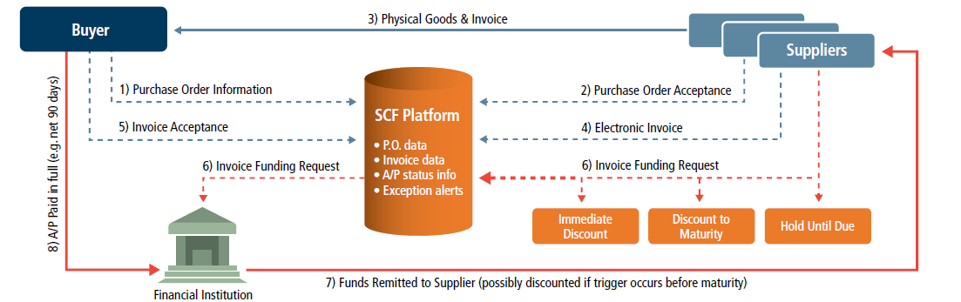

Current Supply chain finance and bottle necks

The transaction involves different agents and intermediaries making the process slow and complex. Security flaws ,time consuming process and complex IT systems are overheads. Inconsistent Government procedure are an additional headache when it comes to data integrity ,historical data and credit risk evaluation.

Seller performs receivable monitoring and fraudulent activities are inevitable.

The major concerns are as below (Yaghoob Omrana, 2017)

What are inefficiencies of existing SCF-instruments from a technical perspective?

What are the general potentials and benefits of BCT?

How does BCT improve SCF-solutions by eliminating technological inefficiencies?

The current SCF has majorly two components.

1. Reverse factoring
2. Dynamic Discounting

**Reverse Factoring:**

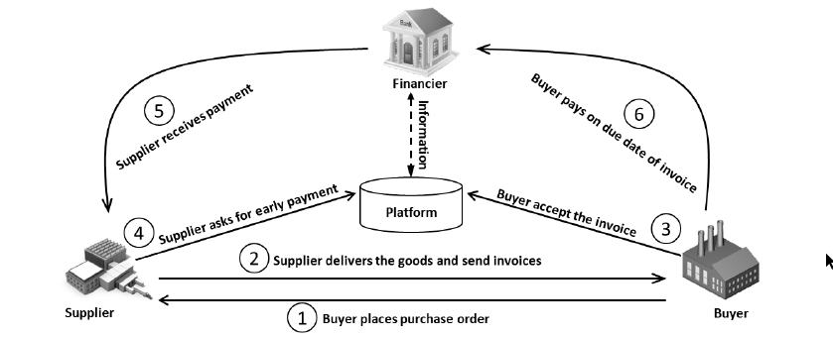

Buyer negotiate with the seller to increase the payment time and sellers get advantage to get paid early by selling their invoices, a method called reverse factoring ,and increasing liquidity

So buyer and seller work hand in hand and Financial institutions provide cheap and short term financing

to increase working capital of each party.

Supplier expects early payment by selling the invoice to a financial institution often called as factor.

Buyer can delay payment or on due date according to the agreement with the financer or factor.

To make the process simpler and transparent the following should be done.

* Financial institutions persuade buyers to do a KYC check on the suppliers.
* Supplier on boarding
* Credit risk calculations of all participating parties
* Credit score calculations
* Rating of funding institutions
* Bidding system can be introduced to generate more revenue from factors

**Dynamic discounting** is another approach where buyer and seller can directly interact with each other without the involvement of a financial institution.

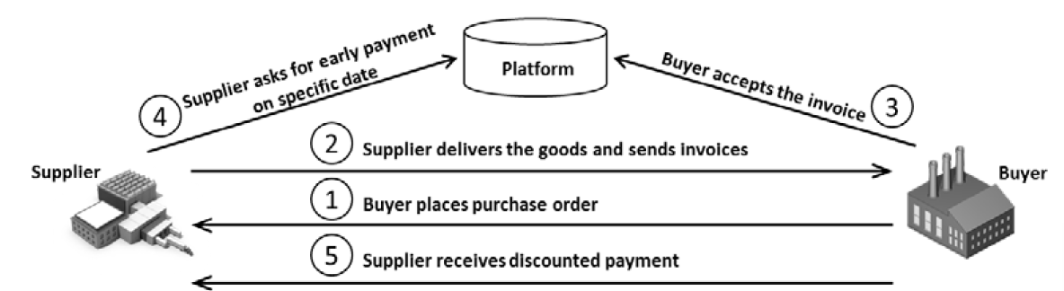

So supplier is funded directly by the buyer and a healthy negotiation from both parties can be seen. The earlier the supplier receives the payment the higher the discount the buyer gets for the order.

Here all participating nodes are non-financers

KYC is not required

The system is Fraud prone in absence of automated infrastr

Evaluation of credit portfolio is required to make it more sustainable

## What can be improved through Blockchain with the following actors

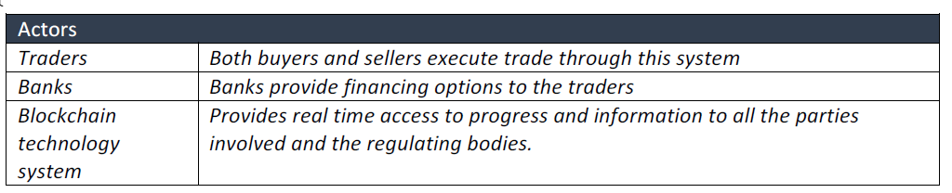

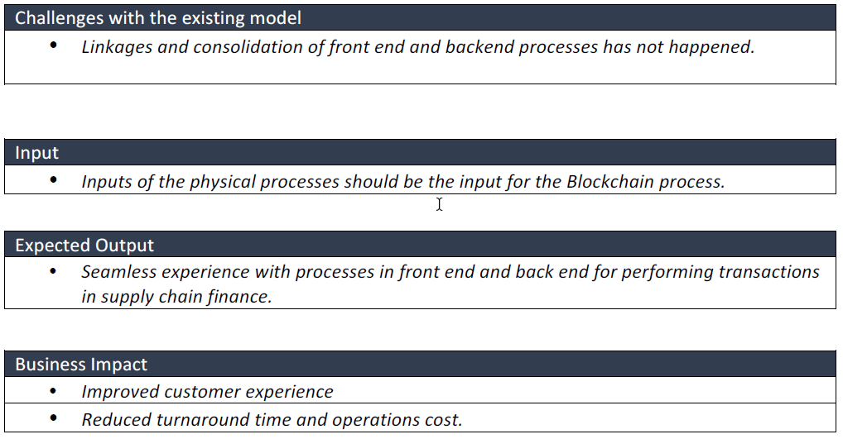

# Bibliography

(n.d.). Retrieved from http://www.edc.ca/EN/Our-Solutions/Documents/supply-chain-financing.pdf

Yaghoob Omrana, M. H. (2017). Blockchain-driven supply chain finance: Towards a conceptual framework from a buyer perspective.

# Glossary

|  |  |
| --- | --- |
| AP | Accounts Payable AP is money owed by a business to its suppliers and shown on its balance sheet as a liability. |
| AR | Accounts Receivable AR is money owed by suppliers to a business and shown on its balance sheet as an asset. |
| COGS | Cost Of Goods Sold COGS represent the direct costs attributable to the production of the goods sold by a company. This amount includes the cost of the materials used in creating the good along with the direct labour costs used to produce the good. It excludes indirect expenses such as distribution costs and sales force costs. |
| DPO | Days Payable Outstanding DPO= (Accounts payable/COGS) x 365 |
| DSO | Days Sales Outstanding DPO= (Accounts Receivables/Net sales) x 365 |
| Full-time equivalents | The number of employees equivalent to one full-time employee. 1FTE = one employee working full time |
| KYC | Know Your Customer Refers to relevant information obtained from a bank’s clients for the purpose of doing business with them. The objective of KYC guidelines is to prevent banks from being used, intentionally or unintentionally, by criminal elements for money laundering activities. Related procedures also enable banks to know or understand their customers, and their financial dealings better. This helps them to manage their risks prudently. |
| Receivable Finance | Receivable Finance allows suppliers to finance their receivables relating to one or many buyers and to receive early payment, usually at a discount on the value. |
| Recourse (with/without) | ‘With recourse’ is a legal agreement that provides protection to lenders, as they are assured of having some sort of repayment – either cash or liquid assets – in the event that the borrower is unable to satisfy the debt obligation. |
| ‘Without recourse’ | In a ‘Without recourse’ agreement, If the borrower defaults, the issuer can seize the collateral (usually property), but cannot seek out the borrower for any further compensation, even if the collateral does not cover the full value of the defaulted amount. |
| SCF | Supply Chain Finance The use of financial instruments, practices and technologies to optimize the management of the working capital and liquidity tied up in supply chain processes for collaborating business partners. SCF is largely ‘event-driven’. Each intervention (finance, risk mitigation or payment) in the financial supply chain is driven by an event in the physical supply chain. The development of advanced technologies to track and control events in the physical supply chain creates opportunities to automate the initiation of SCF interventions. |
| Spread | An amount that each bank decides to add to the base rate as its revenue. The bank buys the money at a price (exchange interbank rate) and resells it to its customers recharged with a profit margin (spread). |
| WACC | Weighted Average Cost of Capital As a company’s assets are financed by either debt or equity, WACC is the average of the costs of these sources of financing, each of which is weighted by its respective use in the given situation. By taking a weighted average, we can see how much interest the company has to pay for every dollar it finances. |
| Working Capital | The amount of day-by-day operating liquidity available to a business. In mathematical terms, working capital is calculated as WC=(AR)+(Inventory) – (AP) + (Cash) |