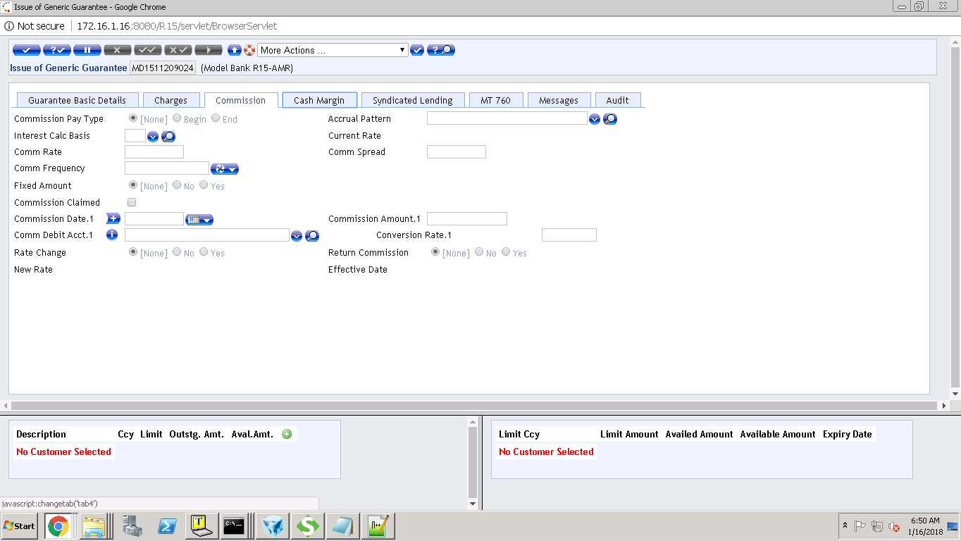

If begin : BELOW ARE MANDATORY

[Commission Date.1](javascript:linkError('tab3',%20'fieldName:CSN.DATE:1')): SHOULD BE VALUE DATE

FIXED AMOUNT:NO Rate change :YES ,RETURN COMMISSION:NO

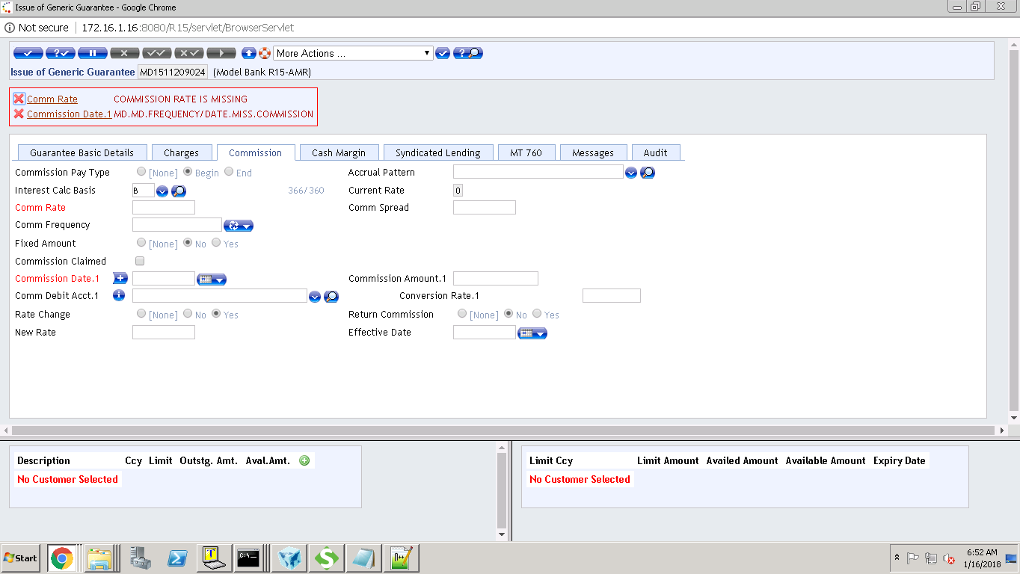

ACCOUNT IS MANDATORY

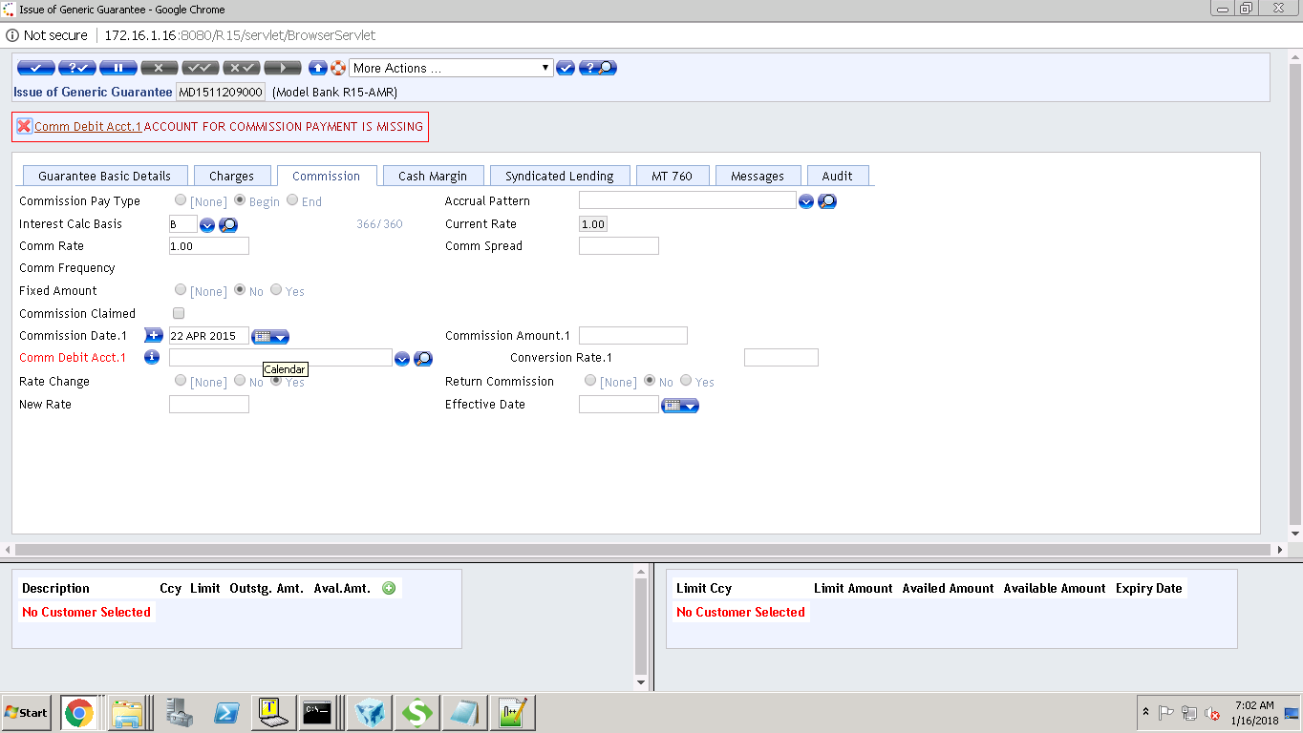

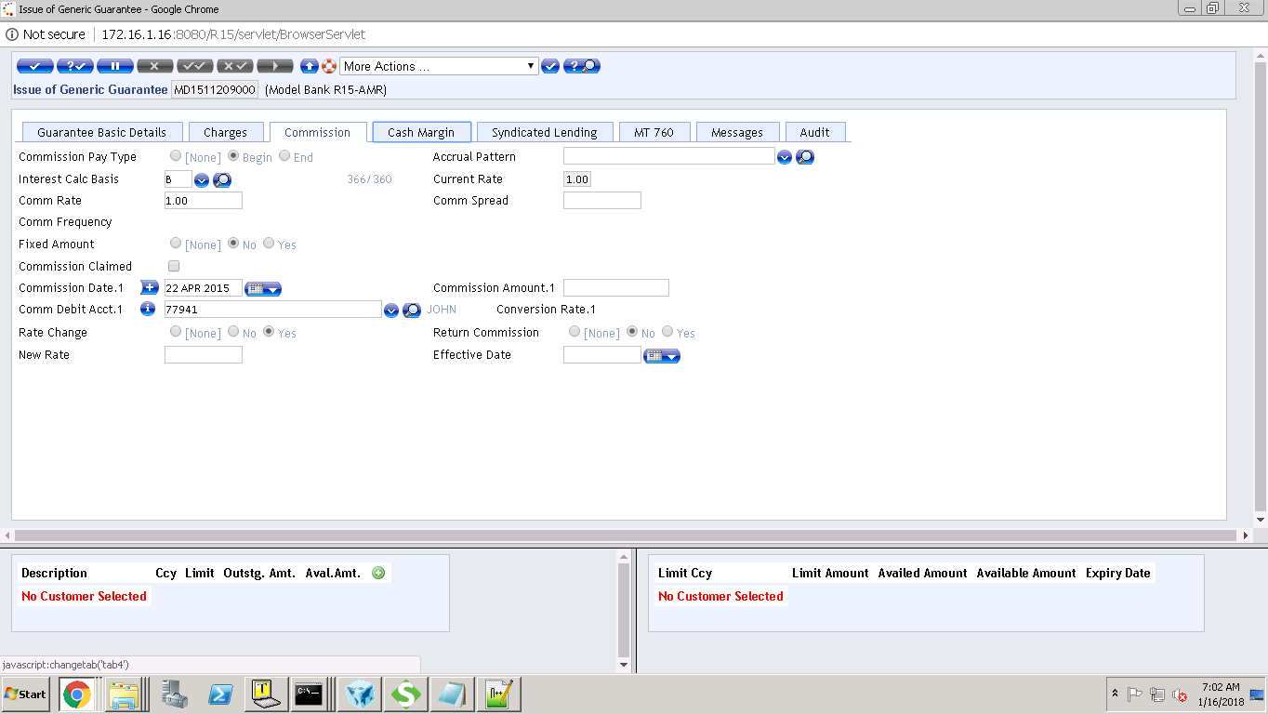

IF END:

|  |  |  |
| --- | --- | --- |
|  | [Commission Date.1](javascript:linkError('tab3',%20'fieldName:CSN.DATE:1')) | LAST SCH SHOULD BE MATURITY DATE |

|  |
| --- |
|  |

DATE,COMM RATE AND ACCOUNT IS MANADATORY

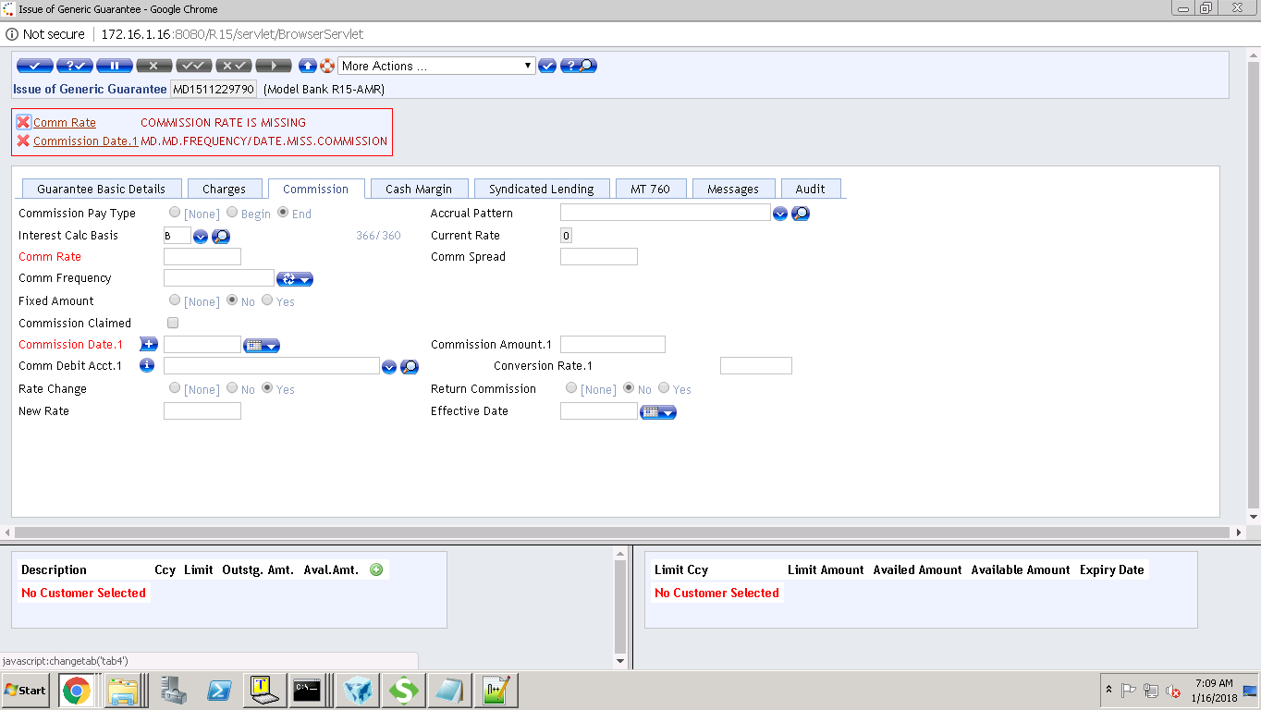

IF FIXED AMOUNT IS YES:

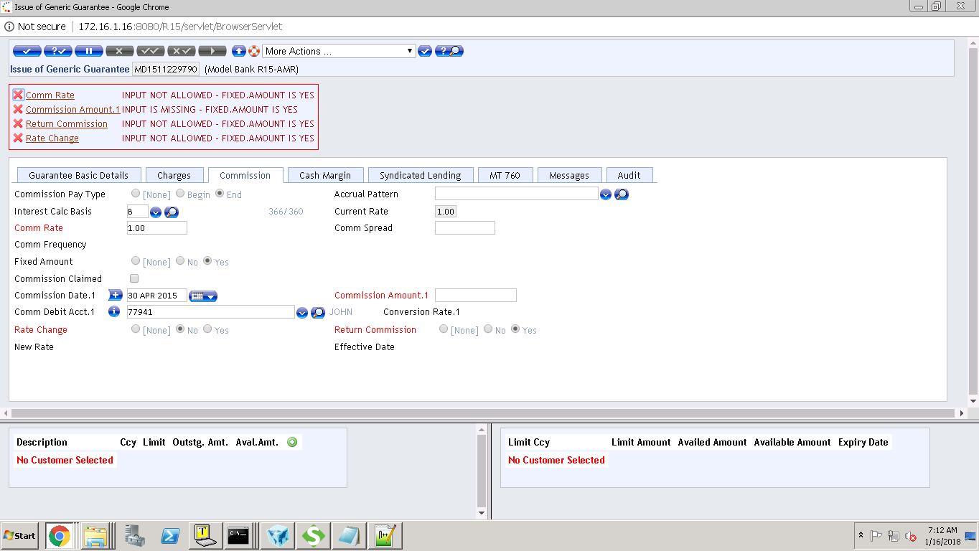

IF FIXED AMOUNT IS YES

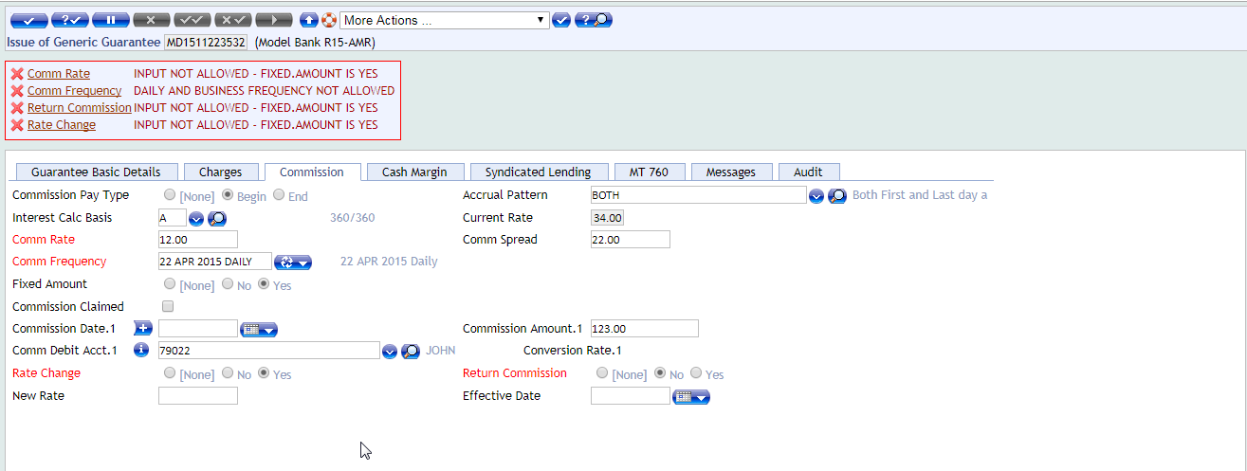

FIXED AMOUNT IS NO: COMM RATE, RATE CHANGE, RETURN COMMISSION SHOULD BE EMPTY

COMM FREQUENCY SHOULD NOT BE DAILY AND BUSINESS

IF COMMISSION CLAIMED IS CHECKED

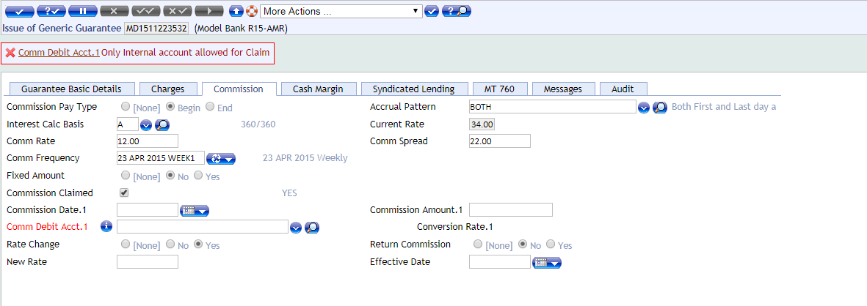

IF COMMISSION PAY TYPE IS END

