

**SWOT Analysis of**

**Royal Challengers Bangalore**

**2007- 2017**

**Contents**

1. **Objective**
2. **Data Analysis and description**
3. **SWOT Report**
4. **Objective**

For the given two data sets first one which provides match and its details and second one provide each ball description. Need to provide the SWOT analysis report of Royal Challenger Bangalore team with detail Data analysis and its description.

1. **Data Analysis and description**
2. Royal Challengers Bangalore (RCB) is very experienced team who played 24% of total IPL matches ( RCB played totally 150 matches out of 633).

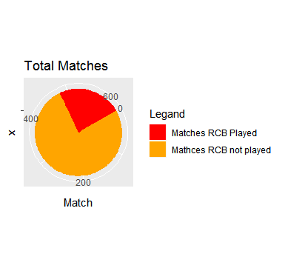

1. Their wining odd is more in the previous majority of seasons

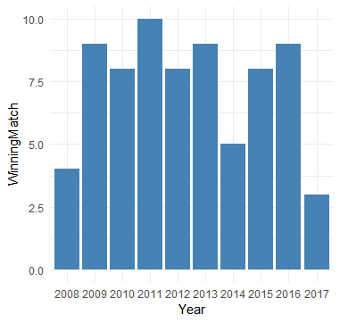

1. RCB performed very well in the foreign and new city grounds

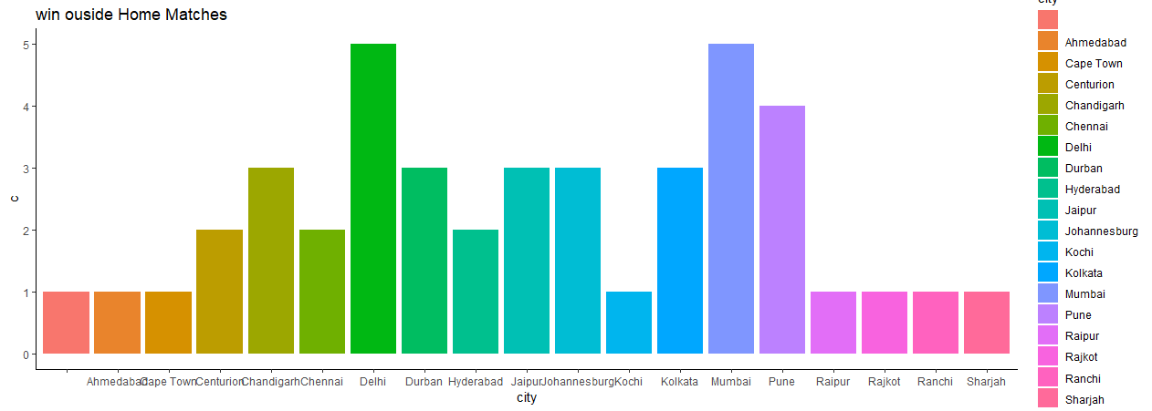

1. They are very good in chasing, Out of 73 winning matches 47 they started with fielding.

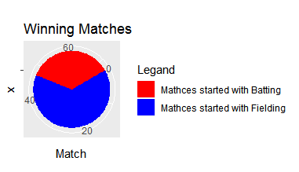

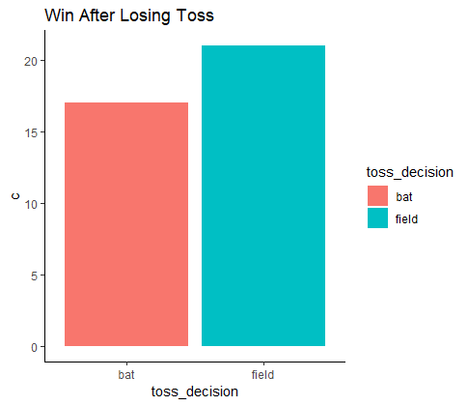

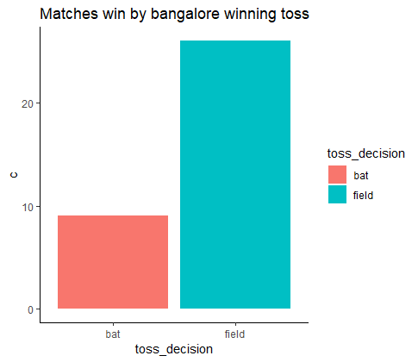

1. Team which one against RCB

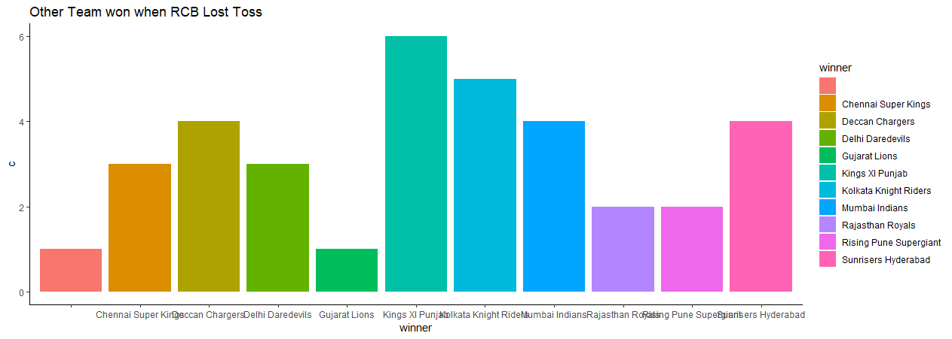

1. RCB is not able to set good target runs, Even when they win the toss and opted for fielding provided the good chance of winning.
2. Man of the match is not distributed. So, match winning is based upon few players performance. (These 5 players bagged 65% of Man of match title)

|  |  |
| --- | --- |
| CH Gayle | 17 |
| AB de Villiers | 13 |
| V Kohli | 10 |
| JH Kallis | 5 |
| R Vinay Kumar | 3 |

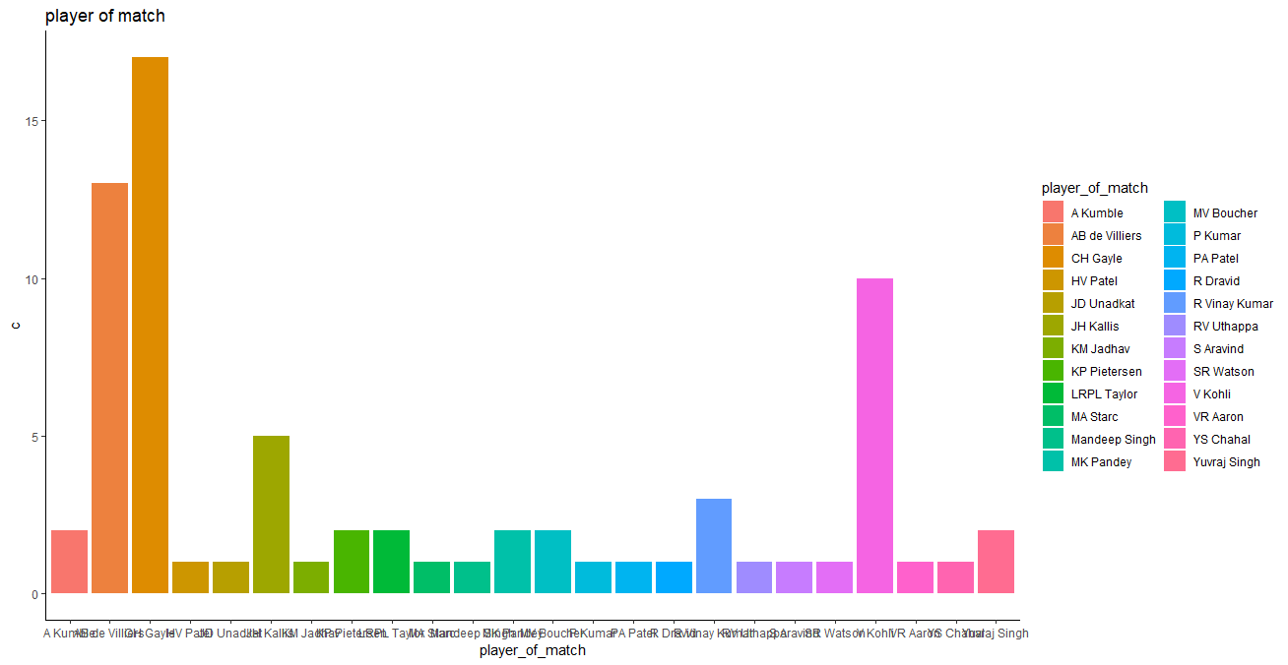

1. RCB is one of the team which is benefited from the DL rule. They declared as winner in 3 matches by using DL.

1. Performance of RCB reduced a lot. In the last session they won only 3 matches out of 13.
2. Most of the RCB winning margin is minor when compared with loosing match margin.

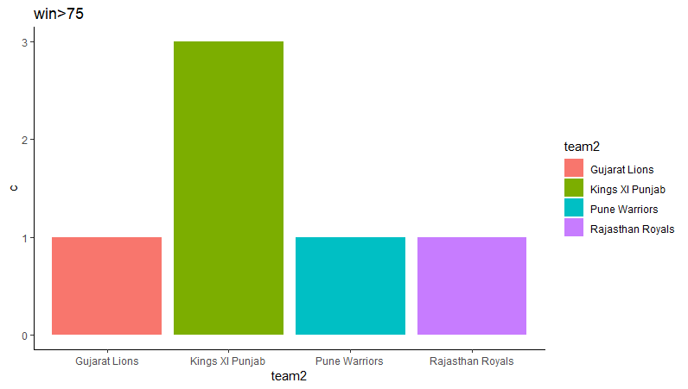

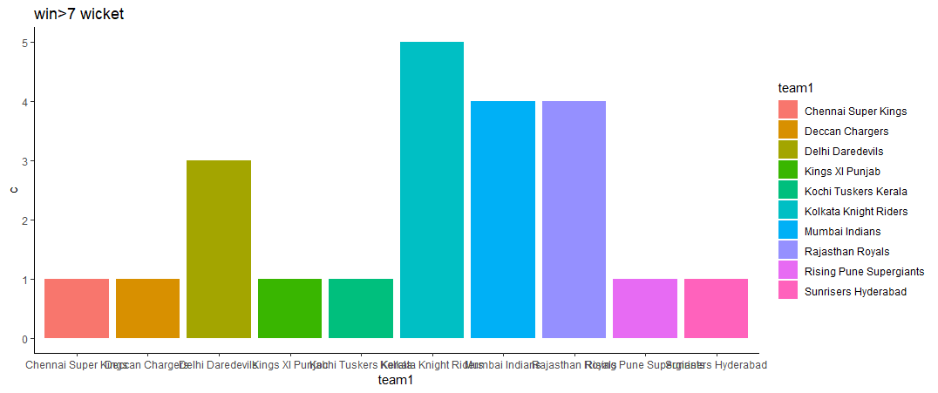

1. **RCB got more than50%of runs from the following 5 batsman**

|  |  |
| --- | --- |
| **Row Labels** | **Sum of total_runs** |
| V Kohli | 4588 |
| CH Gayle | 3389 |
| AB de Villiers | 2933 |
| JH Kallis | 1214 |
| R Dravid | 924 |

1. **RCB received around 10% of runs from extra**

|  |  |  |  |  |  |  |  |  |
| --- | --- | --- | --- | --- | --- | --- | --- | --- |
| **Row Labels** | **Batsman**  **_runs** | **wide_**  **runs** | **extra_**  **runs** | **noball_**  **runs** | **bye_**  **runs** | **legbye_**  **runs** | **total_**  **runs** | **penalty_**  **runs** |
| **Grand Total** | **22244** | **651** | **1192** | **86** | **71** | **384** | **23436** | **0** |

1. **RCB gave around 12% of runs in extra**

|  |  |  |  |  |  |  |  |  |
| --- | --- | --- | --- | --- | --- | --- | --- | --- |
| **Row Labels** | **wide_runs** | **bye_runs** | **legbye_runs** | **noball_runs** | **penalty_runs** | **extra_runs** | **total_runs** | **batsman_runs** |
| **Grand Total** | **725** | **105** | **401** | **78** | **0** | **1309** | **23622** | **22313** |

1. **Below 9 bowler captured more than 50% total wickets**

|  |  |  |  |  |  |  |  |  |  |
| --- | --- | --- | --- | --- | --- | --- | --- | --- | --- |
| Row Labels | bowled | caught | caught and bowled | lbw | retired hurt | run out | stumped | (blank) | Grand Total |
| R Vinay Kumar | 10 | 55 | 3 | 4 |  | 11 |  |  | 83 |
| YS Chahal | 9 | 49 | 1 | 3 |  | 2 | 8 |  | 72 |
| Z Khan | 11 | 33 | 1 | 4 | 1 | 6 |  |  | 56 |
| A Kumble | 8 | 24 | 1 | 4 |  | 4 | 8 |  | 49 |
| S Aravind | 8 | 32 | 3 | 2 |  | 3 |  |  | 48 |
| P Kumar | 3 | 27 | 1 | 3 |  | 6 |  |  | 40 |
| MA Starc | 15 | 17 |  | 2 |  | 5 |  |  | 39 |
| HV Patel | 5 | 26 | 1 | 2 |  | 3 |  |  | 37 |
| DW Steyn | 6 | 19 |  | 2 |  | 6 |  |  | 33 |
|  |  |  |  |  |  |  |  |  |  |
|  |  |  |  |  |  |  |  |  |  |

|  |  |  |
| --- | --- | --- |
|  | **Helpful**  to achieving the objective | **Harmful**  to achieving the objective |
| **Internal origin**  (attributes of the system) | *Strengths*   1. ... 2. .... 3. ..... | *Weaknesses*   1. ... 2. .... 3. ..... |
| **External origin** (attributes of the environment) | *Opportunities*   1. ... 2. .... 3. ..... | *Threats*   1. ... 2. .... 3. ..... |