

DATA STRUCTURES AND ALGORITHMS
23CSE203
LAB MANUAL
SUBMITTED BY
NAME | Katakam Satya Mohit
ROLL NO. | AV.SC.U4CSE25206
YEAR/SEM/SECTION | 2nd YEAR/3rd SEM/CSE-C
Credits | 05

Submitted to | Dr. GAYATHRI PARASA
Designation | Asst. Professor (Sr.Gr)
Department | School of Computing

S.NO | TITLE NAME | PAGE NO-
1 | - A rocket launch system displays a count down before launch. Instead of using a loop, implement the count down using recursion. Write a recursive python program to display countdown from n to 1 followed by launch.  - Banks calculate the growth of investment using compound interest. The formula requires calculating powers, which can be implemented recursively. Write a recursive program to calculate P^n where P = Principal growth factor, n = number of years  - A HR department stores employee details in a list. Develop a recursive program to search for a given employee ID. Write a recursive function to search for an employee ID in a list.  - In a logistic department, the no of possible ways to arrange n diff parcels are calculated using the factorial formula(n!). Write a recursive formula to find the factorial of a given number  - Print first n terms in a fibanocci number series | 5-8
2 | Write the implementation for the linear search algorithm  Write the implementation for the binary search algorithm | 9-10
3 | - Write a python program to implement bubble sort  - Write a python program to implement insertion sort  - Write a python program to implement selection sort | 11-13
4 | - Write a python program to implement merge sort  b) Write a python program to implement quick sort | 14-15

5 | a) Write a Python program to implement a Singly Linked List (SLL) with the following operations:  - Create Linked List  - Insert Beginning  - Insert End  - Insert at Index  - Delete by Value  - Delete First Node  - Delete Last Node  - Count number of nodes  - Sort the data of SLL  - Search data in SLL  - Display or Traverse  12)Exit | 16-19
6 | Write a Python program to implement a Double Linked List (DLL) with the following operations:  - Create Linked List  - Insert Beginning  - Insert End  - Insert at Index  - Delete by Value  - Delete First Node  - Delete Last Node  - Count number of nodes  - Display or Traverse  10)Exit | 20-25
7 | Write a python program to implement stack operations such as push, pop, peek, display using an array.  Write a python program to implement stack operations such as push, pop, peek, display using a linked list. | 26-28
8 | Write a python program to implement Queue and its operations such as enqueue, dequeue, peek, display with a menu driven approach. Implement using array, and linked list data structures.  Write a python program to implement Circular Queue and its operations such as enqueue, dequeue, peek, display with a menu driven approach. Implement using array, and linked list data structures. | 29-34
9 | Write a python program to implement a Binary Search Tree (BST) and perform the following operations.  1. Insertion  2. Deletion  3. Tree Traversals – in-order, pre-order and post-order  4. Count Leaf Nodes  5. Count Internal Nodes  6. Height of the Tree | 35-38
10 | Write a menu driven python program to implement an AVL Tree and perform the following operations.  1. Insertion  2. Deletion  3. Tree Traversals  4. Count Leaf Nodes  5. Count Internal Nodes  6. Height of the Tree | 39-41
11 | Write a menu-driven Python program to implement a Binary Heap (Max Heap and Min Heap) and perform the following operations:  - Insertion of an element into the Heap.  - Deletion of the root element from the Heap.  - Display the array representation of the Heap.  - Exit the program. | 42-43
12 | Write a program to implement the following three collision resolution techniques in a Hash Table:  - Separate Chaining  - Linear Probing  - Quadratic Probing | 44-47

WEEK 1
Aim:

Recursion:

a)A rocket launch system displays a count down before launch. Instead of using a loop, implement the count down using recursion. Write a recursive python program to display countdown from n to 1 followed by launch.
Program:
def countdown(n):
if n == 0:
print("Launch!")
else:
print(n)
countdown(n - 1)

n = int(input("Enter the countdown number: "))

countdown(n)

Output:

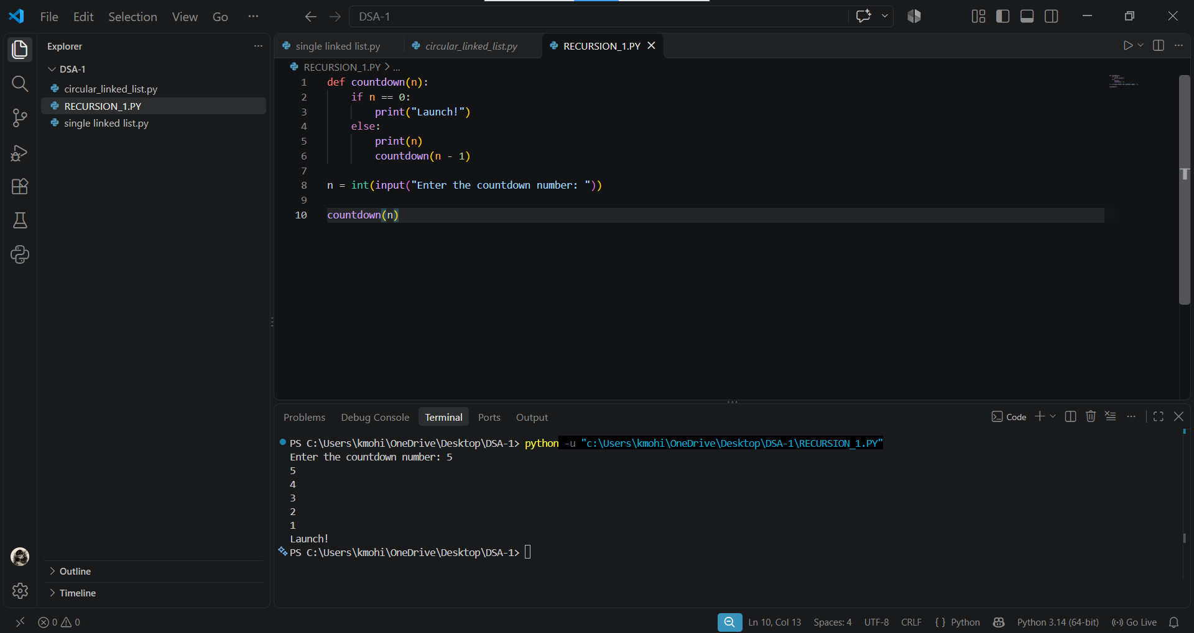

b) Banks calculate the growth of investment using compound interest. The formula requires calculating powers, which can be implemented recursively. Write a recursive program to calculate P^n where P = Principal growth factor, n = number of years

Program:

def power(P, n):
if n == 0:
return 1
else:
return P * power(P, n - 1)

P = int(input("Enter the principal growth factor: "))
n = int(input("Enter the number of years: "))

result = power(P, n)

print("Result =", result)

Output:

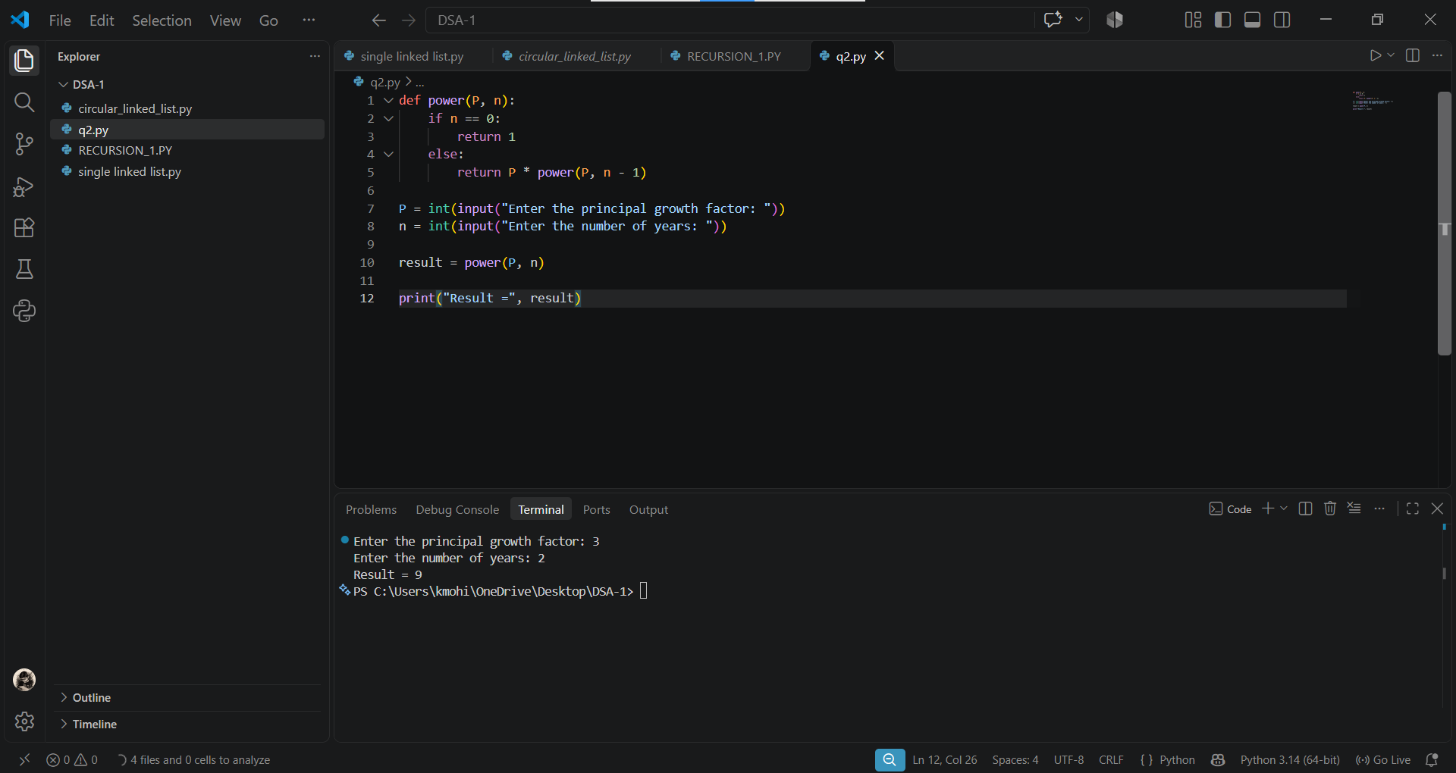

c)A HR department stores employee details in a list. Develop a recursive program to search for a given employee ID. Write a recursive function to search for an employee ID in a list.
Program:

def search(emp, eid, i):
if i == len(emp):
return -1
elif emp[i] == eid:
return i
else:
return search(emp, eid, i + 1)

emp = [101, 102, 103, 104, 105]

eid = int(input("Enter Employee ID to search: "))

result = search(emp, eid, 0)

if result == -1:
print("Employee ID not found")
else:
print("Employee ID found at index", result)

Output:

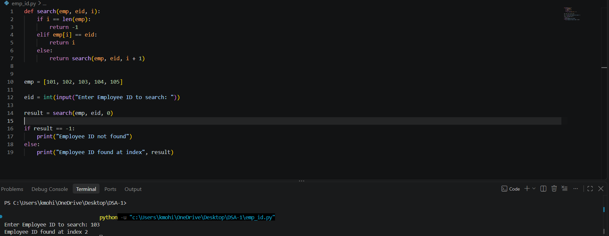

d)In a logistic department, the no of possible ways to arrange n diff parcels are calculated using the factorial formula(n!). Write a recursive formula to find the factorial of a given number.
Program:
def factorial(n):
if n == 0 or n == 1:
return 1
else:
return n * factorial(n - 1)

n = int(input("Enter a number: "))

result = factorial(n)

print("Factorial of", n, "is", result)

Output:

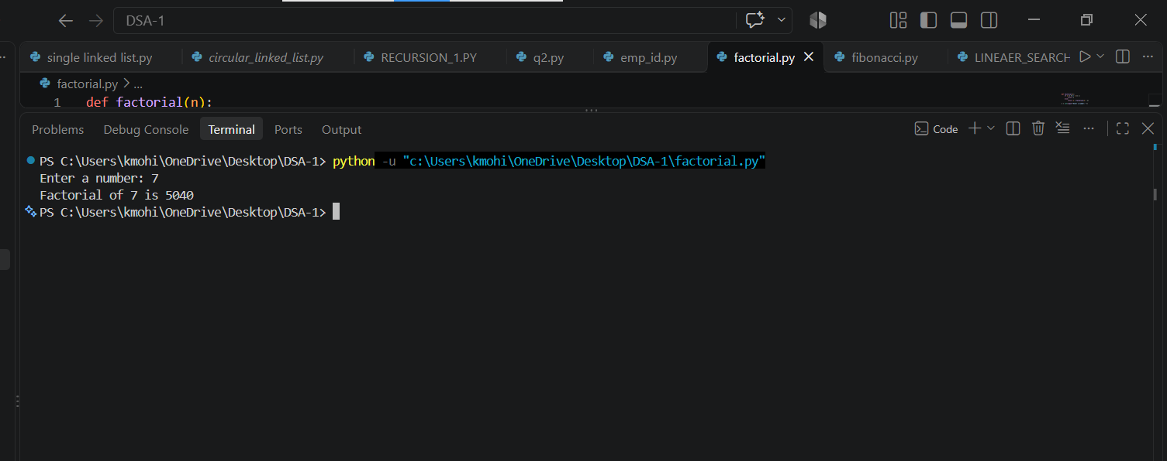

e)Print first n terms in a fibanocci number series
Program:

def fibonacci(n, a=0, b=1):
if n == 0:
return
print(a, end=" ")
fibonacci(n - 1, b, a + b)

n = int(input("Enter number of terms: "))

fibonacci(n)

Output:

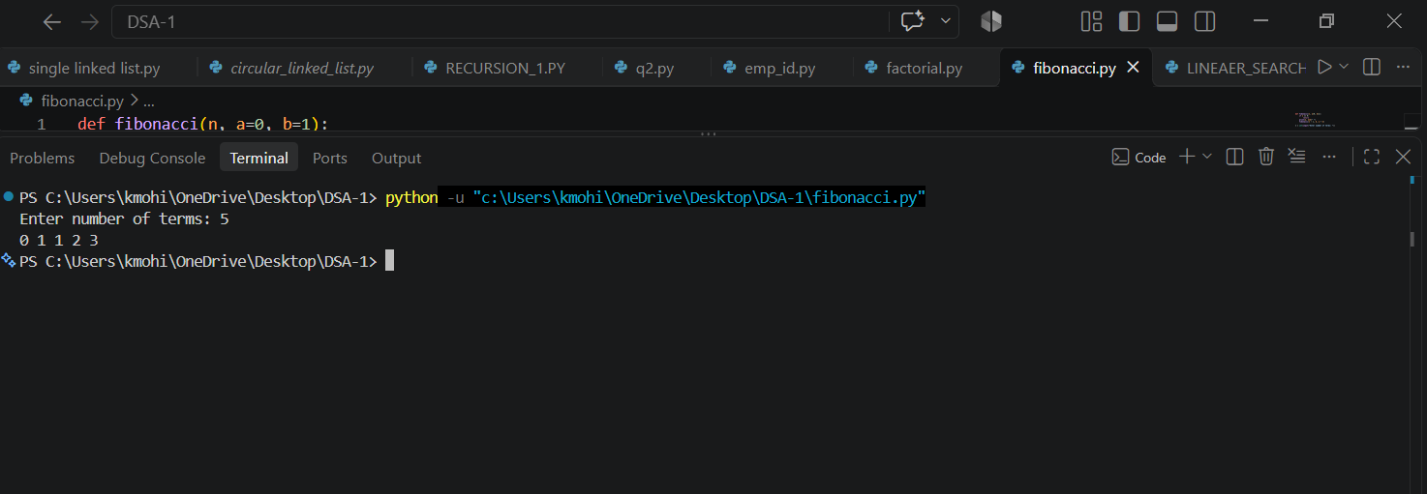

WEEK 2

Aim:

Write the implementation for the linear search algorithm

Program:

def linear_search(arr, key):
for i in range(len(arr)):
if arr[i] == key:
return i
return -1
n=int(input("Enter the number of elements in the array: "))
arr = []
for i in range(n):
element = int(input("Enter element {}: ".format(i + 1)))
arr.append(element)

key = int(input("Enter the element to search: "))

result = linear_search(arr, key)

if result == -1:
print("Element not found")
else:
print("Element found at index", result)

Output:

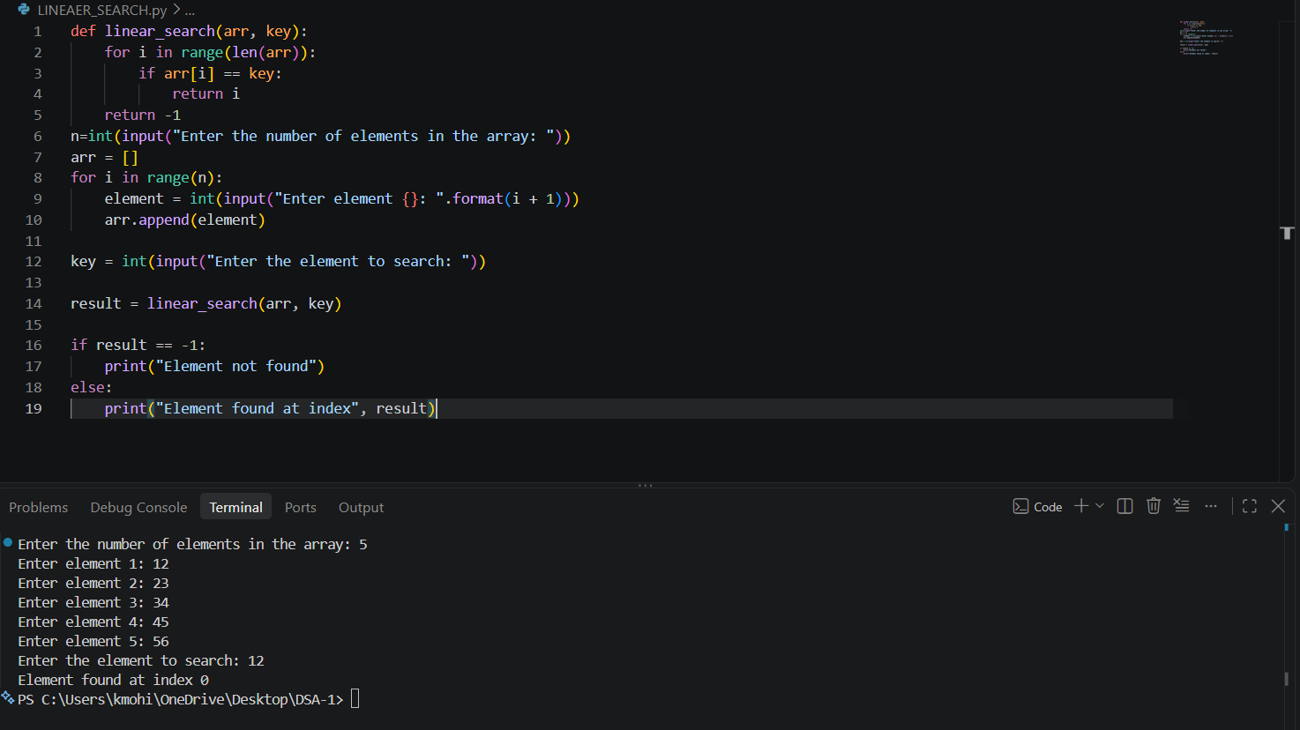

Aim:

Write the implementation for the binary search algorithm
Program:

def binary_search(arr, key):
low = 0
high = len(arr) - 1

while low <= high:
mid = (low + high) // 2

if arr[mid] == key:
return mid
elif key < arr[mid]:
high = mid - 1
else:
low = mid + 1

return -1

n=int(input("Enter the number of elements in the array: "))
arr = []
for i in range(n):
element = int(input("Enter element: "))
arr.append(element)

key = int(input("Enter the element to search: "))

result = binary_search(arr, key)

if result == -1:
print("Element not found")
else:
print("Element found at position", result + 1)

Output:

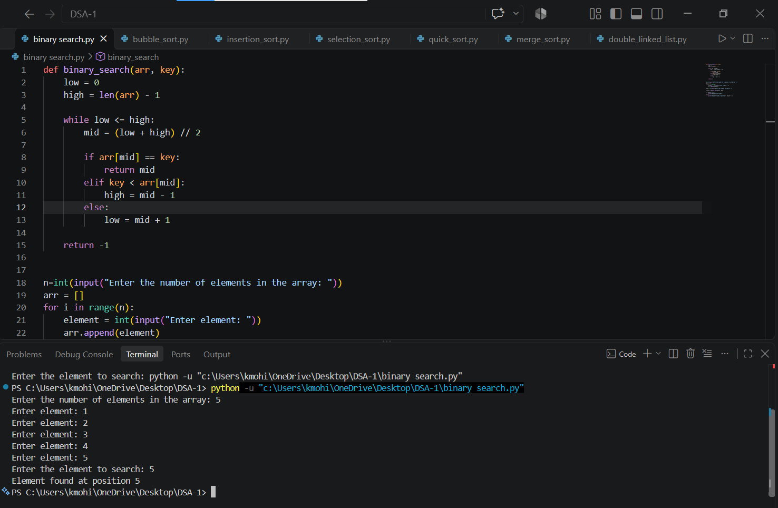

WEEK 3
Aim:

Write a python program to implement bubble sort.

Program:

def bubble_sort(arr):
n = len(arr)

for i in range(n - 1):
for j in range(n - i - 1):
if arr[j] > arr[j + 1]:
arr[j], arr[j + 1] = arr[j + 1], arr[j]

return arr

n = int(input("Enter number of elements: "))

arr = []
for i in range(n):
x = int(input("Enter element: "))
arr.append(x)

print("Sorted array:", bubble_sort(arr))

Output:

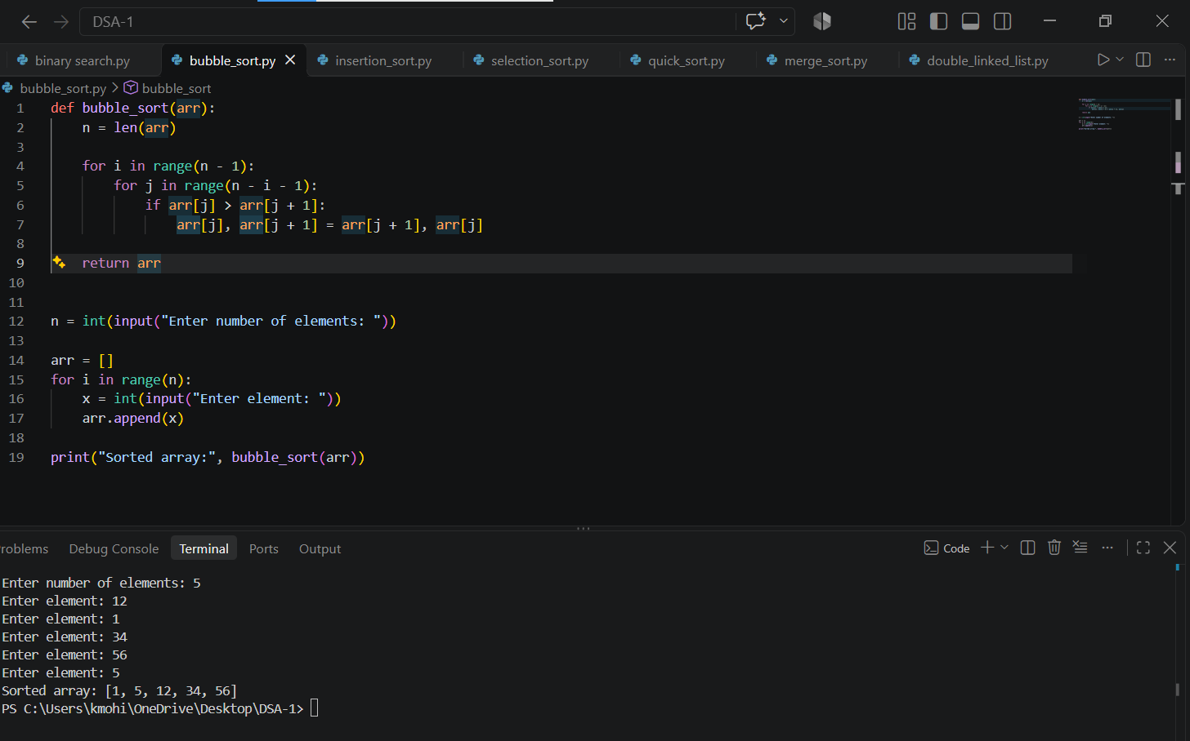

Aim:
Write a python program to implement insertion sort.
Program:

def insertion_sort(arr):
n = len(arr)

for i in range(1, n):
key = arr[i]
j = i - 1

while j >= 0 and arr[j] > key:
arr[j + 1] = arr[j]
j = j - 1

arr[j + 1] = key

return arr

n = int(input("Enter number of elements: "))

arr = []
for i in range(n):
x = int(input("Enter element: "))
arr.append(x)

print("Sorted array:", insertion_sort(arr))
Output:

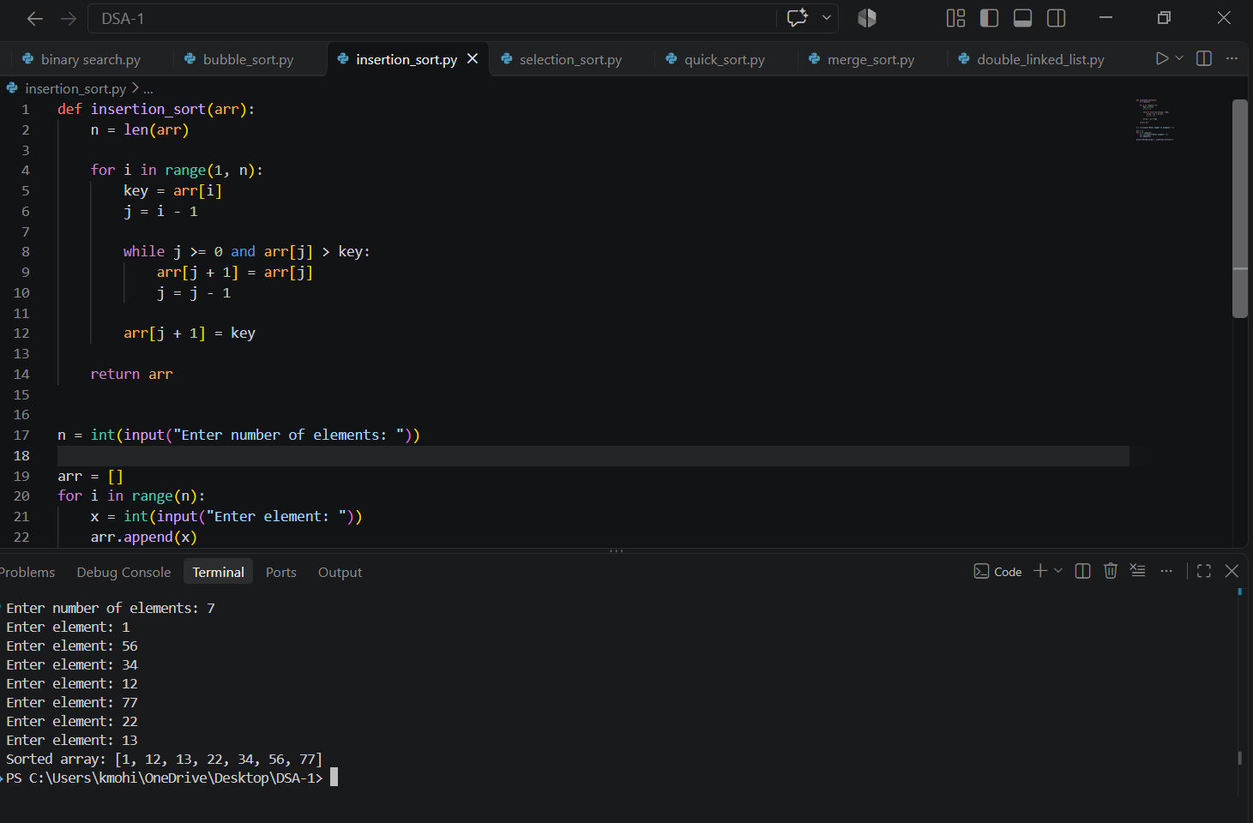

Aim:

Write a python program to implement selection sort.

Program:

def selection_sort(arr):
n = len(arr)

for i in range(n - 1):
min_index = i

for j in range(i + 1, n):
if arr[j] < arr[min_index]:
min_index = j

arr[i], arr[min_index] = arr[min_index], arr[i]

return arr

n = int(input("Enter number of elements: "))

arr = []
for i in range(n):
x = int(input("Enter element: "))
arr.append(x)

print("Sorted array:", selection_sort(arr))

Output:

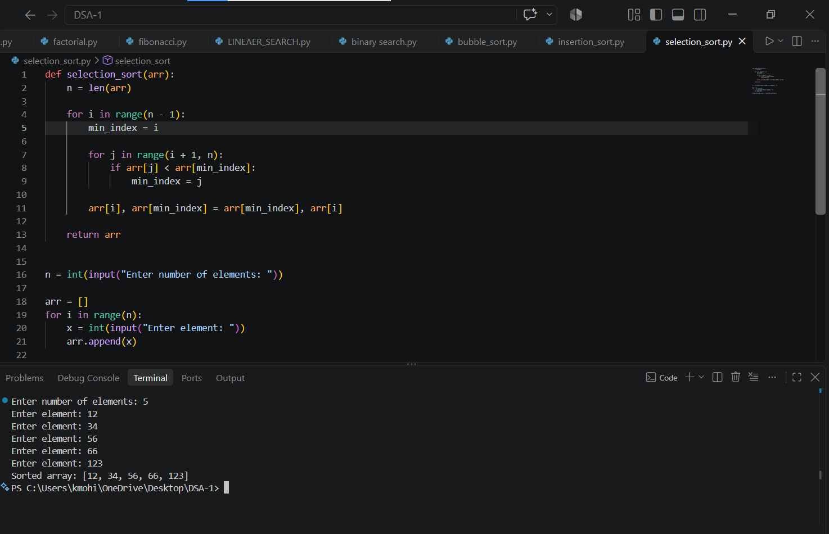

WEEK 4
Aim:

Write a python program to implement quick sort.

Program:

def quicksort(a, low, high):
if low < high:
i, j, pivot = low, high, low

while i < j:
while i < len(a) and a[i] <= a[pivot]:
i += 1
while a[j] > a[pivot]:
j -= 1
if i < j:
a[i], a[j] = a[j], a[i]

a[pivot], a[j] = a[j], a[pivot]

quicksort(a, low, j - 1)
quicksort(a, j + 1, high)

a = list(map(int, input("Enter numbers: ").split()))
quicksort(a, 0, len(a) - 1)
print("Sorted array:", a)

Output:

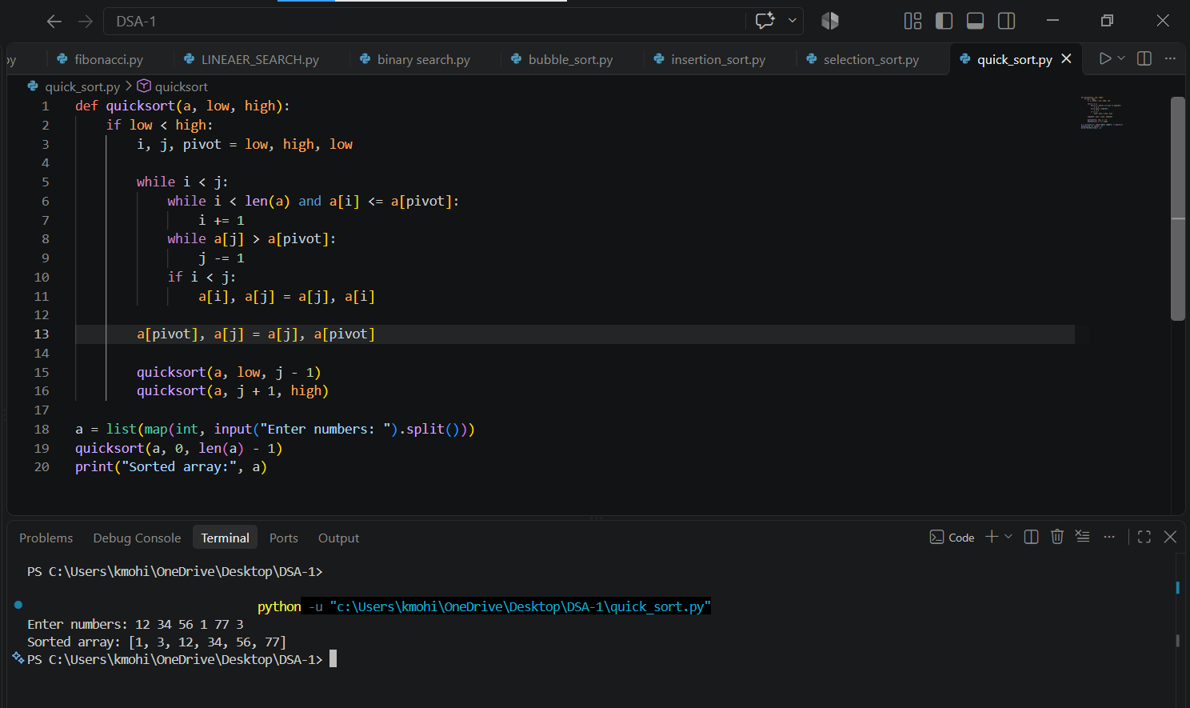

Aim:

Write a python program to implement merge sort.

Program:

def merge_sort(a):
if len(a) > 1:
m = len(a) // 2
L, R = a[:m], a[m:]

merge_sort(L)
merge_sort(R)

i = j = k = 0

while i < len(L) and j < len(R):
if L[i] < R[j]:
a[k] = L[i]
i += 1
else:
a[k] = R[j]
j += 1
k += 1

while i < len(L):
a[k] = L[i]
i += 1
k += 1

while j < len(R):
a[k] = R[j]
j += 1
k += 1

a = list(map(int, input("Enter numbers: ").split()))
merge_sort(a)
print("Sorted array:", a)

Output:

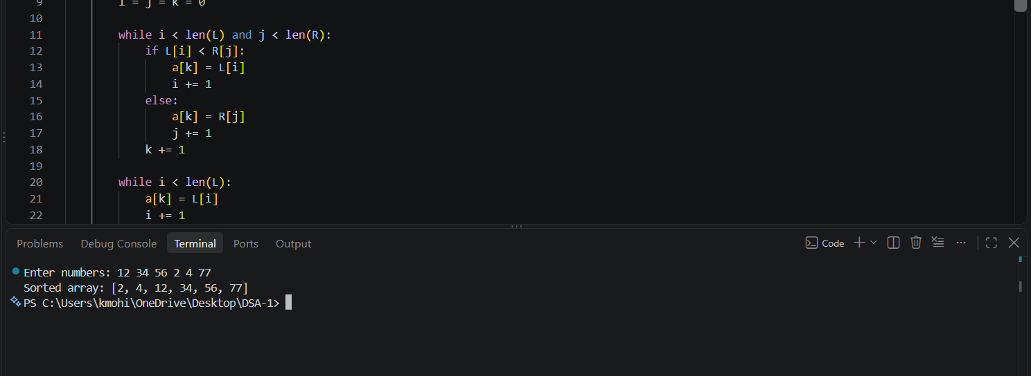

WEEK 5
Aim:
Write a python program to implement a Singly Linked List with the below operations.
- Create Linked List
- Insert Beginning
- Insert End
- Insert at Index
- Delete by Value
- Delete First Node
- Delete Last Node
- Count number of nodes
- Sort the data of SLL
- Search data in SLL
- Display or Traverse
12)Exit

Program:

class Node:
def __init__(self, data):
self.data = data
self.next = None
class SinglyLinkedList:
def __init__(self):
self.head = None
def create(self):
n = int(input("Enter the number of elements: "))
for i in range(n):
x = int(input("Enter the value: "))
new = Node(x)
if self.head is None:
self.head = new
else:
temp = self.head
while temp.next:
temp = temp.next
temp.next = new
def insert_begin(self, data):
new = Node(data)
new.next = self.head
self.head = new
def insert_end(self, data):
new = Node(data)
if self.head is None:
self.head = new
else:
temp = self.head
while temp.next:
temp = temp.next
temp.next = new
def insert_specific(self, index, data):
if index < 0:
print("Invalid index")
return
if index == 0:
self.insert_begin(data)
return

temp = self.head
for i in range(index - 1):
if temp is None:
print("Invalid index")
return
temp = temp.next
if temp is None:
print("Invalid index")
return

new = Node(data)
new.next = temp.next
temp.next = new

def deleteAtBegin(self):
if self.head is None:
print("No data to delete")
else:
temp = self.head
self.head = temp.next
print("Deleted element is:", temp.data)

def deleteAtEnd(self):
if self.head is None:
print("No data to delete")

elif self.head.next is None:
print("Deleted element is:", self.head.data)
self.head = None

else:
temp = self.head
temp1 = temp

while temp.next:
temp1 = temp
temp = temp.next

temp1.next = None
print("Deleted element is:", temp.data)

def delete(self, value):
if self.head is None:
print("No data to delete")
return

temp = self.head

if temp.data == value:
self.head = temp.next
print("Value deleted")
return

while temp.next and temp.next.data != value:
temp = temp.next

if temp.next is None:
print("Value not present")
else:
temp.next = temp.next.next
print("Value deleted")
def display(self):
if self.head is None:
print("No data to display")
else:
temp = self.head
while temp:
print(temp.data, end=" ")
temp = temp.next
print()
def count(self):
if self.head is None:
print("No Linked list")
else:
c=0
temp=self.head
while temp:
c+=1
temp=temp.next
print("Number of nodes:", c)
def search(self, value):
if self.head is None:
print("No data to search")
return

temp = self.head
index = 0

while temp:
if temp.data == value:
print(f"Value found at index: {index}")
return
temp = temp.next
index += 1

print("Value not found in the list")
def sort(self):
if self.head is None:
print("No data to sort")
return

current = self.head
while current:
index = current.next
while index:
if current.data > index.data:
current.data, index.data = index.data, current.data
index = index.next
current = current.next
print("Linked list sorted")
def delete_all(self):
self.head = None
print("Entire linked list deleted")
sll = SinglyLinkedList()
while True:
print("1. Create a linked list")
print("2. Insert at beginning")
print("3. Insert at end")
print("4. Insert at specific position")
print("5. Delete at beginning")
print("6. Delete at end")
print("7. Delete a specific value")
print("8. Display the linked list")
print("9. Count the number of nodes")
print("10. Search for a value")
print("11. Sort the linked list")
print("12. delete entire linked list")
print("13. Exit")

choice = int(input("Enter your choice: "))

if choice == 1:
sll.create()
elif choice == 2:
data = int(input("Enter the value to insert: "))
sll.insert_begin(data)
elif choice == 3:
data = int(input("Enter the value to insert: "))
sll.insert_end(data)
elif choice == 4:
index = int(input("Enter the index to insert: "))
data = int(input("Enter the value to insert: "))
sll.insert_specific(index, data)
elif choice == 5:
sll.deleteAtBegin()
elif choice == 6:
sll.deleteAtEnd()
elif choice == 7:
value = int(input("Enter the value to delete: "))
sll.delete(value)
elif choice == 8:
sll.display()
elif choice == 9:
sll.count()
elif choice == 10:
value = int(input("Enter the value to search: "))
sll.search(value)
elif choice == 11:
sll.sort()
elif choice == 12:
sll.delete_all()
elif choice == 13:
break
else:
print("Invalid choice, please try again.")

Output:

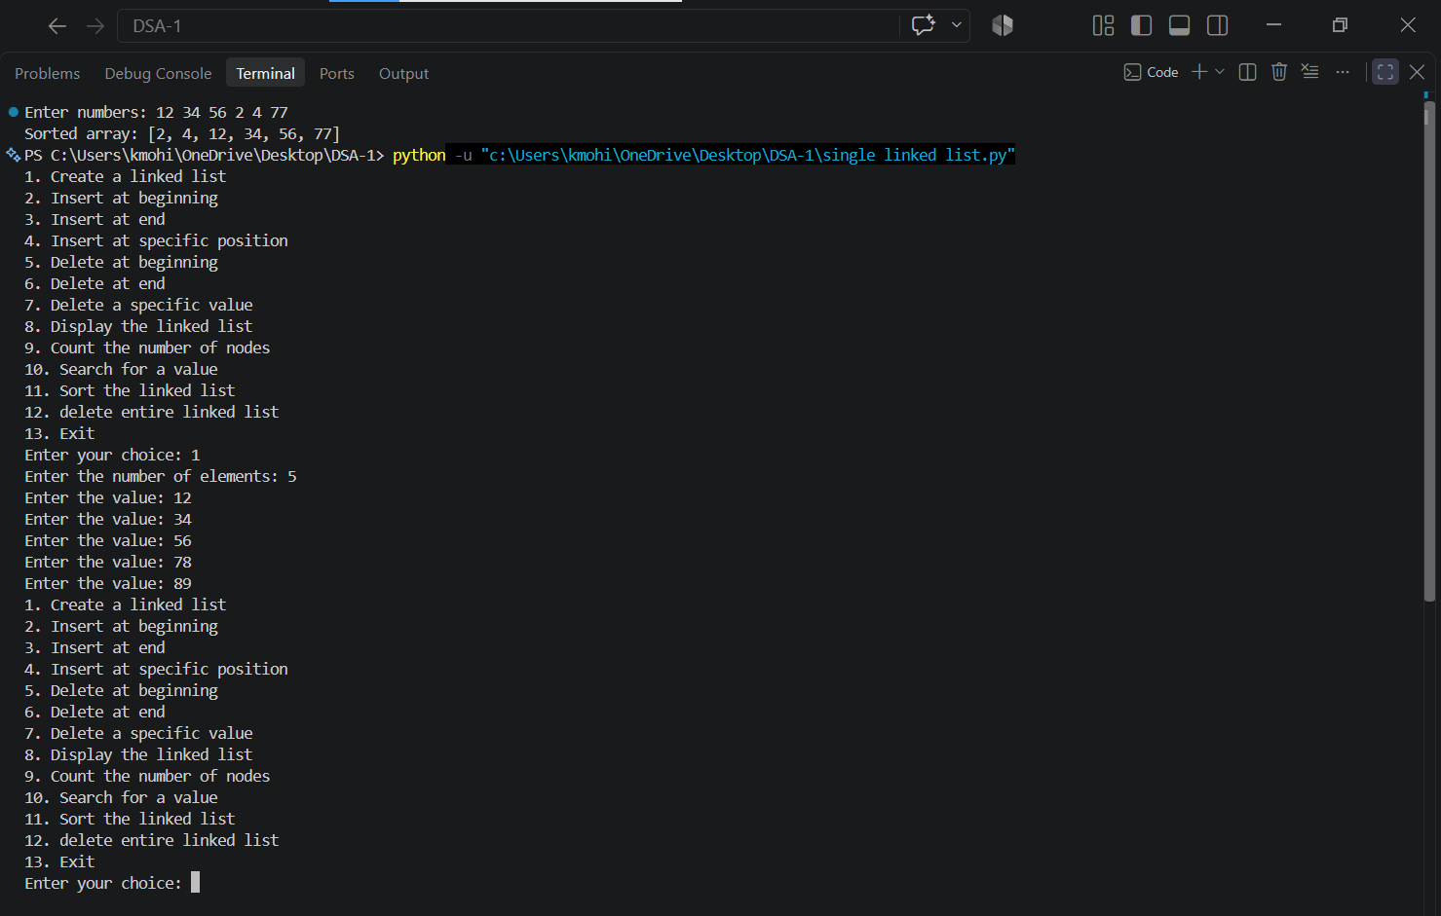

WEEK 6
Aim:

Write a python program to implement a Double Linked List with the below operations.
- Create Linked List
- Insert Beginning
- Insert End
- Insert at Index
- Delete by Value
- Delete First Node
- Delete Last Node
- Count number of nodes
- Display or Traverse
10)Exit

Program:

class Node:
def __init__(self, data):
self.data = data
self.prev = None
self.next = None

class DoublyLinkedList:
def __init__(self):
self.head = None

# Create Linked List
def create(self):
n = int(input("Enter the number of elements: "))

for i in range(n):
x = int(input("Enter the value: "))
new = Node(x)

if self.head is None:
self.head = new
else:
temp = self.head
while temp.next:
temp = temp.next

temp.next = new
new.prev = temp

# Insert at Beginning
def insert_begin(self, data):
new = Node(data)

new.next = self.head

if self.head is not None:
self.head.prev = new

self.head = new

# Insert at End
def insert_end(self, data):
new = Node(data)

if self.head is None:
self.head = new
else:
temp = self.head

while temp.next:
temp = temp.next

temp.next = new
new.prev = temp

# Insert at Specific Index
def insert_specific(self, index, data):
if index < 0:
print("Invalid index")
return

if index == 0:
self.insert_begin(data)
return

temp = self.head

for i in range(index - 1):
if temp is None:
print("Invalid index")
return
temp = temp.next

if temp is None:
print("Invalid index")
return

new = Node(data)

new.next = temp.next
new.prev = temp

if temp.next is not None:
temp.next.prev = new

temp.next = new

# Delete First Node
def deleteAtBegin(self):
if self.head is None:
print("No data to delete")
else:
temp = self.head
self.head = temp.next

if self.head is not None:
self.head.prev = None

print("Deleted element is:", temp.data)

# Delete Last Node
def deleteAtEnd(self):
if self.head is None:
print("No data to delete")

elif self.head.next is None:
print("Deleted element is:", self.head.data)
self.head = None

else:
temp = self.head

while temp.next:
temp = temp.next

temp1 = temp.prev
temp1.next = None

print("Deleted element is:", temp.data)

# Delete by Value
def delete(self, value):
if self.head is None:
print("No data to delete")
return

temp = self.head

if temp.data == value:
self.head = temp.next

if self.head is not None:
self.head.prev = None

print("Value deleted")
return

while temp and temp.data != value:
temp = temp.next

if temp is None:
print("Value not present")
else:
temp.prev.next = temp.next

if temp.next is not None:
temp.next.prev = temp.prev

print("Value deleted")

# Count Number of Nodes
def count(self):
if self.head is None:
print("No Linked list")
else:
c = 0
temp = self.head

while temp:
c += 1
temp = temp.next

print("Number of nodes:", c)

# Display / Traverse
def display(self):
if self.head is None:
print("No data to display")
else:
temp = self.head

while temp:
print(temp.data, end=" ")
temp = temp.next

print()

# Main Program
dll = DoublyLinkedList()

while True:
print("\n1. Create a linked list")
print("2. Insert at beginning")
print("3. Insert at end")
print("4. Insert at specific position")
print("5. Delete a specific value")
print("6. Delete at beginning")
print("7. Delete at end")
print("8. Count the number of nodes")
print("9. Display the linked list")
print("10. Exit")

choice = int(input("Enter your choice: "))

if choice == 1:
dll.create()

elif choice == 2:
data = int(input("Enter the value to insert: "))
dll.insert_begin(data)

elif choice == 3:
data = int(input("Enter the value to insert: "))
dll.insert_end(data)

elif choice == 4:
index = int(input("Enter the index to insert: "))
data = int(input("Enter the value to insert: "))
dll.insert_specific(index, data)

elif choice == 5:
value = int(input("Enter the value to delete: "))
dll.delete(value)

elif choice == 6:
dll.deleteAtBegin()

elif choice == 7:
dll.deleteAtEnd()

elif choice == 8:
dll.count()

elif choice == 9:
dll.display()

elif choice == 10:
break

else:
print("Invalid choice, please try again.")

Output:

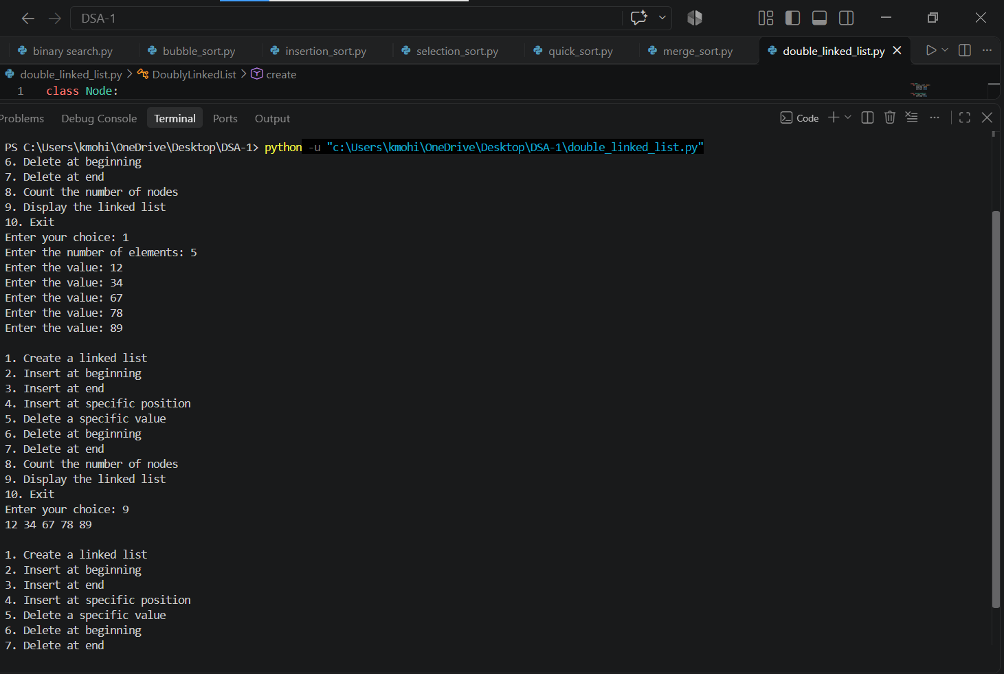

WEEK 7
Aim:

Write a python program to implement stack operations such as push, pop, peek, display using an array.

Program:

stack = []
top = -1
n = int(input("Enter stack size: "))

while True:
print("\n1. Push")
print("2. Pop")
print("3. Peek")
print("4. Display")
print("5. Exit")

ch = int(input("Enter your choice: "))

if ch == 1:
if top == n - 1:
print("Stack Overflow")
else:
x = int(input("Enter element: "))
stack.append(x)
top += 1

elif ch == 2:
if top == -1:
print("Stack Underflow")
else:
print("Deleted element:", stack.pop())
top -= 1

elif ch == 3:
if top == -1:
print("Stack is Empty")
else:
print("Top element:", stack[top])

elif ch == 4:
if top == -1:
print("Stack is Empty")
else:
print("Stack:", stack[::-1])

elif ch == 5:
break

else:
print("Invalid Choice")

Output:

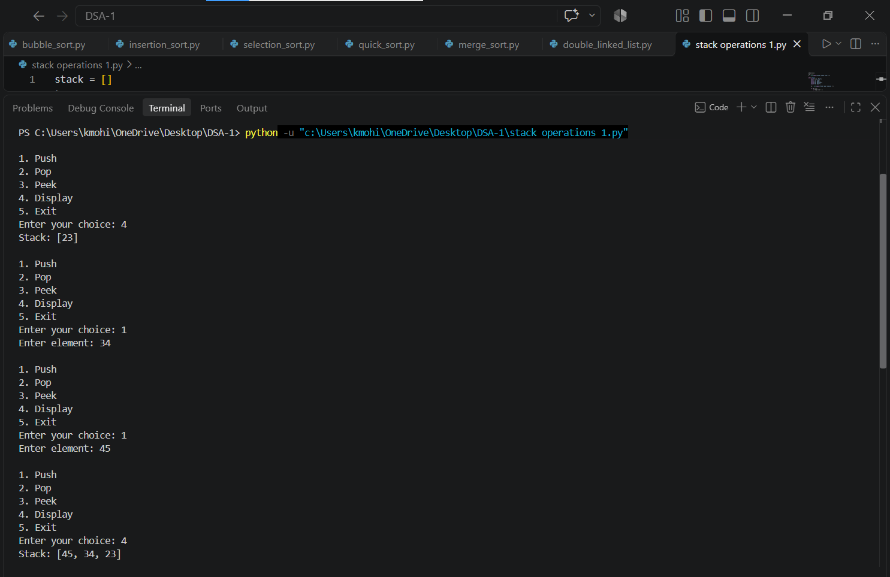

Aim:

Write a python program to implement stack operations such as push, pop, peek, display using a linked list.

Program:

class Node:
def __init__(self, data):
self.data = data
self.next = None

top = None

while True:
print("\n1. Push")
print("2. Pop")
print("3. Peek")
print("4. Display")
print("5. Exit")

ch = int(input("Enter your choice: "))

if ch == 1:
x = int(input("Enter element: "))
new = Node(x)
new.next = top
top = new

elif ch == 2:
if top is None:
print("Stack Underflow")
else:
print("Deleted element:", top.data)
top = top.next

elif ch == 3:
if top is None:
print("Stack is Empty")
else:
print("Top element:", top.data)

elif ch == 4:
if top is None:
print("Stack is Empty")
else:
temp = top
while temp:
print(temp.data, end=" ")
temp = temp.next
print()

elif ch == 5:
break

else:
print("Invalid Choice")

Output:

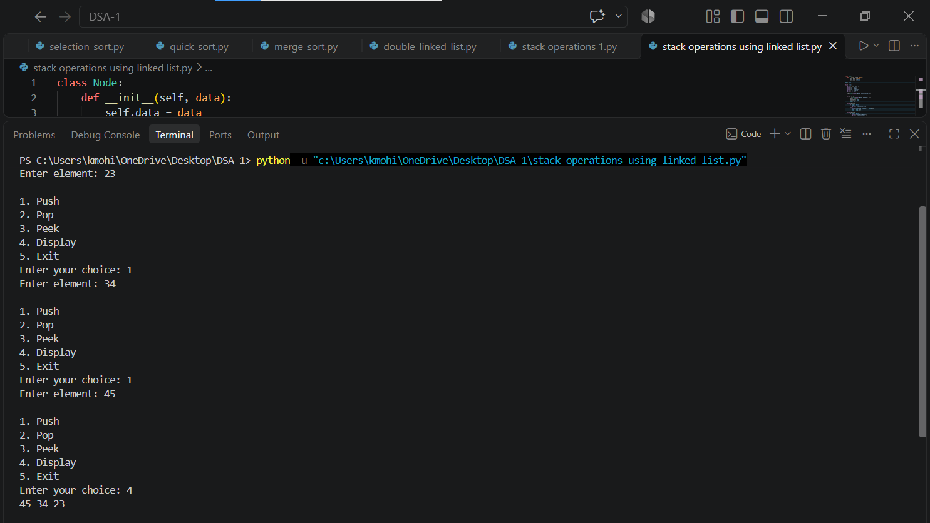

WEEK 8
AIM:

Write a python program to implement Queue and its operations such as enqueue, dequeue, peek, display with a menu driven approach. Implement using array, and linked list data structures.

Program of queue using array:

queue = []
front = rear = -1
n = int(input("Enter queue size: "))

while True:
print("\n1. Enqueue")
print("2. Dequeue")
print("3. Peek")
print("4. Display")
print("5. Exit")

ch = int(input("Enter your choice: "))

if ch == 1:
if rear == n - 1:
print("Queue Overflow")
else:
x = int(input("Enter element: "))
queue.append(x)
if front == -1:
front = 0
rear += 1

elif ch == 2:
if front == -1 or front > rear:
print("Queue Underflow")
else:
print("Deleted element:", queue[front])
front += 1

elif ch == 3:
if front == -1 or front > rear:
print("Queue is Empty")
else:
print("Front element:", queue[front])

elif ch == 4:
if front == -1 or front > rear:
print("Queue is Empty")
else:
print("Queue:", queue[front:rear+1])

elif ch == 5:
break

else:
print("Invalid Choice")

Output:

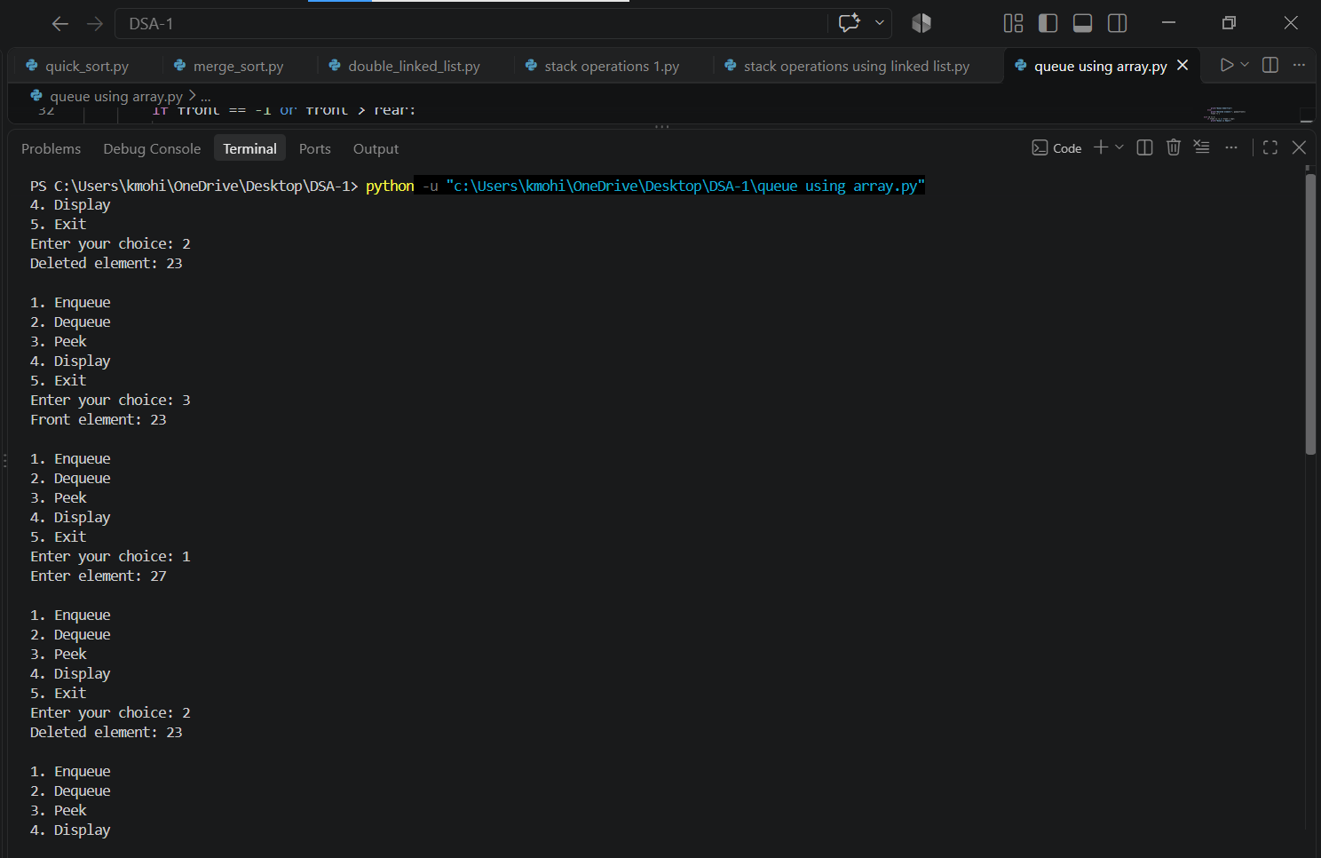

Program using linked list:

class Node:
def __init__(self, data):
self.data = data
self.next = None

front = rear = None

while True:
print("\n1. Enqueue")
print("2. Dequeue")
print("3. Peek")
print("4. Display")
print("5. Exit")

ch = int(input("Enter your choice: "))

if ch == 1:
x = int(input("Enter element: "))
new = Node(x)

if front is None:
front = rear = new
else:
rear.next = new
rear = new

elif ch == 2:
if front is None:
print("Queue Underflow")
else:
print("Deleted element:", front.data)
front = front.next
if front is None:
rear = None

elif ch == 3:
if front is None:
print("Queue is Empty")
else:
print("Front element:", front.data)

elif ch == 4:
if front is None:
print("Queue is Empty")
else:
temp = front
while temp:
print(temp.data, end=" ")
temp = temp.next
print()

elif ch == 5:
break

else:
print("Invalid Choice")

Output:

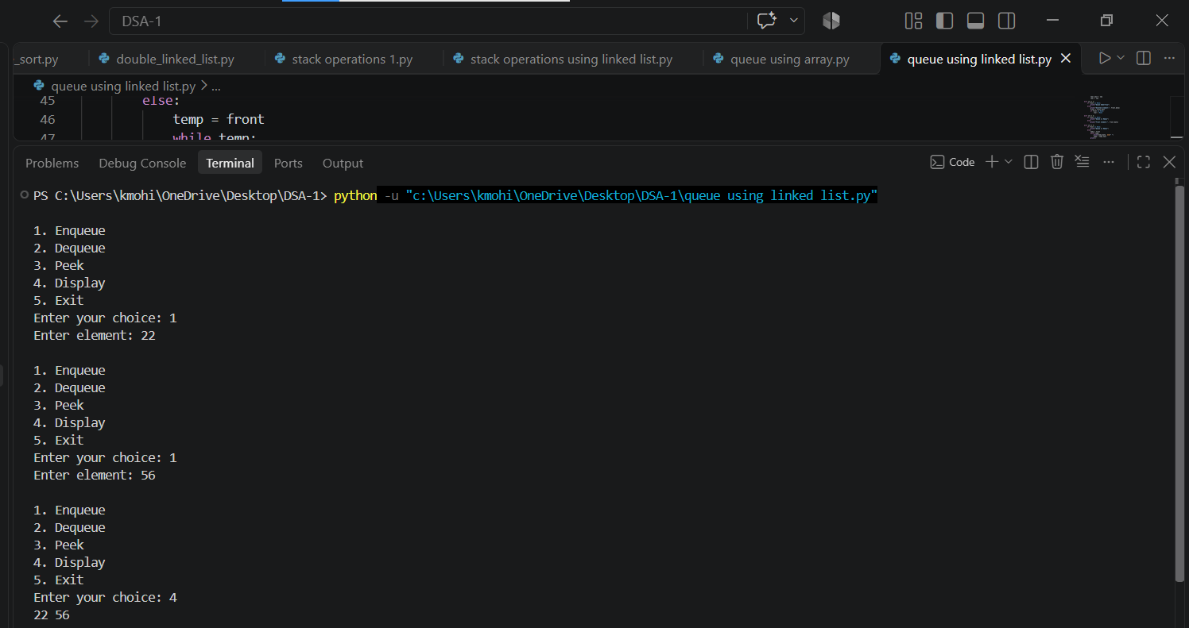

Aim:

Write a python program to implement Circular Queue and its operations such as enqueue, dequeue, peek, display with a menu driven approach. Implement using array, and linked list data structures.

Program using array:

queue = []
front = rear = -1
n = int(input("Enter queue size: "))

while True:
print("\n1. Enqueue")
print("2. Dequeue")
print("3. Peek")
print("4. Display")
print("5. Exit")

ch = int(input("Enter your choice: "))

if ch == 1:
if (rear + 1) % n == front:
print("Queue Overflow")
else:
x = int(input("Enter element: "))
if front == -1:
front = 0
rear = (rear + 1) % n
if len(queue) < n:
queue.append(None)
queue[rear] = x

elif ch == 2:
if front == -1:
print("Queue Underflow")
else:
print("Deleted element:", queue[front])
if front == rear:
front = rear = -1
else:
front = (front + 1) % n

elif ch == 3:
if front == -1:
print("Queue is Empty")
else:
print("Front element:", queue[front])

elif ch == 4:
if front == -1:
print("Queue is Empty")
else:
i = front
while True:
print(queue[i], end=" ")
if i == rear:
break
i = (i + 1) % n
print()

elif ch == 5:
break

else:
print("Invalid Choice")

Output:

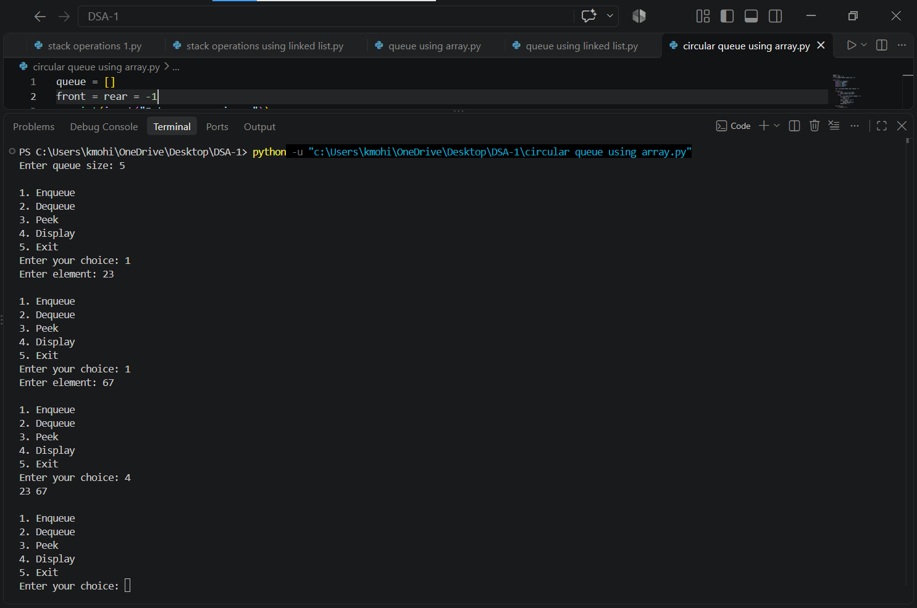

Program using linked list:

class Node:
def __init__(self, data):
self.data = data
self.next = None

front = rear = None

while True:
print("\n1. Enqueue")
print("2. Dequeue")
print("3. Peek")
print("4. Display")
print("5. Exit")

ch = int(input("Enter your choice: "))

if ch == 1:
x = int(input("Enter element: "))
new = Node(x)

if front is None:
front = rear = new
new.next = front
else:
rear.next = new
rear = new
rear.next = front

elif ch == 2:
if front is None:
print("Queue Underflow")
else:
print("Deleted element:", front.data)

if front == rear:
front = rear = None
else:
front = front.next
rear.next = front

elif ch == 3:
if front is None:
print("Queue is Empty")
else:
print("Front element:", front.data)

elif ch == 4:
if front is None:
print("Queue is Empty")
else:
temp = front
while True:
print(temp.data, end=" ")
temp = temp.next
if temp == front:
break
print()

elif ch == 5:
break

else:
print("Invalid Choice")

Output:

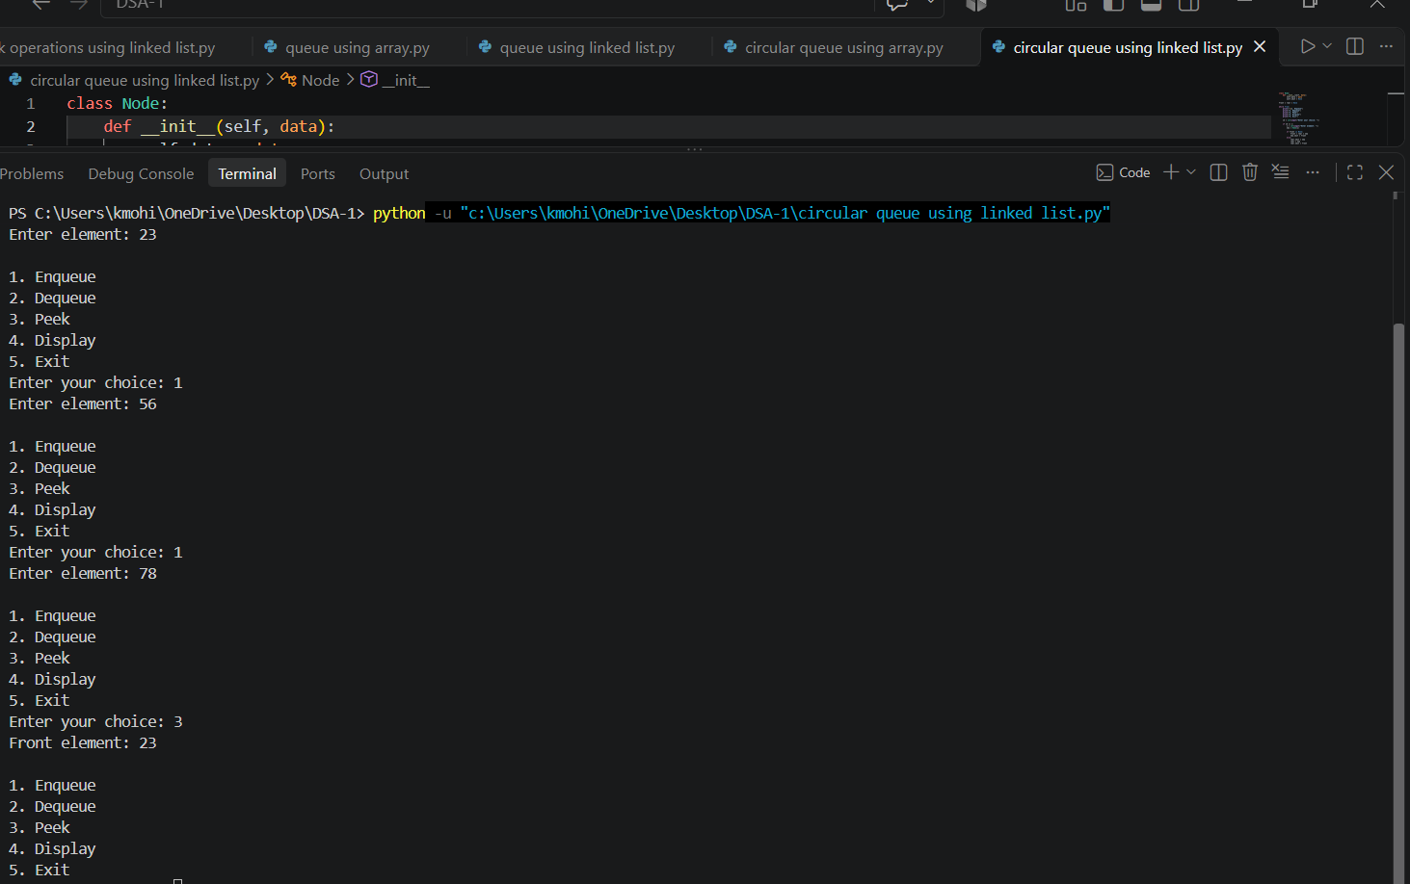

WEEK 9
Aim:
Write a python program to implement a Binary Search Tree (BST) and perform the following operations.
1. Insertion
2. Deletion
3. Tree Traversals – in-order, pre-order and post-order
4. Count Leaf Nodes
5. Count Internal Nodes
6. Height of the Tree

Program:

class Node:
def __init__(self, data):
self.data = data
self.left = None
self.right = None

def insert(root, x):
if root is None:
return Node(x)
if x < root.data:
root.left = insert(root.left, x)
elif x > root.data:
root.right = insert(root.right, x)
else:
print("Duplicate value is not allowed.")
return root

def inorder(root):
if root is None:
return
inorder(root.left)
print(root.data, end=" ")
inorder(root.right)

def preorder(root):
if root is None:
return
print(root.data, end=" ")
preorder(root.left)
preorder(root.right)

def postorder(root):
if root is None:
return
postorder(root.left)
postorder(root.right)
print(root.data, end=" ")

def find_min(root):
if root is None:
return None
while root.left is not None:
root = root.left
return root

def find_max(root):
if root is None:
return None
while root.right is not None:
root = root.right
return root

def search(root, data):
if root is None:
return None
if data < root.data:
return search(root.left, data)
elif data > root.data:
return search(root.right, data)
else:
return root

def count_nodes(root):
if root is None:
return 0
return count_nodes(root.left) + count_nodes(root.right) + 1

def count_leaves(root):
if root is None:
return 0
if root.left is None and root.right is None:
return 1
return count_leaves(root.left) + count_leaves(root.right)

def count_internal(root):
if root is None:
return 0
if root.left is None and root.right is None:
return 0
return count_internal(root.left) + count_internal(root.right) + 1

def height(root):
if root is None:
return -1
left_height = height(root.left)
right_height = height(root.right)
return max(left_height, right_height) + 1

def delete(root, x):
if root is None:
print("Element not found.")
return None
if x < root.data:
root.left = delete(root.left, x)
elif x > root.data:
root.right = delete(root.right, x)
else:
# Case 1: Node has no children
if root.left is None and root.right is None:
root = None
# Case 2: Node has only right child
elif root.left is None:
root = root.right
# Case 3: Node has only left child
elif root.right is None:
root = root.left
# Case 4: Node has two children
else:
successor = find_min(root.right)
root.data = successor.data
root.right = delete(root.right, successor.data)
return root

def print_level(root, level):
if root is None:
return
if level == 0:
print(root.data, end=" ")
else:
print_level(root.left, level - 1)
print_level(root.right, level - 1)

def level_order(root):
h = height(root)
for level in range(h+1):
print_level(root, level)

# =====================================================
# MAIN PROGRAM
# =====================================================

root = None
while True:
print("\n\n******** BINARY SEARCH TREE ********")
print("1. INSERT")
print("2. PREORDER TRAVERSAL")
print("3. INORDER TRAVERSAL")
print("4. POSTORDER TRAVERSAL")
print("5. FIND MINIMUM")
print("6. FIND MAXIMUM")
print("7. SEARCH")
print("8. DELETE")
print("9. COUNT NODES")
print("10. COUNT LEAVES")
print("11. COUNT INTERNAL NODES")
print("12. HEIGHT")
print("13. LEVEL ORDER TRAVERSAL")
print("14. EXIT")

choice = int(input("Enter your choice: "))
if choice == 1:
data = int(input("Enter the data to be inserted: "))
root = insert(root, data)
print("Element inserted successfully.")
elif choice == 2:
print("Preorder Traversal:", end=" ")
if root is None:
print("Tree is empty.")
else:
preorder(root)
print()
elif choice == 3:
print("Inorder Traversal:", end=" ")
if root is None:
print("Tree is empty.")
else:
inorder(root)
print()
elif choice == 4:
print("Postorder Traversal:", end=" ")
if root is None:
print("Tree is empty.")
else:
postorder(root)
print()
elif choice == 5:
node = find_min(root)
if node is None:
print("Tree is empty.")
else:
print("Minimum element:", node.data)
elif choice == 6:
node = find_max(root)
if node is None:
print("Tree is empty.")
else:
print("Maximum element:", node.data)
elif choice == 7:
data = int(input("Enter the data to be searched: "))
node = search(root, data)
if node is None:
print("Element", data, "is not found.")
else:
print("Element", data, "is found.")
elif choice == 8:
data = int(input("Enter the data to be deleted: "))
root = delete(root, data)
elif choice == 9:
print("Number of nodes:", count_nodes(root))
elif choice == 10:
print("Number of leaf nodes:", count_leaves(root))
elif choice == 11:
print("Number of internal nodes:", count_internal(root))
elif choice == 12:
print("Height of BST:", height(root))
elif choice == 13:
print("Level Order Traversal:", end=" ")
if root is None:
print("Tree is empty.")
else:
level_order(root)
print()
elif choice == 14:
print("Program terminated.")
break
else:
print("Invalid choice. Please try again.")

Output:

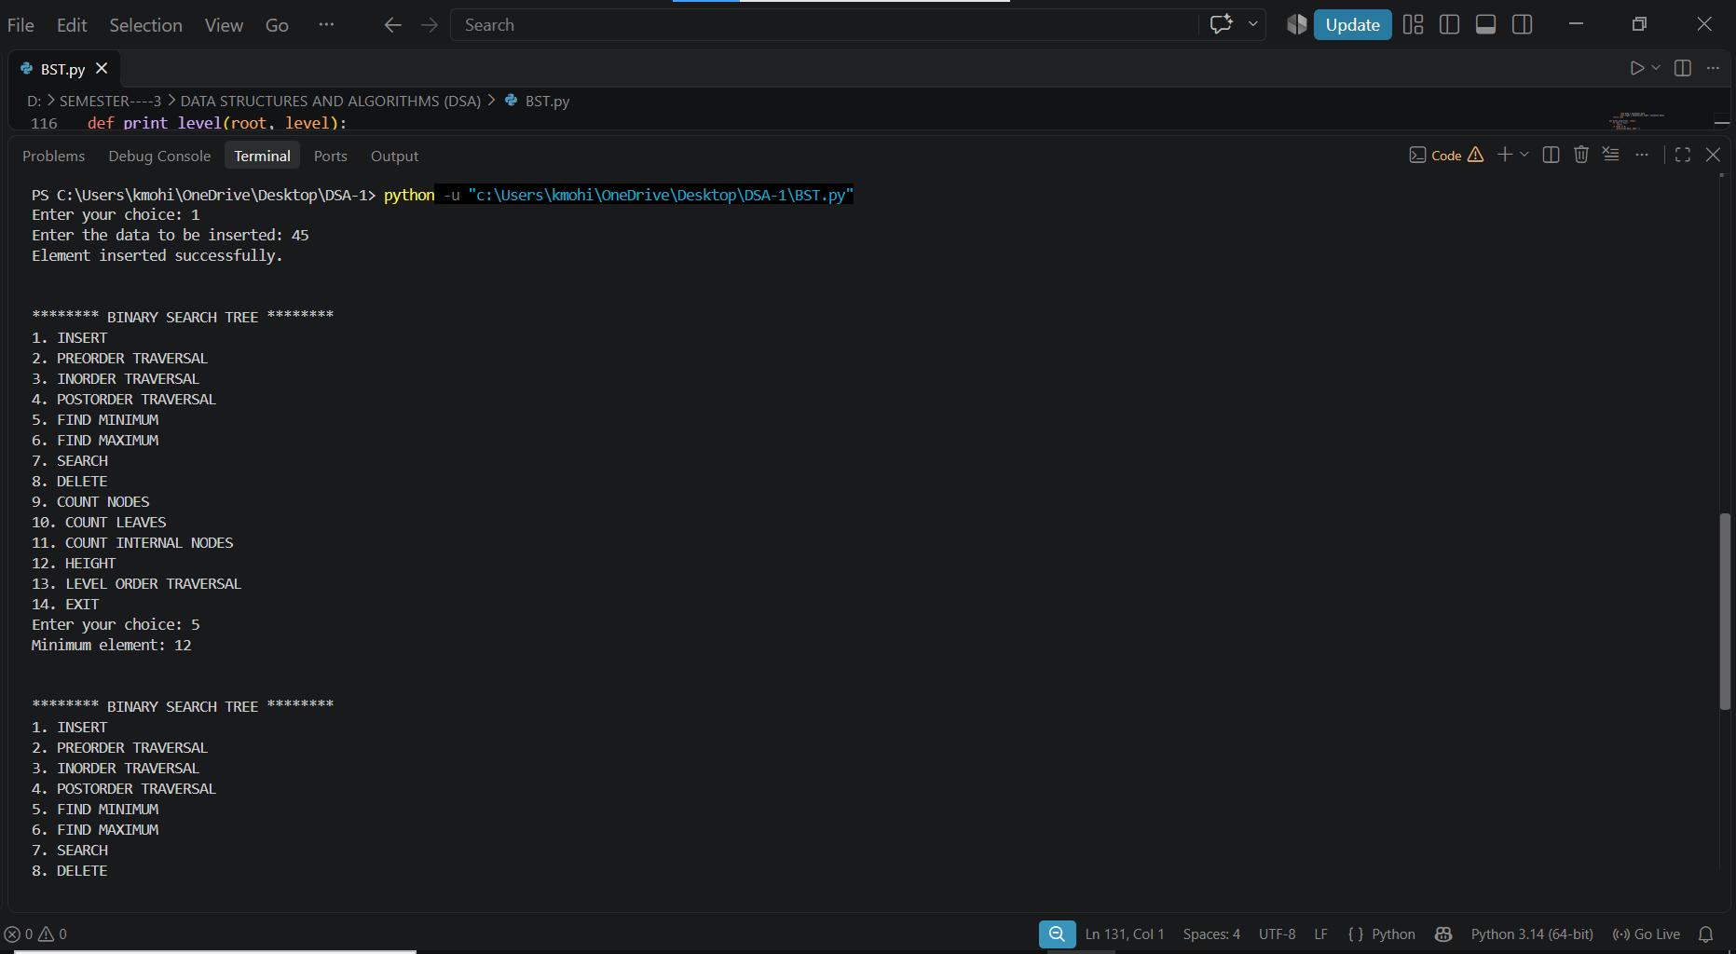

WEEK 10

Aim:
Write a menu driven python program to implement an AVL Tree and perform the following operations.
1. Insertion
2. Deletion
3. Tree Traversals
4. Count Leaf Nodes
5. Count Internal Nodes
6. Height of the Tree

Program:

class Node:
def __init__(self, x):
self.left = None
self.data = x
self.right = None
self.h = 0

#AVL TREE Program
def height(root):
if root is None:
return -1
else:
return root.h

# LL Rotation
def LL(x):
y = x.left
x.left = y.right
y.right = x
x.h = max(height(x.left), height(x.right)) + 1
y.h = max(height(y.left), height(y.right)) + 1
return y

# RR Rotation
def RR(x):
y = x.right
x.right = y.left
y.left = x
x.h = max(height(x.left), height(x.right)) + 1
y.h = max(height(y.left), height(y.right)) + 1
return y

# LR Rotation
def LR(k3):
k3.left = RR(k3.left)
return LL(k3)

# RL Rotation
def RL(k3):
k3.right = LL(k3.right)
return RR(k3)

# Inorder Traversal
def inorder(root):
if root is not None:
inorder(root.left)
print(root.data, end=" ")
inorder(root.right)

# Preorder Traversal
def preorder(root):
if root is not None:
print(root.data, end=" ")
preorder(root.left)
preorder(root.right)

# Postorder Traversal
def postorder(root):
if root is not None:
postorder(root.left)
postorder(root.right)
print(root.data, end=" ")

# Insert a node into AVL Tree
def insert(root, x):
if root is None:
return Node(x)

if x < root.data:
root.left = insert(root.left, x)
if height(root.left) - height(root.right) == 2:
if x < root.left.data:
root = LL(root)
else:
root = LR(root)

elif x > root.data:
root.right = insert(root.right, x)
if height(root.right) - height(root.left) == 2:
if x > root.right.data:
root = RR(root)
else:
root = RL(root)
else:
print("Duplicates not allowed")
root.h = max(height(root.left),height(root.right)) + 1
return root

# Delete a node from AVL Tree
def delete(root, x):
# Element not found
if root is None:
return None

# Search in left subtree
if x < root.data:
root.left = delete(root.left, x)
if height(root.left) - height(root.right) == 2:
if x < root.left.data:
root = LL(root)
else:
root = LR(root)

# Search in right subtree
elif x > root.data:
root.right = delete(root.right, x)
if height(root.right) - height(root.left) == 2:
if x > root.right.data:
root = RR(root)
else:
root = RL(root)

# When target found
else:
if root.left is None and root.right is None:
root = None
elif root.right is None:
root = root.left
elif root.left is None:
root = root.right
else:
successor = root.right # Find inorder successor
while successor.left is not None:
successor = successor.left
root.data = successor.data #Copy successor data
root.right = delete(root.right, successor.data) # Delete the inorder successor

root.h = max(height(root.left), height(root.right)) + 1
return root

# -------------------------------
# Main Program
# -------------------------------

root = None

while True:

print("\n***** AVL TREE MENU *****")
print("1. INSERT")
print("2. PREORDER TRAVERSAL")
print("3. INORDER TRAVERSAL")
print("4. POSTORDER TRAVERSAL")
print("5. DELETE")
print("6. EXIT")

choice = int(input("Enter your choice: "))
if choice == 1:
data = int(input("Enter the data to be inserted: "))
root = insert(root, data)
elif choice == 2:
print("Preorder Traversal:")
preorder(root)
print()
elif choice == 3:
print("Inorder Traversal:")
inorder(root)
print()
elif choice == 4:
print("Postorder Traversal:")
postorder(root)
print()
elif choice == 5:
data = int(input("Enter the data to be deleted: "))
root = delete(root, data)
elif choice == 6:
print("Program terminated.")
break
else:
print("Invalid choice!")

Output:

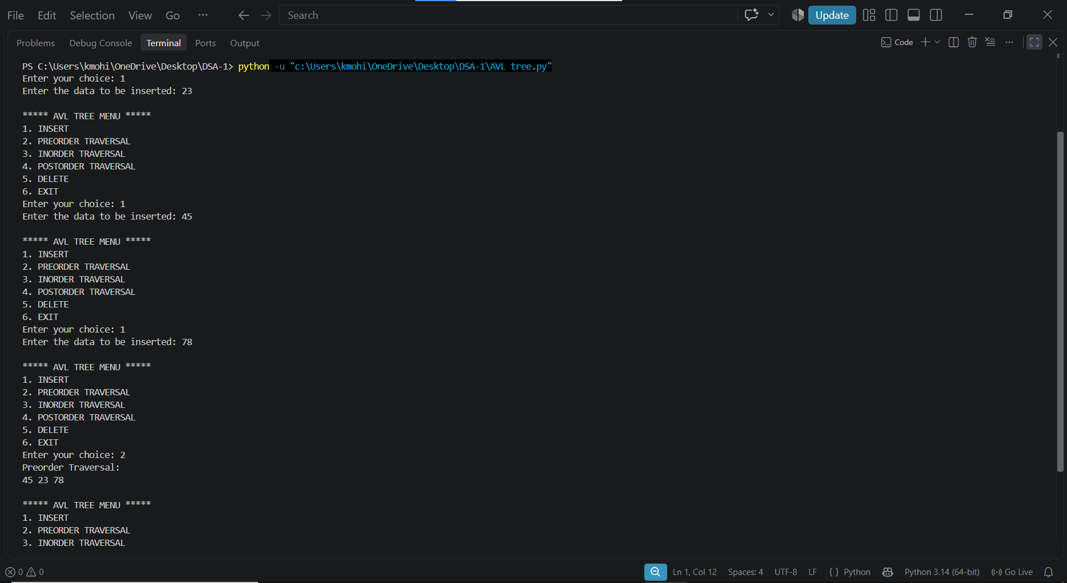

WEEK 11
Aim:
Write a menu-driven Python program to implement a Binary Heap (Max Heap and Min Heap) and perform the following operations:
- Insertion of an element into the Heap.
- Deletion of the root element from the Heap.
- Display the array representation of the Heap.
4. Exit the program

Program:

def insert(heap, value):
heap.append(value)
i = len(heap) - 1
while i > 0:
parent = (i - 1) // 2
if heap[i] > heap[parent]:
heap[i], heap[parent] = heap[parent], heap[i]
i = parent
else:
break

def delete(heap):
if len(heap) == 0:
print("Heap is empty")
return
print("Deleted element:", heap[0])
heap[0] = heap[-1]
heap.pop()

n = len(heap)
i = 0
# Move the root downward
while True:
largest = i
left = 2 * i + 1
right = 2 * i + 2
if left < n and heap[left] > heap[largest]:
largest = left
if right < n and heap[right] > heap[largest]:
largest = right
if largest != i:
heap[i], heap[largest] = heap[largest], heap[i]
i = largest
else:
break

def display(heap):
if len(heap) == 0:
print("Heap is empty")
else:
print("Heap elements:", heap)

#Main Program
heap = []
while True:
print("\n--- MAX HEAP MENU ---")
print("1. Insert")
print("2. Delete")
print("3. Display")
print("4. Exit")
choice = int(input("Enter your choice: "))
if choice == 1:
value = int(input("Enter value to insert: "))
insert(heap, value)
elif choice == 2:
delete(heap)
elif choice == 3:
display(heap)
elif choice == 4:
print("Exiting program")
break
else:
print("Invalid choice")

Output:

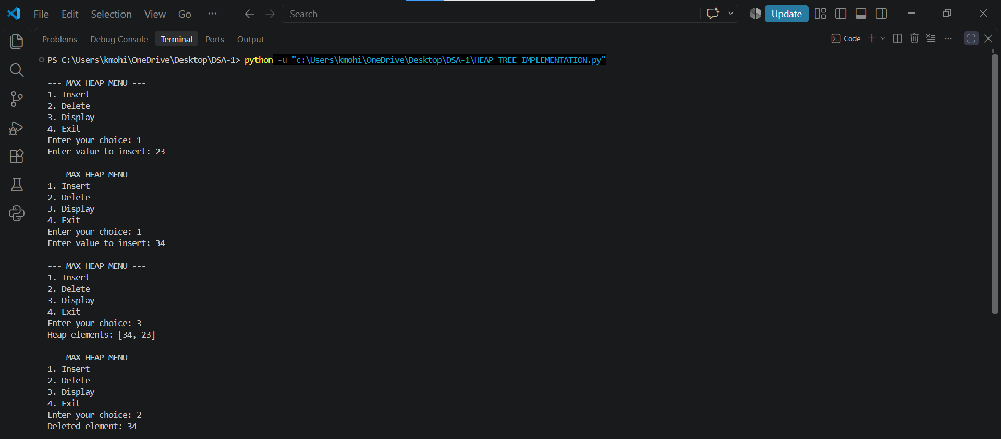

WEEK 12
Aim:

Write a program to implement the following three collision resolution techniques in a Hash Table:
- Separate Chaining
- Linear Probing
- Quadratic Probing

Program (1.seperate chaining):

class Node:
def __init__(self, data):
self.data = data
self.next = None

SIZE = 10
ht = [None] * SIZE

def insertValue(value):
index = value % SIZE
newnode = Node(value)
if ht[index] is None:
ht[index] = newnode
else:
temp = ht[index]
while temp.next is not None:
temp = temp.next
temp.next = newnode

def displayValue():
for i in range(SIZE):
print(i, end=": ")
temp = ht[i]
if temp is None:
print("None")
else:
while temp is not None:
print(temp.data, end=" -> ")
temp = temp.next
print("None")

repeat = True
while repeat:
print("\n1. Insert")
print("2. Display")
print("3. Exit")
ch = int(input("Enter your choice: "))
if ch == 1:
value = int(input("Enter value: "))
insertValue(value)
elif ch == 2:
print("\nHash table values:")
displayValue()
elif ch == 3:
repeat = False
else:
print("Invalid choice")

Output:

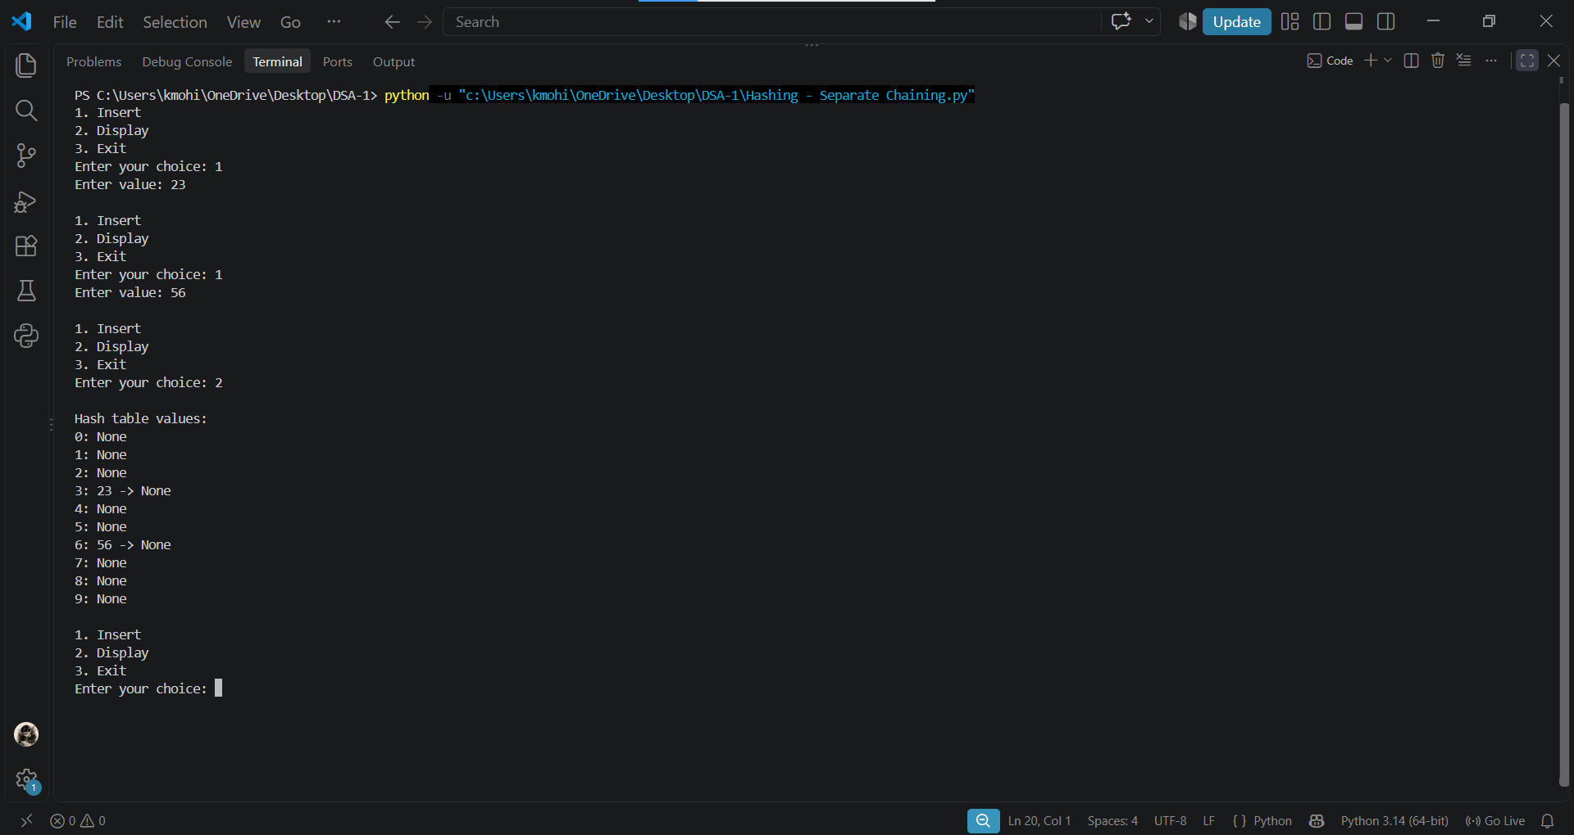

Program(2.Linear probing):

SIZE = 10
a = [-1] * SIZE
def insertValue(x):
for i in range(SIZE):
index = ((x % SIZE) + i) % SIZE
if a[index] == -1:
a[index] = x
print("Element inserted")
return
print("Hash table is full")

def deleteValue(x):
for i in range(SIZE):
index = ((x % SIZE) + i) % SIZE
if a[index] == x:
a[index] = -1
print("Element deleted")
return
print("Element not found")

def search(x):
for i in range(SIZE):
index = ((x % SIZE) + i) % SIZE
if a[index] == x:
print("Element found at index", index)
return
if a[index] == -1:
break
print("Element not found")

def displayValue():
print("Index\tValue")
for i in range(SIZE):
print(i, "\t", a[i])

# Menu-driven program
repeat = True
while repeat:
print("\n1. Insert")
print("2. Display")
print("3. Delete")
print("4. Search")
print("5. Exit")
ch = int(input("Enter your choice: "))
if ch == 1:
value = int(input("Enter value: "))
insertValue(value)
elif ch == 2:
print("Values are:")
displayValue()
elif ch == 3:
value = int(input("Enter value to delete: "))
deleteValue(value)
elif ch == 4:
value = int(input("Enter value to search: "))
search(value)
elif ch == 5:
repeat = False
else:
print("Invalid choice")

Output:

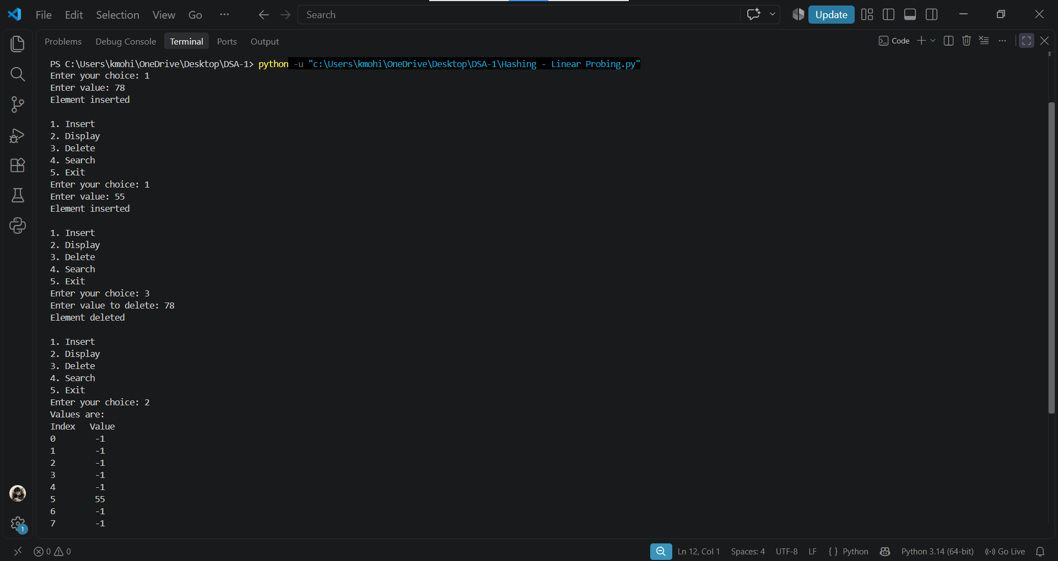

Program(3.Quadratic probing):

SIZE = 10
a = [-1] * SIZE

def insertValue(value):
for i in range(SIZE):
index = ((value % SIZE) + i * i) % SIZE
if a[index] == -1:
a[index] = value
print("Element inserted at index", index)
return
print("No empty slot found in the probe sequence")

def displayValue():
print("Values are:")
for i in range(SIZE):
print(a[i])

# Menu-driven program
repeat = True
while repeat:
print("\n1. Insert")
print("2. Display")
print("3. Exit")
ch = int(input("Enter your choice: "))
if ch == 1:
value = int(input("Enter value: "))
insertValue(value)
elif ch == 2:
displayValue()
elif ch == 3:
repeat = False
else:
print("Invalid choice")

Output:



