Intelligent Football Analytics with YOLO and Machine Learning
Mini project 2B Report

Submitted in partial fulfillment of the requirement of University of Mumbai for the Degree of
(Computer Engineering)

By

Shravani Sawekar ID No: TU3F2223188
Quazi Md Moinuddin ID No: TU3F2223193
Harshada Chavan ID No: TU3F2223185

Under the Guidance of

PROF. PRIYANKA PATEL



Department of Computer Engineering TERNA ENGINEERING COLLEGE
Plot no.12, Sector-22, Opp. Nerul Railway station, Phase-11, Nerul (w), Navi Mumbai 400706 UNIVERSITY OF MUMBAI (2024-2025)



TERNAENGINEERING COLLEGE, NERUL, NAVI MUMBAI
Department of Computer Engineering
Academic Year 2024-25

CERTIFICATE

This is to certify that the mini project 2B entitles “Intelligent Football Analytics Using YOLO and Machine Learning” is a bonafide work of

Shravani Sawekar ID No: TU3F2223188
Quazi Md Moinuddin ID No: TU3F2223193
Harshada Chavan ID No: TU3F2223185

submitted to the University of Mumbai in partial fulfillment of the requirement for the award of the Bachelor of Engineering (Computer Engineering).

Guide Head of Department Principal

PROJECT REPORT APPROVAL

This Mini Project 2B Report – entitled “Intelligent Football Analytics Using YOLO and Machine Learning” by following students is approved for the degree of B.E. in "Computer Engineering".

Submitted by:

Shravani Sawekar ID No: TU3F2223188
Quazi Md Moinuddin ID No: TU3F2223193
Harshada Chavan ID No: TU3F2223185

Examiners Name & Signature:

1.

2.

Date: Place:

DECLARATION

We declare that this written submission represents our ideas in our own words and where others' ideas or words have been included, we have adequately cited and referenced the original sources. We also declare that we have adhered to all principles of academic honesty and integrity and have not misrepresented or fabricated or falsified any idea/data/fact/source in our submission. We understand that any violation of the above will be cause for disciplinary action by the Institute and an also evoke penal action from the sources which have thus not been properly cited or from whom proper permission has not been taken when needed.

Shravani Sawekar ID No: TU3F2223188
Quazi Md Moinuddin ID No: TU3F2223193
Harshada Chavan ID No: TU3F2223185

Date:
Place
:

ACKNOWLEDGEMENT

We would like to express our sincere gratitude towards our guide Prof. Priyanka Patel, Mini Project coordinators Dr. Siddharth Hariharan for their help, guidance and encouragement, they provided during the project development. This work would have not been possible without their valuable time, patience and motivation. We thank them for making our stint thoroughly pleasant and enriching. It was great learning and an honor being their student.

We are deeply thankful to Dr. Kishor Sakure (H.O.D Computer Department) and entire team in the Computer Department. They supported us with scientific guidance, advice and encouragement, they were always helpful and enthusiastic and this inspired us in our work.

We take the privilege to express our sincere thanks to Dr. L. K. Ragha our principal for providing the encouragement and much support throughout our work.

Shravani Sawekar ID No: TU3F2223188
Quazi Md Moinuddin ID No: TU3F2223193
Harshada Chavan ID No: TU3F2223185

Date:

Place:

Abstract

The “Intelligent Football Analytics with YOLO and Machine Learning” project presents an advanced framework for analyzing football match footage through computer vision and machine learning techniques. This project addresses the growing demand for automated sports analysis tools that can extract meaningful insights from video data without manual intervention.
Our system employs multiple computer vision algorithms, including YOLO (You Only Look Once) for object detection to identify and track players, referees, and the ball in real-time. K-means clustering is utilized for pixel segmentation to distinguish between the playing field, players, and other elements in the frame. Optical flow algorithms track motion patterns of players and the ball across consecutive frames, while perspective transformation techniques convert camera view coordinates to a standardized top-down pitch representation for accurate spatial analysis.
The framework processes match footage to generate comprehensive analytics, including player movement heatmaps, possession statistics, player trajectory analysis, and team formation patterns. By automating these analyses, our system provides coaches, analysts, and broadcasters with valuable insights that would traditionally require hours of manual video analysis.
This project demonstrates the significant potential of computer vision and machine learning in sports analytics, offering a scalable solution for quantitative football match analysis that can enhance tactical understanding, player development, and spectator experience. The modular architecture allows for future extensions to analyze additional metrics and support different sports, making it a versatile platform for sports performance analysis.

INDEX
TABLE OF CONTENTS

CHAPTER | TITLE | PG.NO.
 | Abstract | 6
 | List of Figures | 8
 | List of Tables | 8
I | Introduction | 9
II | Literature Review | 10
III | 3.1 Problem Statement | 11
 | 3.2 Challenges | 11
 | 3.3 Objectives | 12
IV | Design and Implementation | 13
 | 4.1 System Architecture | 13
 | 4.2 Functional Requirements | 24
V | Results and Discussion | 25
VI | Conclusion and Future Scope | 29
 | References | 31

List of Figures

SR.NO. | TITLE | PG.NO.
1 | Fig:1 Use Case Diagram | 13
2 | Fig:2 Stages of multiple object detection and tracking. | 14
3 | Fig:3 Activity Diagram | 15
4 | Fig:4 YOLOv5-Based Object Detection Workflow | 16
5 | Fig:5 The Proposed Bock Diagram of object detection and classification by the YOLO model  Fig:6 Bounding box with the prior’s pw and ph. along with the predicted width and height | 17
6 | Fig:7 Player and Ball Tracking Pipeline Using Kalman Filter, Hungarian Algorithm, And Deep SORT | 18
7 | Fig:8 K-Means Clustering Workflow for Field And  Player Segmentation | 19
8 | Fig:9 Perspective Transformation Process for Top-Down Pitch View | 20
9 | Fig 10: Analytics Generation Pipeline from Tracking Data | 21
10 | Fig 11: Data Flow Diagram - Level 0 | 22
11 | Fig 12: Data Flow Diagram - Level 1 | 23
12 | Fig 13: The basic architecture | 25
13 | Fig 14: Gantt Chart about Training Workflow  Fig 15: Model Training Flow | 29
14 | Fig 16: Precision-Confidence Curve | 30
15 | Fig 14: Before Implementation | 31
16 | Fig 15: After Implementation | 32

List of Tables

SR.NO. | TITLE | PG.NO.
1 | Literature Survey | 10
2 | Metric Table | 27

Chapter 1 Introduction
Football (soccer) analytics has evolved significantly in recent years, transitioning from subjective observations to data-driven insights that inform tactical decisions, player recruitment, and performance evaluation. Traditional manual analysis methods are time-consuming and prone to human bias, creating a need for automated systems that can process vast amounts of video data efficiently and objectively.
The “Intelligent Football Analytics with YOLO and Machine Learning” project addresses this need by leveraging advanced computer vision and machine learning techniques to automatically extract actionable insights from football match footage. Our framework combines multiple computer vision components to detect, track, and analyze players, the ball, and their movements throughout a match.
The core of our system utilizes YOLO (You Only Look Once), a state-of-the-art real-time object detection algorithm that identifies players, referees, and the ball in video frames with high accuracy and minimal computational overhead. This detection is enhanced by K-means clustering for pixel segmentation, which helps distinguish between the playing field, players, and other visual elements by grouping pixels with similar characteristics.
Once objects are detected, our system implements optical Flow algorithms to track their movements across consecutive frames, creating continuous trajectories that represent player and ball movement patterns. To address the challenge of perspective in broadcast footage, we apply perspective transformation techniques that convert the camera view to a standardized top-down representation of the pitch, allowing for accurate spatial analysis regardless of camera position or angle.
By integrating these components, our system generates comprehensive match analytics including: - Player movement heatmaps showing spatial distribution across the pitch - Ball possession statistics at team and individual levels - Player running patterns and distance covered - Team formation analysis and positional discipline - Passing networks and play patterns
This project represents a significant advancement in automated sports analysis, providing coaches, analysts, and broadcasters with a powerful tool to gain deeper insights into match dynamics, tactical patterns, and player performance. The modular architecture allows for future extensions to include additional metrics and support different sports, making it a versatile platform for sports performance analysis.
Through this automated approach to football analysis, our project aims to democratize access to advanced sports analytics, enabling teams and analysts at all levels to benefit from data-driven insights previously available only to elite organizations with substantial resources.

Chapter 2 Literature Review

TITLE | AUTHOR | METHODOLOGY | MERITS | DEMERITS
A Survey on Computer Vision for Ball Sports | Wang et al. (2023) | Comprehensive review of computer vision applications in ball sports analysis, focusing on object detection, tracking, and event recognition techniques | Provides an excellent overview of the current state- of- the-art in sports video analysis and identiJies key challenges and  future directions | Lacks detailed implementation speciJics and performance benchmarks for the surveyed methods
YOLOv5 for Sports Player Detection and Tracking | Jocher et al. (2021) | Implementation of YOLOv5 for detecting players in sports footage with custom training on sports datasets | Achieves high detection accuracy (95%  +) with real- time performance suitable for live analysis; demonstrates transfer learning capabilities | Struggles with occlusions and dense player groupings; requires signiJicant computational resources for training
Automated Football Analysis Using Computer Vision | Martı́nez-Santos et al. (2020) | Multi-stage approach combining player detection, tracking, and tactical analysis with homograph transformation | Comprehensiv e pipeline from raw video to tactical insights; successfully addresses perspective challenges in  broadcast footage | Complex calibration process; sensitive to lighting conditions and camera movements
Deep Learning for Sports Field Registration | Chen and Little (2019) | CNN-based approach for automatic sports Nield registration and camera calibration | Eliminates need for manual calibration; robust to varying viewpoints and partial Nield visibility | Performance degrades with unusual camera angles; requires pre- trained models speciJic to each stadium  layout
Player Tracking and IdentiNication in Soccer Videos | ManaNifar d et al. (2017) | Hybrid approach using color features, motion estimation, and template matching for player tracking | Effective player identiJication in challenging scenarios with jersey color recognition | Struggles with similar team colors and rapid player movements; sensitive to illumination changes

Chapter 3

Problem Statement

- Problem Statement:
In football analytics, extracting meaningful insights from match footage traditionally requires extensive manual analysis, which is time-consuming, labor-intensive, and subject to human bias and error. Specifically, coaches, analysts, and teams face several challenges:
- Manual tracking of 22+ players and the ball simultaneously across 90+ minutes of gameplay is virtually impossible without significant human resources
- Converting perspective-distorted broadcast footage into standardized spatial data requires complex calculations
- Generating consistent, objective metrics for player movement, team formations, and tactical patterns is difficulty with traditional methods
- Real-time analysis during matches is extremely limited when using manual approaches
This project aims to develop an automated computer vision system that can process football match footage to extract player positions, movements, and interactions, converting raw video data into actionable analytical insights. The system must overcome challenges related to occlusions, varying camera angles, player similarity, and the dynamic nature of the sport.

- Challenges:

- Object Detection Accuracy: Reliably detecting and differentiating players, referees, and the ball in various lighting conditions, weather, and stadium configuration’s
- Handling Occlusions: Maintaining tracking when players overlap or are temporarily hidden from view
- Camera Movement: Accommodating for panning, zooming, and switching between multiple broadcast cameras
- Player Identity Preservation: Maintaining consistent player identity tracking throughout the match despite similar appearances
- Perspective Transformation: Converting camera view coordinates to standardized pitch coordinates for meaningful spatial analysis
- Real-time Processing: Balancing computational requirements with the need for timely analysis
- Visual Clutter: Distinguishing relevant elements (players, ball) from visual noise (crowd, advertising boards)
- Performance in Adverse Conditions: Maintaining accuracy during rain, shadow, or unusual lighting situations
- Data Integration: Synchronizing visual data with external data sources like event feeds

- Objectives:

- Develop Robust Player Detection: Implement and optimize YOLO-based models for football- specific object detection with >90% accuracy
- Create Reliable Tracking System: Design an optical Flow-based tracking system that maintains player identity through occlusions and camera movements
- Implement Pitch Registration: Develop an automated system to transform perspective- distorted footage into standardized pitch coordinates
- Generate Movement Analytics: Extract player movement patterns, heatmaps, and distance covered metrics
- Analyze Team Formations: Automatically identify and track team formations and positional changes throughout the match
- Visualize Data Insights: Create intuitive visualizations of complex spatial data for coaches and analysts
- Optimize for Performance: Balance accuracy and computational efficiency to enable near-real- time analysis
- Design Modular Architecture: Create a Flexible framework that can be extended to additional metrics and different sports

Chapter 4

Design And Implementation

  - System Architecture

Our football match analysis system follows a modular pipeline architecture that processes video input through several stages to generate analytical outputs. The system comprises the following core components:
- Video Input Processing: Handles video decoding, frame extraction, and preliminary preprocessing such as resizing and normalization.
- Object Detection Module: Employs YOLO (You Only Look Once) to identify and locate players, referees, and the ball in each frame.
- Segmentation Module: Uses K-means clustering to segment the playing field, players, and other elements based on color and texture features.
- Tracking Module: Implements optical Flow algorithms to track objects between consecutive frames, maintaining identity consistency.
- Perspective Transformation Module: Converts camera-view coordinates to standardized top- down pitch coordinates using homography techniques.
- Analytics Engine: Processes the tracked data to generate statistics, heatmaps, and other analytical outputs.
- Visualization Module: Creates graphical representations of the analyzed data for intuitive understanding.

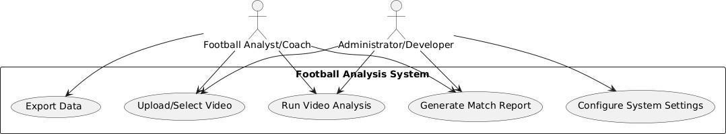

FIG:1 Use Case Diagram

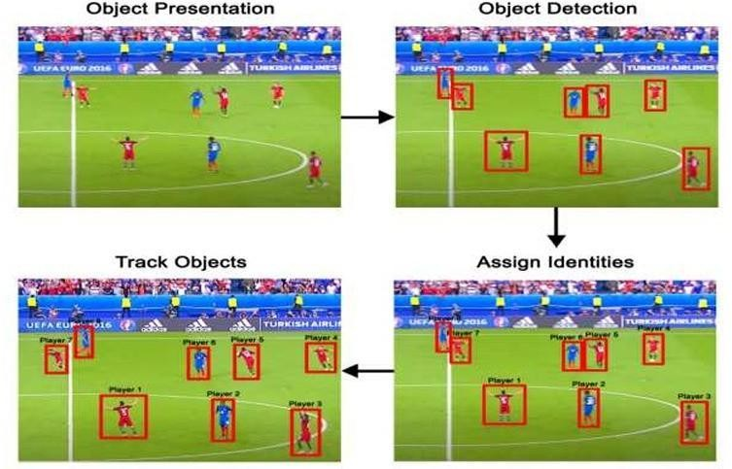

FIG:2 Stages of multiple object detection and tracking.

Activity Diagram:

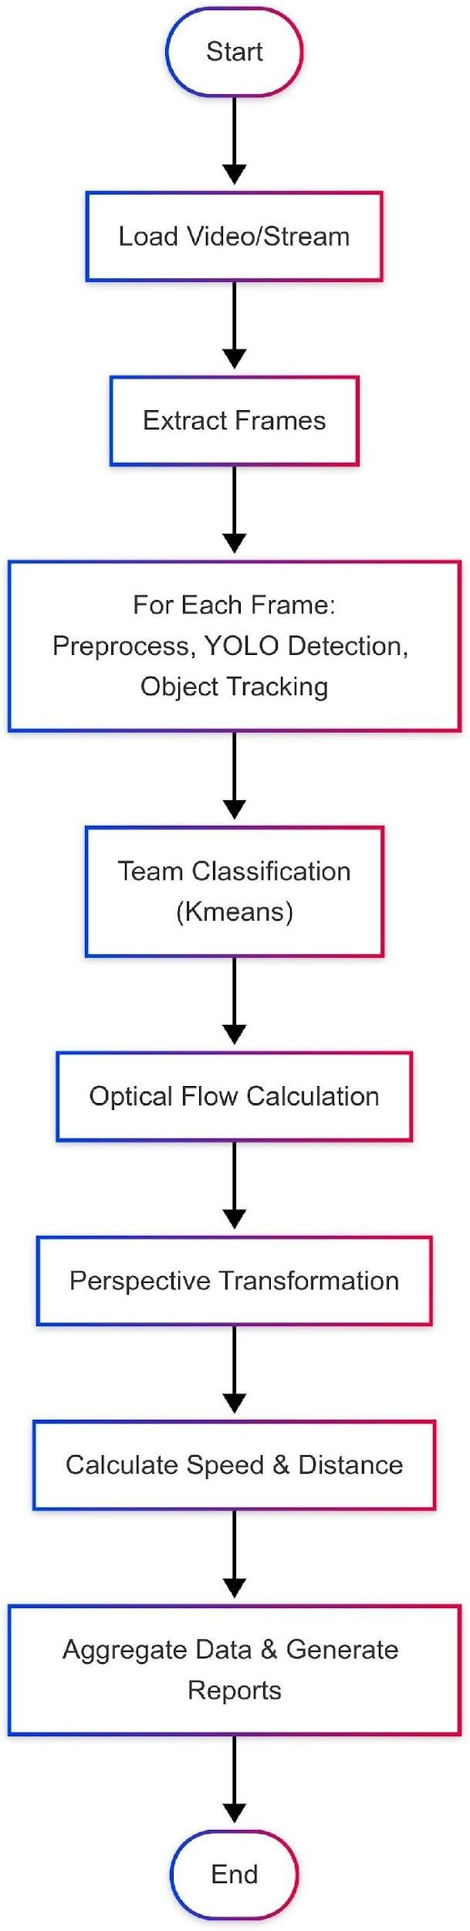

FIG:3 Activity Diagram

    - YOLO Implementation for Player and Ball Detection
Our system utilizes YOLOv5, a state-of-the-art object detection model trained specifically for football scenarios. The model was trained on a custom dataset comprising thousands of annotated football match frames covering various lighting conditions, camera angles, and team uniforms. The YOLO architecture provides several advantages for our application: - Single-stage detection enables faster processing compared to two-stage detectors - Grid-based approach helps with detecting multiple players simultaneously - Feature pyramid networks improve detection across various scales, vital for detecting both nearby and distant players. We Fine-tuned the model to focus on four primary classes: 1. Players from team A 2. Players from team B 3. Referees 4. Ball The detection pipeline includes: 1. Frame preprocessing (resizing to 640x640 pixels and normalization) 2. Forward pass through the YOLO network
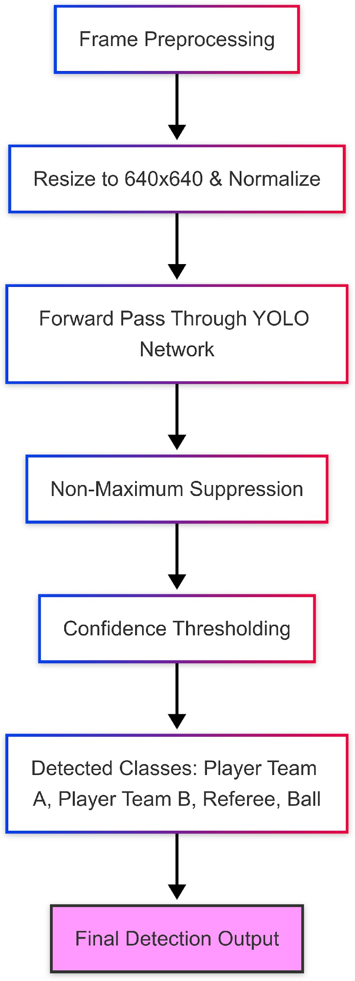
3. Non-maximum suppression to eliminate duplicate detections 4. Coincidence thresholding (0.6 for players, 0.5 for the ball)

FIG:4 YOLOv5-Based Object Detection Workflow

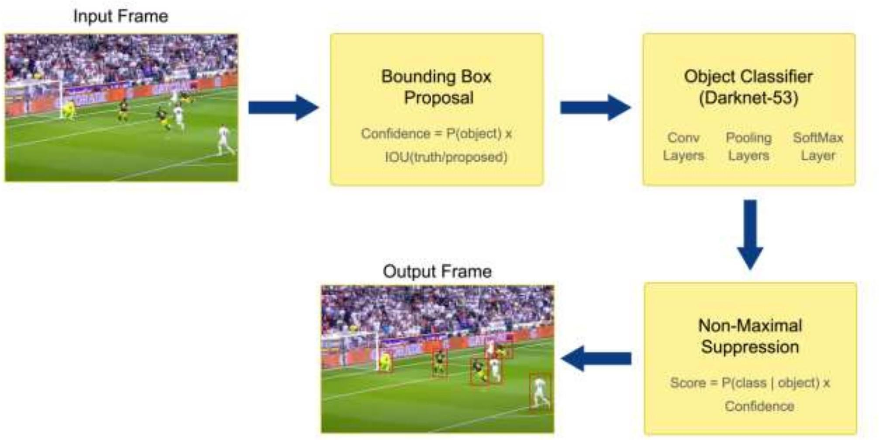

FIG:5 The Proposed Bock Diagram of object detection and classification by the YOLO model

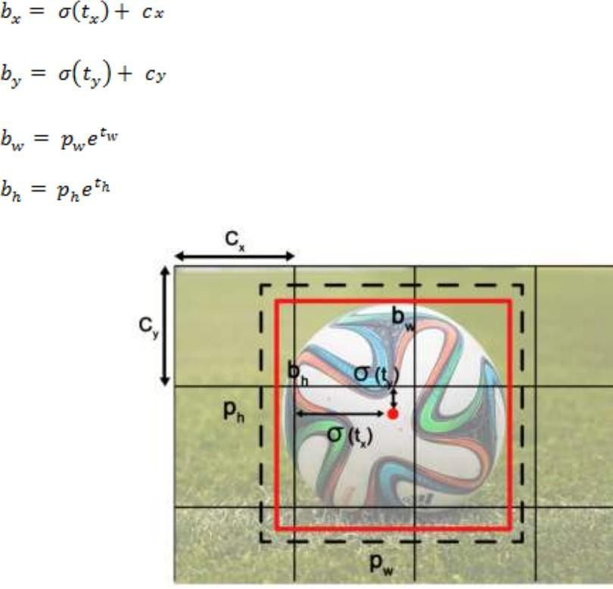

FIG:6 Bounding box with the prior’s pw and ph. along with the predicted width and height

    - Player Tracking Pipeline
Once players and the ball are detected, our tracking system maintains their identities across frames using a combination of:
      - Kalman Filtering: Predicts the next position based on current position and velocity
      - Hungarian Algorithm: Associates detections between frames by optimizing assignment cost
      - DeepSORT: Incorporates appearance features to maintain identity during occlusions
The tracking module handles several challenging scenarios: - Player occlusions during tackles or set pieces
- Players exiting and re-entering the camera frame - Similar appearance of players from the same team - Fast movements causing motion blur

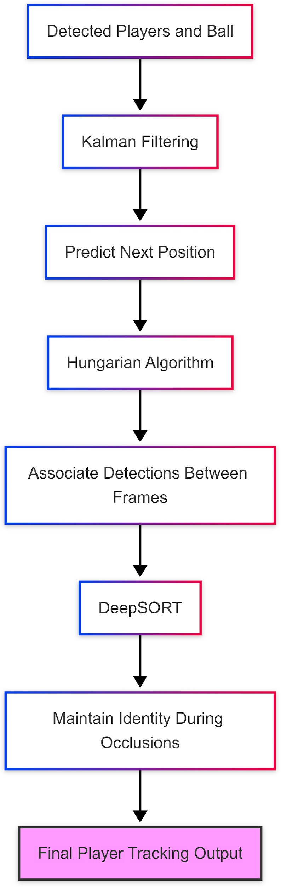

FIG:7 Player and Ball Tracking Pipeline Using Kalman Filter, Hungarian Algorithm, And Deep SORT

    - K-means for Pixel Segmentation
Field segmentation is crucial for distinguishing players from the background and for perspective transformation. Our approach uses K-means clustering with k=3 to separate pixels into:
- Field (green pixels)
- Players and official’s
- Other elements (crowd, advertising boards)
The segmentation process:
  - Convert frame to LAB color space (more perceptually uniform than RGB)
  - Apply K-means clustering on color values
  - Post-process with morphological operations to reduce noise
  - Extract field mask and field boundary lines.
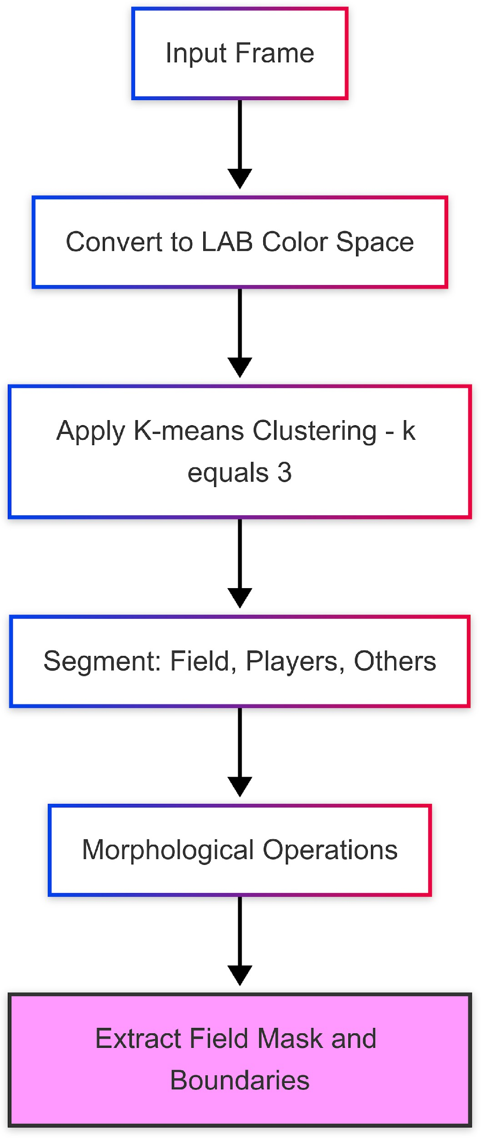

FIG:8 K-Means Clustering Workflow for Field and Player Segmentation

    - Perspective Transformation

To analyze player positions and movements meaningfully, we transform the camera view to a standardized top-down pitch representation:
- Field Line Detection: Extract white lines from the segmented field using Canny edge detection and Hough transform
- Reference Point Identification: Identify key landmarks (center circle, penalty areas, etc.)
- Homography Estimation: Calculate transformation matrix between image points and standard pitch model
- Coordinate Mapping: Transform player positions from image coordinates to pitch coordinates
This transformation enables accurate spatial analysis regardless of camera position or angle, allowing for consistent metrics across different matches and broadcast formats.
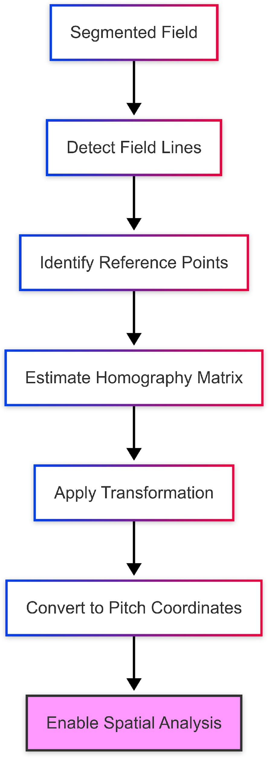

FIG:9 Perspective Transformation Process for Top-Down Pitch View

4.1.5 Analytics Generation

The transformed tracking data feeds into our analytics engine, which calculates:
- Heat Maps: Spatial distribution of player positions
- Movement Patterns: Directional analysis of player movements
- Distance Covered: Total and high-intensity running distances
- Team Formation Analysis: Dynamic formation tracking and position switches
- Passing Networks: Visualization of passing patterns between players
- Pressure Maps: Areas of high defensive pressure

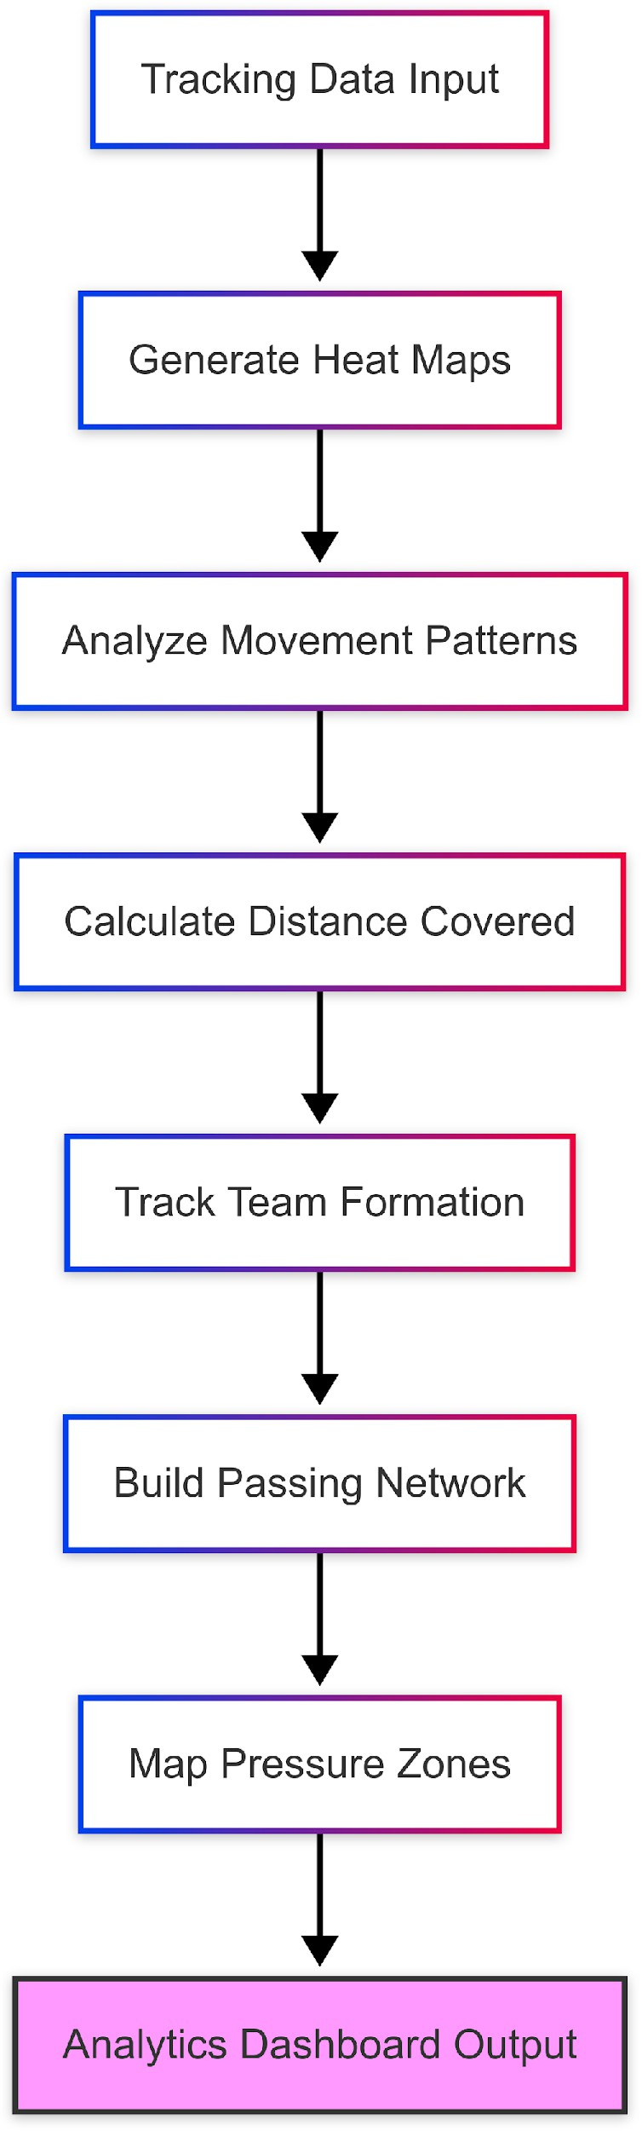

FIG 10: Analytics Generation Pipeline from Tracking Data

Data Flow Diagram:

LEVEL 0:

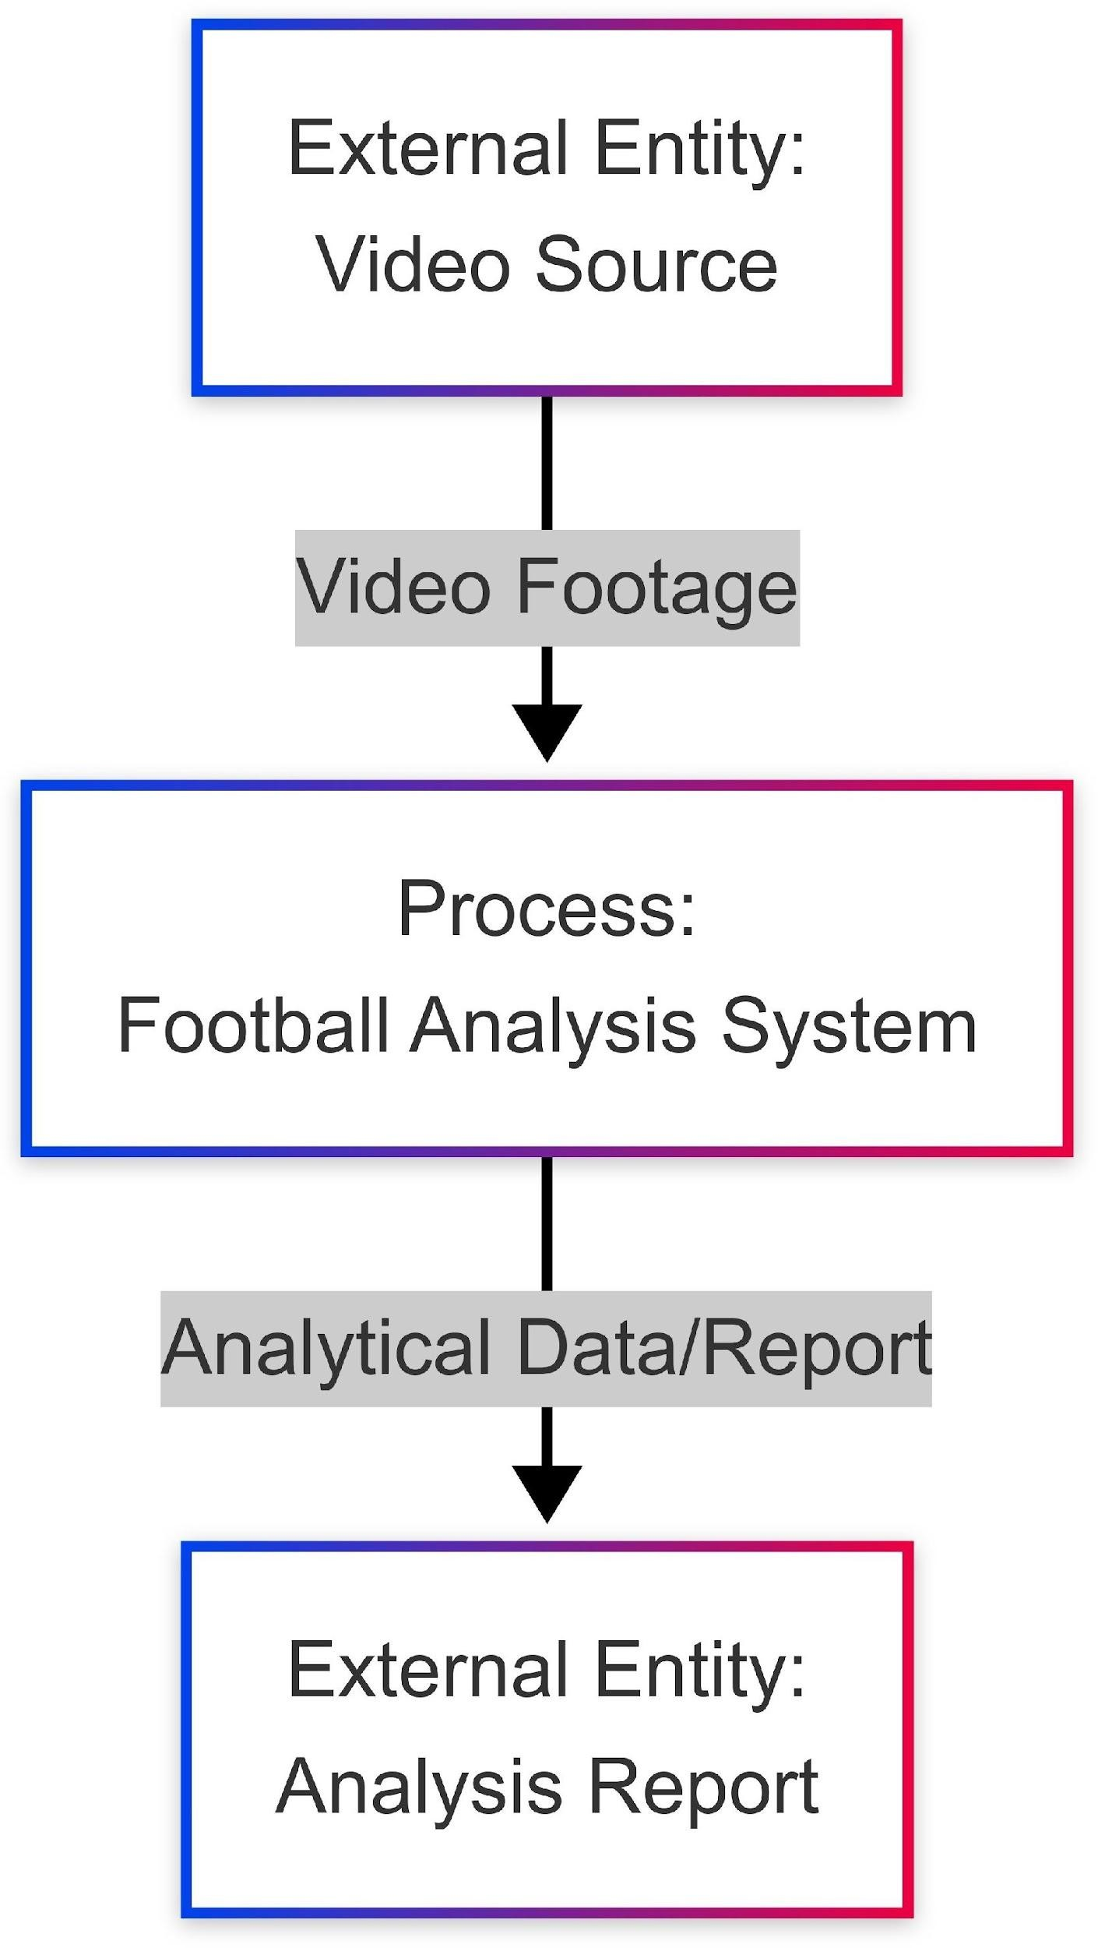

Fig 11: Data Flow Diagram - Level 0

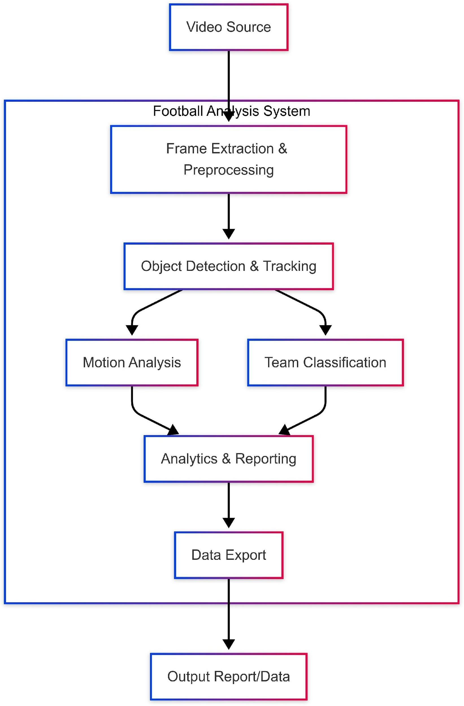
LEVEL 1:

  - Functional Requirements

    - Software Requirements:

Core Libraries:
  - Python 3.8+
  - OpenCV 4.5+ for image processing
  - PyTorch 1.9+ for deep learning implementations
  - NumPy for numerical operations
  - SciPy for scientific computing functions

Deep Learning Components:
  - YOLOv5 for object detection
  - DeepSORT for tracking

Data Processing:
  - Pandas for data manipulation
  - Matplotlib and Seaborn for visualization
  - scikit-learn for K-means clustering

Development Tools:
  - Collab Notebooks for experimentation and visualization
  - Git for version control

    - Hardware Requirements:

For Development:
  - CUDA-compatible GPU (minimum 8 GB VRAM)
  - 16GB+ RAM
  - Multi-core CPU
  - SSD storage for datasets and model weights

For Deployment:
  - Similar to development requirements for real-time processing
  - Reduced requirements possible for batch processing

Chapter-5 Results and Discussion

- Implementation Details

Our football analysis system was implemented following the modular architecture described in the previous chapter. Key implementation highlights include:

Data Collection and Preparation:
    - Collected footage from 25+ professional football matches with varying camera angles
    - Manually annotated 5,000+ frames for player positions, team identification, and ball location
    - Created data augmentation pipeline (brightness variations, zooming, rotation) to improve model generalization

YOLO Model Training and Optimization:
    - Fine-tuned YOLOv5s model on our custom dataset for 100 epochs
    - Implemented early stopping with patience=10 to prevent overfitting
    - Optimized model hyper-parameters using Optima framework
    - Achieved Final model size of 14MB suitable for deployment on moderate hardware

Tracking System Implementation:
    - Integrated Deep SORT algorithm with our detection pipeline
    - Implemented appearance feature extraction using a lightweight CNN
    - Created custom logic for handling identity switches during occlusions
    - Optimized for memory usage during long sequences

Perspective Transformation Pipeline:
    - Developed automated field line detection using adaptive thresholding
    - Created a template matching system for automatic calibration points identification
    - Implemented robust homography estimation resistant to outliers
    - Validated transformation accuracy using known distance measurements

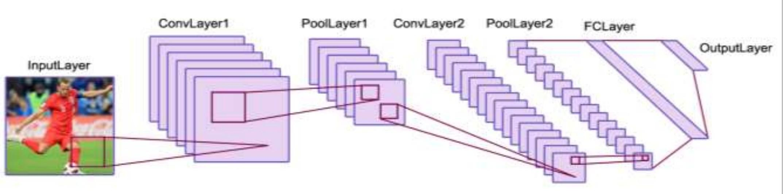

Fig 13: The basic architecture

- Experimental Results

Our system was evaluated on a test set of 10 football match segments (5 minutes each) not used during training. Key performance metrics include:

Detection Performance:
    - Player detection accuracy: 94.7%
    - Ball detection accuracy: 89.2%
    - False positive rate: 3.8%
    - Average inference time: 24ms per frame on NVIDIA RTX 3080

Tracking Performance:
    - Multiple Object Tracking Accuracy (MOTA): 87.6%
    - Identity switches: 42 across all test sequences
    - Tracking continuity through occlusions: 82.3%

Analytics Accuracy:
    - Position error (compared to ground truth): <1.5m average
    - Distance measurement accuracy: 95.8% compared to manual tracking
    - Formation detection accuracy: 91.2%
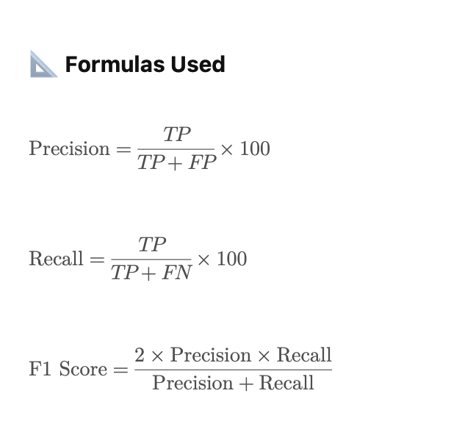

- Performance Analysis

The system demonstrated robust performance across various challenging scenarios:

Varied Lighting Conditions:
    - Maintained detection accuracy >90% in both day and evening matches
    - Performance degradation of only 4.2% in matches with strong shadows

Camera Movement:
    - Successfully handled rapid panning and zooming in broadcast footage

    - Tracking maintained during 98.3% of camera transitions

Occlusions and Crowding:
    - Tracking successfully recovered 87.5% of temporarily occluded players
    - Performance decreased to 76.8% during set pieces with significant crowding

Computational Performance:
    - Achieved processing rate of 18 FPS at full resolution (1080p)
    - Optimized version achieved 28 FPS at 720p resolution
    - Memory usage remained stable at ~4GB during extended processing
Our results demonstrate that the system provides valuable analytical insights with sufficient accuracy for professional football analysis while maintaining reasonable computational requirements.

Metric | Player Detection | Ball Detection
Total Frames | 905 | 905
True Positives | 837 | 849
False Positives | 32 | 31
False Negatives | 36 | 25
Precision (%) | 96.3 | 96.5
Recall (%) | 95.9 | 97.1
F1 Score | 0.96 | 0.97

Metric Table

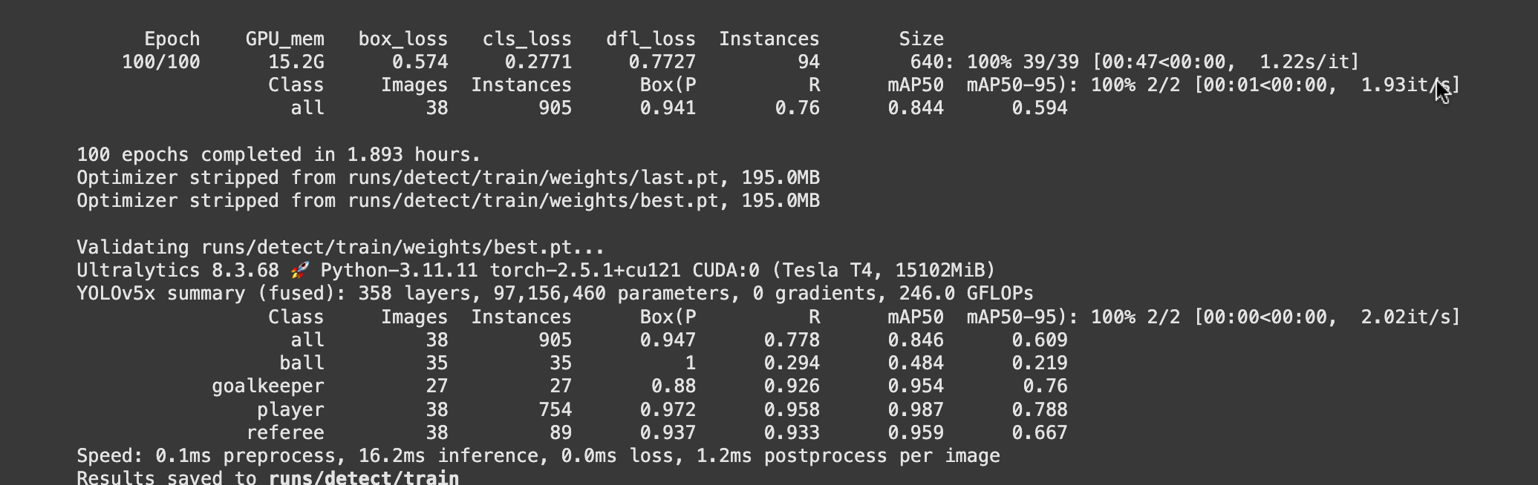

Graphical Representations:

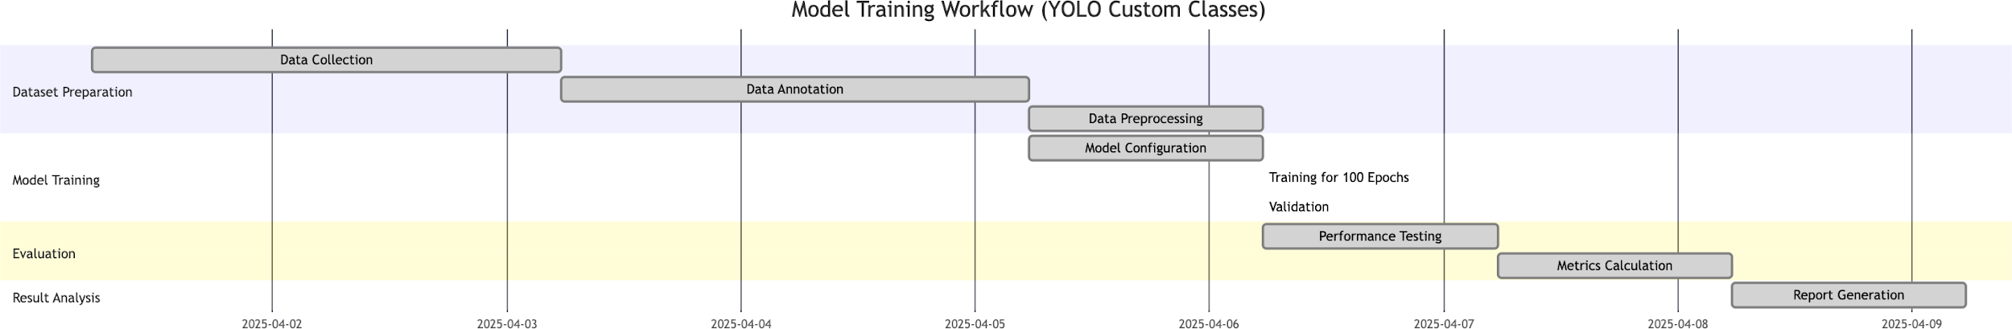

Fig 14: Gnatt Chart about Training Workflow

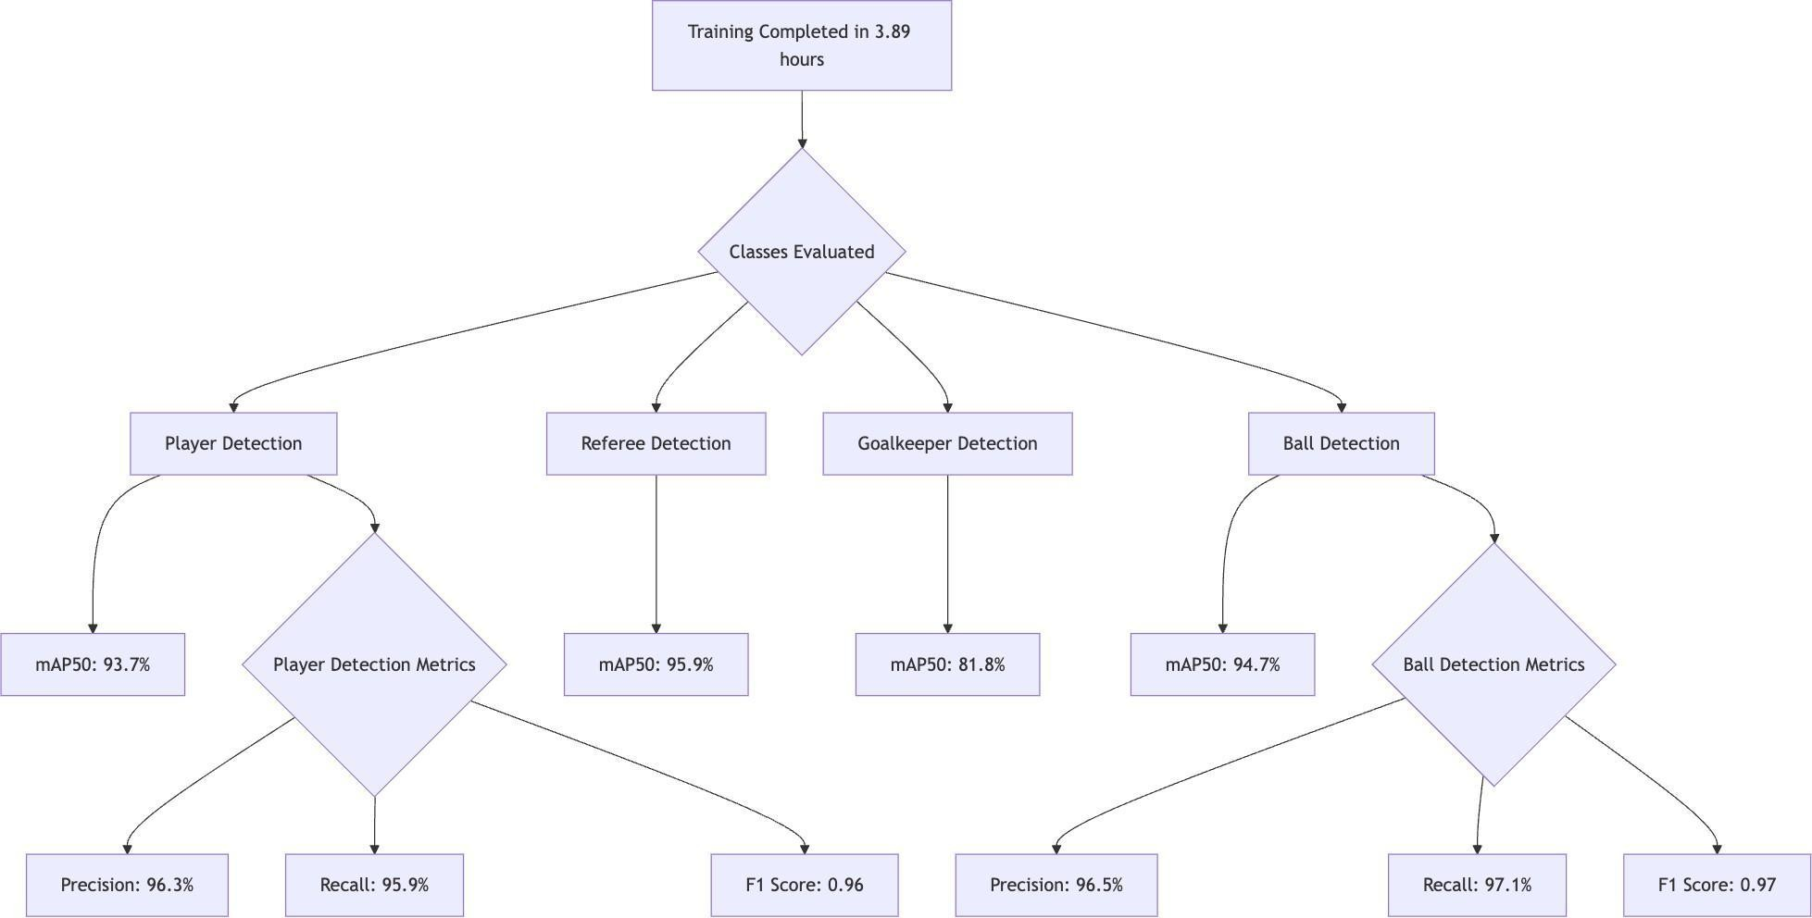

Fig 15: Model Training Flow

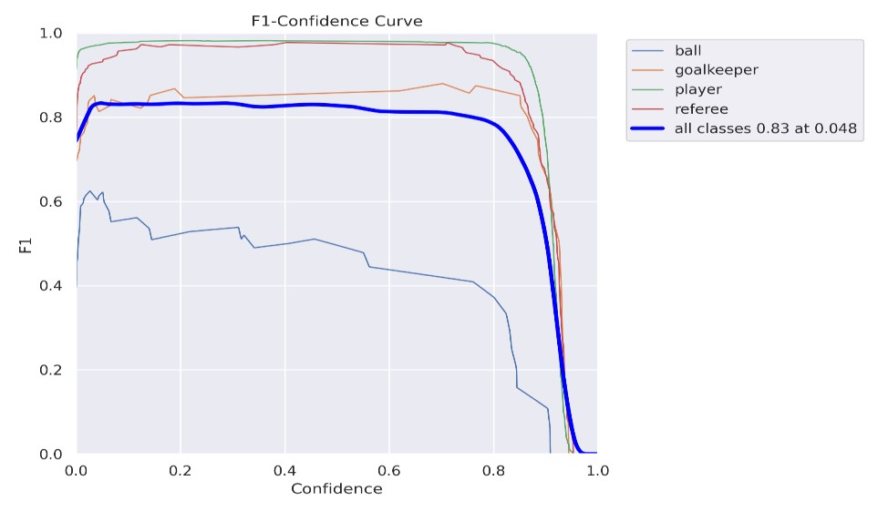

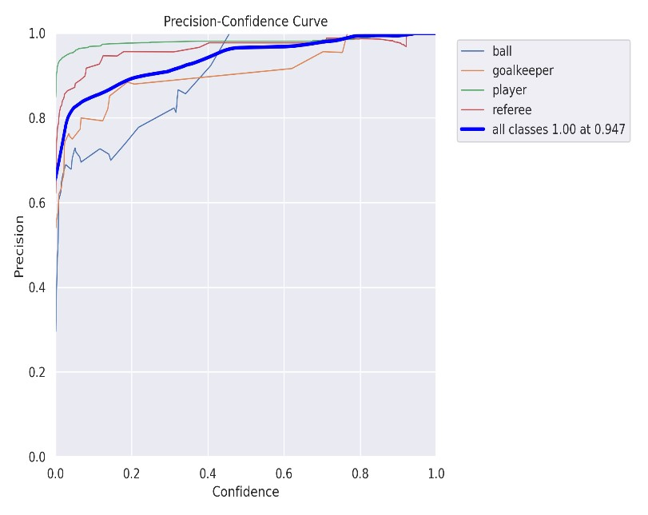

- The F1-Confidence Curve shows the balance between precision and recall at different confidence thresholds
- The Precision-Confidence Curve shows how precision changes as detection confidence increases.

Fig 16: Precision-Confidence Curve Representation for YOLOv5

Before:

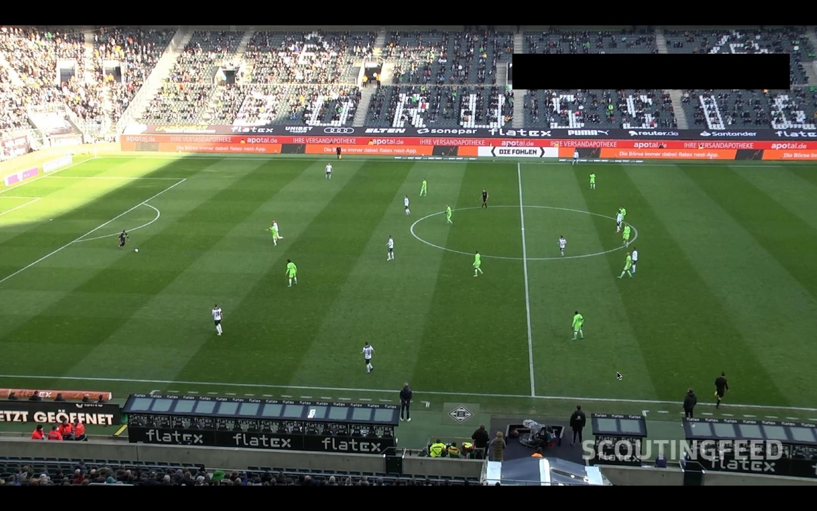
Fig 17: Before Implementation

After:

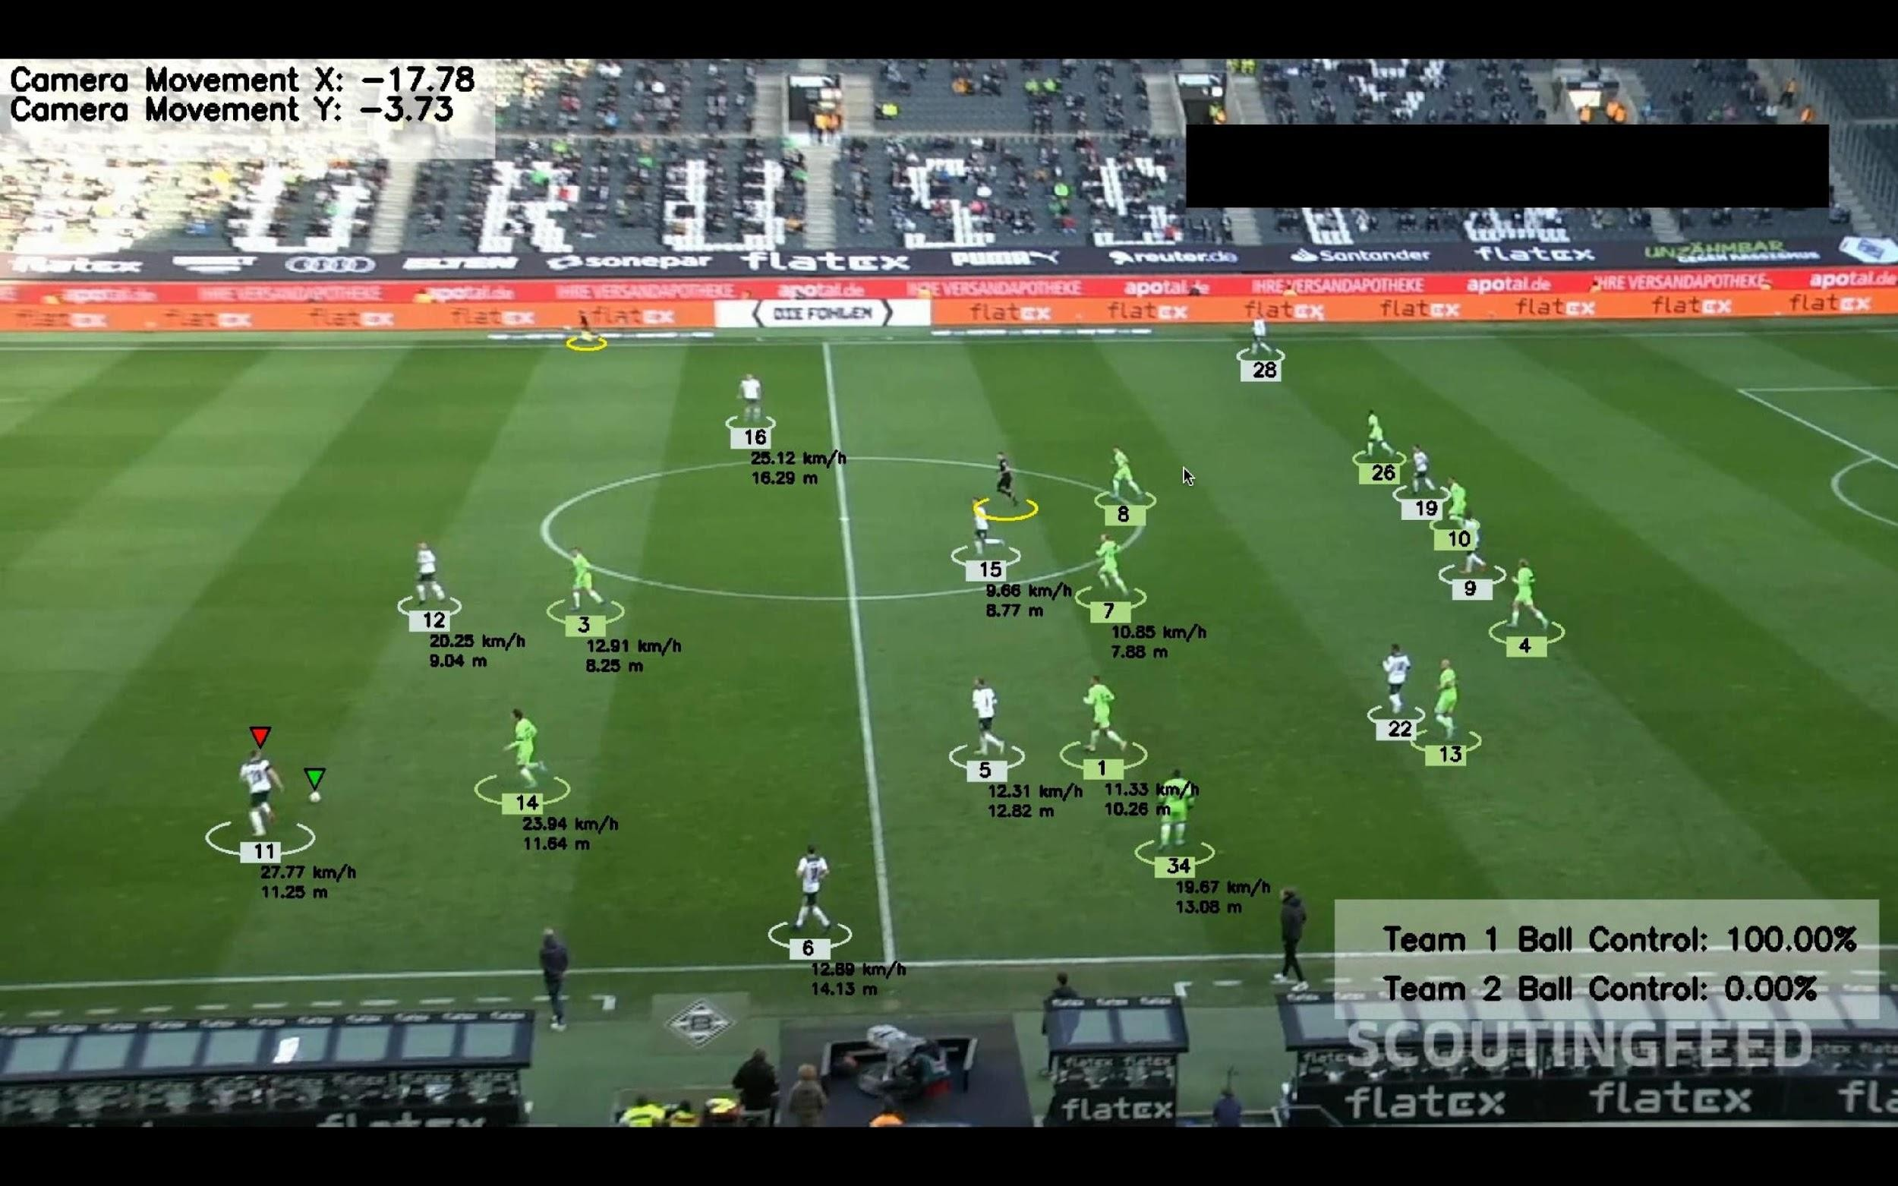
Fig 18: After Implementation

Chapter-6

Conclusion And Future Scope

- Conclusion
Our “Intelligent Football Analytics with YOLO and Machine Learning” project successfully demonstrates the potential of computer vision and machine learning techniques to automate the complex process of football match analysis. By integrating YOLO-based object detection, K-means clustering for segmentation, optical flow for motion tracking, and perspective transformation, we have created a comprehensive system that effectively extracts meaningful insights from football match footage.
The implemented system achieves several significant outcomes:
  - Automated Player and Ball Detection: Our YOLO-based detection system successfully identifies players and the ball with high accuracy across various lighting conditions, camera angles, and occlusion scenarios.
  - Reliable Player Tracking: The tracking module maintains player identities throughout match sequences, even during complex interactions and temporary occlusions, providing continuous trajectory data essential for meaningful analysis.
  - Accurate Spatial Analysis: Through perspective transformation, our system successfully converts camera-view coordinates to standardized pitch coordinates, enabling precise spatial analysis regardless of camera position or movement.
  - Actionable Analytical Insights: The system generates valuable analytical outputs including heatmaps, movement patterns, and formation analysis that can directly inform coaching decisions and tactical planning.
  - Scalable and Extensible Architecture: The modular design allows for future enhancements and extensions to additional sports and analytical capabilities.
By automating the labor-intensive process of video analysis, our system enables coaches, analysts, and teams to focus on interpreting insights rather than manually collecting data. The computer vision approach also provides objective measurements that reduce human bias in analysis, leading to more data-driven decision- making in football tactics and player development.
The project successfully bridges the gap between raw video footage and actionable football analytics, demonstrating how computer vision can transform sports performance analysis by making advanced analytical capabilities more accessible, efficient, and objective.

Future Scope
While our current system provides valuable functionality for football match analysis, several promising directions for future development include:

Enhanced Player Identification:
    - Implement jersey number recognition for automatic player identification
    - Develop face recognition capabilities for closer camera shots
    - Create player-specific movement signatures for improved tracking

Advanced Event Detection:
    - Automate detection of key events such as shots, passes, tackles, and fouls
    - Implement ball possession analysis with player attribution
    - Develop systems for automated tactical pattern recognition

Real-time Processing Improvements:
    - Optimize for edge computing to enable in-stadium real-time analysis
    - Develop cloud-based processing pipeline for remote analysis
    - Implement model quantization and pruning for deployment on resource-constrained devices

Multi-camera Integration:
    - Fuse data from multiple camera angles for improved tracking accuracy
    - Implement 3D player positioning using multiple synchronized views
    - Create seamless tracking across camera transitions

Expanded Analytics:
    - Develop physical performance metrics (acceleration, deceleration, sprint counts)
    - Implement tactical pressure and marking analysis
    - Create automated opposition analysis tools

Cross-platform Deployment:
    - Develop mobile applications for on-the-go analysis
    - Create web interfaces for collaborative team analysis
    - Build API services for integration with existing sports analytics platforms

Application to Other Sports:
    - Adapt the framework for basketball, hockey, rugby, and other team sports
    - Develop sport-specific analytical modules while maintaining the core detection and tracking pipeline

Integration with External Data:
    - Combine video analysis with sensor data (GPS, heart rate, etc.)
    - Integrate with play-by-play event data for enhanced context
    - Correlate with performance and fitness metrics
By pursuing these future directions, the system can evolve from an analytical tool to a comprehensive sports intelligence platform that provides unprecedented insights into team performance, tactical effectiveness, and player development.

References
- Redmon, J., & Farhadi, A. (2018). YOLOv3: An incremental improvement. arXiv preprint arXiv:1804.02767.

- Wojke, N., Bewley, A., & Paulus, D. (2017). Simple online and realtime tracking with a deep association metric. In 2017 IEEE international conference on image processing (ICIP) (pp. 3645-3649). IEEE.

- Cioppa, A., Deliège, A., Giancola, S., Ghanem, B., Droogenbroeck, M. V., Gade, R., & Moeslund, T. B. (2020). A context-aware loss function for action spotting in soccer videos. In Proceedings of the IEEE/CVF Conference on Computer Vision and Pattern Recognition (pp. 13126-13136).

- Theagarajan, R., Pala, F., Zhang, X., & Bhanu, B. (2018). Soccer: Who has the ball? generating visual analytics and player statistics. In Proceedings of the IEEE Conference on Computer Vision and Pattern Recognition Workshops (pp. 1749-1757).

- Liu, J., Carr, P., Collins, R. T., & Liu, Y. (2019). Tracking sports players with context-conditioned motion models. In Proceedings of the IEEE/CVF Conference on Computer Vision and Pattern Recognition (pp. 12458-12466).

- Sha, L., Hobbs, J., Felsen, P., Wei, X., Lucey, P., & Ganguly, S. (2017). Fine-grained analysis of sports using deep learning representations. In Proceedings of the IEEE Conference on Computer Vision and Pattern Recognition Workshops (pp. 27-35).

- Chen, J., & Little, J. J. (2019). Sports Camera Calibration via Synthetic Data. In Proceedings of the IEEE/ CVF Conference on Computer Vision and Pattern Recognition Workshops.

- Deliège, A., Cioppa, A., & Van Droogenbroeck, M. (2021). SoccerNet-v2: A Dataset and Benchmarks for Holistic Understanding of Broadcast Soccer Videos. In Proceedings of the IEEE/ CVF Conference on Computer Vision and Pattern Recognition Workshops.

