Experiment 10: Implementation of income tax/loan EMI calculator and deploy the same on real devices

PART A

A.1 Aim: To Implementation of income tax/loan EMI calculator and deploy the same on real devices.

A.2 Objectives: To introduce students with various tools like Android Studio, NS2, Wireshark, Cisco packet tracer, WAP supported browser etc.

A.3 Outcome: After successful completion of this experiment students will be able to Implementation of income tax/loan EMI calculator and deploy the same on real devices

A.4 Theory:

SOFTWARE:
- Android Studio
- The Android SDK (Starter Package)
- Gradle
- Java Development Kit (JDK) 5

DESCRIPTION:

- Open android studio and select new android project .
- Give project name and select next
- Choose the android version.
- Enter the package name. package name must be two word separated by comma and click finish
- Go to package explorer in the left hand side and select our project.
- Go to res folder and select layout. Double click the main.xml file 21. Now you can see the Graphics layout window.

activity_main.xml

<?xml version="1.0" encoding="utf-8"?>
<androidx.constraintlayout.widget.ConstraintLayoutxmlns:android="http://schemas.android.com/apk/res/android" xmlns:app="http://schemas.android.com/apk/res-auto" xmlns:tools="http://schemas.android.com/tools" android:layout_width="match_parent" android:layout_height="match_parent" android:background="#D8D0D0"

tools:context=".MainActivity">

<EditText
android:id="@+id/editText" android:layout_width="wrap_content" android:layout_height="wrap_content" android:layout_marginStart="8dp" android:layout_marginEnd="8dp" android:layout_marginBottom="8dp" android:ems="10"
android:hint="@string/enter_principle" android:inputType="number" app:layout_constraintBottom_toBottomOf="parent" app:layout_constraintEnd_toEndOf="parent" app:layout_constraintHorizontal_bias="0.45" app:layout_constraintStart_toStartOf="parent" app:layout_constraintTop_toTopOf="parent" app:layout_constraintVertical_bias="0.203" android:autofillHints="" />

<EditText android:id="@+id/editText2" android:layout_width="wrap_content" android:layout_height="wrap_content" android:layout_marginStart="8dp" android:layout_marginTop="8dp" android:layout_marginEnd="8dp" android:ems="10" android:hint="@string/enter_time" android:inputType="number" app:layout_constraintBottom_toBottomOf="parent" app:layout_constraintEnd_toEndOf="parent" app:layout_constraintHorizontal_bias="0.45" app:layout_constraintStart_toStartOf="parent" app:layout_constraintTop_toTopOf="parent" app:layout_constraintVertical_bias="0.274" android:autofillHints="" />

<EditText android:id="@+id/editText3" android:layout_width="wrap_content" android:layout_height="wrap_content" android:layout_marginStart="8dp" android:layout_marginTop="8dp" android:layout_marginEnd="8dp" android:ems="10"
android:hint="@string/enter_rate_of_interest" android:inputType="number" app:layout_constraintBottom_toBottomOf="parent" app:layout_constraintEnd_toEndOf="parent" app:layout_constraintHorizontal_bias="0.45" app:layout_constraintStart_toStartOf="parent"

app
:
layout_constraintTop_toTopOf="parent"

app:layout_constraintVertical_bias="0.386"

android:autofillHints="" />

<
Button

android:id="@+id/button"

android:layout_width="wrap_content"

android:layout_height="wrap_content"

android:layout_marginStart="8dp"

androi
d:layout_marginTop="8dp"

android:layout_marginEnd="8dp"

android:text="@string/calculate_emi"

app:layout_constraintBottom_toBottomOf="parent"

app:layout_constraintEnd_toEndOf="parent"

app:layout_constraintStart_toStartOf="parent"

app:layout_constraintTop_toTopOf="parent"

app:layout_constraintVertical_bias="0.62" />

<
TextView

android:id="@+id/textView"

android:layout_width="95dp"

android:layout_height="104dp"

android:layout_marginStart="8dp"

android:layout_marginTop="8dp"

android:l
ayout_marginEnd="8dp"

app:layout_constraintBottom_toBottomOf="parent"

app:layout_constraintEnd_toEndOf="parent"

app:layout_constraintHorizontal_bias="0.486"

app:layout_constraintStart_toStartOf="parent"

app:layout_constraintTop_toTopOf="parent"

app:layout_
constraintVertical_bias="0.901" />

>
/androidx.constraintlayout.widget.ConstraintLayout
<

MainActivity.java

package com.example.emicalculator;

import android.os.Bundle;

import android.view.View;

import android.widget.Button;

import
android.widget.EditText;

import android.widget.TextView;

import androidx.appcompat.app.AppCompatActivity;

public class MainActivity extends AppCompatActivity {

Button calculate;

TextView result;

EditText pe, ne, re;

@Override

protected void

onCreate(Bundle savedInstanceState) {

super.onCreate(savedInstanceState);

setContentView(R.layout.activity_main);

calculate = findViewById(R.id.button);

result = findViewById(R.id.textView);

pe = findViewById(R.id.editText);

ne = findViewById(R.id.editText2);

re = findViewById(R.id.editText3);

calculate.setOnClickListener(new View.OnClickListener() {

@Override

public void onClick(View view) {

Double p = Double.parseDouble
(
pe.getText().toString());

Double n = Double.parseDouble(ne.getText().toString());

Double r = Double.parseDouble(re.getText().toString());

Double rate= (r/1200);
Double res = (p * rate * Math.pow(1 + rate, n) / Math.pow(1 + rate, n) - 1);

result.setText("EMI = "+String.valueOf(res));
}
});
}
}

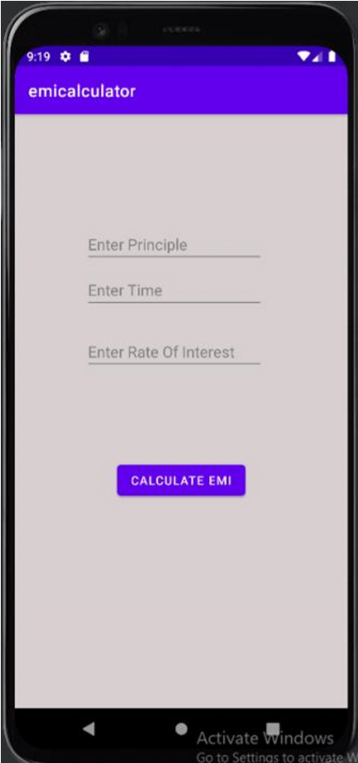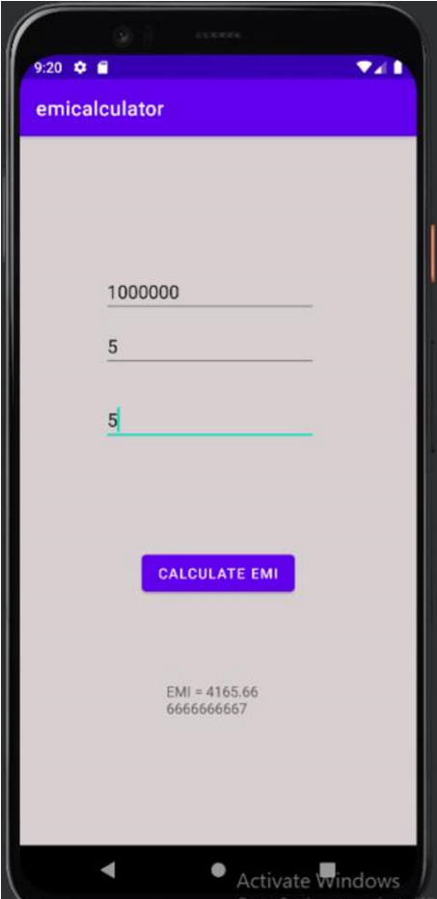

Output

PART B

(PART B: TO BE COMPLETED BY STUDENTS)

(Students must submit the soft copy as per following segments within two hours of the practical. The soft copy must be uploaded on the Blackboard or emailed to the concerned lab in charge faculties at the end of the practical in case the there is no Black board access available)

Roll. No. C-54 | Name: Quazi Md Moinuddin
Class : TE Comps C | Batch: C-3
Date of Experiment: 26.03.25 | Date of Submission: 4.04.25
Grade:

B.1 Software Code written by student/steps:
AndroidManifest.xml
<?xml version="1.0" encoding="utf-8"?>
<manifest xmlns:tools="http://schemas.android.com/tools"
xmlns:android="http://schemas.android.com/apk/res/android">

<application
android:allowBackup="true"
android:icon="@mipmap/ic_launcher"
android:label="EMI Calculator"
android:roundIcon="@mipmap/ic_launcher_round"
android:supportsRtl="true"
android:theme="@style/Theme.EMIcalculator">

<activity android:name=".MainActivity"
android:exported="true">
<intent-filter>
<action android:name="android.intent.action.MAIN" />
<category android:name="android.intent.category.LAUNCHER" />
</intent-filter>
</activity>

</application>

</manifest>

MainActivity.java
package com.example.emicalculator;

import android.os.Bundle;
import android.widget.Button;
import android.widget.EditText;
import android.widget.TextView;
import androidx.appcompat.app.AppCompatActivity;

public class MainActivity extends AppCompatActivity {

@Override
protected void onCreate(Bundle savedInstanceState) {
super.onCreate(savedInstanceState);
setContentView(R.layout.activity_main);

// Linking UI elements
EditText etSalary = findViewById(R.id.etSalary);
Button btnCalculateTax = findViewById(R.id.btnCalculateTax);
TextView tvTaxResult = findViewById(R.id.tvTaxResult);

EditText etLoanAmount = findViewById(R.id.etLoanAmount);
EditText etInterestRate = findViewById(R.id.etInterestRate);
EditText etTenure = findViewById(R.id.etTenure);
Button btnCalculateEMI = findViewById(R.id.btnCalculateEMI);
TextView tvEMIResult = findViewById(R.id.tvEMIResult);

// Tax Calculation Logic
btnCalculateTax.setOnClickListener(v -> {
String salaryStr = etSalary.getText().toString();
if (!salaryStr.isEmpty()) {
double salary = Double.parseDouble(salaryStr);
double tax = calculateTax(salary);
tvTaxResult.setText("Tax Payable: ₹" + tax);
} else {
tvTaxResult.setText("Please enter a valid salary");
}
});

// EMI Calculation Logic
btnCalculateEMI.setOnClickListener(v -> {
String loanStr = etLoanAmount.getText().toString();
String rateStr = etInterestRate.getText().toString();
String tenureStr = etTenure.getText().toString();

if (!loanStr.isEmpty() && !rateStr.isEmpty() && !tenureStr.isEmpty()) {
double principal = Double.parseDouble(loanStr);
double rate = Double.parseDouble(rateStr);
int tenure = Integer.parseInt(tenureStr);
double emi = calculateEMI(principal, rate, tenure);
tvEMIResult.setText("Monthly EMI: ₹" + emi);
} else {
tvEMIResult.setText("Please enter valid inputs");
}
});
}

// Function to calculate tax
private double calculateTax(double salary) {
if (salary <= 250000) return 0;
if (salary <= 500000) return (salary - 250000) * 0.05;
if (salary <= 1000000) return (250000 * 0.05) + (salary - 500000) * 0.2;
return (250000 * 0.05) + (500000 * 0.2) + (salary - 1000000) * 0.3;
}

// Function to calculate Loan EMI
private double calculateEMI(double principal, double rate, int years) {
double monthlyRate = rate / (12 * 100);
int months = years * 12;
return (principal * monthlyRate * Math.pow(1 + monthlyRate, months)) /
(Math.pow(1 + monthlyRate, months) - 1);
}
}

Android_main.xml
<LinearLayout
xmlns:android="http://schemas.android.com/apk/res/android"
android:layout_width="match_parent"
android:layout_height="match_parent"
android:padding="20dp"
android:orientation="vertical">

<!-- Income Tax Calculator -->
<EditText
android:id="@+id/etSalary"
android:layout_width="match_parent"
android:layout_height="wrap_content"
android:hint="Enter Annual Salary"
android:inputType="numberDecimal"/>

<Button
android:id="@+id/btnCalculateTax"
android:layout_width="match_parent"
android:layout_height="wrap_content"
android:text="Calculate Tax"/>

<TextView
android:id="@+id/tvTaxResult"
android:layout_width="match_parent"
android:layout_height="wrap_content"
android:text="Tax Result will be shown here"
android:textSize="16sp"/>

<!-- Loan EMI Calculator -->
<EditText
android:id="@+id/etLoanAmount"
android:layout_width="match_parent"
android:layout_height="wrap_content"
android:hint="Enter Loan Amount"
android:inputType="numberDecimal"/>

<EditText
android:id="@+id/etInterestRate"
android:layout_width="match_parent"
android:layout_height="wrap_content"
android:hint="Enter Interest Rate (%)"
android:inputType="numberDecimal"/>

<EditText
android:id="@+id/etTenure"
android:layout_width="match_parent"
android:layout_height="wrap_content"
android:hint="Enter Tenure (Years)"
android:inputType="number"/>

<Button
android:id="@+id/btnCalculateEMI"
android:layout_width="match_parent"
android:layout_height="wrap_content"
android:text="Calculate EMI"/>

<TextView
android:id="@+id/tvEMIResult"
android:layout_width="match_parent"
android:layout_height="wrap_content"
android:text="EMI Result will be shown here"
android:textSize="16sp"/>
</LinearLayout>

B.2 Input and Output:

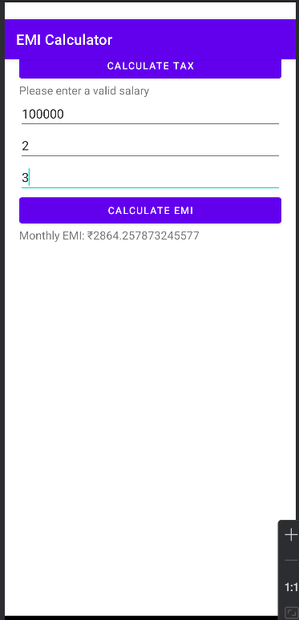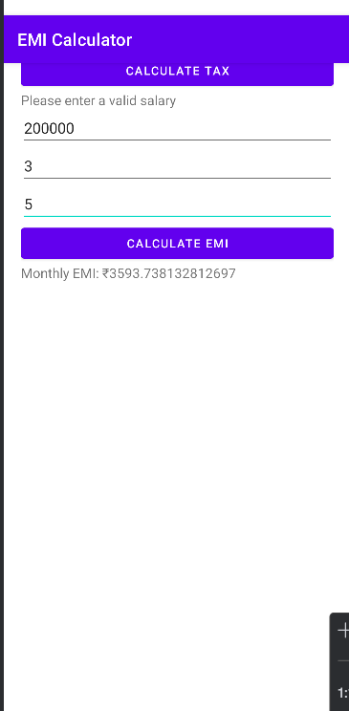

B.3 Observations and learning:
- Faced issues in AndroidManifest.xml (namespace, android:exported error).
- Encountered "Android resource linking failed" due to incorrect theme references.
- Successfully implemented EMI & Income Tax calculations using Java.
- Deployed and tested the app after fixing build errors.

B.4 Conclusion:
- Learned Android debugging, Gradle fixes, and Manifest configurations.
- Successfully built and deployed a functional financial calculator.
- Future improvements: Better UI, tax slab integration, and EMI breakdown visuals.

B.5 Question of Curiosity
- Explain different steps required to build up this project?
Steps to Build EMI & Tax Calculator App
1️⃣ Project Setup:
- Create a new Android project in Android Studio with Java.
2️⃣ UI Design (activity_main.xml):
- Add EditText (for loan amount, interest rate, etc.), Button (to calculate), and TextView (to display results).
3️⃣ Backend Logic (MainActivity.java):
- Implement EMI formula:
EMI=P×R×(1+R)N(1+R)N−1EMI = \frac{P \times R \times (1+R)^N}{(1+R)^N-1}EMI=(1+R)N−1P×R×(1+R)N​
- Add logic for income tax calculation.
4️⃣ Manifest & Permissions (AndroidManifest.xml):
- Set android:exported="true" for MainActivity.
5️⃣ Testing & Deployment:
- Run on Emulator/Real Device → Fix errors → Deploy successfully

