Terna Engineering College
Computer Engineering Department

Class: TE Sem.: VI

Course: System Security Lab

PART A
(PART A : TO BE REFFERED BY STUDENTS)
Experiment No.9
A.1 Aim: Simulate DOS attack using Hping, hping3 and Wireshark
A.2 Prerequisite:
1. Basic Knowledge of DOS attacks,

A.3 Outcome:
After successful completion of this experiment students will be able to

To be able to use open source technologies and explore email security and explore various attacks.

A.4 Theory:
Denial-of-service (DoS) attack is an attempt to make a machine or network resource unavailable to its intended users, such as to temporarily or indefinitely interrupt or suspend services. A distributed denial-of-service (DDoS) is where the attack source is more than one, often thousands of, unique IP addresses. It is analogous to a group of people crowding the entry door or gate to a shop or business, and not letting legitimate parties enter into the shop or business, disrupting normal operations.
A DoS attack tries to make a web resource unavailable to its users by flooding the target URL with more requests than the server can handle. That means that during the attack period, regular trafficon the website will be either slowed down or completelyinterrupted.

ADistributedDenialofService(DDoS)attackisaDoSattackthatcomesfrommorethanonesource at the same time. A DDoS attack is typically generated using thousands (potentially hundreds of thousands) of unsuspecting zombie machines. The machines used in such attacks are collectively known as “botnets” and will have previously been infected with malicious software, so they can be remotely controlled by the attacker. According to research, tens of millions of computers are likely to be infected with botnet programsworldwide.

Cybercriminals use DoS attacks to extort money from companies that rely on their websites being accessible. But there have also been examples of legitimate businesses having paid underground elementsoftheInternettohelpthemcripplerivalwebsites.Inaddition,cybercriminalscombineDoS attacks and phishing to target online bank customers. They use a DoS attack to take down the bank's website and then send out phishing e-mails to direct customers to a fake emergency siteinstead.

Installation Steps:
- Install Hping3 andwireshark
- Flood the victim with TCP/ICMP/UDP packet using Hping3 (-- floodoption)
- Observe the Dos attack and DDos attack usingWireshark

PART B

(PART B : TO BE COMPLETED BY STUDENTS)
(Students must submit the soft copy as per following segments within two hours of the practical. The soft copy must be uploaded on the Blackboard or emailed to the concerned lab in charge faculties at the end of the practical in case the there is no Black board access available)

Roll No. C54 | Name: Quazi Md Moinuddin
Class : TE-C | Batch : C3
Date of Experiment: | Date of Submission: 28-3-25
Grade :

B.1 | Output
(add snapshot ofoutput )
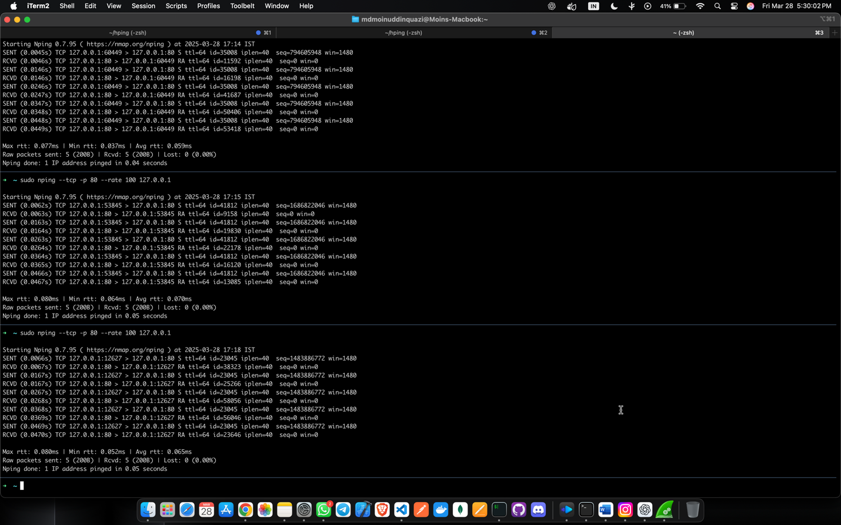
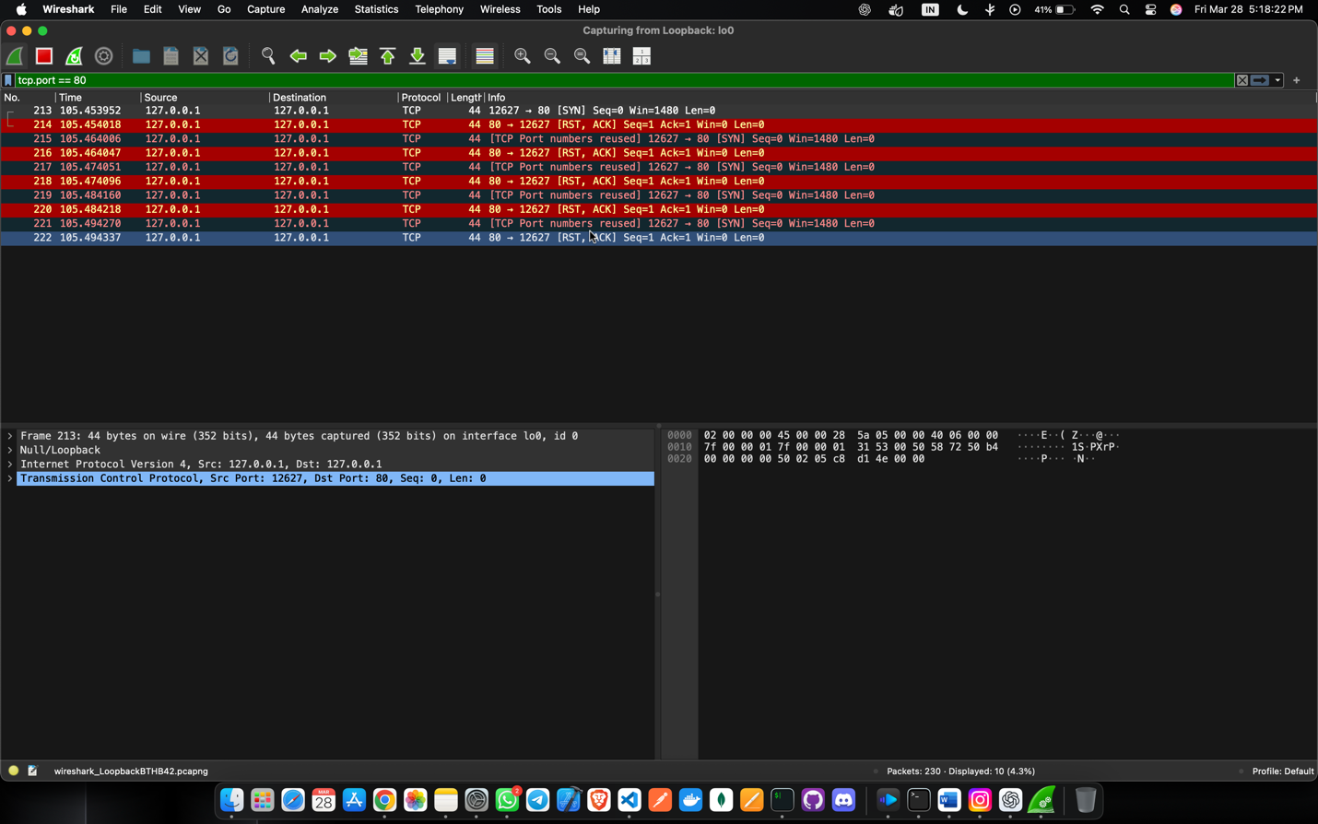
 | 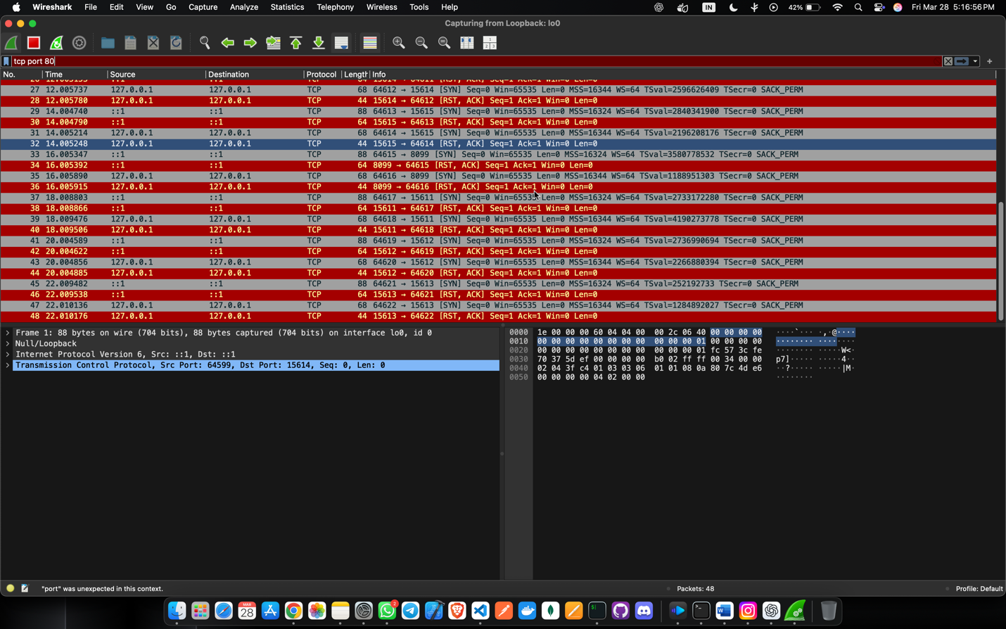
B.2. | Commands / tools used with syntax:
 | sudo nping --tcp -p 80 --rate 100 127.0.0.1
B.3 | Question of Curiosity: (Attempt at least 3 questions handwritten)  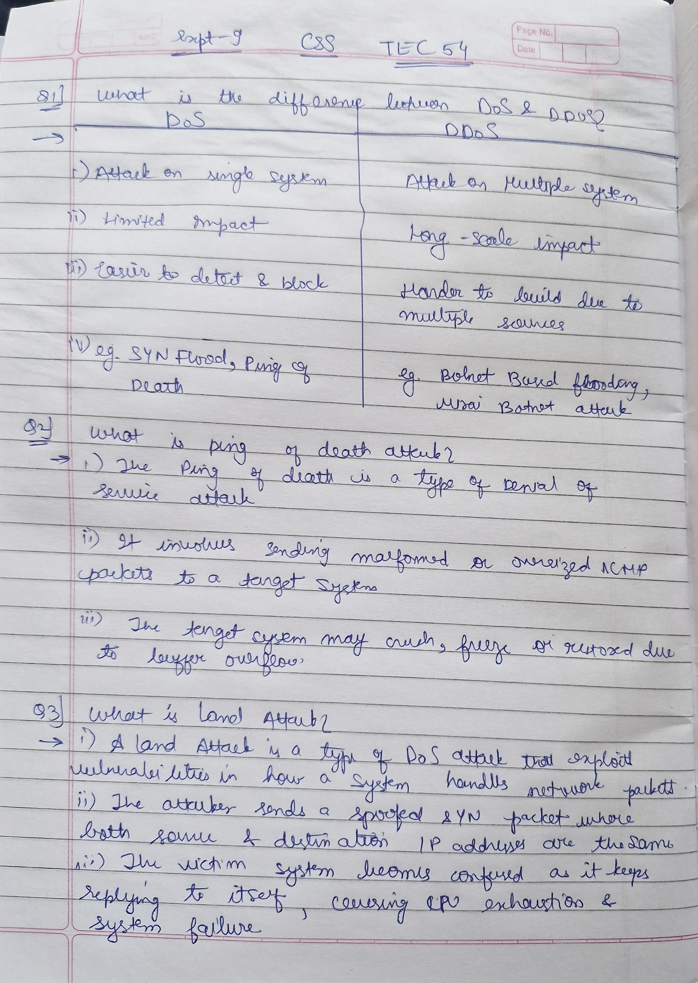
B.4 | Conclusion:  (Write appropriate conclusion.)
In this experiment, we demonstrated how to simulate a Denial-of-Service (DoS) attack using hping3 while analyzing the network traffic using Wireshark. By crafting and sending a large number of TCP, UDP packets to a target system, we observed how excessive traffic can overload network resources, potentially making a system unresponsive.

