Experiment 09: Write an application that draws basic graphical primitives in the screen

PART A

A.1 Aim: To write an application that draws basic graphical primitives in the screen.

A.2 Objectives: To introduce students with various tools like Android Studio, NS2, Wire-shark, Cisco packet tracer, WAP supported browser etc.

A.3 Outcome: After successful completion of this experiment students will be able to develop an application that draws basic graphical primitives in the screen.

A.4 Theory:

SOFTWARE:

- Android Studio
- The Android SDK (Starter Package)
- Gradle
- Java Development Kit (JDK) 5

DESCRIPTION:

- Open android studio and select new android project .
- Give project name and select next
- Choose the android version.
- Enter the package name. package name must be two word separated by comma and click finish
- Go to package explorer in the left hand side and select our project.
- Go to res folder and select layout. Double click the main.xml file 14. Now you can see the Graphics layout window.

SourceCode:
CodeforActivity_main.xml:

<?xmlversion="1.0"encoding="utf-8"?>
<RelativeLayoutxmlns:android="http://schemas.android.com/apk /res/android"android:layout_width="match_parent"android:layo ut_height=" match_parent">

<ImageView android:layout_width="match_pare nt"android:layout_height="match_p arent"android:id="@+id/imageVie w"/>
< /RelativeLayout >

Code for MainActivity.java:

package com.example.exno4; import android.app.Activity; import
android.graphics.Bitmap; import android.graphics.Canvas;

import android.graphics.Color; importandroid.graphics.Pain t;
import android.graphics.drawable.BitmapDrawable;

import android.os.Bundle; importandroid.widget.ImageView; publicclassMainActivityextendsActivi ty
{

@Override
publicvoidonCreate(BundlesavedInstanceSt ate)
{
super.onCreate(savedInstanceState);setContentView(R.layout.a ctivity_main);

//CreatingaBitmap
Bitmapbg=Bitmap.createBitmap(720,1280,Bitmap.Config.ARGB_888
8);
//Setting the Bitmap as background for the ImageViewImageViewi = (ImageView) findViewById(R.id.imageView);i.setBackgroundDraw ab le(newBitmapDrawable(bg)); //CreatingtheCanvasObject
Canvascanvas=newCanvas(bg
);
//Creating the Paint Object and set its color &TextSizePaint paint = new Paint();paint.setColor(Color.BLUE);paint.se tT extSize(50);
//To draw a
Rectanglecanvas.drawText("Rectangle",
42 0,150,paint); canvas.drawRect(400,200,650,700,pain

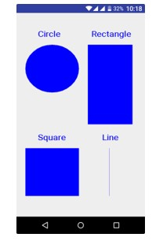

Lab Manual: Mobile Compu
ting Lab (CSL
-
603)
Branch: Computer Engg.

Sem: VI Year:

FH 2022

//Todrawa Circle
canvas.drawText("Circle",120,150,paint);
canvas.drawCircle(200,350,150,paint);

//Todrawa Square
canvas.drawText("Square",120,800,paint);
canvas.drawRect(50,850,350,1150,paint);

//Todrawa Line
canvas.drawText("Line",480,800,paint);

canvas.drawLine(520,850,520,1150,paint);

}

}

Output:

PART B

(PART B: TO BE COMPLETED BY STUDENTS)

(Students must submit the soft copy as per following segments within two hours of the practical. The soft copy must be uploaded on the Blackboard or emailed to the concerned lab in charge faculties at the end of the practical in case the there is no Black board access available)

Roll. No. : C-54 | Name: Quazi Md Moinuddin
Class : TE Comps C | Batch: C-3
Date of Experiment: 26.03.25 | Date of Submission:01.04.25
Grade:

B.1 Software Code written by student/steps:
Android_main.xml
<?xml version="1.0" encoding="utf-8"?>
<RelativeLayout xmlns:android="http://schemas.android.com/apk/res/android"
android:layout_width="match_parent"
android:layout_height="match_parent">

<ImageView
android:id="@+id/imageView"
android:layout_width="match_parent"
android:layout_height="match_parent" />

</RelativeLayout>

MainActivity.java
package com.example.shapesapp;

import android.app.Activity;
import android.graphics.Bitmap;
import android.graphics.Canvas;
import android.graphics.Color;
import android.graphics.Paint;
import android.graphics.drawable.BitmapDrawable;
import android.os.Bundle;
import android.widget.ImageView;

public class MainActivity extends Activity {
@Override
protected void onCreate(Bundle savedInstanceState) {
super.onCreate(savedInstanceState);
setContentView(R.layout.activity_main);

// Creating a Bitmap
Bitmap bg = Bitmap.createBitmap(720, 1280, Bitmap.Config.ARGB_8888);

// Setting the Bitmap as background for the ImageView
ImageView i = findViewById(R.id.imageView);
i.setBackground(new BitmapDrawable(getResources(), bg));

// Creating the Canvas object
Canvas canvas = new Canvas(bg);

// Creating the Paint Object and setting its color & text size
Paint paint = new Paint();
paint.setTextSize(50);
paint.setStrokeWidth(10); // For line thickness

// Drawing Shapes
paint.setColor(Color.BLUE);
canvas.drawText("Rectangle", 420, 150, paint);
canvas.drawRect(400, 200, 650, 700, paint);

paint.setColor(Color.RED);
canvas.drawText("Circle", 100, 150, paint);
canvas.drawCircle(200, 350, 100, paint);

paint.setColor(Color.MAGENTA);
canvas.drawText("Square", 400, 750, paint);
canvas.drawRect(400, 800, 600, 1000, paint); // Square

paint.setColor(Color.CYAN);
canvas.drawText("Vertical Line", 50, 900, paint);
canvas.drawLine(100, 900, 100, 1200, paint); // Vertical Line
}
}

AndroidManifest.xml
<?xml version="1.0" encoding="utf-8"?>
<manifest xmlns:android="http://schemas.android.com/apk/res/android">

<application
android:allowBackup="true"
android:icon="@mipmap/ic_launcher"
android:label="ShapesApp"
android:roundIcon="@mipmap/ic_launcher_round"
android:supportsRtl="true"
android:theme="@style/Theme.AppCompat.Light.NoActionBar">

<activity android:name=".MainActivity"
android:exported="true"> <!-- Added this line -->

<intent-filter>
<action android:name="android.intent.action.MAIN" />
<category android:name="android.intent.category.LAUNCHER" />
</intent-filter>
</activity>

</application>

</manifest>

B.2 Input and Output:

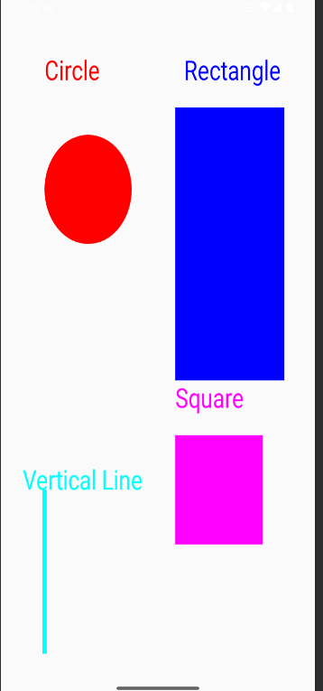
B.3 Observations and learning:
The application successfully displays a blue rectangle on the screen along with the text "Rectangle" using the Canvas and Paint classes in Android. The graphical primitives are drawn dynamically on a Bitmap and displayed in an ImageView.

B.4 Conclusion:
This experiment demonstrates how to create and manipulate graphical objects in an Android application using the Canvas API. It provides a foundation for developing drawing-based applications, such as simple graphic editors or interactive UI elements.

B.5 Question of Curiosity

1) Explain different steps required to build up this project?

Steps to Build the Shape Drawing Android Project
- Create a New Project – Open Android Studio, create a new project (ShapesApp), and select Java as the language.
- Modify activity_main.xml – Add an ImageView inside a RelativeLayout to display the shapes.
- Update AndroidManifest.xml – Ensure android:exported="true" is set for Android 12+ compatibility.
- Write Java Code in MainActivity.java –
  - Create a Bitmap and Canvas.
  - Use Paint to draw rectangle, circle, square, horizontal & vertical lines.
  - Set the Bitmap as the background for ImageView.
- Run the Project – Use an emulator or real device to test the app.
- Enhance & Debug – Fix errors via Logcat, and improve by adding buttons or custom views for dynamic shapes.

