Experiment 07: To develop an android application that uses GPS Location Information.

PART A

A.1 Aim: To develop an android application that uses GPS Location Information.

A.2 Objectives: To introduce students with various tools like Android Studio, NS2, Wire-shark, Cisco packet tracer, WAP supported browser etc.

A.3 Outcome: After successful completion of this experiment students will be able to develop an android application that uses GPS Location Information. A.4Theory:

SOFTWARE:

- Android Studio
- The Android SDK (Starter Package)
- Gradle
- Java Development Kit (JDK) 5

DESCRIPTION:

- Open android studio and select new android project .
- Give project name and select next
- Choose the android version.
- Enter the package name. package name must be two word separated by comma and click finish
- Go to package explorer in the left hand side and select our project.
- Go to res folder and select layout. Double click the main.xml file
- Now you can see the Graphics layout window.

INPUT:

MAINACTIVITY.JAVA

package com.gpslocation;

//import android.R; import android.view.View;
import android.widget.Button; import android.widget.Toast;
import androidx.appcompat.app.AppCompatActivity; import android.os.Bundle;

public class MainActivityextends AppCompatActivity{

/** Called when the activity is first created. */ Button btnShowLocation; GPStracegps;

@Override

public void onCreate(Bundle savedInstanceState) { super.onCreate(savedInstanceState); setContentView(R.layout.activity_main); btnShowLocation=(Button)findViewById(R.id.show_Location); btnShowLocation.setOnClickListener(new View.OnClickListener() {

@Override
public void onClick(View v) {
// TODO Auto-generated method stub gps=new
GPStrace(MainActivity.this); if(gps.canGetLocation()) { double latitude=gps.getLatitude(); double
longitude=gps.getLongtiude();
Toast.makeText(getApplicationContext(),"Your Location is \nLat:"+latitude+"\nLong:"+longitude, Toast.LENGTH_LONG).show();
}
else { gps.showSettingAlert();
}

}
});
}
}

ACTIVITY_MAIN.XML

<?xml version="1.0" encoding="utf-8"?>

<RelativeLayoutxmlns:android="http://schemas.android.com/apk/res/android"andro id:id="@+id/relativeLayout1" android:layout_width="match_parent" android:layout_height="match_parent">

<Button android:id="@+id/show_Location" android:layout_width="wrap_content" android:layout_height="wrap_content" android:text="Show_Location" android:layout_centerVertical="true" android:layout_centerHorizontal="true" />

</RelativeLayout>

GPSTRACE.JAVA

package com.gpslocation;

import android.app.AlertDialog; import android.app.Service; import android.content.Context;
import android.content.DialogInterface; import android.content.Intent; import android.location.Location; import android.location.LocationListener; import android.location.LocationManager; import android.os.Bundle; import android.os.IBinder; import android.provider.Settings;

public class GPStraceextends Service implements LocationListener{ private final Context context; booleanisGPSEnabled=false; booleancanGetLocation=false; booleanisNetworkEnabled=false; Location location;
double latitude; double longtitude;
private static final long MIN_DISTANCE_CHANGE_FOR_UPDATES=10; private static

final long MIN_TIME_BW_UPDATES=1000*60*1; protected
LocationManagerlocationManager; public GPStrace(Context context) { this.context=context; getLocation();
}

public Location getLocation() { try { locationManager=(LocationManager)
context.getSystemService(LOCATION_SERVICE);

isGPSEnabled=locationManager.isProviderEnabled(LocationManager.GPS_PROVIDER
);

isNetworkEnabled=locationManager.isProviderEnabled(LocationManager.NETWORK_ PROVIDER);

if(!isGPSEnabled&& !isNetworkEnabled) {
}
else { this.canGetLocation=true; if(isNetworkEnabled) {

locationManager.requestLocationUpdates( LocationManager.NETWORK_PROVIDER, MIN_TIME_BW_UPDATES, MIN_DISTANCE_CHANGE_FOR_UPDATES,this);
}
if(locationManager!=null) {

location=locationManager.getLastKnownLocation(LocationManager.NETWORK_PROVI DER);
if(location !=null) { latitude=location.getLatitude();
longtitude=location.getLongitude();
}
}
}

if(isGPSEnabled) { if(location==null) {

locationManager.requestLocationUpdates(LocationManager.GPS_PROVIDER,MIN_TIM E_BW_UPDATES, MIN_DISTANCE_CHANGE_FOR_UPDATES, this); if(locationManager!=null) {

location=locationManager.getLastKnownLocation(LocationManager.GPS_PROVIDER)
;
if(location!=null) { latitude=location.getLatitude(); longtitude=location.getLongitude();

}
}
}
}
}
catch(Exception e) {
e.printStackTrace();
}
return location;
}

public void stopUsingGPS() { if(locationManager!=null) { locationManager.removeUpdates(GPStrace.this);
}
}

public double getLatitude() { if(location!=null) { latitude=location.getLatitude();
}
return latitude;
}

public double getLongtiude() { if(location!=null) { longtitude=location.getLatitude();
}
return longtitude;
}

public booleancanGetLocation() { return this.canGetLocation;
}

public void showSettingAlert() {
AlertDialog.BuilderalertDialog= new AlertDialog.Builder(context);


alertDialog
.setTitle(
"GPS is settings"
)
;
alertDialog
.setMessage(
"GPS is not
enabled.Do
you want to go to

setting menu?"
)
;

alertDialog.setPositiveButton(
"settings"
,
new
DialogInterface.OnClickListener() {

@Override

public void
onClick
(
DialogInterface
dialog,
int
which) {
Intent intent
=

new

Intent(
Settings
.
ACTION_LOCATION_SOURCE_SETTINGS
)
;

context
.startActivity(intent);

}

;
})

alertDialog.setNegativeButton(
"cancel"
,
new
DialogInterface.OnClickListener() {

@Override

public void
onClick
(
DialogInterface
dialog,
int
which) {

//
TODO Auto
-
generated method stub
dialog.cancel();

}

})
;

alertDialog
.show();

}

@Override

public void
onLocationChanged
(
Location
location) {

//
TODO Auto
-
generated method stub

}

@Override

public void
onProviderDisabled
(
String
provider) {

//
TODO Auto
-
generated method stub

}

@Override

public void
onProviderEnabled
(
String
provider) {

//
TODO Auto
-
generated method stub

}

@Override

public void
onStatusChanged
(
String
provider,
int
status,
Bundle
extras)

{

//
TODO Auto
-
generated method stub

}

@Override

public
IBinder
onBind
(
Intent intent)
{

//
TODO Auto
-
generated method stub return
null
;

}

}

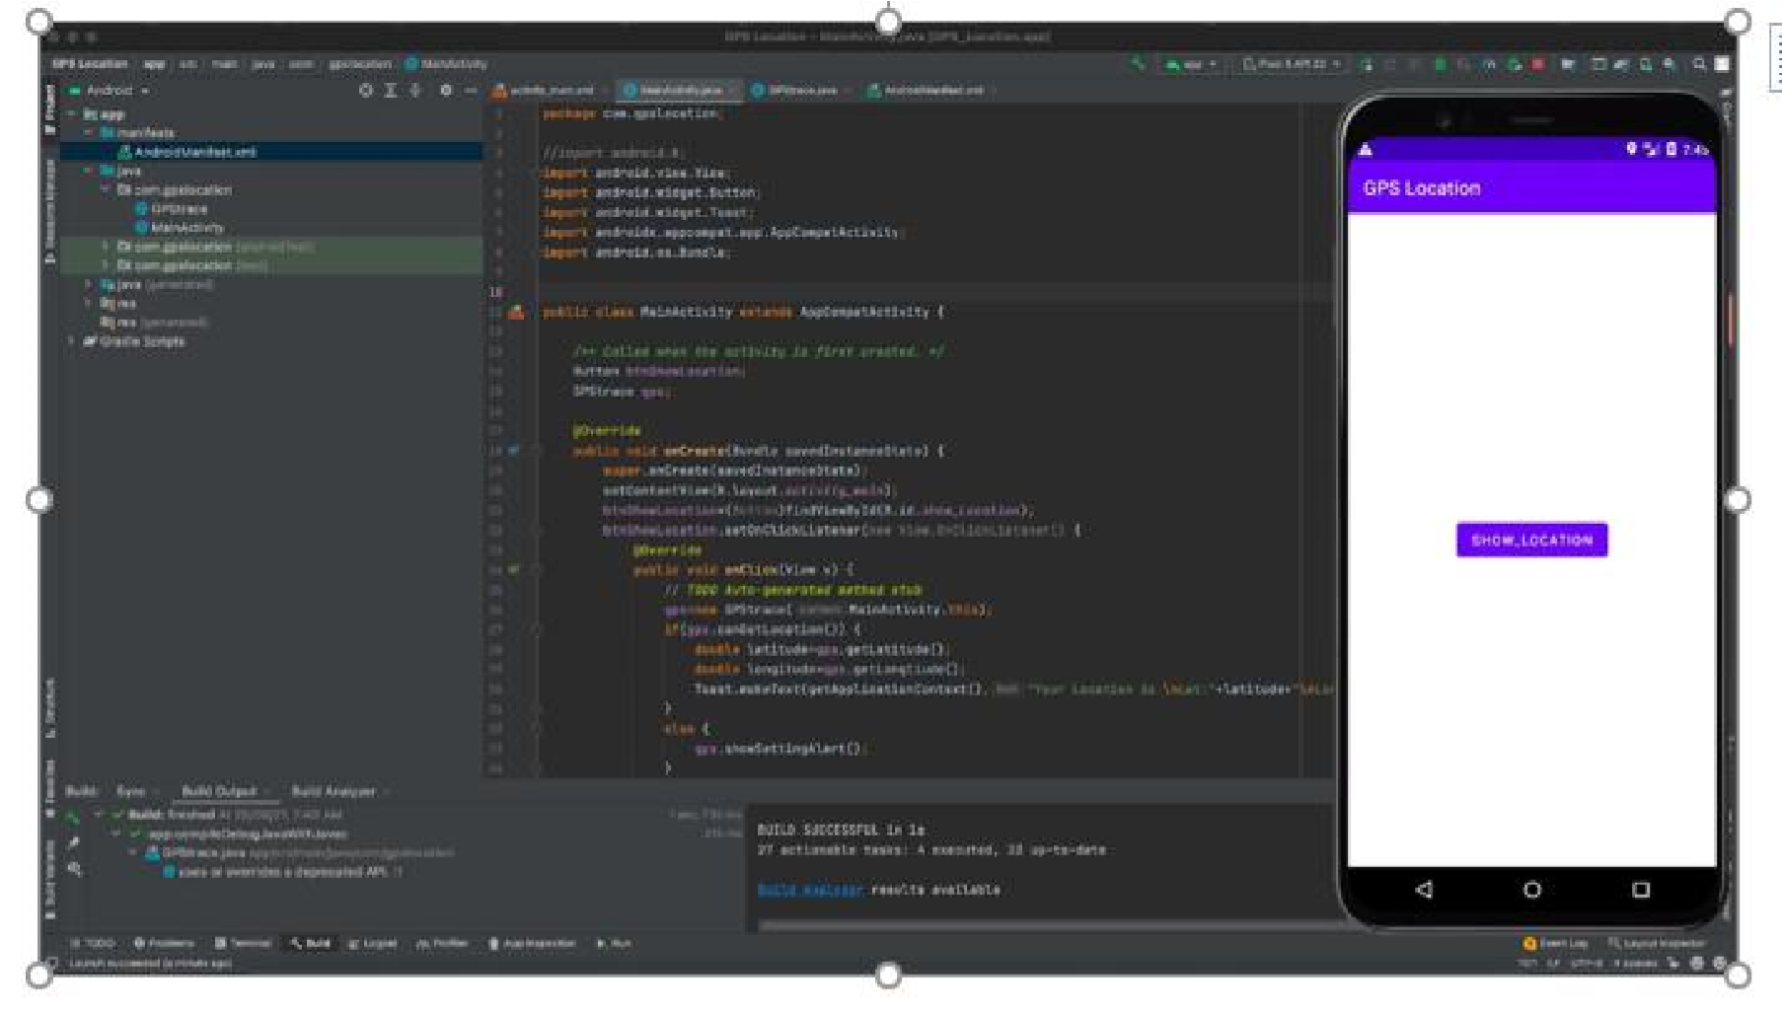

ANDROIDMANIFEST.XML

<
?
xml version
=
"1.0"
encoding
=
"utf
-
8
"
?>

<
manifest
xmlns:
android
=
"http://schemas.android.com/apk/res/android
"
ackage
p
=
"com.gpsl
ocation"
>

<
application

android
:
allowBackup
=
"true"
android
:
icon
=
"@mipmap/ic_launcher"
android
label
:
"@string/app_name"
=
android
roundIcon
:
=
"@mipmap/ic_launcher_round"
android
:
supportsRtl
=
"true"
android
:
theme
=
"@style/Theme.GPSLocation"
>

<
activity

android
name
:
=
".MainActivity"
android
:
exported
=
"true"
>

<
intent
-
filter
>

<
action
android
:
name
=
"android.intent.action.MAIN"
/>

<
category
android
:
name
=
"android.intent.category.LAUNCHER"
/>

<
/
intent
-
filter
>

<
/
activity
>

/
<
application
>

<
uses
-
permission
android
:
name
=
"android.permission.ACCESS_FINE_LOCATION"
/>

<
uses
-
permission
android
:
name
=
"android.permission.INTERNET"
/>

<
/
manifest
>

OUTPUT:

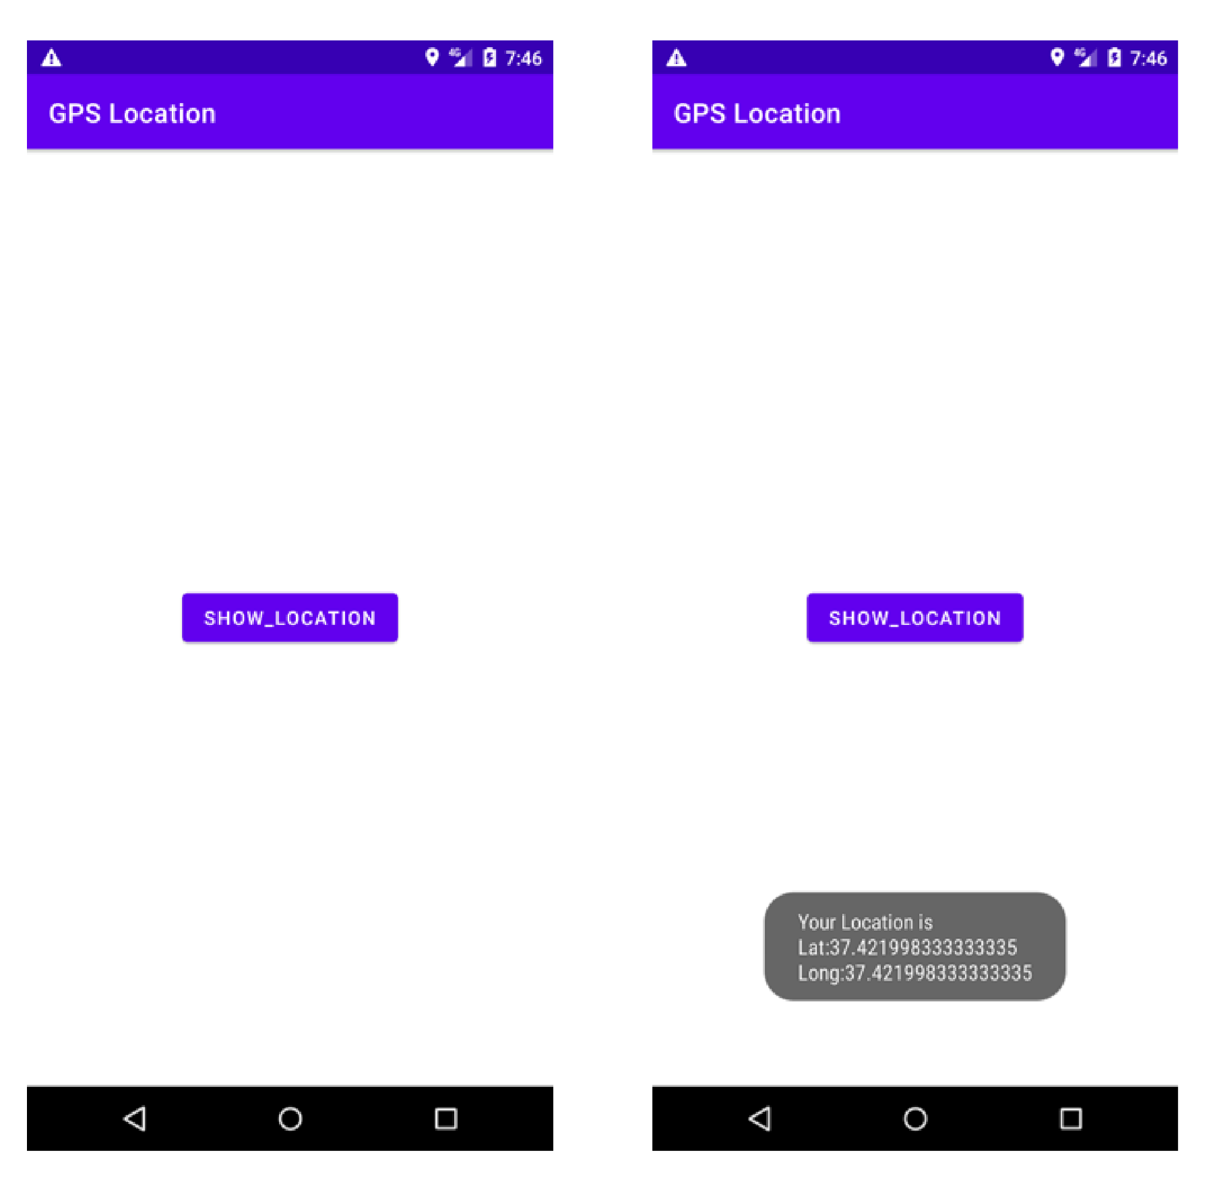

PART B

(PART B: TO BE COMPLETED BY STUDENTS)

(Students must submit the soft copy as per following segments within two hours of the practical. The soft copy must be uploaded on the Blackboard or emailed to the concerned lab in charge faculties at the end of the practical in case the there is no Black board access available)

Roll. No. : C-54 | Name: Quazi Md Moinuddin
Class : TE Comps C | Batch: C-3
Date of Experiment: 17.03.25 | Date of Submission:27.03.25
Grade:

B.1 Software Code written by student/steps:
AndroidManifest.xml

<manifest xmlns:android="http://schemas.android.com/apk/res/android"
package="com.example.gpslocationapp">

<!-- Permissions for Internet and Location -->
<uses-permission android:name="android.permission.INTERNET"/>
<uses-permission android:name="android.permission.ACCESS_FINE_LOCATION"/>
<uses-permission android:name="android.permission.ACCESS_COARSE_LOCATION"/>

<application
android:allowBackup="true"
android:icon="@mipmap/ic_launcher"
android:label="GPS Location App"
android:roundIcon="@mipmap/ic_launcher_round"
android:supportsRtl="true"
android:theme="@style/Theme.Material3.Light">

<!-- Fix: Add android:exported="true" -->
<activity android:name=".MainActivity"
android:exported="true">
<intent-filter>
<action android:name="android.intent.action.MAIN"/>
<category android:name="android.intent.category.LAUNCHER"/>
</intent-filter>
</activity>

</application>

</manifest>

MainActivity.java
package com.example.gpslocationapp;

import android.location.Address;
import android.location.Geocoder;
import android.os.Bundle;
import android.view.View;
import android.widget.Button;
import android.widget.EditText;
import android.widget.TextView;
import android.widget.Toast;
import androidx.appcompat.app.AppCompatActivity;
import java.io.IOException;
import java.util.List;
import java.util.Locale;

public class MainActivity extends AppCompatActivity {

private EditText locationInput;
private Button findButton;
private TextView resultText;

@Override
protected void onCreate(Bundle savedInstanceState) {
super.onCreate(savedInstanceState);
setContentView(R.layout.activity_main);

locationInput = findViewById(R.id.locationInput);
findButton = findViewById(R.id.findButton);
resultText = findViewById(R.id.resultText);

findButton.setOnClickListener(new View.OnClickListener() {
@Override
public void onClick(View v) {
String locationName = locationInput.getText().toString().trim();
if (!locationName.isEmpty()) {
getCoordinates(locationName);
} else {
Toast.makeText(MainActivity.this, "Please enter a location!", Toast.LENGTH_SHORT).show();
}
}
});
}

private void getCoordinates(String location) {
Geocoder geocoder = new Geocoder(this, Locale.getDefault());
try {
List<Address> addresses = geocoder.getFromLocationName(location, 1);
if (addresses != null && !addresses.isEmpty()) {
Address address = addresses.get(0);
double latitude = address.getLatitude();
double longitude = address.getLongitude();

resultText.setText("Coordinates:\nLatitude: " + latitude + "\nLongitude: " + longitude);
} else {
resultText.setText("Location not found!");
}
} catch (IOException e) {
Toast.makeText(this, "Error fetching location!", Toast.LENGTH_SHORT).show();
e.printStackTrace();
}
}

}

Activity_main.xml
<?xml version="1.0" encoding="utf-8"?>
<LinearLayout xmlns:android="http://schemas.android.com/apk/res/android"
android:layout_width="match_parent"
android:layout_height="match_parent"
android:orientation="vertical"
android:gravity="center"
android:padding="20dp"
android:background="#E3F2FD">

<EditText
android:id="@+id/locationInput"
android:layout_width="match_parent"
android:layout_height="wrap_content"
android:hint="Enter location name"
android:textSize="16sp"
android:padding="10dp"
android:background="@android:drawable/editbox_background"/>

<Button
android:id="@+id/findButton"
android:layout_width="match_parent"
android:layout_height="wrap_content"
android:text="Find Coordinates"
android:background="#2196F3"
android:textColor="#FFFFFF"
android:padding="10dp"
android:layout_marginTop="10dp"/>

<TextView
android:id="@+id/resultText"
android:layout_width="wrap_content"
android:layout_height="wrap_content"
android:text="Coordinates will appear here"
android:textSize="18sp"
android:textColor="#000000"
android:padding="10dp"
android:layout_marginTop="20dp"/>
</LinearLayout>

B.2 Input and Output:

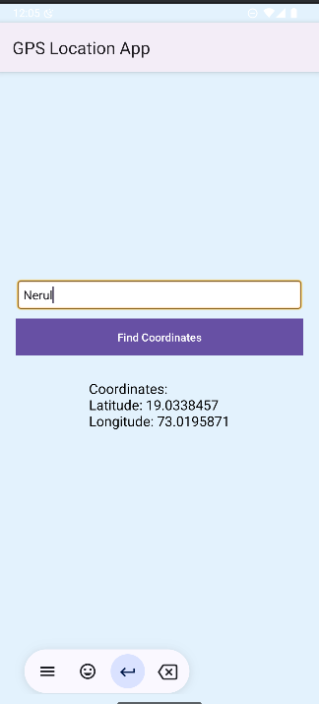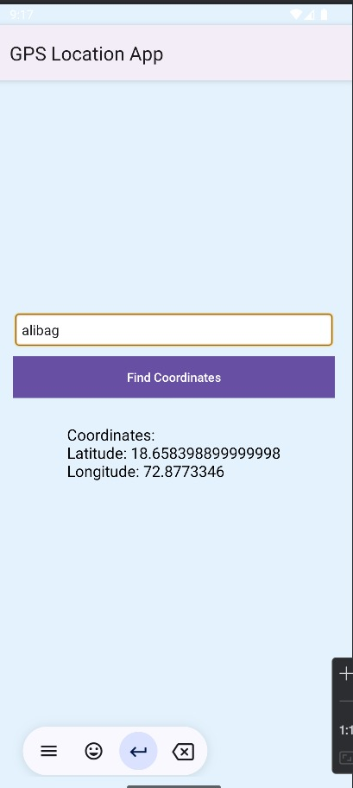

B.3 Observations and learning:
The application effectively accesses the device’s GPS module and handles location data. It maintains accuracy under open-sky conditions, but performance may degrade in areas with poor satellite visibility, such as indoors or dense urban environments. Additionally, permissions management and battery consumption are important considerations for real-world applications.

B.4 Conclusion:
The Android application utilizing GPS location information successfully retrieves and displays the user's current geographical coordinates. By leveraging location services, the app provides real-time updates, ensuring accurate tracking. It demonstrates the practical use of GPS in mobile applications for location-based services like navigation, ride-hailing, and location sharing.

B.5 Question of Curiosity

1) Explain different steps required to build up this GPS project?

Steps to Build a GPS-based Android Application
- Set Up Android Studio:
  - Create a new Android project using Empty Activity.
- Add Permissions:
  - In AndroidManifest.xml, add location permissions using ACCESS_FINE_LOCATION and ACCESS_COARSE_LOCATION.
- Add Dependencies:
  - Add Google Play Services Location API in build.gradle.
- Design UI:
  - Create a simple interface with a Button to get location and a TextView to display coordinates.
- Implement GPS Functionality:
  - Use FusedLocationProviderClient to fetch the user's current location.
- Request Permissions:
  - Handle location permission requests using ActivityCompat.requestPermissions().
- Display Location:
  - Once permission is granted, display latitude and longitude in the TextView.
- Test the App:
  - Run the app on a physical device or emulator with GPS enabled.

