Terna Engineering College
Computer Engineering Department

Class: TE Sem.: VI

Course: System Security Lab

PART A
(PART A : TO BE REFFERED BY STUDENTS)
Experiment No.06
A.1 Aim: Design a network and implement packet sniffing on telnet traffic using wireshark.
A.2 Prerequisite:
1. Basic Knowledge of IP addresses, Port numbers, TCP and UDP Protocols.

A.3 Outcome:
After successful completion of this experiment students will be able to

Apply basic network command to gather basic network information.

A.4 Theory:
Wireshark, a network analysis tool formerly known as Ethereal, captures packets in real time and
display them in human-readable format. Wireshark includes filters, color-coding and other features
that let you dig deep into network traffic and inspect individual packets.
Features of Wireshark :
- Available for UNIX and Windows.
- Capture live packet data from a network interface.
- Open files containing packet data captured with tcpdump/WinDump, Wireshark, and a number of other packet capture programs.
- Import packets from text files containing hex dumps of packet data.
- Display packets with very detailed protocol information.
- Export some or all packets in a number of capture file formats.
- Filter packets on many criteria.
- Search for packets on many criteria.
- Colorize packet display based on filters.
- Create various statistics.
Capturing Packets
After downloading and installing wireshark, you can launch it and click the name of an interface
under Interface List to start capturing packets on that interface. For example, if you want to capture
traffic on the wireless network, click your wireless interface. You can configure advanced features
by clicking Capture Options.

Filtering Packets

If you‘re trying to inspect something specific, such as the traffic a program sends when phoning home, it helps to close down all other applications using the network so you can narrow down the traffic. Still, you‘ll likely have a large amount of packets to sift through. That‘s where Wireshark‘s filters come in. The most basic way to apply a filter is by typing it into the filter box at the top of the window and clicking Apply (or pressing Enter). For example, type ―dns‖ and you‘ll see only DNS packets. When you start typing, Wireshark will help you autocomplete your filter.

A5. Interface Configuration table

SNO. | NAME OF THE DEVICE | INTERFACE | IP ADDRESS | Subnet Mask | Default Gateway
1. | Router 0 | g0/0 | 192.168.120.1 | 255.255.255.0 | --------
2. | PC | Fast Ethernet | 192.168.120.2 | 255.255.255.0 | 192.168.120.1

A6. Design
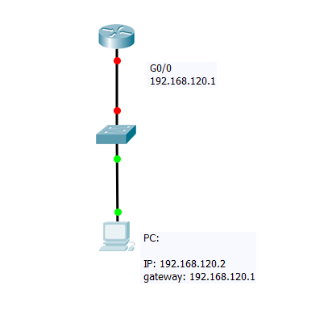

PART B
(PART B : TO BE COMPLETED BY STUDENTS)
(Students must submit the soft copy as per following segments within two hours of the practical. The soft copy must be uploaded on the Blackboard or emailed to the concerned lab in charge faculties at the end of the practical in case the there is no Black board access available)

Roll No.C54 | Name: Quazi Md Moinuddin
Class :TE-C | Batch :C3
Date of Experiment: 27-2-25 | Date of Submission: 6-3-25
Grade :

B.1 | Output
(add snapshot of output )
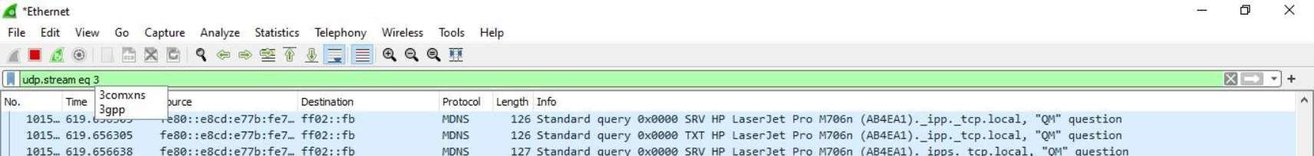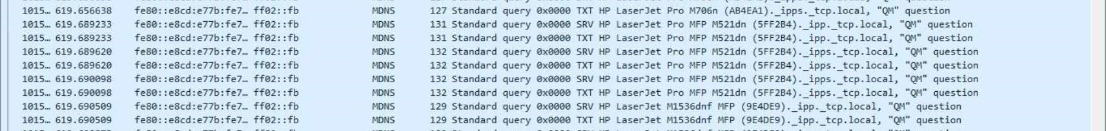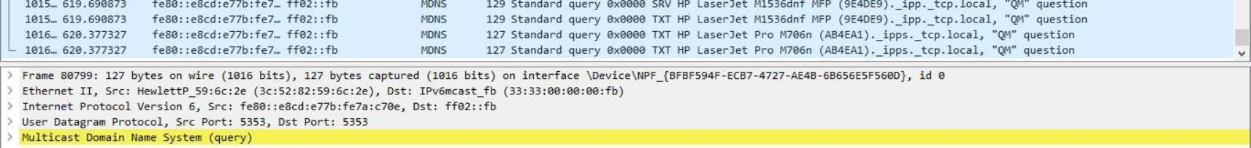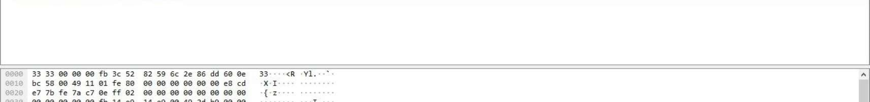
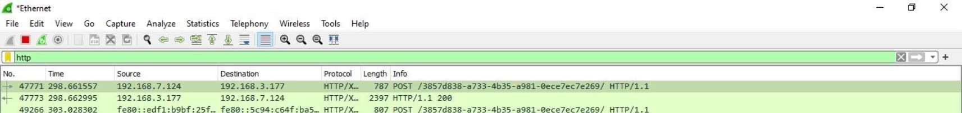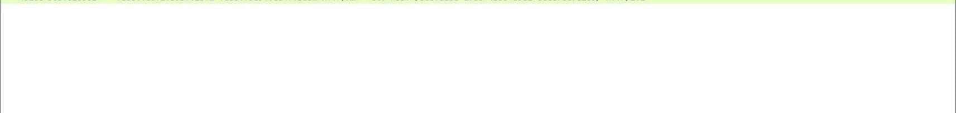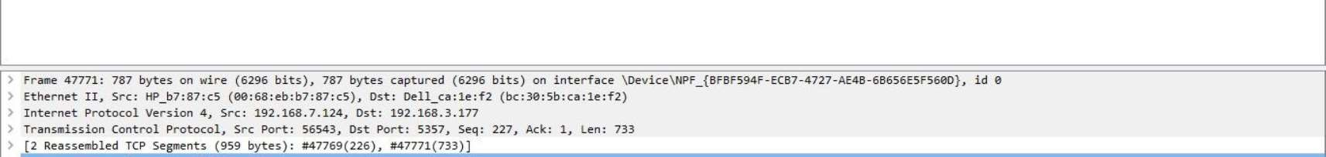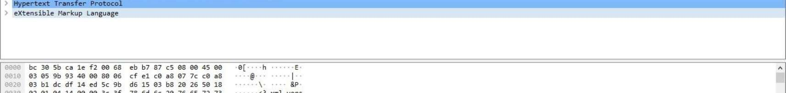
B.2. | Commands / tools used with syntax:
Tools:
- Wireshark: A packet sniffing tool used to capture and analyze network traffic.
- Telnet Client: A Telnet client software installed on a computer to establish Telnet sessions with devices on the network.
Commands:
sudo wireshark
telnet telnet <hostname or IP address> telnet 192.168.1.100

B.3 | Question of Curiosity:  - Which command is need to configure telnet in router?  - What are the steps needed to extract data from sniffed traffic?  - What type of packets to be filtered for accessing remote login username and password of a router?  - What are the differences between Telnet and SSH in terms of security?  - What filtering techniques can be used in Wireshark to analyze Telnet sessions?  - How can encrypted protocols mitigate the risks identified in sniffed Telnet traffic?  
 | 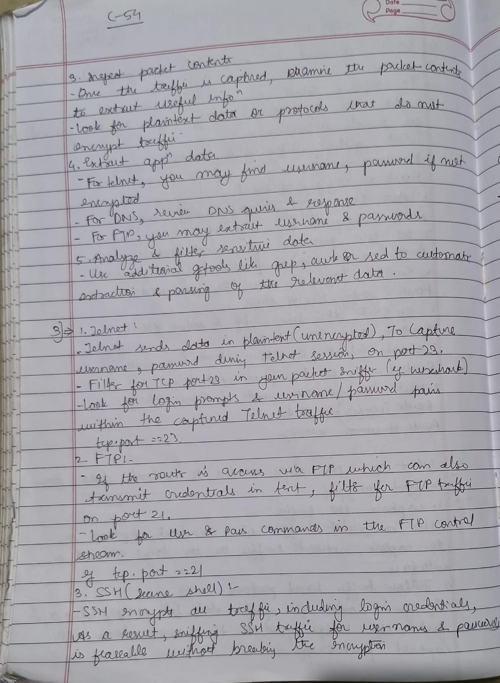
 | 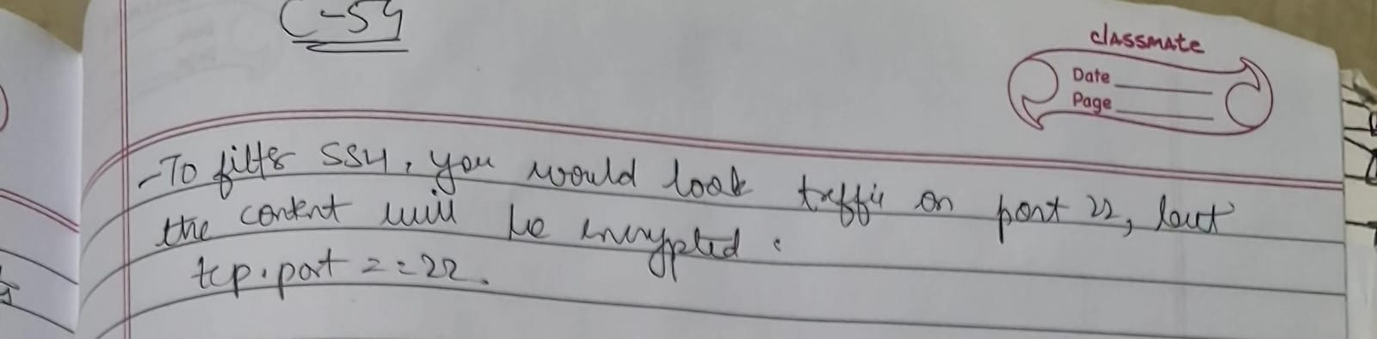
B.4 | Conclusion:  (Write appropriate conclusion.)  In conclusion, designing a network and implementing packet sniffing on Telnet traffic using Wireshark requires careful planning, ethical considerations, and a focus on security. By analyzing captured packets and identifying potential vulnerabilities, organizations can improve their network security posture and mitigate risks associated with insecure protocols like Telnet.

