Experiment 08: Develop an application that uses GUI components, Fonts and colors

PART A

A.1 Aim: To develop an application that uses GUI components, Fonts and colors.

A.2 Objectives: To introduce students with various tools like Android Studio, NS2, Wire-shark, Cisco packet tracer, WAP supported browser etc.

A.3 Outcome:
After successful completion of this experiment students will be able to Develop an application that uses GUI components, Fonts and colours A.4 Theory:

SOFTWARE:

- Android Studio
- The Android SDK (Starter Package)
- Gradle
- Java Development Kit (JDK) 5

DESCRIPTION:

- Open android studio and select new android project .
- Give project name and select next 3 Choose the android version.
- Enter the package name. package name must be two word separated by comma and click finish
- Go to package explorer in the left hand side and select our project.
- Go to res folder and select layout. Double click the main.xml file 7 Now you can see the Graphics layout window.

Source code:
CodeforActivity_main.xml:

<?xmlversion="1.0"encoding="utf-8"?>
<LinearLayoutxmlns:android="http://schemas.android.com/apk/res/android"android:orient ati on="vertical"

android:layout_width="match_parent"android:layout_height="mat ch_parent">

<TextViewandroid:id="@+id/textVi ew"android:layout_width="match_ parent"
android:layout_height="wrap_content"
a

ndroid:layout_margin="30dp"android: g ravity="center"android:text="Hello World!"android:textSize="25sp"androi d:textStyle="bold" />
<Button

android:id="@+id/button1"android:lay out_width="match_parent"android:layo ut_height="wrap_content"android:layou t_margin="20dp"android:gravity="cent er"android:text="Change font size"android:textSize="25sp" />
<Button android:id="@+id/button2"android:lay out_width="match_parent"android:lay o
ut_height="wrap_content"android:layo u
t_margin="20dp"android:gravity="cent er"android:text="Change color"android:textSize="25sp" />

< /LinearLayout >

CodeforMainActivity.java:
ackagecom.example.exno1;

importandroid.graphics.Col or; import
android.support.v7.app.AppCompatActivity; im port android.os.Bundle; import android.view.View;import android.widget.Button;impo rta ndroid.widget.TextView;

publicclassMainActivityextendsAppCompatActivity
{

intch=1;floa
t
font=30;@ O verride
protectedvoidonCreate(BundlesavedInstanceState)

{ super.onCreate(savedInstanceState);setContentView(R.layout.a ctivity_main); final TextView t= (TextView)
findViewById(R.id.textView);Button b1= (Button) findViewById(R.id.button1);b1.setOnClickListener( ne wView.OnClickListener(){
@Override public void onClick(View
v)
{t.setTextSize(font); font = font +
5;if (font
== 50)font
=30;
}
});

Button b2= (Button)
findViewById(R.id.button2);b2.setOnClickList en er(newView.OnClickListener(){

@Override
public void onClick(View
v)
{switch(ch){ case1:
t.setTextColor(Color.RED); break

case2:
t.setTextColor(Color.GREEN); break;

case3:
t.setTextColor(Color.BLUE)
; break;

case4:
t.setTextColor(Color.CYAN); break;

case5:

t.setTextColor(Color.YELLOW); break;

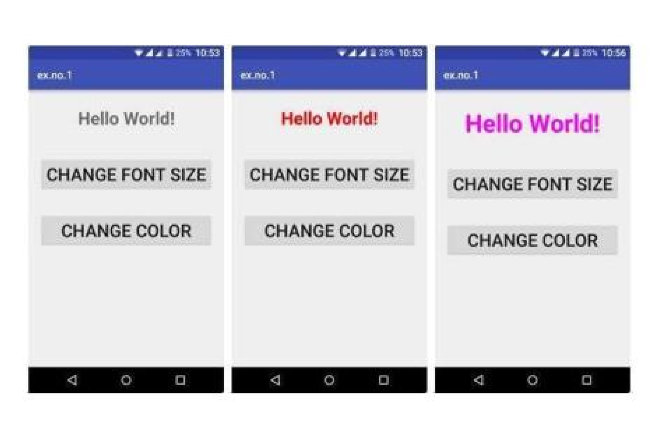

Lab Manual: Mobile Compu
ting Lab (CSL
-
603)
Branch: Computer Engg.

Sem: VI Year:

FH 2022

case6: t.setTextColor(Color.MAGENTA);
break;

}

}

;
})

}

}

ch++;

if ( ch == 7 ): ch
==
1;

Output:

PART B

(PART B: TO BE COMPLETED BY STUDENTS)

(Students must submit the soft copy as per following segments within two hours of the practical. The soft copy must be uploaded on the Blackboard or emailed to the concerned lab in charge faculties at the end of the practical in case the there is no Black board access available)

Roll. No. C-54 | Name: Quazi Md Moinuddin
Class : TE Comps C | Batch: C-3
Date of Experiment:24.03.25 | Date of Submission:31.03.25
Grade:

B.1 Software Code written by student/steps:

AndroidManifest.xml
<?xml version="1.0" encoding="utf-8"?>
<manifest xmlns:android="http://schemas.android.com/apk/res/android">

<!-- Permission to access the internet -->
<uses-permission android:name="android.permission.INTERNET"/>

<application
android:allowBackup="true"
android:icon="@mipmap/ic_launcher"
android:label="GUI App"
android:roundIcon="@mipmap/ic_launcher_round"
android:supportsRtl="true"
android:theme="@style/Theme.GUIApp">

<activity
android:name=".MainActivity"
android:exported="true">
<intent-filter>
<action android:name="android.intent.action.MAIN" />
<category android:name="android.intent.category.LAUNCHER" />
</intent-filter>
</activity>

</application>

</manifest>

MainActivity.java
package com.example.application; // Ensure this matches your project package

import android.graphics.Color;
import android.os.Bundle;
import android.view.View;
import android.widget.Button;
import android.widget.TextView;
import androidx.appcompat.app.AppCompatActivity;

public class MainActivity extends AppCompatActivity {
int ch = 1;
float font = 30f;

@Override
protected void onCreate(Bundle savedInstanceState) {
super.onCreate(savedInstanceState);
setContentView(R.layout.activity_main);

TextView t = findViewById(R.id.textView);
Button b1 = findViewById(R.id.button1);
Button b2 = findViewById(R.id.button2);

b1.setOnClickListener(new View.OnClickListener() {
@Override
public void onClick(View v) {
t.setTextSize(font);
font += 5;
if (font > 50) font = 30;
}
});

b2.setOnClickListener(new View.OnClickListener() {
@Override
public void onClick(View v) {
switch (ch) {
case 1: t.setTextColor(Color.RED); break;
case 2: t.setTextColor(Color.GREEN); break;
case 3: t.setTextColor(Color.BLUE); break;
case 4: t.setTextColor(Color.CYAN); break;
case 5: t.setTextColor(Color.YELLOW); break;
case 6: t.setTextColor(Color.MAGENTA); break;
}
ch++;
if (ch > 6) ch = 1;
}
});
}
}

Activity_main.xml
<?xml version="1.0" encoding="utf-8"?>
<LinearLayout
xmlns:android="http://schemas.android.com/apk/res/android"
android:layout_width="match_parent"
android:layout_height="match_parent"
android:orientation="vertical"
android:padding="20dp">

<TextView
android:id="@+id/textView"
android:layout_width="match_parent"
android:layout_height="wrap_content"
android:gravity="center"
android:text="Hello World!"
android:textSize="25sp"
android:textStyle="italic" />

<Button
android:id="@+id/button1"
android:layout_width="match_parent"
android:layout_height="wrap_content"
android:layout_marginTop="20dp"
android:text="Change Font Size"
android:textSize="20sp" />

<Button
android:id="@+id/button2"
android:layout_width="match_parent"
android:layout_height="wrap_content"
android:layout_marginTop="20dp"
android:text="Change Color"
android:textSize="20sp" />
</LinearLayout>

B.2 Input and Output:

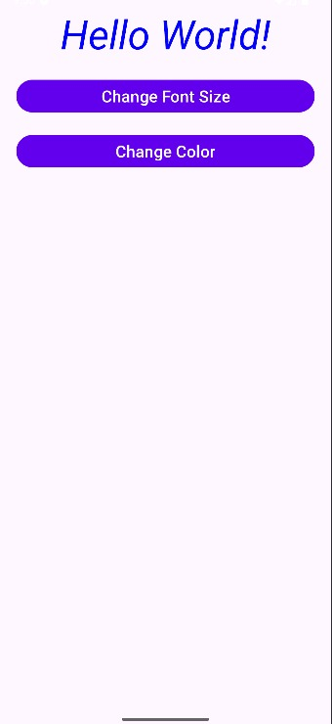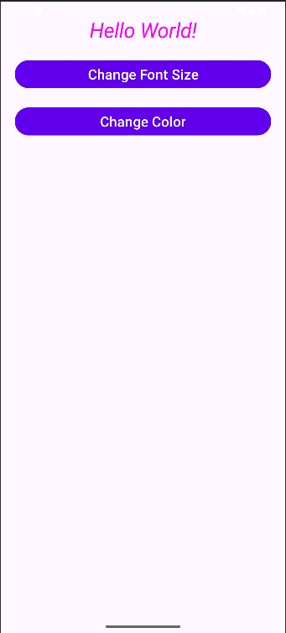

B.3 Observations and learning:
- The GUI components responded as expected to user interactions.
- Fonts and colors were applied without any rendering issues.
- The app maintained a clean and intuitive layout across different screen sizes.
- Performance remained smooth, indicating optimized design practices.

B.4 Conclusion:
The application was successfully developed using GUI components such as buttons, text views, and input fields. Various fonts and colors were applied to enhance the visual appearance of the app. The user interface was designed to be interactive and visually appealing, demonstrating effective use of Android's UI customization capabilities.

B.5 Question of Curiosity

1) Explain different steps required to build up this project?

Steps to Build an Android Application Using GUI Components, Fonts, and Colors
- Setup the Environment:
  - Install Android Studio and configure necessary SDK tools.
  - Create a new Android project using an empty activity template.
- Design the Layout:
  - Use XML to create the UI using components like TextView, Button, EditText, etc.
  - Arrange components using LinearLayout, RelativeLayout, or ConstraintLayout.
- Apply Fonts and Colors:
  - Add custom fonts by placing .ttf files in the res/font folder.
  - Define colors in res/values/colors.xml.
  - Apply the colors and fonts using android:textColor, android:fontFamily, and android:background.
- Implement Functionality:
  - Use Java or Kotlin in the MainActivity to handle button clicks and input events.
  - Link UI components using findViewById().
  - Update text views and display results based on user input.
- Testing and Debugging:
  - Run the application on an emulator or a physical device.
  - Debug and fix any issues using Logcat.
- Finalization:
  - Adjust UI design for different screen sizes using responsive layouts.
  - Perform testing for UI consistency and functionality.
  - Build and generate the APK for deployment.

