PART A
(PART A: TO BE REFFERED BY STUDENTS)
Experiment No. 6 A.1 Aim: To create database using RDS.

A.2 Prerequisite: Basics of working with linux, database concepts, networking rules

A.3 Outcome:
After successful completion of this course, students will be able to, install and appreciate security features and user management. A.4 Theory:
What is Amazon Relational Database Service (Amazon RDS)?
Amazon Relational Database Service (Amazon RDS) is a web service that makes it easier to set up, operate, and scale a relational database in the cloud. It provides costefficient, resizable capacity for an industry-standard relational database and manages common database administration tasks.
Overview of Amazon RDS:
Why do you want a managed relational database service? Because Amazon RDS takes over many of the difficult or tedious management tasks of a relational database:
When you buy a server, you get CPU, memory, storage, and IOPS, all bundled together. With Amazon RDS, these are split apart so that you can scale them independently. If you need more CPU, less IOPS, or more storage, you can easily allocate them.
Amazon RDS manages backups, software patching, automatic failure detection, and recovery.
To deliver a managed service experience, Amazon RDS doesn't provide shell access to DB instances, and it restricts access to certain system procedures and tables that require advanced privileges.
You can have automated backups performed when you need them, or manually create your own backup snapshot. You can use these backups to restore a database. The Amazon RDS restore process works reliably and efficiently.
You can get high availability with a primary instance and a synchronous secondary instance that you can fail over to when problems occur. You can also use MySQL, MariaDB, or PostgreSQL Read Replicas to increase read scaling.
You can use the database products you are already familiar with: MySQL, MariaDB, PostgreSQL, Oracle, and Microsoft SQL Server.
In addition to the security in your database package, you can help control who can access your RDS databases by using AWS Identity and Access Management (IAM) to define users and permissions. You can also help protect your databases by putting them in a virtual private cloud.
Amazon RDS Interfaces:
AWS Management Console
The AWS Management Console is a simple web-based user interface. You can manage your DB instances from the console with no programming required. To access the Amazon RDS console, sign in to the AWS Management Console and open the Amazon RDS console.

Command Line Interface
You can use the AWS Command Line Interface (AWS CLI) to access the Amazon RDS API interactively. To install the AWS CLI, see Installing the AWS Command Line
Interface. To begin using the AWS CLI for RDS, see AWS Command Line Interface Reference for Amazon RDS.

Programming with Amazon RDS
If you are a developer, you can access the Amazon RDS programmatically. For more information, see Amazon RDS Application Programming Interface (API) Reference. For application development, we recommend that you use one of the AWS Software Development Kits (SDKs). The AWS SDKs handle low-level details such as authentication, retry logic, and error handling, so that you can focus on your application logic. AWS SDKs are available for a wide variety of languages. AWS also provides libraries, sample code, tutorials, and other resources to help you get started more easily. For more information, see Sample Code & Libraries.

PART B
(PART B: TO BE COMPLETED BY STUDENTS)

(Students must submit the soft copy as per following segments within two hours of the practical. The soft copy must be uploaded on the Blackboard or emailed to the concerned lab in charge faculties at the end of the practical in case the there is no Black board access available)

Roll. No. C54 | Name: Quazi Md Moinuddin
Class: TE-C-Comps | Batch: C3
Date of Experiment: 17-3-25 | Date of Submission: 19-3-25
Grade:

B.1 Software Code written by student:
(Paste your Search material completed during the 2 hours of practical in the lab here)

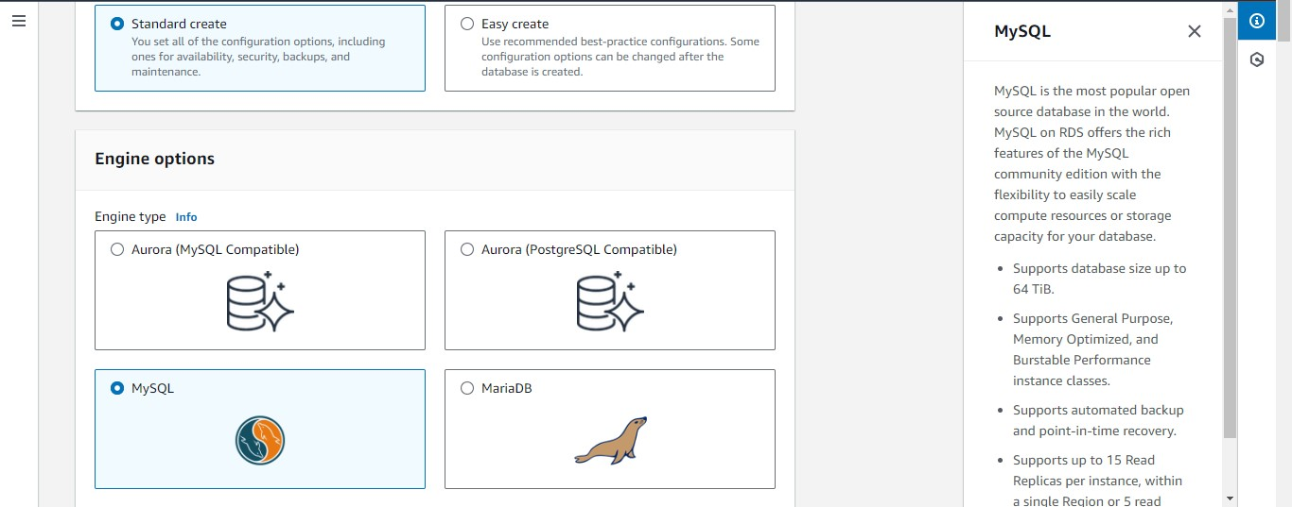

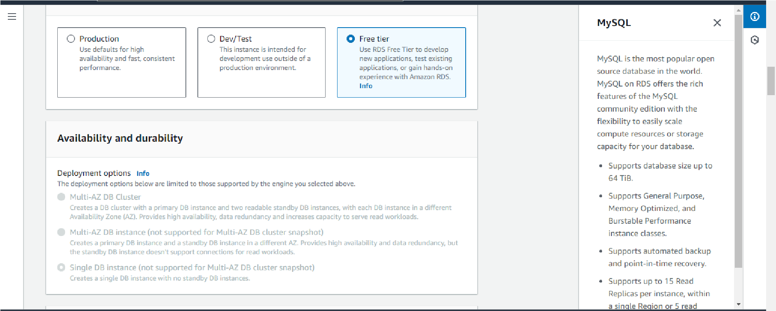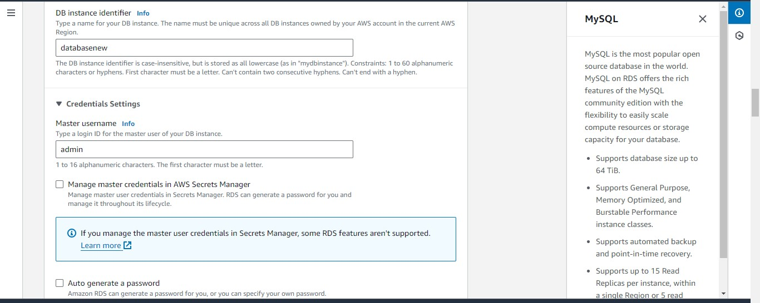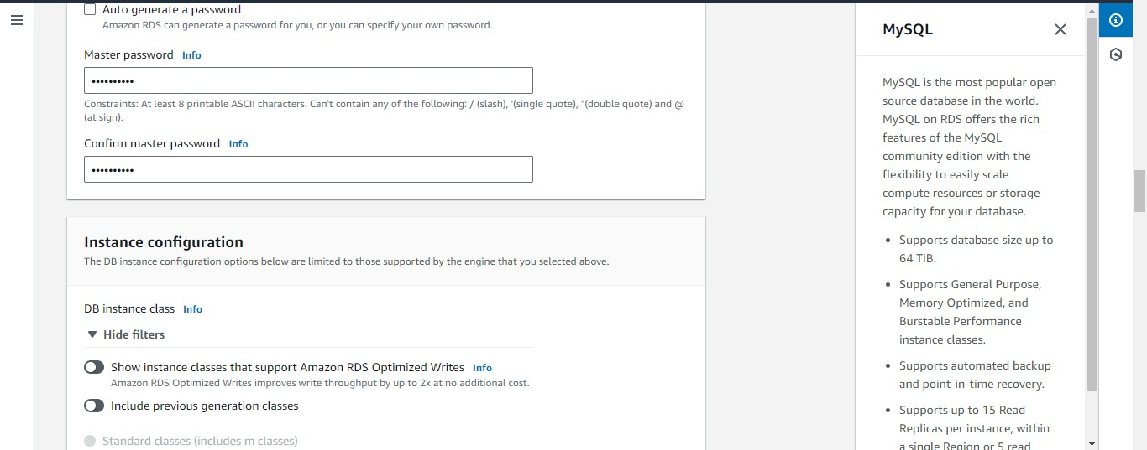

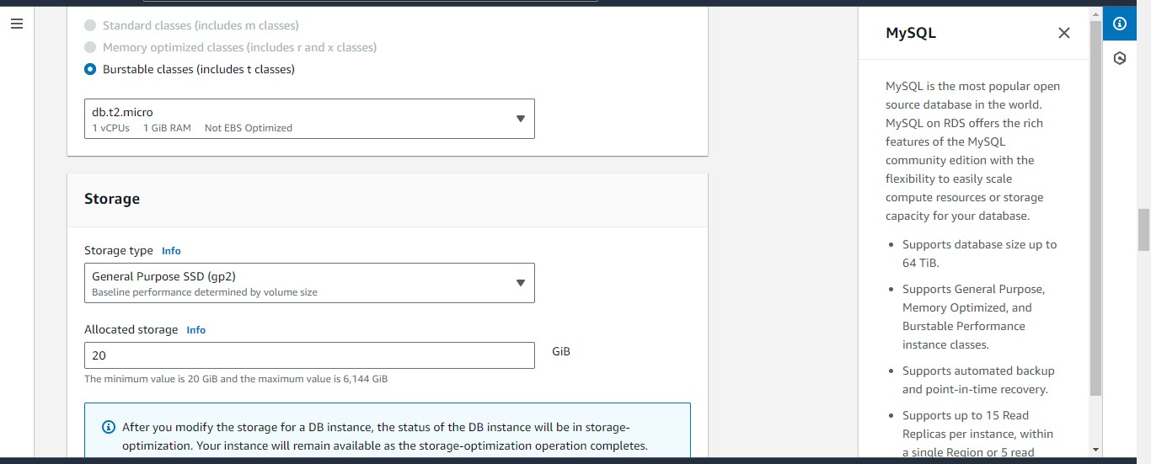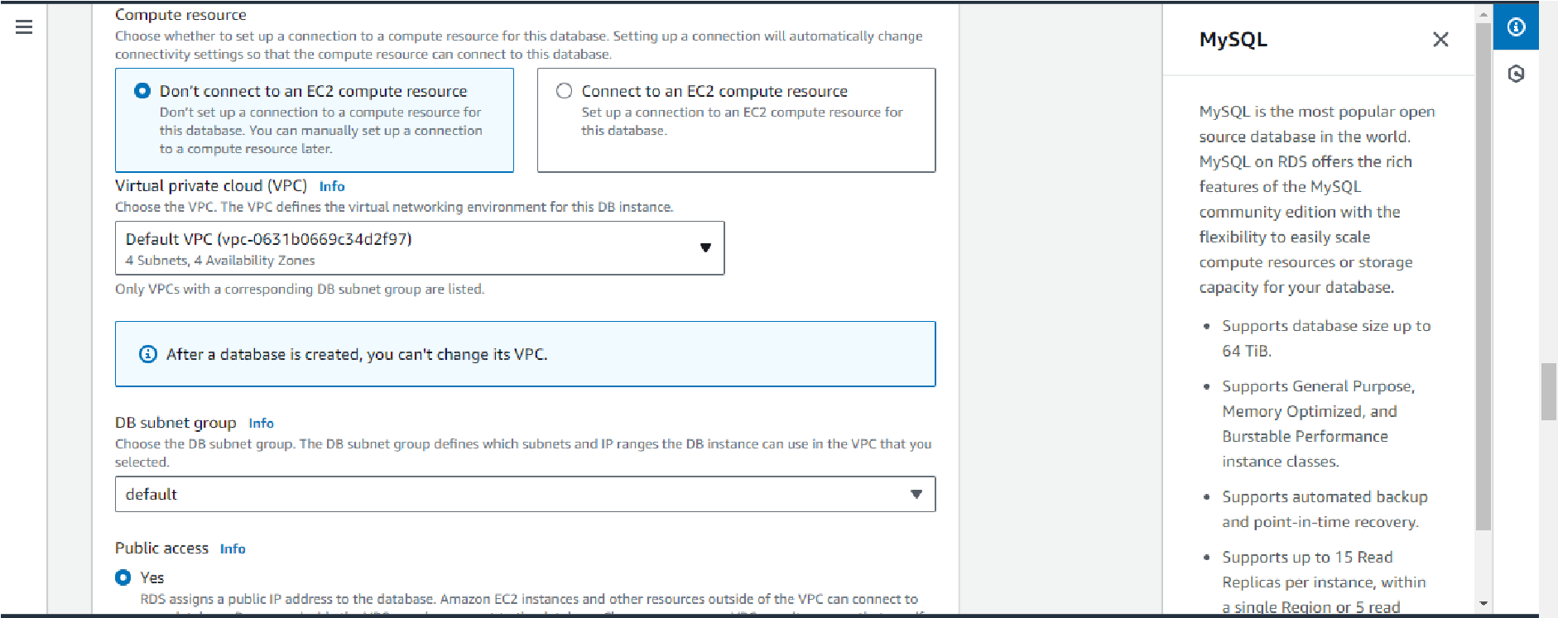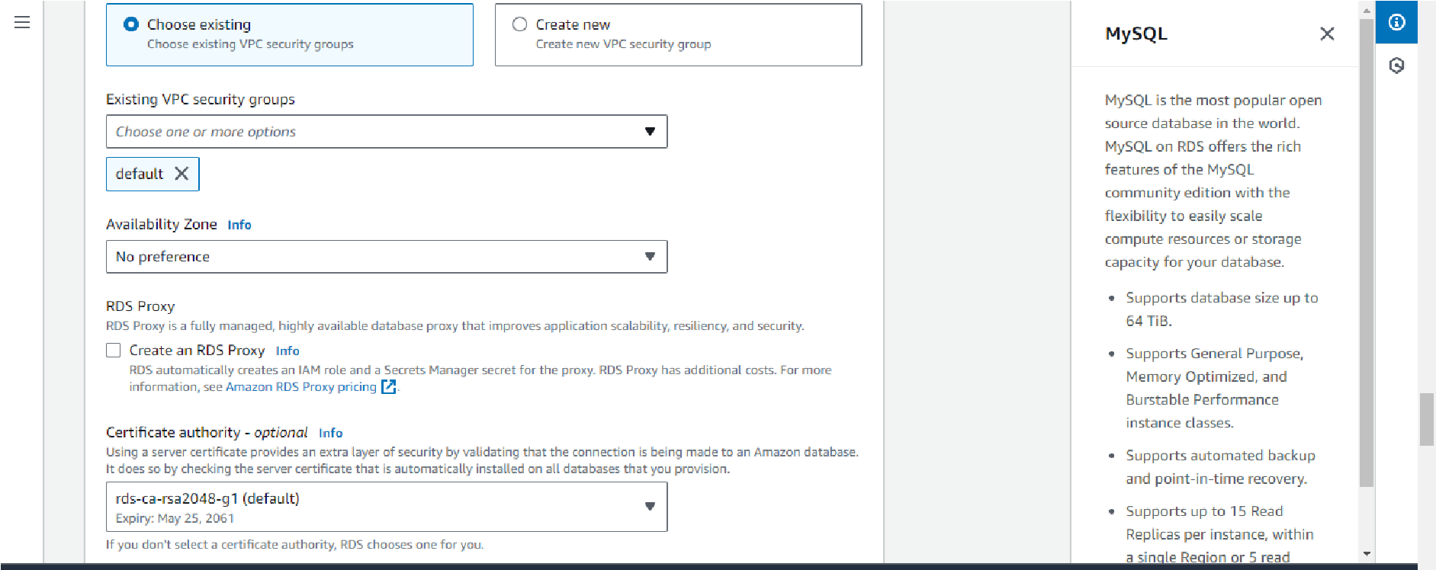

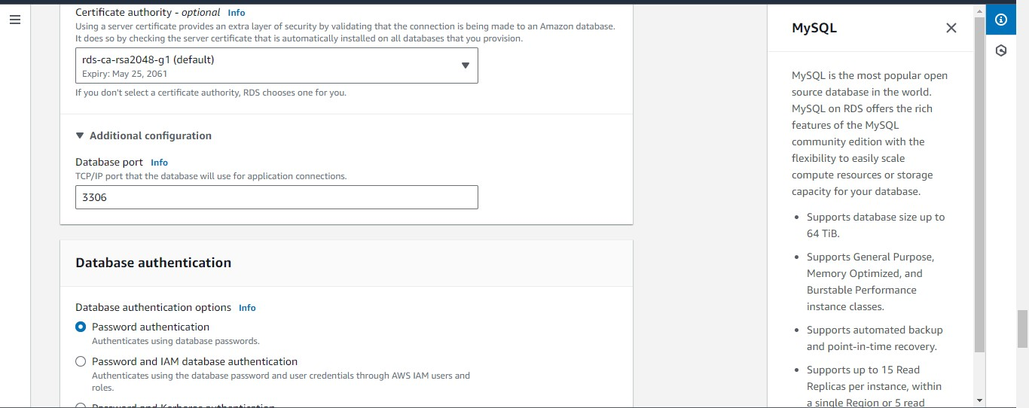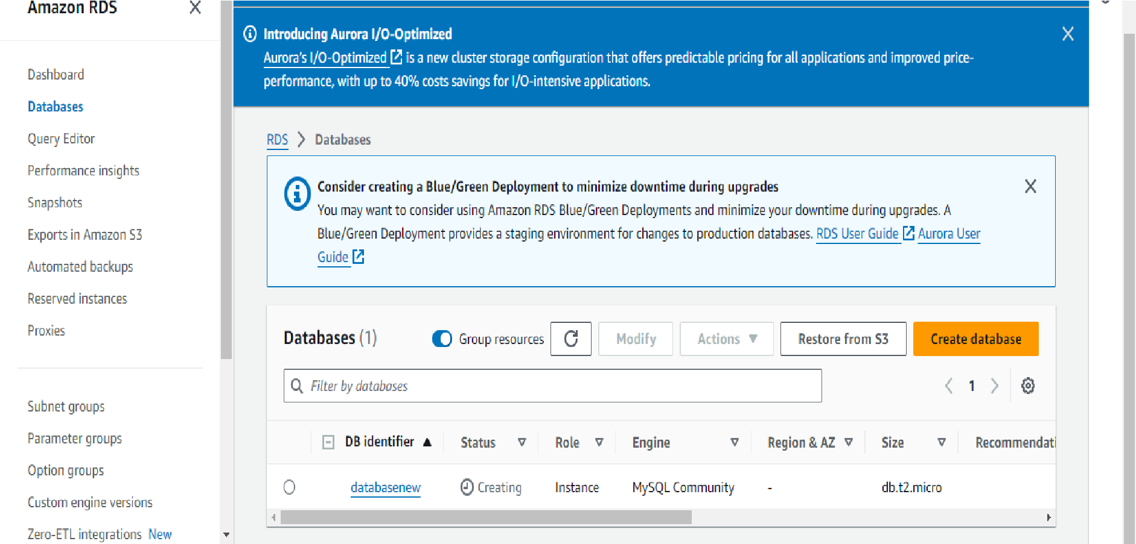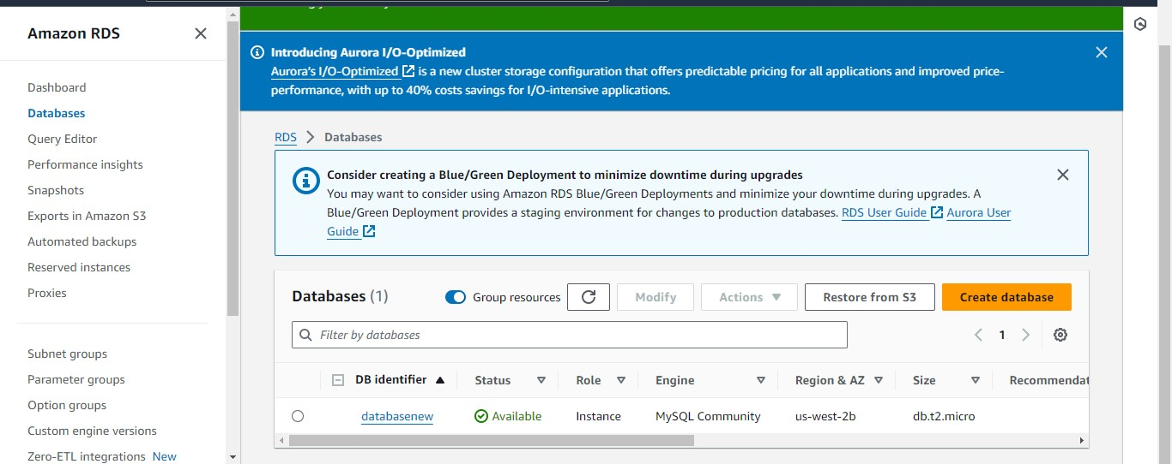

B.2 Input and Output:
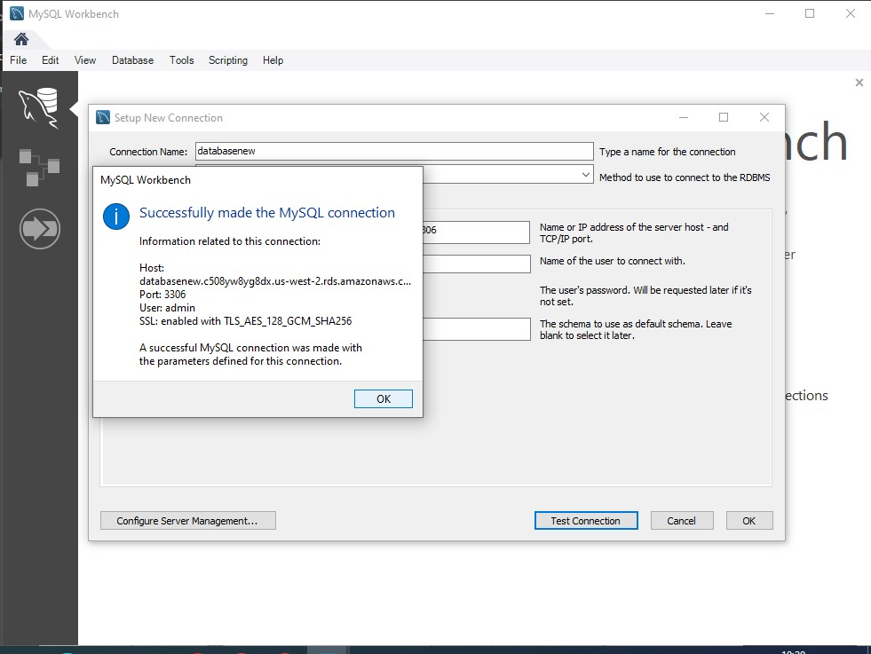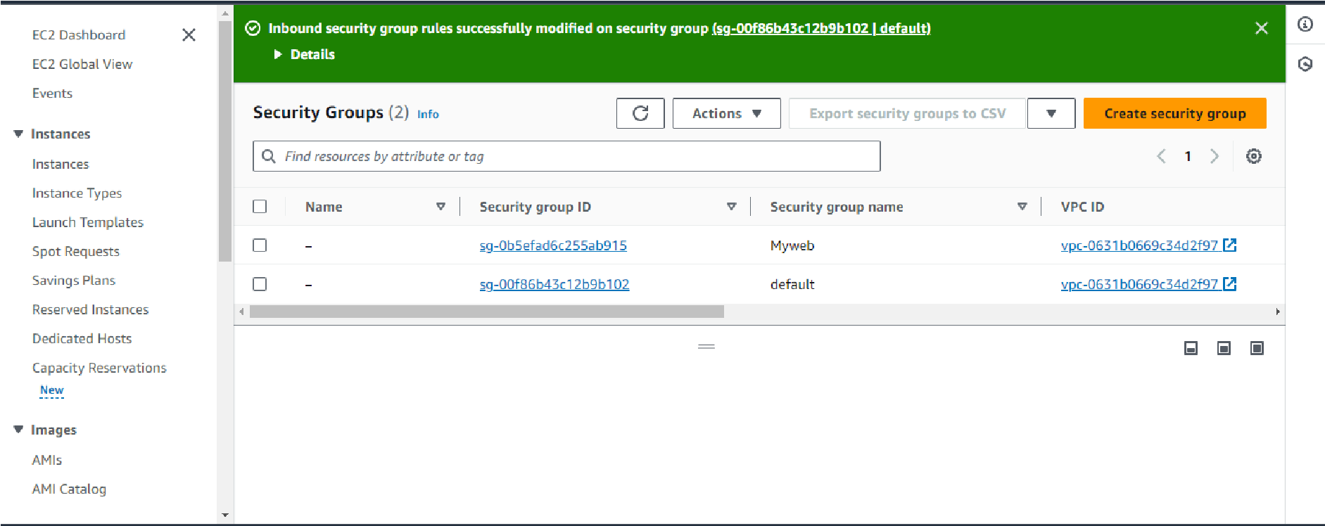

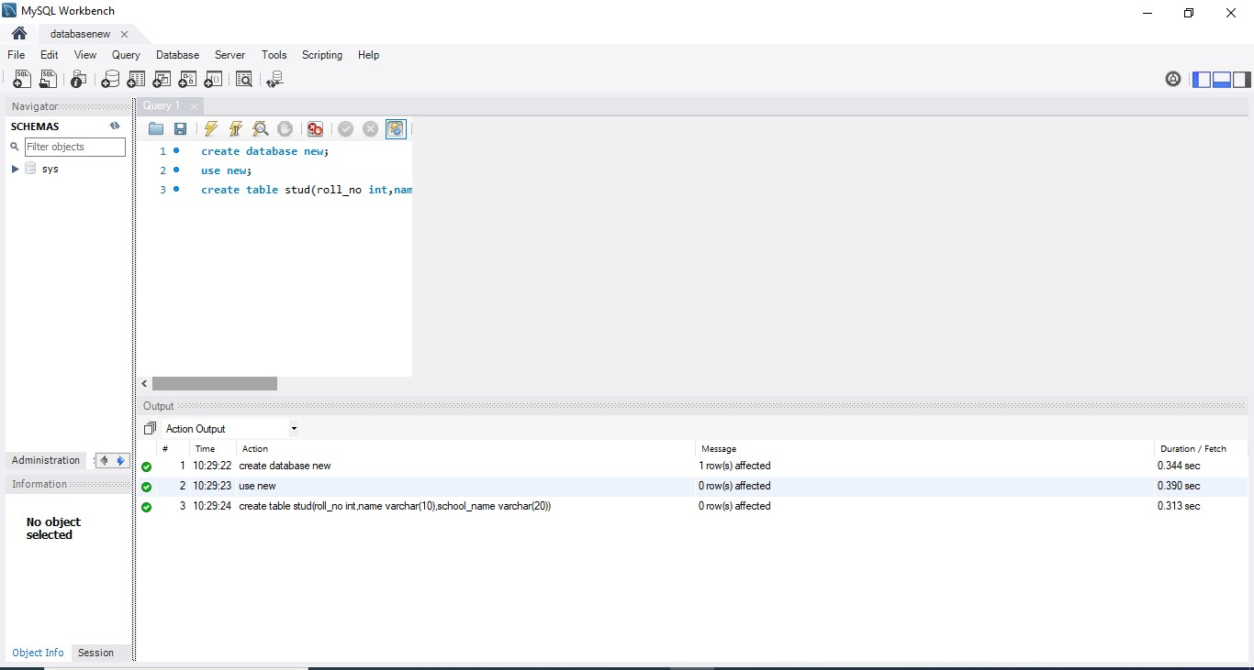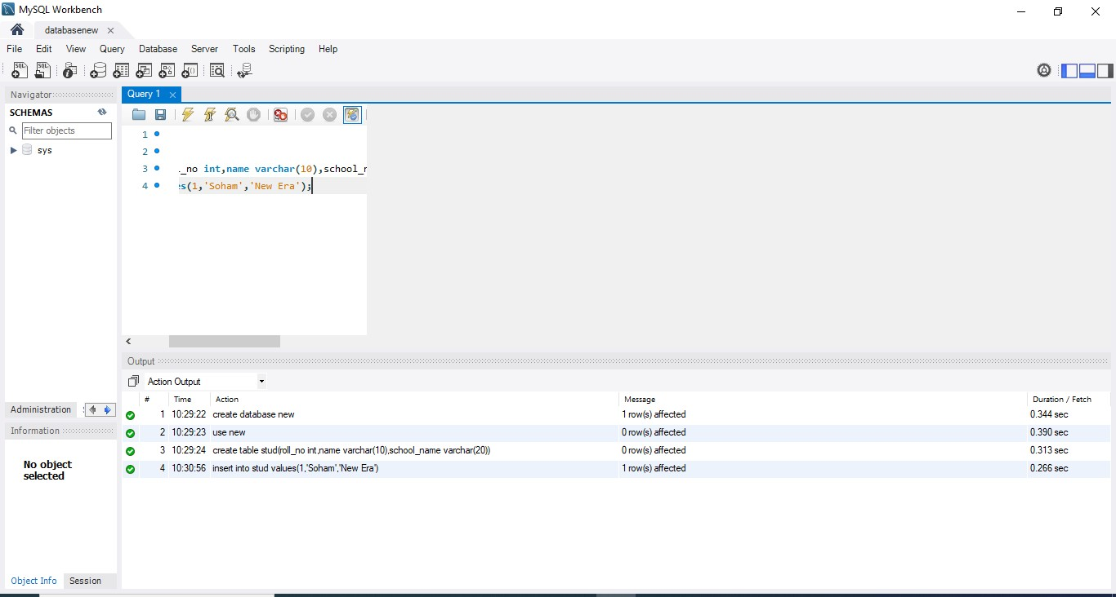

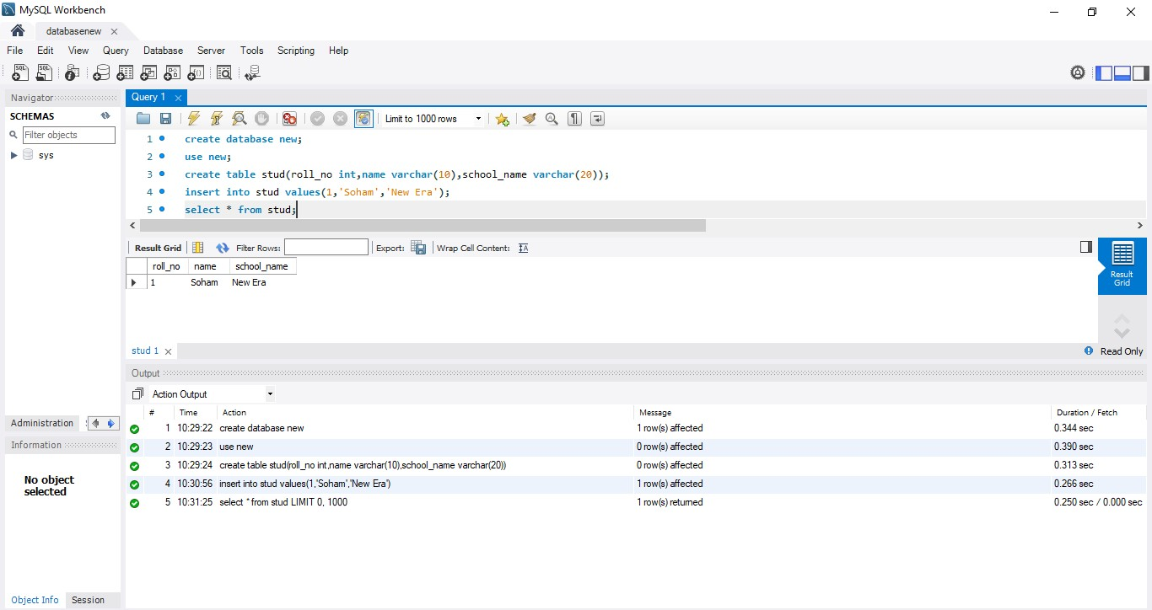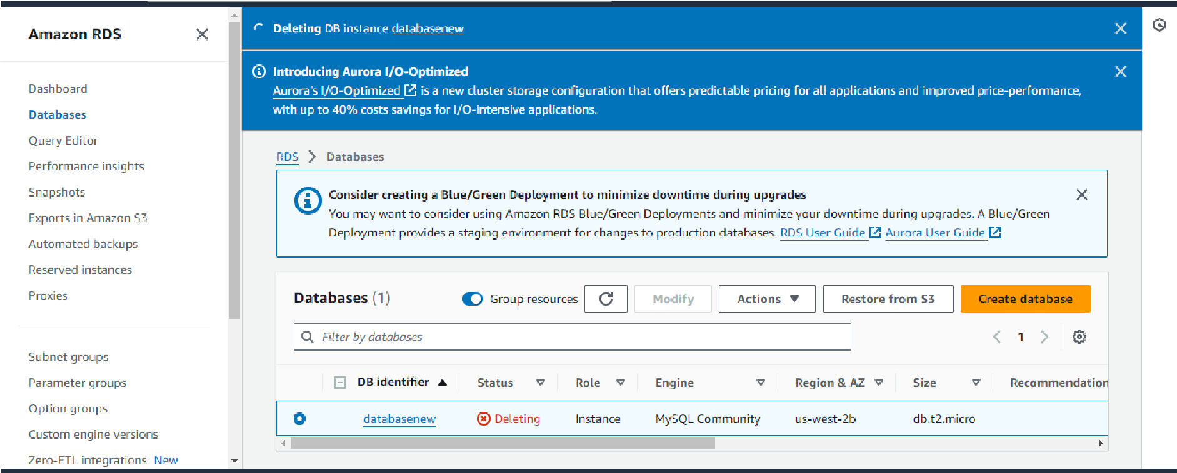

B.3 Observations and learning:
Through this experiment, I learned how to install and appreciate the security features and user management capabilities offered by Amazon RDS. This hands-on experience enhanced my understanding of database administration tasks in the cloud and equipped me with valuable skills for deploying and managing relational databases efficiently.

B.4 Conclusion:
During the experiment, I gained practical experience in setting up a database using Amazon RDS. I familiarized myself with the features and functionalities of Amazon RDS, including its ability to manage backups, automatic failure detection, and recovery.

B.5 Question of Curiosity
(To be answered by student based on the practical performed and learning/observations) Q1: What types of RDS databases are currently available?
Ans : Amazon RDS offers several types of relational database engines, including:
- Amazon Aurora: A MySQL and PostgreSQL-compatible relational database built for the cloud, offering high performance, scalability, and reliability.
- MySQL: An open-source relational database management system (RDBMS) known for its ease of use, scalability, and robust feature set.
- PostgreSQL: A powerful open-source object-relational database system known for its advanced features, extensibility, and standards compliance.
- MariaDB: A community-developed fork of MySQL, offering enhanced performance, scalability, and security features.
- Oracle: A widely used commercial relational database management system known for its reliability, security, and comprehensive feature set.
- Microsoft SQL Server: A popular commercial database management system developed by Microsoft, offering robust features for enterprise applications.

Q2: Where are RDS backups stored?
Ans : RDS backups are stored in Amazon S3 (Simple Storage Service), which is a scalable object storage service designed for storing and retrieving any amount of data from anywhere on the web. Amazon RDS automatically backs up your database to S3 at regular intervals, allowing you to restore your database to a specific point in time if needed.

Q3: Is RDS A PaaS?
Ans : Yes, RDS (Relational Database Service) is considered a Platform as a Service (PaaS) offering by AWS. PaaS platforms provide a complete development and deployment environment in the cloud, including infrastructure, middleware, development tools, and runtime environments. With RDS, AWS manages the underlying infrastructure and database administration tasks, allowing users to focus on developing and deploying applications without worrying about hardware provisioning, database maintenance, or software updates.

Q4: Explain the difference between a Multi-AZ deployment and a Single-AZ deployment in Amazon RDS? What are the benefits of each? Ans :
Aspect | Multi-AZ Deployment | Single-AZ Deployment
Deployment Configuration | Database instance is replicated synchronously to a standby instance in a different Availability Zone (AZ). | Database instance runs in a single Availability Zone (AZ) without synchronous replication to another AZ.
High Availability | Provides automatic failover to the standby instance in case of a failure or outage in the primary AZ, ensuring high availability and data durability. | Vulnerable to downtime in case of an infrastructure failure or maintenance event in the primary AZ, resulting in potential service interruptions.
Data Redundancy | Ensures data redundancy and durability with six copies of your data replicated across multiple AZs, providing enhanced data integrity and resilience. | Relies on single-instance storage architecture without data replication across AZs, increasing the risk of data loss or corruption in case of hardware failures or disasters.
Scalability | Supports scalable and resilient architectures with seamless capacity expansion and automatic resource provisioning across multiple AZs. | Limited scalability within the confines of a single AZ, potentially leading to performance bottlenecks or resource constraints under heavy workloads.
Cost | Incurs higher costs due to the additional resources required for maintaining standby instances and data replication across multiple AZs. | Generally more cost-effective compared to Multi-AZ deployments, as it involves fewer resources and infrastructure components.
Use Cases | Ideal for mission-critical workloads and production environments that require maximum uptime, fault tolerance, and data durability. | Suitable for non-critical workloads, development environments, or applications with lower uptime requirements and cost constraints.

Q5: Explain the various storage types available for Amazon RDS and when each one should be used?
Ans : Amazon RDS offers several storage types optimized for different use cases and performance requirements:
General Purpose (SSD): Provides a balance of performance and cost-effectiveness for a wide range of workloads, including small to medium-sized databases with moderate I/O requirements.
Provisioned IOPS (SSD): Offers high-performance storage with predictable I/O performance for I/O-intensive workloads, such as databases requiring low-latency, high-throughput access to storage.
Magnetic: Provides cost-effective storage for infrequently accessed or less performancesensitive workloads, with lower throughput and higher latency compared to SSD storage types.
Amazon Aurora Storage: A proprietary storage engine designed for Amazon Aurora databases, offering high performance, durability, and scalability for demanding OLTP and OLAP workloads.

Q6: Describe Amazon Aurora and its advantages over traditional relational database services provided by Amazon RDS?
Ans : Amazon Aurora is a relational database engine developed by Amazon Web Services (AWS) as part of their Amazon RDS (Relational Database Service) offering. It is designed to deliver high performance, reliability, and scalability while maintaining compatibility with existing MySQL and PostgreSQL databases. Here are the key features and advantages of Amazon Aurora over traditional relational database services provided by Amazon RDS:
Performance:
Amazon Aurora is built for high performance and offers up to five times better performance than standard MySQL databases and up to three times better performance than standard PostgreSQL databases.
It achieves this performance through a distributed, fault-tolerant storage architecture that is designed to scale seamlessly with the workload, enabling applications to handle high transaction volumes and complex queries efficiently.
Storage Scalability:
Amazon Aurora provides scalable and elastic storage options that automatically grow as your database storage needs increase, without the need for manual intervention or downtime.
It supports storage volumes of up to 64 TB per database instance, allowing organizations to store large volumes of data and accommodate growing datasets without compromising performance or reliability.
Automated Backups and Point-in-Time Recovery:
Amazon Aurora automatically takes continuous backups of your database and stores them in Amazon S3, enabling point-in-time recovery to any second within the backup retention period.
This feature allows you to restore your database to a specific point in time, minimizing data loss in case of accidental deletions, corruptions, or other data-related incidents.

Compatibility and Integration:
Amazon Aurora is compatible with MySQL and PostgreSQL, allowing seamless migration of existing databases to Aurora without requiring any changes to the application code or database schema.
It integrates seamlessly with other AWS services such as AWS Lambda, Amazon Redshift, Amazon EMR, and Amazon RDS Proxy, enabling you to build scalable and cost-effective architectures for a wide range of use cases.

Advantage over traditional relational database :
Amazon Aurora offers significant advantages over traditional relational database services by providing higher performance, scalability, availability, and compatibility, making it an ideal choice for demanding enterprise workloads and mission-critical applications.

