Terna Engineering College
Computer Engineering Department

Class: TE Sem.: VI

Course: System Security Lab

PART A
(PART A : TO BE REFFERED BY STUDENTS)

Experiment No.04
  - Aim: For varying message sizes, test integrity of message using MD-5, SHA-1, and analyze the performance of the two protocols. Use crypt APIs
  - Prerequisite:
    - Basic Knowledge of MD5 and SHA 1

  - Outcome:
After successful completion of this experiment students will be able to

To analyze and evaluate performance of hashing algorithms.

  - Theory:

MD5 (Message Digest algorithm 5) is a widely used cryptographic hash function with a 128 bit hash value. MD5 hash is typically expressed as a 32 digit hexadecimal number. MD5 processes a variable length message into a fixed length output of 128 bits. The input message is broken up into chunks of 512 bit blocks (sixteen 32bit little endian integers) ; The message is padded so that its length is divisible by 512. The padding works as follows: first a single bit, 1, is appended to the end of the message. This is followed by as many zeros as are required to bring the length of the message up to 64 bits less than a multiple of 512. The remaining bits are filled up with a 64bit integer representing the length of the original message, inbits.

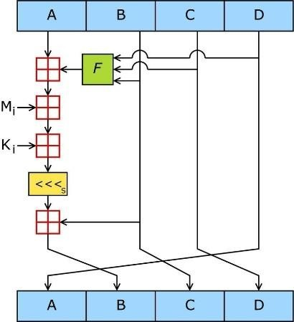

Figure 1: One MD5 operation.
MD5 consists of 64 of these operations, grouped in four rounds of 16 operations. F is a nonlinear function; one function is used in each round. Mi denotes a 32bit block of the message input, and Ki denotes a 32bit constant, different for each operation.
The main MD5 algorithm operates on a 128bit state, divided into four 32bit words, denoted A, B, C and D. These are initialized to certain fixed constants. The main algorithm then operates on each 512bit message block in turn, each block modifying the state. The processing of a message block consistsoffoursimilarstages,termedrounds;eachroundiscomposedof16similaroperationsb ased on a nonlinear function F, modular addition, and leftrotation.

Figure 1 illustrates one operation within a round. There are four possible functions F; a differentone is used in eachround:
F(X,Y,Z) = (X˄Y) ˅(¬X ˄Z)
G(X,Y,Z) = (X ˄Z)˅(Y ˄¬Z)
H(X,Y,Z) = X ⊕ Y⊕ Z I(X,Y,Z) =Y ⊕ (X ˅¬Z)

⊕ , ∧ , ∨ , ¬ denote the XOR, AND, OR and NOT operations respectively.

Algorithm:

    - Append PaddingBits The message is”padded"(extended)so that its length (in bits) is congruent to 448 modulo 512. That is, the message is extended so that it is just 64 bits shy of being a multiple of 512 bits long. Padding is always performed, even if the length of the message is already congruent to 448 modulo 51
    - Padding is performed as follows: a single "1" bit is appended to the message, and then "0" bits are appended so that the length in bits of the padded message becomes congruent to 448, modulo 512. In all, at least one bit and at most 512 bits are appended.

Append Length
A 64 bit representation of b (the length of the message before the padding bits were added) is appendedtotheresultofthepreviousstep.Intheunlikelyeventthatbisgreaterthan2^64,th enonly the low order 64 bits of b are used. (These bits are appended as two 32bit words and appended low- order word first in accordance with the previous conventions.) At this point the resulting message (after padding with bits and with b) has a length that is an exact multiple of 512 bits. Equivalently, this message has a length that is an exact multiple of 16 (32 bit) words. Let M[0 ... N1] denote the words of the resulting message, where N is a multiple of16.

Initialize MDBuffer
A fourword buffer (A,B,C,D) is used to compute the message digest. Here each of A, B, C, D is a 32bit register. These registers are initialized to the following values in hexadecimal, loworder bytes first):

- Process Message in 16WordBlocks Wefirstdefinefourauxiliaryfunctionsthateachtakeasinputthree32bitwordsandproduc easoutput one 32bitword.

Note: Do not write code for MD5 or SHA analyze the performance using crypt APIs

PART B
(PART B : TO BE COMPLETED BY STUDENTS)
(Students must submit the soft copy as per following segments within two hours of the practical. The soft copy must be uploaded on the Blackboard or emailed to the concerned lab in charge faculties at the end of the practical in case the there is no Black board access available)

Roll No: C-54 | Name: Quazi Md Moinuddin
Class : TE-C | Batch : C3
Date of Experiment: 21-01-2025 | Date of Submission: 15-02-2025
Grade :

Output / Observations
(Add snapshot of output of the experiment performed)

MD5 :


ENCRYPTER:


DECRYPTER:

SHA-1:

ENCRYPTER:



DECRYPTER:



OBSERVATION:

- Performance Comparison
  - For small messages (128B, 1KB), SHA-1 is marginally faster than MD5.
  - For large messages (1MB), SHA-1 maintains better performance, processing the hash in a shorter time than MD5.
- Computational Efficiency
  - The hashing time increases as message size grows.
  - SHA-1 consistently shows better efficiency, especially for larger message sizes.
- Integrity Check
  - Both MD5 and SHA-1 generate unique hash values for different inputs, confirming message integrity.
  - However, MD5 is more prone to collisions, making SHA-1 a more secure choice.

Question of Curiosity:
    - How many bits of output MD5 generate?
    - How many bits of output SHA1 generate?
    - Discuss the strength and limitations of MD5 and SHA1.
    - How SHA512 differs from other variants of SHA?
    - How does the collision resistance property differ between MD5 and SHA1?
    - What are the practical applications of MD5 and SHA1 in modern cryptographic systems?

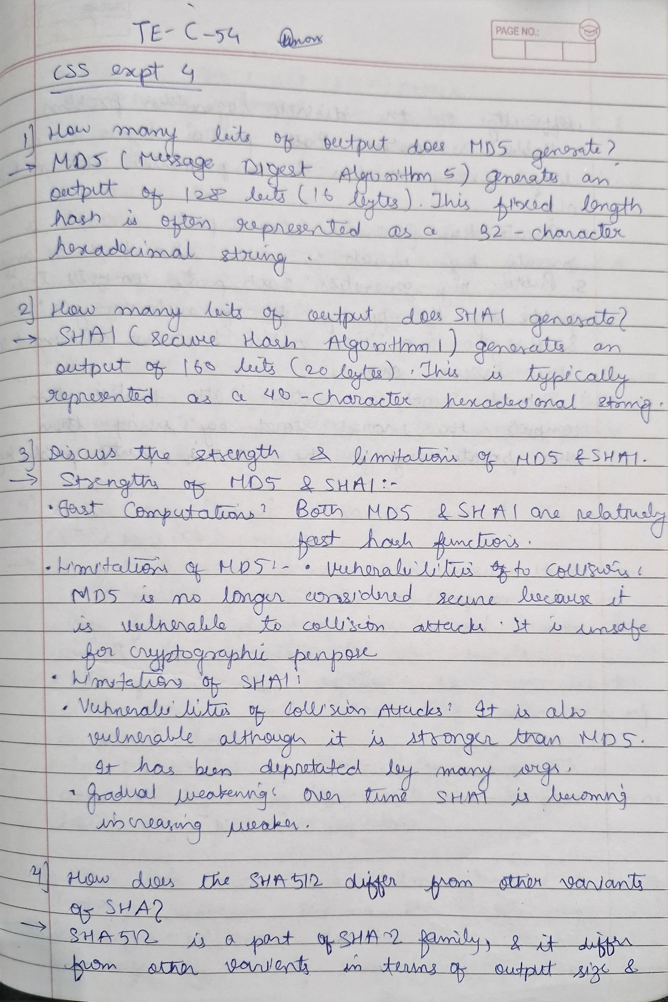

B.4 Conclusion:
(Write appropriate conclusion.)

- MD5 is slightly slower and has known security vulnerabilities.
- SHA-1 is faster and more secure but still vulnerable to attacks.
- For stronger security, modern alternatives like SHA-256 or SHA-3 should be considered.

