Terna Engineering College
Computer Engineering Department
Program: Sem VI

Course: Cloud Computing Lab (CSL605)

PART A
(PART A: TO BE REFFERED BY STUDENTS)
Experiment No.9
Title: To study and Implement Containerization using Docker

A.1 Objective: To know the basic differences between Virtual machine and Container. It involves demonstration of creating, finding, and building, installing, and running Linux/Windows application containers inside local machine or cloud platform.
A.2 Prerequisite:
Knowledge of Networking, Distributed Computing and knowledge of Software architectures.
A.3 Objective:
Objectives this experiment is to provide students an overview AWS, its Features and Services.
A.4 Outcome: (LO3)
After successful completion of this experiment student will be able to run Linux/ windows application containers inside local machine.

A.5 Theory :
Docker is the containerization platform that is used to package your application and all its dependencies together in the form of containers to make sure that your application works seamlessly in any environment which can be developed or tested or in production.



Containerization:
Containerization is OS-based virtualization that creates multiple virtual units in the userspace, known as Containers. Containers share the same host kernel but are isolated from each other through private namespaces and resource control mechanisms at the OS level. Container-based Virtualization provides a different level of abstraction in terms of virtualization and isolation when compared with hypervisors. Hypervisors use a lot of hardware which results in overhead in terms of virtualizing hardware and virtual device drivers. A full operating system (e.g -Linux, Windows) runs on top of this virtualized hardware in each virtual machine instance.
But in contrast, containers implement isolation of processes at the operating system level, thus avoiding such overhead. These containers run on top of the same shared operating system kernel of the underlying host machine and one or more processes can be run within each container. In containers you don’t have to pre-allocate any RAM, it is allocated dynamically during the creation of containers while in VMs you need to first pre-allocate the memory and then create the virtual machine. Containerization has better resource utilization compared to VMs and a short boot-up process. It is the next evolution in virtualization.
Containers can run virtually anywhere, greatly easy development and deployment: on Linux, Windows, and Mac operating systems; on virtual machines or bare metal, on a developer’s machine or in data centers on-premises; and of course, in the public cloud. Containers virtualize CPU, memory, storage, and network resources at the OS level, providing developers with a sandboxed view of the OS logically isolated from other applications. Docker is the most popular open-source container format available and is supported on Google Cloud Platform and by Google Kubernetes Engine.

After you understand the concept of Docker, now let’s get into the implementation. There are several steps that we will do:
- Install Docker
- Create a file called Dockerfile
- Build the image
- Run the image

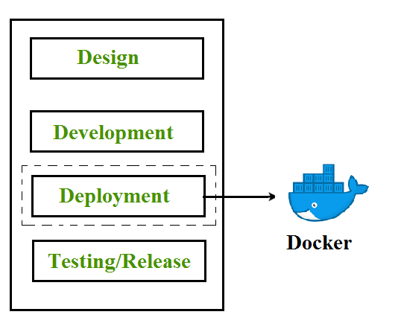

Useful link:

https://docs.docker.com/

PART B
(PART B: TO BE COMPLETED BY STUDENTS)
(Students must submit the soft copy as per following segments within two hours of the practical. The soft copy must be uploaded on the ERP or emailed to the concerned lab in charge faculties at the end of the practical in case the there is no ERP access available)

Roll No.C54 | Name: Quazi Md Moinuddin
Class :TE-C | Batch : C-3
Date of Experiment: 3-4-25 | Date of Submission: 5-4-25
Grade :

B.1Question of Curiosity:
(To be answered by student based on the practical performed and learning/observations)

Q.1 What is containerization?
Ans: Containerization is a software deployment process that bundles an application's code with all the files and libraries it needs to run on any infrastructure. Traditionally, to run any application on your computer, you had to install the version that matched your machine's operating system. For example, you needed to install the Windows version of a software package on a Windows machine. However, with containerization, you can create a single software package, or container, that runs on all types of devices and operating systems.
Q.2 Difference between virtualization and containerization.
Sno. | Virtual Machines (VM) | Containers
1 | VM is piece of software that allows you to install other software inside of it so you basically control it virtually as opposed to installing the software directly on the computer. | While a container is a software that allows different functionalities of an application independently.
2. | Applications running on VM system can run different OS. | While applications running in a container environment share a single OS.
3. | VM virtualizes the computer system. | While containers virtualize the operating system only.
4. | VM size is very large. | While the size of container is very light; i.e. a few megabytes.
5. | VM takes minutes to run, due to large size. | While containers take a few seconds to run.
6. | VM uses a lot of system memory. | While containers require very less memory.
7. | VM is more secure. | While containers are less secure.
8. | all of OS resources to run various applications. | While containers are useful when we are required to maximise the running applications using minimal servers.
9. | Examples of VM are: KVM, Xen, VMware. | While examples of containers are:RancherOS, PhotonOS, Containers by Docker.

Q.3 What is docker image?
Ans : A Docker image is a lightweight, standalone, executable package that includes everything needed to run a piece of software, including the code, runtime, libraries, dependencies, and configurations. It is essentially a snapshot of a Docker container. Docker images are built from a Dockerfile, which contains instructions on how to assemble the image. Images are stored in a Docker registry, such as Docker Hub, where they can be shared and pulled by others. Docker images follow a layered approach, where each layer represents a specific instruction in the Dockerfile. These layers are stacked on top of each other, and when a new image is created, only the layers that have changed are rebuilt, making the process efficient and lightweight.

Q.4 What is docker container?
Ans : A Docker container is a lightweight, runnable instance of a Docker image. It encapsulates an application and its dependencies in an isolated environment, ensuring consistency and reproducibility across different environments. Containers share the host operating system kernel but are isolated from each other through namespaces and control groups (cgroups), providing a level of abstraction and security. Docker containers can be started, stopped, moved, and deleted quickly and easily. They provide portability, scalability, and efficiency, allowing developers to package applications into standardized units that can run consistently on any infrastructure, from a developer's laptop to production servers or cloud environments. Containers are ephemeral, meaning they can be spun up, used, and destroyed as needed, making them ideal for modern, dynamic, and scalable application architectures.
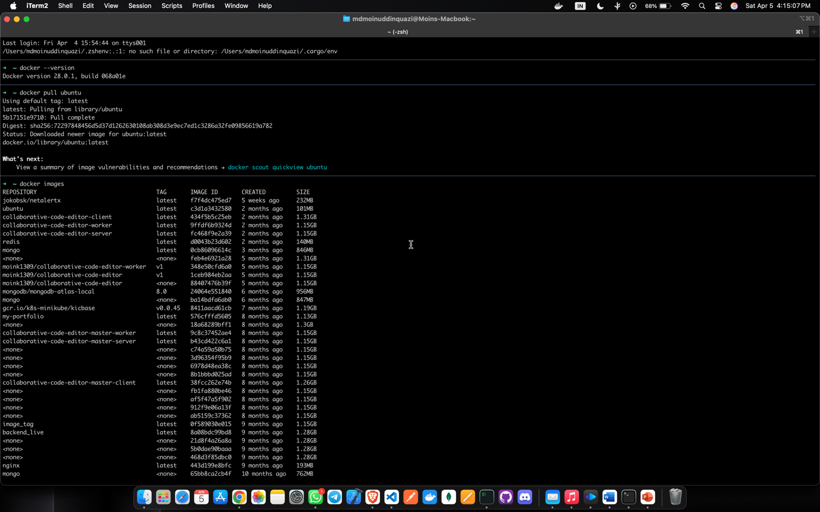
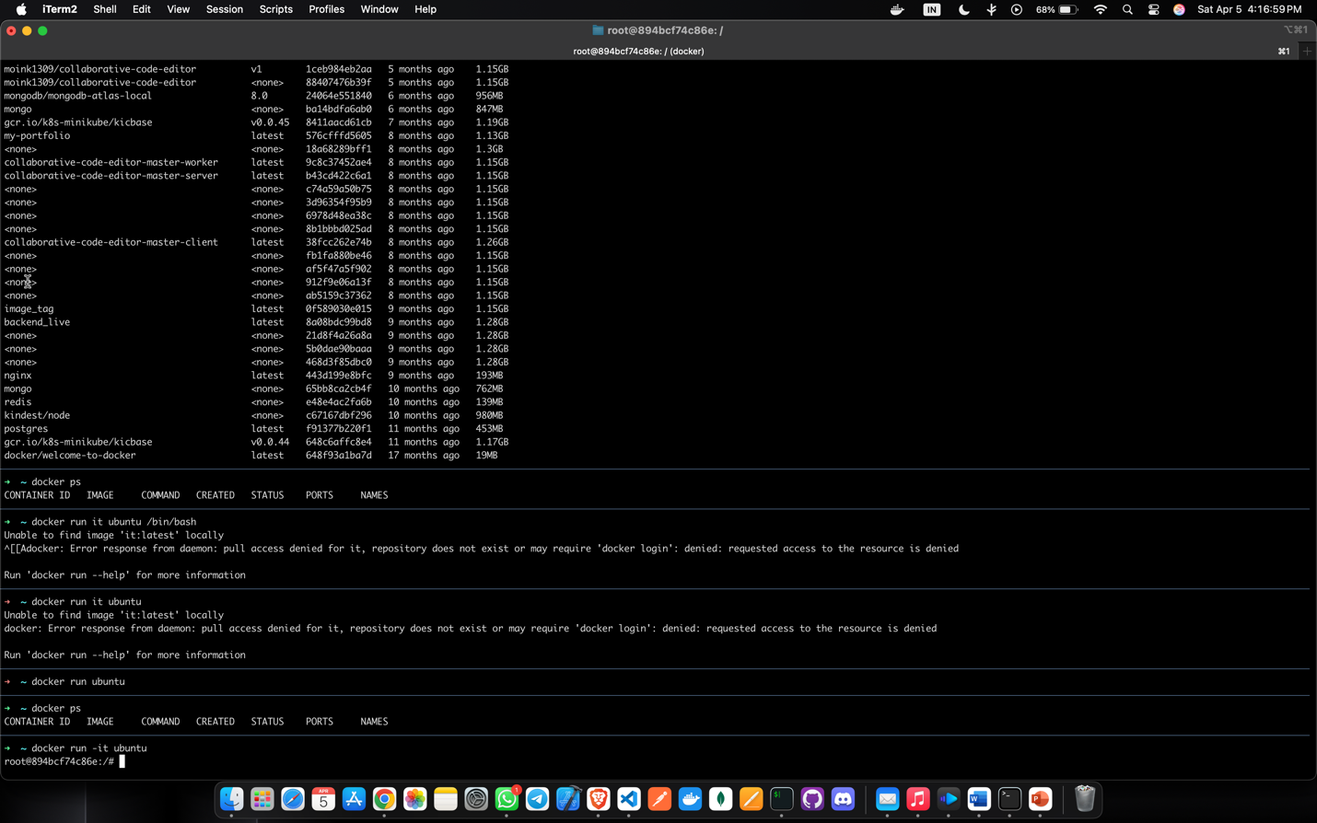
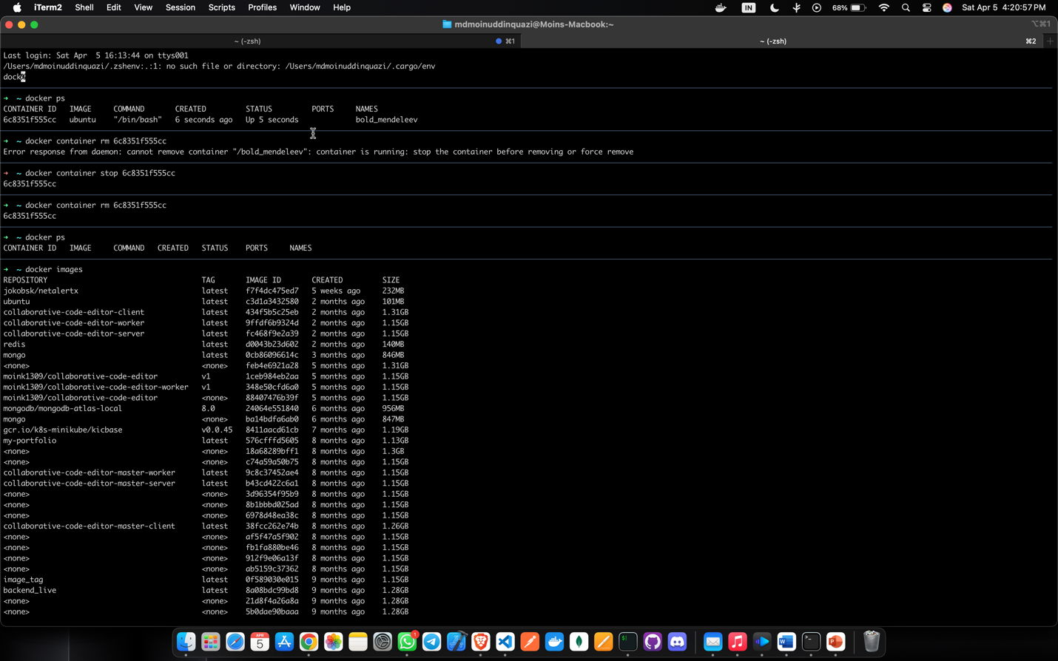

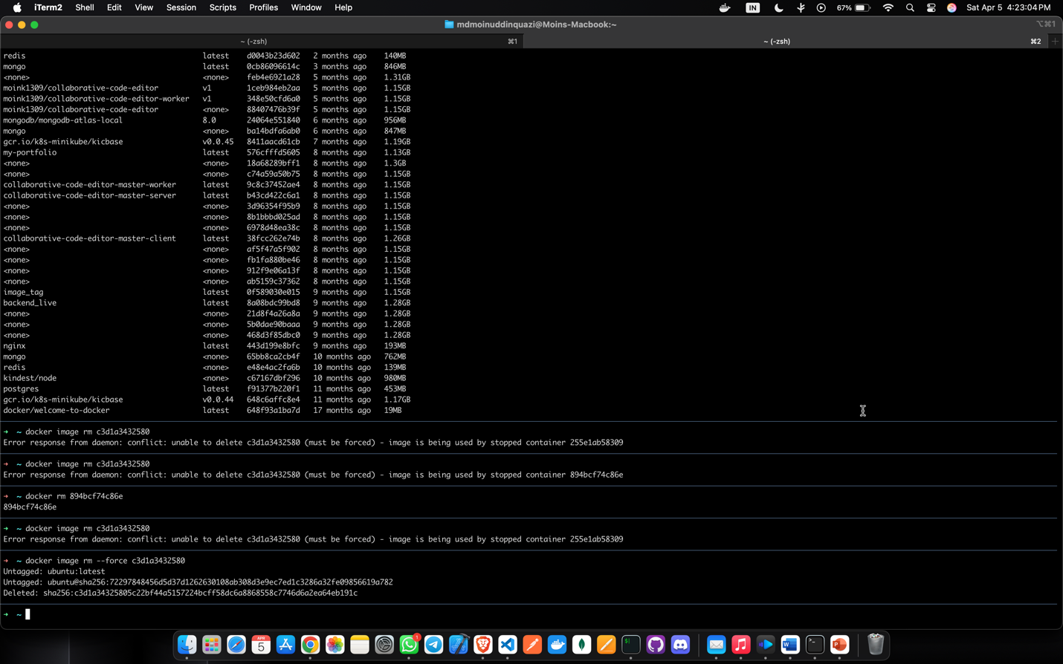
B.3 Conclusion:
(Students must write the conclusion as per the attainment of individual outcome listed above and learning/observation)
Through this experiment, I gained a comprehensive understanding of containerization using Docker. I learned about the key differences between virtual machines and containers, the benefits of containerization, and how to implement Docker for application deployment. This experience enhanced my knowledge of software deployment and resource utilization in cloud computing environments.

