Terna Engineering College
Computer Engineering Department

Class: TE Sem.: VI

Course: System Security Lab

PART A
(PART A : TO BE REFFERED BY STUDENTS)
Experiment No.13
A.1 Aim: Explore the GPGwin tool and implement email security
A.2 Prerequisite:
1. Basic Knowledge of email, symmetric and asymmetric encryption and decryption

A.3 Outcome:
After successful completion of this experiment students will be able to

To be able to use open source technologies and explore email security and explore various attacks.

A.4 Theory:

Pretty Good Privacy (PGP) is a data encryption and decryption computer program that provides cryptographic privacy and authentication for data communication. PGP is often used for signing, encrypting, and decrypting texts, e-mails, files, directories, and whole disk partitions and to increase the security of e-mail communications.
PGP encryption uses a serial combination of hashing, data compression, symmetric-key cryptography, and finally public-key cryptography; each step uses one of several supported algorithms. Each public key is bound to a user name and/or an e-mail address. The first version of this system was generally known as a web of trust to contrast with the X.509 system, which uses a hierarchical approach based on certificate authority and which was added to PGP implementations later. Current versions of PGP encryption include both options through an automated key management server.
GNU Privacy Guard (GnuPG or GPG) is a free software replacement for Symantec's PGP cryptographic software suite. GnuPG is a hybrid-encryption software program because it uses a combination of conventional symmetric-key cryptography for speed, and public-key cryptography foreaseofsecurekeyexchange,typicallybyusingtherecipient'spublickeytoencryptasessionkey which is only used once. This mode of operation is part of the OpenPGP standard and has been part of PGP from its firstversion.

PART B
(PART B : TO BE COMPLETED BY STUDENTS)
(Students must submit the soft copy as per following segments within two hours of the practical. The soft copy must be uploaded on the Blackboard or emailed to the concerned lab in charge faculties at the end of the practical in case the there is no Black board access available)

 | Roll No.C54 |  | Name: Quazi Md Moinuddin
 | Class:TE-C |  | Batch:C3
 | Date of Experiment: |  | Date of Submission: 28-3-25
 | Grade :
B.1 |  | Output
 |  | (add snapshot of output ) 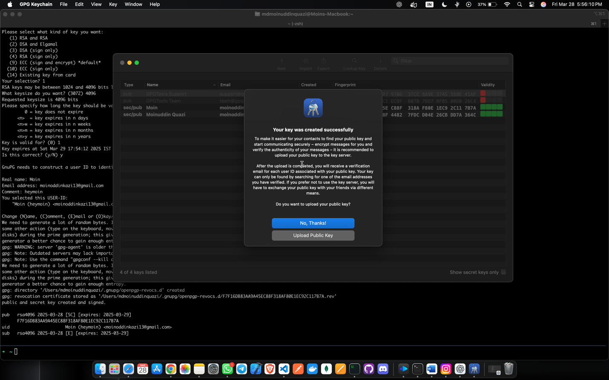
 |  | 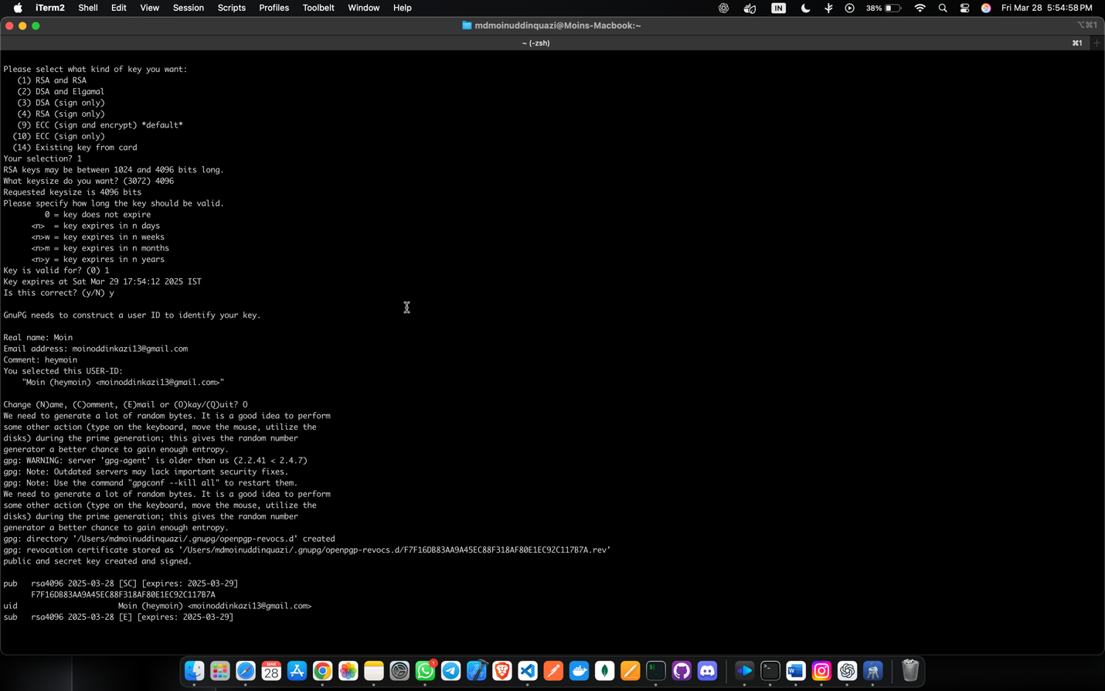
 |  | 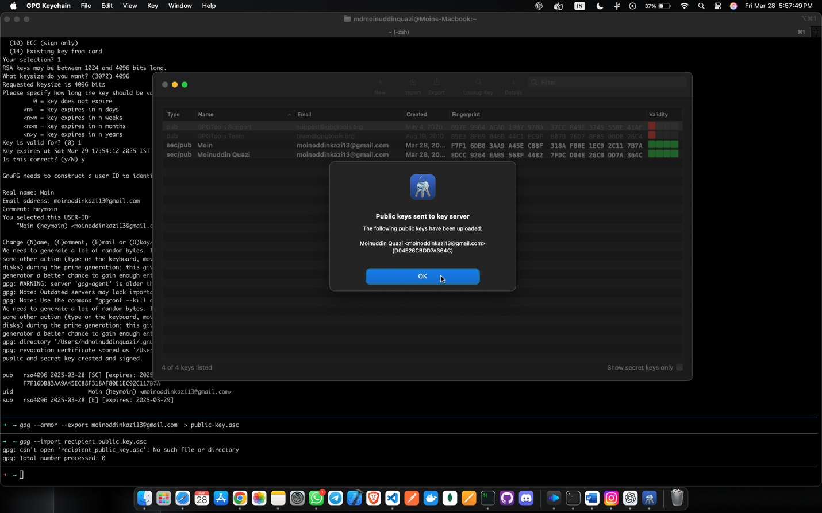
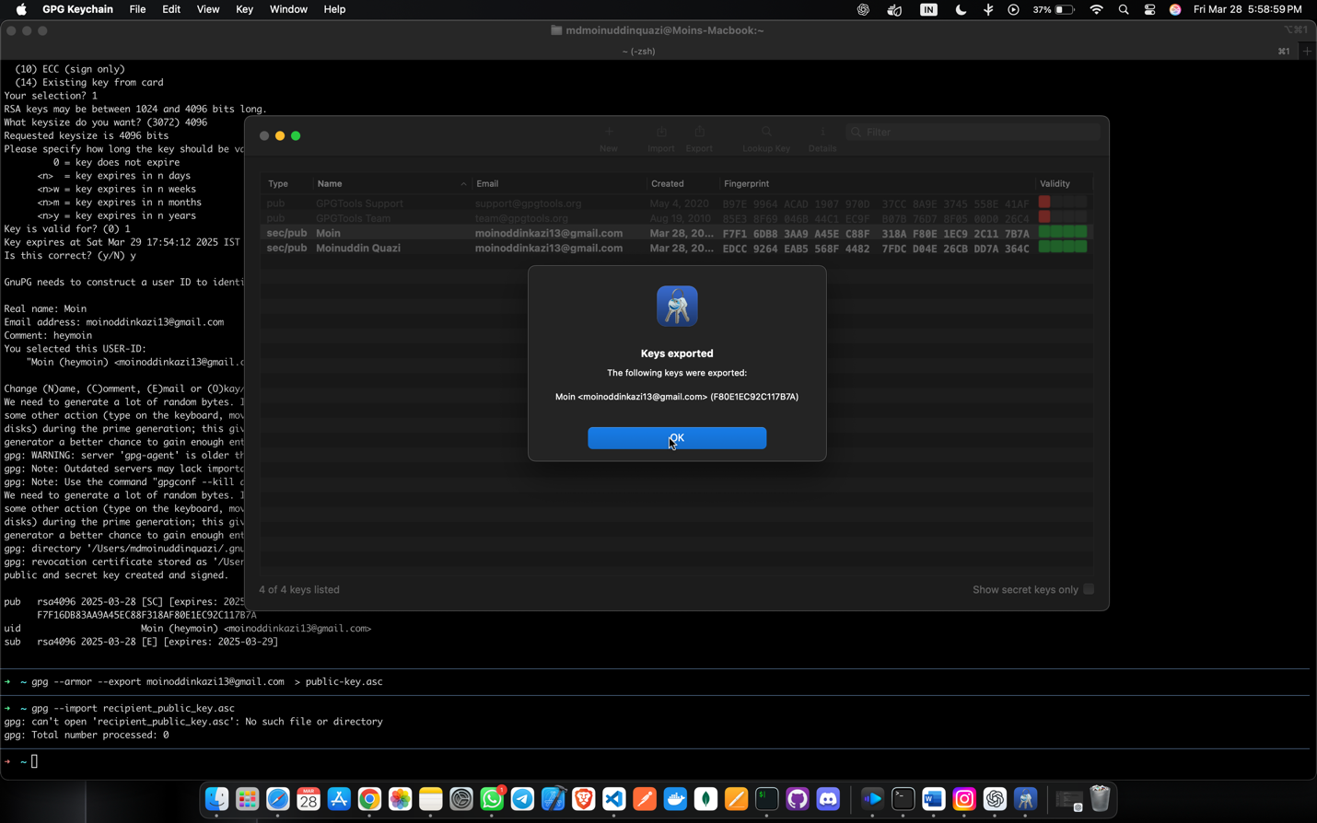
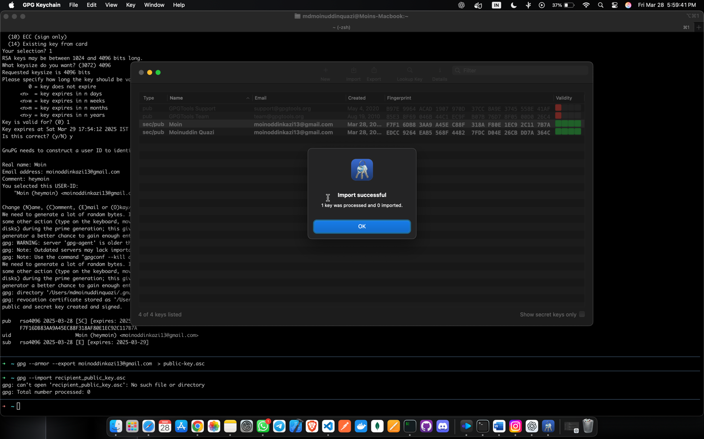
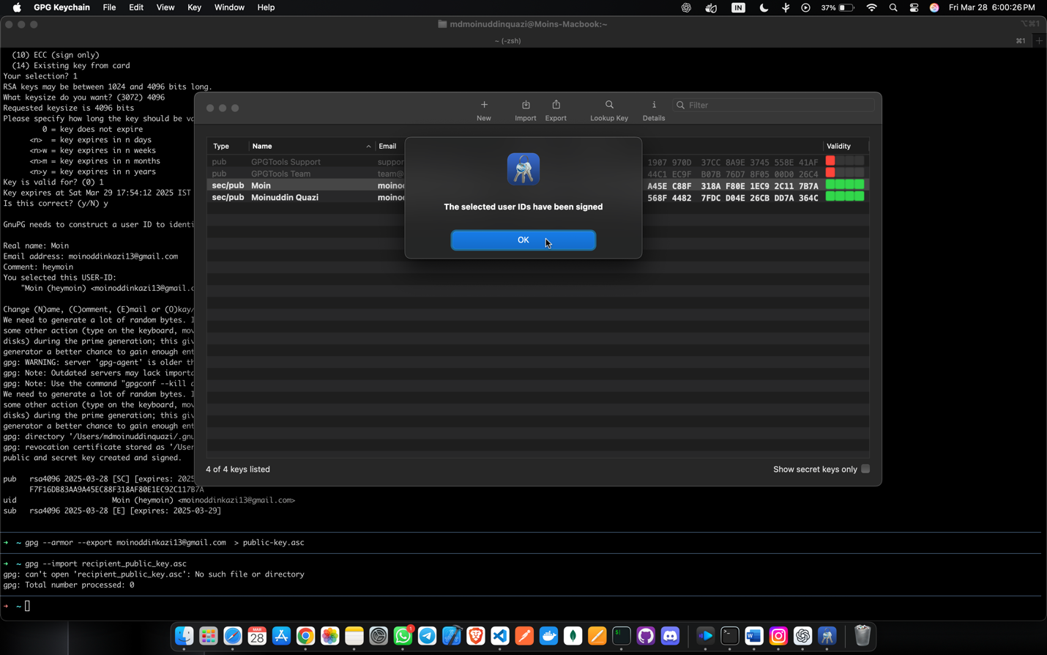
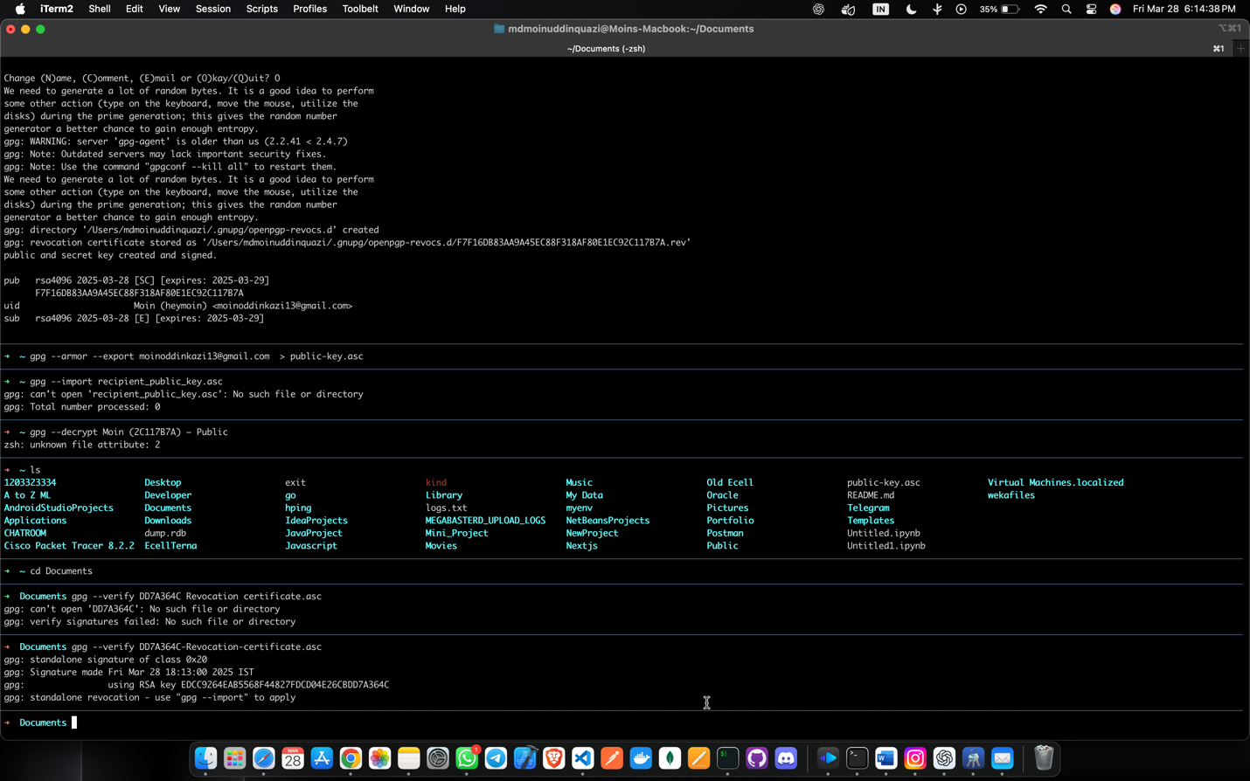
B.2. |  | Commands / tools used with syntax:  gpg --full-generate-key  gpg --armor --export your_email@example.com > public-key.asc  gpg --import recipient_public_key.asc  gpg --encrypt --recipient recipient@example.com filename.txt  gpg --decrypt filename.txt.gpg  gpg --verify signed_file.asc
B.3 |  | Question of Curiosity: (Attempt at least 3 questions handwritten)  - What is the full form of PGP?  - Why email security is required ?  - What is GPG (GNU Privacy Guard) and how does it ensure email security?  - What is the difference between symmetric and asymmetric encryption in the context of GPG?  - What is the role of a public key and private key in email encryption with GPG?  - What is the process for verifying the authenticity of an email using GPG?  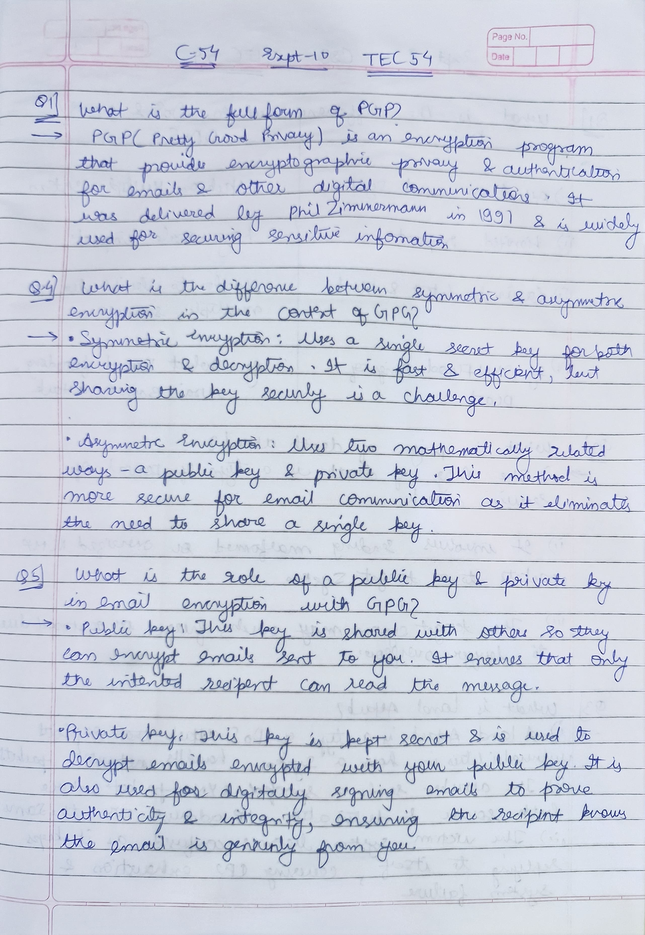
B.4 |  | Conclusion:  (Write appropriate conclusion.)  You have successfully set up email encryption and file security using GPG. Now, we can securely communicate by encrypting messages and verifying sender authenticity.

