Terna Engineering College
Computer Engineering Department

Class: TE Sem.: VI
Course: System Security Lab

PART A
(PART A : TO BE REFFERED BY STUDENTS)

Experiment No.7
A.1 Aim: Download and install nmap. Use it with different options to scan open ports, perform OSfingerprinting, do a ping scan, tcp port scan, udp port scan, xmas scan etc. A.2 Prerequisite:
1. Basic Knowledge of Ports, TCP, UDP, Ping

A.3 Outcome:
After successful completion of this experiment students will be able to

Install and use nmap and use it for gathering detailed network and remote host information. A.4 Theory:
Nmap (Network Mapper) is a security scanner originally written by Gordon Lyon (also known by his pseudonym Fyodor Vaskovich) used to discover hosts and services on a computer network, thus creating a "map" of the network. To accomplish its goal, Nmap sends specially crafted packets to the target host and then analyzes the responses. Unlike many simple port scanners that just send packets at some predefined constant rate, Nmap accounts for the network conditions (latency fluctuations, network congestion, the target interference with the scan) during the run. Also, owing to the large and active user community providing feedback and contributing to its features, Nmap has been able to extend its discovery capabilities beyond simply figuring out whether a host is up or down and which ports are open and closed; it can determine the operating system of the target, names and versions of the listening services, estimated uptime, type of device, and presence of a firewall.
Nmap features include:
- Host Discovery – Identifying hosts on a network. For example, listing the hosts which respond to pings or have a particular port open.
- Port Scanning – Enumerating the open ports on one or more target hosts.
- Version Detection – Interrogating listening network services listening on remote devices to determine the application name and version number.
• OS Detection –Remotely determining the operating system and some hardware characteristics of network devices.
Basic commands working in Nmap:
- For target specifications: nmap<target‘s URL or IP with spaces between them>
- For OS detection: nmap -O <target-host's URL or IP>
- For version detection: nmap -sV<target-host's URL or IP>
SYN scan is the default and most popular scan option for good reasons. It can be performed quickly, scanning thousands of ports per second on a fast network not hampered by restrictive firewalls. It isalso relatively unobtrusive and stealthy since it never completes TCP connections.
A5.Procedure:
Installation of Nmap: $ sudo apt-get install nmap
Commands:
  - nmap -sP<10.0.0.0/24>
Ping scans the network, listing machines that respond to ping.
  - FIN scan (-sF)
Sets just the TCP FIN bit.

  - -sV (Version detection) .
Enables version detection, as discussed above. Alternatively, can use -A, which enables version detection among other things.

  - -sO (IP protocol scan) .
IP protocol scan allows you to determine which IP protocols (TCP, ICMP, IGMP, etc.) are supported by target machines. This isn´t technically a port scan, since it cycles through IP protocol numbers rather than TCP or UDP port numbers.

  - -O (Enable OS detection) .
Enables OS detection, as discussed above. Alternatively, you can use -A to enable OS detection along with other things.

  - -p port ranges (Only scan specified ports) .
This option specifies which ports you want to scan and overrides the default. Individual port numbers are OK, as are ranges separated by a hyphen (e.g. 1-1023). The beginning and/or end values of a range may be omitted, causing Nmap to use 1 and 65535, respectively.

  - --top-ports <integer of 1 or greater>
Scans the N highest-ratio ports found in nmap-services file.

  - nmap –iflist host interface and route information with nmap by using ―–iflist‖ option.

PART B

(PART B : TO BE COMPLETED BY STUDENTS)
(Students must submit the soft copy as per following segments within two hours of the practical. The soft copy must be uploaded on the Blackboard or emailed to the concerned lab in charge faculties at the end of the practical in case the there is no Black board access available)

Roll No. C54 | Name: Quazi Md Moinuddin
Class : TE-C | Batch : C3
Date of Experiment: 3-3-25 | Date of Submission :17-3-25
Grade :

B.1 Output
(add snapshot of output )
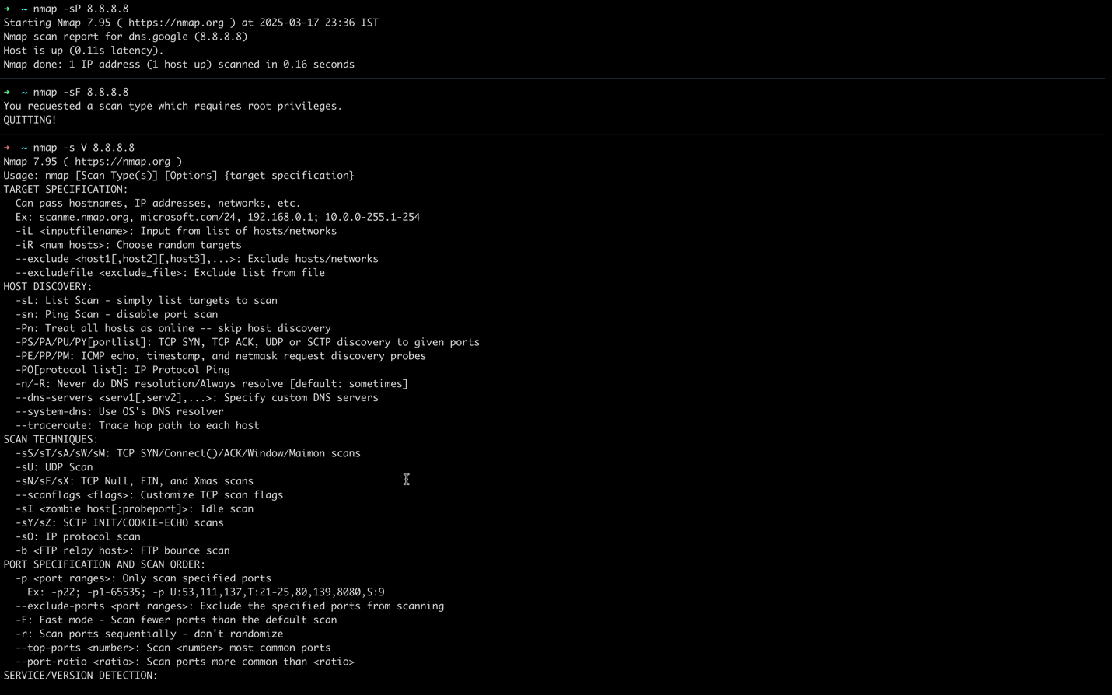

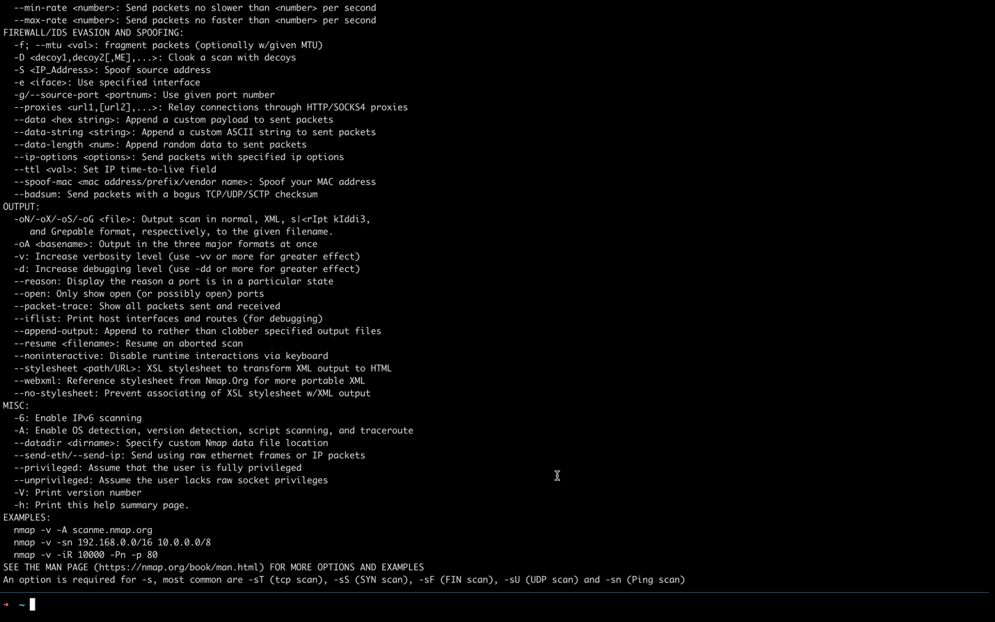
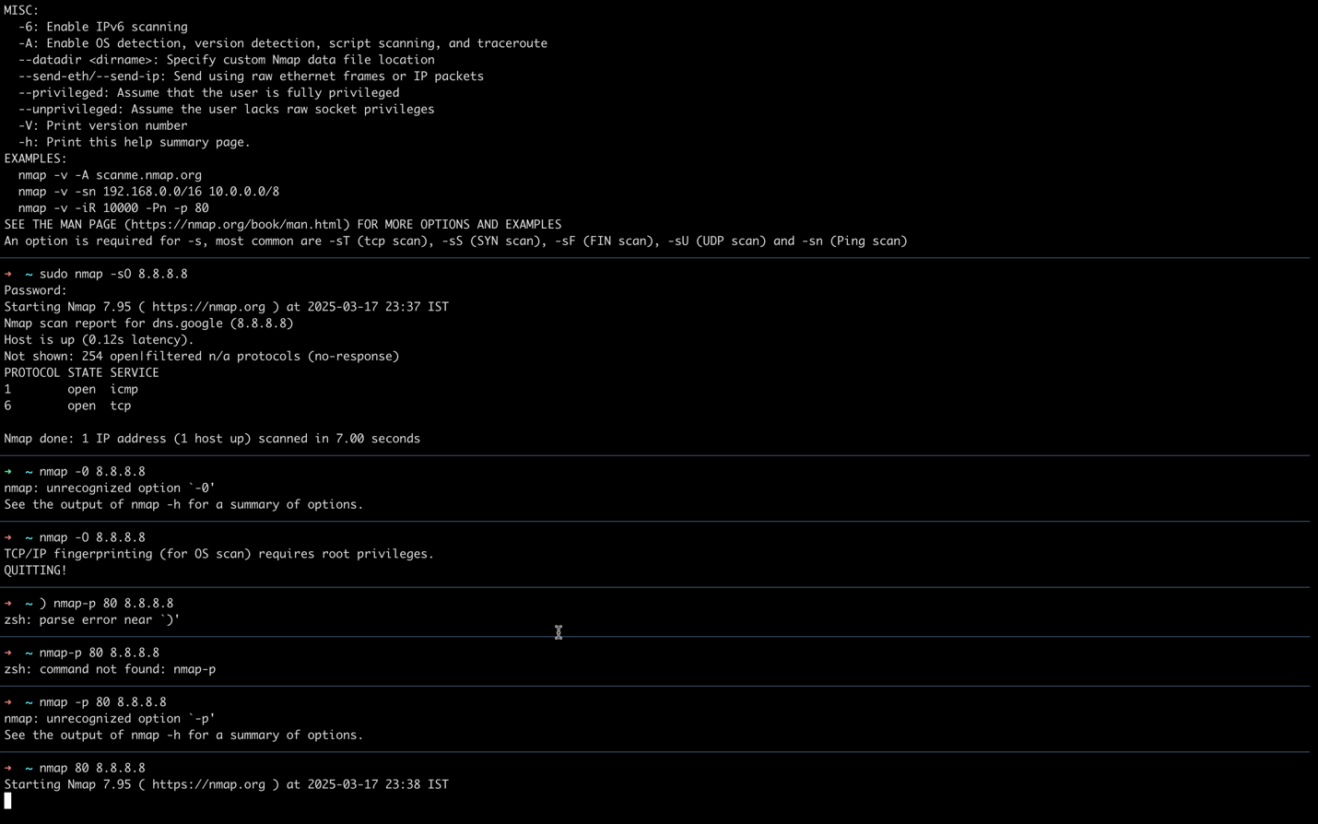
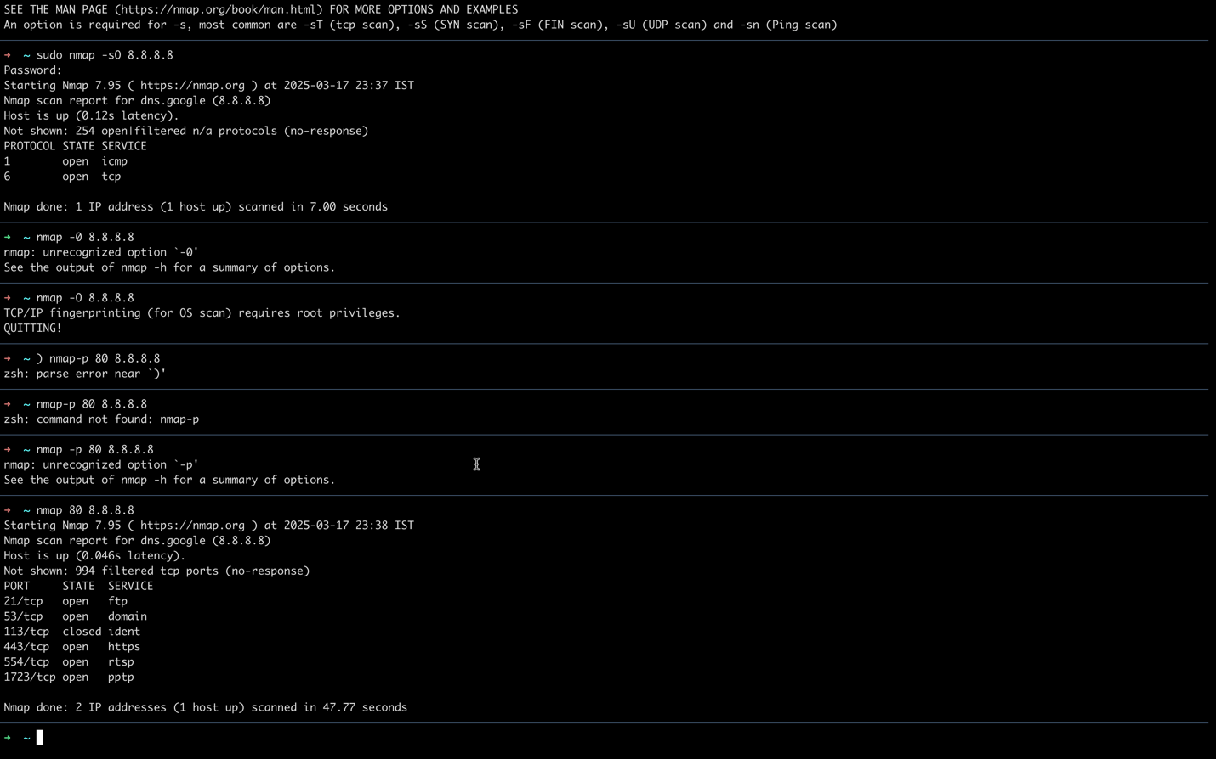
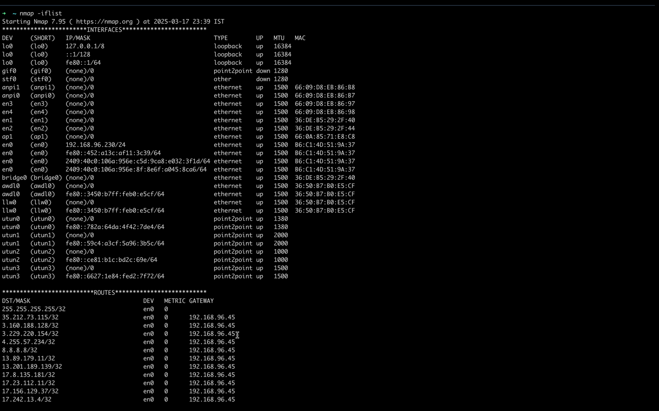
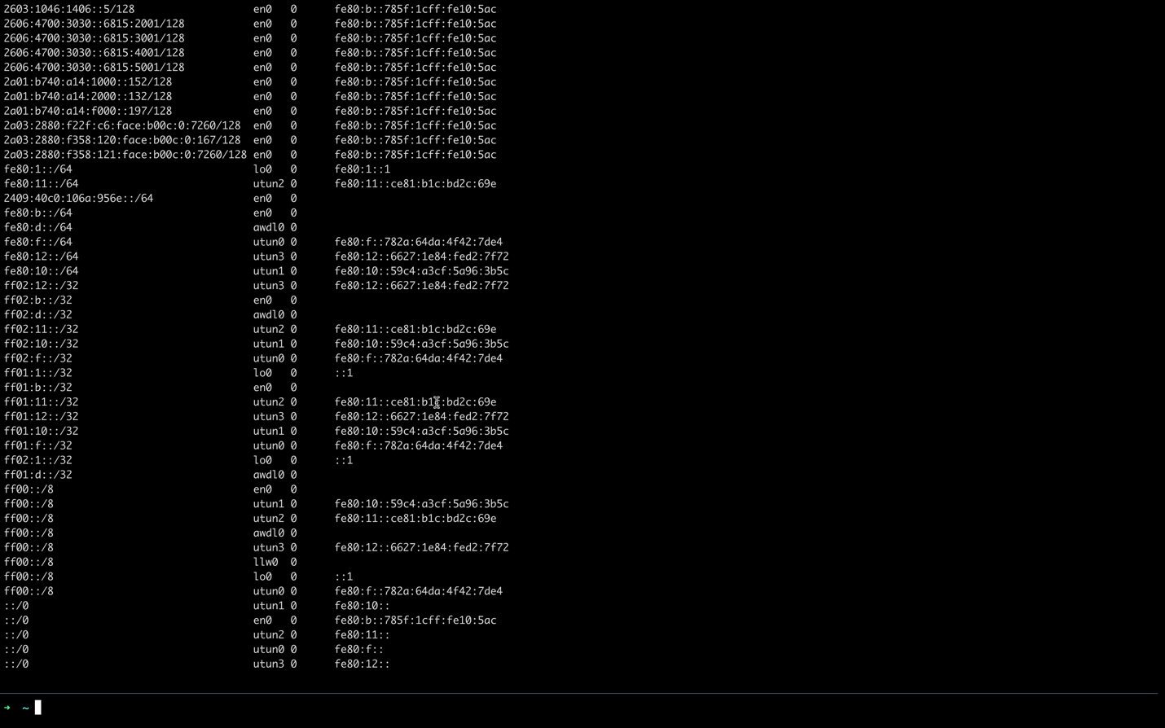
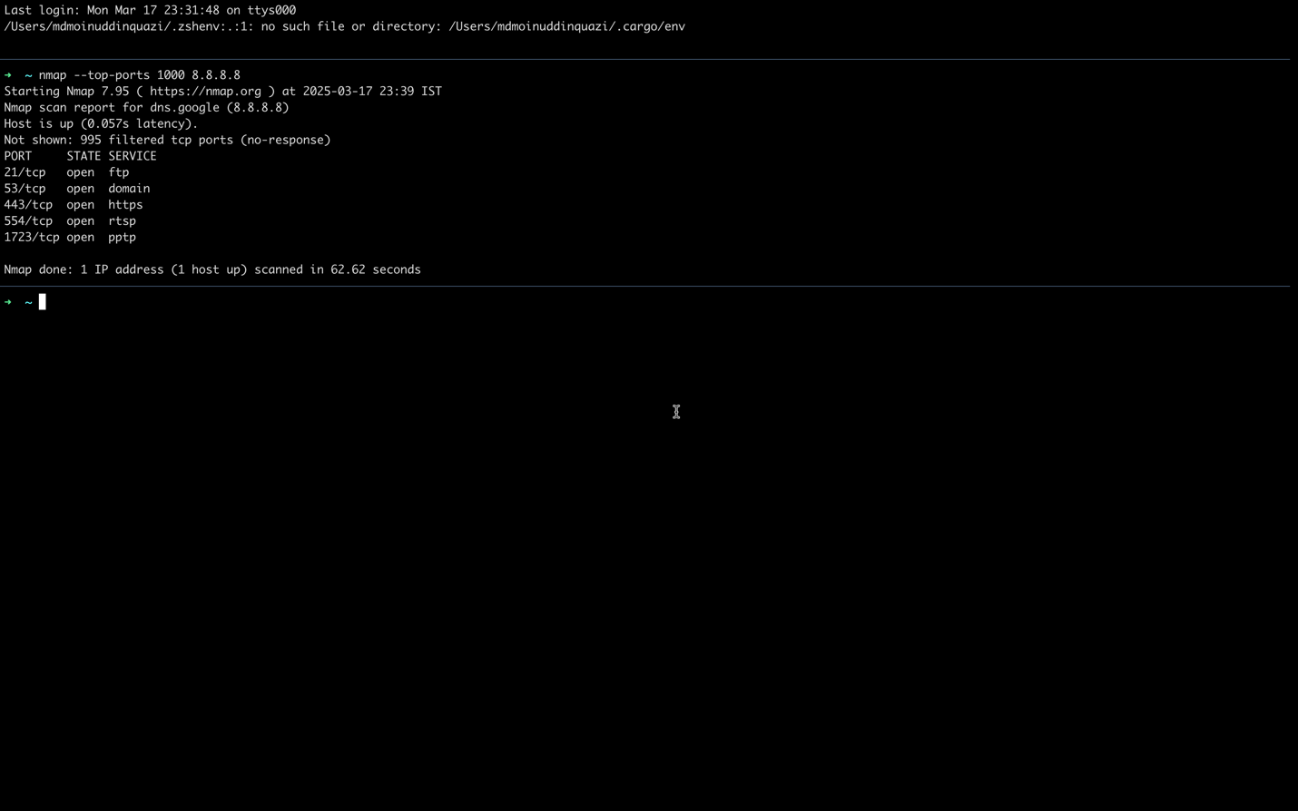
B.2. Commands / tools used with syntax:
1) nmap -sP 8.8.8.8
2) nmap -sF 8.8.8.8
3) nmap -s V 8.8.8.8
4) sudo nmap -sO 8.8.8.8
5) nmap -0 8.8.8.8
6) nmap-р 80 8.8.8.8
7) nmap --top-ports 1000 8.8.8.8
8) nmap -iflist

B.3 Question of Curiosity:

- What are the ethical considerations when using Nmap for scanning networks?
- What precautions should be taken to avoid detection when using Nmap for network scanning?
- What is the purpose of OS fingerprinting in network scanning?
- How does an Xmas scan work, and what does it detect?
- What is the difference between TCP and UDP port scanning?
- How can Nmap be used to detect firewalls and filtering devices?
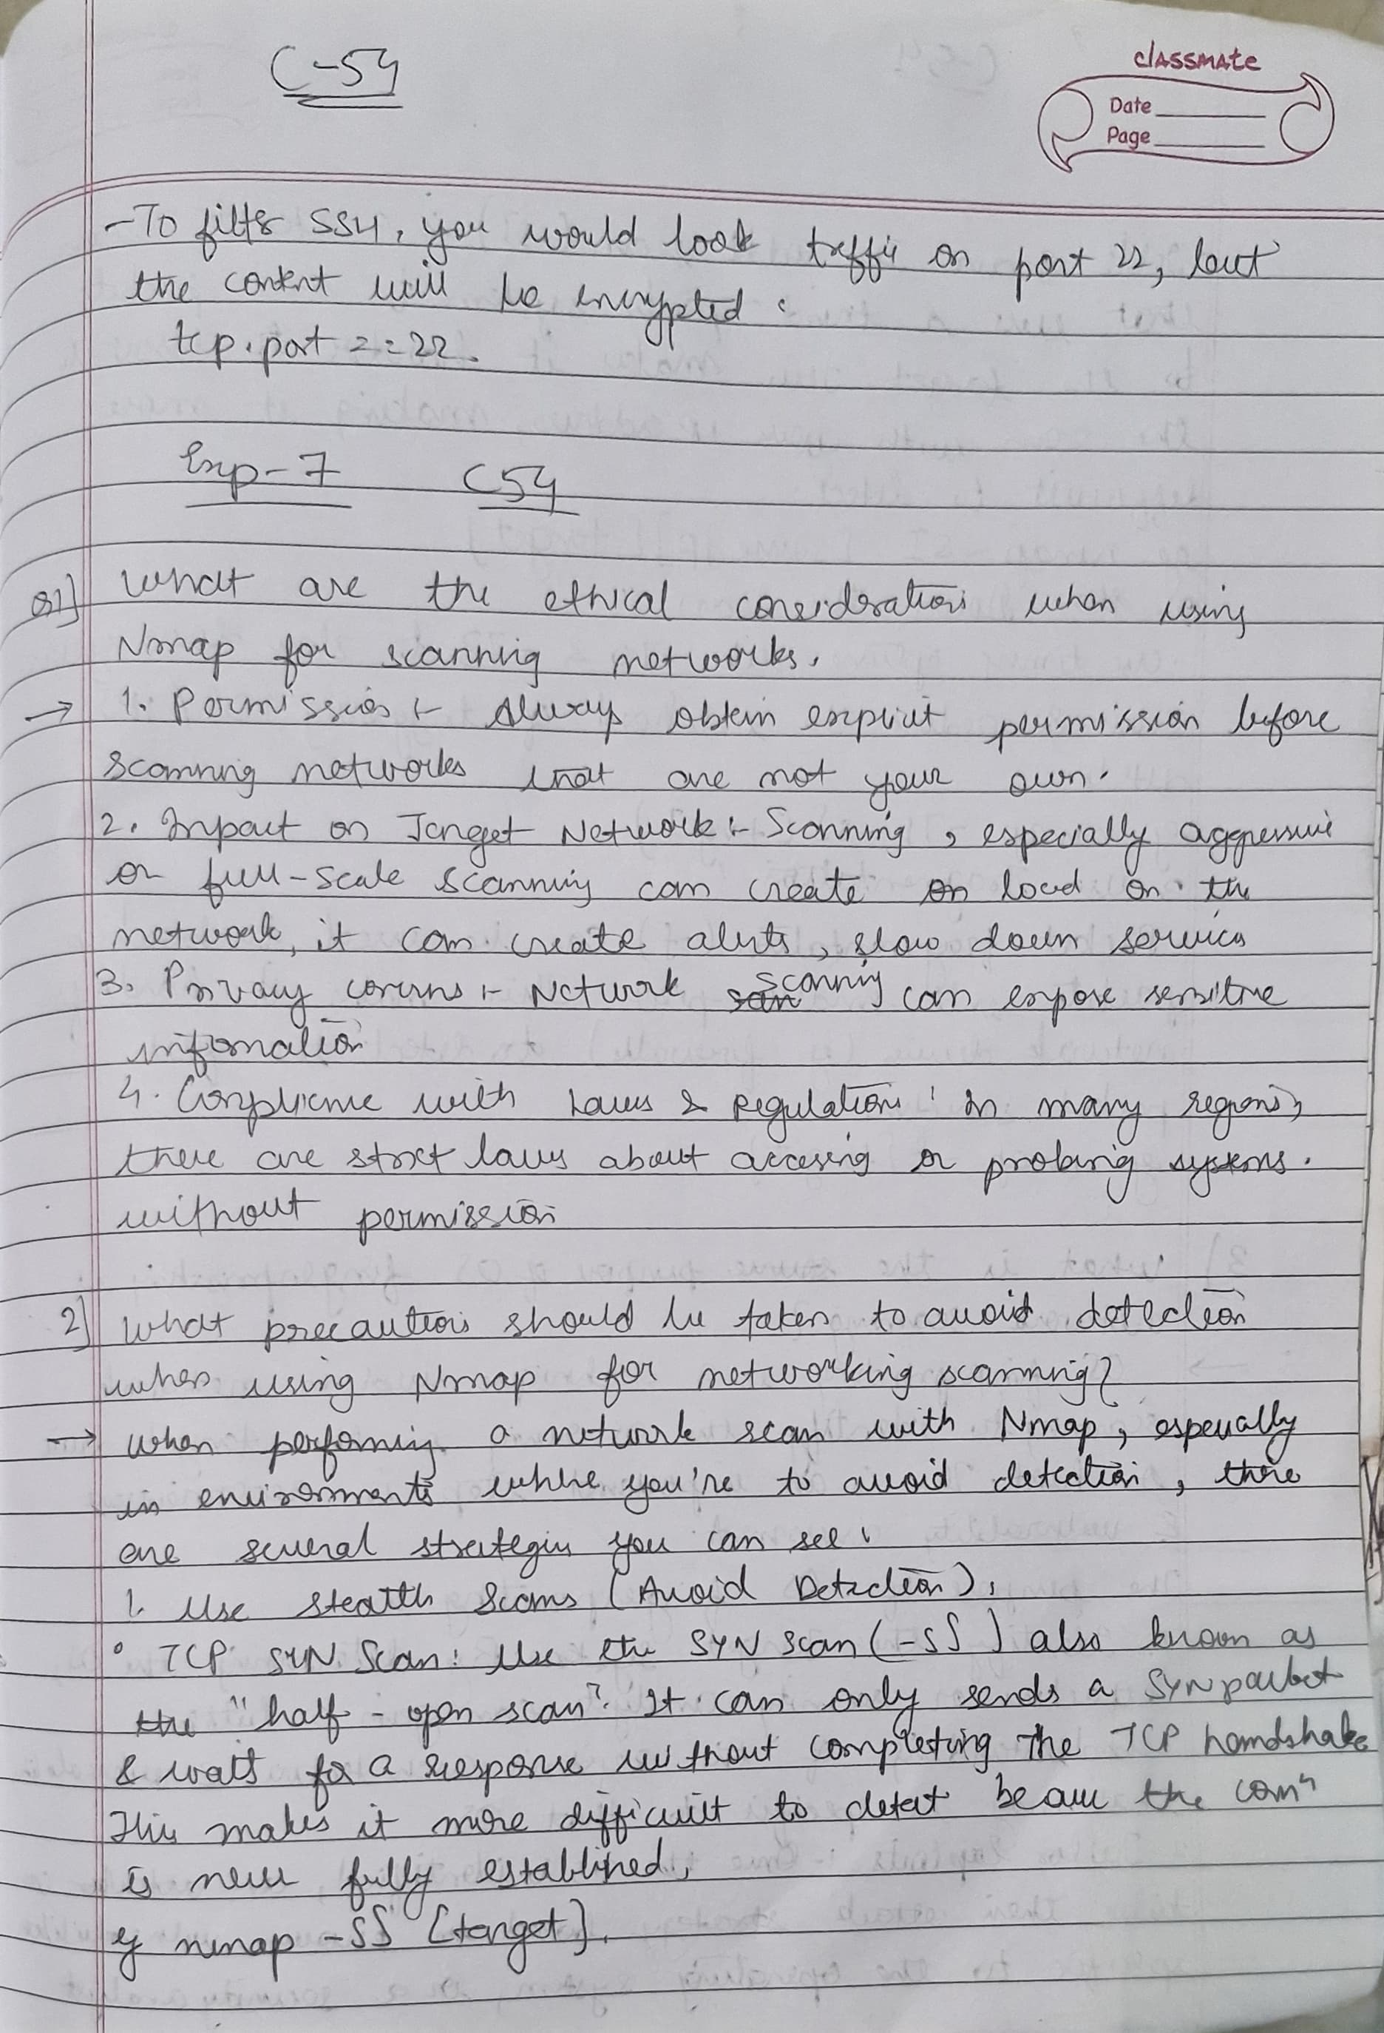
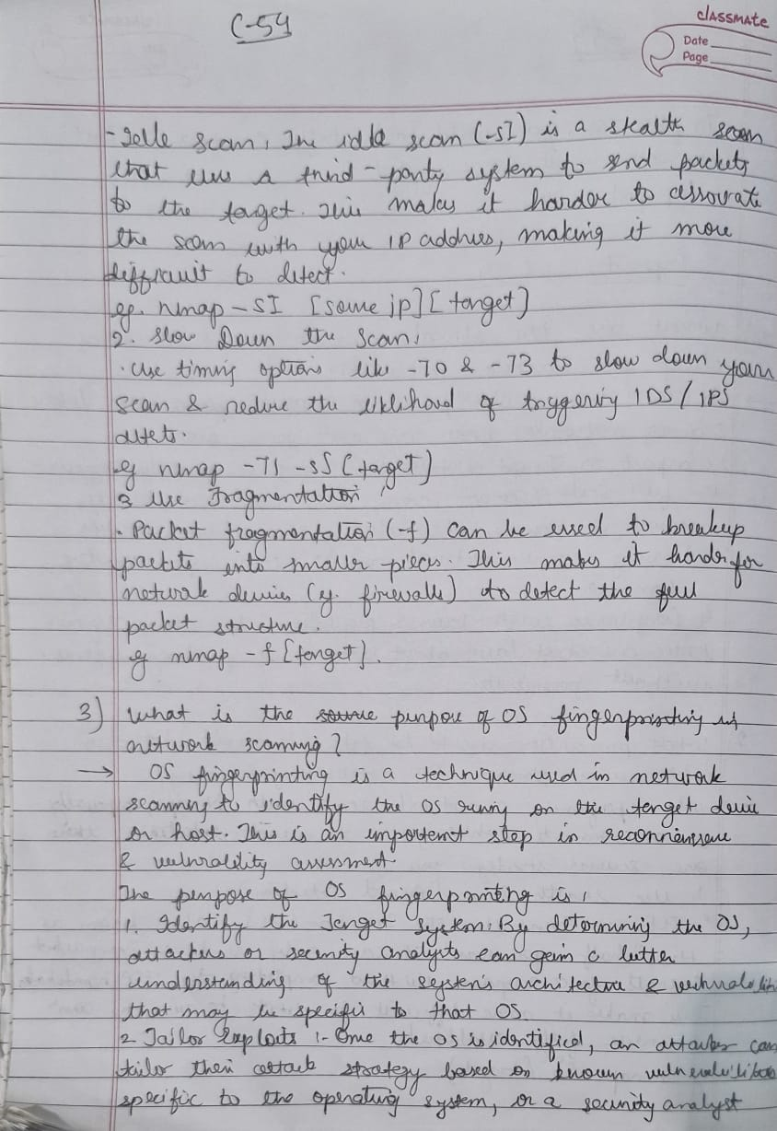


B.4 Conclusion:
(Write appropriate conclusion.)
We've effectively showed how to use Nmap for network reconnaissance, including port scanning and OS fingerprinting and completed the experiment. By understanding the principles of port scanning and using Nmap and other relevant tools, we were able to gain information about vulnerability discovery and network security assessment.

