GROUP 1 FINAL PROJECT REPORT
CEIS 200 Software Engineering I
Professor Messaoud Laddada
Nathalie Davis, Kamil Moralewski, Phillip Tette
Final Session
2/22/2023

Table of Contents
1 IEEE 830 Software Requirements Specifications 5
1.1 Introduction 5
1.1.1 Purpose 5
1.1.2 Document Conventions 5
1.1.3 Intended Audience and Reading Suggestions 5
1.1.4 Product Scope 5
1.1.5 Reference 6
1.2 Overall Description 6
1.2.1 Product Perspective 6
1.2.2 Product Functions 6
1.2.3 User Classes and Characteristics 6
1.2.4 Operating Environment 8
1.2.5 Design and Implementation Constraints 8
1.2.6 User Documentation 9
1.2.7 Assumptions and Dependencies 9
1.3 External Interface Requirements 9
1.3.1 User Interfaces 9
1.3.2 Hardware Interfaces 9
1.3.3 Software Interfaces 9
1.3.4 Communications Interfaces 9
1.4 System Features 10
1.4.1 System Feature #1 – Questionnaire 10
1.4.2 System Feature #2 – Training & Advice 10
1.4.3 System Feature #3 – Community Support 10
1.4.4 System Feature #4 – GPS 10
1.4.5 System Feature #5 – User Profile Page 10
1.4.6 System Feature #6 – Pending 10
1.5 Other Nonfunctional Requirements 10
1.5.1 Performance Requirements 10
1.5.2 Portability 11
1.5.3 Security Requirements 11
1.5.4 Software Quality Attributes 11
2 OOAD Diagrams 12
2.1 Use Case Diagram 12
2.2 Use Case Specifications 13
2.2.1 Use Case #1 13
2.2.2 Use Case #2 14
2.2.3 Use Case #3 15
2.2.4 Use Case #4 16
2.3 Class Diagram 17
2.4 Sequence Diagrams 18
2.5 State Machine Diagram 20
3 Risk Assessment Matrix 21
4 Test Plan 22
4.1 Test Plan Identifier 22
4.2 Introduction 22
4.3 Test Items 22
4.4 Features to be Tested 22
4.5 Features not to be Tested 23
4.6 Approach 23
4.7 Items Pass/Fail Criteria 23
4.8 Test Deliverables 24
4.9 Environmental Needs 24
4.10 Responsibilities 24
4.11 Staffing and Training Needs 24
4.12 Schedule 24
4.13 Risks and contingencies 25
5 Test Cases 26
5.1 Test Case #1 26
5.2 Test Case #2 27
5.3 Test Case #3 28
5.4 Test Case #4 29
6 Updated Project Plan 30

IEEE 830 Software Requirements Specifications

Introduction
“Perfect Pet Finder”

Many people have unrealistic expectations of what they can handle and genuinely do not have much knowledge of the wide scope of pet varieties and breeds. Specifically, each unique breeds personality traits, activity levels, ease of care and training requirements. Adopting a pet without this knowledge often leads to a poor experience for both the person and their pet. Our application will educate and guide the would-be owners to an informed decision as to which pet would suit them best. When we match their time and lifestyle choices to an optimal type and breed, it becomes an overall net positive for both the new owner and pet.

Purpose
Our purpose is to help new and existing pet owners find their ideal pet through a questionnaire that will build their user profile to find matches. To maximize matching opportunities, shelters and adoption agencies will be able to list and match pets to potential owners.

To create the software “Perfect Pet Finder” that aims to connect clients to their prospective companions.

Short term goal Scope: General personality and personal information plus preferences quiz to align client with prospective animal companions.

Long term goal Scope: Reduce the number of strays globally and aid the appropriate parties in finding the perfect animal companions for a multitude of needs.

Document Conventions
There are no unique or special typographical conventions. All items of interest, such as the diagrams will adhere to widely used and known standards IOT enable expeditious comprehension of project requirements.

Intended Audience and Reading Suggestions
- General public
- Shelters and Rehabilitation clinics
- Adoption agencies
- New and existing pet owners
- Service animal agencies
- Animal Trainers

Product Scope
Using a questionnaire styled setup, we will narrow down pet recommendations through a series of classes (listed below) until the user lands on a perfect pet.

Reference
Pressman, Roger S., Maxim, Bruce R. (2020) Software engineering: a practitioner’s approach
Nineth edition. New York, NY McGraw-Hill Education

Nestec S.A. (2022). Petfinder – Adopt a Pet. Societe des Produits Nestle S.A.

Praveen, Malik. (2022). Back to Basics: Assumption vs. Constraints vs. Dependencies. https://www.mpug.com/back-to-basics-assumptions-vs-constraints-vs-dependencies/

(2023). Software Engineering. https://t4tutorials.com/external-interface-requirements-srs/.

IEEE. (1998). IEEE Recommended Practice for Software Requirements Specifications. The Institute of Electrical and Electronics Engineers, Inc. http://www.math.uaa.alaska.edu/~afkjm/cs401/IEEE830.pdf

Overall Description

Product Perspective
- Users will complete a questionnaire to build their pet profiles and begin searching for their best matched pets.
- Once the search is complete, users will be able to see contact information and submit their profiles to the pet owners for review.
- After reviewing, users will receive their response whether they can continue with the process or verify more information.
- There will be a section with training videos including where to begin with the questionnaire and how to care for your pet.
- There will be a section with tips and guides on nutrition and medicine.
- There will be a section where a community of pet owners will be able to chat and ask questions.
- In app support will ensure the entire process is quick and easy.

Product Functions
- Questionnaire to match user to their desired pet
- Location-based results
- Training videos
- Tips and guides
- Community
- In app support

User Classes and Characteristics
1. Commitment Level
1.1. Grooming
1.2. Hygiene
1.3. Exercise
1.4. Training
1.5. Attention requirements
2. Purchase Cost
2.1. 0 to 1000
2.2. 1001 to 2000
2.3. 2001+
3. Annual Cost (Vet, Grooming, Etc.)
3.1. 0 to 1000
3.2. 1001 to 2000
3.3. 2001+
4. Type
4.1. Dog
4.2. Cat
4.3. Reptile
4.4. Amphibian
4.5. Bird
4.6. Rabbit
4.7. Rodent
4.8. Exotic
5. Preferences
5.1. Temperament
5.2. Hyper
5.3. Calm
5.4. Playful
5.5. Timid
5.6. Independent
5.7. Dependent
5.8. Aggressive
5.9. Affectionate
5.10. Courageous
6. Physical Characteristics
6.1. Color
6.2. Size
6.3. Hair or Fur
6.4. Shed or No Shed
6.5. Coat Length
6.6. Long snout or short snout
6.7. Gender
7. Life Expectancy
7.1. Years
8. Medical Considerations
8.1. Allergens
9. Aptitudes
9.1. Guard Purposes
9.2. Service Purposes
9.3. Emotional Support
9.4. Good with children
10. Domicile
10.1. Apartment
10.2. Single Family Home
10.3. Highrise
10.4. Townhome
10.5. Condo
10.6. Farmhouse
11. Distance
11.1. Less than 50 miles
11.2. 51 to 100
11.3. 101 to 200
11.4. 201+

Operating Environment
Web-based Application for all devices.

Mobile Devices
- iOS
- Android/Linux

Design and Implementation Constraints
- The app must be able to match the user with their perfect pet based on their answers and in their desired distance to travel.
- The app will be free for use but will have to implement some kind of ad structure, in app purchases, or donation tabs to sustain operations.
- All the features and functions must be in sync at all times to keep the users projected experience flowing.
- The app must follow all laws, regulations, and standards.
- The decisions of the owners of the pets are final and cannot be appealed.
- Users will need to complete the questionnaire before browsing the other app features.
- Users who spam the questionnaire or posts will be temporarily timed out or banned as necessary.

User Documentation
- Users will begin by creating an account and filling out the questionnaire.
- Upon completion, they will be presented with results of possible pets to own based on their answers.
- After browsing the results, users will be able to see all the information about each specific pet and be able to contact the owners for further information.
- After initial contact, the owner will begin a review of the person who wants the pet and see if they feel it, is a great fit.
- Once approved, the user will be able to travel to see their new pet and finish all the paperwork for ownership.
- After taking their new pet home, users will still be able to engage in our app with all our features.

Assumptions and Dependencies
- Users will want a pet to own.
- Users have a pet and want to learn more about caring for them.
- Users want to socialize with other pet owners.

External Interface Requirements

User Interfaces
- Show the interface between the software and a user.
- Example of User Interface Requirements:
- Screenshots/ screen layout of each separate part (i.e., pages of a website) of a software.

Hardware Interfaces
- Windows
- Mac
- Linux
- iOS
- Android

Software Interfaces
- Location based searches using map software
- Forum for community of pet owners
- Questionnaire module

Communications Interfaces
- Touchscreen GUI
- Database with user information and pet information

System Features

System Feature #1 – Questionnaire
- Questionnaire to match the perfect pet
  - Class database with questions and answers

System Feature #2 – Training & Advice
- Training videos, tips, and guides
  - Database of videos and guides for training and care
  - Moderation for new content that is posted

System Feature #3 – Community Support
- Community forum
  - Functional messaging system between users
  - Ability to create groups and threads for all kinds of information

System Feature #4 – GPS
- Access to a location-based app to map out potential results
  - Turn on location when at pet parks or animal friendly locations pin map.

System Feature #5 – User Profile Page
- Profile page
  - Users
  - Vendors
  - Trainers
  - Animal Agencies

System Feature #6 – Pending
<Provide description>
<Provide functional requirements>

Other Nonfunctional Requirements

Performance Requirements
- Communication between databases and in app services
- Clear search results based on answers to questionnaire
- Structure in user profiles and pet profiles to ensure accuracy

Portability
- Available in all app stores and for download on our site.
- Available to run across many platforms.
- Internet connection required to browse app

Security Requirements
- Username
- Password
- Address
- Card Information
- Pet Identity
- User and Pet location
- Reporting system to keep away spam and solicitation

Software Quality Attributes
- Usability
- Efficiency
- Maintainability
- Portability
- Easy to use

OOAD Diagrams

Use Case Diagram

Use Case Specifications

Use Case #1
Use Case Name: Purchase Pet |  | ID: 1 | Importance Level: High
Primary Actor: User, Service animal agency | Use Case Type: Business
Stakeholders and Interests: User, pet adoption agencies, shelters, & pet owners.
Brief Description: The user will contact the vendor to initiate a secure transaction and determine method of exchange.
Trigger: Clicking purchase pet
Type: Mouse or touchscreen
Relationships:

Association: Contact

Include: Pet Trainers and Community Forums

Extend: Remove pet information/listing upon sale

Generalization: N/A
Normal Flow of Events:

- User clicks create an account.
- User fills out questionnaire to create profile.
- User receives pet matches based on their answers.
- Users can choose pets and contact the owners directly for more information.
SubFlows:

S-1: Using mouse
- User clicks “purchase pet” on pet profile page.
- User will enter valid payment information.
- Payment will post as successful or unsuccessful.
- Upon payment, delivery/pickup instructions will be determined.

S-2: Using touchscreen
- User touches “purchase pet” on pet profile page.
- User will enter valid payment information.
- Payment will post as successful or unsuccessful.
- Upon payment, delivery/pickup instructions will be determined.
Alternate/Exceptional Flows:

Pet vendors and search for pet requests to sell their animals to interested parties i.e., Service animal agencies.

Use Case #2

Use Case Name: List a pet for adoption |  | ID: 2 | Importance Level: High
Primary Actor: Vendor | Use Case Type: Business
Stakeholders and Interests: Users, Service animal agencies, vendors
Brief Description: The vendor will list a pet or pets for adoption.
Trigger: Clicking upload pet information
Type: Mouse or touchscreen
Relationships:

Association: Create an account

Include: N/A

Extend: N/A

Generalization: N/A
Normal Flow of Events:

1. Vendor clicks list a pet.
2. Vendor fills out listing information.
3. Vendor submits listings and waits for contact or searches for consumer.
SubFlows:

S-1: Using mouse
- Vendor clicks “list pet” on pet on vendor page.
- Vendor types in pet information and uploads photos.
- Vendor clicks “save and post” to finish listing.

S-2: Using touchscreen
- Vendor taps “list pet” on pet on vendor page.
- Vendor types in pet information and uploads photos.
- Vendor taps “save and post” to finish listing.
Alternate/Exceptional Flows: N/A

Use Case #3
Use Case Name: Browse Pets | ID: 3 | Importance Level: Medium
Primary Actor: Users | Use Case Type: Essential
Stakeholders and Interests: All users
Brief Description: The user will look for a pet or pets to find one or many that will suit their needs and lifestyle.
Trigger: Clicking browse pets
Type: Mouse or touchscreen
Relationships:

Association: Pet preferences or skip preferences

Include: Preview pet profiles or Full pet profiles

Extend: N/A

Generalization: N/A
Normal Flow of Events:

1. User continues as a guest or creates an account.
2. User fills out pet preferences or opts to skip.
3. User browses pets until finding desired pet.
SubFlows:

S-1: Using mouse
- User clicks “browse pets.”

S-2: Using touchscreen
- User touches “browse pets.”
Alternate/Exceptional Flows: N/A

Use Case #4
Use Case Name: Make a forum post | ID: 4 |  | Importance Level: Low
Primary Actor: All users | Use Case Type: Special
Stakeholders and Interests: Users, moderators, pet trainers
Brief Description: The user will make a forum post for desired information or recommendations.
Trigger: Clicking to create a new post in the community tab.
Type: Mouse or touchscreen
Relationships:

Association: Community participation

Include: N/A

Extend: N/A

Generalization: N/A
Normal Flow of Events:

1. User clicks create a new post.
2. User fills out their question or information.
3. User submits their post for the whole community to interact with.
SubFlows:

S-1: Using mouse
- User clicks “create a post” on the forum.
- User types in appropriate information or request.
- User clicks “post” to finish process.

S-2: Using touchscreen
- User taps “create a post” on the forum.
- User types in appropriate information or request.
- User taps “post” to finish process.
Alternate/Exceptional Flows: N/A

Class Diagram
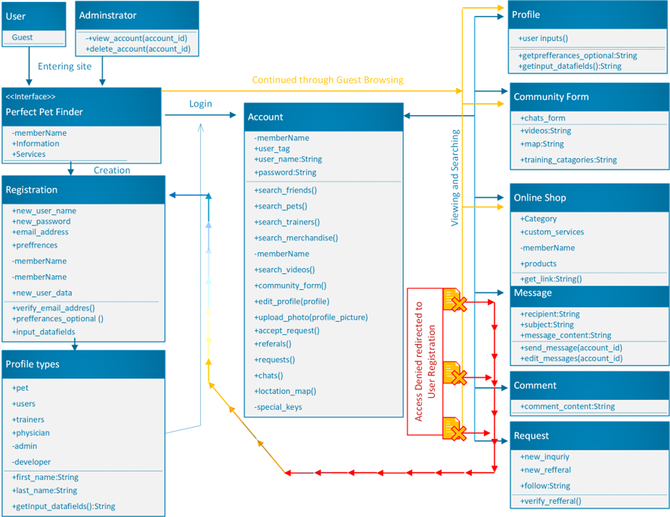

Sequence Diagrams
Normal User:

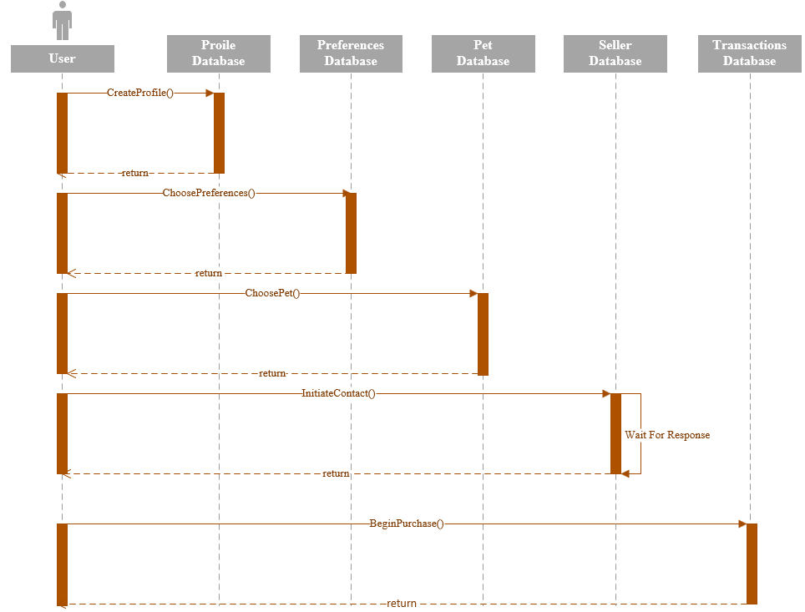

Guest User:

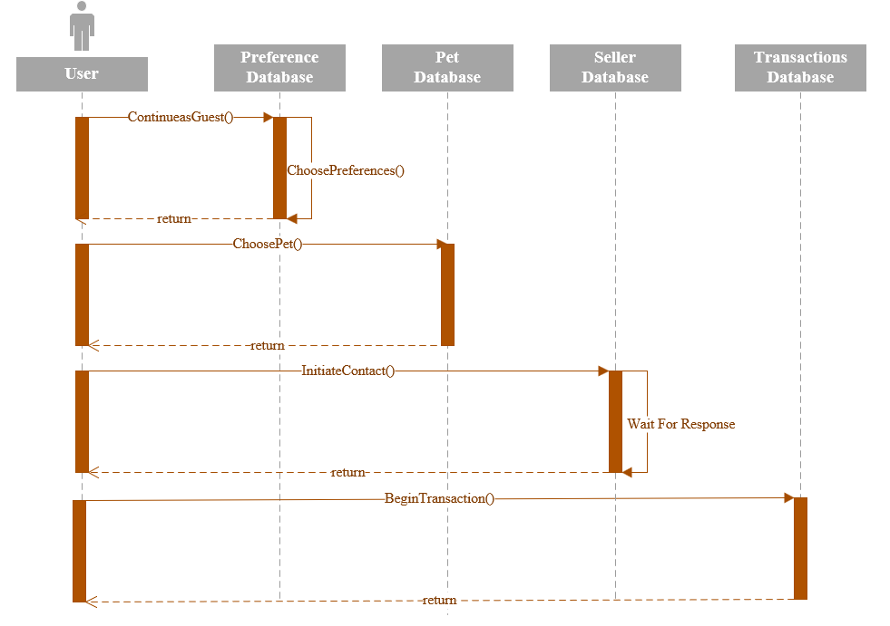

Trainer:

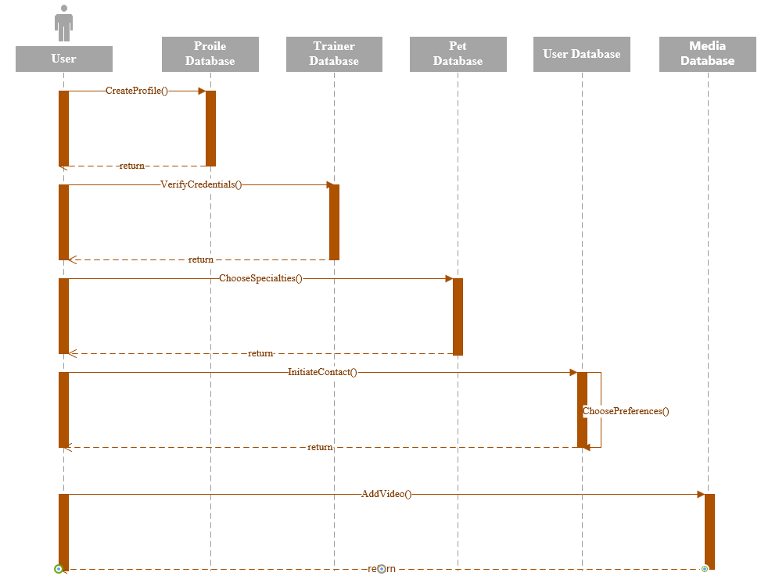

State Machine Diagram

Risk Assessment Matrix
Risk Probability/Severity RMMM
1. Inexperienced Engineering Team A/IV (RAC 3) Extensive research, teamwork
2. Puppy mills selling in app B/I (RAC 1) Thorough screening process, trust metrics i.e., ratings
3. Animal availability C/I (RAC 2) Streamline vendor processes
4. UI interaction is convoluted C/II (RAC 3) Conduct closed beta testing, gather user feedback
5. Poor customer reception C/I (RAC 2) Optimize feedback loop for quick changes A/R
6. Program/Code Quality C/III (RAC 4) Audit random blocks of code, increase frequency A/R
7. Scope creep B/III (RAC 3) Ensure deadlines and product are agreed up in writing

Risk Assessment Matrix |  | Probability (Likelihood)
 |  | A ⋜ 80% | B ⋜ 60% | C ⋜ 40% | D ⋜ 20%
Severity  (Impact) | I | 1 | 1 | 2 | 3
Severity  (Impact) | II | 1 | 2 | 3 | 4
Severity  (Impact) | III | 2 | 3 | 4 | 5
Severity  (Impact) | IV | 3 | 4 | 5 | 5
Risk Assessment Codes (RAC)
1 = Critical 2 = Serious 3 = Moderate 4 = Minor 5 = Negligible

Test Plan

Test Plan Identifier
PerfectPetFinderCTP1_0.doc (component test plan)

Introduction
This test plan was created for Prof. Laddada, CEIS 200 Software Engineering class, and will focus on updating the software product (Perfect Pet Finder) documentation based on the criteria for Lab 3 and the IEEE 829 standard format.

This sample (black-box) test plan will test class behavior and response to actions, covering component/class-based testing for our four test cases.

Two of the test cases are from our original application requirements and two are from our own additional requirements.

Test Items
- Preferences/Questionnaire
- Location-based results (GPS)
- Verify user profile
- In app support
- Requirement Specifications
- User Documentation

Features to be Tested
Original Requirements

Fill out pet preferences/questionnaire
- Update to user profile adding preferences
- Accuracy of results dependent on preferences

Location-based results (GPS)
- Pets displayed to the user are with in selected range

New Requirements

Verifying user profile (security)
- Retrieval of full pet profile from profiles database
- Accuracy of information
- Validate screening process and trust metrics

Feedback loop (for product improvement)
- Optimize developer access to customer feedback

Features not to be Tested
The following items were deemed not necessary to deliberately test before build:
- Tips and Guides page
- Training video upload and stream quality
- Continuing as guest

Approach
Our approach will begin with a Discovery & Planning phase. Within this phase is the foundation which the project is laid out and developed before we build the website.

- Design & UI Coding
- Development
  - Stay under budget
  - Isolated environment
  - Detailed logs
- Quality Control
  - Time for message from user reaching to contact to arrive
  - Team review
- User Acceptance Testing
- Launch

Items Pass/Fail Criteria
Pass:
- All test cases functional
- All buttons and tabs lead to proper destinations
- Spelling and punctuation
- Follows dependencies
- Stays under budget

Fail:
- One test case fails
- Buttons (links) lead to incorrect locations
- System crash
- Hardware overload

Test Deliverables
Below are the deliverables presented after all testing is complete.

- Test plan
- Test cases
- Testing matrixes
- Summary/review reports

Requirement Specifications

Environmental Needs
Our intent is to test in Multiple Environments i.e., Android (Linux), Apple/iOS (Unix), Windows operating environments. So far, we’ve only considered testing with a single version of Python using a virtual environment with a specific set of dependencies. We need to check that our application works on multiple versions of Python, or multiple versions of a package. So, to accomplish this we plan to look further into Tox (VTE), an application that automates testing in multiple environments.

Responsibilities
- Testing Coordinator (Kamil) will lead testing.
- Makes sure all procedures are being followed and logs are being analyzed after each test.
- Makes sure all test users understand their case.
- Leads response to system or app crashes.

Staffing and Training Needs
- Testing Coordinator
- 5 Test Users
- 5 Test Use Observers
- Users need to understand their assigned tasks
- Test observers need to make sure all activities are being logged and processed within configuration management.

Schedule
- Test cases should be completed within a week.
- Review and adjustments should be completed within the next week.
- Second round of testing the following week.
- Final review after.

*No testing processes will take longer than three weeks, without first consulting with the test coordinator (Kamil).

Risks and contingencies
Risks:
- Inexperienced Engineering Team
- Program/Code Quality
- Inaccurate cost estimation

Contingencies:
- All test cases must be logged and documented.
- Set budget left and right lateral limits, and do not exceed the high end without consulting with shareholders/stakeholders.

Test Cases
Fill out pet preferences/questionnaire

Location-based results (GPS)

Verifying user profile (security)

Feedback loop (for product improvement)

Test Case #1
Test Identifier: | PREF_PRO_001
Requirements Addressed: | Preference Profile created via Questionnaire
Prerequisite Conditions: | Test Users and Developers must install the latest version of the app and Python Application Testing Software.
Test Input: | Open Monitoring Software on Desktop, and then begin running the software scan. Open application on Browser. Click “Begin Questionnaire” from the start page then open and click through prompts to reach completion of Questionnaire, Review output log and data test run complete.
Expected Test Results: | Gather successful results and gain resourceful information. Database results bank updated instantly via automation. Users are presented with result details, entailing the recommendations and Statistics in accordance with their preferences.
Instructions for Conducting Procedure: | Open app. Click “Begin Questionnaire”.
Features to be Tested: | Questionnaires outputs are accurate, and verify results are linked to profile database.
Requirements Traceability: | Save Questionnaire results to database object with the capability to save multiple attempts to registry. Application testing Software actively tracks and runs performance quality tests with final output showing all the data gathered into a report that will be validated.
Rationale for Decisions: | If user has latest version of app installed, they should be able to review their results and edit them in order to make informed decisions.

Test Case #2
Test Identifier: | LOC_RES_001
Requirements Addressed: | Verify search results comply with distance metrics.
Prerequisite Conditions: | User must select max distance for search.
Test Input: | Move the radial button on the “Maximum Distance” line from the search page to select preferred distance.
Expected Test Results: | User will only see pets within the scope of their search that fall within the max distance selected.
Instructions for Conducting Procedure: | Conduct multiple searches with varying distances selected, and cross check with google maps “as the bird flies.”
Features to be Tested: | Distance metrics for search results
Requirements Traceability: | Spot check a few vendors within a search result, verify their location and compare for accuracy.
Rationale for Decisions: | If users and vendors desire to pick up or deliver pets within certain boundaries for convenience or care reasons, the option to specify max ranges caters to the needs of all users.

Test Case #3
Test Identifier: | CRE_PRO_001
Requirements Addressed: | Ensure user can create a user account and that it is stored in the proper database for sensitive information.  *Applicable to Vendors only  National background check with companies such as nationalbackgroundcheck.com or sentrylink.com. This will represent our best efforts to prevent illegal pet activities within the application.
Prerequisite Conditions: | User must install latest version of app and open.  Vendors must provide additional information such as SSN to ensure accurate background checks.
Test Input: | Click “Create New Account” from start page.
Expected Test Results: | User is presented with the template to create a new account. Template will vary based on the type of account being created i.e., Buyer, Seller, Service animal agency etc.
Instructions for Conducting Procedure: | Open app. Click “Create New Account”.
Features to be Tested: | Creating new user account  Select type of account
Requirements Traceability: | Current version of app installed.
Rationale for Decisions: | If user has latest version of app installed, they should be able to create a new user account from the start page. Their information should be stored in a secure database.

Test Case #4
Test Identifier: | FB_LOOP_001
Requirements Addressed: | Ensure our users have a way to communicate with the developers in an appropriate fashion to address issues and potentially identify opportunities to improve.
Prerequisite Conditions: | User must be able to submit a message to the dev team.
Test Input: | Click “Contact Us” from within the app or website home page.
Expected Test Results: | User is presented with the template for submitting a new message to the dev team, and will be provided with a few options for subjects i.e., problem with application, submit a recommendation, etc.
Instructions for Conducting Procedure: | Click “Contact Us” from the home page and within the app, follow the on screen instruction and submit the message. The dev team will then check the inbox to determine if the message with received.
Features to be Tested: | Submitting a message to the dev team, from multiple devices.
Requirements Traceability: | If messages are being delivered to the appropriate box.
Rationale for Decisions: | Communication with your community is a key component to success, when properly utilized this form of communication is a force multiplier for success.

Updated Project Plan
