CCD Laboratories

1600 Red Herring Ct.

Atlanta, GA 30329

Virus Research Team,

As you know, I have been traveling the world researching NEONORO and helping where I can. Thank you for taking care of the laboratory in my absence, but things have gone sideways and now I need your direct help.

First, we need to reestablish communication. General Halftrack, who originally sponsored this excursion, has suddenly tried to block my investigations. He has severed my connection to our mail server. We do not have time to mail letters back and forth.

I cannot fix my connection from here. You must do it from the lab complex. I am sending you the digital codes to do it.

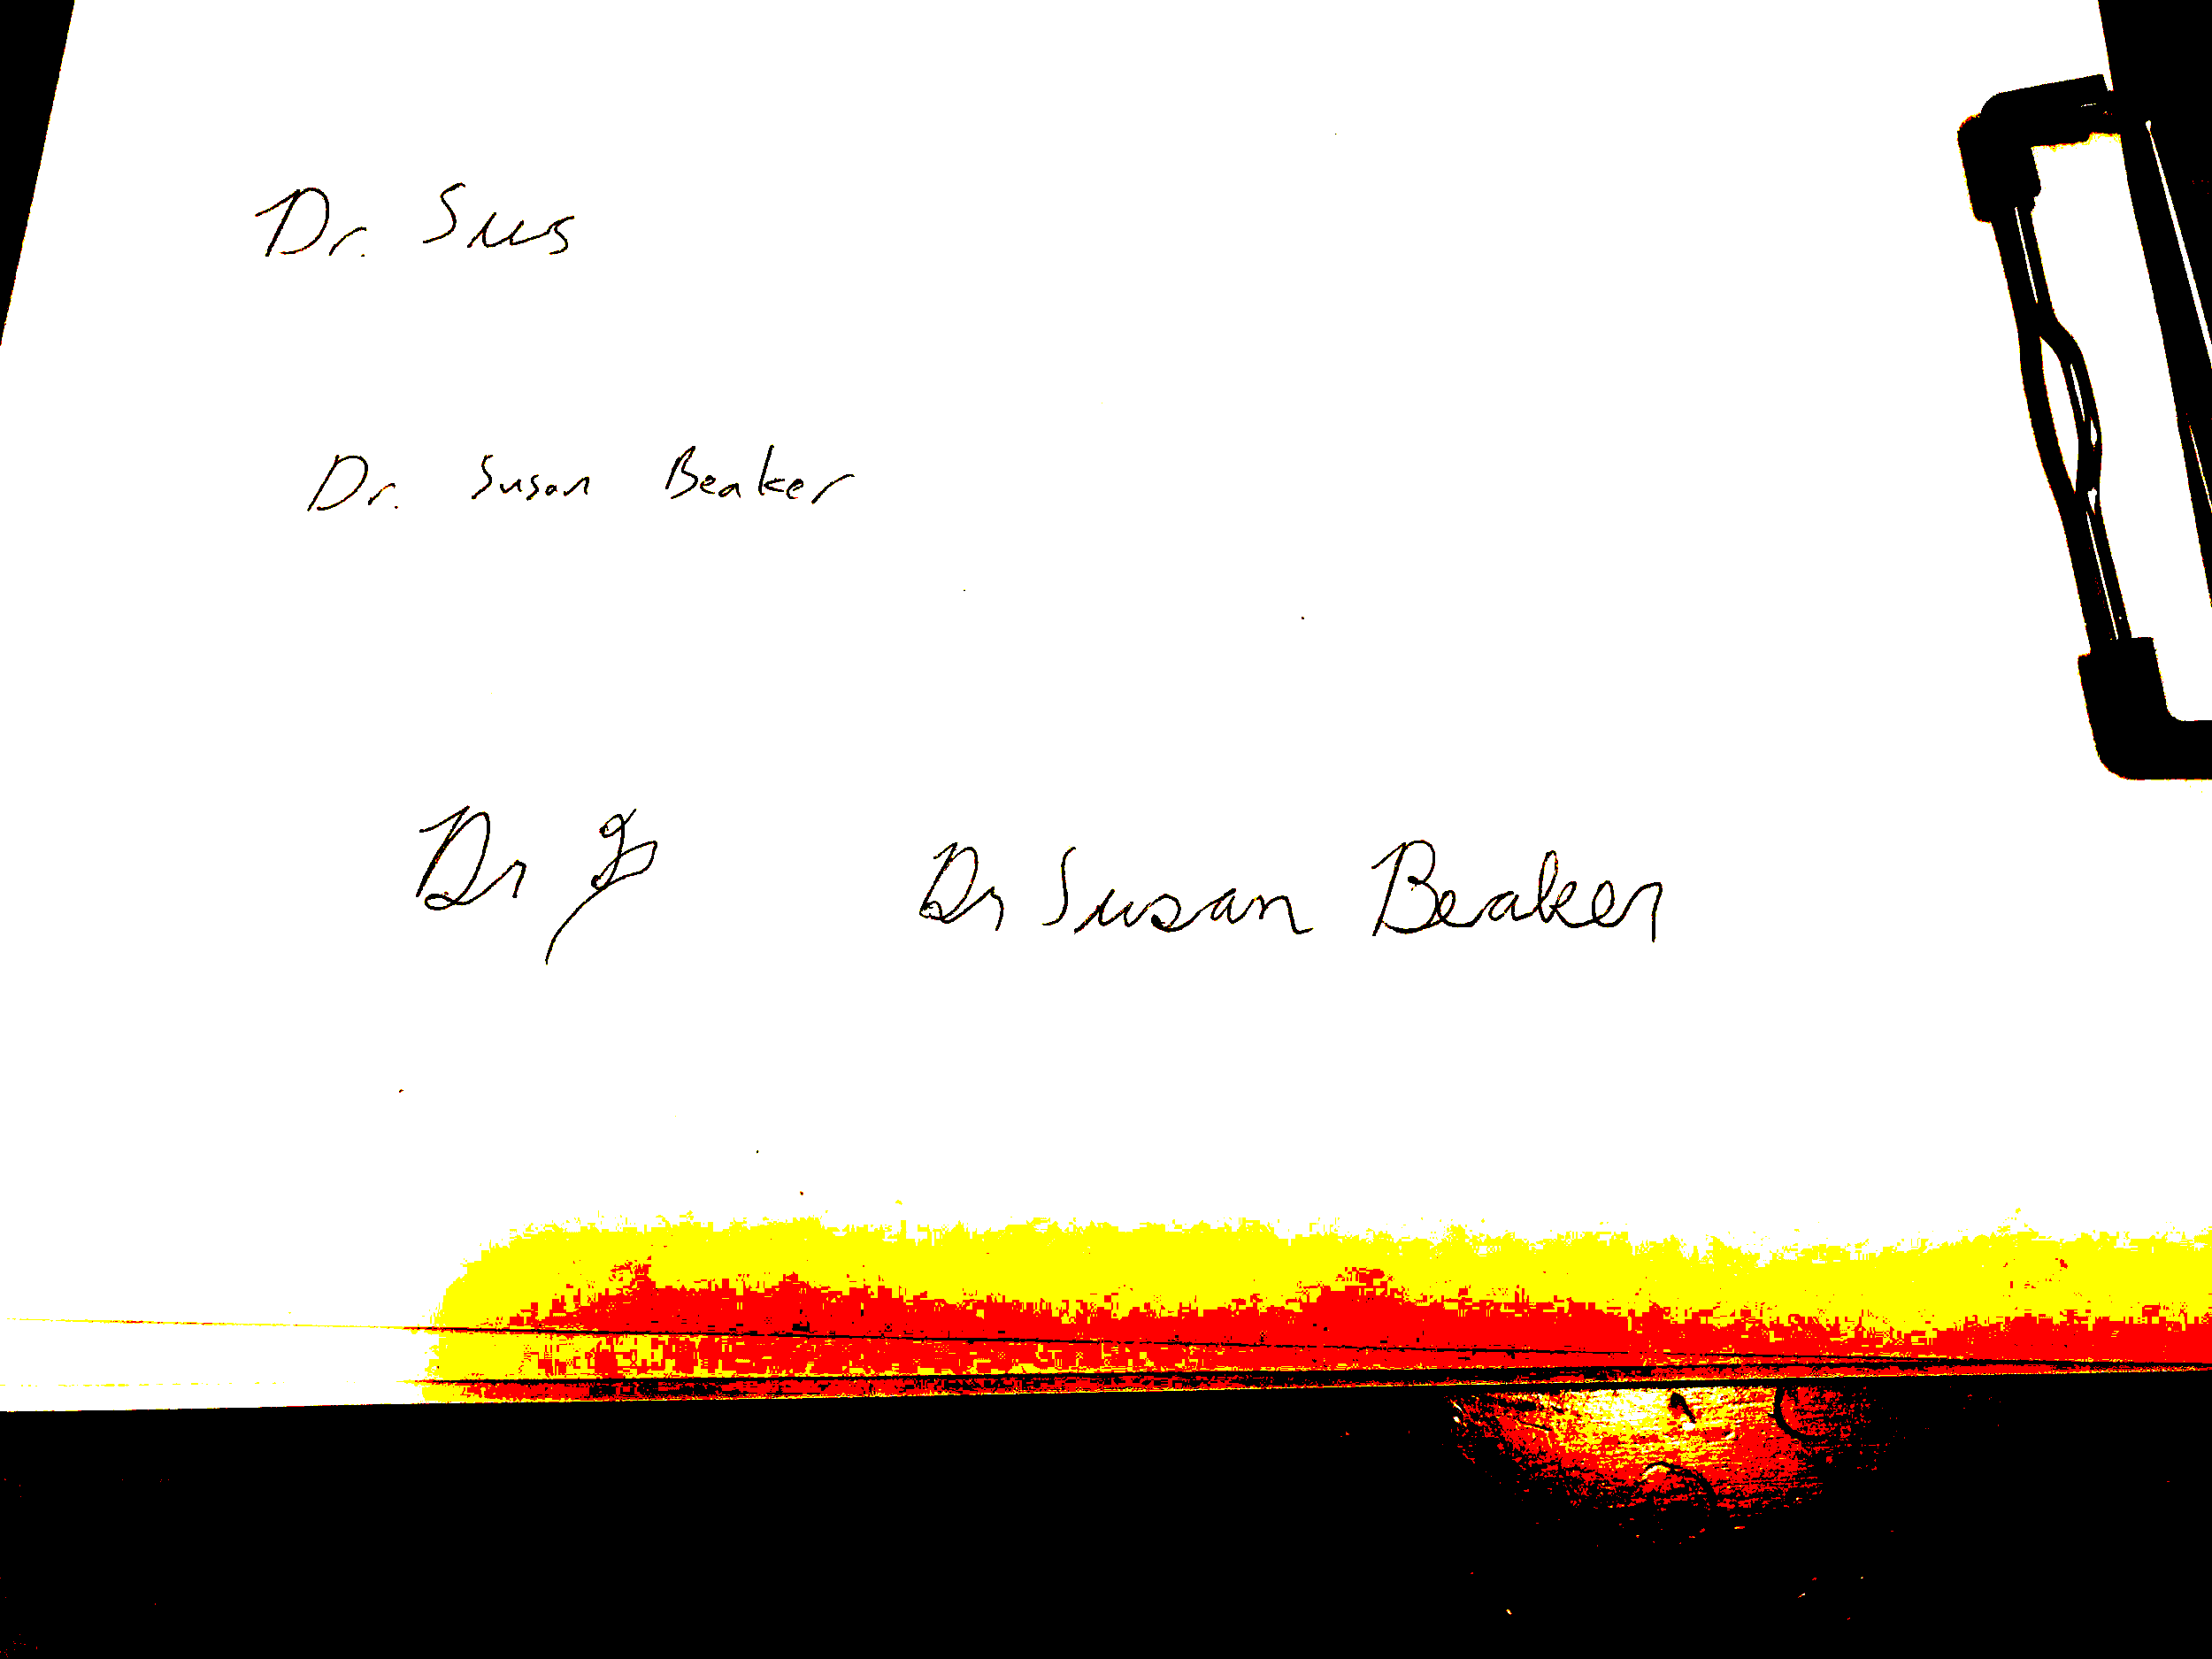

Dr. Susan Beaker