folder (directory)
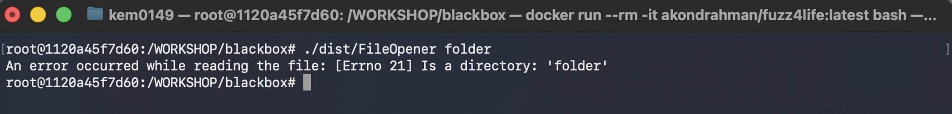
binary.txt
corrupt.txt
longline.txt
unreadable.txt (used test user with non admin rights)

