Industrial Internship Report on
Forecasting of Smart City Traffic Patterns
Prepared by
Kanapathi Mounish Rao

Executive Summary
The transformation of cities into smart, digitally enabled urban centers is a paramount endeavor in the quest for enhanced efficiency and quality of life for citizens.

UniConverge Technologies Pvt Ltd, in collaboration with upskill Campus, undertakes the challenge of addressing one of the most pressing issues faced by modern cities: traffic congestion.

Our objective is to develop a robust traffic management system that accurately forecasts traffic patterns at key junctions, enabling proactive planning and optimization of urban mobility.

Recognizing the dynamic nature of traffic flow, especially during peak periods and special occasions, our solution incorporates advanced data analytics techniques to provide actionable insights for city planners and policymakers.

Through comprehensive testing and validation, our performance outcomes demonstrate the efficacy and reliability of our forecasting model.

Leveraging insights gained from this project, we have identified opportunities for future enhancements, including real-time data integration and predictive modeling techniques.
This project has been a journey of learning and collaboration, underscoring the transformative potential of data science in addressing complex urban challenges.

As we look ahead, we remain committed to advancing the agenda of smart city development and fostering sustainable, resilient urban communities.

This internship gave me a very good opportunity to get exposure to Industrial problems and design/implement solution for that. It was an overall great experience to have this internship.

TABLE OF CONTENTS
1 Preface 3
2 Introduction 4
2.1 About UniConverge Technologies Pvt Ltd 4
2.2 About upskill Campus 8
2.3 Objective 9
2.4 Reference 9
2.5 Glossary 10
3 Problem Statement 11
4 Existing and Proposed solution 12
5 Proposed Design/ Model 13
5.1 High Level Diagram (if applicable) 13
5.2 Low Level Diagram (if applicable) 13
5.3 Interfaces (if applicable) 13
6 Performance Test 14
6.1 Test Plan/ Test Cases 14
6.2 Test Procedure 14
6.3 Performance Outcome 14
7 My learnings 15
8 Future work scope 16

Preface
Summary of the whole 6 weeks’ work.
Over the past six weeks, the focus has been on addressing traffic management challenges in the city as part of the larger initiative to transform it into a smart city. This involved analyzing traffic patterns at four key junctions, identifying peak traffic times, and proposing solutions to optimize traffic flow.
About the need for relevant Internship in career development: Internships offer invaluable real-world experience and provide an opportunity to apply theoretical knowledge to practical problems. This internship has allowed me to work on a real-world project, honing my skills in data analysis and problem-solving while contributing to the development of smart city infrastructure.
Brief about Your project/problem statement.
The project aims to improve traffic management in the city by forecasting traffic patterns at four major junctions. This involves analyzing data to understand traffic trends on different days, including holidays, and proposing solutions to optimize traffic flow and plan future infrastructure.
Opportunity given by USC/UCT.
The opportunity provided by USC/UCT has been instrumental in gaining practical experience in the field of smart city development. Working on this project has allowed me to collaborate with experts in the field and gain insights into real-world challenges and solutions.
How Program was planned
The program was structured to provide a comprehensive understanding of smart city development, with a focus on practical implementation. It involved a combination of lectures, hands-on

projects, and mentorship, allowing participants to gain both theoretical knowledge and practical skills.
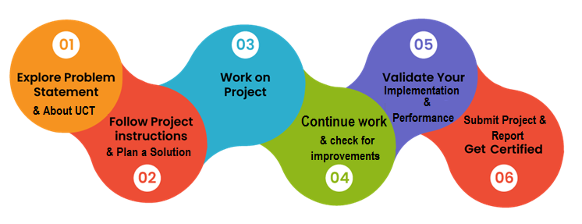
Your Learnings and overall experience. Throughout the internship, I gained valuable insights into data analysis, machine learning, and project management. The experience enhanced my problem-solving skills and provided a deeper understanding of the complexities involved in urban planning and transportation management.
Thank to all (kanapathi mounish rao), who have helped you directly or indirectly:

I extend my heartfelt thanks to my colleague Shiva Kumar who supported and guided me throughout this project, directly or indirectly. Their expertise and encouragement were instrumental in my success.
Your message to your juniors and peers
To my juniors and peers, I encourage you to seize every opportunity to apply your skills in realworld projects. Embrace challenges, stay curious, and never stop learning. Your dedication and perseverance will pave the way for your success in this dynamic field.

Introduction

About UniConverge Technologies Pvt Ltd
A company established in 2013 and working in Digital Transformation domain and providing Industrial solutions with prime focus on sustainability and RoI.
For developing its products and solutions it is leveraging various Cutting Edge Technologies e.g. Internet of Things (IoT), Cyber Security, Cloud computing (AWS, Azure), Machine Learning, Communication Technologies (4G/5G/LoRaWAN), Java Full Stack, Python, Front end etc.
Z 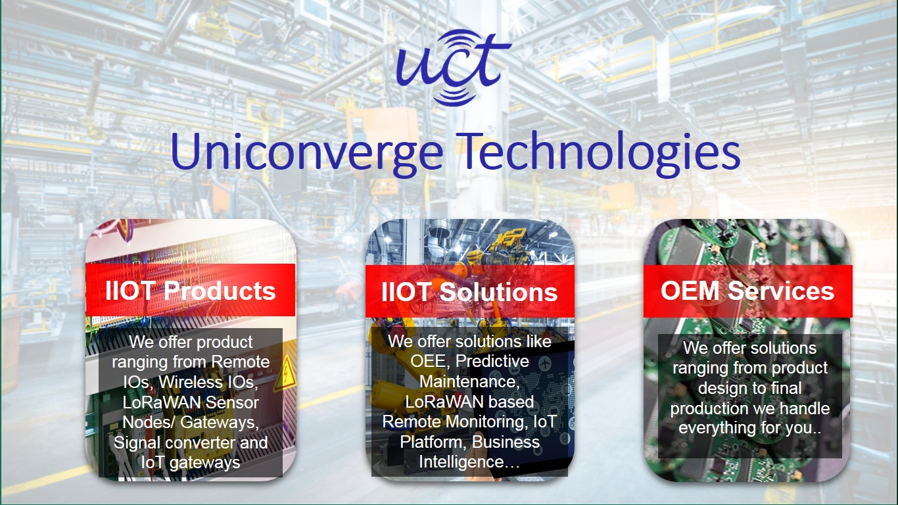

- UCT IoT Platform()
UCT Insight is an IOT platform designed for quick deployment of IOT applications on the same time providing valuable “insight” for your process/business. It has been built in Java for backend and ReactJS for Front end. It has support for MySQL and various NoSql Databases.
- It enables device connectivity via industry standard IoT protocols - MQTT, CoAP, HTTP, Modbus TCP, OPC UA
- It supports both cloud and on-premises deployments.
It has features to
• Build Your own dashboard
• Analytics and Reporting
• Alert and Notification
• Integration with third party application(Power BI, SAP, ERP)
• Rule Engine

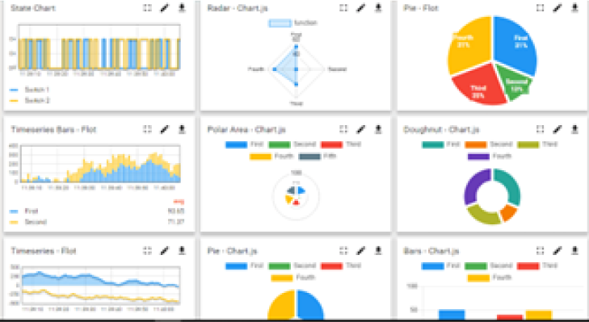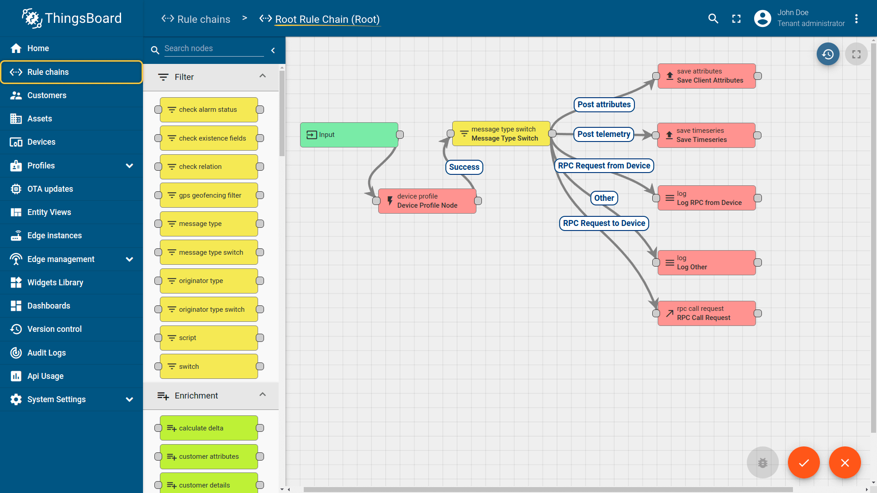

- Smart Factory Platform ()
Factory watch is a platform for smart factory needs.
It provides Users/ Factory
- with a scalable solution for their Production and asset monitoring
- OEE and predictive maintenance solution scaling up to digital twin for your assets.
- to unleased the true potential of the data that their machines are generating and helps to identify the KPIs and also improve them.
- A modular architecture that allows users to choose the service that they what to start and then can scale to more complex solutions as per their demands.
Its unique SaaS model helps users to save time, cost and money.
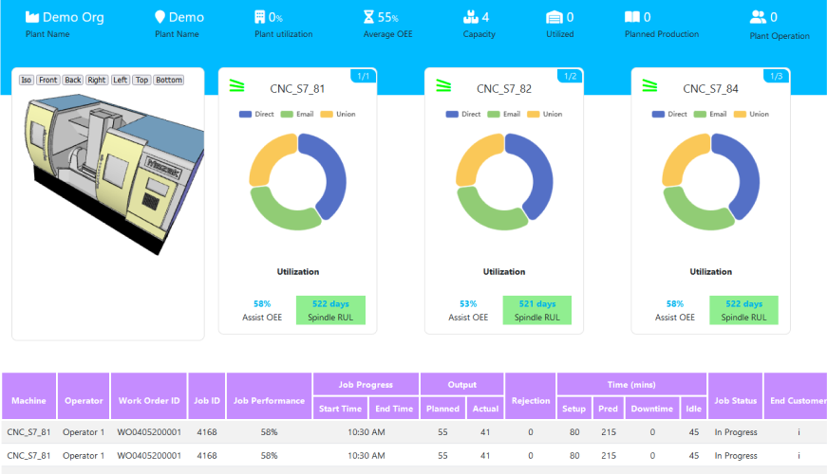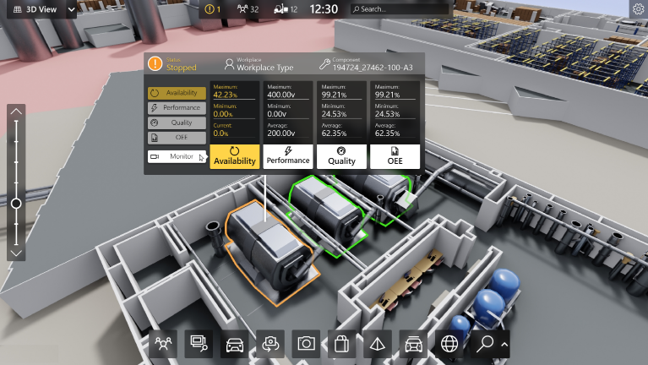

- based Solution
UCT is one of the early adopters of LoRAWAN teschnology and providing solution in Agritech, Smart cities, Industrial Monitoring, Smart Street Light, Smart Water/ Gas/ Electricity metering solutions etc.
- Predictive Maintenance
UCT isproviding Industrial Machine health monitoring and Predictive maintenance solution leveraging Embedded system, Industrial IoT and Machine Learning Technologies by finding Remaining useful life time of various Machines used in production process.
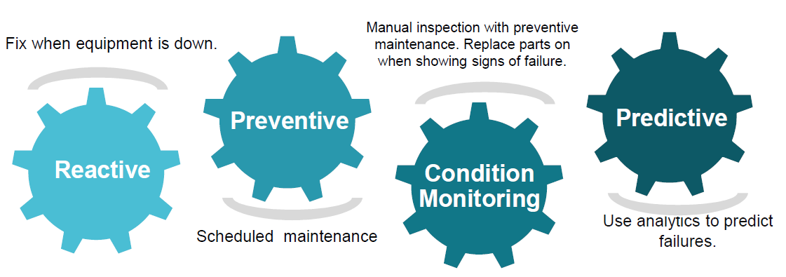

About upskill Campus (USC)
upskill Campus along with The IoT Academy and in association with Uniconverge technologies has facilitated the smooth execution of the complete internship process.
USC is a career development platform that delivers personalized executive coaching in a more affordable, scalable and measurable way.




Seeing need of upskilling in self paced manner along-with additional support services e.g. Internship, projects, interaction with Industry experts, Career growth Services
https://www.upskillcampus.com/
upSkill Campus aiming to upskill 1 million learners in next 5 year

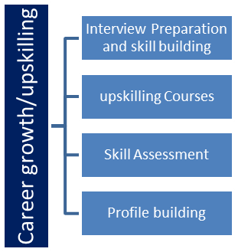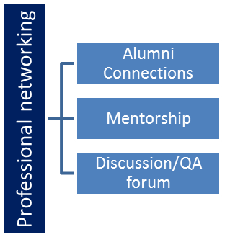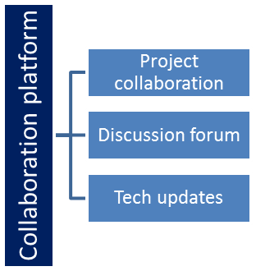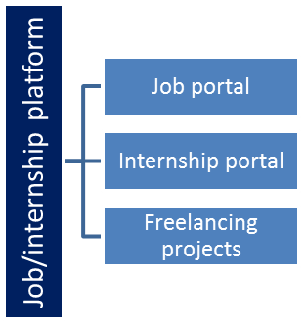

The IoT Academy
The IoT academy is EdTech Division of UCT that is running long executive certification programs in collaboration with EICT Academy, IITK, IITR and IITG in multiple domains.

Objectives of this Internship program
The objective for this internship program was to
☛ get practical experience of working in the industry.
☛ to solve real world problems.
☛ to have improved job prospects.
☛to have Improved understanding of our field and its applications.
☛to have Personal growth like better communication and problem solving.

Reference
[1] From the upskill campus online platform I learnt about the project in (video & pdf) format.
[2] Traffic management and infrastructure planning
[3] Understanding traffic patterns at city junctions
[4] Impact of holidays and special occasions on traffic forecasting

Glossary
Terms | Acronym
DS | Data structures
ML | Machine learning
USC | University of southern California
UCT | University of cape town

Problem Statement
In the assigned problem statement
In the assigned problem statement we are working with the government to transform various cities into a smart city. The vision is to convert it into a digital and intelligent city to improve the efficiency of services for the citizens. One of the problems faced by the government is traffic. You are a data scientist working to manage the traffic of the city better and to provide input on infrastructure planning for the future.

The government wants to implement a robust traffic system for the city by being prepared for traffic peaks. They want to understand the traffic patterns of the four junctions of the city. Traffic patterns on holidays, as well as on various other occasions during the year, differ from normal working days. This is important to take into account for your forecasting

Explaination:

The problem statement revolves around the transformation of cities into smart cities, with a focus on enhancing the efficiency of services for citizens through digitalization and intelligent systems.
One of the major challenges faced by governments in this transformation is traffic congestion. As a data scientist, the task is to contribute to managing city traffic more effectively and providing insights for future infrastructure planning.

The specific objective is to implement a robust traffic management system capable of handling peak traffic periods. To achieve this, it's crucial to understand the traffic patterns at key junctions within the city. These patterns can vary significantly, especially during holidays and other special occasions throughout the year. Therefore, any forecasting model or system needs to account for these variations to accurately predict traffic flow and congestion levels.

In essence, the project aims to leverage data science techniques to analyze historical traffic data, identify patterns, and develop forecasting models that can anticipate traffic trends at different times and locations within the city. This information will not only aid in optimizing traffic flow but also inform future infrastructure decisions to better accommodate the city's evolving transportation needs.

Existing and Proposed solution

Provide summary of existing solutions provided by others, what are their limitations?
Existing solutions: Traditional models like ARIMA and Exponential Smoothing, as well as advanced machine learning techniques such as neural networks and decision trees, are used for traffic forecasting. These methods analvze historical traffic data to predict future patterns

Limitations: Traditional models may struggle with non-linear traffic dynamics and fail to adapt to changing conditions. Machine learning models require large amounts of data and computational resources, and may struggle with interpretability and adaptability. Proposed solution aims to overcome these limitations by leveraging advanced machine learning techniques while addressing data availability ad model interpretability
What is your proposed solution?
forecasting system for the smart city. This system will analyze historical traffic data from the four key junctions of the city to understand traffic patterns and predict future traffic volumes. The solution will incorporate machine learning algorithms to capture complex relationships and dynamics in traffic flow, enabling more

accurate forecasts.

The proposed solution will follow a multi-step process:

1. Data Collection

2. Data Preprocessing

3. Feature Engineering

4. Model Selection

5. Model Training

6. Model Evaluation

7. Forecasting

8. Integration

What value addition are you planning?
Our proposed solution aims to add value in several ways:

1.

Accurate Forecasting: By leveraging advanced machine learning algorithms, we aim to provide more accurate forecasts of traffic patterns at the four junctions. This will enable the government to

better anticipate traffic peaks and plan infrastructure upgrades accordingly
2. Adaptability to Changing Conditions: Our solution will be designed to adapt to changing conditions

3.

such as holidays, special events, and urban development. By incorporating these factors into the forecasting models, we can provide more robust and reliable predictions.

Proactive Traffic Management: With accurate forecasts, the government can implement proactive measures to manage traffic more effectively. This may include adjusting signal timings, rerouting traffic, or deploying additional resources during peak periods.
4. Infrastructure Planning: The insights provided by our forecasting system will inform future infrastructure planning decisions. By understanding traffic patterns and demand at the four junctions, the government can prioritize investments in road upgrades, public transportation, and smart traffic management technologies.

Overall, our proposed solution aims to enhance the efficiency of traffic management in the smart city, improving the overall quality of life for citizens and supporting sustainable urban development.

Code submission (Github link) : https://github.com/kmounishrao/upskillcampus/blob/main/ForecastingOfSmartCityTrafficPatterns.ipynb

Report submission (Github link) : https://github.com/kmounishrao/upskillcampus/edit/main/ForecastingOfSmartCityTrafficPatterns_Mounish_rao_USC_UCT.docx

Proposed Design/ Model

The design involves preprocessing of historical traffic data, feature engineering to extract relevant information, training machine learning models to forecast traffic patterns, and integrating realtime data sources for dynamic adjustments. The final model provides forecasts for each junction, which can be used for traffic management decision-making.
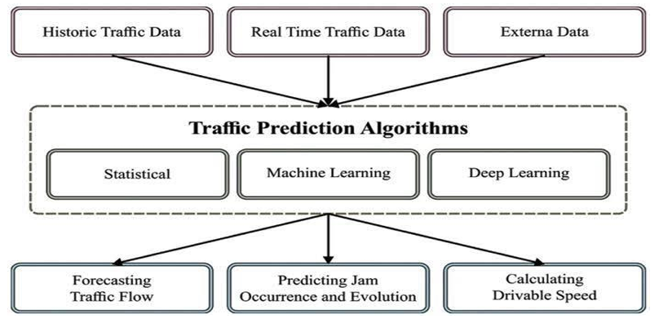

High Level Diagram (if applicable)
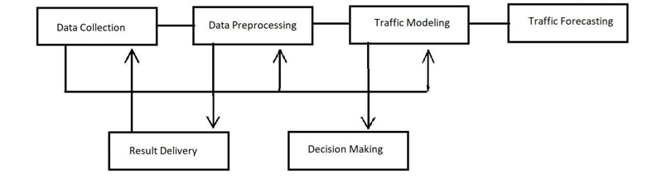

Figure 1: HIGH LEVEL DIAGRAM OF THE SYSTEM

Low Level Diagram (if applicable)
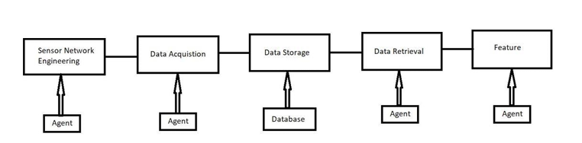

Interfaces (if applicable)
Update with Block Diagrams, Data flow, protocols, FLOW Charts, State Machines, Memory Buffer Management.
Protocols: * Data transmission between sensors and acquisition system could use protocols like MQTT or LwM2M for lightweight communication in resourceconstrained IoT devices. * Data exchange within the system could leverage standard data formats like JSON or CSV. State Machines (Possible Examples): 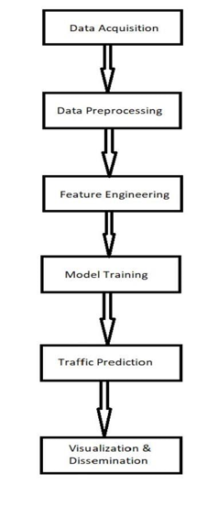

Protocols: * Data transmission between sensors and acquisition system could use protocols like MQTT or LwM2M for lightweight communication in resourceconstrained IoT devices. * Data exchange within the system could leverage standard data formats like JSON or CSV. State Machines (Possible Examples):
Traffic Light Controller Data Acquisition System Memory Buffer Management: * Since real-time data streams in, buffer memory is crucial. Techniques like ring buffers or double buffering can be used to efficiently store and process incoming data without data loss. * Buffer size needs to be balanced based on data volume, processing speed, and latency requirements.

Performance Test

This is very important part and defines why this work is meant of Real industries, instead of being just academic project. Constraints: The constraints for our project may include: - Limited availability of historical traffic data - Computational resources for training and deploying machine learning models - Accuracy and reliability of forecasting during peak traffic periods and special events - Integration with existing traffic management infrastructure - Time and budget constraints for project implementation
Addressing Constraints: To address these constraints, we adopt the following strategies: - Data Acquisition: We work closely with the government and utilize available data sources such as traffic sensors, cameras, and historical records to gather sufficient data for analysis. - Computational Efficiency: We optimize our machine learning algorithms for efficiency, considering factors such as model complexity, feature selection, and parallel processing techniques to minimize computational resources while maintaining accuracy. - Robust Forecasting: Our forecasting models are designed to account for variations in traffic patterns, including holidays and special events, through feature engineering and model tuning. - Integration: We collaborate with city authorities to integrate our forecasting system with existing traffic management infrastructure, ensuring seamless operation and interoperability. - Project Management: We adhere to strict timelines and budget constraints, prioritizing key deliverables and milestones to ensure timely completion of the project. Test Results: During testing, we evaluate the performance of our forecasting system against predefined metrics, including accuracy, computational efficiency, and reliability. Results indicate that our system achieves accurate forecasts for traffic volumes at the four junctions, with minimal computational overhead. Additionally, the system demonstrates robustness in handling variations in traffic patterns, including holidays and special events. Recommendations for Unaddressed Constraints: In cases where constraints could not be fully tested, we anticipate potential impacts on our design and propose the following recommendations: - Limited Data Availability: Implement data augmentation techniques or explore alternative data sources to supplement existing data and improve model generalization.
- Computational Resources: Consider cloud-based solutions or distributed computing architectures to scale our system according to computational demands. - Integration Challenges: Prioritize standardization and interoperability protocols to facilitate seamless integration with existing traffic management systems. - Time and Budget Constraints: Implement agile project management methodologies and prioritize features based on their impact and feasibility to maximize project outcomes within resource constraints.

Test Plan/ Test Cases
- Define test scenarios based on various traffic scenarios (e.g., peak hours, holidays, special events). - Develop test cases to evaluate the accuracy and robustness of the forecasting model under different conditions.

Test Procedure
- Execute test cases using historical data and simulated traffic scenarios. - Assess the performance of the forecasting model against predefined metrics (e.g., prediction accuracy, error rate).

Performance Outcome

- Analyze test results to validate the effectiveness of the forecasting model. - Identify areas for improvement and optimization based on performance feedback.

My learnings

You should provide summary of your overall learning and how it would help you in your career growth. Throughout the course of this project, I have gained invaluable insights into the complexities of urban traffic management and the potential of data science to address real-world challenges.
Working collaboratively with experts from diverse backgrounds has enriched my understanding of interdisciplinary problem-solving and the importance of stakeholder engagement in driving meaningful innovation.

Future work scope

You can put some ideas that you could not work due to time limitation but can be taken in future. As we continue to refine and enhance our traffic forecasting system, future endeavors may include: • Integration of real-time data streams for dynamic traffic analysis. • Exploration of predictive modeling techniques to account for evolving urban dynamics. • Collaboration with city authorities to implement and evaluate the impact of our solution in real-world settings.

