Contents

1.1. View Briefings of the Current Date 2
1.2 View Briefings of the Previous Date 2
1.3. Country Level Categories 5
1.4. Sub Categories of Categories 6
1.5. Most Viewed Files 8
1.6. Documents in Favorites 9
1.7. My Favorite Files 10
1.8. Document Keyword Search 11
1.9. Send Feedback 12
1.10. Viewing Feedback Response. 13
1.11. View Briefings for the selected Date 14
1.12. Searching Content for selected Country 15
1.13. Searching for Network faults in Specific Location 16

1.1. View Briefings of the Current Date

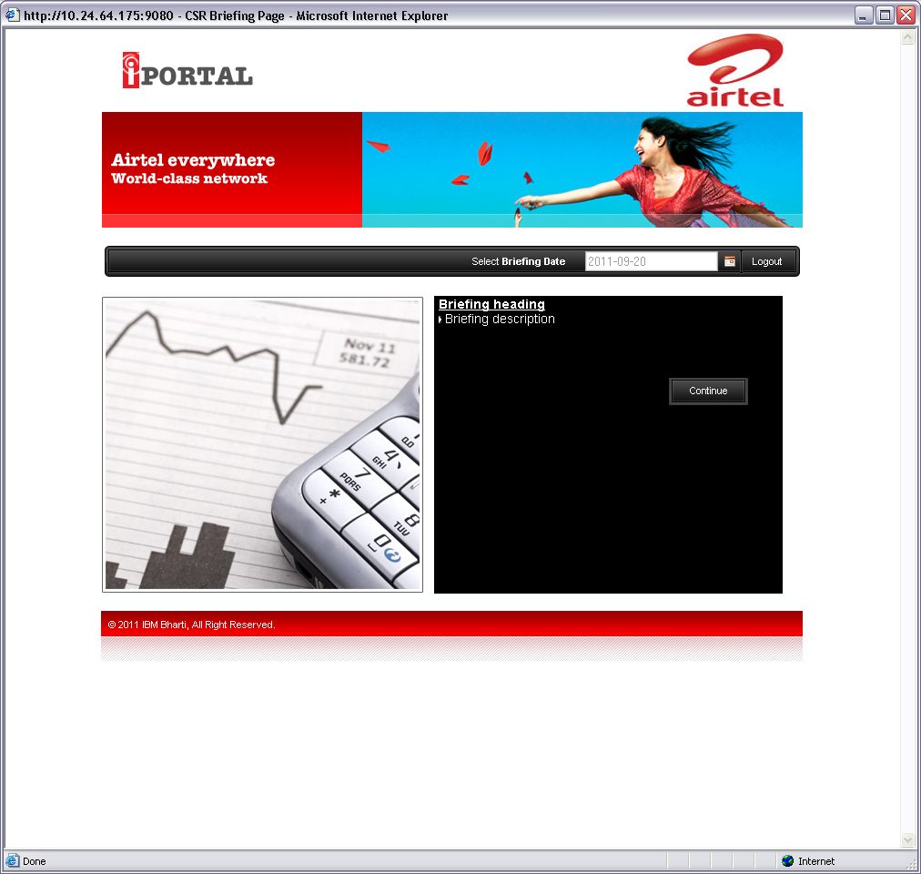
The briefing created appears to CSR as he logs intho iPortal

1.2 View Briefings of the Previous Date

Change the date to a past date to see the briefing for that day

1.3. Country Level Categories

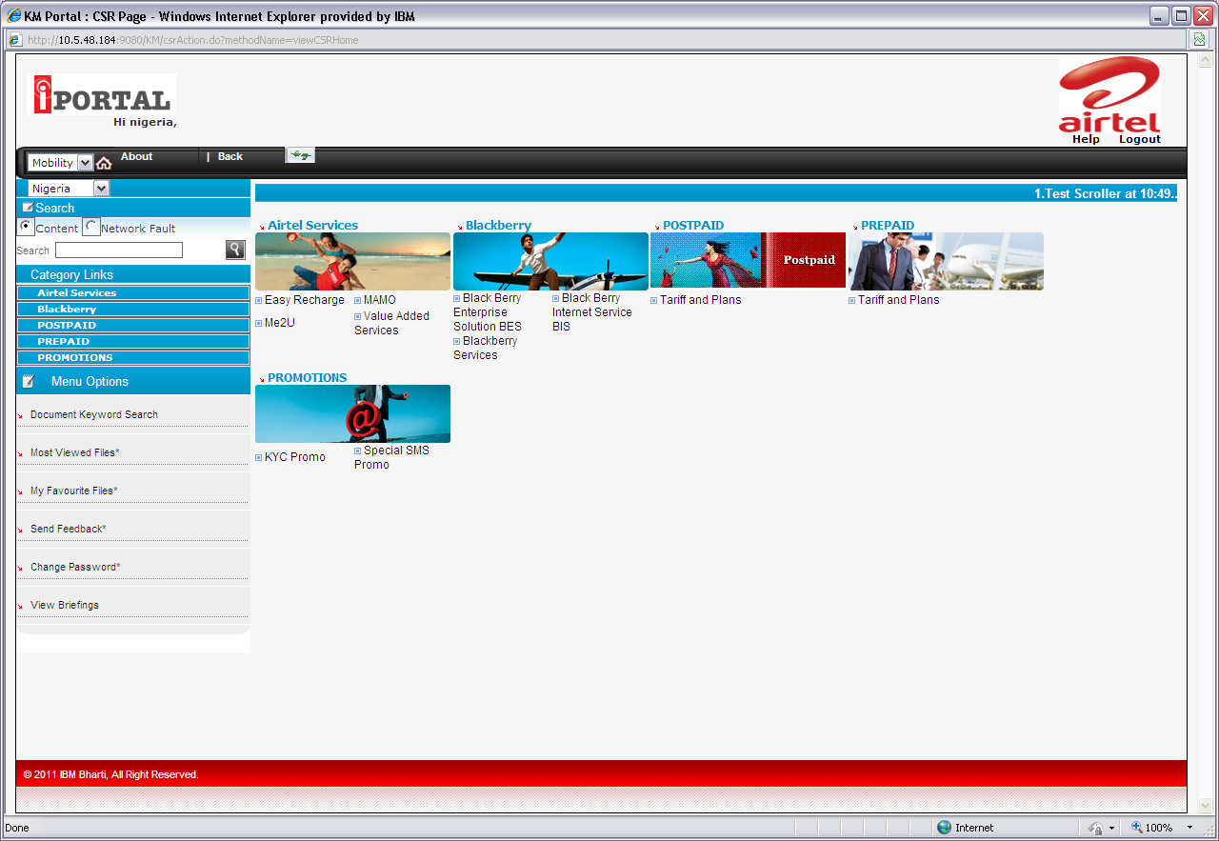

1.4. Sub Categories of Categories

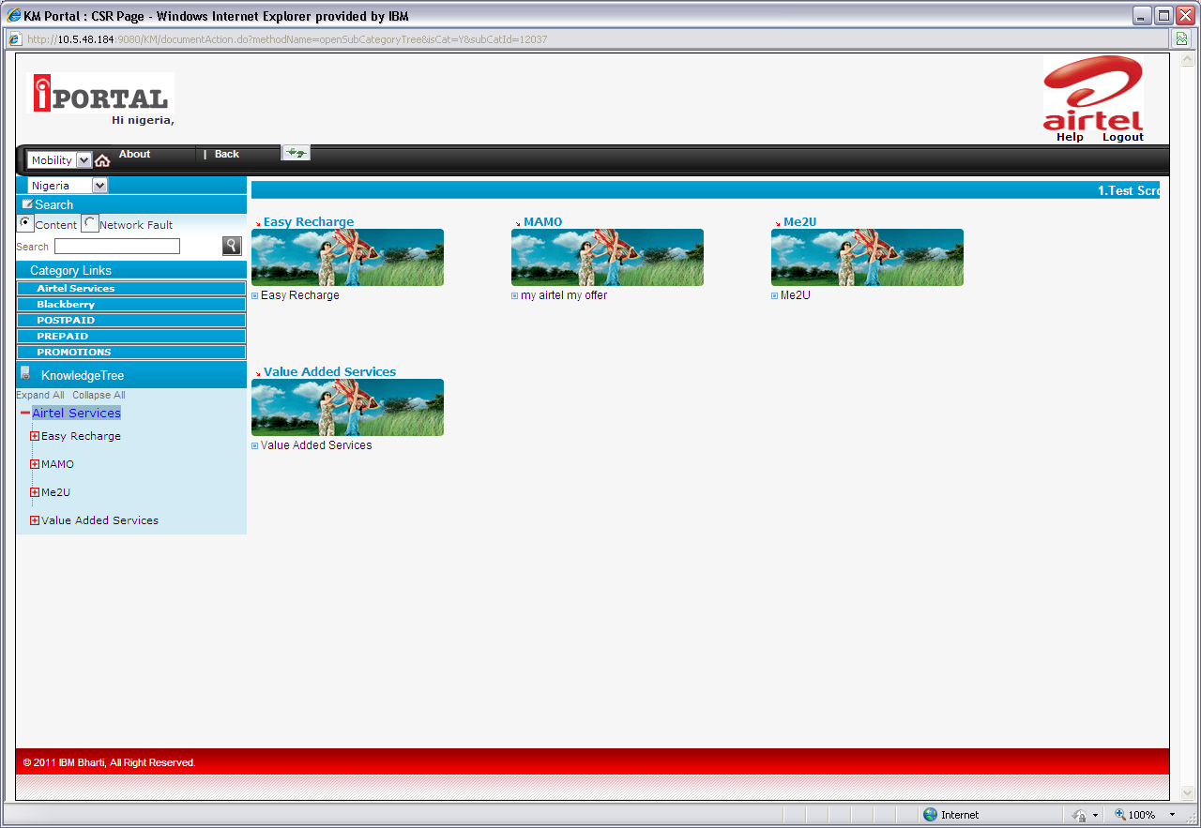
Click on a category link

1.5. Most Viewed Files

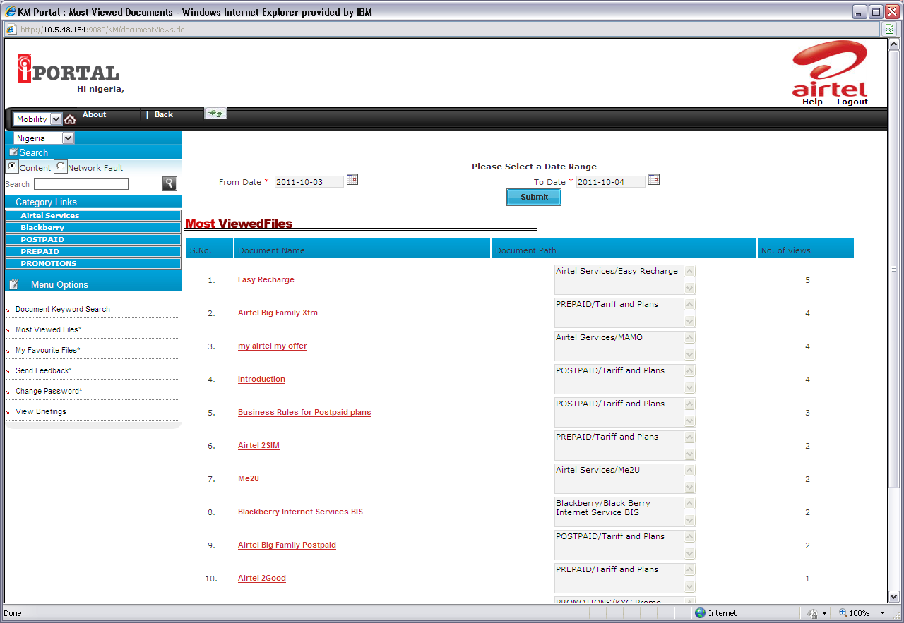
Most viewes files link.

1.6. Documents in Favorites

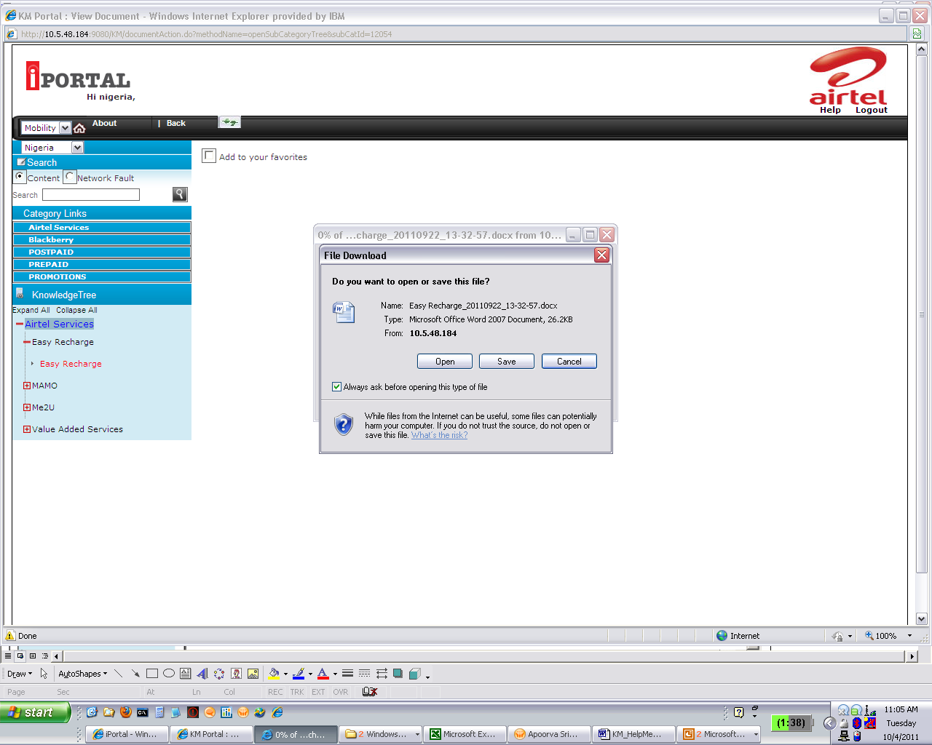
You can add document to favourites

1.7. My Favorite Files

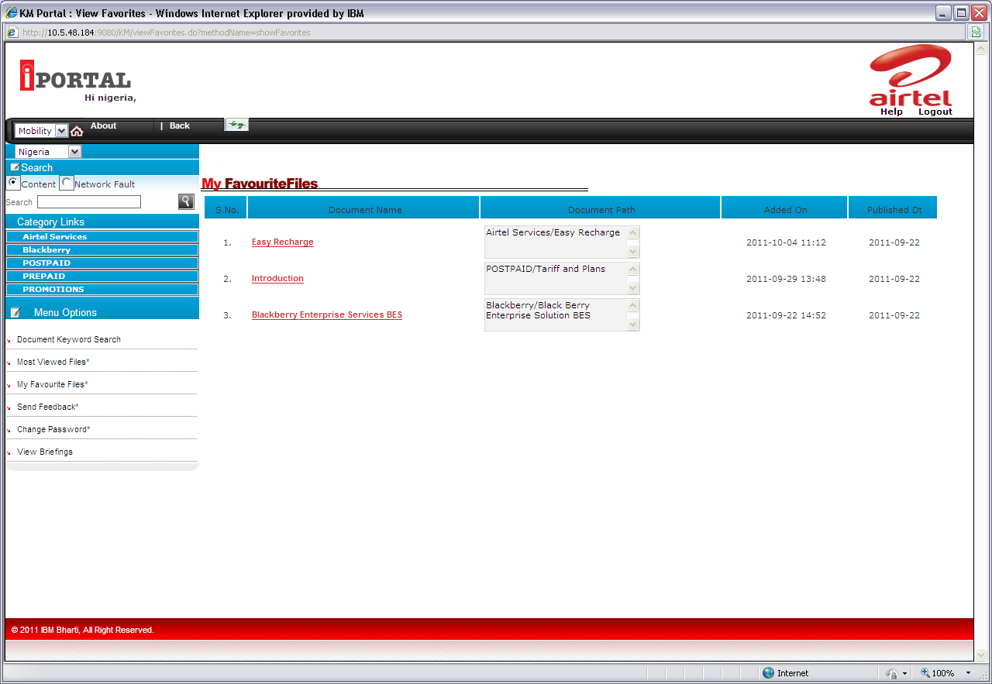
To view the files added in favourites,My favourite files Link is there

1.8. Document Keyword Search

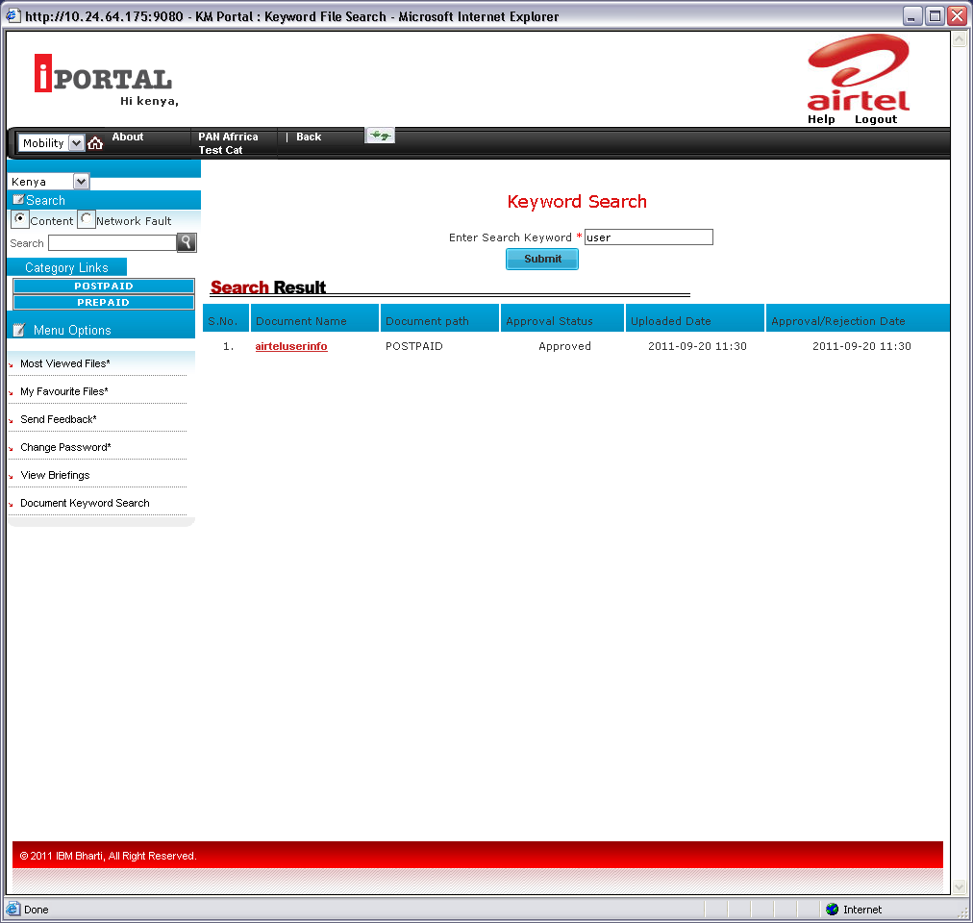
Document keyword search link
Enter keyword to search for a document.

1.9. Send Feedback

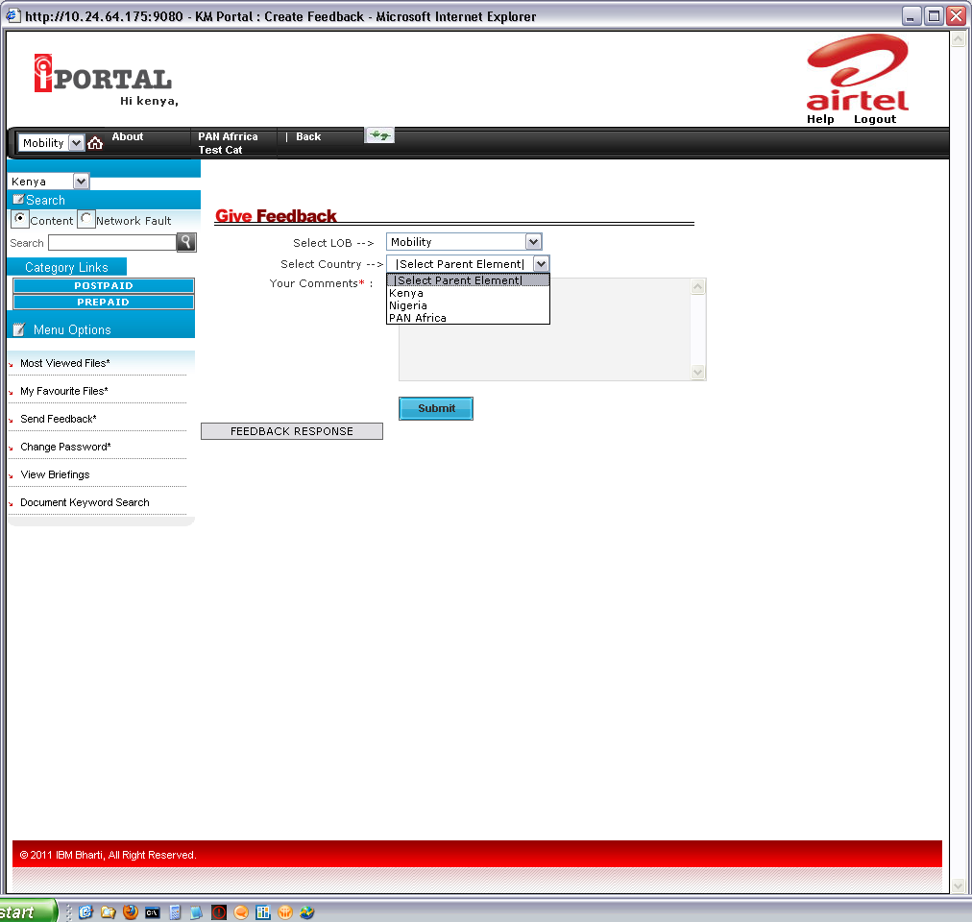
Send feedback link sends feedback to country admin.

1.10. Viewing Feedback Response.

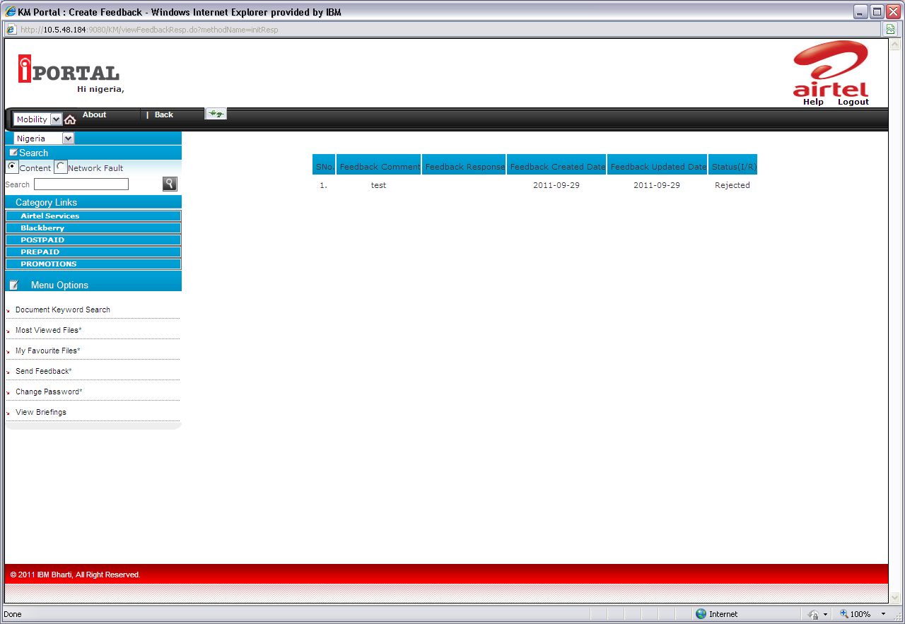
The response given by the admin on the feedback can be viewed.

1.11. View Briefings for the selected Date

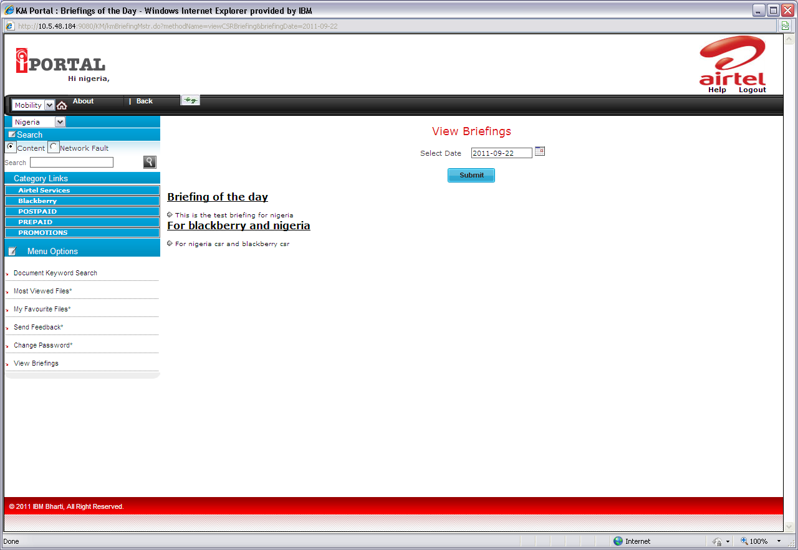

1.12. Searching Content for selected Country

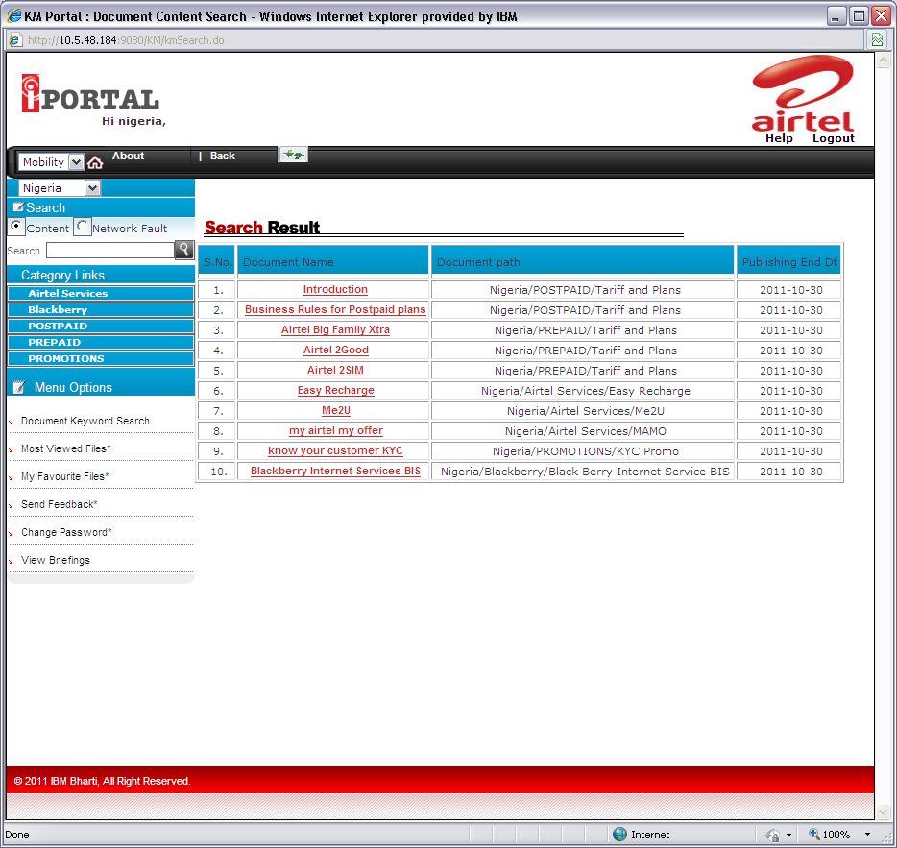
Select a country and enter content to search.

1.13. Searching for Network faults in Specific Location
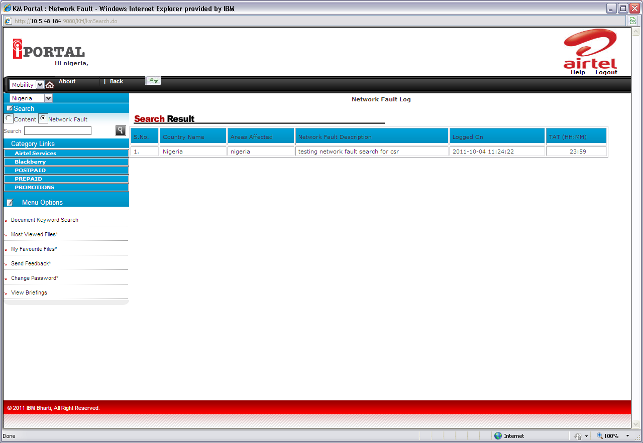
Select Network Fault radio button.
All the location with same name country wise is listed with network fault, logging time & TAT details.
Enter Location and click on Search button or press Enter key.

