Activity Week 5 Visualization

Kevin M Rabidou

2023-06-21

#This scatterplot looks to see any relationship between the driver per billion miles and the percent of the drivers in accidents who were not distracted. We want to look at if there is any correlation with the drivers in states driving distances and whether they get in accidents when they are focused on the road.   
ggplot(renamedDrivingData,aes(x = NoDiFC_perBillionMiles , y = PoDiFC_NotDistracted) ) + geom_point() + labs(title = "Number of Accidents vs Not Distracted Driving", x = "Number of drivers involved in fatal collisions per billion miles", y = "% Of Drivers Involved In Fatal Collisions Who Were Not Distracted")

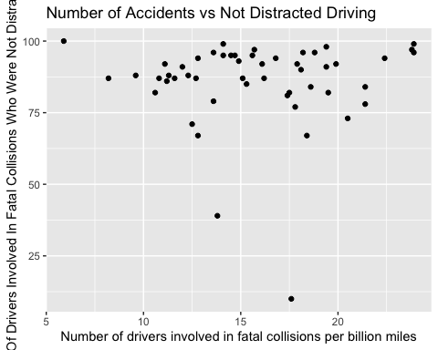

#Another scatterplot to continue looking at the relationship of number of drivers in accidents but now looking at the percentage of drivers who have had no previous accidents. It can be important to see how the number of drivers in states can affect their percentages of carious causes of fatal accidents.   
ggplot(renamedDrivingData,aes(x = NoDiFC_perBillionMiles , y = PoDiFC_NoPreviousAccidents) ) + geom_point() + labs(title = "Number of Accidents vs Speeding", x = "Number of drivers involved in fatal collisions per billion miles", y = "% Of Drivers Involved In Fatal Collisions Who Had Not Been Involved in Any Previous Accidents")

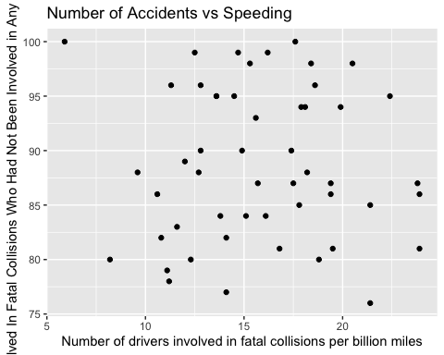

#As speeding appears to be one of the easier variables to track it could be one of the more reliable ones to use so I looked at the distribution of drivers who were speeding at the time of a fatal accident. This helps get a better idea of the distribution fo how many of the dirvers were truly speeding at the time.   
ggplot(data = renamedDrivingData, mapping = aes(x=PoDiFC_Speeding)) + geom_bar() + scale_x_continuous(limits = c(10,60), breaks = seq(10,60,2))

