**Data Structures and Algorithms Design**



**Assignment 02 | PS4 | Pharmacy Run**

***Submitted By: Group 308***

**Group Contribution**

Assignment Set Number:

Problem Statement 4

Group Name:

Group Number: 308

Contribution Table:

| **S.No.** | **Name (as appears in Canvas)** | **ID** | **Contribution (%)** |
| --- | --- | --- | --- |
| 1 | Kumar Anurag | 2021FC04016 | 100/3 |
| 2 | Santoshi Nayak | 2021FC04007 | 100/3 |
| 3 | Maneesh Kumar Shrivastava | 2021FC04011 | 100/3 |

**Problem Statement**

In light of the current pandemic, Harsh has been working from home and is taking extra precaution to make sure he stays safe. However, he has to make an emergency run to the pharmacy as his son hurt himself while playing. There are a couple of pharmacies near his house and he has to decide which one to go to. Every road in his neighborhood has a couple of containment zones. If there are two pharmacies located at specific junctions in his locality, you have to help Harsh identify which is the safer option such that he crosses the least number of containment zones to reach the pharmacy. A map of his locality and the containment zones on each road is given below.

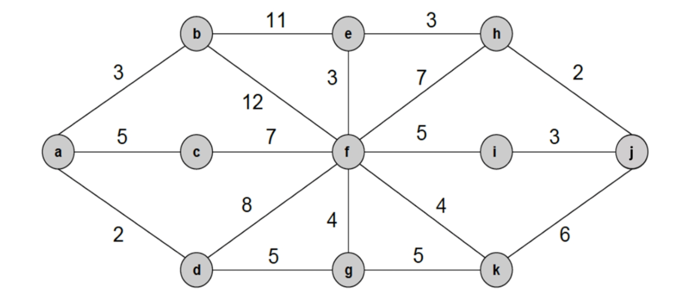

**Requirements**

**1. Formulate an efficient algorithm to help Harsh identify which pharmacy is safer.**

**Algorithm**

*We are making use of Dijkstra's Algorithm for finding out Pharmacy with minimum containment zones*

**STEP 01:**

+ Mark all the Pharmacies as temporary

+ Assign all Pharmacies to have infinite containment zones except the Harsh's house (as Harsh's house is source)

**STEP 02:**

+ Calculate the total no of containment zones for all the adjacent Pharmacies

+ Choose any temporary Pharmacy (u) having the minimum no of containment zone(s)

+ Mark that Pharmacy (u) as permanent

**STEP 03:**

+ If no temporary Pharmacies left then STOP

+ Otherwise, Go to Step 02

**STEP 04:**

+ Finally find out the desired Pharmacy having the minimum containment zones.

**Pseudocode**

* G denotes given Graph
* V denotes each Vertex
* E denotes each Edge
* Q denotes a priority queue of all nodes in the graph
* S denotes a set to indicate which nodes have been visited by the algorithm

—------------------------

G = (V, E): the input graph

source: the source node

/* Initialization

dist[source] ← 0

**initialize** dist[v] = 0, for all v ∈ V and v ≠ source

**add** v to Q, for all v ∈ V

S ← Φ

/* the main loop for the algorithm

**while** Q ≠ Φ do

v ← vertex in Q with min dist[v]

**remove** v from Q

**add** v to S

**foreach** neighbor u of v do

**if** u ∈ S then

**continue**; // if u is visited then ignore it

alt ← dist[v] + weight(v, u)

**if** alt < dist[u] then

dist[u] ← alt; // update distance of u

**update** Q

**return** dist

**2. Provide a description about the design strategy used.**

**Description**

For finding out the Pharmacy having the minimum containment zones, we're making use of Dijkstra's Single Source - Shortest Path Algorithm.

First of all, we will consider all the Pharmacies as the node and all the containment zones as the distances. We are making Harsh's house as the source node.

Now our task is to find an immediate adjacent node (Pharmacy) having the minimum distance (minimum containment zones). We will continue this process until we reach the desired Pharmacies that the user has provided in the input file.

Finally, we will compare which Pharmacy took minimum containment zones while traveling.

**3. Analyze the time complexity of the algorithm and show that it is an “efficient” one.**

**Analysis**

Let the given **Graph (G) = (V, E)** is represented as an adjacency matrix. Here **cz[u, v]** denotes the no containment zones lying on the way from **V** to **E**, where **V** and **E** are vertices and edges respectively.

Also, the priority queue **Q** is represented as an unordered list.

Let **|E|** and **|V|** be the number of edges and vertices in the graph respectively. Then the time complexity is as follows:

(i) Adding all the vertices to **Q** takes **O(|V|)** times.

(ii) Removing the node with minimal dist takes **O(|V|)** time, and we only need **0(1)** to recalculate **dist[u]** and update **Q**. Since we use an adjacency matrix here, we'll need to loop for **|V|** vertices to update the dist array.

(iii) The time taken for each iteration of the loop is **O(|V|)**, as one vertex is deleted from **Q** per loop.

(iv) Thus, the total time complexity becomes:

**O(|V|) + O(|V|) x O(|V|) = O(|V|2)**

**Graph Comparison**

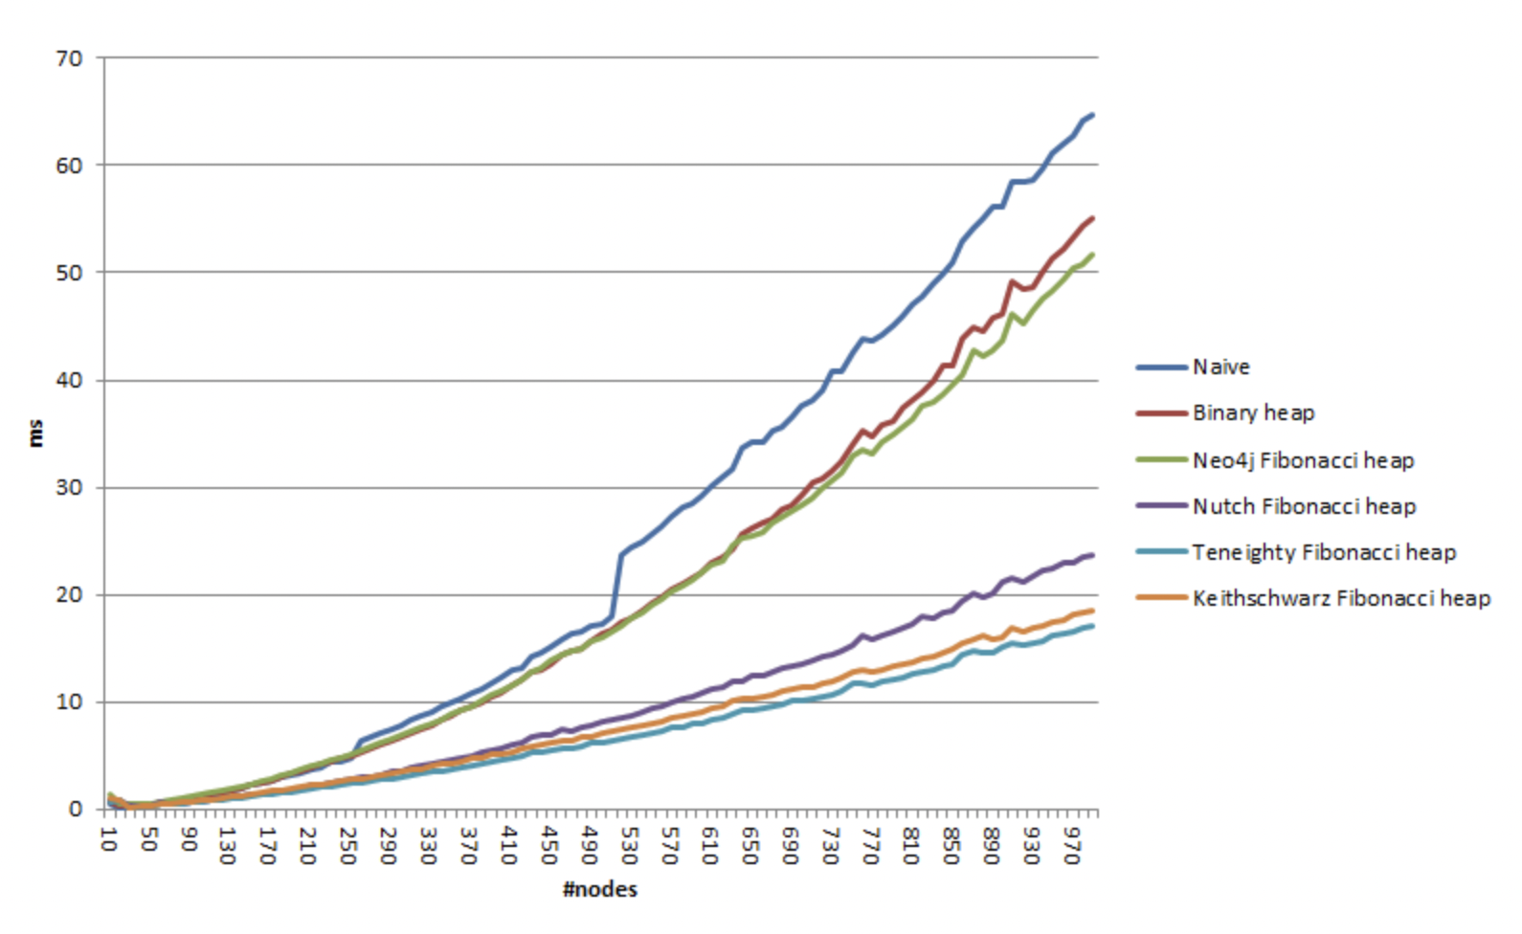

By comparing different approaches in graphical analysis, we found that our algorithm is the most efficient one.

**4. Implement the above problem statement using Python 3.7**

**Source Code**

import re

'''

find_pharmacy(): will find all the possible available Pharmacies with the minimum containment zones

with respect to the Harsh's House (which is a source node)

This function takes 3 parameters:

(i) nodes - means total no of Pharmacies

(ii) edges - consists of no of containment zones lying between 2 Pharmacies

(iii) source_index - Harsh's House

'''

def find_pharmacy(nodes, edges, source_index = 1):

# marking all Pharmacies having infinite containment zones initially

path_lengths = {v: float('inf') for v in nodes}

path_trace = {v: 'a' for v in nodes}

# marking Harsh's house having 0 containment zone as it's the source node

path_lengths[source_index] = 0

# storing all the Pharmacy and containment zone details in 2D dictionary format

adjacent_nodes = {v: {} for v in nodes}

for (u,v), c_uv in edges.items():

adjacent_nodes[u][v] = c_uv

adjacent_nodes[v][u] = c_uv

# calculating actual containment zones lying between each pair of Pharmacies

temporary_nodes = [v for v in nodes]

while len(temporary_nodes) > 0:

upper_bounds = {v: path_lengths[v] for v in temporary_nodes}

# finding a Pharmacy having the minimum containment zones and then removing that node from temporary nodes

u = min(upper_bounds, key=upper_bounds.get)

temporary_nodes.remove(u)

# updating the containment zone no if we found another path having minimum containment zone value

for v, c_uv in adjacent_nodes[u].items():

if path_lengths[v] > (path_lengths[u] + c_uv):

path_trace[v] = path_trace[u] + " " + chr(v+96)

path_lengths[v] = min(path_lengths[v], path_lengths[u] + c_uv)

# finally returning details of all Pharmacies along with their minimum containment zones

return path_lengths, path_trace

# reading the input file

input_file = open("inputPS4.txt","r")

src = input_file.read()

# Data Extraction from Input File

pattern01 = "([a-z])\s/\s([a-z])\s/\s(\d+)"

pattern02 = "Harsh\Ss House:\s([a-z])"

pattern03 = "Pharmacy\s(\d+):\s([a-z])"

details01 = re.findall(pattern01, src)

details02 = re.findall(pattern02, src)

details03 = re.findall(pattern03, src)

input_file.close()

# storing the edges and nodes details from the input file

edges = {}

nodes = []

for x,y,z in details01:

edges[(ord(x)-96,ord(y)-96)] = float(z)

if ord(x)-96 not in nodes:

nodes.append(ord(x)-96)

if ord(y)-96 not in nodes:

nodes.append(ord(y)-96)

# storing harsh house, pharmacy 1 and pharmacy 2 details

harsh_house = ord(details02[0])-96

pharmacy_data = {k: v for k,v in details03}

# executing the algorithm

containment_zone, trace = find_pharmacy(nodes, edges, harsh_house)

final_containment_zone = {}

final_trace = {}

for k,v in containment_zone.items():

final_containment_zone[chr(k+96)] = v

for k,v in trace.items():

final_trace[chr(k+96)] = v

# generating the output file

output_file = open("outputPS4.txt","w")

safer_pharmacy = pharmacy_data[min(pharmacy_data, key=pharmacy_data.get)]

safer_pharmacy_no = "Pharmacy " + str(min(pharmacy_data, key=pharmacy_data.get))

path_to_follow = final_trace[safer_pharmacy]

total_containment_zones = str(int(final_containment_zone[safer_pharmacy]))

final_result = "Safer Pharmacy is: " + safer_pharmacy_no + "\n" + "Path to follow: " + path_to_follow + "\n" + "Containment zones on this path: " + total_containment_zones

output_file.write(final_result)

output_file.close()