# Task 1

## p = 1%

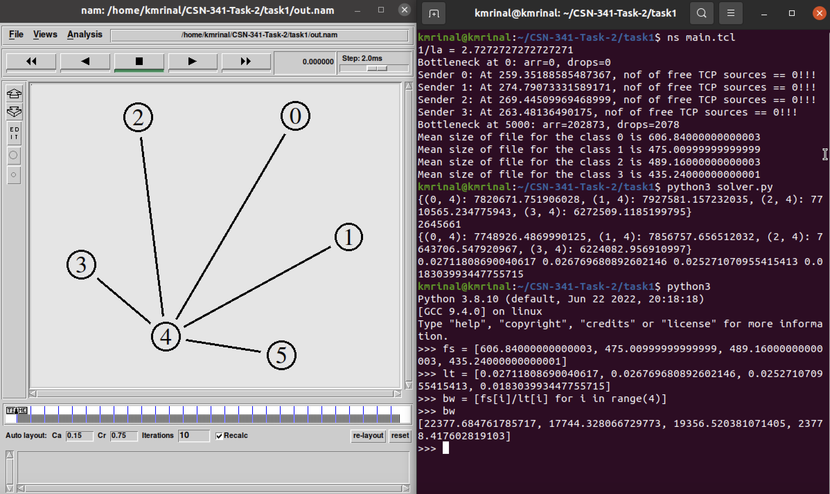

**Average Class Delay:**

1 -> 0.02711

2 -> 0.02676

3 -> 0.02527

4 -> 0.01830

**Average Bandwidth:**

1 -> 22377.684761785717 packets/s

2 -> 17744.328066729773 packets/s

3 -> 19356.520381071405 packets/s

4 -> 23778.417602819103 packets/s

**Wi/W1:**

1 -> 1  
2 -> 0.9871522644984663

3 -> 0.9318898876689162

4 -> 0.6749736260887033

## p = 5%

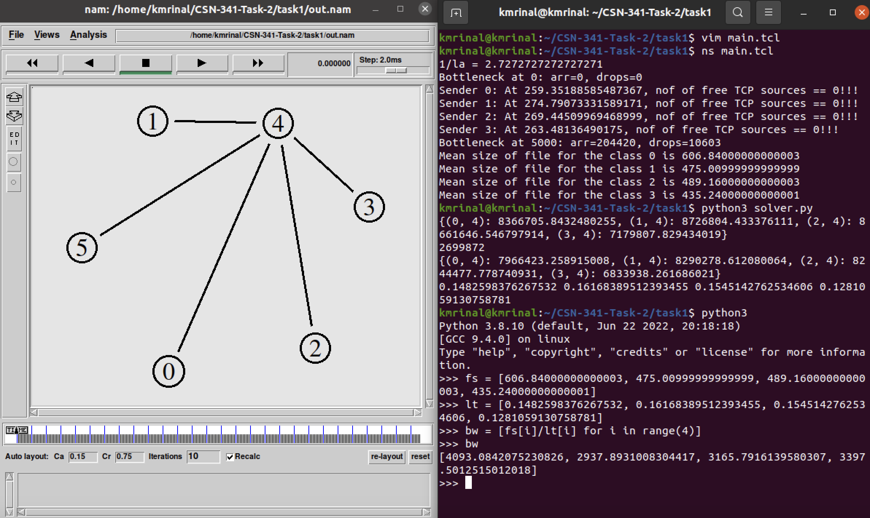

**Average Class Delay:**

1 -> 0.1482598376267532

2 -> 0.16168389512393455

3 -> 0.1545142762534606

4 -> 0.1281059130758781

**Average Bandwidth:**

1 -> 24093.0842075230826 packets/s

2 -> 2937.8931008304417packets/s

3 -> 3165.7916139580307 packets/s

4 -> 3397.5012515012018 packets/s

**Wi/W1:**

1 -> 1  
2 -> 1.0905441265285656

3 -> 1.042185656795693

4 -> 0.8640634923558127

## p = 10%

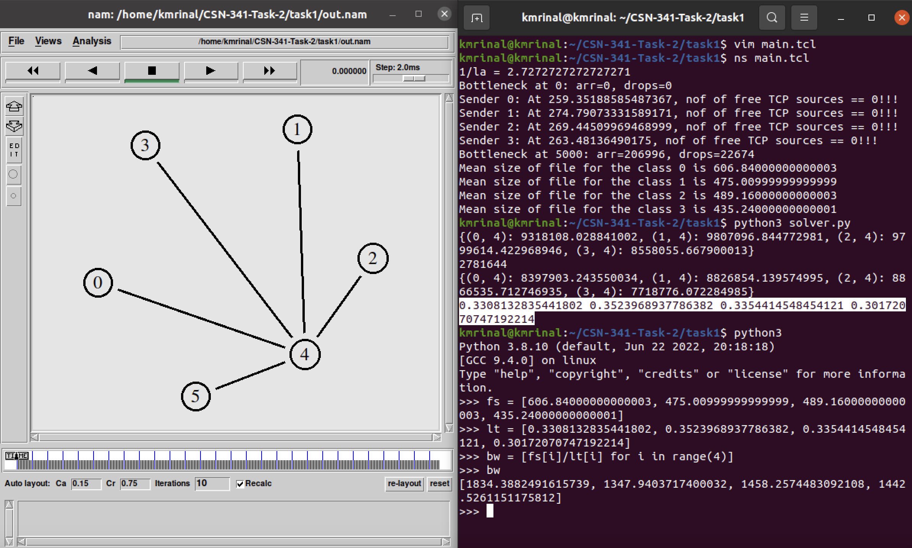

**Average Class Delay:**

1 -> 0.3308132835441802

2 -> 0.3523968937786382

3 -> 0.3354414548454121

4 -> 0.30172070747192214

**Average Bandwidth:**

1 -> 1834.3882491615739 packets/s

2 -> 1347.9403717400032 packets/s

3 -> 1458.2574483092108 packets/s

4 -> 1442.5261151175812 packets/s

**Wi/W1:**

1 -> 1  
2 -> 1.0652440857368881

3 -> 1.013990282529310

4 -> 0.9120574126873816