**Supriya Kumari PERSONAL SUMMARY**

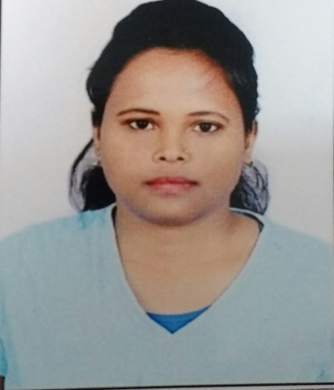

|  |  |
| --- | --- |
| **Role:** Associate  **Mail Address:** Supriya.Kumari2@cognizant.com  **Mobile Number:** 9108996370 | Dear Sir/Madam,  Kindly find enclosed my resume to provide you with an overview of my relevant experience and training in various Domains. I have around **4 years of experience in Java,J2ee.**  I will be delighted to discuss my experience further with you to suit your requirement.  Looking forward to hear from you,  Yours Sincerely,  Supriya kumari |

**PROFESSIONAL SUMMARY:**

* **3+ years,** of experience in all aspects of Design and Development on **JSE, J2EE, Spring, Hibernate and Web Services** based system.
* Good knowledge on Data Stuructures and algorithms.
* Ability to learn new technologies with minimal time period.
* Having Good experience in interacting with onsite teams in getting Requirement Clarifications, Business flows, Test Data etc. through Emails, Communicator calls.
* Flexible and versatile to adopt any new environment and work on any project.
* A dedicated team player with excellent organizational and Interpersonal skills.
* Involved in Technical discussions, sharing and communicating the project related ideas within team.

**TECHNICAL SKILLS**

|  |  |
| --- | --- |
| **Programming Languages** | Java, JEE[Servlets, JSP,Hibernate, Spring,REST Services] |
| **Databases & Tools** | MySQL , Oracle 11g |
| **Other Utilities** | HTML5, CSS3, Angular |

**EDUCATION**

|  |  |
| --- | --- |
| **Degree** | **College/University** |
| Bachelor Degree in Computer Application(BCA) | TilkaManjhi Bhagalpur University,Bihar |

**EMPLOYMENT HISTORY**

|  |  |  |  |
| --- | --- | --- | --- |
| **Name of the Company** | **Designation** | **From** | **To** |
| Cognizant Technologies Solutions, US | Associate | May 2018 | Till Date |
| SoftMind informatics Pvt Ltd | Software Engineer | Jan 2015 | April 2018 |

**PROJECT SUMMARY**

**PROJECT - 1**

|  |  |  |
| --- | --- | --- |
|  | **Project Title : Domain : Tools and technology used :** | **EPDS (Enterprise provider database system).**  **Healthcare.**  **Core Java, Hibernate 3.0, Spring, RESTFUL, JSP,**  **Angular JS, Maven,Bigdata.** |
|  |  |  |
|  | **Database : Team Size : Role : Duration :** | **Oracle 11g.**  **12**  **Software Engineer**  **Sep 2017 to April 2018** |

**DESCRIPTION:**

**ROLE AND RESPONSIBILITIES:**

* Designed Message Spec as per the requirements and Fix the Bug which is assign to me in an given time only.
* Wrote Service and DAO layer in my OSM module for the Business implementation Scenarios.
* Wrote the controller classes for OSM Service Modules.
* Developed GUI using Spring MVC Framework to enable the business users to upload client billing report information for application model to service framework model.

**PROJECT – 2**

|  |  |  |
| --- | --- | --- |
|  | **Project Title : Domain : Tools and technology used :** | **MAHINDRA FINANCE**  **Banking(**Loan Organization System) **Core Java, JSP, Java Script, Struts, Oracle 11g, Core Ftp, Oracle Sql Developer** |
|  |  |  |
|  | **Database : Team Size : Role : Duration :** | **Oracle 10g.**  **10**  **Associate Software Engineer. Feb 2015 to Aug 2017.** |

**DESCRIPTION:**

**ROLE AND RESPONSIBILITIES:**

* Involved in Client Interaction on Regular Basis to understand the Business of the client.
* Involving in writing XSD’s WSDL based on requirements and implementing Soap based JAX-

WS Web-Services for request processing.

* Involved in the Analysis, Design, Coding, modification of user requirements in the application.

* .Using Spring for delegating the Service layer request to process layer and process layer and

process layer request to Integration layer.

**DECLERATION:**

I hereby declare that, the above given information is correct to the best of my knowledge.

Date: Supriya Kumari

|  |
| --- |
|  |
|  |
|  |