EXPERIMENT #10

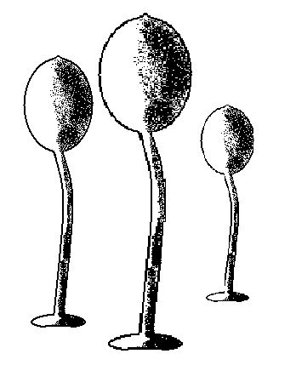

LIFE CYCLE
OF A CELLULAR
SLIME MOLD

DICTYOSTELIUM DISCOIDEUM

Derrick Brazill,
Dept. of Biological Sciences
Hunter College
695 Park Avenue
New York, NY 10021

OBJECTIVE:
To observe the life cycle of wild type and mutant
Dictyostelium discoideum

The slime mold Dictyostelium discoideum is a social amoeba that has an unusual life cycle. When adequate food (bacteria) is available, it lives as an individual and reproduces by binary fission. However, upon depletion of its food source, it initiates the “social” phase of its life cycle. Thousands of starving cells gather together into central collection points, and undergo morphological, biochemical and molecular changes which ultimately lead to the construction of a multicellular structure called a fruiting body. The fruiting body is approximately 4 mm tall and consists of a mass of spore cells situated upon a column of stalk cells. The spores are the resting stage of the amoeba, while the stalk cells are dead. When food is available once more, the spores germinate and each releases an amoeba, thus reinitiating the life cycle.

Because cellular slime molds undergo the same fundamental processes that more complex organisms like vertebrates undergo, they have been used extensively to study basic biological questions about gene expression, morphogenesis, cell differentiation and cell signaling and communication. In fact, D. discoideum has recently been designated a model research organism by the National Institutes of Health (NIH). In this lab, you will culture and starve Dictyostelium cells to observe their development.

_______________________________________________________________________________

1. Aggregate 5. Mexican Hat
2. Tight Mound 6. Early Culminant
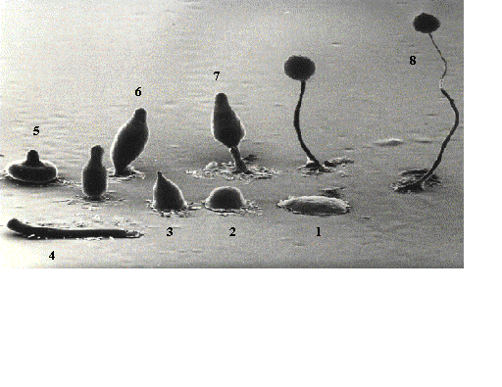
3. Tipped Mound 7. Late Culminant
4. Pseudoplasmodium (slug) 8. Fruiting Body

MATERIALS

Organisms per class:
Three plates of Klebsiella aerogenes

Organisms per pair of students:
One tube of Dictyostelium discoideum, wild type
One tube of Dictyostelium discoideum, mutant

Materials per pair of students:
2, SM/5 plates
1 bottle of sterile PBM
1 ml and 5 ml sterile serological pipets

PROCEDURE
The class will work in groups of two.

A. Preparation of lawn bacteria.

1. Add 4.0 ml of sterile PBM to empty dilution tube using a 5.0 ml pipet.
2. Add 1 loopful of Klebsiella aerogenes to dilution tube with PBM. Cap and vortex lightly to suspend bacteria.
The solution should be turbid. This is the lawn bacteria.

B. Addition of lawn bacteria to SM/5 plates.

1. Each pair of students will prepare two SM/5 plates. Label one plate wild type and one plate mutant.
Remember to label your section and initials on each plate.
2. Add 0.2 ml of lawn bacteria to the center of each plate. Use spreaders to spread the bacterial suspension evenly over the surface of the plate.
3. Allow plates to sit for 15 minutes. DO NOT TURN OVER.

C. Addition of wild type and mutant Dictyostelium discoideum to SM/5 plates with lawn bacteria.

1. Streak one loopful of wild type Dictyostelium discoideum once across and back near the top of the SM/5 plate with lawn bacteria labeled wild type.

2. Streak one loopful of mutant Dictyostelium discoideum once across and back near the top of the SM/5 plate
with lawn bacteria labeled mutant.

3. Allow plates to sit for 15 minutes. DO NOT TURN OVER.

Plates will be incubated for four days at 23^{O}C.

NEXT LAB PERIOD:
View SM/5 plates with wild type and mutant Dictyostelium discoideum under a microscope and make observations.

PREPARATION OF THE LAB
EQUIPMENT AND SUPPLIES:

1. Usual lab equipment (loops, needles, etc.,).
2. 6 Turntables and 6 250 ml beakers.
3. Beaker to put out ethanol fires
4. 4 buckets with disinfectant for used pipets.
5. Sterile 1.0 ml and 5.0 ml pipets.
6. Glass rods or 9" Pasteur pipets for making spreaders.
7. 1 bottle of 95% Ethanol.
8. 17 x 100 ml sterile tubes (dilution tubes).
9. 12 x 75 ml sterile tubes (for Dictyostelium).

ORGANISMS FOR EXPERIMENT

Organisms are provided by Dr. Brazil.
1 flask per day of Dictyostelium discoideum, wild type
1 flask per day of Dictyostelium discoideum, mutant
3 plates per section of Klebsiella aerogenes

MEDIA REQUIREMENTS

MEDIA: /SECTION TOTAL CODE
(6 grps) (10 sec)
1. SM/5 Plates.........................12 plates..................120 (make 160).......3 blue lines
2. PBM....................................6, 25 ml bottles........60 bottles (2 liters)

MEDIA PREPARATION

SM/5 PLATES - 40 plates/liter, make 4 liters (160 plates)
Autoclave for 30 minutes
Let plates sit at room temperature for 2 days to dry before use.

1liter
Glucose 2.0 grams
Peptone (Oxoid) 2.0 grams
Yeast 2.0 grams
MgSO₄.7H₂O 0.2 grams
anhydrous KH₂PO₄ 1.9 grams
anhydrous K₂HPO₄ 1.0 gram
Agar 15.0 grams

PBM - make 2liters, 25 ml per bottle
autoclave for 20 minutes
Store at room temperature.

2 liters
anhydrous KH₂PO₄ 5.44 grams
0.1 M CaCl₂ 0.2 ml
1.0 M MgCl₂ 2.0 ml

Add deionized water to 2.0 liters
pH to 6.1 with 5 M KOH

note:
0.1 M CaCl₂ = 1.1g / 100 ml deionized water
1.0 M MgCl₂ = 20.3 grams / 100 ml deionized water

PREPARATION FOR CLASS

Keep flasks of Dictyostelium discoideum on shaker set at 110 rpm at room temperature.
Prepare Dictyostelium discoideum before each section.

Add 1.0 ml of D. discoideum, wild type, to each of 6, labeled, 12 x 75 ml sterile tubes.
Add 1.0 ml of D. discoideum, mutant, to each of 6, labeled, 12 x 75 ml sterile tubes.

3 plates per section of Klebsiella aerogenes. Plates can be left at room temperature.

Inoculated plates can be left at room temperature.
When Dictyostelium discoideum covers 3/4 of the surface of the plates, refrigerate.

NEXT LAB PERIOD:
View SM/5 plates with wild type and mutant Dictyostelium discoideum under a microscope and make observations.

****DANGER - WHEN USING SPREADERS****
KEEP BEAKERS OF ETHANOL AWAY FROM BUNSEN BURNERS AND POSSIBLE PATHWAY OF THE SPREADERS.
IF AN ETHANOL FIRE OCCURS, DO NOT USE THE FIRE EXTINGUISHER. HAVE STUDENTS LEAVE THE AREA AND INVERT A LARGER BEAKER OVER THE BURNING ONE. A PIECE OF ALUMINUM FOIL PLACED OVER THE BURNING EtOH WILL ALSO SUFFICE. THE FIRE WILL BURN ITSELF OUT IN A MANNER OF SECONDS.

