Bio 410 – Dictyostelium Cell Migration Under-Agarose Experiment
(based on protocol and information from David Woznica and David Knecht (2006) Under-Agarose Chemotaxis of Dictyostelium discoideum In Dictyostelium discoideum Protocols. L. Eichinger and F. Rivero, eds.)
Background on Dictyostelium discoideum – this week’s model organism of choice:
The ameboid protozoan Dictyostelium discoideum is a powerful system for genetic and functional analysis of gene function. The 34 Mb genome contains many genes that are homologous to those in higher eukaryotes and are missing in Saccharomyces cerevisiae. The organism is uniquely suited for studying cytokinesis, cell motility, phagocytosis, chemotaxis, signal transduction, and cell differentiation during development. Many of these processes, which play important roles in health and disease, are either absent or are less accessible in other model organisms.
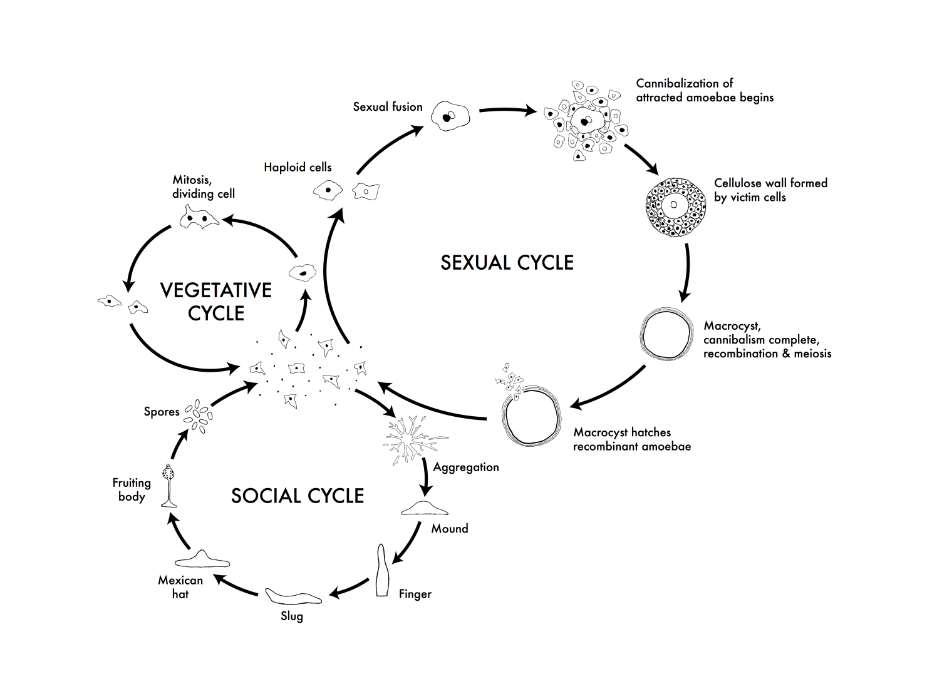
Dictyostelium amoebae grow as separate, independent cells but interact to form multicellular structures when challenged by adverse conditions such as starvation. Up to 100,000 cells signal each other by releasing the chemoattractant cAMP and aggregate together by chemotaxis to form a mound that is surrounded by an extracellular matrix. This mechanism for generating a multicellular organism differs radically from the early steps of metazoan embryogenesis. However, subsequent processes depend on cell-cell communication in both Dictyostelium and metazoans. Many of the underlying molecular and cellular processes appear to have arisen in primitive precursor cells and to have remained fundamentally unchanged throughout evolution. Basic processes of development such as differential cell sorting, pattern formation, stimulus-induced gene expression, and cell-type regulation are common to Dictyostelium and metazoans. (from Dictybase.org)
Figure 1. The life cycles of Dictyostelium discoideum. Most of its life, this haploid social amoeba undergoes the vegetative cycle, preying upon bacteria in the soil, and periodically dividing mitotically. When food is scarce, either the sexual cycle or the social cycle begins. Under the social cycle, amoebae aggregate to cAMP by the thousands, and form a motile slug, which moves towards light. Ultimately the slug forms a fruiting body in which about 20% of the cells die to lift the remaining cells up to a better place for sporulation and dispersal. Under the sexual cycle, amoebae aggregate to cAMP and sex pheromones, and two cells of opposite mating types fuse, and then begin consuming the other attracted cells. Before they are consumed, some of the prey cells form a cellulose wall around the entire group. When cannibalism is complete, the giant diploid cell is a hardy macrocyst which eventually undergoes recombination and meiosis, and hatches hundreds of recombinants. Not drawn to scale.
CC Creative Commons Attribution – Share Alike 3.0, David Brown & Joan E. Strassmann

The Experiment:
During their vegetative cycle, Dictyostelium eat bacteria. They sense and move toward pterines like folate or folic acid released by the bacteria. Chemotaxis is the term for when cells move toward a chemical. Cells can sense a gradient of a chemoattractant (the chemical) and are able to follow the gradient, moving from where the chemoattractant is least concentrated, toward where it is most concentrated.
The purpose of this assay is to compare the speed and directionality of Dictyostelium cells during chemotaxis towards folic acid. You will use an assay (an investigative procedure) called an under-agarose Chemotaxis assay. In this procedure, a thin agarose gel is poured and a razor blade is used to cut into the agarose, in a thin rectangle, removing the piece of agarose from the rectangle and creating a well in the gel. Multiple wells are cut (see Figure two for example diagrams of gel wells). The chemoattractant (folate) is placed into the middle well and Dictyostelium cells are placed into either of the other wells. The Dictyostelium cells will sense the gradient of folate that is formed by the chemical slowly leaking out from its well under the gel and leave their well, migrating toward the folate.
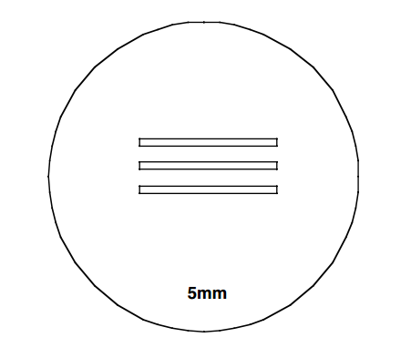
Figure 2. Sample drawing of agarose gel with three wells cut into it. You will be given a printed sheet of paper that has a correctly-sized diagram for using to cut our your wells for the under-agarose chemotaxis assay. DO NOT USE THIS ONE!
You will design your own hypothesis to use for the basic experiment. You need to develop a hypothesis to test about the migration of cells toward two different concentrations of folic acid. What is your hypothesis? And what is a biological reason why the hypothesis might be true? (write out below)

The Procedure –
Planning and Calculations: DO CALCULATIONS AHEAD OF TIME!!!
(may want to consult with your group and work on ahead of time, if possible)
- You need to develop a hypothesis to test about the migration of cells toward two different concentrations of folic acid. What concentrations do you want to use? (remember, only two!) A normal concentration to use in this assay is 1 mM folic acid. I will have 50 mM stock folic acid and you will have to dilute it to the concentration(s) you need. Plan to make 500 uL of each concentration. You will use SM media to dilute the folic acid. Do your calculations here:

Preparing Agarose Plates:
- The 1% agarose plates in SM media (6 cm) have been poured for you ahead of time. Get one plate from the front bench. Also get one thin spatula and a razor blade (careful!)
- Gently slide the spatula up and down between the edge of the gel and the side of the plate a couple time until you see the agarose gel start to turn a little bit. This releases tough connections between the plate and the gel that would prevent the Dictyostelium from being able to crawl under the gel.
- Turn to the page of the lab with the trough-cutting template and place the dish on the circle.
- First, wet the razor blade by cutting into the gel far away from the spots the wells will be.
- Then, cut the six straight lines that make up the long edges of the wells. Just hold the razor level and press gently but firmly down, don’t scratch the bottom of the dish, don’t use “sawing” motions to cut. Don’t cut the short ends with your razor blade!!
- Next, take the pointy end of your thin spatula and use it to cut the small ends of each trough or well. Pry out the agarose slab by lifting one end with the spatula and then grabbing it with your fingers and pulling it out. BE CAREFUL NOT TO DISTURB THE AGAROSE IN BETWEEN THE WELLS!!!
- Write the concentrations of folic acid you are going to use on the side or edge of the bottom dish (the one that has your agarose in it) one on each side of the dish, on the same side of the dish as a well.
- You will not move the plate (for a while) after the folic acid and cells are added, so before you fill the wells, put the plate in a location where it can sit undisturbed until your second lab time later that day.
Loading the gel:
- Then, using a P100 and yellow tip, carefully load 100 uL of one of your chosen folic acid concentrations into one of the outer wells (NOT the middle one!) that corresponds to the side where you wrote the concentration. Add another 50 or 100 uL more only if there is space in the well. Ask your professor to double-check if you aren’t sure and add extra only until nearing the top of the well. Do not overfill.
- Add the other folic acid concentration to the other outer well in the same way.
- Once the folic acid is added, obtain Dictyostelium cells from your professor. They will be at a concentration of 10⁷ per mL. Gently mix the cells by inverting the tube two or three times, and then carefully add 100 uL of cells to the middle well. Do not add extra cells.
- Do not disturb the plate! Leave it on your lab bench and let the cells adhere to the dish for 15 min.
- After 15 min, obtain a small circular glass coverslip from the front table and carefully place it over the middle well, making sure that it doesn’t also cover any parts of the chemoattractant wells! (the outer wells)
- Sometime after 1.5 hours after plating the cells (but before 8 hours have passed!) look at the cells on the inverted microscope. Carry the plate very carefully and keep it level. See if you can find and focus on the cells in the middle well using the 20x objective. Take note of what the cells look like. What shape(s) are they? Are they contained in the well or can you see any starting to move under the agarose toward chemoattractant?
- When it is time for your movies, the instructor will help you find the cells using the Olympus IX-81 microscope and adjust the Olympus XM-10 camera.
- You will take one movie on each side of the well (so one movie of the cells moving toward the first concentration of folic acid, and the second movie toward the second concentration.
- The time-lapse movies will likely each last 10 minutes, with pictures taken every minute.
- Obtain the movies on the USB drive from the professor.
- Download MTrack J and follow the instructions that will be posted on eLearn for tracking cells and determining cell speed and directionality. There will be time next week in lab for working on this part, though it is essential you download MTrackJ before lab time, and useful to begin the process of tracking.

