Microtubule gliding assay for microtubule-associated motors

Reagents:

Dynein sample or extract sample to be tested for motility
Taxol stabilized microtubules (see step 1.1 and 2.4)
1 mM Mg ATP (10 mM MgATP if not using perfusion chamber)
VALAP (borrow from CC lab)

Protocol 1 (works well if you have pretty concentrated protein in your dynein sample)
1. Make microtubules: to 100 μl of 1mg/ml DEAE tubulin, add 1 μl 100 mM MgGTP. Mix, and incubate at 37 degrees for 6 min. Add 1 μl 10 mM taxol. Mix and incubate at 37 degrees for 6 min. Place at room temp. Preincubating tubulin with GTP will give you longer microtubules.
2. On a clean glass slide, place 25 μl dynein sample and allow it to adsorb for 15 minutes at room temp.
3. Add 2 μl microtubules from step 1 and 3 μl 10 mM MgATP.
4. Invert a coverslip over the sample taking care not to trap bubbles in between and seal with VALAP.
5. Observe motility with video-enhanced DIC optics (see photography section)

Protocol 2 (works better for dilute dynein samples or if testing an extract or un-enriched supernatant)
1. Make a perfusion chamber by cutting 2 narrow strips from a coverslip with a diamond pen to use as spacers between a glass slide and an uncut coverslip. Seal chamber with VALAP (see diagram)
2. Perfuse dynein sample or extract sample (25 μl) through the chamber. Allow 10 minutes at room temp for the sample to adsorb. If the protein concentration in the sample is low, you can perfuse several alliquots through consecutively, placing a piece of filter paper at the opposite side to absorb excess buffer.
3. Perfuse 50-100 μl of buffer through the chamber (P100 or PEM) to wash away unbound protein.
4. Make microtubules: to 100 μl of 1mg/ml DEAE tubulin, add 1 μl 100 mM MgGTP. Mix, and incubate at 37 degrees for 6 min. Add 1 μl 10 mM taxol. Mix and incubate at 37 degrees for 6 min. Preincubating tubulin with GTP will give you longer microtubules.
5. Mix 2 μl microtubule sample with 23 μl PEM. Perfuse through chamber. Incubate 5 min. Wash away unbound MT by perfusing with 50 μl P100 or PEM buffer.
6. Perfuse through 25 μl 1mM MgATP.
7. Observe motility with video-enhanced DIC optics (see photography section)
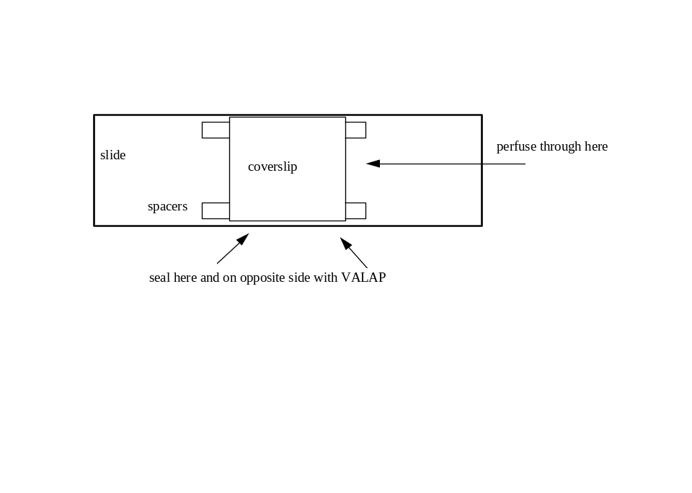
Diagram of perfusion chamber for motility assay

