DNA Mediated Transformation of Dictyostelium and Soil Amoebae

One of the most important innovations in cell biology is the ability to genetically engineer cells to express genes of interest. In this experiment, you will introduce the plasmid DNA into the cells by electroporation to transform the cells. Transfection of cells is very inefficient. A small number of cells acquire the DNA and an even smaller number are able to stably incorporate it into the genome. Therefore, we use a drug selection to identify and isolate the transfected cells because only they possess the DNA that encodes the new gene that allows them to survive in the presence of an antibiotic (hygromycin in this case).

We have plasmids that express either a red fluorescent protein- (mCherry) or a green fluorescent protein (GFP) from a Dictyostelium promoter. They also encode resistance to the antibiotic hygromycin. We also have a plasmid that expresses a fusion of GFP + small peptide called Lifeact that binds F-actin filaments in cells. The plasmids replicate extra-chromosomally.

We know from experience, that NC4 cells are sensitive to G418 and hygromycin antibiotics. However, we don’t know whether the soil amoebae you isolate will be sensitive. The first experiment you must do before transformation is to determine if your cell lines are sensitive or resistant to the antibiotics. To this, set up 3 flasks or petri dishes with a low titer of amoebae and add nothing to one, 10µg/ml G418 to one and 50µg/ml hygromycin to one. Monitor growth over the next few days. If the cells don’t grow in antibiotic, you are ready to transform. If they grow normally in one of the drugs, then you can’t use it. If you get a partial effect, you might be able to increase the concentration and kill the cells. You can use NC4 as your positive control for this experiment. If you need a G418 vector (G418 kills your cells but hygromycin does not) ask for help.

Possible questions:

- What proportion of drug resistant cells express the fluorescent protein.
- How does the localization of mCherry compare to the localization of GFP-lifeact. What do you expect to see for each?
- Are all cells expressing the same amount of fluorescent protein

Transformation Procedure:

Setting up the experiment

Vector DNA available:

- pDM1042 mCherry extrachromosomal vector (hygromycin resistance)
- pDM1066 GFP-lifeact extrachromosomal vector (hygromycin resistance)
- pDM1207 GFP-extrachromosomal vector (G418 resistance)
- pDM1208 mCherry extrachromosomal vector (G418 resistance)
- pPI137- mCherry extrachromosomal GFP-lifeact (G418 resistance)

Decide what cells you are going to transfect with which vector.

Preparing DIshes and Tubes

Label your electroporation cuvettes and put them on ice to chill.

Set up Petri Dishes for electroporated cells- one for each transfection:
Set up, label and add SorCM (or HL5 for axenic cells) to 100 mm Petri dishes to put the cells in after electroporation (step 8). You need one dish per cuvette.

Get an ice bucket and add 2 mm electroporation cuvettes and 1.5 ml centrifuge tubes to chill them (one of each for each transfection)

Preparing Cells

Harvesting Cells in SorCM Buffer
The procedure does not require a specific number of cells or amount of DNA. Generally, the more cells you use, the more transformants you will get up to some (unknown) limit.

- Harvest your cells into a 15 ml centrifuge tube(s) on ice. Take an aliquot to titer on the hemocytometer (so you know how many cells you are spinning down). Centrifuge in 15ml conical tube for 4 min (500xg) at 4°C.

THE REST OF THE ASSAY IS DONE ON ICE! Cuvettes, cells and buffers must be kept cold throughout this procedure

- After spinning, pour off the supernatant leaving the pellet untouched and vortex to resuspend the cells in 5 ml cold SorCM buffer. It works best if you flick the tubes (ask how to do this if you don’t know) to dislodge the pellet before adding the buffer.

- Spin the cells again for 4 min (500xg) at 4°C.

- While cells are spinning, calculate to volume of SorCM buffer to resuspend your cells. The procedure works with a wide range of numbers of cells, but our general target is to start with a suspension between 5 x 10⁶ - 1 x 10⁷ cells/ml. if you don’t have enough cell, it will just take longer to see fluorescent cells.

- Aspirate SorCM buffer from the tubes and add the appropriate amount of cold SorCM buffer to your cells and resuspend the pellet.

- Add 400µl of cells to each sterile 1.5 ml microcentrifuge tubes on ice, one for each cuvette.

- Add 2 µl of DNA to the tube and mix

- One at a time, transfer a cell/DNA mixture to an ice cold cuvettes. Then take it to the electroporator and pulse as indicated below. Pulse each cuvette separately so the cells will NOT have time to settle to the bottom of the cuvette before you get to pulse them. You should bring your ice bucket to the electroporator, pulse each cuvette and then return it to the ice bucket.

- Electroporation

  - Electroporation setting: 500 V, 25µF, 50 Ohms, 0.2 mm cuvette
  - Put the first cuvette in the apparatus and push the Red pulse button.
  - After a few seconds, the machine will pulse and then the screen will show you the time constant for that pulse. Take note of the time constant for each pulse and write this data in your notebook.
  - Wait about 5 seconds and then push the red button to pulse again (you have to push twice: once to get back to ready, and then again to pulse).
  - Place the cuvette back on ice.
  - Repeat for each cuvette

- Transfer all of the cells from each of the cuvettes to the corresponding labeled Petri dish containing media. To do this, remove the cuvette cap, tip the cuvette on its side and insert a P200 pipetter set to 100-200 µl into the side of the cuvette and pull out the cells and buffer. Repeat until you get as much of the 400µl of cells as possible. By tilting the cuvette nearly horizontal and sticking your tip down the side as far as you can, you can remove most of the volume in the cuvette. Disperse the cells in the Petri dish by gently swirling.

- Look at the cells on your bench top microscope as they settle to see if the cells look OK and attach after settling. Too stressful of an electroporation will kill the cells by blasting them apart and you will see only small fragments of cells.

- The cuvettes are reused, so when done using them, rinse the cuvettes out with distilled tap water about 5 times and leave them by the sink. We will sterilize the cuvettes for future use. They can be used many times if treated appropriately.

- For your Notebook, record an image of what one of the plates looks like once they have settled. Presumably, each dish will all look the same, but if not, note which looks different and why. Did the electroporation leave them rounded, dead looking or do they look healthy?
- For wild-type cells, add Ka or Ec bacteria to the dish
- After about 5 hours, add the antibiotic for selection to each dish. The cells are going to grow for a while before the drug begins killing them. If you wait too long to add drug, the cells will deplete the bacterial food, so you may need to add more bacteria to the plate. We have not determined the minimum time after electroporation that you can add antibiotic and still recover resistant cells. It takes time for the DNA to get into the nucleus and for the protein to be expressed at a high enough level to provide resistance. You could do this experiment if you wish. Note- for axenic cells in HL5, we add drug the next day.
a. 10 µl of 1000x Hygromycin B (50mg/ml stock) to each plate with 10 ml of media to bring it to 1x (final concentration of 50 µg/ml).
b. For G418, add 10 µl of 1000x (10 mg/ml) G418 stock (final 10 µg/ml)
This will eventually kill any cells that do not express the resistance gene on the plasmid.

Over the next week
Over the next few days you should take images of the cells once each day as they respond to the drug. For axenic cells, you will see sensitive cells first round up and then detach from the plate as they die. Resistant cells will remain attached and grow. By day 3, they should be mostly detached and you should begin to see colonies of resistant cells growing. For wild-type cells growing on bacteria, it is hard to tell except by comparing to the control dish with no DNA. Eventually, the transformed cells should grow and consume all the bacteria and need to be passaged. The best way to tell before that is to image the cells with the fluorescence microscope and look for red or green cells. You can take an image each day to record what is happening to the cells in the dishes.
Once you have these cells, keep them growing as you will need them for future experiments.

Vectors used for transfection-

pDM 1042 extrachromosomal mCherry expression vector (hygromycin)

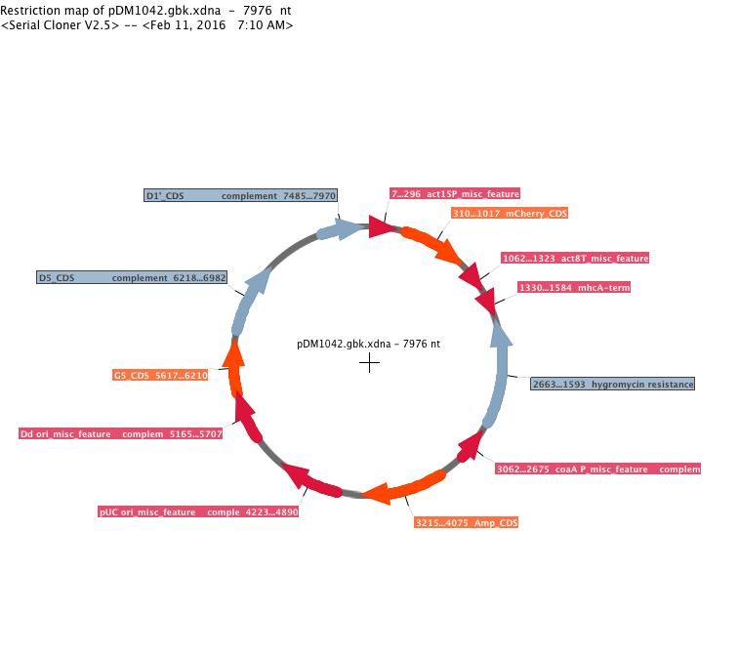

pDM 1066 extrachromosomal GFP-lifeact expression vector (hygromycin)

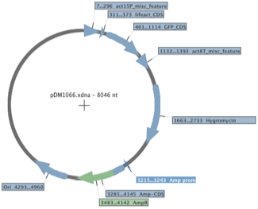
pDM 1207 extrachromosomal

pDM-1208 extrachromosomal mCherry expression vector G418

