Experiment 10: Under-agarose Chemotaxis to folic acid

Chemotaxis: finding the way forward with Dictyostelium, Jason S. King and Robert H. Insall Trends Cell Biol. 2009 Oct;19(10):523-30

Signal relay during chemotaxis G.L. GARCIA & C.A. PARENT Journal of Microscopy, Vol. 231, Pt 3 2008, pp. 529–534.

You have measured the movement of cells in growth media where they have no directional cues. Dictyostelium amoebae eat bacteria as their food source. They find the bacteria in the soil by sensing molecules that are released from bacteria. The only characterized molecule that amoebae sense is folic acid. Folic acid is a vitamin required for growth of eukaryotic organisms from Dictyostelium to man. We don’t synthesize our own folic acid, but acquire it from what we eat. It is synthesized by prokaryotes. Folic acid is also emitted from areas with many bacteria and leads to a concentration gradient that is highest near the bacteria and lower as the distance increases. Dictyostelium cells have surface receptors that bind and sense folic acid and can move from areas of low concentration to areas of high concentration. This directional movement in response to a diffusible signal is CHEMOTAXIS.

The purpose of this experiment is to quantify the speed and directionality of the movement of AX2 and HK321 cells during chemotaxis towards folate and to compare chemotactic movement to random vegetative movement (which you have already analyzed). There are many devices that can be used to set up a gradient of folic acid for cells to respond to. The Knecht lab developed the under-agarose chemotaxis assay to study this process and it is fairly easy to set up and works well for microscopy. The reason you are using agarose is to stabilize the chemotactic folate gradient that the cells will see. In liquid media, there is too much convection and other disturbances so it is hard to get a stable gradient that the cells can sense. The folic acid diffuses through the agarose as it would in water (the gel is 99% water) because the pores are so large that the folate doesn’t see them.

Read through the entire protocol so you understand the assay before planning how many plates you will make and what you will do with each plate. The protocol describes a general approach that works, so if you decide to try different conditions, be sure to do the standard protocol as a positive control. Discuss with Sarah or I once you have a protocol.
- At a minimum, you should compare the HK321 with AX2 using the standard condition
- You can set up several variations on the basic experiment: different agarose concentrations, folate concentrations, different well spacings (different gradient shape) or use different numbers of cells in different plates.
- You should also do a negative control with no folate so you can see the extent of random movement under these conditions.
- An interesting alternative that we have been studying in the Knecht lab is to put folate uniformly in the agarose instead of making a gradient. You add the folate to the agarose before it cools. Then you only cut one well and add the cells and those cells should have folate everywhere surrounding them. What do you hypothesize would happen in this case?

You want to make sure you have log phase cells for this assay.

Procedure

The general design of the experiment is to pour a hot agarose solution into a Petri dish, allowing it to cool and gel and then cut wells in the agarose. The cells will be loaded into one well and so they will settle onto the plastic surface. The chemoattractant (or control) will be loaded in the other well. You will image them as they move between the agarose sheet and the plastic in response to a chemotactic gradient or no gradient. Given the relatively short time frame of the experiment (less than 12 hours) there is no need to worry about sterility.

Pretreating the Petri dishes
If you simple add the agarose solution to a Petri dish, the agarose will stick to the plastic and prevent cells from moving between the plastic and the agarose. To block this sticking, pretreat the dishes with a non-specific protein solution. We will give you a 10 mg/ml BSA (Bovine Serum Albumin) solution to use. The protein sticks to the plastic and prevents the agarose from sticking. Simply pipette about 5 ml of the blocking solution into a 60mm dish, make sure it spreads around the bottom, leave it for 5 minutes to allow protein to attach to the plastic, and then remove the blocking solution and rinse the dish several times with SorCM or SM3 or water.

Pouring Agarose Plates

This assay uses SM3 media because there is a significant amount of folic acid in HL5 medium (another variable you could test- you could try running the assay in HL5 and see if it works). You want 8 ml (agar + SM) per P60 dish. You can use any concentration above 0.75% agarose (0.75g/100ml). Below this concentration the agarose is very soft and hard to work with. Our standard concentration is 1.5% agarose but you can try varying the concentration to see the effect on cells. Plates may be prepared a day in advance as long as you don’t cut the troughs in advance. You should make several extra plates so you can practice cutting troughs. Make more agarose solution than the number of dishes you plan to pour as you lose some liquid when boiling to melt the agarose.

1. To prepare several dishes, combine the appropriate amount of agarose with SM3 media in a screw cap flask. Make sure the cap is loose.

- Heat the agarose/SM3 in the microwave. Watch carefully and stop (open the door) as soon as it begins to boil. It will easily boil over if you are not careful. Open the microwave door and gently swirl the flask. Be careful because the superheated fluid can boil over when you swirl the flask. Wear protective gloves and eyewear. Repeat the heating 3-4 times until the you cannot see any bits of agarose floating in the flask.

- Pipet 8 ml of melted agarose into each p60 Petri dish and allow to cool on a level surface (your benchtop). It takes about 15-30 minutes to harden. If you decide to do a plate with uniform folate, add the concentrated folate to the dish and then add agarose. The folate will mix with the agarose solution as you pipette it in.

- Be sure to pour at least one extra plate per person so you can practice cutting and filling wells.

Prepare the cells while the plates are cooling.
When you are done with the flask, make sure all the agar is rinsed out of the flask. If you allowed it to solidify, add some water, microwave to melt and rinse out the flask.

Preparing AX2 and HK321 cells for Chemotaxis

You should do the assay with cells in log phase of growth. For best results, change the media on your cells the day before the assay so they have fresh media and think they are in log phase.

You will need about 300 µl of cells at about 3 x10⁶ cells/ml for each plate. You can do two cell troughs per plate but you can only image one at a time.
Folate

- Triturate your cells in your growth plate and pipette them into a 15ml centrifuge tube. Add a small amount to the hemocytometer so you can titer the cells while they are spinning down.

- Spin down cells for 5 min at 500xg (1500 rpm on our centrifuge) at 4°C.

- Aspirate off the HL-5. Do not put the tip too close to the cell pellet so you avoid sucking up the cells. A small amount of residual HL5 should not be a problem. Vortex the tube to break up the pellet and then add the proper volume of SM3 to bring concentration to about 3x10⁶ cells/ml and then vortex the cells. Make sure the pellet is dispersed as it is sometimes hard to resuspend. If you are having trouble, suck up the SM3 with a P1000 or 5 ml pipette and use the stream of media to break up the pellet. Check your cell density again to make sure you prepared them correctly.
Cells

Cutting the troughs in the agarose

- Use your extra plates to practice cutting the troughs and removing the agarose. Once you are done cutting, use the extra plates to practice filling a well with media/buffer so you get a sense of what it looks like when a well is full, without spilling over the top.

- The troughs should be cut the length of a single edged razor blade, 2-5 mm wide and 5mm apart (See last page for a template). Blades can be reused, but you want it sharp to make a clean cut.

3. Lay the plate with the agarose sheet on top of the template (last page of this document) so you have a cutting guide. Use your first plate as a trial to practice. Make several troughs in this plate to get a feel for the cutting action. The blade tends to cut smoother after being wetted by the agarose. Place the blade flat on the agarose surface, make sure the blade is vertical and aligned with the guide and then push straight down so the entire blade cuts through to the bottom in one motion. Don’t try to saw your way through. If you saw, you may score the plastic and that will interfere with cell movement.
Make each of the 4 cuts for the two troughs. You want the edge of the cell trough and the edge of the chemoattractant trough to be about 5mm apart. The guide will create this space. The separation between the troughs is important as that determines the shape of the chemoattractant gradient. NOTE: We have a solution of fluorescent dye that you can use to image the shape of the gradient over time. You would put the dye in one well and image the area between the wells with the appropriate filter set and LED.

- After the troughs are cut, use a pointed spatula to cut the ends of the agarose block and then gently lift the edge of the agar block and lift it out to form a trough. This assay is short enough in duration that it does not require sterile technique, so you can use your fingers. The bridge between the troughs is weak and flexible, so be gentle and careful removing the agar blocks.

Adding cells and chemoattractant

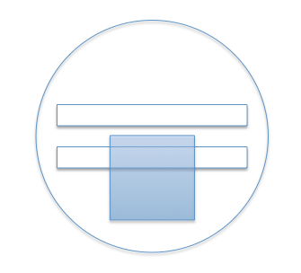
- Place an 18x18 mm coverslip in the center of the trough so it covers the cell well and covers part of the area between the troughs, but does not overlap the chemoattractant well (Diagram at right). The meniscus from the well disturbs the phase contrast near the trough edge and having the coverslip eliminates this problem.
- After vortexing your tube of cells again, begin adding the cells to the trough. Insert the pipette tip end into the empty space not covered by the coverslip and slowly push the plunger to expel. If you expel too quickly, you will force cells under the agarose. You can put the tip all the way down to the plastic surface if that is easier but don’t push the agarose sheet or you will push cells under the agarose.
- It will take about 300-500µl of cells to fill the trough. You want to fill until the solution contacts the coverslip. It will not be the same volume for each well because it depends on precisely how wide you cut the wells.
- After you have added the cells and especially after they have settled, look at the well with your benchtop microscope. You should have a dense layer of cells covering most of the surface and few cells under the agarose. If the cells are sparse, the assay will not work well. If you encounter this, you can remove some of the media in the trough and add more of your cell suspension and let them settle until the density is good (but it means you did not titer the cells correctly, so check this).

- Now place the plate on the microscope stage and add the 0.3mM folate solution to fill the other well. Don’t overfill and spill but you want to add enough so the level is nearly the same as the cell well so you are not creating a pressure gradient and forcing liquid to flow from one well to the other.
- Begin taking images

The gradient will take about 1 hour to reach the cells so do not expect a response before that.

Imaging

- Set up a time lapse video to capture images of the moving cells. Set the position of the dish so the edge of the cell well is just barely in the field of view so you maximize the area you are able to image movement. Within one to two hours, the first few cells start to exit the trough and move underneath the agarose. Cells will continue exiting over time so you will have a leading edge of cells that left early and many trailing cells. The cells will continue for 8-12 hours until the leading cells reach the folate trough. As far as we know, the cells that leave the well first are cells that started out near the edge so they are not special, they just happened to land near the agarose edge where the gradient is formed. It is best to start with the 4x objective to have a large field of view to track cells. If you want to try to get more detail on how the cells are moving, come back once the cells begin moving, and move to a higher magnification objective and focus on the cells near the moving front. You could also use the transformed fluorescent cells and capture images of the actin localization in cells moving chemotactically to compare with randomly moving cells.

- If you plan to compare some variations, you can either capture long time lapse movies of each condition, or you can set up several conditions, wait 4-6 hours until the cells have moved out of the trough, and then image each for a shorter time. You could also capture still images of each dish at time intervals. If you are testing a set of variables (for instance different folate concentrations), you can take images at several hour intervals of a number of dishes or you could record short movies of each.

- It is important to remember that because the cells are degrading the chemoattractant as them move, only the cells near the front of the wave of moving cells will likely be moving chemotactically. The trailing cells are not expected to be seeing a gradient because the cells between them and the folate well have degraded the folate. You can test this hypothesis by quantifying the motility of cells at the front as compared to cells behind the front.

Analysis: Use ImageJ and mTrackJ plugin make measure the distance and speed of cells and make movies of cells with tracks. You can also measure the position of the front of cells over time as a bulk measure of cell speed. You should measure the parameters of movement (speed, persistence, directionality) and compare that to the random motility of vegetative cells you have previously measured. You can also use the Set Reference feature of mTrackJ to tell the program where the folate source is and measure movement relative to that directional reference.

You can cut two or three wells with this template. It depends on your experimental design whether these is any reason to cut three!

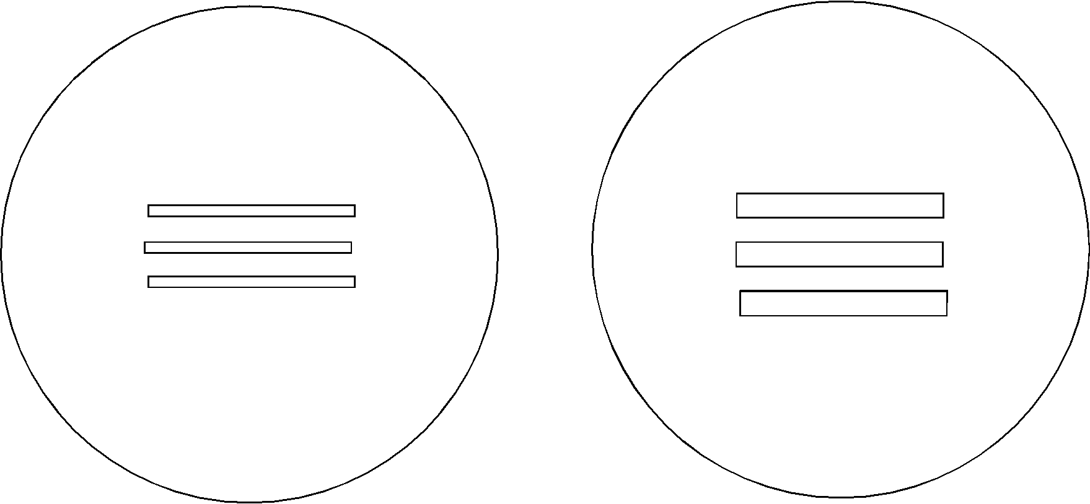

Well cutting template- there should be one at each lab bench in your drawer.

