Confocal 3D image Processing

Download the two data sets from the link I provide to you. You can work with one, the other or both.
Dicty data:
Cells were fixed with formaldehye to allow the cells to be stained with antibodies and phalloidin. See the Lecture on Fixation and Immunostaining in HuskyCT. One channel of data is the microtubule network in the cells. The other channel is the same field of cells imaged in the phalloidin channel. Phalloidin binds to F-actin filaments so it is like the Lifeact probe you used to image live cells. Phalloidin does not enter live cells but fixation and permeabilization allows it to get into the cytoplasm to stain the filaments. The advantage is since the cells are permanently fixed, everything is fixed in position so you can optically slice through the volume with the confocal microscope and see the relative positions of various structures. It is very difficult to do this with live cells because things are moving and changing faster than you can collect the data.

Intestine Data: This is a purchased prepared test slide in which actin is stained with phalloidin and nuclei with a fluorescent dye that binds DNA. It is a relative thick section through part of a mouse intestine so many cells are stacked through the tissue.

- Open the data set in Fiji. These are image stacks of confocal sections through specimens so as you step through the images you are moving in the Z dimension, starting at the coverslip and working up through the specimen. Many of the functions you can do in Fiji with 3D data are described here: https://imagej.net/Z-functions

- Filtering- Your renderings will only be as good as the raw data used. You can clean up the data by filtering. Save each alteration you do separately and try projecting or rendering it to see the effect.
  - Crop to view a smaller number of cells or smaller chunk of tissue
  - Brightness/contrast adjust- but it doesn’t affect projections like images due to max projection
  - Process/Noise/Despeckle or Plugins/ Non-local means denoising to remove noise from data
  - 3d Median- Does a median filter in 3 dimensions instead of two. This takes a few seconds to run. It allows you to average noise in the X.Y and Z dimensions (no preview) which can help with 3D data.

- Viewing data from any angle in 2D
  - Image/Stacks/Orthogonal Views
    - Shows top, and two side views at the same time for a single channel
    - As you move the cursor, the postion of the line will change so you can see the slice through the volume in different places. This is very useful to get a sense of the data from different angles. For instance, you may not have a good idea of the shape of cells attached to a coverslip. In the side view you will see the extent to which they flatten on the surface.
    - Save some of the slices to show in your notebook and what you learn from that view
  - Image/Stacks /Dynamic Reslice
      - Draw a line on the image. The software will create a side view of the volume as if you sliced through the volume with a knife along that line. Keep the mouse button down as you draw the line. As you change the length of the line or the orientation of the line, the reslice will change accordingly. These are not volumes but individual slices.
      - If you draw a line first, it will slice along that line and move down and to the left the number of slices you designate in the slice count box

  - Volume Viewer Plugin (not 3D volume plugin)- Use the center window to click and drag and the view rotates as you move. There are many options here for viewing the volume from different angles and different zoom levels. You can take snapshots of different views.

- Viewing Data in 3D- There are two ways to see the data as a volume rather then slices so you can rotate it in space and see it from any angle. A projection creates a 2D view of the data from any angle. It is a 2D view, but is like looking at the volume from a particular perspective. It is done by mathematically looking through the data and projecting a line through the volume from the defined angle and calculating what each pixel would look like depending on what is in front or behind each pixel. A rendering creates a true 3D volume that can be freely rotated in space. This is mathematically more complex, but produces a true 3D volume.
  - 3D projection – There are choices for how to do the projection. You start looking straight down on the stack of data, and at each pixel, you look through the volume and record an intensity value at each position (a ray trace through the volume). Usually, one does a maximum intensity projection in which you record the maximum pixel intensity along each ray through the volume. There are functions to take into account how deep a pixel is from that angle so you can either reduce or increase the value relative to depth. If you are trying to see things deeper in the volume, you want to minimize the effect of the surface (the first pixel the ray encounters). If you are trying to see the surface, then you prioritize the first pixels the ray encounters over deeper pixels. This is described below as Surface/Interior depth cueing. For whatever parameters you use, you can create a series of 2D views from various angles to create a rotating stack of 2D planes of the volume from various angles. The more angles, the longer it takes to create. I would start with 10° angles and 180 degrees total while you play with parameters.
    - Image/Stacks/Z projection- does a top down projection
    - Image/Stacks/3D project- allows you to project from any angle
      - Lower transparency bound- nearest/brightest point
      - Upper transparency bound - nearest/brightest point
      - Initial angle
      - Rotation Angle Increment
      - Depth cueing - changing the effect of depth of the image. Read the manual below or online.
      - Interpolate- Watch the difference in what you get if you click the interpolate check box vs. not checked. This function smooths the data to fill in the information between slices (which it views as infinitely thin). This slows down the computation, but generates a nicer looking image.

  - Stereo Projection- You see the world in 3D in part because your left eye and right eye see slightly different things. It is partly how you do depth perception. With this method, you create a series of projections from two slightly different angles. You then use a red LUT for one stack and a blue LUT for the other and merge them. When you view with red/green glasses, one eye sees one stack and the other eye sees the other and they differ by a 5° angle. This tricks your brain into thinking it is seeing a 3D object. Unfortunately, you need red/green stereo glasses to view this. They are in the lab, so this is not useful unless you happen to have glasses of this sort at home.
    - Project two versions of the stack one starting at 0° and one at 5°
    - Color merge the two with one red and one green
    - Your two eyes see different images fooling your brain into thinking it is stereo
    - You can only do 1 channel (actin vs. tubulin) at a time because you are using two colors to visualize the one channel.

- 3D rendering- creates an actual volume in the computer that can be viewed from any angle. The pixels are now voxels with three dimensions so you can now measure things in 3D space. There is very expensive software for doing this, but the Fiji plugin does a reasonable job. It is however, sometimes challenging to use.
    - Plugins/3D viewer (instruction manual attached)
    - Have the stack you want to render open and choose the plugin. Better to set the Resampling factor to 1 (default is 2). For large datasets this is very computer intensive so resampling allows you to limit the data it is calculating from.
      - You can set the color of the channel
      - Mouse wheel zooms, mouse drag rotates
      - View menu options creates movies of various sorts
    - In order to do both channels you need to start from scratch. Re-render one channel (actin, for instance) and assign a color from the color pulldown box. Now use the File/Open or Add/From Image command to open the other stack and assign it a different color. You will see the two data sets rendered at the same time. I have found that on my computer, if I click and drag to rotate the volume, only one dataset rotates. But if I use the View options to rotate it works better.
Instructions:

https://imagej.net/Z-functions
or below
ImageJ Image/Stacks Commands

25.6.9 Reslice… [/]
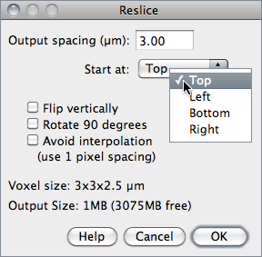
Reconstructs one or more orthogonal slices through the image volume represented by the current stack or hyperstack [15].

The estimated size of the output stack and the amount of available memory are displayed at the bottom of the dialog. Increase Output spacing to reduce the size of the output stack.

A dialog allows you to specify the spacing of the reconstructed slices.
Output spacing Determines the number of orthogonal slices that will be reconstructed. Increasing Output spacing reduces the size of the output stack.
Start at Determines the image edge (top, left, bottom or right) from which reconstruction starts. Start at is replaced by Slice count if there is a line selection. With lines selections, a stack is created by shifting (by Output spacing) the line down and to the left to generate additional slices for the output stack. In this case, the size of the output stack in determined by Slice count.
Flip vertically If checked, each slice in the output stack will be flipped vertically.
Rotate 90 degrees If checked, each slice in the output stack will be rotated 90○.
Avoid interpolation If checked, no interpolation will be done.
Help Opens http://imagej.nih.gov/ij/docs/menus/image.html#reslice.
See Also: Dynamic Reslice and Radial Reslice plugins

25.6.10 Orthogonal Views [H]
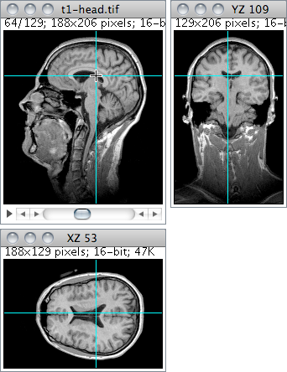
Provides an orthogonal view display of the current stack or hyperstack [16]. E.g., if a stack displays sagittal sections, coronal (YZ projection image) and transverse (XZ projection image) will be displayed through the data-set.

The two extra planar views are displayed in ‘sticky’ panels next to original image and can be toggled using Shift H , the command shortcut.

The intersection point of the three views follows the location of the mouse click and can be controlled by clicking and dragging in either the XY, XZ or YZ view. XY and XZ coordinates are displayed in the title of the projection panels. The mouse wheel changes the screen plane in all three views.

Voxel dimensions can be adjusted in Image ▷ Properties… [P]↑.
See Also: 3D Project…↓, and 3D Viewer [23], Volume Viewer, Stack Slicer Display3_TP plugins, Edit ▷ Options ▷ DICOM…↑

25.6.11 Z Project…
Projects an image stack along the axis perpendicular to image plane (the so-called z axis) [15]. Five different projection types are supported. With ImageJ 1.44l and later, the preferred projection method is stored in the preferences file.
Average Intensity projection outputs an image wherein each pixel stores average intensity over all images in stack at corresponding pixel location.
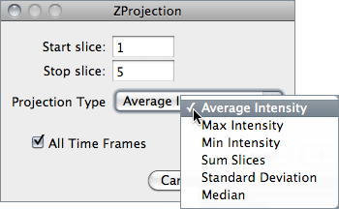
Average Intensity projection outputs an image wherein each pixel stores average intensity over all images in stack at corresponding pixel location.
Maximum Intensity projection (MIP ) creates an output image each of whose pixels contains the maximum value over all images in the stack at the particular pixel location.
Sum Slices projection creates a real image that is the sum of the slices in the stack.
Standard Deviation projection creates a real image containing the standard deviation of the slices.
Median projection outputs an image wherein each pixel stores median intensity over all images in stack at corresponding pixel location.
See Also: Grouped Z Project…↓, 3D Project…↓, Plot Z-axis Profile…↓

25.6.12 3D Project…
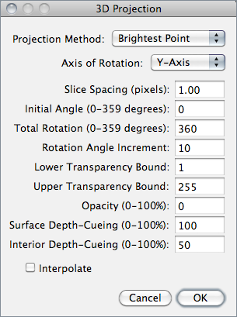
This command creates a sequence of projections of a rotating volume (stack or hyperstack) onto a plane using nearest-point (surface), brightest-point, or mean-value projection or a weighted combination of nearest point projection with either of the other two methods (partial opacity) [17]. The user may choose to rotate the volume about any of the three orthogonal axes (x, y, or z), make portions of the volume transparent (using thresholding), or add a greater degree of visual realism by employing depth cues.

Each frame in the animation sequence is the result of projecting from a different viewing angle. To visualize this, imagine a field of parallel rays passing through a volume containing one or more solid objects and striking a screen oriented normal to the directions of the rays.
Each ray projects a value onto the screen, or projection plane, based on the values of points along its path. Three methods are available for calculating the projections onto this plane: nearest-point, brightest-point, and mean-value. The choice of projection method and the settings of various visualization parameters determine how both surface and interior structures will appear.
Projection Method Select Nearest Point projection to produce an image of the surfaces visible from the current viewing angle. At each point in the projection plane, a ray passes normal to the plane through the volume. The value of the nearest non transparent point which the ray encounters is stored in the projection image. Brightest Point projection examines points along the rays, projecting the brightest point encountered along each ray. This will display the brightest objects, such as bone in a CT (computed tomographic) study. Mean Value projection, a modification of brightest--point projection, sums the values of all transparent points along each ray and projects their mean value. It produces images with softer edges and lower contrast, but can be useful when attempting to visualize objects contained within a structure of greater brightness (e.g. a skull).
Slice Spacing The interval, in pixels, between the slices that make up the volume. ImageJ projects the volume onto the viewing plane at each Rotation Angle Increment, beginning with the volume rotated by Initial Angle and ending once the volume has been rotated by Total Rotation.
Lower / Upper Transparency Bound Determine the transparency of structures in the volume. Projection calculations disregard points having values less than the lower threshold or greater than the upper threshold. Setting these thresholds permits making background points (those not belonging to any structure) invisible. By setting appropriate thresholds, you can strip away layers having reasonably uniform and unique intensity values and highlight (or make invisible) inner structures. Note that you can also use Image ▷ Adjust ▷ Threshold… [T]↑ to set the transparency bounds.
Opacity Can be used to reveal hidden spatial relationships, specially on overlapping objects of different colors and dimensions. The (surface) Opacity parameter permits the display of weighted combinations of nearest-point projection with either of the other two methods, often giving the observer the ability to view inner structures through translucent outer surfaces. To enable this feature, set Opacity to a value greater than zero and select either Mean Value or Brightest Point projection.
Surface / Interior Depth--Cueing Depth cues can contribute to the three-dimensional quality of projection images by giving perspective to projected structures. The depth-cueing parameters determine whether projected points originating near the viewer appear brighter, while points further away are dimmed linearly with distance. The trade-off for this increased realism is that data points shown in a depth-cued image no longer possess accurate densitometric values. Two kinds of depth-cueing are available: Surface Depth-Cueing and Interior Depth-Cueing. Surface Depth-Cueing works only on nearest-point projections and the nearest-point component of other projections with opacity turned on. Interior Depth-Cueing works only on brightest-point projections. For both kinds, depth-cueing is turned off when set to zero (i.e. 100% of intensity in back to 100% of intensity in front) and is on when set at 0 < n 100 (i.e. (100 − n)% of intensity in back to 100% intensity in front). Having independent depth-cueing for surface (nearest-point) and interior (brightest-point) allows for more visualization possibilities.
Interpolate Check Interpolate to generate a temporary z-scaled stack that is used to generate the projections. Z-scaling eliminates the gaps seen in projections of volumes with slice spacing greater than 1.0 pixels. This option is equivalent to using the Scale plugin from the TransformJ package to scale the stack in the z-dimension by the slice spacing (in pixels). This checkbox is ignored if the slice spacing is less than or equal to 1.0 pixels.
See Also: Orthogonal Views [H]↑, Z Project…↑, Grouped Z Project…↓ and 3D Viewer [26], Volume Viewer plugins

ImageJ 3D Viewer:
http://rsb.info.nih.gov/ij/plugins/3d-viewer/index.html
Author: | Benjamin Schmid(Bene.Schmid at gmail.com)
History: | 2007/04/20: First public version
Limitation: | Requires Java3D to be installed.
Installation: | Download ImageJ_3D_Viewer.jar to the plugins folder, or subfolder, restart ImageJ, and there will be a new command in the Plugins menu, "ImageJ 3D Viewer".
Description:

1. Demo video
Find here a screencast which shows some of the viewers feature (file size: 60 MB, duration: about 15 minutes).

2. Installation of Java3D
Before you start off, make sure you have Java3D installed in your Java JRE. If you are not sure whether Java3D is installed on your machine, simply download Java3Dexample.jar and start it (double-click on Windows or Mac, java -jar Java3Dexample.jar from a console under Linux). If you can see a rotating cube and no error or exception pops up, you are fine. If this is not the case, see here for a plugin which installs Java3D for you.

3. General notations
This plugins offers both Texture-based volume rendering and surface reconstruction and visualisation. Common to both is the limitation to 8-bit stacks, be it 8-bit grayscale images or 8-bit indexed color images. Note at this point that you can always convert an RGB image to an 8-bit color image. If you need an example stack, try this.

Texture-based Volume Rendering
In order to invoke the volume renderer, open your image stack and click on "ImageJ 3D Viewer" in the plugins menu. A dialog pops up, asking you whether you want to display a volume or a surface. Select "Volume" here:
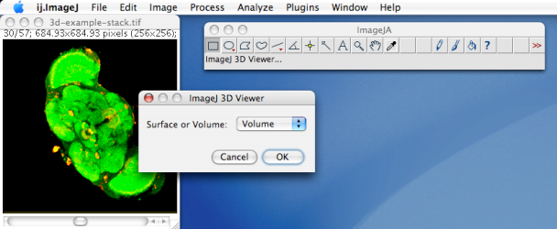
A second dialog appears, asking for a few parameters, which you can just ignore if you don't know what they mean:
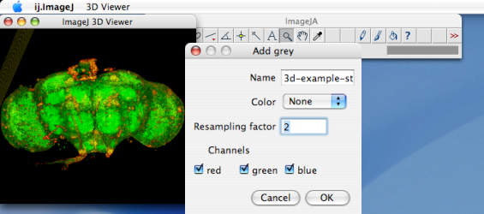
- Name in the above dialog specifies the name of the content which you add to the 3D world.
- Color specifies the color which is used to display the element. If you select "None", which is the default, the colors of your stack will be used. If you select another color, the element will be shown unicolored in the color you selected.
- Resampling factor is the factor by which the stack is resampled before it is rendered.
- Channels specifies the channels of the original image which you want to use. The example image has just two channels, red and green. If we just want to display the red channel, uncheck the other two:
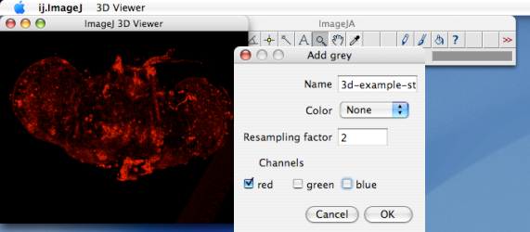
You can rotate the brains using the left mouse button, or zoom using your middle mouse button and drag. The "Hand" tool in ImageJ's menu bar has to be selected therefore.

5. Surface Extraction and visualisation
If you want to view a surface at a certain intensity threshold, choose "Surface" instead of "Volume" in the initial dialogue, just after clicking "ImageJ 3D Viewer". The appearing dialog is similar to the one used in Volume rendering, but additionally asks for the value of the threshold. As surface reconstruction algorithm the well-known marching-cubes algorithm is utilised.
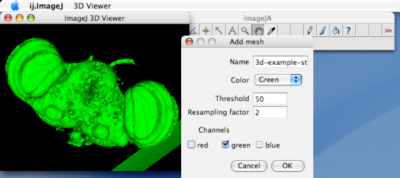
Before the surface is extracted, an average gray value is calculated for each voxel including all specified channels.

6. Navigation
You can do several things with the contents of the 3D world: You can rotate them, you can move them, and you can zoom in and out. In order to rotate and translate, the HAND tool in ImageJ's toolbar must be selected. To rotate, just drag with the left mouse button. To translate, press the SHIFT-key and drag simultaneously with the left mouse button. For zooming, the MAGNIFIER tool from ImageJ's toolbar must be selected. You can then zoom in and out by dragging vertically in the 3D world.

Operation | ImageJ tool | How to do it
Rotate | HAND tool | Drag with the left mouse button
Translate | HAND tool | Press the SHIFT key and drag with the left mouse button
Zoom | MAGNIFIER tool | Drag with the left mouse button

Since it is possible to have more than one content in a 3D world, one has to distinguish, if one wants to rotate/translate the whole world or just one of the contents.
If you just want to work with one content, you have to select it before. Selection is done by left-clicking on a content. A brief message will appear for a few seconds which shows the name of the selected content. Then you can rotate and translate as described above. Zooming is not possible for a single content.
If you got lost, you can at any time select "Reset view" from the "3D Viewer" menu. It will place all objects where they have initially been.
7. Using the menu
The Viewer3D menu offers some ways to work with the content of the 3D world:
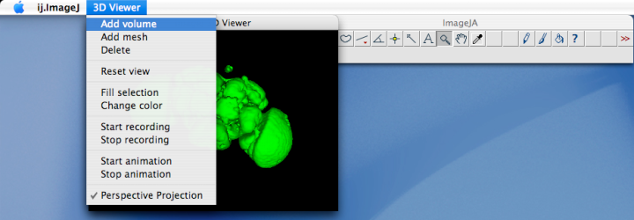
You can add other volumes, meshes (reconstructed surfaces). You can also delete them or change their color. For this, you have to select a content, by clicking on it.

"Fill selection" offers a powerful way to edit a volume (this doesn't work with surfaces) and with the volume your original stack: Open therefore a volume, select the Freehand Selection Tool of ImageJ's toolbar, and draw a ROI around the region you want to fill. Afterwards, click on "Fill selection" in the 3D Viewer menu, and wait, until the image is reloaded. The part you selected is filled with black color.
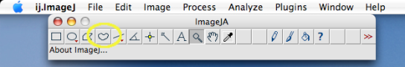
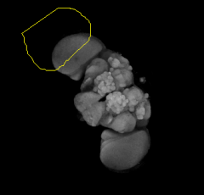 | 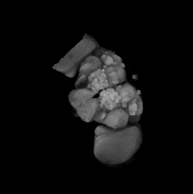 | 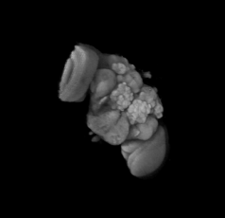

8. Creating Movies
It might happen that you'd like to create a short movie, e.g. for presentations, showing your 3D world rotating or zooming. This is also possible. To do that, Click in the menu on "Start recording", then select ImageJ's Hand tool, rotate your content, and click on "Stop recording". An image stack opens, showing your rotation from slide to slide. You can store this stack as a movie file by saving it in AVI format.

Using ImageJ's GIF Stack Writer you can also create animated GIFs like the one you see above.
If you want a smoother movie, you can animate the 3D world. This will rotate the world about a vertical axis at the origin. Note that if you have moved objects in the 3D world, the vertical axis through the origin might no longer pass the center of the object. Animation is started and stopped using the commands from the "3D Viewer" menu.

Using ImageJ's GIF Stack Writer you can also create animated GIFs like the one you see above.
If you want a smoother movie, you can animate the 3D world. This will rotate the world about a vertical axis at the origin. Note that if you have moved objects in the 3D world, the vertical axis through the origin might no longer pass the center of the object. Animation is started and stopped using the commands from the "3D Viewer" menu.
9. Macro language
The 3D Viewer now also supports ImageJ's macro language. Download this example to see how this works. Of course you can also just record it as a macro to see the commands.

| Back |
Theodor-Boveri-Institut für Biowissenschaften, Lehrstuhl für Genetik und Neurobiologie, Würzburg

