File that you provided:

Data extracted from my previous project



With the IFC settings you provided me, I tried to convert these values into Revit, but the values didn’t coincide

I also tried changing the coordinate system in a new IFC files with different properties:

Exporting rvt file into IFC using “Shared Coordinates” I get new,different values for globalX

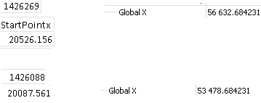

Top row is for wall of ID 1426269, on the left is revit start point and on the right is IFC startpoint “GlobalX” for this specific wall.

Bottom row is for wall of tag 1426088, on the left is revit start point and on the right is IFC startpoint “GlobalX” for this specific wall.

I tried changing the coordinate system, but the values didn’t coincide

If this value “55 422” coincided with revit’s “56632” I could use a change of coordinate system.

