PETRA – Pet Tracking and Recommendation System
Software Project Documentation
Database Layer: MySQL
Planned Application Layer: Java (Spring Boot), HTML, CSS, JavaScript

1. Project Overview

1.1 What is this project?
Petra (Pet Tracking and Recommendation System) is a relational database project designed to help pet owners manage the complete lifecycle of pet ownership through a single, structured platform. It centralizes information about pet breeds, adoption records, health tracking, grooming schedules, daily care routines, and personalized breed recommendations. The current implementation covers the database layer, built entirely in MySQL, and is designed to be extended with a full-stack web application using Java with Spring Boot on the backend and HTML, CSS, and JavaScript on the frontend.

1.2 Purpose
The primary purpose of this system is to solve a common problem faced by pet owners: fragmented and inconsistent pet care information. Instead of relying on memory, scattered notes, or generic online searches, users can rely on a structured system that tracks vaccination schedules, grooming routines, daily care tasks, and breed-specific guidance in one place. For prospective pet owners, the system also provides a recommendation engine that suggests suitable breeds based on lifestyle factors such as house type, budget, climate, and prior experience with pets.

1.3 Who will use it?
- Pet owners who want to track vaccination schedules, grooming routines, and daily care tasks for their pets.
- Prospective pet owners who need breed recommendations based on their living situation, budget, and experience level.
- Administrators who manage breed data, care guides, and vaccination guidelines within the system.
- Developers extending the system into a full web application with authentication, dashboards, and notifications.

2. Features
The system is organized around ten core feature areas, each backed by a dedicated database table.
User Management
Handles registration, authentication data, roles (admin or standard user), account status, and profile information for every user of the system.
Pet Profile Management
Stores each pet's identity, including name, breed, gender, age, weight, photo, and adoption date, linked to its owner.
Breed Information
Maintains a catalog of pet breeds across categories (dogs, cats, birds, rabbits, fish), including temperament, price range, lifespan, and suitability attributes.
Breed Care Guide
Provides breed-specific guidance on recommended food, foods to avoid, grooming needs, bathing frequency, and general maintenance tips.
Vaccination Guide
Defines the standard vaccination schedule for each breed, including vaccine names, first-dose age, and booster periods.
Vaccination Records
Tracks the actual vaccination history of each individual pet, including dates administered, next due dates, and completion status.
Grooming Checklist
Logs grooming sessions per pet along with the next scheduled grooming date and any relevant remarks.

Daily Care Checklist
Tracks recurring daily tasks such as feeding, walking, or cage cleaning, with a completion status for each task.
User Preferences
Captures each user's lifestyle profile, such as house type, budget, climate, and household composition, used to drive recommendations.
Breed Recommendation History
Records which breeds were recommended to which users and why, forming a history of the recommendation engine's output.

3. Database Overview
MySQL was selected as the database engine for this project for several reasons. First, the data in this system is inherently relational: pets belong to users, breeds belong to categories, and care records belong to specific pets. MySQL's support for foreign keys, referential integrity, and joins makes it well suited to modeling these relationships accurately.
Second, MySQL provides strong support for stored procedures, functions, and triggers, all of which are used in this project to encapsulate business logic directly at the database layer. This reduces duplicate logic in the application layer and ensures data integrity is enforced consistently, regardless of which client or application accesses the database.
Third, MySQL integrates seamlessly with Java through JDBC and Spring Data JPA, which aligns directly with the project's planned future integration using Spring Boot. This makes MySQL a practical long-term choice, not just for the current database-only phase, but for the full-stack application that will be built on top of it.

4. Database Schema
The database consists of eleven interrelated tables. Each table is described below in terms of its purpose, primary key, foreign key relationships, and general structure.
users
Purpose: Stores account information for every person who uses the system, including administrators and standard users.
Primary Key: user_id (auto-increment integer)
Foreign Keys: None. This is a root-level entity referenced by other tables.
Description: Includes full name, email (unique), password hash, phone number, city, profile photo, role (ADMIN or USER), account status (ACTIVE or INACTIVE), and account creation timestamp.

pet_category
Purpose: Defines the high-level categories of pets supported by the system, such as Dog, Cat, Bird, Rabbit, and Fish.
Primary Key: category_id (auto-increment integer)
Foreign Keys: None. This is a root-level entity referenced by the breed table.
Description: Includes category name (unique), a short description, and an optional category image reference.

breed
Purpose: Maintains detailed information about individual pet breeds within each category.
Primary Key: breed_id (auto-increment integer)
Foreign Keys: category_id references pet_category(category_id).
Description: Includes breed name (unique), temperament, climate suitability, suitability flags for first-time owners, apartment living, children, and other pets, price range, estimated monthly cost, breed image, and minimum/maximum lifespan in years.

breed_care
Purpose: Provides a one-to-one care guide for each breed, covering feeding, grooming, and maintenance.
Primary Key: care_id (auto-increment integer)
Foreign Keys: breed_id references breed(breed_id), with a unique constraint enforcing a one-to-one relationship.
Description: Includes recommended food, foods to avoid, a grooming guide, bathing frequency, maintenance tips, and a reference link to further resources such as an instructional video.

vaccination_guide
Purpose: Defines the standard, breed-level vaccination schedule that pet owners should follow.
Primary Key: vaccine_id (auto-increment integer)
Foreign Keys: breed_id references breed(breed_id).
Description: Includes vaccine name, recommended age for the first dose, booster period, and any additional notes.

pet_profile
Purpose: Represents an individual pet owned by a user, linking that pet to both its owner and its breed.
Primary Key: pet_id (auto-increment integer)
Foreign Keys: user_id references users(user_id); breed_id references breed(breed_id).
Description: Includes pet name, photo, gender, age in months, weight, and adoption date. Includes check constraints ensuring age and weight are non-negative and positive respectively, and is additionally protected by a validation trigger described in Section 11.

vaccination_record
Purpose: Tracks the actual vaccination history of a specific pet, as opposed to the general guidance in vaccination_guide.
Primary Key: record_id (auto-increment integer)
Foreign Keys: pet_id references pet_profile(pet_id).
Description: Includes vaccine name, vaccination date, next due date, and status (COMPLETED, PENDING, or OVERDUE).

grooming_checklist
Purpose: Logs grooming activity for each pet over time.
Primary Key: grooming_id (auto-increment integer)
Foreign Keys: pet_id references pet_profile(pet_id).
Description: Includes the grooming date, the next due date, and free-text remarks about the session.

daily_care_checklist
Purpose: Tracks recurring daily care tasks for each pet, such as feeding or cleaning.
Primary Key: task_id (auto-increment integer)
Foreign Keys: pet_id references pet_profile(pet_id).
Description: Includes task name, task date, and status (PENDING or DONE).

user_preferences
Purpose: Captures a user's lifestyle profile, used as input to the breed recommendation logic.
Primary Key: preference_id (auto-increment integer)
Foreign Keys: user_id references users(user_id), with a unique constraint enforcing a one-to-one relationship.
Description: Includes house type (apartment or house), budget level, climate, and flags for first-time ownership, presence of children, and presence of other pets.

recommendation_history
Purpose: Records the history of breed recommendations made to users, along with the reasoning behind each suggestion.
Primary Key: recommendation_id (auto-increment integer)
Foreign Keys: user_id references users(user_id); breed_id references breed(breed_id).
Description: Includes a recommendation timestamp and a free-text reason describing why the breed was suggested.

5. Database Relationships
The schema is organized around two central entities: users and breed. Every other table either describes these two entities in more detail or connects them together.
- A user can own multiple pets, but each pet belongs to exactly one user (one-to-many, users to pet_profile).
- A breed belongs to exactly one pet category, but a category can contain many breeds (one-to-many, pet_category to breed).
- Each breed has exactly one care guide (one-to-one, breed to breed_care).
- Each breed can have multiple vaccination guide entries, since several vaccines may apply to one breed (one-to-many, breed to vaccination_guide).
- Each pet belongs to exactly one breed, but a breed can be owned by many pets across the system (one-to-many, breed to pet_profile).
- Each pet can have multiple vaccination records, grooming entries, and daily care tasks over time (one-to-many, pet_profile to vaccination_record, grooming_checklist, and daily_care_checklist).
- Each user has exactly one preferences profile (one-to-one, users to user_preferences).
- A user can receive multiple breed recommendations over time, and a breed can be recommended to multiple users, with each individual recommendation event captured in recommendation_history (many-to-many in effect, resolved through users and breed to recommendation_history).
Referential integrity is enforced throughout the schema using foreign key constraints, ensuring that records such as pet profiles, vaccination entries, and recommendations can never reference a user or breed that does not exist.

6. Entity Relationship (ER) Diagram
The diagram below should illustrate all eleven tables and their relationships as described in Section 5. It should show primary keys, foreign keys, and cardinality (one-to-one, one-to-many) between connected tables. An ER diagram exported from MySQL Workbench (Database > Reverse Engineer) or generated using a tool such as dbdiagram.io is recommended for this section.
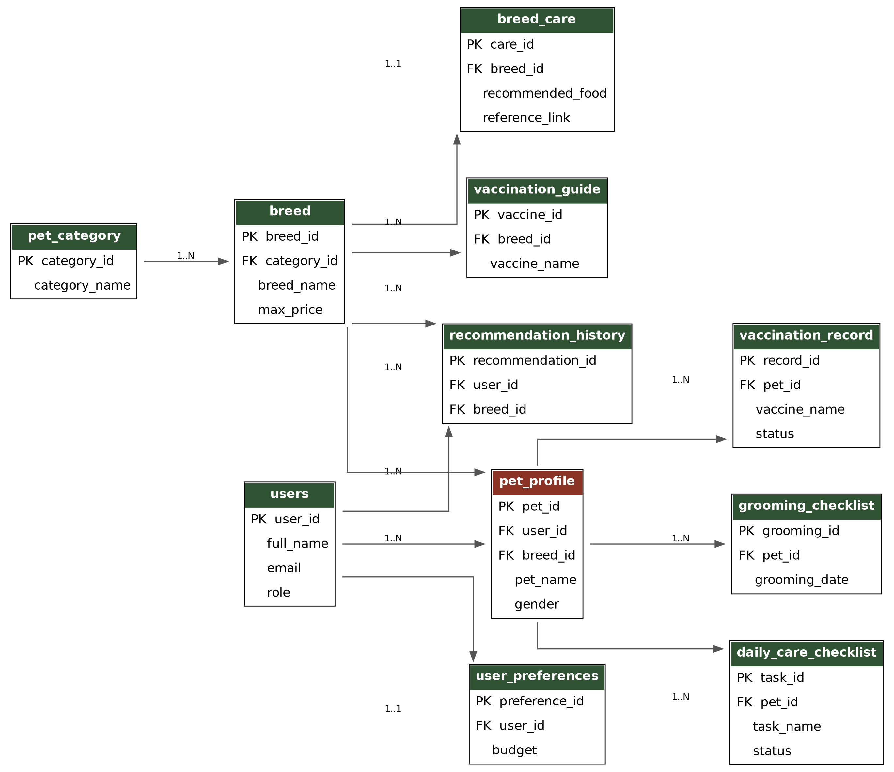
In summary, the diagram centers on users and breed as the two primary reference entities, with pet_profile acting as the bridge between them, and the remaining tables (breed_care, vaccination_guide, vaccination_record, grooming_checklist, daily_care_checklist, user_preferences, recommendation_history) extending from these three core tables to capture care details, history, and recommendations.

7. System Architecture
This section outlines the intended architecture of the full system once the application and presentation layers are built on top of the current database. The system is planned as a three-tier architecture:
- Presentation Layer: HTML, CSS, and JavaScript, responsible for rendering the user interface, handling client-side validation, and communicating with the server layer.
- Application Layer: Java with Spring Boot, responsible for exposing REST APIs, applying business logic through service classes, managing authentication and sessions, and communicating with the database through Spring Data JPA / JDBC.
- Data Layer: MySQL, responsible for persistent storage, referential integrity, and encapsulated business logic through stored procedures, functions, and triggers, as documented in this file.
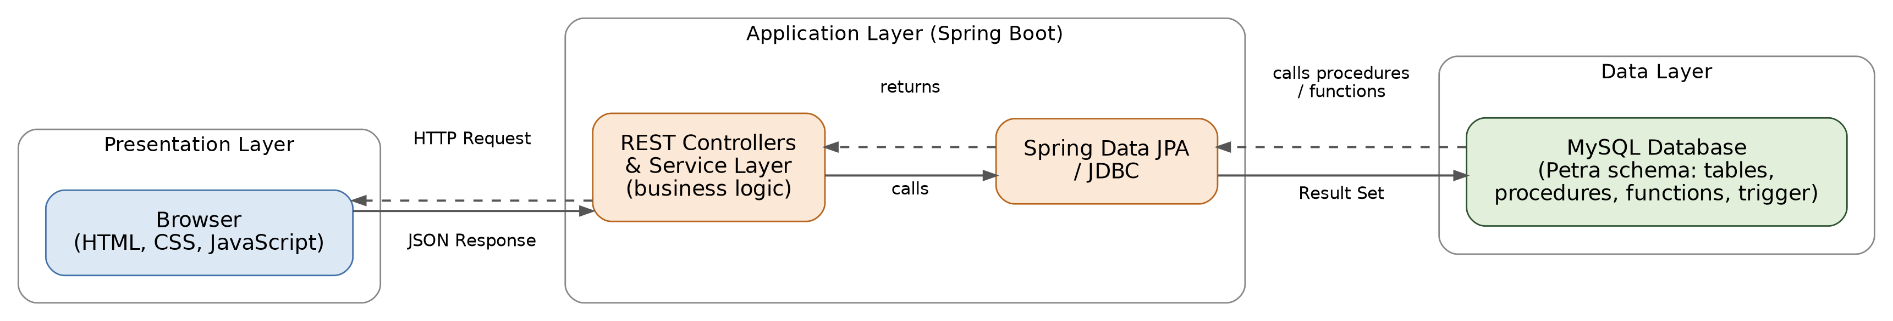
The diagram should show the flow of a request from the browser (HTML/CSS/JavaScript) to the Spring Boot application layer (REST controllers and services), and from there to the MySQL database via Spring Data JPA / JDBC, along with the response flowing back through the same layers, typically as JSON.

8. SQL Concepts Used
The following core SQL concepts are used throughout the project.
CREATE DATABASE
Used once to establish the pet_care_management_system database, which acts as the container for all tables, procedures, functions, and triggers in this project.
CREATE TABLE
Used to define the structure of all eleven tables, including column data types, constraints (NOT NULL, UNIQUE, CHECK), and default values.
ALTER TABLE
Used to modify existing table structures after creation, such as adding a column (pet_category.category_image), dropping a column (breed.lifespan), adding multiple columns at once (breed.min_lifespan_years and max_lifespan_years), renaming a column (breed_care.youtube_url to reference_link), and modifying an existing column definition (pet_profile.gender to include an UNKNOWN option).
INSERT
Used to populate all tables with sample data, including users, categories, breeds, care guides, vaccination guides, pet profiles, and related records.
SELECT
Used extensively to retrieve data, ranging from simple full-table queries to filtered, joined, and aggregated queries described in the sections below.
UPDATE
Used to modify existing records, such as changing a vaccination record's status to OVERDUE.
DELETE
Used to remove records, such as deleting a temporary demo user created for testing purposes.
WHERE
Used throughout to filter result sets based on conditions such as role, city, price range, or status.
GROUP BY
Used to aggregate data by category, such as counting breeds per category or pets per user.
ORDER BY
Used to sort result sets, such as listing breeds from lowest to highest price.
Aggregate Functions
COUNT, SUM, AVG, MIN, and MAX are used to summarize data, such as total users, average pet weight, and highest breed maintenance cost.
INNER JOIN
Used to combine rows from two or more tables where a matching relationship exists, such as joining pet_profile with users and breed to produce complete pet information.
LEFT JOIN
Used to retrieve all rows from a primary table even when no matching row exists in a related table, such as listing all users regardless of whether they own a pet.
RIGHT JOIN
Used as the inverse of a LEFT JOIN, ensuring all rows from the right-hand table are included regardless of matches on the left.
Stored Procedures
Used to encapsulate reusable, parameterized query logic directly within the database, described in detail in Section 9.
Functions
Used to encapsulate reusable scalar calculations that return a single value, described in detail in Section 10.
Triggers
Used to enforce data validation rules automatically at the database level, described in detail in Section 11.

9. Stored Procedures

GetPetDetailsByUser(p_user_id)
This procedure accepts a user ID as input and returns the full details of every pet owned by that user, including pet name, breed name, category name, age, and weight. It is used whenever the application needs to display a user's complete list of pets in a single call, joining across pet_profile, breed, and pet_category.

GetVaccinationHistory(p_pet_id)
This procedure accepts a pet ID as input and returns that pet's complete vaccination history, including vaccine name, vaccination date, next due date, and status. It is used to power a pet's health record view, allowing an owner or administrator to review past and upcoming vaccinations for a single pet in one call.

10. Functions

TotalPets(userId)
This function accepts a user ID and returns an integer representing the total number of pets owned by that user. It is used wherever a simple pet count is needed without retrieving full pet details, such as displaying a badge or summary count on a user's dashboard.

AveragePetWeight()
This function takes no parameters and returns the average weight, as a decimal value, across all pets currently recorded in the system. It is used for reporting and analytics purposes, such as displaying system-wide statistics to an administrator.

11. Trigger

CheckPetAge
The CheckPetAge trigger fires automatically BEFORE INSERT on the pet_profile table. It inspects the age_months value of the row being inserted, and if that value is negative, it raises a custom SQL error using SIGNAL SQLSTATE '45000' with the message "Pet age cannot be negative", preventing the invalid row from being inserted.
This trigger exists to enforce data validity directly at the database layer, independent of whatever application code eventually calls it. Even though a CHECK constraint on age_months already exists on the table, the trigger provides an additional, explicit validation path with a clear, custom error message. This is particularly valuable once the system is connected to a Java application layer, since it guarantees that invalid data cannot enter the pet_profile table regardless of whether the validation logic in the Java layer is bypassed, incomplete, or contains a bug.

12. Scenario-Based Queries
The following scenario-based queries demonstrate how the database supports real, practical use cases beyond simple table lookups.
Display all pets owned by a specific user
Demonstrates retrieving a single user's complete list of pets by filtering on the owner's name, useful for a personal "My Pets" dashboard view.
Display all pets belonging to the Dog category
Demonstrates filtering pets by category across a three-table join, useful for category-based browsing.
Display pets with overdue vaccinations
Demonstrates identifying pets that require immediate attention, forming the basis of an alert or reminder feature.
Display all users from a specific city
Demonstrates simple demographic filtering, useful for location-based features or reporting.
Display breeds suitable for first-time owners
Demonstrates filtering the breed catalog by a suitability flag, directly supporting the recommendation feature.
Display all pets weighing more than 10 kg
Demonstrates numeric range filtering on pet attributes, useful for health or care-related segmentation.
Count the number of pets in each category
Demonstrates aggregate reporting across categories, useful for administrative dashboards.
Display all completed vaccinations
Demonstrates status-based filtering, complementing the overdue vaccination scenario.
Display pets whose grooming is due before today
Demonstrates date-based filtering against the current date, forming the basis of a grooming reminder feature.
Display pending daily care tasks
Demonstrates status-based filtering on recurring tasks, directly supporting a daily task checklist feature.
Display users and their recommended breeds
Demonstrates joining recommendation history with users and breeds to reconstruct a readable recommendation log.
Display breeds with monthly maintenance cost above a threshold
Demonstrates cost-based filtering, useful for budget-conscious recommendation filtering.
Find the average pet weight
Demonstrates a system-wide aggregate statistic, matching the AveragePetWeight function.
Display users who own more than one pet
Demonstrates grouping combined with a HAVING clause to filter on an aggregate condition, useful for identifying multi-pet households.
Display complete pet information (owner, pet, breed, category)
Demonstrates a four-table join producing a single, comprehensive view of every pet in the system, representative of the primary data view the application layer will rely on.

13. Future Scope
The current database is designed to serve as the foundation for a complete web application. The following areas outline how this system is expected to evolve.

Java Spring Boot Integration
The next phase of development will introduce a Java-based application layer using Spring Boot. REST controllers will expose endpoints for pets, breeds, vaccinations, grooming, and recommendations, service classes will hold business logic, and Spring Data JPA (or JDBC directly) will connect to the MySQL database, invoking the existing stored procedures and functions. Spring Boot's built-in support for dependency injection, validation, and configuration will make it straightforward to structure the application into clean, testable layers.

HTML, CSS, and JavaScript Frontend
A browser-based frontend will be built using HTML for structure, CSS for styling, and JavaScript for interactivity such as form validation, dynamic content updates, and asynchronous requests to the backend. This layer will consume JSON data served by the Spring Boot REST API.

Authentication
The existing users table, including password_hash and role columns, is designed to support a future authentication system. This will involve secure password hashing, session or token-based login handling, and role-based access control distinguishing administrators from standard users.

Admin Dashboard
An administrative interface will allow authorized users to manage breed data, care guides, and vaccination guidelines, monitor system-wide statistics such as total users and pets, and review recommendation history, building directly on the aggregate queries and functions already defined in the database.

Pet Recommendation System
The user_preferences and recommendation_history tables already capture the data needed to support an automated recommendation engine. Future development will implement matching logic that scores breeds against a user's stated preferences (house type, budget, climate, experience level, and household composition) and logs the resulting suggestions.

Notification System
The vaccination_record, grooming_checklist, and daily_care_checklist tables already track due dates and statuses. A future notification system can query these tables on a scheduled basis to alert users about overdue vaccinations, upcoming grooming sessions, or pending daily care tasks, through in-app alerts or email notifications.

14. Conclusion
Petra establishes a well-structured, normalized database foundation covering user management, pet profiles, breed information, care guidance, vaccination tracking, grooming and daily care scheduling, and a breed recommendation history. The schema enforces data integrity through primary and foreign key constraints, check constraints, and a validation trigger, while stored procedures and functions encapsulate common data access patterns directly within the database layer.
This documentation is intended to serve as a reference for both the current database implementation and the planned application layer. As the project evolves to include a Java Spring Boot backend, a web-based frontend, authentication, and additional features such as recommendations and notifications, this database is designed to support that growth without requiring structural rework.

